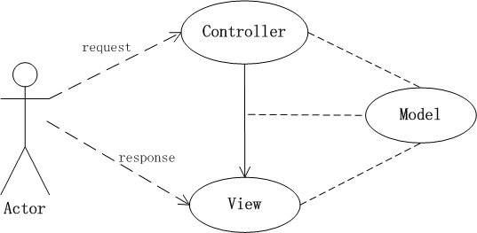

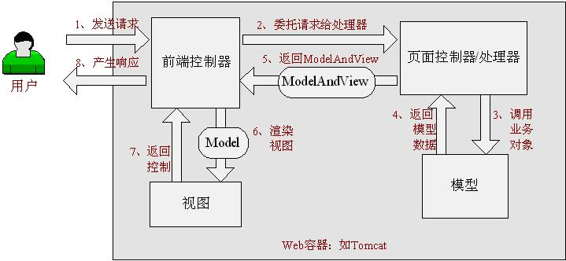

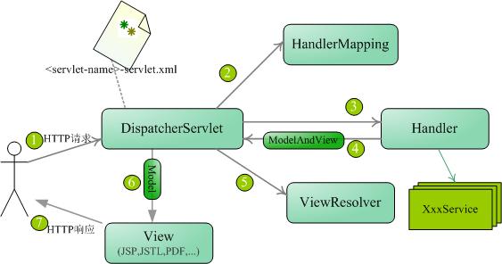

**第一步：导入相关的jar包**

**第二部：编写关于springmvc的配置文件**

xmlns:mvc=[*http://www.springframework.org/schema/mvc*](http://www.springframework.org/schema/mvc)

*http://www.springframework.org/schema/mvc*

[*http://www.springframework.org/schema/mvc/spring-mvc-3.1.xsd*](http://www.springframework.org/schema/mvc/spring-mvc-3.1.xsd)

<!-- 开启对注解的支持 -->

<context:annotation-config/>

<!-- 扫描src目录下所有的包 -->

<context:component-scan base-package=*"*"*/>

<!-- 默认的注解映射的支持 -->

<mvc:annotation-driven/>

<!-- 视图解析器 -->

<bean class=*"org.springframework.web.servlet.view.InternalResourceViewResolver"*>

<property name=*"prefix"* value=*"/WEB-INF/"*/>

<property name=*"suffix"* value=*".jsp"*/>

</bean>

**第三部：编写web.xml文件**

<listener>

<listener-class>org.springframework.web.context.ContextLoaderListener</listener-class>

</listener>

<context-param>

<param-name>contextConfigLocation</param-name>

<param-value>classpath:applicationContext.xml</param-value>

</context-param>

<servlet>

<servlet-name>SpringMVCLesson</servlet-name>

<servlet-class>org.springframework.web.servlet.DispatcherServlet</servlet-class>

<init-param>

<param-name>contextConfigLocation</param-name>

<param-value>classpath:applicationContext.xml</param-value>

</init-param>

<load-on-startup>1</load-on-startup><!-- load-on-startup必须放在最后 -->

</servlet>

<!-- Spring MVC配置文件结束 -->

<servlet-mapping>

<servlet-name>SpringMVCLesson</servlet-name>

<url-pattern>/</url-pattern>

</servlet-mapping>

**第四部：编写测试类**

@Controller

@RequestMapping(value="/helloworld")

**public** **class** HelloWorldController {

@RequestMapping(value="/index")

**public** String index(HttpServletRequest request){

System.*out*.println("index......");

request.setAttribute("name", "张三");

**return** "jsp/index";

}

@RequestMapping(value="mav")

**public** ModelAndView mav(){

ModelAndView mav = **new** ModelAndView();

mav.setViewName("jsp/mav");

mav.addObject("name", "李四");

**return** mav;

}

}

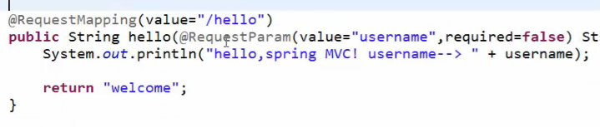

**解决中文乱码问题的filter**

<filter>

<filter-name>CharacterEncodingFilter</filter-name>

<filter-class>org.springframework.web.filter.CharacterEncodingFilter</filter-class>

<init-param>

<param-name>encoding</param-name>

<param-value>utf-8</param-value>

</init-param>

</filter>

<filter-mapping>

<filter-name>CharacterEncodingFilter</filter-name>

<url-pattern>/*</url-pattern>

</filter-mapping>