Indoor Gateway http-server v1.0 Function Definition
As Required by Zhe on Feb.21, 2018, a http-server needs to be developed for Appropolis indoor gateway product. Generally, the http-server hosted by a gateway to interact with user to show the information, status of the gateway and trigger some pre-defined functions. The http-server read information from mySQL database. If everything works well, gateway will synchronize data with mySQL . However, if http-server or mySQL database are down, gateway still can run.

. Login page (Required by Zhe)
- Text box to input username and password
- After a user input the correct username and password, switch to main page.

Main page (Required by Zhe) (read only)
The main page shows the general information and the status of the gateway which includes
- Gateway type: indoor/outdoor, BLUETOOTH/LoRa /BLUETOOTH5+LoRa
- Version: hardware (core and mother boards) and software (LGA) version.
- Gateway location (Latitude, Longitude, altitude)
- Network interface used: Wi-Fi/ LTE/Ethernet
- Wi-Fi mode: AP/station mode
- SSID
- Gateway uptime
- Is connecting to LoRa/BLUETOOTH servers?
- Gateway serial number
- Gateway MAC
- Debug Mode

The main page also show tabs that link to other pages which includes
- Administration page (read and write)
- System log page (read only)
- LoRa page (read only)
- Bluetooth page (read only)
which will be described below.

Administration page (Required by Zhe)
- Set login user name and pass word
Text box and save button
- Change Wi-Fi mode between AP and station mode
If it is under station mode, user has to enter SSID and password for linking the wifi they want.
If it is under AP mode, gateway is running as router and other devices can use gateway as wifi hot spot. Setting SSID and password is optional and will give default SSID and password if user don’t enter.
- Debug model button for enabling or dis-enabling debug.
Once the gateway is under debug, the Lora system will insert dynamic records into mySQL database, otherwise it wouldn’t. Be default, the debug mode is off.
- Allow to change network connection mode (Wi-Fi/ LTE/Ethernet)
Needs to trigger a function to tell hardware the changes.

System log page (suggested by Yuqi)
The system log page lists the system events, e.g., RF malfunction for a certain period (e.g., for the past 24 hours)
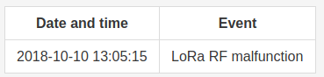
Figure 1: System log example

LoRa Page (Required by Zhe originally as Traffic Page, and suggested by Yuqi to change to LoRa page)
LoRa page shows the LoRa parameters of the gateway and the LoRa page

LoRa parameters and status
Frequency band
Uplink channels
LoRa gateway-server IP and port
control server IP and port
Antenna Gain
FSK enable
Beacon enable
Packets received
Packets sent
Beacons sent
SX1301 clock drift and bias

LoRa page
The LoRa page sub-page includes OTAA records and latest uplink/downlink data of a set of nodes (e.g., 100 nodes with traffic recently)
Figure 2: OTAA record
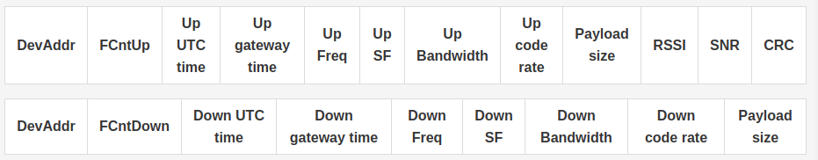
Figure 3: LoRa uplink/downlink latest traffic of all nodes
The DevAddr is a clickable and link to the detailed history of this node (e.g., 100 previous records )
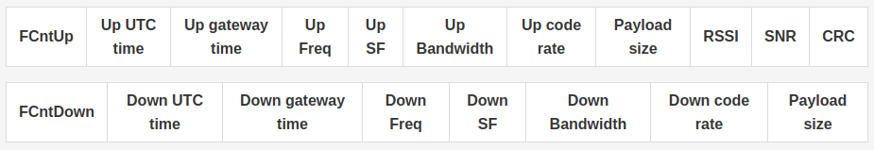
Figure 4: LoRa uplink/downlink records of a node

Bluetooth5 page (suggested by Yuqi)
Bluetooth5 page shows the Bluetooth5 parameters of the gateway and the LoRa page

Bluetooth5 parameters and status
Broad cast channels covered
Bluetooth gateway-server IP and port
Packet received

LoRa page sub-page
The LoRa page subpage shows the latest data of a set of tags (e.g., 100 tags with traffic recently)
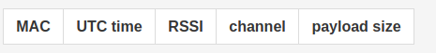
Figure 5: Bluetooth5 latest traffic of a set of tags

The MAC if clickable and link to the detailed history of this tag

Figure 6: Bluetooth5 traffic records of a tag
1.7 Hardware, Database and Table Schema
Indoor gateway will run on raspberry pi with Linux. The hardware would be 1.2G 4 core cpu and 1 G memory and 32GB TF card as disk. The http server will be implemented by nodejs and the database would be mySQL. The following tables are required for the operations defined above:
adminAccount, gatewayStatus, wifiAPaccount, systemLog, loraOverviewInfo, loraDeviceRegistry, loraDeviceRegistryHistory, loraDeviceStatus, loraDeviceHistory
1.7.1 adminAccount is used to save admin user account information.
userID: interger, auto populated, key
username: string, not null
password: string, not null
1.7.2 gatewayStatus is used to save gateway static and running status information. (one record in this table)
gatewaySN: string, not null, key
gatewayMAC: string, not null
gatewayType: string
version:string
gatewayLat: double
gatewayLng:double
gatewayAlt:double
networkInterface: string (Network interface used: Wi-Fi/ LTE/Ethernet)
wifiMode: string
uptimeInMins: double
connectionMode: string (LoRa/BLUETOOTH)
1.7.3 wifiAccount is used to save wifi ssid and password information. (two records: one for ap and one for station.)
ssid: string
password: string
mode: stirng (ap/station), key
1.7.4 systemLog is used to save gateway system info. Needs stored procedure to clean records to limit table size.
Changes below: changed column names (lower camelcase), and actual MySQL data types given next to the original data types.
id: double, auto populated, key , int(16)
event: string, varchar(256)
date: ISO date, datetime
1.7.5 loraOverviewInfo is used to save Lora system overview information.(one record in this table)
Changes below: changed column names (lower camelcase, abbreviated long words), and actual MySQL data types given next to the original data types.
id: integer,auto populated, int(11)
freqBand: string, varchar(45)
uplinkChannel: integer, int(11)
gwServerIpPort: string, varchar(45)
ctrlServerIpPort: string, varchar(45)
antennaGain: double, double
fskEnable: Boolean, bit(1)
beaconEnable: Boolean, bit(1)
pktRecdNum: double, double
pktSentNum:double, double
beaconSentNum:double, double
clkDriftBias: double, double
1.7.6 loraDeviceRegistry is used to save static lora device registry information.
Changes below: changed column names (lower camelcase), and actual MySQL data types given next to the original data types.
devEUI: string, not null, key, varchar(45)
utcTime: UTC date, datetime
1.7.7 loraDeviceRegistryHistory is used to save dynamic registry information of the lora devices served by the gateway.
Changes below: changed column names (lower camelcase), and actual MySQL data types given next to the original data types.
devEUI: string, not null, key, varchar(45)
utcTime: UTC date, datetime
gatewayTime: local date, datetime
rssi: double, double
snr: double, double
sf: integer, int(11)
bandwidth: integer, int(11)
codeRate: integer, int(11)
crc: Boolean, bit(1)
1.7.8 loraDeviceStatus is used to save static information of the lora devices served by the gateway. (one device, one record in this table)
Changes below: changed column names (lower camelcase), and actual MySQL data types given next to the original data types.
devAddr: string, not null, key, varchar(45)
utcTime: UTC date, datetime
1.7.9 loraDeviceStatusHistory (changed name to be consistent with above) is used to save dynamic information of the lora devices served by the gateway. The record with not null RSSI attribute means that it is a uplink record, otherwise it is a downlink record.
Changes below: changed column names (lower camelcase), and actual MySQL data types given next to the original data types.
id: int, primary key, int(11)
devAddr: string, not null, foreign key, varchar(45)
fCnt:double, double
frequency: double, double
sf: integer, int(11)
bandwidth: integer, int(11)
codeRate: integer, int(11)
payloadSize: integer , int(11)
payload:string, varchar(45)
utcTime: UTC date, datetime
gatewayTime: local date, datetime
rssi: double (not null for uplink), double
snr: double (not null for uplink), double
crc: Boolean (not null for uplink), bit(1)
1.8 Work Flow
1.8.1 Prerequisite
1. All the NPM modules and pm2 module are installed in gateway.
2. mySQL server is installed in gateway server.
3. http-server code is deployed to gateway and all the tables and stored procedure function are created in mySQL database.
4. add http-server and mySQL starting scripts into Linux cron job.
1.8.2 Setup
Once power on, gateway will detect if mySQL is available. If so, for initial setup, it will populate all the gateway static information and default settings into mySQL. If mySQL already has static and setting information, the gateway starts up based on those settings. If mySQL is unavailable, gateway will be started based on its own configuration file.

Date | Version | Comments | Approved by
2018.03.02 | 1.0 | First created
2018.03.14 | 1.1 | Add db and table schema and work flow sections (highlighted)

