**Team BRAMS**

**Members:** Bryan Vu, Rachel Pai, Autumn Nguyen,   
Marjorie Balaoro and Saurav Chhapawala  
CECS 323 Term Project: Views Output

**MENUITEM_V**

CREATE VIEW MENUITEM_V AS

SELECT ITS.MENUITEMNAME, ITS.MENUID, ITEMPRICE, SPICELEVEL, PORTIONSIZE, ITS.AGEGROUP

FROM ITEMSPECIFICATION ITS

INNER JOIN MENU

INNER JOIN MENUITEM

WHERE ITS.MENUID = '1'

UNION

SELECT ITS.MENUITEMNAME, ITS.MENUID, ITEMPRICE, SPICELEVEL, PORTIONSIZE, ITS.AGEGROUP

FROM ITEMSPECIFICATION ITS

INNER JOIN MENU

INNER JOIN MENUITEM

WHERE ITS.MENUID = '2'

UNION

SELECT ITS.MENUITEMNAME, ITS.MENUID, ITEMPRICE, SPICELEVEL, PORTIONSIZE, ITS.AGEGROUP

FROM ITEMSPECIFICATION ITS

INNER JOIN MENU

INNER JOIN MENUITEM

WHERE ITS.MENUID = '3'

UNION

SELECT ITS.MENUITEMNAME, ITS.MENUID, ITEMPRICE, SPICELEVEL, PORTIONSIZE, ITS.AGEGROUP

FROM ITEMSPECIFICATION ITS

INNER JOIN MENU

INNER JOIN MENUITEM

WHERE ITS.MENUID = '4'

UNION

SELECT ITS.MENUITEMNAME, ITS.MENUID, ITEMPRICE, SPICELEVEL, PORTIONSIZE, ITS.AGEGROUP

FROM ITEMSPECIFICATION ITS

INNER JOIN MENU

INNER JOIN MENUITEM

WHERE ITS.MENUID = '5'

UNION

SELECT ITS.MENUITEMNAME, ITS.MENUID, ITEMPRICE, SPICELEVEL, PORTIONSIZE, ITS.AGEGROUP

FROM ITEMSPECIFICATION ITS

INNER JOIN MENU

INNER JOIN MENUITEM

WHERE ITS.MENUID = '6';

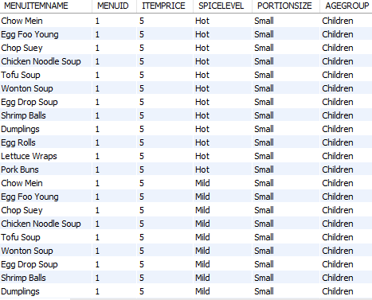

**CUSTOMER_ADDRESSES_V**

CREATE VIEW CUSTOMER_ADDRESSES_V AS

SELECT P.CustomerID, P. CustomerType, P.CustomerName, IF(P.CustomerType = 'Private','Email','N/A') AS 'ContactInfoType',P.Email AS 'Contact Info', P.PhysicalAddress,IF(P.CustomerType = 'Private','N/A','N/A'), IF(P.CustomerType = 'Private','N/A','N/A'),P.MimingsMoneyAmount

FROM CustomerAccounts AS P

WHERE P.CustomerType = 'Private'

UNION

SELECT C.CustomerID, C. CustomerType, C.CustomerName,C.ContactInfoType, C.ContactInfo, C.PhysicalAddress,C.CorporationName,C.DepartmentName,C.MimingsMoneyAmount

FROM (SELECT * FROM CustomerAccounts NATURAL JOIN CorporationContactInfo

WHERE CustomerAccounts.CustomerID = CorporationContactInfo.CustomerID) AS C

WHERE C.CustomerType = 'Corporation';

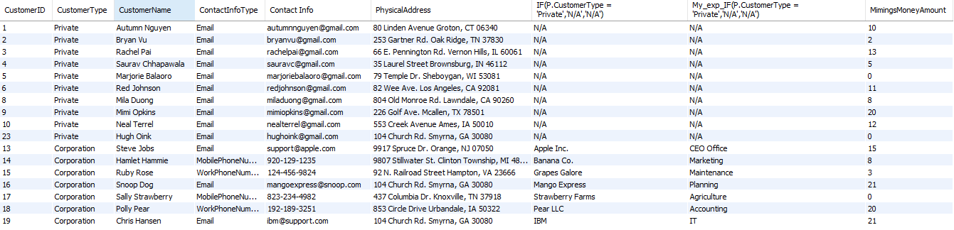

**SOUS_MENTOR_V**

CREATE VIEW SOUS_MENTOR_V AS

SELECT P1.LASTNAME AS 'MENTOR LAST NAME', P1.FIRSTNAME AS 'MENTOR FIRST NAME', P2.LASTNAME AS 'MENTEE LAST NAMNE', P2.FIRSTNAME AS 'MENTEE LAST NAME', MENUITEMNAME, STARTDATE

FROM MENTORSHIP

INNER JOIN STAFF P1

ON P1.STAFFID = MENTORSHIP.SOUSCHEFMENTORID

INNER JOIN STAFF P2

ON MENTORSHIP.SOUSCHEFMENTEEID = P2.STAFFID

ORDER BY P1.LASTNAME, P1.FIRSTNAME, P2.LASTNAME, P2.FIRSTNAME;

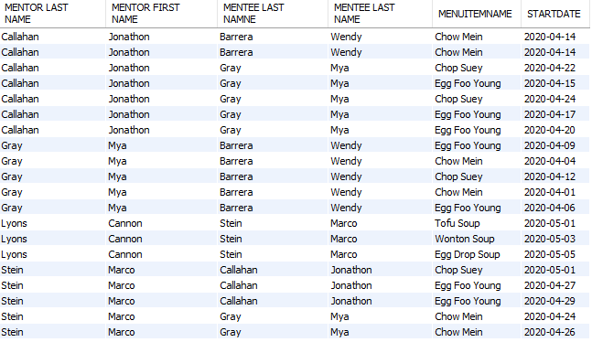

**CUSTOMER_SALES_V**

CREATE VIEW CUSTOMER_SALES_V AS

SELECT CustomerID, CustomerName, YEAR(ORDERDATE) AS 'YEAR', SUM(AMOUNTTOTAL) AS 'TOTAL'

FROM CUSTOMERORDER NATURAL JOIN Customers

GROUP BY CustomerID,YEAR(ORDERDATE)

ORDER BY CustomerName, YEAR(ORDERDATE);

SELECT * FROM CUSTOMER_SALES_V;

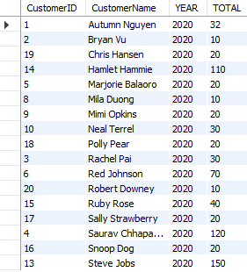

**CUSTOMER_VALUE_V (works)**

CREATE VIEW CUSTOMER_VALUE_V AS

SELECT A.OrderDate as 'Date', A.CustomerName, SUM(A.AmountTotal) AS 'Total Spent In The Year'

FROM (SELECT *

FROM Customers NATURAL JOIN CUSTOMERORDER

WHERE ORDERDATE >= DATE_SUB(NOW(), INTERVAL 1 YEAR)

) AS A

GROUP BY CUSTOMERID

ORDER BY SUM(AmountTotal) DESC;

SELECT * FROM CUSTOMER_VALUE_V;

