Harmonics – Per EN/IEC61000-3-12, Ed. 2.0(Phase A-Run time)

EUT: Equipment under test Tested by: Tested by
Test category: Table:3, Rsce=250, Test Margin: 100
Test date: 2016/4/18 Start time: 15:32:05 End time: 15:34:58
Test duration (min): 2.5 Data file name: CTSMXH_H-000031.cts_data
Comment: Comment
Customer: Customer information

Test Result: Pass Source qualification: Distorted

Current & voltage waveforms

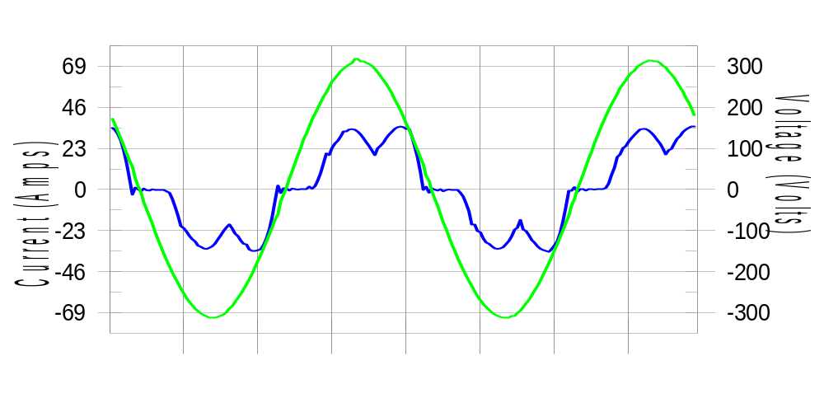

Harmonics and Class 3 limit line European Limits

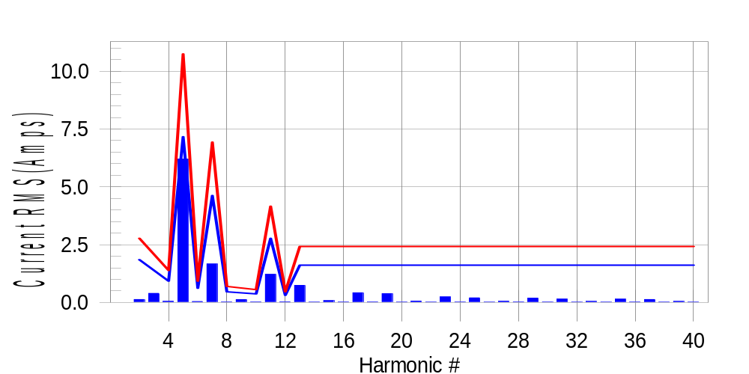

Test result: Pass Worst harmonic was #5 with 57.84 % of the limit.
Current Test Result Summary (Phase A-Run time)

EUT: Equipment under test Tested by: Tested by
Test category: Table:3, Rsce=250, Test Margin: 100
Test date: 2016/4/18 Start time: 15:32:05 End time: 15:34:58
Test duration (min): 2.5 Data file name: CTSMXH_H-000031.cts_data
Comment: Comment
Customer: Customer information

Test Result: Pass Measured I-ref: 23.203(Amps) Source: Distorted
I-THC(%): 28.7 Limit(%): 37.0 PWHC(%): 14.7 PWHC Limit(%): 38.0

Highest parameter values during test:
V_RMS (Volts): 220.42 Frequency(Hz): 50.00
I_Peak (Amps): 46.903 I_RMS (Amps): 23.203
I_Fund (Amps): 22.132 Crest Factor: 2.029
Power (Watts): 4718 Power Factor: 0.923

Harm# Harms(avg) 100%Limit %of Limit Harms(max) 150%Limit %of Limit Status

2 0.128 1.849 6.9 0.160 2.774 5.8 Pass
3 0.394 N/A N/A 0.423 N/A N/A N/A
4 0.051 0.925 5.5 0.065 1.387 4.7 Pass
5 6.199 7.165 86.5 6.211 10.748 57.8 Pass
6 0.042 0.616 6.8 0.052 0.925 5.6 Pass
7 1.663 4.623 36.0 1.675 6.934 24.2 Pass
8 0.022 0.462 4.7 0.036 0.693 5.2 Pass
9 0.126 N/A N/A 0.135 N/A N/A N/A
10 0.022 0.370 5.9 0.030 0.555 5.4 Pass
11 1.219 2.774 44.0 1.227 4.160 29.5 Pass
12 0.027 0.308 8.9 0.037 0.462 8.0 Pass
13 0.738 1.618 45.6 0.750 2.427 30.9 Pass
14 0.016 N/A N/A 0.024 N/A N/A N/A
15 0.078 N/A N/A 0.088 N/A N/A N/A
16 0.017 N/A N/A 0.030 N/A N/A N/A
17 0.418 N/A N/A 0.426 N/A N/A N/A
18 0.021 N/A N/A 0.029 N/A N/A N/A
19 0.381 N/A N/A 0.390 N/A N/A N/A
20 0.016 N/A N/A 0.022 N/A N/A N/A
21 0.060 N/A N/A 0.068 N/A N/A N/A
22 0.016 N/A N/A 0.022 N/A N/A N/A
23 0.241 N/A N/A 0.248 N/A N/A N/A
24 0.018 N/A N/A 0.025 N/A N/A N/A
25 0.198 N/A N/A 0.211 N/A N/A N/A
26 0.015 N/A N/A 0.024 N/A N/A N/A
27 0.052 N/A N/A 0.060 N/A N/A N/A
28 0.020 N/A N/A 0.030 N/A N/A N/A
29 0.190 N/A N/A 0.199 N/A N/A N/A
30 0.018 N/A N/A 0.025 N/A N/A N/A
31 0.147 N/A N/A 0.155 N/A N/A N/A
32 0.014 N/A N/A 0.021 N/A N/A N/A
33 0.047 N/A N/A 0.053 N/A N/A N/A
34 0.015 N/A N/A 0.024 N/A N/A N/A
35 0.143 N/A N/A 0.151 N/A N/A N/A
36 0.017 N/A N/A 0.024 N/A N/A N/A
37 0.128 N/A N/A 0.136 N/A N/A N/A
38 0.014 N/A N/A 0.021 N/A N/A N/A
39 0.046 N/A N/A 0.058 N/A N/A N/A
40 0.016 N/A N/A 0.023 N/A N/A N/A

Note: Measured I-ref was applied for this test.

Voltage Source Verification Data (Phase A-Run time)

EUT: Equipment under test Tested by: Tested by
Test category: Table:3, Rsce=250, Test Margin: 100
Test date: 2016/4/18 Start time: 15:32:05 End time: 15:34:58
Test duration (min): 2.5 Data file name: CTSMXH_H-000031.cts_data
Comment: Comment
Customer: Customer information

Test Result: Pass Source qualification: Distorted
Current harmonics are corrected for source distortion, and are within +/-5%
Measurements are compliant with IEC/EN61000-3-12 Ed.4 & IEC/EN61000-4-7

Highest parameter values during test:
Voltage (Vrms): 220.42 Frequency(Hz): 50.00
I_Peak (Amps): 46.903 I_RMS (Amps): 23.203
I_Fund (Amps): 22.132 Crest Factor: 2.029
Power (Watts): 4718 Power Factor: 0.923

Harm# Harmonics V-rms Limit V-rms % of Limit Status

2 0.212 0.881 24.02 OK
3 0.383 2.754 13.89 OK
4 0.181 0.881 20.49 OK
5 1.090 3.305 32.98 OK
6 0.117 0.881 13.30 OK
7 0.462 2.754 16.77 OK
8 0.103 0.881 11.71 OK
9 0.196 1.322 14.84 OK
10 0.089 0.881 10.14 OK
11 0.410 1.542 26.56 OK
12 0.084 0.661 12.64 OK
13 0.354 1.322 26.79 OK
14 0.093 0.661 14.09 OK
15 0.182 0.661 27.51 OK
16 0.083 0.661 12.56 OK
17 0.239 0.661 36.21 OK
18 0.083 0.661 12.56 OK
19 0.258 0.661 39.07 OK
20 0.165 0.661 24.97 OK
21 0.162 0.661 24.46 OK
22 0.081 0.661 12.31 OK
23 0.207 0.661 31.38 OK
24 0.080 0.661 12.03 OK
25 0.203 0.661 30.65 OK
26 0.079 0.661 11.97 OK
27 0.137 0.661 20.77 OK
28 0.092 0.661 13.96 OK
29 0.188 0.661 28.41 OK
30 0.082 0.661 12.48 OK
31 0.172 0.661 26.09 OK
32 0.079 0.661 11.93 OK
33 0.144 0.661 21.80 OK
34 0.083 0.661 12.50 OK
35 0.177 0.661 26.81 OK
36 0.080 0.661 12.17 OK
37 0.182 0.661 27.57 OK
38 0.092 0.661 13.93 OK
39 0.157 0.661 23.77 OK
40 0.132 0.661 20.03 OK

Harmonics – Per EN/IEC61000-3-12, Ed. 2.0(Phase B-Run time)

EUT: Equipment under test Tested by: Tested by
Test category: Table:3, Rsce=250, Test Margin: 100
Test date: 2016/4/18 Start time: 15:32:05 End time: 15:34:58
Test duration (min): 2.5 Data file name: CTSMXH_H-000031.cts_data
Comment: Comment
Customer: Customer information

Test Result: Pass Source qualification: Distorted

Current & voltage waveforms

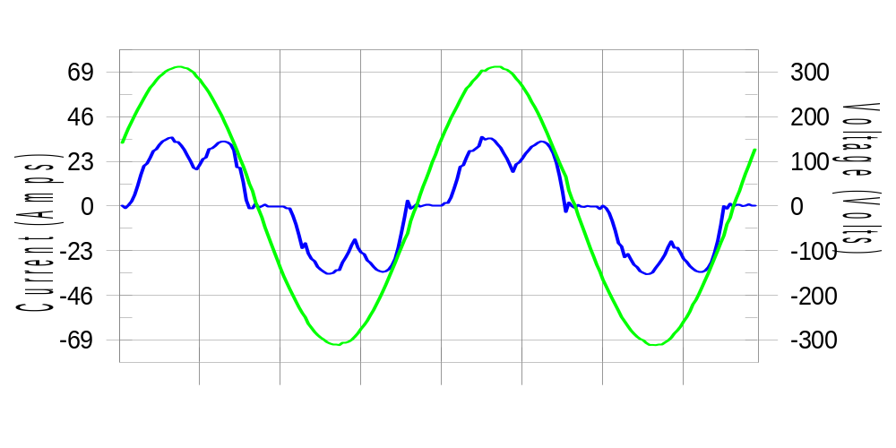

Harmonics and Class 3 limit line European Limits

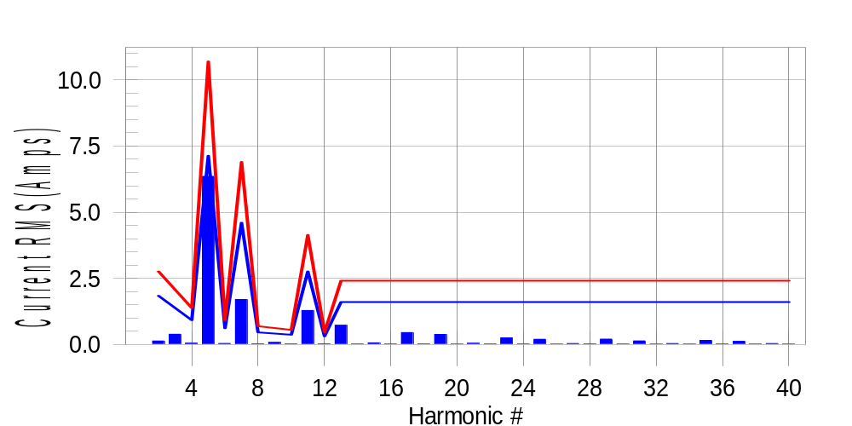

Test result: Pass Worst harmonic was #5 with 59.58 % of the limit.
Current Test Result Summary (Phase B-Run time)

EUT: Equipment under test Tested by: Tested by
Test category: Table:3, Rsce=250, Test Margin: 100
Test date: 2016/4/18 Start time: 15:32:05 End time: 15:34:58
Test duration (min): 2.5 Data file name: CTSMXH_H-000031.cts_data
Comment: Comment
Customer: Customer information

Test Result: Pass Measured I-ref: 23.092(Amps) Source: Distorted
I-THC(%): 29.6 Limit(%): 37.0 PWHC(%): 15.2 PWHC Limit(%): 38.0

Highest parameter values during test:
V_RMS (Volts): 220.19 Frequency(Hz): 50.00
I_Peak (Amps): 46.783 I_RMS (Amps): 23.092
I_Fund (Amps): 21.968 Crest Factor: 2.033
Power (Watts): 4715 Power Factor: 0.928

Harm# Harms(avg) 100%Limit %of Limit Harms(max) 150%Limit %of Limit Status

2 0.133 1.841 7.2 0.158 2.761 5.7 Pass
3 0.394 N/A N/A 0.418 N/A N/A N/A
4 0.049 0.920 5.4 0.063 1.380 4.6 Pass
5 6.355 7.132 89.1 6.367 10.698 59.5 Pass
6 0.041 0.614 6.6 0.051 0.920 5.5 Pass
7 1.700 4.601 37.0 1.710 6.902 24.8 Pass
8 0.023 0.460 5.1 0.031 0.690 4.5 Pass
9 0.126 N/A N/A 0.089 N/A N/A N/A
10 0.022 0.368 6.0 0.032 0.552 5.7 Pass
11 1.287 2.761 46.6 1.298 4.141 31.3 Pass
12 0.024 0.307 8.0 0.032 0.460 6.9 Pass
13 0.730 1.610 45.3 0.739 2.416 30.6 Pass
14 0.017 N/A N/A 0.028 N/A N/A N/A
15 0.063 N/A N/A 0.073 N/A N/A N/A
16 0.017 N/A N/A 0.024 N/A N/A N/A
17 0.453 N/A N/A 0.463 N/A N/A N/A
18 0.020 N/A N/A 0.028 N/A N/A N/A
19 0.380 N/A N/A 0.389 N/A N/A N/A
20 0.016 N/A N/A 0.022 N/A N/A N/A
21 0.046 N/A N/A 0.056 N/A N/A N/A
22 0.017 N/A N/A 0.024 N/A N/A N/A
23 0.253 N/A N/A 0.271 N/A N/A N/A
24 0.018 N/A N/A 0.028 N/A N/A N/A
25 0.198 N/A N/A 0.206 N/A N/A N/A
26 0.015 N/A N/A 0.024 N/A N/A N/A
27 0.038 N/A N/A 0.047 N/A N/A N/A
28 0.022 N/A N/A 0.033 N/A N/A N/A
29 0.203 N/A N/A 0.212 N/A N/A N/A
30 0.017 N/A N/A 0.024 N/A N/A N/A
31 0.138 N/A N/A 0.148 N/A N/A N/A
32 0.014 N/A N/A 0.020 N/A N/A N/A
33 0.036 N/A N/A 0.044 N/A N/A N/A
34 0.016 N/A N/A 0.021 N/A N/A N/A
35 0.157 N/A N/A 0.164 N/A N/A N/A
36 0.017 N/A N/A 0.024 N/A N/A N/A
37 0.120 N/A N/A 0.130 N/A N/A N/A
38 0.015 N/A N/A 0.022 N/A N/A N/A
39 0.037 N/A N/A 0.046 N/A N/A N/A
40 0.016 N/A N/A 0.024 N/A N/A N/A

Note: Measured I-ref was applied for this test.

Voltage Source Verification Data (Phase B-Run time)

EUT: Equipment under test Tested by: Tested by
Test category: Table:3, Rsce=250, Test Margin: 100
Test date: 2016/4/18 Start time: 15:32:05 End time: 15:34:58
Test duration (min): 2.5 Data file name: CTSMXH_H-000031.cts_data
Comment: Comment
Customer: Customer information

Test Result: Pass Source qualification: Distorted
Current harmonics are corrected for source distortion, and are within +/-5%
Measurements are compliant with IEC/EN61000-3-12 Ed.4 & IEC/EN61000-4-7

Highest parameter values during test:
Voltage (Vrms): 220.19 Frequency(Hz): 50.00
I_Peak (Amps): 46.783 I_RMS (Amps): 23.092
I_Fund (Amps): 21.968 Crest Factor: 2.033
Power (Watts): 4715 Power Factor: 0.928

Harm# Harmonics V-rms Limit V-rms % of Limit Status

2 0.192 0.880 21.77 OK
3 0.323 2.750 11.74 OK
4 0.141 0.880 16.00 OK
5 1.148 3.302 34.77 OK
6 0.106 0.881 12.04 OK
7 0.461 2.752 16.74 OK
8 0.131 0.880 14.85 OK
9 0.162 1.321 12.25 OK
10 0.119 0.880 13.57 OK
11 0.487 1.541 31.59 OK
12 0.093 0.660 14.05 OK
13 0.391 1.321 29.64 OK
14 0.087 0.660 13.17 OK
15 0.139 0.660 21.09 OK
16 0.107 0.660 16.17 OK
17 0.283 0.660 42.78 OK
18 0.097 0.660 14.69 OK
19 0.284 0.660 42.95 OK
20 0.125 0.660 18.95 OK
21 0.135 0.660 20.48 OK
22 0.113 0.660 17.18 OK
23 0.246 0.660 37.26 OK
24 0.094 0.660 14.21 OK
25 0.193 0.660 29.17 OK
26 0.097 0.660 14.66 OK
27 0.108 0.660 16.38 OK
28 0.124 0.660 18.83 OK
29 0.237 0.660 35.92 OK
30 0.099 0.660 15.03 OK
31 0.191 0.660 28.87 OK
32 0.098 0.660 14.90 OK
33 0.120 0.660 18.20 OK
34 0.100 0.660 15.09 OK
35 0.208 0.660 31.50 OK
36 0.111 0.660 16.75 OK
37 0.195 0.660 29.56 OK
38 0.113 0.660 17.18 OK
39 0.121 0.660 18.25 OK
40 0.128 0.660 19.39 OK

Harmonics – Per EN/IEC61000-3-12, Ed. 2.0(Phase C-Run time)

EUT: Equipment under test Tested by: Tested by
Test category: Table:3, Rsce=250, Test Margin: 100
Test date: 2016/4/18 Start time: 15:32:05 End time: 15:34:58
Test duration (min): 2.5 Data file name: CTSMXH_H-000031.cts_data
Comment: Comment
Customer: Customer information

Test Result: Pass Source qualification: Distorted

Current & voltage waveforms

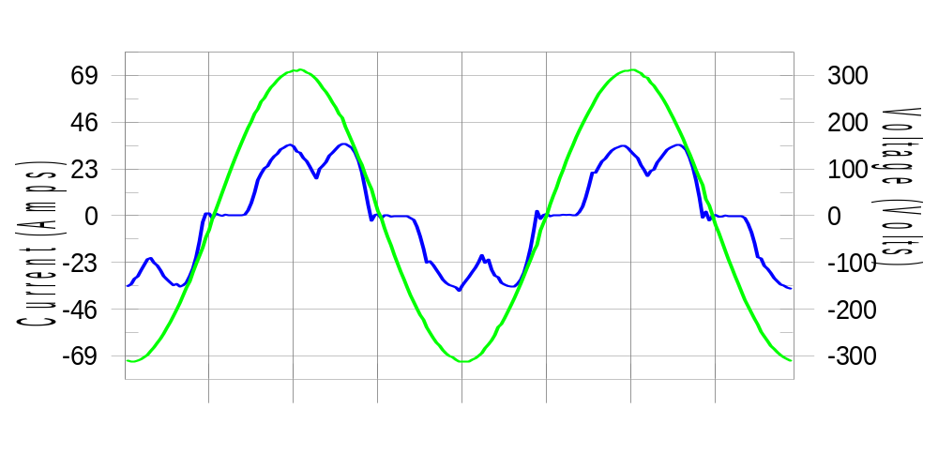

Harmonics and Class 3 limit line European Limits

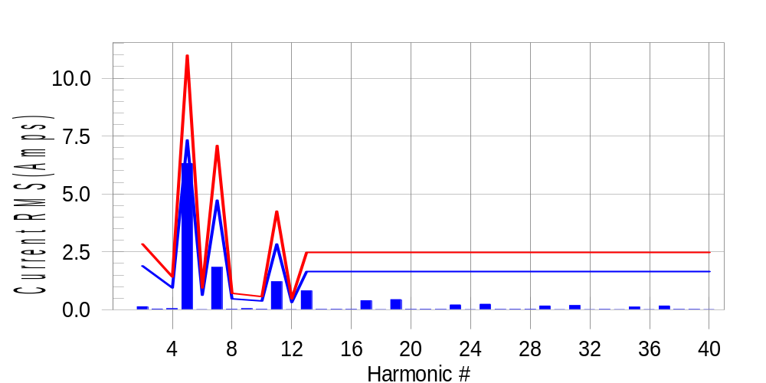

Test result: Pass Worst harmonic was #5 with 57.63 % of the limit.
Current Test Result Summary (Phase C-Run time)

EUT: Equipment under test Tested by: Tested by
Test category: Table:3, Rsce=250, Test Margin: 100
Test date: 2016/4/18 Start time: 15:32:05 End time: 15:34:58
Test duration (min): 2.5 Data file name: CTSMXH_H-000031.cts_data
Comment: Comment
Customer: Customer information

Test Result: Pass Measured I-ref: 23.711(Amps) Source: Distorted
I-THC(%): 28.7 Limit(%): 37.0 PWHC(%): 14.7 PWHC Limit(%): 38.0

Highest parameter values during test:
V_RMS (Volts): 220.12 Frequency(Hz): 50.00
I_Peak (Amps): 43.598 I_RMS (Amps): 23.711
I_Fund (Amps): 22.629 Crest Factor: 1.844
Power (Watts): 4840 Power Factor: 0.928

Harm# Harms(avg) 100%Limit %of Limit Harms(max) 150%Limit %of Limit Status

2 0.129 1.891 6.8 0.157 2.836 5.5 Pass
3 0.394 N/A N/A 0.045 N/A N/A N/A
4 0.049 0.945 5.2 0.062 1.418 4.4 Pass
5 6.316 7.326 86.2 6.331 10.989 57.6 Pass
6 0.013 0.630 2.1 0.018 0.945 1.9 Pass
7 1.832 4.726 38.8 1.840 7.090 26.0 Pass
8 0.022 0.473 4.7 0.029 0.709 4.1 Pass
9 0.126 N/A N/A 0.056 N/A N/A N/A
10 0.020 0.378 5.3 0.028 0.567 4.9 Pass
11 1.213 2.836 42.8 1.220 4.254 28.7 Pass
12 0.013 0.315 4.0 0.019 0.473 4.1 Pass
13 0.819 1.654 49.5 0.827 2.481 33.3 Pass
14 0.016 N/A N/A 0.020 N/A N/A N/A
15 0.018 N/A N/A 0.029 N/A N/A N/A
16 0.015 N/A N/A 0.024 N/A N/A N/A
17 0.391 N/A N/A 0.398 N/A N/A N/A
18 0.012 N/A N/A 0.018 N/A N/A N/A
19 0.438 N/A N/A 0.446 N/A N/A N/A
20 0.016 N/A N/A 0.033 N/A N/A N/A
21 0.018 N/A N/A 0.024 N/A N/A N/A
22 0.014 N/A N/A 0.037 N/A N/A N/A
23 0.210 N/A N/A 0.225 N/A N/A N/A
24 0.012 N/A N/A 0.017 N/A N/A N/A
25 0.241 N/A N/A 0.251 N/A N/A N/A
26 0.014 N/A N/A 0.021 N/A N/A N/A
27 0.017 N/A N/A 0.025 N/A N/A N/A
28 0.019 N/A N/A 0.039 N/A N/A N/A
29 0.165 N/A N/A 0.183 N/A N/A N/A
30 0.013 N/A N/A 0.019 N/A N/A N/A
31 0.182 N/A N/A 0.191 N/A N/A N/A
32 0.013 N/A N/A 0.020 N/A N/A N/A
33 0.015 N/A N/A 0.022 N/A N/A N/A
34 0.013 N/A N/A 0.021 N/A N/A N/A
35 0.118 N/A N/A 0.126 N/A N/A N/A
36 0.012 N/A N/A 0.018 N/A N/A N/A
37 0.163 N/A N/A 0.173 N/A N/A N/A
38 0.014 N/A N/A 0.019 N/A N/A N/A
39 0.016 N/A N/A 0.022 N/A N/A N/A
40 0.013 N/A N/A 0.023 N/A N/A N/A

Note: Measured I-ref was applied for this test.

Voltage Source Verification Data (Phase C-Run time)

EUT: Equipment under test Tested by: Tested by
Test category: Table:3, Rsce=250, Test Margin: 100
Test date: 2016/4/18 Start time: 15:32:05 End time: 15:34:58
Test duration (min): 2.5 Data file name: CTSMXH_H-000031.cts_data
Comment: Comment
Customer: Customer information

Test Result: Pass Source qualification: Distorted
Current harmonics are corrected for source distortion, and are within +/-5%
Measurements are compliant with IEC/EN61000-3-12 Ed.4 & IEC/EN61000-4-7

Highest parameter values during test:
Voltage (Vrms): 220.12 Frequency(Hz): 50.00
I_Peak (Amps): 43.598 I_RMS (Amps): 23.711
I_Fund (Amps): 22.629 Crest Factor: 1.844
Power (Watts): 4840 Power Factor: 0.928

Harm# Harmonics V-rms Limit V-rms % of Limit Status

2 0.167 0.880 18.95 OK
3 0.336 2.751 12.21 OK
4 0.144 0.880 16.37 OK
5 1.076 3.300 32.59 OK
6 0.091 0.880 10.38 OK
7 0.453 2.751 16.47 OK
8 0.087 0.880 9.94 OK
9 0.143 1.320 10.84 OK
10 0.094 0.880 10.69 OK
11 0.461 1.540 29.94 OK
12 0.100 0.660 15.09 OK
13 0.381 1.320 28.87 OK
14 0.084 0.660 12.68 OK
15 0.160 0.660 24.27 OK
16 0.084 0.660 12.79 OK
17 0.233 0.660 35.29 OK
18 0.090 0.660 13.62 OK
19 0.277 0.660 41.93 OK
20 0.099 0.660 15.03 OK
21 0.140 0.660 21.15 OK
22 0.086 0.660 13.06 OK
23 0.226 0.660 34.23 OK
24 0.084 0.660 12.71 OK
25 0.214 0.660 32.43 OK
26 0.082 0.660 12.43 OK
27 0.118 0.660 17.88 OK
28 0.115 0.660 17.45 OK
29 0.195 0.660 29.61 OK
30 0.087 0.660 13.22 OK
31 0.190 0.660 28.78 OK
32 0.091 0.660 13.84 OK
33 0.121 0.660 18.35 OK
34 0.090 0.660 13.70 OK
35 0.183 0.660 27.68 OK
36 0.099 0.660 15.02 OK
37 0.219 0.660 33.12 OK
38 0.082 0.660 12.36 OK
39 0.143 0.660 21.66 OK
40 0.084 0.660 12.72 OK

5th Harmonic Phase Angle and Magnitude for Phase A :
H-5_min_phase : 93.1 Degree (Leading)
H-5_max_phase : 93.7 Degree (Leading)
H-5_ave_phase : 93.4 Degree (Leading)

H-5_ave_vector_magnitude : 6.313 Amp
H-5_standard_ave_magnitude : 6.199 Amp
H-5_standard_max_magnitude : 6.331 Amp
Ratio of H-5_ave_vector / H-5_standard_ave : 1.000

Phase A = 86.514% of tested Rsce = 250.000, Rsce = 216.284
Phase B = 89.112% of tested Rsce = 250.000, Rsce = 222.781
Phase C = 86.218% of tested Rsce = 250.000, Rsce = 215.544
Minimum Rsce required: Rsce = 222.781

