Harmonics – Per EN/IEC61000-3-12, Ed. 2.0(Phase A-Run time)

EUT: Equipment under test Tested by: Tested by
Test category: Table:3, Rsce=250, Test Margin: 100
Test date: 2016/4/18 Start time: 15:47:13 End time: 15:50:06
Test duration (min): 2.5 Data file name: CTSMXH_H-000032.cts_data
Comment: Comment
Customer: Customer information

Test Result: Pass Source qualification: Normal

Current & voltage waveforms

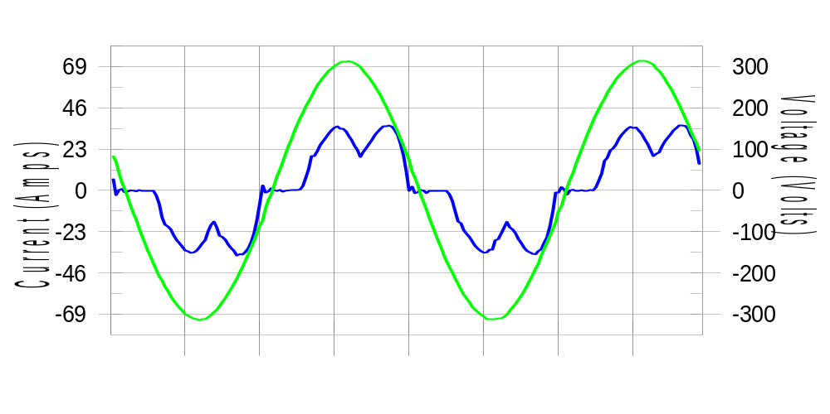

Harmonics and Class 3 limit line European Limits

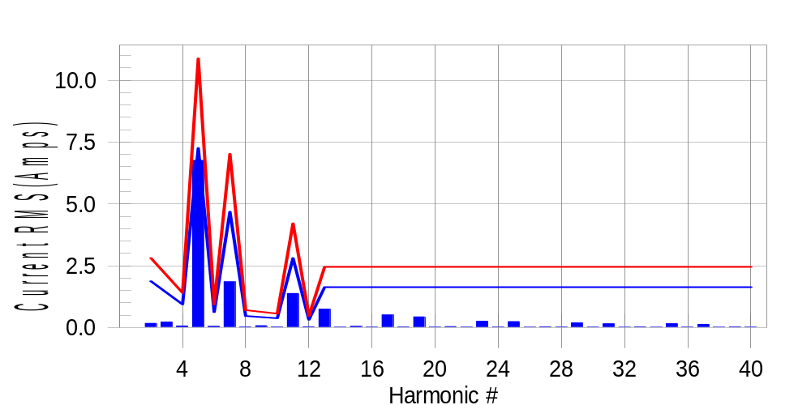

Test result: Pass Worst harmonic was #5 with 62.41 % of the limit.
Current Test Result Summary (Phase A-Run time)

EUT: Equipment under test Tested by: Tested by
Test category: Table:3, Rsce=250, Test Margin: 100
Test date: 2016/4/18 Start time: 15:47:13 End time: 15:50:06
Test duration (min): 2.5 Data file name: CTSMXH_H-000032.cts_data
Comment: Comment
Customer: Customer information

Test Result: Pass Measured I-ref: 23.520(Amps) Source: Normal
I-THC(%): 30.9 Limit(%): 37.0 PWHC(%): 16.2 PWHC Limit(%): 38.0

Highest parameter values during test:
V_RMS (Volts): 220.41 Frequency(Hz): 50.00
I_Peak (Amps): 56.069 I_RMS (Amps): 23.520
I_Fund (Amps): 22.245 Crest Factor: 2.391
Power (Watts): 4777 Power Factor: 0.922

Harm# Harms(avg) 100%Limit %of Limit Harms(max) 150%Limit %of Limit Status

2 0.170 1.872 9.1 0.199 2.809 7.1 Pass
3 0.224 N/A N/A 0.254 N/A N/A N/A
4 0.063 0.936 6.7 0.080 1.404 5.7 Pass
5 6.760 7.256 93.2 6.780 10.883 62.3 Pass
6 0.049 0.624 7.8 0.057 0.936 6.1 Pass
7 1.850 4.681 39.5 1.860 7.022 26.5 Pass
8 0.026 0.468 5.6 0.033 0.702 4.7 Pass
9 0.073 N/A N/A 0.086 N/A N/A N/A
10 0.025 0.374 6.6 0.030 0.562 5.4 Pass
11 1.378 2.809 49.1 1.391 4.213 33.0 Pass
12 0.030 0.312 9.8 0.040 0.468 8.5 Pass
13 0.745 1.638 45.5 0.754 2.458 30.7 Pass
14 0.018 N/A N/A 0.025 N/A N/A N/A
15 0.047 N/A N/A 0.055 N/A N/A N/A
16 0.019 N/A N/A 0.026 N/A N/A N/A
17 0.510 N/A N/A 0.521 N/A N/A N/A
18 0.024 N/A N/A 0.032 N/A N/A N/A
19 0.432 N/A N/A 0.440 N/A N/A N/A
20 0.017 N/A N/A 0.030 N/A N/A N/A
21 0.037 N/A N/A 0.046 N/A N/A N/A
22 0.017 N/A N/A 0.024 N/A N/A N/A
23 0.254 N/A N/A 0.265 N/A N/A N/A
24 0.020 N/A N/A 0.026 N/A N/A N/A
25 0.242 N/A N/A 0.252 N/A N/A N/A
26 0.016 N/A N/A 0.026 N/A N/A N/A
27 0.031 N/A N/A 0.041 N/A N/A N/A
28 0.022 N/A N/A 0.034 N/A N/A N/A
29 0.189 N/A N/A 0.197 N/A N/A N/A
30 0.018 N/A N/A 0.025 N/A N/A N/A
31 0.153 N/A N/A 0.161 N/A N/A N/A
32 0.015 N/A N/A 0.020 N/A N/A N/A
33 0.027 N/A N/A 0.045 N/A N/A N/A
34 0.016 N/A N/A 0.024 N/A N/A N/A
35 0.155 N/A N/A 0.164 N/A N/A N/A
36 0.018 N/A N/A 0.025 N/A N/A N/A
37 0.128 N/A N/A 0.140 N/A N/A N/A
38 0.015 N/A N/A 0.023 N/A N/A N/A
39 0.027 N/A N/A 0.035 N/A N/A N/A
40 0.017 N/A N/A 0.036 N/A N/A N/A

Note: Measured I-ref was applied for this test.

Voltage Source Verification Data (Phase A-Run time)

EUT: Equipment under test Tested by: Tested by
Test category: Table:3, Rsce=250, Test Margin: 100
Test date: 2016/4/18 Start time: 15:47:13 End time: 15:50:06
Test duration (min): 2.5 Data file name: CTSMXH_H-000032.cts_data
Comment: Comment
Customer: Customer information

Test Result: Pass Source qualification: Normal
Measured source distortion is within the requirements of the standards
Measurements are compliant with IEC/EN61000-3-12 Ed.4 & IEC/EN61000-4-7 Ed. 2.1

Highest parameter values during test:
Voltage (Vrms): 220.41 Frequency(Hz): 50.00
I_Peak (Amps): 56.069 I_RMS (Amps): 23.520
I_Fund (Amps): 22.245 Crest Factor: 2.391
Power (Watts): 4777 Power Factor: 0.922

Harm# Harmonics V-rms Limit V-rms % of Limit Status

2 0.200 0.881 22.67 OK
3 0.339 2.754 12.32 OK
4 0.228 0.881 25.87 OK
5 1.170 3.305 35.40 OK
6 0.132 0.881 15.01 OK
7 0.457 2.754 16.58 OK
8 0.105 0.882 11.91 OK
9 0.177 1.322 13.36 OK
10 0.092 0.881 10.49 OK
11 0.479 1.542 31.06 OK
12 0.096 0.661 14.48 OK
13 0.365 1.322 27.63 OK
14 0.080 0.661 12.15 OK
15 0.160 0.661 24.23 OK
16 0.081 0.661 12.32 OK
17 0.283 0.661 42.76 OK
18 0.079 0.661 12.00 OK
19 0.290 0.661 43.80 OK
20 0.152 0.661 23.02 OK
21 0.157 0.661 23.75 OK
22 0.087 0.661 13.21 OK
23 0.206 0.661 31.11 OK
24 0.089 0.661 13.50 OK
25 0.207 0.661 31.34 OK
26 0.089 0.661 13.52 OK
27 0.142 0.661 21.54 OK
28 0.105 0.661 15.94 OK
29 0.195 0.661 29.47 OK
30 0.099 0.661 14.99 OK
31 0.171 0.661 25.88 OK
32 0.089 0.661 13.39 OK
33 0.132 0.661 19.92 OK
34 0.083 0.661 12.58 OK
35 0.199 0.661 30.08 OK
36 0.090 0.661 13.66 OK
37 0.178 0.661 27.01 OK
38 0.076 0.661 11.49 OK
39 0.148 0.661 22.37 OK
40 0.161 0.661 24.35 OK

Harmonics – Per EN/IEC61000-3-12, Ed. 2.0(Phase B-Run time)

EUT: Equipment under test Tested by: Tested by
Test category: Table:3, Rsce=250, Test Margin: 100
Test date: 2016/4/18 Start time: 15:47:13 End time: 15:50:06
Test duration (min): 2.5 Data file name: CTSMXH_H-000032.cts_data
Comment: Comment
Customer: Customer information

Test Result: Pass Source qualification: Normal

Current & voltage waveforms

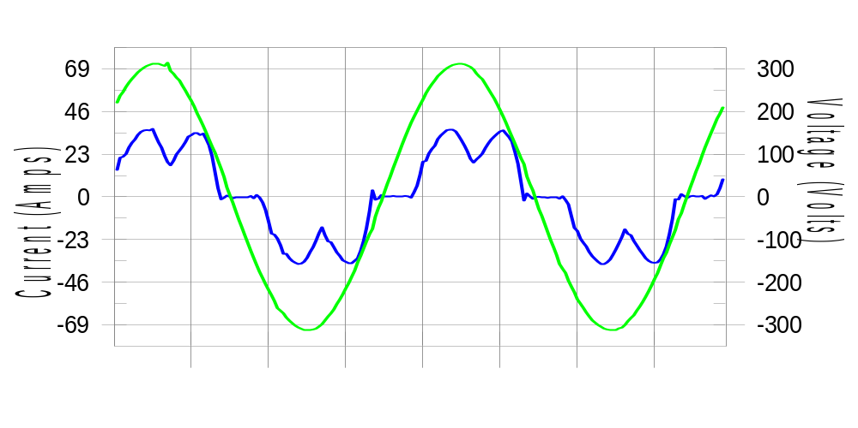

Harmonics and Class 3 limit line European Limits

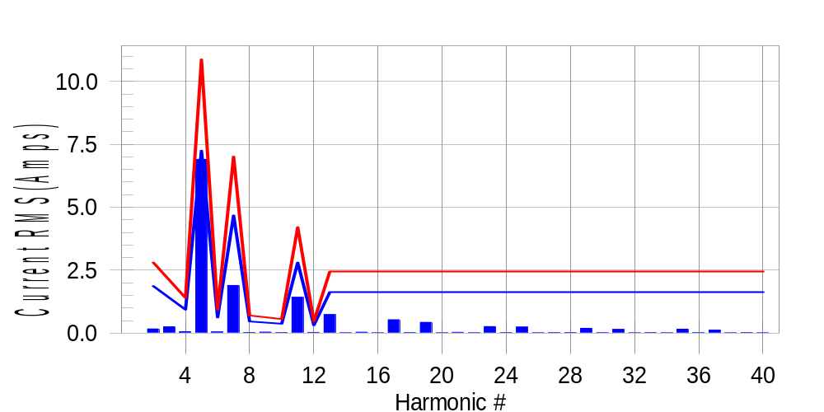

Test result: Pass Worst harmonic was #5 with 63.81 % of the limit.
Current Test Result Summary (Phase B-Run time)

EUT: Equipment under test Tested by: Tested by
Test category: Table:3, Rsce=250, Test Margin: 100
Test date: 2016/4/18 Start time: 15:47:13 End time: 15:50:06
Test duration (min): 2.5 Data file name: CTSMXH_H-000032.cts_data
Comment: Comment
Customer: Customer information

Test Result: Pass Measured I-ref: 23.522(Amps) Source: Normal
I-THC(%): 31.7 Limit(%): 37.0 PWHC(%): 16.6 PWHC Limit(%): 38.0

Highest parameter values during test:
V_RMS (Volts): 220.18 Frequency(Hz): 50.00
I_Peak (Amps): 47.726 I_RMS (Amps): 23.522
I_Fund (Amps): 22.168 Crest Factor: 2.041
Power (Watts): 4783 Power Factor: 0.924

Harm# Harms(avg) 100%Limit %of Limit Harms(max) 150%Limit %of Limit Status

2 0.168 1.871 9.0 0.197 2.806 7.0 Pass
3 0.224 N/A N/A 0.288 N/A N/A N/A
4 0.061 0.935 6.5 0.075 1.403 5.3 Pass
5 6.903 7.248 95.2 6.926 10.872 63.7 Pass
6 0.054 0.624 8.6 0.065 0.935 6.9 Pass
7 1.897 4.676 40.6 1.909 7.014 27.2 Pass
8 0.029 0.468 6.1 0.038 0.701 5.4 Pass
9 0.073 N/A N/A 0.055 N/A N/A N/A
10 0.025 0.374 6.6 0.033 0.561 5.9 Pass
11 1.428 2.806 50.9 1.446 4.209 34.4 Pass
12 0.032 0.312 10.3 0.040 0.468 8.6 Pass
13 0.742 1.637 45.3 0.751 2.455 30.6 Pass
14 0.019 N/A N/A 0.025 N/A N/A N/A
15 0.041 N/A N/A 0.052 N/A N/A N/A
16 0.019 N/A N/A 0.027 N/A N/A N/A
17 0.536 N/A N/A 0.547 N/A N/A N/A
18 0.025 N/A N/A 0.034 N/A N/A N/A
19 0.430 N/A N/A 0.439 N/A N/A N/A
20 0.018 N/A N/A 0.024 N/A N/A N/A
21 0.033 N/A N/A 0.041 N/A N/A N/A
22 0.018 N/A N/A 0.027 N/A N/A N/A
23 0.264 N/A N/A 0.274 N/A N/A N/A
24 0.022 N/A N/A 0.029 N/A N/A N/A
25 0.245 N/A N/A 0.254 N/A N/A N/A
26 0.017 N/A N/A 0.023 N/A N/A N/A
27 0.025 N/A N/A 0.034 N/A N/A N/A
28 0.026 N/A N/A 0.039 N/A N/A N/A
29 0.194 N/A N/A 0.204 N/A N/A N/A
30 0.020 N/A N/A 0.030 N/A N/A N/A
31 0.153 N/A N/A 0.171 N/A N/A N/A
32 0.016 N/A N/A 0.023 N/A N/A N/A
33 0.024 N/A N/A 0.041 N/A N/A N/A
34 0.017 N/A N/A 0.024 N/A N/A N/A
35 0.163 N/A N/A 0.173 N/A N/A N/A
36 0.020 N/A N/A 0.027 N/A N/A N/A
37 0.124 N/A N/A 0.135 N/A N/A N/A
38 0.016 N/A N/A 0.021 N/A N/A N/A
39 0.024 N/A N/A 0.034 N/A N/A N/A
40 0.017 N/A N/A 0.026 N/A N/A N/A

Note: Measured I-ref was applied for this test.

Voltage Source Verification Data (Phase B-Run time)

EUT: Equipment under test Tested by: Tested by
Test category: Table:3, Rsce=250, Test Margin: 100
Test date: 2016/4/18 Start time: 15:47:13 End time: 15:50:06
Test duration (min): 2.5 Data file name: CTSMXH_H-000032.cts_data
Comment: Comment
Customer: Customer information

Test Result: Pass Source qualification: Normal
Measured source distortion is within the requirements of the standards
Measurements are compliant with IEC/EN61000-3-12 Ed.4 & IEC/EN61000-4-7 Ed. 2.1

Highest parameter values during test:
Voltage (Vrms): 220.18 Frequency(Hz): 50.00
I_Peak (Amps): 47.726 I_RMS (Amps): 23.522
I_Fund (Amps): 22.168 Crest Factor: 2.041
Power (Watts): 4783 Power Factor: 0.924

Harm# Harmonics V-rms Limit V-rms % of Limit Status

2 0.187 0.880 21.24 OK
3 0.343 2.751 12.48 OK
4 0.182 0.880 20.73 OK
5 1.209 3.301 36.63 OK
6 0.117 0.880 13.33 OK
7 0.496 2.752 18.02 OK
8 0.109 0.880 12.41 OK
9 0.164 1.321 12.41 OK
10 0.096 0.880 10.92 OK
11 0.545 1.541 35.40 OK
12 0.108 0.660 16.37 OK
13 0.370 1.320 28.00 OK
14 0.102 0.660 15.40 OK
15 0.147 0.660 22.19 OK
16 0.098 0.660 14.88 OK
17 0.312 0.660 47.30 OK
18 0.107 0.660 16.14 OK
19 0.294 0.660 44.59 OK
20 0.129 0.660 19.52 OK
21 0.127 0.660 19.27 OK
22 0.113 0.660 17.18 OK
23 0.235 0.660 35.64 OK
24 0.106 0.660 16.12 OK
25 0.223 0.660 33.82 OK
26 0.120 0.660 18.14 OK
27 0.117 0.660 17.73 OK
28 0.150 0.660 22.79 OK
29 0.222 0.660 33.58 OK
30 0.105 0.660 15.84 OK
31 0.196 0.660 29.75 OK
32 0.101 0.660 15.25 OK
33 0.120 0.660 18.14 OK
34 0.116 0.660 17.60 OK
35 0.210 0.660 31.85 OK
36 0.102 0.660 15.47 OK
37 0.211 0.660 32.00 OK
38 0.110 0.660 16.73 OK
39 0.122 0.660 18.52 OK
40 0.114 0.660 17.32 OK

Harmonics – Per EN/IEC61000-3-12, Ed. 2.0(Phase C-Run time)

EUT: Equipment under test Tested by: Tested by
Test category: Table:3, Rsce=250, Test Margin: 100
Test date: 2016/4/18 Start time: 15:47:13 End time: 15:50:06
Test duration (min): 2.5 Data file name: CTSMXH_H-000032.cts_data
Comment: Comment
Customer: Customer information

Test Result: Pass Source qualification: Normal

Current & voltage waveforms

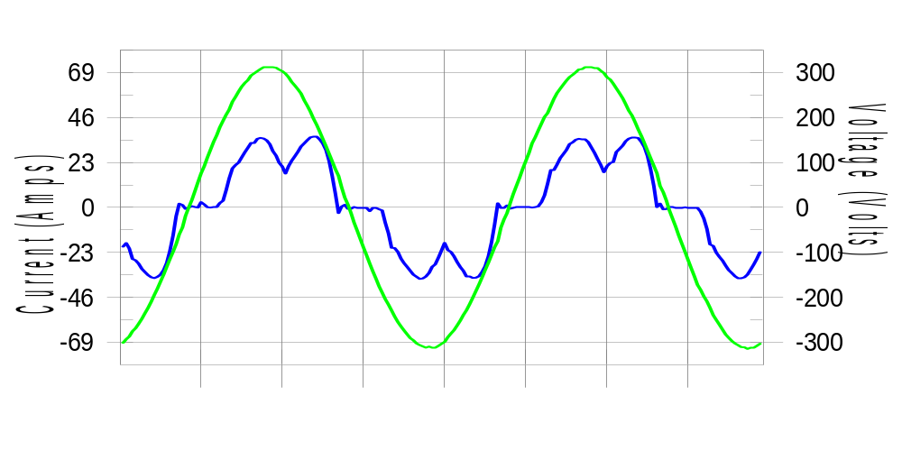

Harmonics and Class 3 limit line European Limits

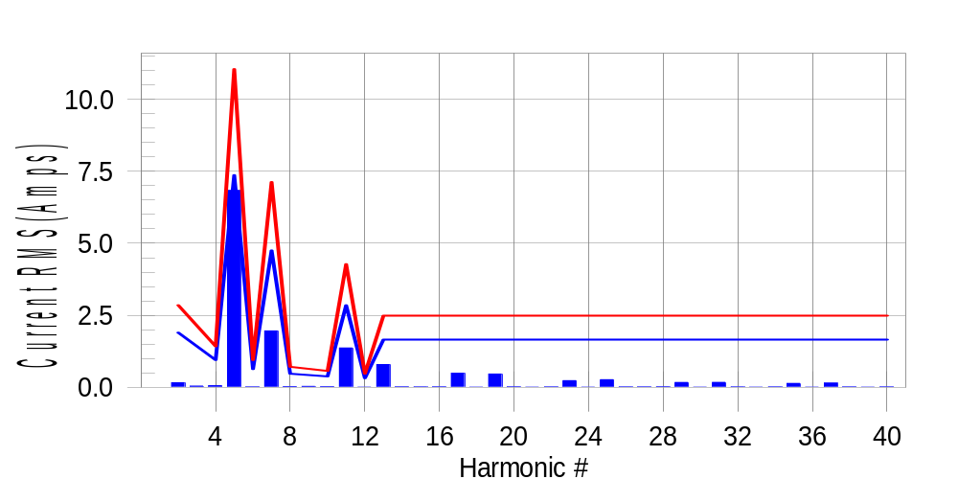

Test result: Pass Worst harmonic was #5 with 62.13 % of the limit.
Current Test Result Summary (Phase C-Run time)

EUT: Equipment under test Tested by: Tested by
Test category: Table:3, Rsce=250, Test Margin: 100
Test date: 2016/4/18 Start time: 15:47:13 End time: 15:50:06
Test duration (min): 2.5 Data file name: CTSMXH_H-000032.cts_data
Comment: Comment
Customer: Customer information

Test Result: Pass Measured I-ref: 23.867(Amps) Source: Normal
I-THC(%): 30.9 Limit(%): 37.0 PWHC(%): 16.2 PWHC Limit(%): 38.0

Highest parameter values during test:
V_RMS (Volts): 220.11 Frequency(Hz): 50.00
I_Peak (Amps): 45.137 I_RMS (Amps): 23.867
I_Fund (Amps): 22.586 Crest Factor: 1.903
Power (Watts): 4857 Power Factor: 0.925

Harm# Harms(avg) 100%Limit %of Limit Harms(max) 150%Limit %of Limit Status

2 0.161 1.901 8.5 0.190 2.851 6.7 Pass
3 0.224 N/A N/A 0.071 N/A N/A N/A
4 0.058 0.950 6.1 0.074 1.425 5.2 Pass
5 6.832 7.365 92.8 6.854 11.047 62.0 Pass
6 0.014 0.634 2.3 0.021 0.950 2.2 Pass
7 1.961 4.751 41.3 1.972 7.127 27.7 Pass
8 0.028 0.475 5.8 0.035 0.713 4.9 Pass
9 0.073 N/A N/A 0.046 N/A N/A N/A
10 0.025 0.380 6.5 0.049 0.570 8.6 Pass
11 1.369 2.851 48.0 1.380 4.276 32.3 Pass
12 0.013 0.317 4.1 0.019 0.475 3.9 Pass
13 0.794 1.663 47.7 0.804 2.494 32.2 Pass
14 0.017 N/A N/A 0.032 N/A N/A N/A
15 0.014 N/A N/A 0.021 N/A N/A N/A
16 0.017 N/A N/A 0.023 N/A N/A N/A
17 0.493 N/A N/A 0.500 N/A N/A N/A
18 0.013 N/A N/A 0.017 N/A N/A N/A
19 0.464 N/A N/A 0.471 N/A N/A N/A
20 0.017 N/A N/A 0.024 N/A N/A N/A
21 0.013 N/A N/A 0.019 N/A N/A N/A
22 0.015 N/A N/A 0.024 N/A N/A N/A
23 0.234 N/A N/A 0.245 N/A N/A N/A
24 0.013 N/A N/A 0.021 N/A N/A N/A
25 0.268 N/A N/A 0.279 N/A N/A N/A
26 0.015 N/A N/A 0.022 N/A N/A N/A
27 0.014 N/A N/A 0.022 N/A N/A N/A
28 0.022 N/A N/A 0.033 N/A N/A N/A
29 0.170 N/A N/A 0.178 N/A N/A N/A
30 0.013 N/A N/A 0.018 N/A N/A N/A
31 0.176 N/A N/A 0.187 N/A N/A N/A
32 0.014 N/A N/A 0.027 N/A N/A N/A
33 0.013 N/A N/A 0.023 N/A N/A N/A
34 0.015 N/A N/A 0.020 N/A N/A N/A
35 0.139 N/A N/A 0.147 N/A N/A N/A
36 0.013 N/A N/A 0.020 N/A N/A N/A
37 0.148 N/A N/A 0.157 N/A N/A N/A
38 0.014 N/A N/A 0.020 N/A N/A N/A
39 0.013 N/A N/A 0.022 N/A N/A N/A
40 0.014 N/A N/A 0.020 N/A N/A N/A

Note: Measured I-ref was applied for this test.

Voltage Source Verification Data (Phase C-Run time)

EUT: Equipment under test Tested by: Tested by
Test category: Table:3, Rsce=250, Test Margin: 100
Test date: 2016/4/18 Start time: 15:47:13 End time: 15:50:06
Test duration (min): 2.5 Data file name: CTSMXH_H-000032.cts_data
Comment: Comment
Customer: Customer information

Test Result: Pass Source qualification: Normal
Measured source distortion is within the requirements of the standards
Measurements are compliant with IEC/EN61000-3-12 Ed.4 & IEC/EN61000-4-7 Ed. 2.1

Highest parameter values during test:
Voltage (Vrms): 220.11 Frequency(Hz): 50.00
I_Peak (Amps): 45.137 I_RMS (Amps): 23.867
I_Fund (Amps): 22.586 Crest Factor: 1.903
Power (Watts): 4857 Power Factor: 0.925

Harm# Harmonics V-rms Limit V-rms % of Limit Status

2 0.182 0.880 20.67 OK
3 0.335 2.750 12.17 OK
4 0.178 0.880 20.17 OK
5 1.145 3.300 34.68 OK
6 0.103 0.880 11.66 OK
7 0.468 2.750 17.02 OK
8 0.104 0.880 11.84 OK
9 0.171 1.320 12.92 OK
10 0.093 0.880 10.58 OK
11 0.479 1.540 31.07 OK
12 0.084 0.660 12.69 OK
13 0.363 1.321 27.49 OK
14 0.092 0.660 13.88 OK
15 0.160 0.660 24.18 OK
16 0.083 0.660 12.50 OK
17 0.271 0.660 41.11 OK
18 0.090 0.660 13.71 OK
19 0.285 0.660 43.17 OK
20 0.104 0.660 15.83 OK
21 0.146 0.660 22.07 OK
22 0.085 0.660 12.83 OK
23 0.209 0.660 31.70 OK
24 0.082 0.660 12.44 OK
25 0.235 0.660 35.60 OK
26 0.085 0.660 12.91 OK
27 0.118 0.660 17.86 OK
28 0.127 0.660 19.25 OK
29 0.198 0.660 29.95 OK
30 0.089 0.660 13.42 OK
31 0.176 0.660 26.68 OK
32 0.091 0.660 13.79 OK
33 0.127 0.660 19.21 OK
34 0.092 0.660 13.98 OK
35 0.193 0.660 29.19 OK
36 0.092 0.660 13.92 OK
37 0.193 0.660 29.26 OK
38 0.091 0.660 13.84 OK
39 0.130 0.660 19.65 OK
40 0.111 0.660 16.76 OK

5th Harmonic Phase Angle and Magnitude for Phase A :
H-5_min_phase : 97.7 Degree (Leading)
H-5_max_phase : 98.5 Degree (Leading)
H-5_ave_phase : 98.1 Degree (Leading)

H-5_ave_vector_magnitude : 6.829 Amp
H-5_standard_ave_magnitude : 6.760 Amp
H-5_standard_max_magnitude : 6.854 Amp
Ratio of H-5_ave_vector / H-5_standard_ave : 1.000

Phase A = 93.171% of tested Rsce = 250.000, Rsce = 232.927
Phase B = 95.243% of tested Rsce = 250.000, Rsce = 238.107
Phase C = 92.767% of tested Rsce = 250.000, Rsce = 231.918
Minimum Rsce required: Rsce = 238.107

