Harmonics – Per EN/IEC61000-3-12, Ed. 2.0(Phase A-Run time)

EUT: Equipment under test Tested by: Tested by
Test category: Table:3, Rsce=250, Test Margin: 100
Test date: 2016/4/18 Start time: 16:04:12 End time: 16:07:05
Test duration (min): 2.5 Data file name: CTSMXH_H-000033.cts_data
Comment: Comment
Customer: Customer information

Test Result: Pass Source qualification: Distorted

Current & voltage waveforms

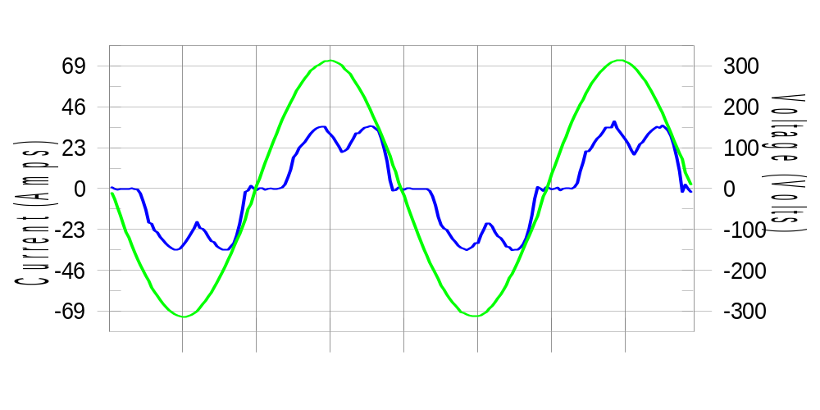

Harmonics and Class 3 limit line European Limits

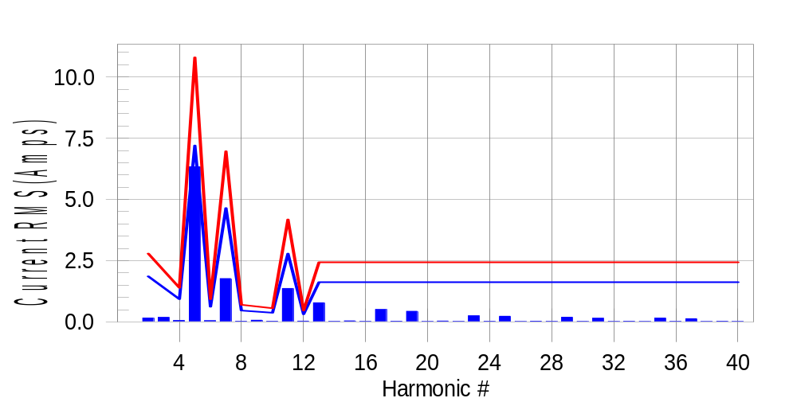

Test result: Pass Worst harmonic was #5 with 59.02 % of the limit.
Current Test Result Summary (Phase A-Run time)

EUT: Equipment under test Tested by: Tested by
Test category: Table:3, Rsce=250, Test Margin: 100
Test date: 2016/4/18 Start time: 16:04:12 End time: 16:07:05
Test duration (min): 2.5 Data file name: CTSMXH_H-000033.cts_data
Comment: Comment
Customer: Customer information

Test Result: Pass Measured I-ref: 23.371(Amps) Source: Distorted
I-THC(%): 29.4 Limit(%): 37.0 PWHC(%): 16.1 PWHC Limit(%): 38.0

Highest parameter values during test:
V_RMS (Volts): 220.42 Frequency(Hz): 50.00
I_Peak (Amps): 44.267 I_RMS (Amps): 23.371
I_Fund (Amps): 22.191 Crest Factor: 1.900
Power (Watts): 4782 Power Factor: 0.929

Harm# Harms(avg) 100%Limit %of Limit Harms(max) 150%Limit %of Limit Status

2 0.158 1.858 8.5 0.182 2.787 6.5 Pass
3 0.184 N/A N/A 0.220 N/A N/A N/A
4 0.057 0.929 6.1 0.075 1.394 5.4 Pass
5 6.333 7.200 88.0 6.357 10.800 58.9 Pass
6 0.048 0.619 7.7 0.057 0.929 6.2 Pass
7 1.766 4.645 38.0 1.780 6.968 25.5 Pass
8 0.025 0.465 5.3 0.034 0.697 4.8 Pass
9 0.066 N/A N/A 0.077 N/A N/A N/A
10 0.024 0.372 6.5 0.033 0.557 6.0 Pass
11 1.363 2.787 48.9 1.373 4.181 32.8 Pass
12 0.031 0.310 9.9 0.038 0.465 8.2 Pass
13 0.778 1.626 47.9 0.788 2.439 32.3 Pass
14 0.018 N/A N/A 0.032 N/A N/A N/A
15 0.042 N/A N/A 0.052 N/A N/A N/A
16 0.018 N/A N/A 0.026 N/A N/A N/A
17 0.505 N/A N/A 0.515 N/A N/A N/A
18 0.024 N/A N/A 0.031 N/A N/A N/A
19 0.430 N/A N/A 0.438 N/A N/A N/A
20 0.016 N/A N/A 0.023 N/A N/A N/A
21 0.033 N/A N/A 0.044 N/A N/A N/A
22 0.017 N/A N/A 0.025 N/A N/A N/A
23 0.249 N/A N/A 0.257 N/A N/A N/A
24 0.020 N/A N/A 0.027 N/A N/A N/A
25 0.229 N/A N/A 0.239 N/A N/A N/A
26 0.016 N/A N/A 0.026 N/A N/A N/A
27 0.028 N/A N/A 0.037 N/A N/A N/A
28 0.018 N/A N/A 0.025 N/A N/A N/A
29 0.190 N/A N/A 0.198 N/A N/A N/A
30 0.018 N/A N/A 0.025 N/A N/A N/A
31 0.148 N/A N/A 0.155 N/A N/A N/A
32 0.015 N/A N/A 0.021 N/A N/A N/A
33 0.025 N/A N/A 0.034 N/A N/A N/A
34 0.016 N/A N/A 0.022 N/A N/A N/A
35 0.156 N/A N/A 0.166 N/A N/A N/A
36 0.018 N/A N/A 0.027 N/A N/A N/A
37 0.128 N/A N/A 0.137 N/A N/A N/A
38 0.015 N/A N/A 0.020 N/A N/A N/A
39 0.024 N/A N/A 0.032 N/A N/A N/A
40 0.016 N/A N/A 0.022 N/A N/A N/A

Note: Measured I-ref was applied for this test.

Voltage Source Verification Data (Phase A-Run time)

EUT: Equipment under test Tested by: Tested by
Test category: Table:3, Rsce=250, Test Margin: 100
Test date: 2016/4/18 Start time: 16:04:12 End time: 16:07:05
Test duration (min): 2.5 Data file name: CTSMXH_H-000033.cts_data
Comment: Comment
Customer: Customer information

Test Result: Pass Source qualification: Distorted
Current harmonics are corrected for source distortion, and are within +/-5%
Measurements are compliant with IEC/EN61000-3-12 Ed.4 & IEC/EN61000-4-7

Highest parameter values during test:
Voltage (Vrms): 220.42 Frequency(Hz): 50.00
I_Peak (Amps): 44.267 I_RMS (Amps): 23.371
I_Fund (Amps): 22.191 Crest Factor: 1.900
Power (Watts): 4782 Power Factor: 0.929

Harm# Harmonics V-rms Limit V-rms % of Limit Status

2 0.197 0.882 22.31 OK
3 0.390 2.754 14.17 OK
4 0.206 0.881 23.38 OK
5 1.100 3.305 33.30 OK
6 0.125 0.881 14.14 OK
7 0.462 2.754 16.77 OK
8 0.092 0.881 10.44 OK
9 0.196 1.322 14.80 OK
10 0.083 0.881 9.43 OK
11 0.486 1.542 31.50 OK
12 0.087 0.661 13.09 OK
13 0.372 1.322 28.16 OK
14 0.082 0.661 12.39 OK
15 0.177 0.661 26.79 OK
16 0.082 0.661 12.38 OK
17 0.277 0.661 41.84 OK
18 0.087 0.661 13.22 OK
19 0.272 0.661 41.20 OK
20 0.164 0.661 24.86 OK
21 0.151 0.661 22.79 OK
22 0.077 0.661 11.58 OK
23 0.220 0.661 33.26 OK
24 0.071 0.661 10.81 OK
25 0.242 0.661 36.54 OK
26 0.090 0.661 13.56 OK
27 0.146 0.661 22.10 OK
28 0.098 0.661 14.82 OK
29 0.192 0.661 29.09 OK
30 0.095 0.661 14.30 OK
31 0.167 0.661 25.29 OK
32 0.078 0.661 11.84 OK
33 0.147 0.661 22.21 OK
34 0.083 0.661 12.56 OK
35 0.171 0.661 25.88 OK
36 0.086 0.661 13.03 OK
37 0.190 0.661 28.72 OK
38 0.081 0.661 12.21 OK
39 0.147 0.661 22.22 OK
40 0.135 0.661 20.43 OK

Harmonics – Per EN/IEC61000-3-12, Ed. 2.0(Phase B-Run time)

EUT: Equipment under test Tested by: Tested by
Test category: Table:3, Rsce=250, Test Margin: 100
Test date: 2016/4/18 Start time: 16:04:12 End time: 16:07:05
Test duration (min): 2.5 Data file name: CTSMXH_H-000033.cts_data
Comment: Comment
Customer: Customer information

Test Result: Pass Source qualification: Distorted

Current & voltage waveforms

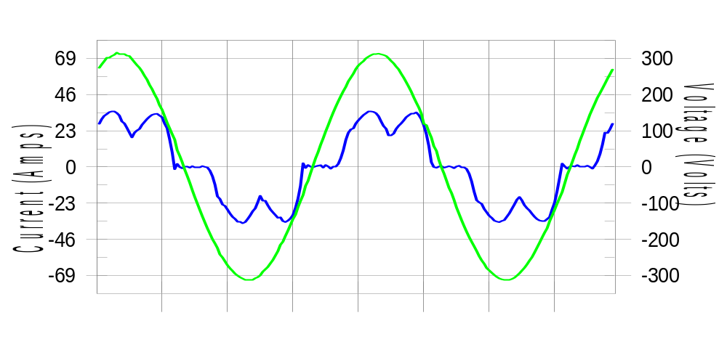

Harmonics and Class 3 limit line European Limits

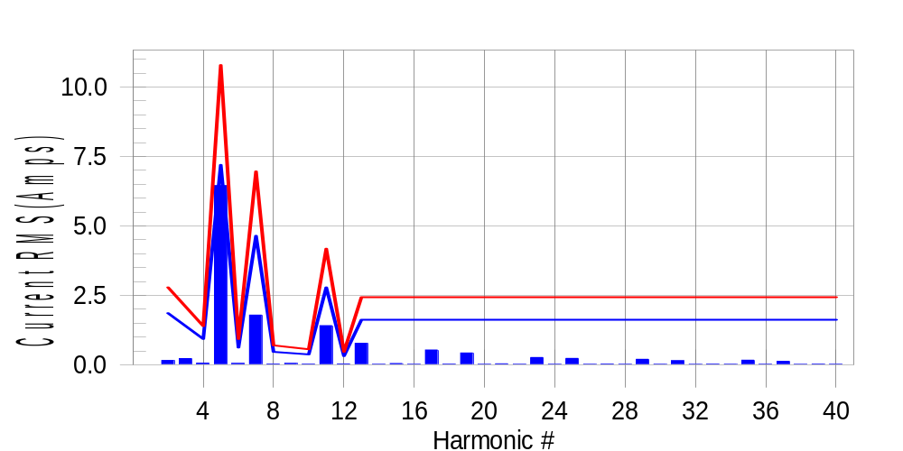

Test result: Pass Worst harmonic was #5 with 60.09 % of the limit.
Current Test Result Summary (Phase B-Run time)

EUT: Equipment under test Tested by: Tested by
Test category: Table:3, Rsce=250, Test Margin: 100
Test date: 2016/4/18 Start time: 16:04:12 End time: 16:07:05
Test duration (min): 2.5 Data file name: CTSMXH_H-000033.cts_data
Comment: Comment
Customer: Customer information

Test Result: Pass Measured I-ref: 23.338(Amps) Source: Distorted
I-THC(%): 29.9 Limit(%): 37.0 PWHC(%): 16.5 PWHC Limit(%): 38.0

Highest parameter values during test:
V_RMS (Volts): 220.18 Frequency(Hz): 50.00
I_Peak (Amps): 48.495 I_RMS (Amps): 23.338
I_Fund (Amps): 22.131 Crest Factor: 2.098
Power (Watts): 4780 Power Factor: 0.931

Harm# Harms(avg) 100%Limit %of Limit Harms(max) 150%Limit %of Limit Status

2 0.155 1.856 8.3 0.183 2.785 6.6 Pass
3 0.184 N/A N/A 0.255 N/A N/A N/A
4 0.056 0.928 6.0 0.070 1.392 5.0 Pass
5 6.449 7.194 89.7 6.475 10.790 60.0 Pass
6 0.048 0.619 7.7 0.059 0.928 6.3 Pass
7 1.789 4.641 38.5 1.800 6.962 25.9 Pass
8 0.026 0.464 5.6 0.040 0.696 5.8 Pass
9 0.066 N/A N/A 0.061 N/A N/A N/A
10 0.025 0.371 6.6 0.032 0.557 5.7 Pass
11 1.409 2.785 50.6 1.422 4.177 34.0 Pass
12 0.030 0.309 9.5 0.039 0.464 8.3 Pass
13 0.771 1.624 47.4 0.781 2.437 32.0 Pass
14 0.018 N/A N/A 0.025 N/A N/A N/A
15 0.044 N/A N/A 0.054 N/A N/A N/A
16 0.019 N/A N/A 0.027 N/A N/A N/A
17 0.530 N/A N/A 0.539 N/A N/A N/A
18 0.023 N/A N/A 0.031 N/A N/A N/A
19 0.424 N/A N/A 0.438 N/A N/A N/A
20 0.018 N/A N/A 0.038 N/A N/A N/A
21 0.033 N/A N/A 0.044 N/A N/A N/A
22 0.017 N/A N/A 0.024 N/A N/A N/A
23 0.261 N/A N/A 0.269 N/A N/A N/A
24 0.019 N/A N/A 0.025 N/A N/A N/A
25 0.228 N/A N/A 0.238 N/A N/A N/A
26 0.017 N/A N/A 0.030 N/A N/A N/A
27 0.026 N/A N/A 0.034 N/A N/A N/A
28 0.019 N/A N/A 0.028 N/A N/A N/A
29 0.197 N/A N/A 0.206 N/A N/A N/A
30 0.018 N/A N/A 0.025 N/A N/A N/A
31 0.146 N/A N/A 0.156 N/A N/A N/A
32 0.016 N/A N/A 0.024 N/A N/A N/A
33 0.024 N/A N/A 0.033 N/A N/A N/A
34 0.018 N/A N/A 0.036 N/A N/A N/A
35 0.164 N/A N/A 0.174 N/A N/A N/A
36 0.018 N/A N/A 0.025 N/A N/A N/A
37 0.123 N/A N/A 0.136 N/A N/A N/A
38 0.016 N/A N/A 0.024 N/A N/A N/A
39 0.025 N/A N/A 0.034 N/A N/A N/A
40 0.017 N/A N/A 0.024 N/A N/A N/A

Note: Measured I-ref was applied for this test.

Voltage Source Verification Data (Phase B-Run time)

EUT: Equipment under test Tested by: Tested by
Test category: Table:3, Rsce=250, Test Margin: 100
Test date: 2016/4/18 Start time: 16:04:12 End time: 16:07:05
Test duration (min): 2.5 Data file name: CTSMXH_H-000033.cts_data
Comment: Comment
Customer: Customer information

Test Result: Pass Source qualification: Distorted
Current harmonics are corrected for source distortion, and are within +/-5%
Measurements are compliant with IEC/EN61000-3-12 Ed.4 & IEC/EN61000-4-7

Highest parameter values during test:
Voltage (Vrms): 220.18 Frequency(Hz): 50.00
I_Peak (Amps): 48.495 I_RMS (Amps): 23.338
I_Fund (Amps): 22.131 Crest Factor: 2.098
Power (Watts): 4780 Power Factor: 0.931

Harm# Harmonics V-rms Limit V-rms % of Limit Status

2 0.193 0.881 21.97 OK
3 0.342 2.751 12.43 OK
4 0.180 0.880 20.50 OK
5 1.144 3.302 34.66 OK
6 0.123 0.880 13.94 OK
7 0.477 2.751 17.35 OK
8 0.147 0.880 16.74 OK
9 0.172 1.321 13.04 OK
10 0.106 0.880 12.08 OK
11 0.525 1.540 34.11 OK
12 0.115 0.660 17.47 OK
13 0.391 1.321 29.64 OK
14 0.102 0.660 15.43 OK
15 0.151 0.660 22.86 OK
16 0.099 0.660 15.01 OK
17 0.310 0.660 46.93 OK
18 0.097 0.660 14.75 OK
19 0.297 0.660 44.97 OK
20 0.149 0.660 22.53 OK
21 0.137 0.660 20.75 OK
22 0.095 0.660 14.32 OK
23 0.223 0.660 33.85 OK
24 0.097 0.660 14.71 OK
25 0.207 0.660 31.28 OK
26 0.110 0.660 16.62 OK
27 0.137 0.660 20.70 OK
28 0.117 0.660 17.74 OK
29 0.224 0.660 33.94 OK
30 0.104 0.660 15.72 OK
31 0.185 0.660 28.08 OK
32 0.107 0.660 16.25 OK
33 0.111 0.660 16.80 OK
34 0.103 0.660 15.66 OK
35 0.199 0.660 30.15 OK
36 0.100 0.660 15.12 OK
37 0.194 0.660 29.33 OK
38 0.112 0.660 16.92 OK
39 0.132 0.660 20.01 OK
40 0.132 0.660 20.06 OK

Harmonics – Per EN/IEC61000-3-12, Ed. 2.0(Phase C-Run time)

EUT: Equipment under test Tested by: Tested by
Test category: Table:3, Rsce=250, Test Margin: 100
Test date: 2016/4/18 Start time: 16:04:12 End time: 16:07:05
Test duration (min): 2.5 Data file name: CTSMXH_H-000033.cts_data
Comment: Comment
Customer: Customer information

Test Result: Pass Source qualification: Distorted

Current & voltage waveforms

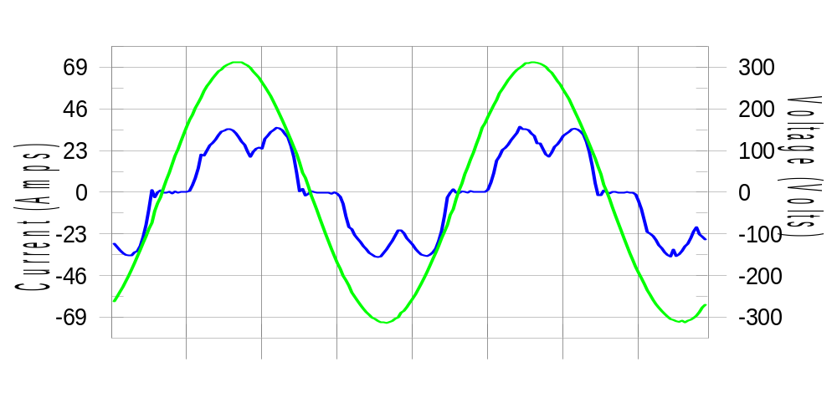

Harmonics and Class 3 limit line European Limits

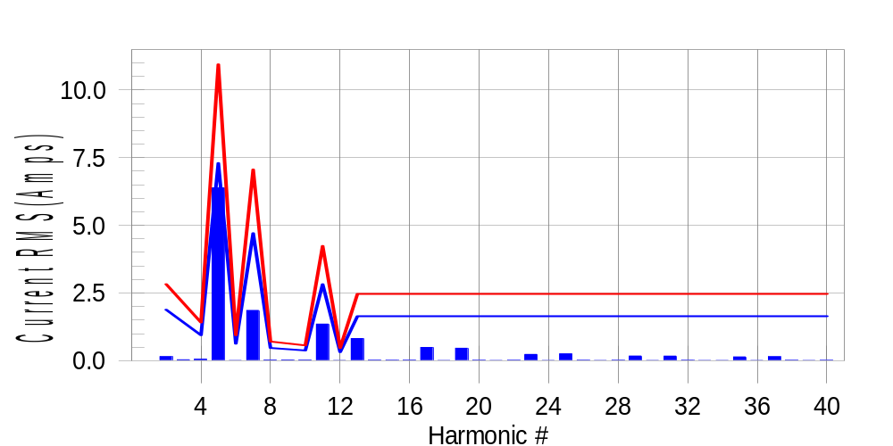

Test result: Pass Worst harmonic was #5 with 58.60 % of the limit.
Current Test Result Summary (Phase C-Run time)

EUT: Equipment under test Tested by: Tested by
Test category: Table:3, Rsce=250, Test Margin: 100
Test date: 2016/4/18 Start time: 16:04:12 End time: 16:07:05
Test duration (min): 2.5 Data file name: CTSMXH_H-000033.cts_data
Comment: Comment
Customer: Customer information

Test Result: Pass Measured I-ref: 23.671(Amps) Source: Distorted
I-THC(%): 29.3 Limit(%): 37.0 PWHC(%): 16.0 PWHC Limit(%): 38.0

Highest parameter values during test:
V_RMS (Volts): 220.10 Frequency(Hz): 50.00
I_Peak (Amps): 45.021 I_RMS (Amps): 23.671
I_Fund (Amps): 22.500 Crest Factor: 1.911
Power (Watts): 4849 Power Factor: 0.931

Harm# Harms(avg) 100%Limit %of Limit Harms(max) 150%Limit %of Limit Status

2 0.149 1.883 7.9 0.181 2.825 6.4 Pass
3 0.184 N/A N/A 0.066 N/A N/A N/A
4 0.053 0.942 5.6 0.067 1.412 4.7 Pass
5 6.382 7.297 87.5 6.406 10.946 58.5 Pass
6 0.013 0.628 2.1 0.018 0.942 2.0 Pass
7 1.855 4.708 39.4 1.870 7.062 26.5 Pass
8 0.026 0.471 5.5 0.035 0.706 4.9 Pass
9 0.066 N/A N/A 0.043 N/A N/A N/A
10 0.023 0.377 6.1 0.032 0.565 5.7 Pass
11 1.352 2.825 47.9 1.363 4.237 32.2 Pass
12 0.013 0.314 4.1 0.020 0.471 4.2 Pass
13 0.819 1.648 49.7 0.830 2.472 33.6 Pass
14 0.017 N/A N/A 0.023 N/A N/A N/A
15 0.014 N/A N/A 0.020 N/A N/A N/A
16 0.017 N/A N/A 0.023 N/A N/A N/A
17 0.488 N/A N/A 0.497 N/A N/A N/A
18 0.013 N/A N/A 0.018 N/A N/A N/A
19 0.459 N/A N/A 0.467 N/A N/A N/A
20 0.016 N/A N/A 0.025 N/A N/A N/A
21 0.013 N/A N/A 0.017 N/A N/A N/A
22 0.015 N/A N/A 0.021 N/A N/A N/A
23 0.231 N/A N/A 0.239 N/A N/A N/A
24 0.012 N/A N/A 0.017 N/A N/A N/A
25 0.252 N/A N/A 0.262 N/A N/A N/A
26 0.015 N/A N/A 0.022 N/A N/A N/A
27 0.012 N/A N/A 0.019 N/A N/A N/A
28 0.016 N/A N/A 0.024 N/A N/A N/A
29 0.173 N/A N/A 0.179 N/A N/A N/A
30 0.012 N/A N/A 0.020 N/A N/A N/A
31 0.168 N/A N/A 0.176 N/A N/A N/A
32 0.014 N/A N/A 0.018 N/A N/A N/A
33 0.012 N/A N/A 0.017 N/A N/A N/A
34 0.013 N/A N/A 0.020 N/A N/A N/A
35 0.141 N/A N/A 0.150 N/A N/A N/A
36 0.013 N/A N/A 0.018 N/A N/A N/A
37 0.147 N/A N/A 0.158 N/A N/A N/A
38 0.014 N/A N/A 0.020 N/A N/A N/A
39 0.013 N/A N/A 0.022 N/A N/A N/A
40 0.014 N/A N/A 0.022 N/A N/A N/A

Note: Measured I-ref was applied for this test.

Voltage Source Verification Data (Phase C-Run time)

EUT: Equipment under test Tested by: Tested by
Test category: Table:3, Rsce=250, Test Margin: 100
Test date: 2016/4/18 Start time: 16:04:12 End time: 16:07:05
Test duration (min): 2.5 Data file name: CTSMXH_H-000033.cts_data
Comment: Comment
Customer: Customer information

Test Result: Pass Source qualification: Distorted
Current harmonics are corrected for source distortion, and are within +/-5%
Measurements are compliant with IEC/EN61000-3-12 Ed.4 & IEC/EN61000-4-7

Highest parameter values during test:
Voltage (Vrms): 220.10 Frequency(Hz): 50.00
I_Peak (Amps): 45.021 I_RMS (Amps): 23.671
I_Fund (Amps): 22.500 Crest Factor: 1.911
Power (Watts): 4849 Power Factor: 0.931

Harm# Harmonics V-rms Limit V-rms % of Limit Status

2 0.191 0.880 21.66 OK
3 0.326 2.749 11.86 OK
4 0.200 0.880 22.73 OK
5 1.074 3.301 32.55 OK
6 0.123 0.880 14.02 OK
7 0.474 2.750 17.25 OK
8 0.105 0.880 11.98 OK
9 0.167 1.320 12.64 OK
10 0.082 0.880 9.35 OK
11 0.468 1.540 30.40 OK
12 0.087 0.660 13.21 OK
13 0.373 1.320 28.30 OK
14 0.089 0.660 13.50 OK
15 0.147 0.660 22.29 OK
16 0.080 0.660 12.16 OK
17 0.256 0.660 38.82 OK
18 0.089 0.660 13.54 OK
19 0.289 0.660 43.74 OK
20 0.093 0.660 14.10 OK
21 0.153 0.660 23.13 OK
22 0.089 0.660 13.48 OK
23 0.214 0.660 32.45 OK
24 0.087 0.660 13.22 OK
25 0.205 0.660 31.06 OK
26 0.083 0.660 12.52 OK
27 0.113 0.660 17.18 OK
28 0.094 0.660 14.19 OK
29 0.194 0.660 29.41 OK
30 0.089 0.660 13.45 OK
31 0.179 0.660 27.15 OK
32 0.075 0.660 11.40 OK
33 0.121 0.660 18.32 OK
34 0.093 0.660 14.04 OK
35 0.172 0.660 26.11 OK
36 0.102 0.660 15.38 OK
37 0.199 0.660 30.12 OK
38 0.104 0.660 15.80 OK
39 0.120 0.660 18.17 OK
40 0.102 0.660 15.51 OK

5th Harmonic Phase Angle and Magnitude for Phase A :
H-5_min_phase : 99.8 Degree (Leading)
H-5_max_phase : 100.5 Degree (Leading)
H-5_ave_phase : 100.1 Degree (Leading)

H-5_ave_vector_magnitude : 6.379 Amp
H-5_standard_ave_magnitude : 6.333 Amp
H-5_standard_max_magnitude : 6.406 Amp
Ratio of H-5_ave_vector / H-5_standard_ave : 0.999

Phase A = 87.962% of tested Rsce = 250.000, Rsce = 219.905
Phase B = 89.664% of tested Rsce = 250.000, Rsce = 224.161
Phase C = 87.462% of tested Rsce = 250.000, Rsce = 218.655
Minimum Rsce required: Rsce = 224.161

