Harmonics – Per EN/IEC61000-3-12, Ed. 2.0(Phase A-Run time)

EUT: Equipment under test Tested by: Tested by
Test category: Table:3, Rsce=250, Test Margin: 100
Test date: 2016/4/18 Start time: 16:15:13 End time: 16:18:06
Test duration (min): 2.5 Data file name: CTSMXH_H-000034.cts_data
Comment: Comment
Customer: Customer information

Test Result: Pass Source qualification: Normal

Current & voltage waveforms

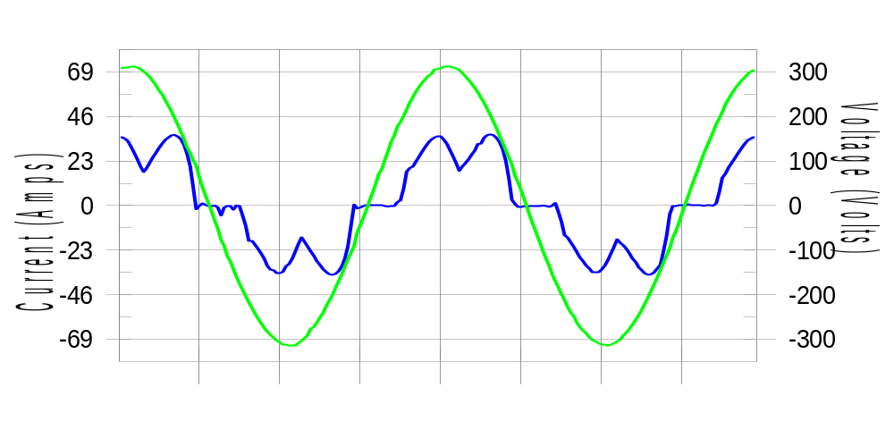

Harmonics and Class 3 limit line European Limits

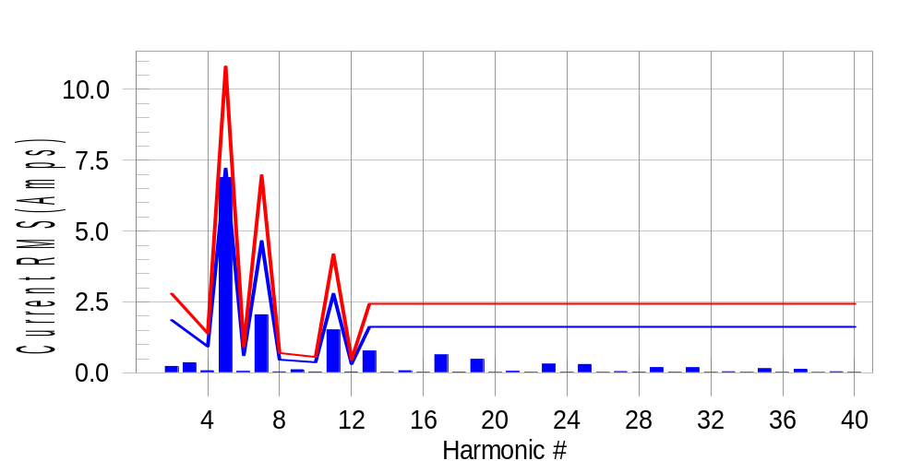

Test result: Pass Worst harmonic was #5 with 64.10 % of the limit.
Current Test Result Summary (Phase A-Run time)

EUT: Equipment under test Tested by: Tested by
Test category: Table:3, Rsce=250, Test Margin: 100
Test date: 2016/4/18 Start time: 16:15:13 End time: 16:18:06
Test duration (min): 2.5 Data file name: CTSMXH_H-000034.cts_data
Comment: Comment
Customer: Customer information

Test Result: Pass Measured I-ref: 23.362(Amps) Source: Normal
I-THC(%): 32.1 Limit(%): 37.0 PWHC(%): 18.9 PWHC Limit(%): 38.0

Highest parameter values during test:
V_RMS (Volts): 220.42 Frequency(Hz): 50.00
I_Peak (Amps): 47.994 I_RMS (Amps): 23.362
I_Fund (Amps): 22.008 Crest Factor: 2.061
Power (Watts): 4761 Power Factor: 0.925

Harm# Harms(avg) 100%Limit %of Limit Harms(max) 150%Limit %of Limit Status

2 0.227 1.860 12.2 0.255 2.790 9.1 Pass
3 0.357 N/A N/A 0.391 N/A N/A N/A
4 0.072 0.930 7.8 0.089 1.395 6.4 Pass
5 6.888 7.207 95.6 6.906 10.811 63.9 Pass
6 0.050 0.620 8.1 0.060 0.930 6.5 Pass
7 2.048 4.650 44.1 2.061 6.975 29.5 Pass
8 0.033 0.465 7.1 0.044 0.697 6.3 Pass
9 0.108 N/A N/A 0.120 N/A N/A N/A
10 0.031 0.372 8.4 0.040 0.558 7.1 Pass
11 1.514 2.790 54.3 1.523 4.185 36.4 Pass
12 0.032 0.310 10.2 0.041 0.465 8.9 Pass
13 0.774 1.627 47.6 0.784 2.441 32.1 Pass
14 0.021 N/A N/A 0.039 N/A N/A N/A
15 0.072 N/A N/A 0.082 N/A N/A N/A
16 0.022 N/A N/A 0.030 N/A N/A N/A
17 0.632 N/A N/A 0.641 N/A N/A N/A
18 0.025 N/A N/A 0.032 N/A N/A N/A
19 0.478 N/A N/A 0.488 N/A N/A N/A
20 0.018 N/A N/A 0.028 N/A N/A N/A
21 0.055 N/A N/A 0.065 N/A N/A N/A
22 0.019 N/A N/A 0.025 N/A N/A N/A
23 0.309 N/A N/A 0.318 N/A N/A N/A
24 0.022 N/A N/A 0.029 N/A N/A N/A
25 0.296 N/A N/A 0.303 N/A N/A N/A
26 0.017 N/A N/A 0.027 N/A N/A N/A
27 0.045 N/A N/A 0.053 N/A N/A N/A
28 0.024 N/A N/A 0.034 N/A N/A N/A
29 0.184 N/A N/A 0.195 N/A N/A N/A
30 0.020 N/A N/A 0.027 N/A N/A N/A
31 0.181 N/A N/A 0.197 N/A N/A N/A
32 0.017 N/A N/A 0.025 N/A N/A N/A
33 0.038 N/A N/A 0.045 N/A N/A N/A
34 0.018 N/A N/A 0.029 N/A N/A N/A
35 0.144 N/A N/A 0.154 N/A N/A N/A
36 0.018 N/A N/A 0.025 N/A N/A N/A
37 0.126 N/A N/A 0.135 N/A N/A N/A
38 0.016 N/A N/A 0.023 N/A N/A N/A
39 0.036 N/A N/A 0.045 N/A N/A N/A
40 0.018 N/A N/A 0.024 N/A N/A N/A

Note: Measured I-ref was applied for this test.

Voltage Source Verification Data (Phase A-Run time)

EUT: Equipment under test Tested by: Tested by
Test category: Table:3, Rsce=250, Test Margin: 100
Test date: 2016/4/18 Start time: 16:15:13 End time: 16:18:06
Test duration (min): 2.5 Data file name: CTSMXH_H-000034.cts_data
Comment: Comment
Customer: Customer information

Test Result: Pass Source qualification: Normal
Measured source distortion is within the requirements of the standards
Measurements are compliant with IEC/EN61000-3-12 Ed.4 & IEC/EN61000-4-7 Ed. 2.1

Highest parameter values during test:
Voltage (Vrms): 220.42 Frequency(Hz): 50.00
I_Peak (Amps): 47.994 I_RMS (Amps): 23.362
I_Fund (Amps): 22.008 Crest Factor: 2.061
Power (Watts): 4761 Power Factor: 0.925

Harm# Harmonics V-rms Limit V-rms % of Limit Status

2 0.171 0.881 19.38 OK
3 0.340 2.755 12.35 OK
4 0.212 0.881 24.02 OK
5 1.163 3.305 35.18 OK
6 0.141 0.881 16.02 OK
7 0.490 2.754 17.78 OK
8 0.100 0.881 11.39 OK
9 0.179 1.322 13.54 OK
10 0.097 0.881 10.96 OK
11 0.517 1.542 33.55 OK
12 0.100 0.661 15.13 OK
13 0.360 1.322 27.25 OK
14 0.098 0.661 14.90 OK
15 0.160 0.661 24.17 OK
16 0.102 0.661 15.37 OK
17 0.314 0.661 47.48 OK
18 0.091 0.661 13.78 OK
19 0.318 0.661 48.07 OK
20 0.170 0.661 25.66 OK
21 0.173 0.661 26.20 OK
22 0.081 0.661 12.28 OK
23 0.206 0.661 31.14 OK
24 0.088 0.661 13.30 OK
25 0.242 0.661 36.67 OK
26 0.096 0.661 14.45 OK
27 0.146 0.661 22.12 OK
28 0.114 0.661 17.25 OK
29 0.181 0.661 27.42 OK
30 0.089 0.661 13.45 OK
31 0.177 0.661 26.81 OK
32 0.089 0.661 13.40 OK
33 0.134 0.661 20.33 OK
34 0.078 0.661 11.83 OK
35 0.183 0.661 27.62 OK
36 0.082 0.661 12.44 OK
37 0.159 0.661 24.08 OK
38 0.088 0.661 13.33 OK
39 0.144 0.661 21.80 OK
40 0.156 0.661 23.64 OK

Harmonics – Per EN/IEC61000-3-12, Ed. 2.0(Phase B-Run time)

EUT: Equipment under test Tested by: Tested by
Test category: Table:3, Rsce=250, Test Margin: 100
Test date: 2016/4/18 Start time: 16:15:13 End time: 16:18:06
Test duration (min): 2.5 Data file name: CTSMXH_H-000034.cts_data
Comment: Comment
Customer: Customer information

Test Result: Pass Source qualification: Normal

Current & voltage waveforms

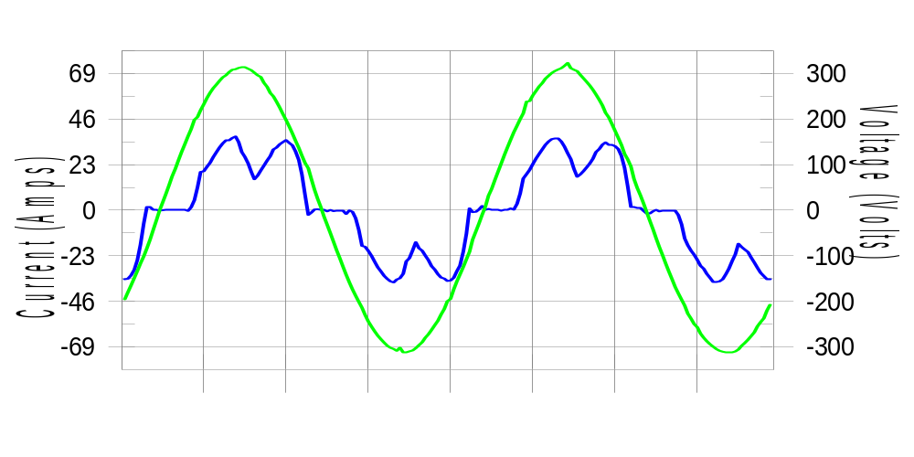

Harmonics and Class 3 limit line European Limits

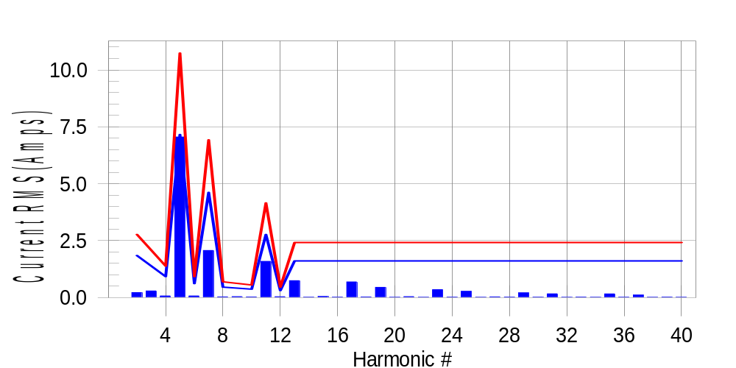

Test result: Pass Worst harmonic was #5 with 65.93 % of the limit.
Current Test Result Summary (Phase B-Run time)

EUT: Equipment under test Tested by: Tested by
Test category: Table:3, Rsce=250, Test Margin: 100
Test date: 2016/4/18 Start time: 16:15:13 End time: 16:18:06
Test duration (min): 2.5 Data file name: CTSMXH_H-000034.cts_data
Comment: Comment
Customer: Customer information

Test Result: Pass Measured I-ref: 23.199(Amps) Source: Normal
I-THC(%): 33.1 Limit(%): 37.0 PWHC(%): 19.6 PWHC Limit(%): 38.0

Highest parameter values during test:
V_RMS (Volts): 220.21 Frequency(Hz): 50.00
I_Peak (Amps): 49.076 I_RMS (Amps): 23.199
I_Fund (Amps): 21.787 Crest Factor: 2.127
Power (Watts): 4730 Power Factor: 0.927

Harm# Harms(avg) 100%Limit %of Limit Harms(max) 150%Limit %of Limit Status

2 0.220 1.848 11.9 0.250 2.772 9.0 Pass
3 0.357 N/A N/A 0.331 N/A N/A N/A
4 0.072 0.924 7.8 0.089 1.386 6.4 Pass
5 7.053 7.160 98.5 7.071 10.740 65.8 Pass
6 0.073 0.616 11.8 0.082 0.924 8.8 Pass
7 2.071 4.619 44.8 2.082 6.929 30.0 Pass
8 0.035 0.462 7.5 0.046 0.693 6.6 Pass
9 0.108 N/A N/A 0.057 N/A N/A N/A
10 0.031 0.370 8.4 0.041 0.554 7.4 Pass
11 1.592 2.772 57.4 1.603 4.157 38.6 Pass
12 0.040 0.308 13.1 0.050 0.462 10.9 Pass
13 0.745 1.617 46.1 0.758 2.425 31.3 Pass
14 0.022 N/A N/A 0.030 N/A N/A N/A
15 0.050 N/A N/A 0.060 N/A N/A N/A
16 0.024 N/A N/A 0.032 N/A N/A N/A
17 0.689 N/A N/A 0.700 N/A N/A N/A
18 0.030 N/A N/A 0.037 N/A N/A N/A
19 0.452 N/A N/A 0.464 N/A N/A N/A
20 0.019 N/A N/A 0.026 N/A N/A N/A
21 0.043 N/A N/A 0.055 N/A N/A N/A
22 0.019 N/A N/A 0.030 N/A N/A N/A
23 0.351 N/A N/A 0.363 N/A N/A N/A
24 0.025 N/A N/A 0.032 N/A N/A N/A
25 0.277 N/A N/A 0.284 N/A N/A N/A
26 0.017 N/A N/A 0.028 N/A N/A N/A
27 0.034 N/A N/A 0.043 N/A N/A N/A
28 0.027 N/A N/A 0.046 N/A N/A N/A
29 0.210 N/A N/A 0.219 N/A N/A N/A
30 0.023 N/A N/A 0.032 N/A N/A N/A
31 0.167 N/A N/A 0.177 N/A N/A N/A
32 0.018 N/A N/A 0.026 N/A N/A N/A
33 0.027 N/A N/A 0.035 N/A N/A N/A
34 0.019 N/A N/A 0.027 N/A N/A N/A
35 0.162 N/A N/A 0.177 N/A N/A N/A
36 0.021 N/A N/A 0.029 N/A N/A N/A
37 0.111 N/A N/A 0.122 N/A N/A N/A
38 0.017 N/A N/A 0.024 N/A N/A N/A
39 0.027 N/A N/A 0.037 N/A N/A N/A
40 0.018 N/A N/A 0.026 N/A N/A N/A

Note: Measured I-ref was applied for this test.

Voltage Source Verification Data (Phase B-Run time)

EUT: Equipment under test Tested by: Tested by
Test category: Table:3, Rsce=250, Test Margin: 100
Test date: 2016/4/18 Start time: 16:15:13 End time: 16:18:06
Test duration (min): 2.5 Data file name: CTSMXH_H-000034.cts_data
Comment: Comment
Customer: Customer information

Test Result: Pass Source qualification: Normal
Measured source distortion is within the requirements of the standards
Measurements are compliant with IEC/EN61000-3-12 Ed.4 & IEC/EN61000-4-7 Ed. 2.1

Highest parameter values during test:
Voltage (Vrms): 220.21 Frequency(Hz): 50.00
I_Peak (Amps): 49.076 I_RMS (Amps): 23.199
I_Fund (Amps): 21.787 Crest Factor: 2.127
Power (Watts): 4730 Power Factor: 0.927

Harm# Harmonics V-rms Limit V-rms % of Limit Status

2 0.220 0.881 25.00 OK
3 0.307 2.752 11.14 OK
4 0.159 0.880 18.02 OK
5 1.226 3.302 37.13 OK
6 0.138 0.880 15.70 OK
7 0.524 2.752 19.05 OK
8 0.110 0.881 12.52 OK
9 0.160 1.320 12.14 OK
10 0.098 0.881 11.16 OK
11 0.571 1.540 37.05 OK
12 0.145 0.660 21.94 OK
13 0.363 1.321 27.45 OK
14 0.113 0.660 17.14 OK
15 0.150 0.660 22.75 OK
16 0.107 0.660 16.15 OK
17 0.366 0.660 55.42 OK
18 0.113 0.660 17.12 OK
19 0.313 0.660 47.44 OK
20 0.143 0.660 21.62 OK
21 0.135 0.660 20.39 OK
22 0.104 0.660 15.79 OK
23 0.259 0.660 39.29 OK
24 0.109 0.660 16.56 OK
25 0.268 0.660 40.53 OK
26 0.138 0.660 20.96 OK
27 0.129 0.660 19.51 OK
28 0.138 0.660 20.94 OK
29 0.248 0.660 37.61 OK
30 0.117 0.660 17.66 OK
31 0.195 0.660 29.49 OK
32 0.109 0.660 16.53 OK
33 0.141 0.660 21.38 OK
34 0.105 0.660 15.97 OK
35 0.206 0.660 31.21 OK
36 0.107 0.660 16.19 OK
37 0.181 0.660 27.45 OK
38 0.113 0.660 17.05 OK
39 0.121 0.660 18.37 OK
40 0.139 0.660 20.99 OK

Harmonics – Per EN/IEC61000-3-12, Ed. 2.0(Phase C-Run time)

EUT: Equipment under test Tested by: Tested by
Test category: Table:3, Rsce=250, Test Margin: 100
Test date: 2016/4/18 Start time: 16:15:13 End time: 16:18:06
Test duration (min): 2.5 Data file name: CTSMXH_H-000034.cts_data
Comment: Comment
Customer: Customer information

Test Result: Pass Source qualification: Normal

Current & voltage waveforms

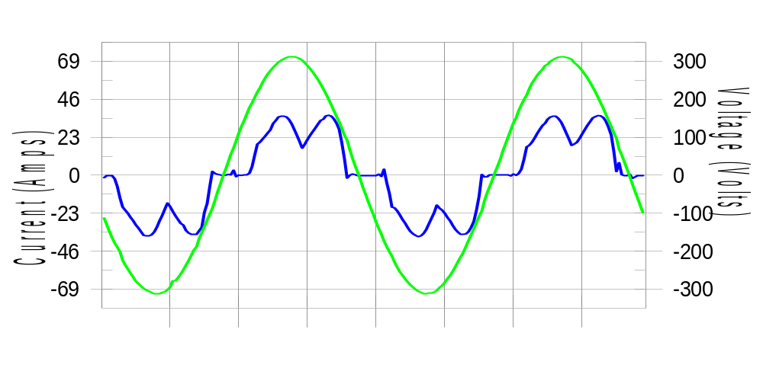

Harmonics and Class 3 limit line European Limits

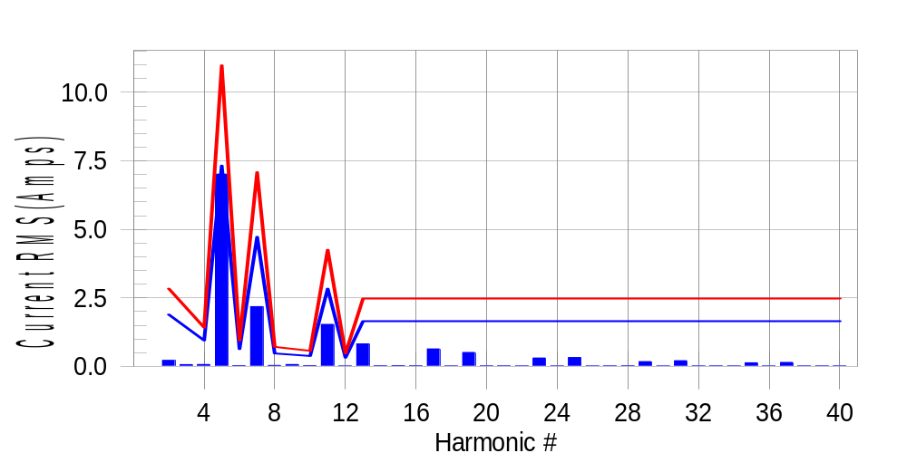

Test result: Pass Worst harmonic was #5 with 64.16 % of the limit.
Current Test Result Summary (Phase C-Run time)

EUT: Equipment under test Tested by: Tested by
Test category: Table:3, Rsce=250, Test Margin: 100
Test date: 2016/4/18 Start time: 16:15:13 End time: 16:18:06
Test duration (min): 2.5 Data file name: CTSMXH_H-000034.cts_data
Comment: Comment
Customer: Customer information

Test Result: Pass Measured I-ref: 23.736(Amps) Source: Normal
I-THC(%): 32.3 Limit(%): 37.0 PWHC(%): 19.0 PWHC Limit(%): 38.0

Highest parameter values during test:
V_RMS (Volts): 220.10 Frequency(Hz): 50.00
I_Peak (Amps): 46.256 I_RMS (Amps): 23.736
I_Fund (Amps): 22.356 Crest Factor: 1.957
Power (Watts): 4849 Power Factor: 0.929

Harm# Harms(avg) 100%Limit %of Limit Harms(max) 150%Limit %of Limit Status

2 0.218 1.890 11.5 0.253 2.835 8.9 Pass
3 0.357 N/A N/A 0.095 N/A N/A N/A
4 0.069 0.945 7.3 0.086 1.418 6.1 Pass
5 7.014 7.324 95.8 7.033 10.987 64.0 Pass
6 0.027 0.630 4.3 0.035 0.945 3.7 Pass
7 2.181 4.725 46.2 2.191 7.088 30.9 Pass
8 0.034 0.473 7.1 0.043 0.709 6.0 Pass
9 0.108 N/A N/A 0.077 N/A N/A N/A
10 0.029 0.378 7.7 0.039 0.567 6.8 Pass
11 1.534 2.835 54.1 1.546 4.253 36.4 Pass
12 0.016 0.315 4.9 0.021 0.473 4.5 Pass
13 0.823 1.654 49.7 0.830 2.481 33.5 Pass
14 0.021 N/A N/A 0.034 N/A N/A N/A
15 0.029 N/A N/A 0.039 N/A N/A N/A
16 0.020 N/A N/A 0.029 N/A N/A N/A
17 0.636 N/A N/A 0.644 N/A N/A N/A
18 0.015 N/A N/A 0.023 N/A N/A N/A
19 0.509 N/A N/A 0.520 N/A N/A N/A
20 0.019 N/A N/A 0.027 N/A N/A N/A
21 0.018 N/A N/A 0.023 N/A N/A N/A
22 0.016 N/A N/A 0.022 N/A N/A N/A
23 0.306 N/A N/A 0.313 N/A N/A N/A
24 0.014 N/A N/A 0.021 N/A N/A N/A
25 0.322 N/A N/A 0.329 N/A N/A N/A
26 0.016 N/A N/A 0.024 N/A N/A N/A
27 0.017 N/A N/A 0.024 N/A N/A N/A
28 0.022 N/A N/A 0.034 N/A N/A N/A
29 0.173 N/A N/A 0.180 N/A N/A N/A
30 0.014 N/A N/A 0.021 N/A N/A N/A
31 0.205 N/A N/A 0.214 N/A N/A N/A
32 0.016 N/A N/A 0.022 N/A N/A N/A
33 0.017 N/A N/A 0.022 N/A N/A N/A
34 0.016 N/A N/A 0.022 N/A N/A N/A
35 0.131 N/A N/A 0.139 N/A N/A N/A
36 0.014 N/A N/A 0.020 N/A N/A N/A
37 0.145 N/A N/A 0.158 N/A N/A N/A
38 0.015 N/A N/A 0.031 N/A N/A N/A
39 0.016 N/A N/A 0.022 N/A N/A N/A
40 0.015 N/A N/A 0.021 N/A N/A N/A

Note: Measured I-ref was applied for this test.

Voltage Source Verification Data (Phase C-Run time)

EUT: Equipment under test Tested by: Tested by
Test category: Table:3, Rsce=250, Test Margin: 100
Test date: 2016/4/18 Start time: 16:15:13 End time: 16:18:06
Test duration (min): 2.5 Data file name: CTSMXH_H-000034.cts_data
Comment: Comment
Customer: Customer information

Test Result: Pass Source qualification: Normal
Measured source distortion is within the requirements of the standards
Measurements are compliant with IEC/EN61000-3-12 Ed.4 & IEC/EN61000-4-7 Ed. 2.1

Highest parameter values during test:
Voltage (Vrms): 220.10 Frequency(Hz): 50.00
I_Peak (Amps): 46.256 I_RMS (Amps): 23.736
I_Fund (Amps): 22.356 Crest Factor: 1.957
Power (Watts): 4849 Power Factor: 0.929

Harm# Harmonics V-rms Limit V-rms % of Limit Status

2 0.165 0.880 18.72 OK
3 0.308 2.750 11.21 OK
4 0.157 0.880 17.85 OK
5 1.157 3.300 35.05 OK
6 0.092 0.880 10.50 OK
7 0.517 2.749 18.80 OK
8 0.096 0.880 10.95 OK
9 0.145 1.320 10.97 OK
10 0.085 0.880 9.63 OK
11 0.523 1.540 33.97 OK
12 0.099 0.660 15.08 OK
13 0.379 1.320 28.74 OK
14 0.107 0.660 16.26 OK
15 0.136 0.660 20.64 OK
16 0.088 0.660 13.27 OK
17 0.317 0.660 48.05 OK
18 0.096 0.660 14.52 OK
19 0.318 0.660 48.18 OK
20 0.111 0.660 16.82 OK
21 0.158 0.660 23.90 OK
22 0.091 0.660 13.85 OK
23 0.201 0.660 30.44 OK
24 0.101 0.660 15.23 OK
25 0.245 0.660 37.12 OK
26 0.099 0.660 14.96 OK
27 0.125 0.660 18.94 OK
28 0.116 0.660 17.63 OK
29 0.186 0.660 28.21 OK
30 0.088 0.660 13.31 OK
31 0.192 0.660 29.10 OK
32 0.091 0.660 13.83 OK
33 0.122 0.660 18.52 OK
34 0.091 0.660 13.84 OK
35 0.187 0.660 28.33 OK
36 0.089 0.660 13.43 OK
37 0.186 0.660 28.17 OK
38 0.100 0.660 15.17 OK
39 0.125 0.660 18.96 OK
40 0.097 0.660 14.72 OK

5th Harmonic Phase Angle and Magnitude for Phase A :
H-5_min_phase : 107.6 Degree (Leading)
H-5_max_phase : 108.2 Degree (Leading)
H-5_ave_phase : 107.9 Degree (Leading)

H-5_ave_vector_magnitude : 7.010 Amp
H-5_standard_ave_magnitude : 6.888 Amp
H-5_standard_max_magnitude : 7.033 Amp
Ratio of H-5_ave_vector / H-5_standard_ave : 0.999

Phase A = 95.580% of tested Rsce = 250.000, Rsce = 238.950
Phase B = 98.505% of tested Rsce = 250.000, Rsce = 246.262
Phase C = 95.774% of tested Rsce = 250.000, Rsce = 239.435
Minimum Rsce required: Rsce = 246.262

