Harmonics – Per EN/IEC61000-3-12, Ed. 2.0(Phase A-Run time)

EUT: Equipment under test Tested by: Tested by
Test category: Table:3, Rsce=250, Test Margin: 100
Test date: 2016/4/18 Start time: 16:25:15 End time: 16:28:08
Test duration (min): 2.5 Data file name: CTSMXH_H-000035.cts_data
Comment: Comment
Customer: Customer information

Test Result: Pass Source qualification: Distorted

Current & voltage waveforms

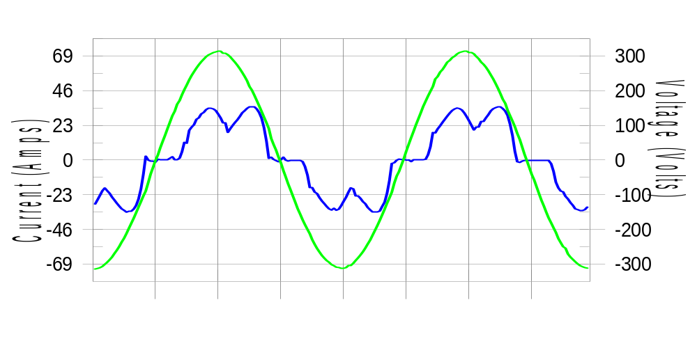

Harmonics and Class 3 limit line European Limits

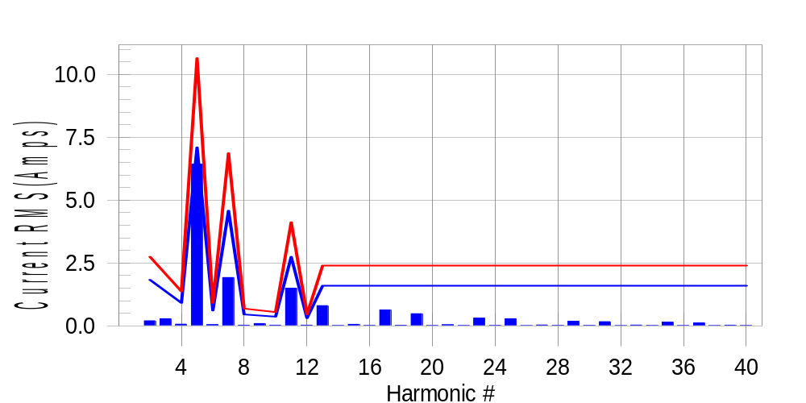

Test result: Pass Worst harmonic was #5 with 60.66 % of the limit.
Current Test Result Summary (Phase A-Run time)

EUT: Equipment under test Tested by: Tested by
Test category: Table:3, Rsce=250, Test Margin: 100
Test date: 2016/4/18 Start time: 16:25:15 End time: 16:28:08
Test duration (min): 2.5 Data file name: CTSMXH_H-000035.cts_data
Comment: Comment
Customer: Customer information

Test Result: Pass Measured I-ref: 23.032(Amps) Source: Distorted
I-THC(%): 30.6 Limit(%): 37.0 PWHC(%): 19.1 PWHC Limit(%): 38.0

Highest parameter values during test:
V_RMS (Volts): 220.41 Frequency(Hz): 50.00
I_Peak (Amps): 47.487 I_RMS (Amps): 23.032
I_Fund (Amps): 21.794 Crest Factor: 2.071
Power (Watts): 4730 Power Factor: 0.932

Harm# Harms(avg) 100%Limit %of Limit Harms(max) 150%Limit %of Limit Status

2 0.205 1.832 11.2 0.234 2.748 8.5 Pass
3 0.286 N/A N/A 0.318 N/A N/A N/A
4 0.068 0.916 7.4 0.085 1.374 6.2 Pass
5 6.432 7.100 90.6 6.459 10.650 60.7 Pass
6 0.053 0.611 8.7 0.063 0.916 6.8 Pass
7 1.924 4.580 42.0 1.938 6.871 28.2 Pass
8 0.029 0.458 6.3 0.036 0.687 5.2 Pass
9 0.093 N/A N/A 0.104 N/A N/A N/A
10 0.029 0.366 7.9 0.036 0.550 6.6 Pass
11 1.500 2.748 54.6 1.511 4.122 36.6 Pass
12 0.032 0.305 10.3 0.040 0.458 8.8 Pass
13 0.807 1.603 50.4 0.818 2.405 34.0 Pass
14 0.019 N/A N/A 0.026 N/A N/A N/A
15 0.064 N/A N/A 0.074 N/A N/A N/A
16 0.021 N/A N/A 0.029 N/A N/A N/A
17 0.635 N/A N/A 0.643 N/A N/A N/A
18 0.026 N/A N/A 0.033 N/A N/A N/A
19 0.486 N/A N/A 0.494 N/A N/A N/A
20 0.018 N/A N/A 0.025 N/A N/A N/A
21 0.048 N/A N/A 0.058 N/A N/A N/A
22 0.018 N/A N/A 0.027 N/A N/A N/A
23 0.311 N/A N/A 0.321 N/A N/A N/A
24 0.022 N/A N/A 0.030 N/A N/A N/A
25 0.287 N/A N/A 0.296 N/A N/A N/A
26 0.016 N/A N/A 0.023 N/A N/A N/A
27 0.038 N/A N/A 0.050 N/A N/A N/A
28 0.021 N/A N/A 0.030 N/A N/A N/A
29 0.186 N/A N/A 0.194 N/A N/A N/A
30 0.020 N/A N/A 0.028 N/A N/A N/A
31 0.169 N/A N/A 0.178 N/A N/A N/A
32 0.016 N/A N/A 0.023 N/A N/A N/A
33 0.034 N/A N/A 0.043 N/A N/A N/A
34 0.017 N/A N/A 0.024 N/A N/A N/A
35 0.150 N/A N/A 0.160 N/A N/A N/A
36 0.018 N/A N/A 0.026 N/A N/A N/A
37 0.119 N/A N/A 0.127 N/A N/A N/A
38 0.016 N/A N/A 0.023 N/A N/A N/A
39 0.031 N/A N/A 0.041 N/A N/A N/A
40 0.017 N/A N/A 0.023 N/A N/A N/A

Note: Measured I-ref was applied for this test.

Voltage Source Verification Data (Phase A-Run time)

EUT: Equipment under test Tested by: Tested by
Test category: Table:3, Rsce=250, Test Margin: 100
Test date: 2016/4/18 Start time: 16:25:15 End time: 16:28:08
Test duration (min): 2.5 Data file name: CTSMXH_H-000035.cts_data
Comment: Comment
Customer: Customer information

Test Result: Pass Source qualification: Distorted
Current harmonics are corrected for source distortion, and are within +/-5%
Measurements are compliant with IEC/EN61000-3-12 Ed.4 & IEC/EN61000-4-7

Highest parameter values during test:
Voltage (Vrms): 220.41 Frequency(Hz): 50.00
I_Peak (Amps): 47.487 I_RMS (Amps): 23.032
I_Fund (Amps): 21.794 Crest Factor: 2.071
Power (Watts): 4730 Power Factor: 0.932

Harm# Harmonics V-rms Limit V-rms % of Limit Status

2 0.176 0.881 19.93 OK
3 0.345 2.755 12.54 OK
4 0.194 0.881 21.99 OK
5 1.112 3.306 33.64 OK
6 0.111 0.882 12.61 OK
7 0.505 2.754 18.35 OK
8 0.102 0.882 11.59 OK
9 0.199 1.322 15.03 OK
10 0.096 0.881 10.91 OK
11 0.512 1.542 33.20 OK
12 0.112 0.661 17.00 OK
13 0.397 1.322 30.05 OK
14 0.099 0.661 14.97 OK
15 0.173 0.661 26.15 OK
16 0.094 0.661 14.15 OK
17 0.308 0.661 46.66 OK
18 0.088 0.661 13.25 OK
19 0.313 0.661 47.39 OK
20 0.167 0.661 25.30 OK
21 0.181 0.661 27.34 OK
22 0.097 0.661 14.73 OK
23 0.216 0.661 32.65 OK
24 0.085 0.661 12.83 OK
25 0.237 0.661 35.84 OK
26 0.082 0.661 12.35 OK
27 0.147 0.661 22.31 OK
28 0.094 0.661 14.29 OK
29 0.177 0.661 26.72 OK
30 0.081 0.661 12.21 OK
31 0.174 0.661 26.30 OK
32 0.084 0.661 12.76 OK
33 0.135 0.661 20.47 OK
34 0.080 0.661 12.04 OK
35 0.172 0.661 25.99 OK
36 0.093 0.661 14.13 OK
37 0.167 0.661 25.25 OK
38 0.088 0.661 13.25 OK
39 0.133 0.661 20.04 OK
40 0.128 0.661 19.41 OK

Harmonics – Per EN/IEC61000-3-12, Ed. 2.0(Phase B-Run time)

EUT: Equipment under test Tested by: Tested by
Test category: Table:3, Rsce=250, Test Margin: 100
Test date: 2016/4/18 Start time: 16:25:15 End time: 16:28:08
Test duration (min): 2.5 Data file name: CTSMXH_H-000035.cts_data
Comment: Comment
Customer: Customer information

Test Result: Pass Source qualification: Distorted

Current & voltage waveforms

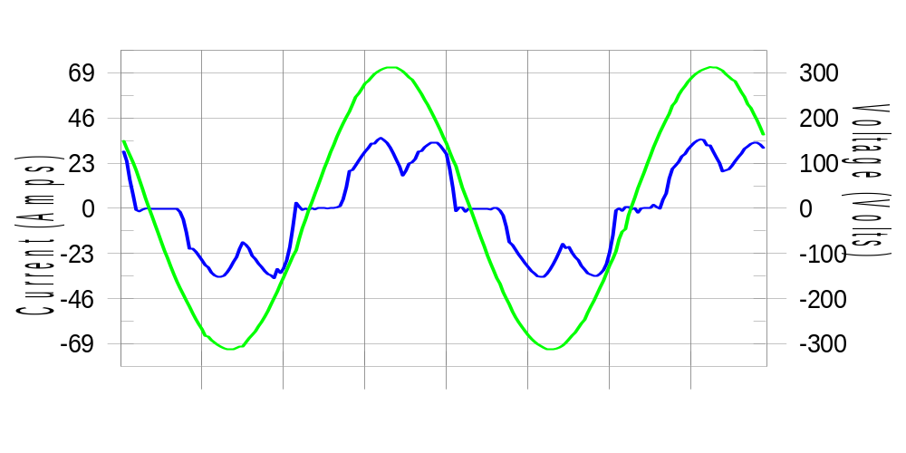

Harmonics and Class 3 limit line European Limits

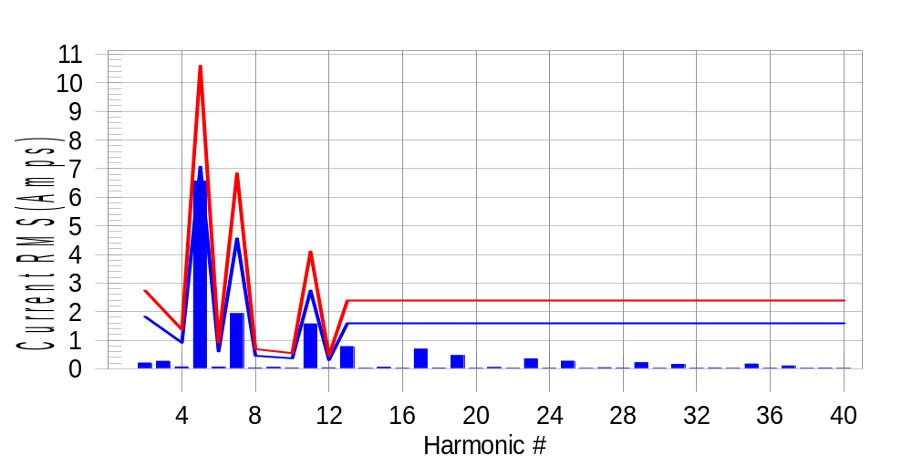

Test result: Pass Worst harmonic was #5 with 62.25 % of the limit.
Current Test Result Summary (Phase B-Run time)

EUT: Equipment under test Tested by: Tested by
Test category: Table:3, Rsce=250, Test Margin: 100
Test date: 2016/4/18 Start time: 16:25:15 End time: 16:28:08
Test duration (min): 2.5 Data file name: CTSMXH_H-000035.cts_data
Comment: Comment
Customer: Customer information

Test Result: Pass Measured I-ref: 22.944(Amps) Source: Distorted
I-THC(%): 31.4 Limit(%): 37.0 PWHC(%): 19.8 PWHC Limit(%): 38.0

Highest parameter values during test:
V_RMS (Volts): 220.18 Frequency(Hz): 50.00
I_Peak (Amps): 45.601 I_RMS (Amps): 22.944
I_Fund (Amps): 21.635 Crest Factor: 2.003
Power (Watts): 4713 Power Factor: 0.934

Harm# Harms(avg) 100%Limit %of Limit Harms(max) 150%Limit %of Limit Status

2 0.202 1.824 11.1 0.231 2.735 8.4 Pass
3 0.286 N/A N/A 0.311 N/A N/A N/A
4 0.066 0.912 7.3 0.081 1.368 5.9 Pass
5 6.565 7.066 92.9 6.594 10.600 62.2 Pass
6 0.062 0.608 10.3 0.071 0.912 7.8 Pass
7 1.929 4.559 42.3 1.939 6.838 28.3 Pass
8 0.030 0.456 6.6 0.038 0.684 5.6 Pass
9 0.093 N/A N/A 0.066 N/A N/A N/A
10 0.030 0.365 8.1 0.038 0.547 6.9 Pass
11 1.570 2.735 57.4 1.581 4.103 38.5 Pass
12 0.034 0.304 11.3 0.042 0.456 9.2 Pass
13 0.776 1.596 48.6 0.784 2.393 32.8 Pass
14 0.020 N/A N/A 0.028 N/A N/A N/A
15 0.055 N/A N/A 0.063 N/A N/A N/A
16 0.022 N/A N/A 0.033 N/A N/A N/A
17 0.688 N/A N/A 0.699 N/A N/A N/A
18 0.026 N/A N/A 0.035 N/A N/A N/A
19 0.460 N/A N/A 0.475 N/A N/A N/A
20 0.018 N/A N/A 0.026 N/A N/A N/A
21 0.045 N/A N/A 0.056 N/A N/A N/A
22 0.020 N/A N/A 0.026 N/A N/A N/A
23 0.349 N/A N/A 0.363 N/A N/A N/A
24 0.022 N/A N/A 0.031 N/A N/A N/A
25 0.267 N/A N/A 0.276 N/A N/A N/A
26 0.017 N/A N/A 0.023 N/A N/A N/A
27 0.036 N/A N/A 0.045 N/A N/A N/A
28 0.023 N/A N/A 0.034 N/A N/A N/A
29 0.212 N/A N/A 0.221 N/A N/A N/A
30 0.021 N/A N/A 0.029 N/A N/A N/A
31 0.152 N/A N/A 0.161 N/A N/A N/A
32 0.016 N/A N/A 0.023 N/A N/A N/A
33 0.030 N/A N/A 0.042 N/A N/A N/A
34 0.018 N/A N/A 0.025 N/A N/A N/A
35 0.167 N/A N/A 0.178 N/A N/A N/A
36 0.020 N/A N/A 0.035 N/A N/A N/A
37 0.101 N/A N/A 0.110 N/A N/A N/A
38 0.017 N/A N/A 0.023 N/A N/A N/A
39 0.027 N/A N/A 0.040 N/A N/A N/A
40 0.019 N/A N/A 0.041 N/A N/A N/A

Note: Measured I-ref was applied for this test.

Voltage Source Verification Data (Phase B-Run time)

EUT: Equipment under test Tested by: Tested by
Test category: Table:3, Rsce=250, Test Margin: 100
Test date: 2016/4/18 Start time: 16:25:15 End time: 16:28:08
Test duration (min): 2.5 Data file name: CTSMXH_H-000035.cts_data
Comment: Comment
Customer: Customer information

Test Result: Pass Source qualification: Distorted
Current harmonics are corrected for source distortion, and are within +/-5%
Measurements are compliant with IEC/EN61000-3-12 Ed.4 & IEC/EN61000-4-7

Highest parameter values during test:
Voltage (Vrms): 220.18 Frequency(Hz): 50.00
I_Peak (Amps): 45.601 I_RMS (Amps): 22.944
I_Fund (Amps): 21.635 Crest Factor: 2.003
Power (Watts): 4713 Power Factor: 0.934

Harm# Harmonics V-rms Limit V-rms % of Limit Status

2 0.162 0.880 18.39 OK
3 0.301 2.751 10.95 OK
4 0.163 0.880 18.47 OK
5 1.160 3.301 35.13 OK
6 0.109 0.880 12.39 OK
7 0.484 2.751 17.59 OK
8 0.116 0.881 13.17 OK
9 0.157 1.321 11.92 OK
10 0.100 0.881 11.35 OK
11 0.569 1.541 36.89 OK
12 0.098 0.660 14.86 OK
13 0.377 1.320 28.56 OK
14 0.113 0.660 17.11 OK
15 0.141 0.660 21.35 OK
16 0.099 0.660 15.03 OK
17 0.374 0.660 56.66 OK
18 0.102 0.660 15.45 OK
19 0.323 0.660 48.86 OK
20 0.143 0.660 21.59 OK
21 0.131 0.660 19.83 OK
22 0.113 0.660 17.12 OK
23 0.244 0.660 37.03 OK
24 0.105 0.660 15.92 OK
25 0.254 0.660 38.52 OK
26 0.109 0.660 16.50 OK
27 0.123 0.660 18.70 OK
28 0.120 0.660 18.10 OK
29 0.213 0.661 32.32 OK
30 0.099 0.660 15.01 OK
31 0.194 0.660 29.44 OK
32 0.100 0.660 15.14 OK
33 0.126 0.660 19.16 OK
34 0.121 0.660 18.30 OK
35 0.210 0.660 31.75 OK
36 0.111 0.660 16.83 OK
37 0.183 0.660 27.75 OK
38 0.102 0.660 15.42 OK
39 0.109 0.660 16.51 OK
40 0.137 0.660 20.72 OK

Harmonics – Per EN/IEC61000-3-12, Ed. 2.0(Phase C-Run time)

EUT: Equipment under test Tested by: Tested by
Test category: Table:3, Rsce=250, Test Margin: 100
Test date: 2016/4/18 Start time: 16:25:15 End time: 16:28:08
Test duration (min): 2.5 Data file name: CTSMXH_H-000035.cts_data
Comment: Comment
Customer: Customer information

Test Result: Pass Source qualification: Distorted

Current & voltage waveforms

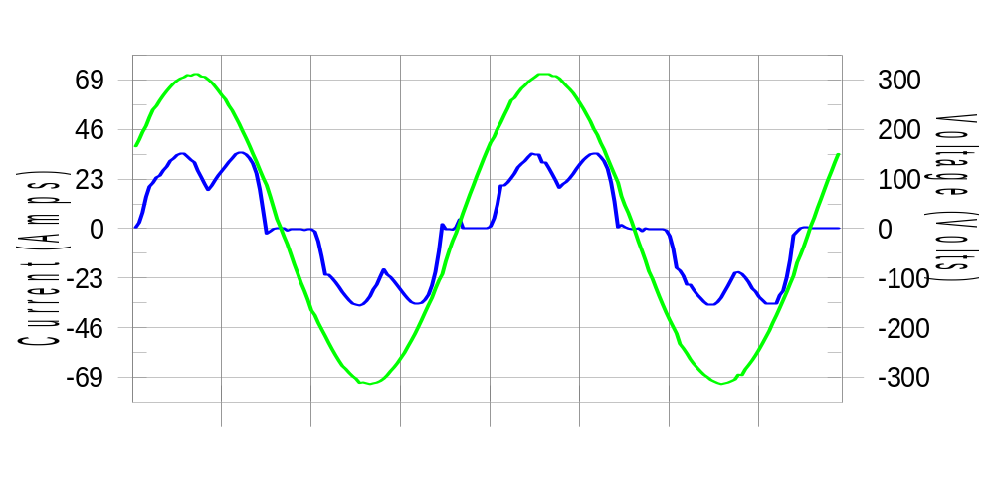

Harmonics and Class 3 limit line European Limits

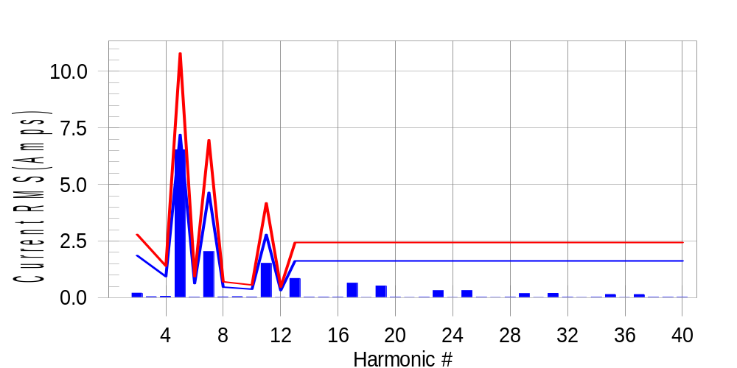

Test result: Pass Worst harmonic was #5 with 60.75 % of the limit.
Current Test Result Summary (Phase C-Run time)

EUT: Equipment under test Tested by: Tested by
Test category: Table:3, Rsce=250, Test Margin: 100
Test date: 2016/4/18 Start time: 16:25:15 End time: 16:28:08
Test duration (min): 2.5 Data file name: CTSMXH_H-000035.cts_data
Comment: Comment
Customer: Customer information

Test Result: Pass Measured I-ref: 23.393(Amps) Source: Distorted
I-THC(%): 30.7 Limit(%): 37.0 PWHC(%): 19.3 PWHC Limit(%): 38.0

Highest parameter values during test:
V_RMS (Volts): 220.11 Frequency(Hz): 50.00
I_Peak (Amps): 44.930 I_RMS (Amps): 23.393
I_Fund (Amps): 22.113 Crest Factor: 1.938
Power (Watts): 4811 Power Factor: 0.935

Harm# Harms(avg) 100%Limit %of Limit Harms(max) 150%Limit %of Limit Status

2 0.200 1.859 10.8 0.232 2.789 8.3 Pass
3 0.286 N/A N/A 0.071 N/A N/A N/A
4 0.061 0.930 6.6 0.077 1.395 5.5 Pass
5 6.534 7.205 90.7 6.562 10.808 60.7 Pass
6 0.016 0.620 2.7 0.028 0.930 3.0 Pass
7 2.031 4.649 43.7 2.043 6.973 29.3 Pass
8 0.030 0.465 6.5 0.039 0.697 5.5 Pass
9 0.093 N/A N/A 0.055 N/A N/A N/A
10 0.028 0.372 7.5 0.037 0.558 6.6 Pass
11 1.515 2.789 54.3 1.527 4.184 36.5 Pass
12 0.013 0.310 4.2 0.019 0.465 4.0 Pass
13 0.846 1.627 52.0 0.856 2.441 35.1 Pass
14 0.019 N/A N/A 0.026 N/A N/A N/A
15 0.019 N/A N/A 0.026 N/A N/A N/A
16 0.019 N/A N/A 0.027 N/A N/A N/A
17 0.639 N/A N/A 0.653 N/A N/A N/A
18 0.013 N/A N/A 0.019 N/A N/A N/A
19 0.514 N/A N/A 0.522 N/A N/A N/A
20 0.016 N/A N/A 0.024 N/A N/A N/A
21 0.013 N/A N/A 0.020 N/A N/A N/A
22 0.015 N/A N/A 0.022 N/A N/A N/A
23 0.308 N/A N/A 0.316 N/A N/A N/A
24 0.012 N/A N/A 0.019 N/A N/A N/A
25 0.311 N/A N/A 0.321 N/A N/A N/A
26 0.016 N/A N/A 0.023 N/A N/A N/A
27 0.013 N/A N/A 0.018 N/A N/A N/A
28 0.019 N/A N/A 0.031 N/A N/A N/A
29 0.178 N/A N/A 0.188 N/A N/A N/A
30 0.013 N/A N/A 0.020 N/A N/A N/A
31 0.190 N/A N/A 0.202 N/A N/A N/A
32 0.014 N/A N/A 0.022 N/A N/A N/A
33 0.013 N/A N/A 0.020 N/A N/A N/A
34 0.015 N/A N/A 0.021 N/A N/A N/A
35 0.139 N/A N/A 0.155 N/A N/A N/A
36 0.013 N/A N/A 0.019 N/A N/A N/A
37 0.136 N/A N/A 0.144 N/A N/A N/A
38 0.014 N/A N/A 0.020 N/A N/A N/A
39 0.014 N/A N/A 0.019 N/A N/A N/A
40 0.015 N/A N/A 0.022 N/A N/A N/A

Note: Measured I-ref was applied for this test.

Voltage Source Verification Data (Phase C-Run time)

EUT: Equipment under test Tested by: Tested by
Test category: Table:3, Rsce=250, Test Margin: 100
Test date: 2016/4/18 Start time: 16:25:15 End time: 16:28:08
Test duration (min): 2.5 Data file name: CTSMXH_H-000035.cts_data
Comment: Comment
Customer: Customer information

Test Result: Pass Source qualification: Distorted
Current harmonics are corrected for source distortion, and are within +/-5%
Measurements are compliant with IEC/EN61000-3-12 Ed.4 & IEC/EN61000-4-7

Highest parameter values during test:
Voltage (Vrms): 220.11 Frequency(Hz): 50.00
I_Peak (Amps): 44.930 I_RMS (Amps): 23.393
I_Fund (Amps): 22.113 Crest Factor: 1.938
Power (Watts): 4811 Power Factor: 0.935

Harm# Harmonics V-rms Limit V-rms % of Limit Status

2 0.160 0.880 18.17 OK
3 0.309 2.751 11.22 OK
4 0.157 0.880 17.80 OK
5 1.086 3.300 32.90 OK
6 0.097 0.880 10.98 OK
7 0.495 2.750 18.01 OK
8 0.098 0.880 11.15 OK
9 0.153 1.320 11.56 OK
10 0.089 0.880 10.16 OK
11 0.532 1.540 34.57 OK
12 0.085 0.660 12.85 OK
13 0.409 1.320 30.98 OK
14 0.096 0.660 14.58 OK
15 0.130 0.660 19.64 OK
16 0.092 0.660 14.00 OK
17 0.316 0.660 47.90 OK
18 0.086 0.660 13.08 OK
19 0.321 0.660 48.71 OK
20 0.143 0.660 21.59 OK
21 0.137 0.660 20.71 OK
22 0.088 0.660 13.36 OK
23 0.213 0.660 32.34 OK
24 0.083 0.660 12.64 OK
25 0.242 0.660 36.64 OK
26 0.083 0.660 12.64 OK
27 0.122 0.660 18.45 OK
28 0.111 0.660 16.76 OK
29 0.178 0.660 27.00 OK
30 0.087 0.660 13.16 OK
31 0.194 0.660 29.39 OK
32 0.084 0.660 12.76 OK
33 0.122 0.660 18.53 OK
34 0.112 0.660 16.99 OK
35 0.179 0.660 27.17 OK
36 0.094 0.660 14.29 OK
37 0.180 0.660 27.34 OK
38 0.102 0.660 15.43 OK
39 0.113 0.660 17.11 OK
40 0.120 0.660 18.21 OK

5th Harmonic Phase Angle and Magnitude for Phase A :
H-5_min_phase : 109.6 Degree (Leading)
H-5_max_phase : 110.3 Degree (Leading)
H-5_ave_phase : 109.9 Degree (Leading)

H-5_ave_vector_magnitude : 6.530 Amp
H-5_standard_ave_magnitude : 6.432 Amp
H-5_standard_max_magnitude : 6.562 Amp
Ratio of H-5_ave_vector / H-5_standard_ave : 0.999

Phase A = 90.602% of tested Rsce = 250.000, Rsce = 226.504
Phase B = 92.911% of tested Rsce = 250.000, Rsce = 232.278
Phase C = 90.690% of tested Rsce = 250.000, Rsce = 226.726
Minimum Rsce required: Rsce = 232.278

