Harmonics – Per EN/IEC61000-3-12, Ed. 2.0(Phase A-Run time)

EUT: Equipment under test Tested by: Tested by
Test category: Table:3, Rsce=250, Test Margin: 100
Test date: 2016/4/13 Start time: 13:43:30 End time: 13:46:22
Test duration (min): 2.5 Data file name: CTSMXH_H-000010.cts_data
Comment: Comment
Customer: Customer information

Test Result: Fail Source qualification: Distorted

Current & voltage waveforms

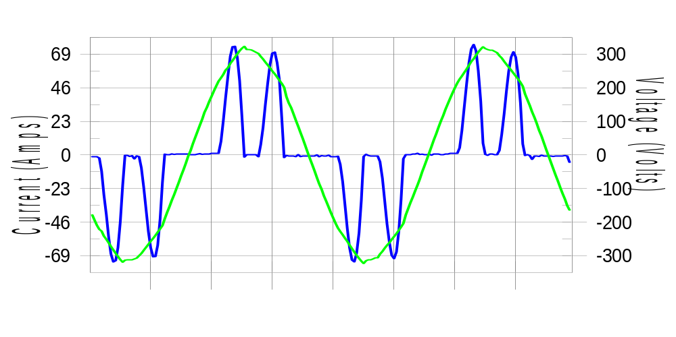

Harmonics and Class 3 limit line European Limits

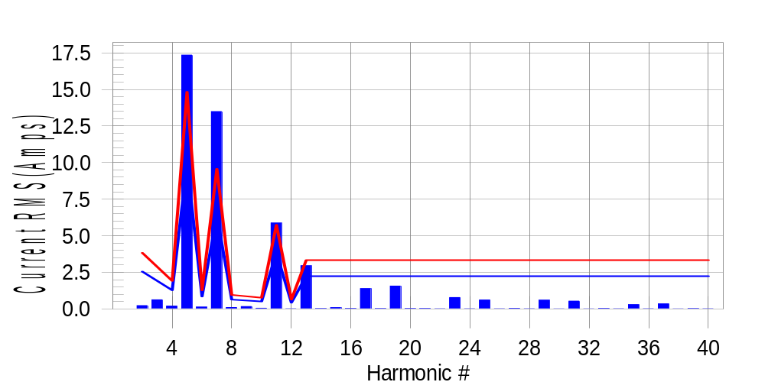

Test result: Fail Worst harmonic was #7 with 141.69 % of the limit.
Current Test Result Summary (Phase A-Run time)

EUT: Equipment under test Tested by: Tested by
Test category: Table:3, Rsce=250, Test Margin: 100
Test date: 2016/4/13 Start time: 13:43:30 End time: 13:46:22
Test duration (min): 2.5 Data file name: CTSMXH_H-000010.cts_data
Comment: Comment
Customer: Customer information

Test Result: Fail Measured I-ref: 32.087(Amps) Source: Distorted
I-THC(%): 72.4 Limit(%): 37.0 PWHC(%): 35.7 PWHC Limit(%): 38.0

Highest parameter values during test:
V_RMS (Volts): 220.43 Frequency(Hz): 50.00
I_Peak (Amps): 84.023 I_RMS (Amps): 32.087
I_Fund (Amps): 22.024 Crest Factor: 2.630
Power (Watts): 4882 Power Factor: 0.691

Harm# Harms(avg) 100%Limit %of Limit Harms(max) 150%Limit %of Limit Status

2 0.228 2.552 8.9 0.260 3.828 6.8 Pass
3 0.622 N/A N/A 0.693 N/A N/A N/A
4 0.196 1.276 15.4 0.218 1.914 11.4 Pass
5 17.346 9.890 175.4 17.410 14.835 117.4 Fail
6 0.129 0.851 15.2 0.139 1.276 10.9 Pass
7 13.487 6.380 211.4 13.543 9.571 141.5 Fail
8 0.095 0.638 14.9 0.111 0.957 11.6 Pass
9 0.165 N/A N/A 0.183 N/A N/A N/A
10 0.047 0.510 9.2 0.063 0.766 8.2 Pass
11 5.871 3.828 153.4 5.890 5.742 102.6 Fail
12 0.018 0.425 4.2 0.027 0.638 4.2 Pass
13 2.953 2.233 132.2 2.965 3.350 88.5 Fail
14 0.023 N/A N/A 0.037 N/A N/A N/A
15 0.090 N/A N/A 0.105 N/A N/A N/A
16 0.028 N/A N/A 0.039 N/A N/A N/A
17 1.390 N/A N/A 1.403 N/A N/A N/A
18 0.022 N/A N/A 0.033 N/A N/A N/A
19 1.562 N/A N/A 1.582 N/A N/A N/A
20 0.030 N/A N/A 0.046 N/A N/A N/A
21 0.028 N/A N/A 0.044 N/A N/A N/A
22 0.018 N/A N/A 0.028 N/A N/A N/A
23 0.783 N/A N/A 0.792 N/A N/A N/A
24 0.018 N/A N/A 0.029 N/A N/A N/A
25 0.606 N/A N/A 0.622 N/A N/A N/A
26 0.020 N/A N/A 0.029 N/A N/A N/A
27 0.041 N/A N/A 0.051 N/A N/A N/A
28 0.019 N/A N/A 0.030 N/A N/A N/A
29 0.600 N/A N/A 0.608 N/A N/A N/A
30 0.014 N/A N/A 0.027 N/A N/A N/A
31 0.535 N/A N/A 0.544 N/A N/A N/A
32 0.015 N/A N/A 0.022 N/A N/A N/A
33 0.032 N/A N/A 0.043 N/A N/A N/A
34 0.016 N/A N/A 0.022 N/A N/A N/A
35 0.296 N/A N/A 0.306 N/A N/A N/A
36 0.016 N/A N/A 0.032 N/A N/A N/A
37 0.348 N/A N/A 0.359 N/A N/A N/A
38 0.015 N/A N/A 0.024 N/A N/A N/A
39 0.022 N/A N/A 0.030 N/A N/A N/A
40 0.018 N/A N/A 0.025 N/A N/A N/A

Note: Measured I-ref was applied for this test.

Voltage Source Verification Data (Phase A-Run time)

EUT: Equipment under test Tested by: Tested by
Test category: Table:3, Rsce=250, Test Margin: 100
Test date: 2016/4/13 Start time: 13:43:30 End time: 13:46:22
Test duration (min): 2.5 Data file name: CTSMXH_H-000010.cts_data
Comment: Comment
Customer: Customer information

Test Result: Fail Source qualification: Distorted
Current harmonics are corrected for source distortion, and are within +/-5%
Measurements are compliant with IEC/EN61000-3-12 Ed.4 & IEC/EN61000-4-7

Highest parameter values during test:
Voltage (Vrms): 220.43 Frequency(Hz): 50.00
I_Peak (Amps): 84.023 I_RMS (Amps): 32.087
I_Fund (Amps): 22.024 Crest Factor: 2.630
Power (Watts): 4882 Power Factor: 0.691

Harm# Harmonics V-rms Limit V-rms % of Limit Status

2 0.144 0.881 16.39 OK
3 0.220 2.754 7.99 OK
4 0.095 0.881 10.80 OK
5 2.574 3.306 77.86 OK
6 0.105 0.881 11.95 OK
7 2.664 2.755 96.69 OK
8 0.100 0.881 11.37 OK
9 0.130 1.322 9.80 OK
10 0.084 0.881 9.48 OK
11 1.656 1.542 107.39 Marg.
12 0.099 0.661 14.94 OK
13 0.930 1.322 70.36 OK
14 0.081 0.661 12.33 OK
15 0.088 0.661 13.31 OK
16 0.097 0.661 14.60 OK
17 0.668 0.661 100.99 Marg.
18 0.083 0.661 12.52 OK
19 0.760 0.661 114.96 Dist.
20 0.163 0.661 24.67 OK
21 0.083 0.661 12.49 OK
22 0.082 0.661 12.47 OK
23 0.418 0.661 63.23 OK
24 0.080 0.661 12.12 OK
25 0.370 0.661 56.01 OK
26 0.073 0.661 11.07 OK
27 0.083 0.661 12.48 OK
28 0.099 0.661 14.99 OK
29 0.429 0.661 64.95 OK
30 0.091 0.661 13.70 OK
31 0.380 0.661 57.51 OK
32 0.080 0.661 12.08 OK
33 0.082 0.661 12.47 OK
34 0.077 0.661 11.69 OK
35 0.273 0.661 41.23 OK
36 0.082 0.661 12.44 OK
37 0.298 0.661 45.07 OK
38 0.077 0.661 11.72 OK
39 0.082 0.661 12.44 OK
40 0.131 0.661 19.75 OK

Harmonics – Per EN/IEC61000-3-12, Ed. 2.0(Phase B-Run time)

EUT: Equipment under test Tested by: Tested by
Test category: Table:3, Rsce=250, Test Margin: 100
Test date: 2016/4/13 Start time: 13:43:30 End time: 13:46:22
Test duration (min): 2.5 Data file name: CTSMXH_H-000010.cts_data
Comment: Comment
Customer: Customer information

Test Result: Fail Source qualification: Distorted

Current & voltage waveforms

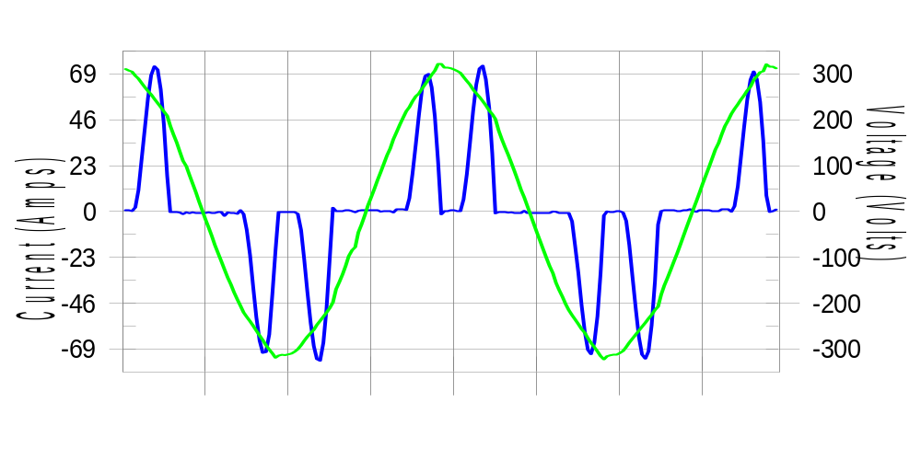

Harmonics and Class 3 limit line European Limits

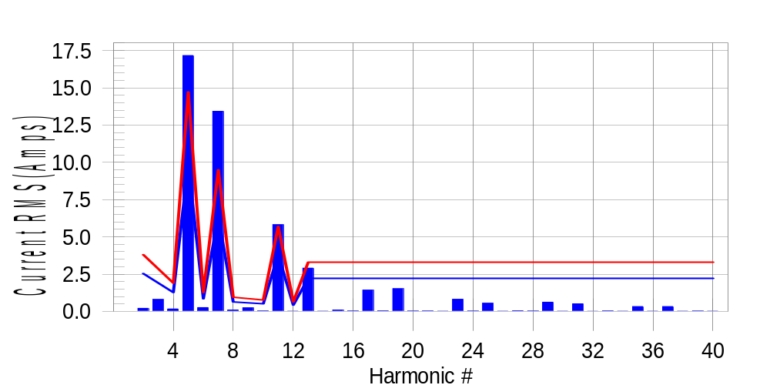

Test result: Fail Worst harmonic was #7 with 141.98 % of the limit.
Current Test Result Summary (Phase B-Run time)

EUT: Equipment under test Tested by: Tested by
Test category: Table:3, Rsce=250, Test Margin: 100
Test date: 2016/4/13 Start time: 13:43:30 End time: 13:46:22
Test duration (min): 2.5 Data file name: CTSMXH_H-000010.cts_data
Comment: Comment
Customer: Customer information

Test Result: Fail Measured I-ref: 31.829(Amps) Source: Distorted
I-THC(%): 72.4 Limit(%): 37.0 PWHC(%): 35.9 PWHC Limit(%): 38.0

Highest parameter values during test:
V_RMS (Volts): 220.25 Frequency(Hz): 50.00
I_Peak (Amps): 86.615 I_RMS (Amps): 31.829
I_Fund (Amps): 21.860 Crest Factor: 2.740
Power (Watts): 4819 Power Factor: 0.688

Harm# Harms(avg) 100%Limit %of Limit Harms(max) 150%Limit %of Limit Status

2 0.206 2.533 8.1 0.239 3.800 6.3 Pass
3 0.622 N/A N/A 0.848 N/A N/A N/A
4 0.161 1.267 12.7 0.185 1.900 9.7 Pass
5 17.172 9.816 174.9 17.232 14.723 117.0 Fail
6 0.257 0.844 30.5 0.268 1.267 21.2 Pass
7 13.430 6.333 212.1 13.474 9.499 141.9 Fail
8 0.090 0.633 14.3 0.107 0.950 11.3 Pass
9 0.165 N/A N/A 0.256 N/A N/A N/A
10 0.032 0.507 6.4 0.044 0.760 5.8 Pass
11 5.822 3.800 153.2 5.838 5.699 102.4 Fail
12 0.018 0.422 4.2 0.027 0.633 4.2 Pass
13 2.900 2.216 130.8 2.913 3.325 87.6 Fail
14 0.020 N/A N/A 0.032 N/A N/A N/A
15 0.093 N/A N/A 0.110 N/A N/A N/A
16 0.026 N/A N/A 0.040 N/A N/A N/A
17 1.429 N/A N/A 1.443 N/A N/A N/A
18 0.038 N/A N/A 0.055 N/A N/A N/A
19 1.524 N/A N/A 1.541 N/A N/A N/A
20 0.021 N/A N/A 0.031 N/A N/A N/A
21 0.030 N/A N/A 0.047 N/A N/A N/A
22 0.019 N/A N/A 0.029 N/A N/A N/A
23 0.816 N/A N/A 0.827 N/A N/A N/A
24 0.024 N/A N/A 0.038 N/A N/A N/A
25 0.552 N/A N/A 0.570 N/A N/A N/A
26 0.019 N/A N/A 0.028 N/A N/A N/A
27 0.046 N/A N/A 0.062 N/A N/A N/A
28 0.022 N/A N/A 0.035 N/A N/A N/A
29 0.615 N/A N/A 0.626 N/A N/A N/A
30 0.017 N/A N/A 0.026 N/A N/A N/A
31 0.511 N/A N/A 0.522 N/A N/A N/A
32 0.015 N/A N/A 0.025 N/A N/A N/A
33 0.035 N/A N/A 0.043 N/A N/A N/A
34 0.017 N/A N/A 0.024 N/A N/A N/A
35 0.325 N/A N/A 0.335 N/A N/A N/A
36 0.019 N/A N/A 0.026 N/A N/A N/A
37 0.321 N/A N/A 0.330 N/A N/A N/A
38 0.017 N/A N/A 0.025 N/A N/A N/A
39 0.024 N/A N/A 0.035 N/A N/A N/A
40 0.016 N/A N/A 0.023 N/A N/A N/A

Note: Measured I-ref was applied for this test.

Voltage Source Verification Data (Phase B-Run time)

EUT: Equipment under test Tested by: Tested by
Test category: Table:3, Rsce=250, Test Margin: 100
Test date: 2016/4/13 Start time: 13:43:30 End time: 13:46:22
Test duration (min): 2.5 Data file name: CTSMXH_H-000010.cts_data
Comment: Comment
Customer: Customer information

Test Result: Fail Source qualification: Distorted
Current harmonics are corrected for source distortion, and are within +/-5%
Measurements are compliant with IEC/EN61000-3-12 Ed.4 & IEC/EN61000-4-7

Highest parameter values during test:
Voltage (Vrms): 220.25 Frequency(Hz): 50.00
I_Peak (Amps): 86.615 I_RMS (Amps): 31.829
I_Fund (Amps): 21.860 Crest Factor: 2.740
Power (Watts): 4819 Power Factor: 0.688

Harm# Harmonics V-rms Limit V-rms % of Limit Status

2 0.169 0.881 19.24 OK
3 0.330 2.752 11.97 OK
4 0.134 0.881 15.25 OK
5 2.682 3.302 81.21 OK
6 0.124 0.881 14.05 OK
7 2.807 2.752 101.99 Marg.
8 0.122 0.881 13.84 OK
9 0.164 1.321 12.45 OK
10 0.113 0.881 12.87 OK
11 1.749 1.541 113.46 Dist.
12 0.120 0.661 18.16 OK
13 0.973 1.321 73.63 OK
14 0.099 0.660 15.01 OK
15 0.143 0.661 21.59 OK
16 0.105 0.660 15.90 OK
17 0.723 0.661 109.45 Marg.
18 0.118 0.660 17.94 OK
19 0.788 0.660 119.32 Dist.
20 0.145 0.661 21.96 OK
21 0.095 0.661 14.36 OK
22 0.115 0.661 17.37 OK
23 0.454 0.661 68.73 OK
24 0.100 0.661 15.11 OK
25 0.361 0.661 54.61 OK
26 0.112 0.661 16.92 OK
27 0.134 0.661 20.34 OK
28 0.127 0.661 19.18 OK
29 0.455 0.660 68.84 OK
30 0.116 0.660 17.54 OK
31 0.388 0.661 58.80 OK
32 0.090 0.660 13.56 OK
33 0.135 0.661 20.49 OK
34 0.096 0.660 14.59 OK
35 0.306 0.661 46.32 OK
36 0.091 0.661 13.76 OK
37 0.295 0.661 44.67 OK
38 0.102 0.660 15.46 OK
39 0.121 0.661 18.31 OK
40 0.122 0.660 18.46 OK

Harmonics – Per EN/IEC61000-3-12, Ed. 2.0(Phase C-Run time)

EUT: Equipment under test Tested by: Tested by
Test category: Table:3, Rsce=250, Test Margin: 100
Test date: 2016/4/13 Start time: 13:43:30 End time: 13:46:22
Test duration (min): 2.5 Data file name: CTSMXH_H-000010.cts_data
Comment: Comment
Customer: Customer information

Test Result: Fail Source qualification: Distorted

Current & voltage waveforms

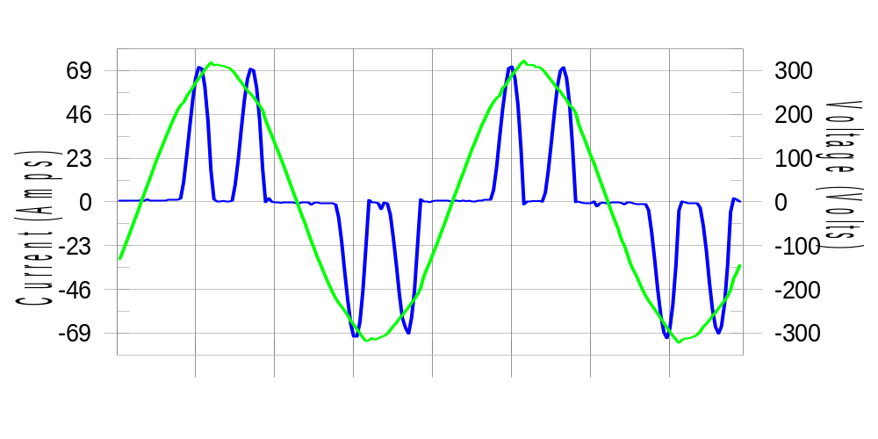

Harmonics and Class 3 limit line European Limits

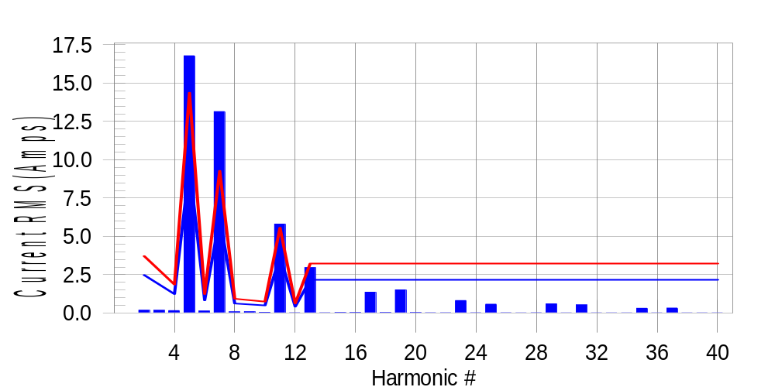

Test result: Fail Worst harmonic was #7 with 142.35 % of the limit.
Current Test Result Summary (Phase C-Run time)

EUT: Equipment under test Tested by: Tested by
Test category: Table:3, Rsce=250, Test Margin: 100
Test date: 2016/4/13 Start time: 13:43:30 End time: 13:46:22
Test duration (min): 2.5 Data file name: CTSMXH_H-000010.cts_data
Comment: Comment
Customer: Customer information

Test Result: Fail Measured I-ref: 31.086(Amps) Source: Distorted
I-THC(%): 72.5 Limit(%): 37.0 PWHC(%): 36.0 PWHC Limit(%): 38.0

Highest parameter values during test:
V_RMS (Volts): 220.15 Frequency(Hz): 50.00
I_Peak (Amps): 80.216 I_RMS (Amps): 31.086
I_Fund (Amps): 21.280 Crest Factor: 2.602
Power (Watts): 4705 Power Factor: 0.688

Harm# Harms(avg) 100%Limit %of Limit Harms(max) 150%Limit %of Limit Status

2 0.178 2.473 7.2 0.212 3.710 5.7 Pass
3 0.622 N/A N/A 0.231 N/A N/A N/A
4 0.155 1.237 12.5 0.180 1.855 9.7 Pass
5 16.786 9.584 175.1 16.845 14.376 117.2 Fail
6 0.129 0.824 15.6 0.138 1.237 11.1 Pass
7 13.144 6.183 212.6 13.187 9.275 142.2 Fail
8 0.075 0.618 12.2 0.094 0.927 10.1 Pass
9 0.165 N/A N/A 0.093 N/A N/A N/A
10 0.039 0.495 7.8 0.055 0.742 7.4 Pass
11 5.801 3.710 156.4 5.816 5.565 104.5 Fail
12 0.016 0.412 3.8 0.024 0.618 3.9 Pass
13 2.962 2.164 136.9 2.975 3.246 91.6 Fail
14 0.018 N/A N/A 0.027 N/A N/A N/A
15 0.023 N/A N/A 0.033 N/A N/A N/A
16 0.023 N/A N/A 0.036 N/A N/A N/A
17 1.354 N/A N/A 1.367 N/A N/A N/A
18 0.023 N/A N/A 0.033 N/A N/A N/A
19 1.510 N/A N/A 1.527 N/A N/A N/A
20 0.022 N/A N/A 0.031 N/A N/A N/A
21 0.017 N/A N/A 0.027 N/A N/A N/A
22 0.018 N/A N/A 0.026 N/A N/A N/A
23 0.809 N/A N/A 0.818 N/A N/A N/A
24 0.017 N/A N/A 0.025 N/A N/A N/A
25 0.575 N/A N/A 0.586 N/A N/A N/A
26 0.016 N/A N/A 0.031 N/A N/A N/A
27 0.015 N/A N/A 0.022 N/A N/A N/A
28 0.018 N/A N/A 0.029 N/A N/A N/A
29 0.593 N/A N/A 0.601 N/A N/A N/A
30 0.013 N/A N/A 0.019 N/A N/A N/A
31 0.526 N/A N/A 0.532 N/A N/A N/A
32 0.013 N/A N/A 0.019 N/A N/A N/A
33 0.014 N/A N/A 0.021 N/A N/A N/A
34 0.014 N/A N/A 0.030 N/A N/A N/A
35 0.304 N/A N/A 0.311 N/A N/A N/A
36 0.015 N/A N/A 0.021 N/A N/A N/A
37 0.323 N/A N/A 0.333 N/A N/A N/A
38 0.014 N/A N/A 0.018 N/A N/A N/A
39 0.013 N/A N/A 0.019 N/A N/A N/A
40 0.014 N/A N/A 0.021 N/A N/A N/A

Note: Measured I-ref was applied for this test.

Voltage Source Verification Data (Phase C-Run time)

EUT: Equipment under test Tested by: Tested by
Test category: Table:3, Rsce=250, Test Margin: 100
Test date: 2016/4/13 Start time: 13:43:30 End time: 13:46:22
Test duration (min): 2.5 Data file name: CTSMXH_H-000010.cts_data
Comment: Comment
Customer: Customer information

Test Result: Fail Source qualification: Distorted
Current harmonics are corrected for source distortion, and are within +/-5%
Measurements are compliant with IEC/EN61000-3-12 Ed.4 & IEC/EN61000-4-7

Highest parameter values during test:
Voltage (Vrms): 220.15 Frequency(Hz): 50.00
I_Peak (Amps): 80.216 I_RMS (Amps): 31.086
I_Fund (Amps): 21.280 Crest Factor: 2.602
Power (Watts): 4705 Power Factor: 0.688

Harm# Harmonics V-rms Limit V-rms % of Limit Status

2 0.138 0.880 15.71 OK
3 0.231 2.751 8.41 OK
4 0.116 0.880 13.18 OK
5 2.522 3.301 76.41 OK
6 0.109 0.880 12.41 OK
7 2.622 2.750 95.31 OK
8 0.096 0.880 10.96 OK
9 0.155 1.320 11.72 OK
10 0.098 0.880 11.15 OK
11 1.659 1.540 107.73 Marg.
12 0.090 0.660 13.56 OK
13 0.932 1.320 70.57 OK
14 0.085 0.660 12.92 OK
15 0.102 0.660 15.38 OK
16 0.081 0.660 12.23 OK
17 0.667 0.660 101.00 Marg.
18 0.084 0.660 12.78 OK
19 0.753 0.660 114.04 Dist.
20 0.116 0.660 17.62 OK
21 0.085 0.660 12.85 OK
22 0.088 0.660 13.33 OK
23 0.433 0.660 65.52 OK
24 0.082 0.660 12.48 OK
25 0.353 0.660 53.52 OK
26 0.087 0.660 13.14 OK
27 0.084 0.660 12.76 OK
28 0.094 0.660 14.19 OK
29 0.439 0.660 66.46 OK
30 0.080 0.660 12.08 OK
31 0.350 0.660 53.05 OK
32 0.099 0.660 14.97 OK
33 0.095 0.660 14.38 OK
34 0.082 0.660 12.42 OK
35 0.271 0.660 41.00 OK
36 0.085 0.660 12.85 OK
37 0.276 0.660 41.75 OK
38 0.083 0.660 12.55 OK
39 0.103 0.660 15.63 OK
40 0.096 0.660 14.54 OK

5th Harmonic Phase Angle and Magnitude for Phase A :
H-5_min_phase : 149.2 Degree (Leading)
H-5_max_phase : 149.8 Degree (Leading)
H-5_ave_phase : 149.5 Degree (Leading)

H-5_ave_vector_magnitude : 16.766 Amp
H-5_standard_ave_magnitude : 17.346 Amp
H-5_standard_max_magnitude : 16.845 Amp
Ratio of H-5_ave_vector / H-5_standard_ave : 0.999

Phase A = 211.396% of tested Rsce = 250.000, Rsce = 528.490
Phase B = 212.078% of tested Rsce = 250.000, Rsce = 530.196
Phase C = 212.567% of tested Rsce = 250.000, Rsce = 531.417
Minimum Rsce required: Rsce = 531.417

