Harmonics – Per EN/IEC61000-3-12, Ed. 2.0(Phase A-Run time)

EUT: Equipment under test Tested by: Tested by
Test category: Table:3, Rsce=250, Test Margin: 100
Test date: 2016/4/13 Start time: 15:02:15 End time: 15:05:08
Test duration (min): 2.5 Data file name: CTSMXH_H-000011.cts_data
Comment: Comment
Customer: Customer information

Test Result: Fail Source qualification: Normal

Current & voltage waveforms

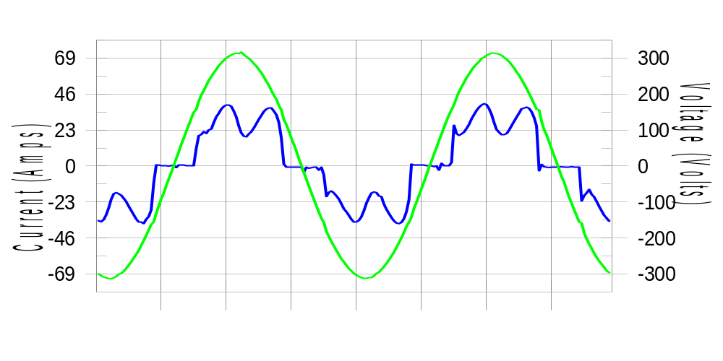

Harmonics and Class 3 limit line European Limits

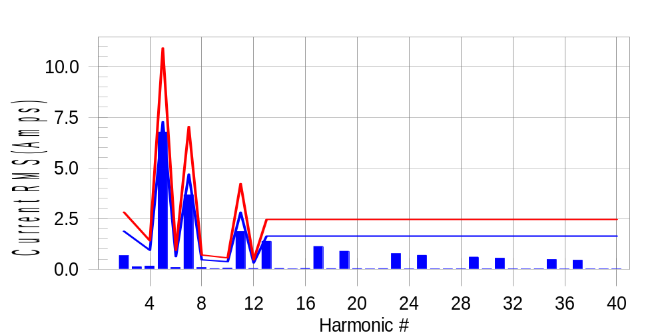

Test result: Fail Worst harmonic was #5 with 62.30 % of the limit.
Current Test Result Summary (Phase A-Run time)

EUT: Equipment under test Tested by: Tested by
Test category: Table:3, Rsce=250, Test Margin: 100
Test date: 2016/4/13 Start time: 15:02:15 End time: 15:05:08
Test duration (min): 2.5 Data file name: CTSMXH_H-000011.cts_data
Comment: Comment
Customer: Customer information

Test Result: Fail Measured I-ref: 23.614(Amps) Source: Normal
I-THC(%): 35.5 Limit(%): 37.0 PWHC(%): 42.2 PWHC Limit(%): 38.0

Highest parameter values during test:
V_RMS (Volts): 220.44 Frequency(Hz): 50.00
I_Peak (Amps): 50.480 I_RMS (Amps): 23.614
I_Fund (Amps): 21.893 Crest Factor: 2.140
Power (Watts): 4852 Power Factor: 0.933

Harm# Harms(avg) 100%Limit %of Limit Harms(max) 150%Limit %of Limit Status

2 0.675 1.877 35.9 0.717 2.816 25.5 Pass
3 0.123 N/A N/A 0.157 N/A N/A N/A
4 0.156 0.939 16.7 0.182 1.408 12.9 Pass
5 6.765 7.274 93.0 6.790 10.912 62.2 Pass
6 0.088 0.626 14.0 0.100 0.939 10.6 Pass
7 3.666 4.693 78.1 3.681 7.040 52.3 Pass
8 0.084 0.469 17.9 0.096 0.704 13.7 Pass
9 0.036 N/A N/A 0.052 N/A N/A N/A
10 0.063 0.375 16.7 0.076 0.563 13.5 Pass
11 1.863 2.816 66.2 1.880 4.224 44.5 Pass
12 0.042 0.313 13.3 0.066 0.469 14.1 Pass
13 1.381 1.643 84.1 1.394 2.464 56.6 Pass
14 0.045 N/A N/A 0.052 N/A N/A N/A
15 0.023 N/A N/A 0.031 N/A N/A N/A
16 0.044 N/A N/A 0.055 N/A N/A N/A
17 1.128 N/A N/A 1.140 N/A N/A N/A
18 0.035 N/A N/A 0.044 N/A N/A N/A
19 0.893 N/A N/A 0.905 N/A N/A N/A
20 0.033 N/A N/A 0.042 N/A N/A N/A
21 0.020 N/A N/A 0.029 N/A N/A N/A
22 0.034 N/A N/A 0.046 N/A N/A N/A
23 0.774 N/A N/A 0.784 N/A N/A N/A
24 0.023 N/A N/A 0.032 N/A N/A N/A
25 0.690 N/A N/A 0.702 N/A N/A N/A
26 0.024 N/A N/A 0.039 N/A N/A N/A
27 0.023 N/A N/A 0.048 N/A N/A N/A
28 0.028 N/A N/A 0.038 N/A N/A N/A
29 0.604 N/A N/A 0.620 N/A N/A N/A
30 0.023 N/A N/A 0.031 N/A N/A N/A
31 0.547 N/A N/A 0.559 N/A N/A N/A
32 0.023 N/A N/A 0.032 N/A N/A N/A
33 0.017 N/A N/A 0.022 N/A N/A N/A
34 0.026 N/A N/A 0.053 N/A N/A N/A
35 0.480 N/A N/A 0.488 N/A N/A N/A
36 0.019 N/A N/A 0.040 N/A N/A N/A
37 0.448 N/A N/A 0.458 N/A N/A N/A
38 0.020 N/A N/A 0.034 N/A N/A N/A
39 0.021 N/A N/A 0.027 N/A N/A N/A
40 0.022 N/A N/A 0.031 N/A N/A N/A

Note: Measured I-ref was applied for this test.

Voltage Source Verification Data (Phase A-Run time)

EUT: Equipment under test Tested by: Tested by
Test category: Table:3, Rsce=250, Test Margin: 100
Test date: 2016/4/13 Start time: 15:02:15 End time: 15:05:08
Test duration (min): 2.5 Data file name: CTSMXH_H-000011.cts_data
Comment: Comment
Customer: Customer information

Test Result: Fail Source qualification: Normal
Measured source distortion is within the requirements of the standards
Measurements are compliant with IEC/EN61000-3-12 Ed.4 & IEC/EN61000-4-7 Ed. 2.1

Highest parameter values during test:
Voltage (Vrms): 220.44 Frequency(Hz): 50.00
I_Peak (Amps): 50.480 I_RMS (Amps): 23.614
I_Fund (Amps): 21.893 Crest Factor: 2.140
Power (Watts): 4852 Power Factor: 0.933

Harm# Harmonics V-rms Limit V-rms % of Limit Status

2 0.173 0.881 19.66 OK
3 0.299 2.755 10.85 OK
4 0.111 0.881 12.59 OK
5 1.096 3.305 33.15 OK
6 0.092 0.881 10.41 OK
7 0.808 2.754 29.33 OK
8 0.110 0.881 12.49 OK
9 0.143 1.322 10.83 OK
10 0.094 0.881 10.70 OK
11 0.624 1.543 40.47 OK
12 0.093 0.661 14.14 OK
13 0.571 1.322 43.22 OK
14 0.083 0.661 12.58 OK
15 0.128 0.661 19.38 OK
16 0.090 0.661 13.57 OK
17 0.543 0.661 82.07 OK
18 0.086 0.661 12.96 OK
19 0.502 0.661 75.87 OK
20 0.174 0.661 26.35 OK
21 0.130 0.661 19.68 OK
22 0.093 0.661 14.04 OK
23 0.462 0.661 69.85 OK
24 0.088 0.661 13.38 OK
25 0.479 0.661 72.52 OK
26 0.084 0.661 12.76 OK
27 0.124 0.661 18.82 OK
28 0.110 0.661 16.60 OK
29 0.408 0.661 61.66 OK
30 0.081 0.661 12.31 OK
31 0.434 0.661 65.71 OK
32 0.082 0.661 12.39 OK
33 0.123 0.661 18.55 OK
34 0.103 0.661 15.56 OK
35 0.372 0.661 56.29 OK
36 0.084 0.661 12.66 OK
37 0.411 0.661 62.23 OK
38 0.101 0.661 15.22 OK
39 0.134 0.661 20.30 OK
40 0.159 0.661 24.05 OK

Harmonics – Per EN/IEC61000-3-12, Ed. 2.0(Phase B-Run time)

EUT: Equipment under test Tested by: Tested by
Test category: Table:3, Rsce=250, Test Margin: 100
Test date: 2016/4/13 Start time: 15:02:15 End time: 15:05:08
Test duration (min): 2.5 Data file name: CTSMXH_H-000011.cts_data
Comment: Comment
Customer: Customer information

Test Result: Fail Source qualification: Normal

Current & voltage waveforms

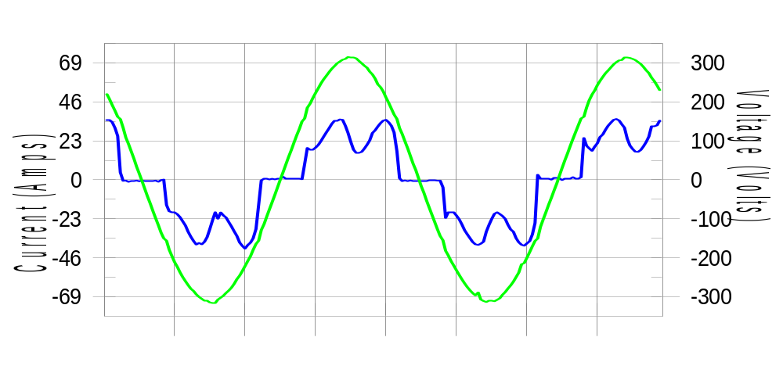

Harmonics and Class 3 limit line European Limits

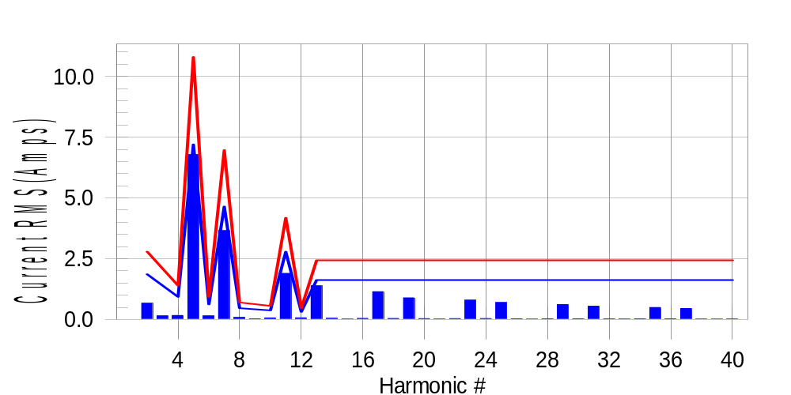

Test result: Fail Worst harmonic was #5 with 63.10 % of the limit.
Current Test Result Summary (Phase B-Run time)

EUT: Equipment under test Tested by: Tested by
Test category: Table:3, Rsce=250, Test Margin: 100
Test date: 2016/4/13 Start time: 15:02:15 End time: 15:05:08
Test duration (min): 2.5 Data file name: CTSMXH_H-000011.cts_data
Comment: Comment
Customer: Customer information

Test Result: Fail Measured I-ref: 23.377(Amps) Source: Normal
I-THC(%): 36.0 Limit(%): 37.0 PWHC(%): 43.1 PWHC Limit(%): 38.0

Highest parameter values during test:
V_RMS (Volts): 220.23 Frequency(Hz): 50.00
I_Peak (Amps): 47.300 I_RMS (Amps): 23.377
I_Fund (Amps): 21.621 Crest Factor: 2.040
Power (Watts): 4787 Power Factor: 0.931

Harm# Harms(avg) 100%Limit %of Limit Harms(max) 150%Limit %of Limit Status

2 0.669 1.858 36.0 0.708 2.787 25.4 Pass
3 0.123 N/A N/A 0.182 N/A N/A N/A
4 0.163 0.929 17.6 0.181 1.393 13.0 Pass
5 6.782 7.199 94.2 6.809 10.799 63.1 Pass
6 0.149 0.619 24.1 0.163 0.929 17.5 Pass
7 3.656 4.645 78.7 3.673 6.967 52.7 Pass
8 0.084 0.464 18.1 0.098 0.697 14.1 Pass
9 0.036 N/A N/A 0.035 N/A N/A N/A
10 0.064 0.372 17.1 0.073 0.557 13.1 Pass
11 1.895 2.787 68.0 1.914 4.180 45.8 Pass
12 0.067 0.310 21.6 0.084 0.464 18.2 Pass
13 1.386 1.626 85.2 1.399 2.438 57.4 Pass
14 0.048 N/A N/A 0.061 N/A N/A N/A
15 0.018 N/A N/A 0.025 N/A N/A N/A
16 0.043 N/A N/A 0.051 N/A N/A N/A
17 1.141 N/A N/A 1.149 N/A N/A N/A
18 0.041 N/A N/A 0.053 N/A N/A N/A
19 0.890 N/A N/A 0.902 N/A N/A N/A
20 0.034 N/A N/A 0.045 N/A N/A N/A
21 0.018 N/A N/A 0.030 N/A N/A N/A
22 0.035 N/A N/A 0.043 N/A N/A N/A
23 0.793 N/A N/A 0.815 N/A N/A N/A
24 0.036 N/A N/A 0.044 N/A N/A N/A
25 0.696 N/A N/A 0.707 N/A N/A N/A
26 0.026 N/A N/A 0.036 N/A N/A N/A
27 0.016 N/A N/A 0.022 N/A N/A N/A
28 0.027 N/A N/A 0.038 N/A N/A N/A
29 0.611 N/A N/A 0.621 N/A N/A N/A
30 0.028 N/A N/A 0.038 N/A N/A N/A
31 0.543 N/A N/A 0.555 N/A N/A N/A
32 0.023 N/A N/A 0.034 N/A N/A N/A
33 0.017 N/A N/A 0.027 N/A N/A N/A
34 0.026 N/A N/A 0.034 N/A N/A N/A
35 0.493 N/A N/A 0.502 N/A N/A N/A
36 0.026 N/A N/A 0.038 N/A N/A N/A
37 0.450 N/A N/A 0.461 N/A N/A N/A
38 0.019 N/A N/A 0.031 N/A N/A N/A
39 0.016 N/A N/A 0.023 N/A N/A N/A
40 0.022 N/A N/A 0.031 N/A N/A N/A

Note: Measured I-ref was applied for this test.

Voltage Source Verification Data (Phase B-Run time)

EUT: Equipment under test Tested by: Tested by
Test category: Table:3, Rsce=250, Test Margin: 100
Test date: 2016/4/13 Start time: 15:02:15 End time: 15:05:08
Test duration (min): 2.5 Data file name: CTSMXH_H-000011.cts_data
Comment: Comment
Customer: Customer information

Test Result: Fail Source qualification: Normal
Measured source distortion is within the requirements of the standards
Measurements are compliant with IEC/EN61000-3-12 Ed.4 & IEC/EN61000-4-7 Ed. 2.1

Highest parameter values during test:
Voltage (Vrms): 220.23 Frequency(Hz): 50.00
I_Peak (Amps): 47.300 I_RMS (Amps): 23.377
I_Fund (Amps): 21.621 Crest Factor: 2.040
Power (Watts): 4787 Power Factor: 0.931

Harm# Harmonics V-rms Limit V-rms % of Limit Status

2 0.172 0.881 19.52 OK
3 0.321 2.752 11.68 OK
4 0.132 0.880 14.96 OK
5 1.165 3.302 35.27 OK
6 0.109 0.881 12.40 OK
7 0.825 2.752 29.97 OK
8 0.112 0.881 12.75 OK
9 0.136 1.321 10.32 OK
10 0.116 0.881 13.22 OK
11 0.673 1.541 43.67 OK
12 0.131 0.660 19.77 OK
13 0.593 1.321 44.89 OK
14 0.103 0.660 15.59 OK
15 0.130 0.660 19.65 OK
16 0.114 0.661 17.30 OK
17 0.568 0.661 85.94 OK
18 0.121 0.660 18.38 OK
19 0.524 0.660 79.41 OK
20 0.142 0.661 21.52 OK
21 0.137 0.660 20.67 OK
22 0.107 0.660 16.27 OK
23 0.501 0.661 75.83 OK
24 0.121 0.660 18.30 OK
25 0.511 0.660 77.38 OK
26 0.122 0.660 18.55 OK
27 0.144 0.660 21.81 OK
28 0.117 0.660 17.67 OK
29 0.455 0.661 68.92 OK
30 0.097 0.660 14.75 OK
31 0.445 0.660 67.34 OK
32 0.104 0.660 15.76 OK
33 0.136 0.660 20.64 OK
34 0.117 0.660 17.71 OK
35 0.408 0.660 61.73 OK
36 0.105 0.660 15.88 OK
37 0.433 0.660 65.58 OK
38 0.099 0.660 14.94 OK
39 0.142 0.660 21.55 OK
40 0.137 0.660 20.78 OK

Harmonics – Per EN/IEC61000-3-12, Ed. 2.0(Phase C-Run time)

EUT: Equipment under test Tested by: Tested by
Test category: Table:3, Rsce=250, Test Margin: 100
Test date: 2016/4/13 Start time: 15:02:15 End time: 15:05:08
Test duration (min): 2.5 Data file name: CTSMXH_H-000011.cts_data
Comment: Comment
Customer: Customer information

Test Result: Fail Source qualification: Normal

Current & voltage waveforms

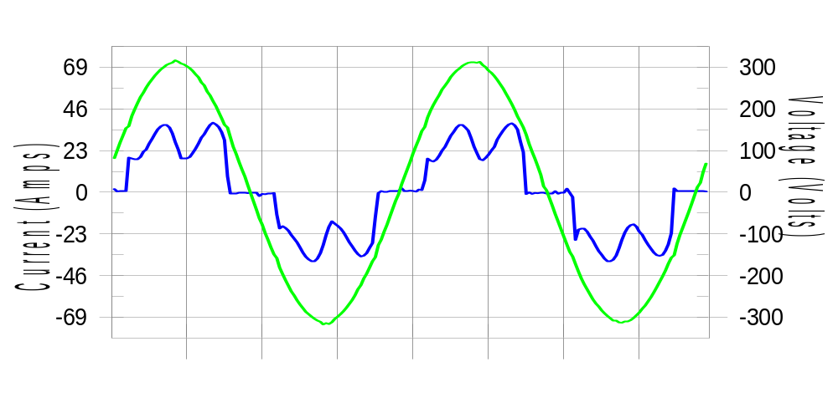

Harmonics and Class 3 limit line European Limits

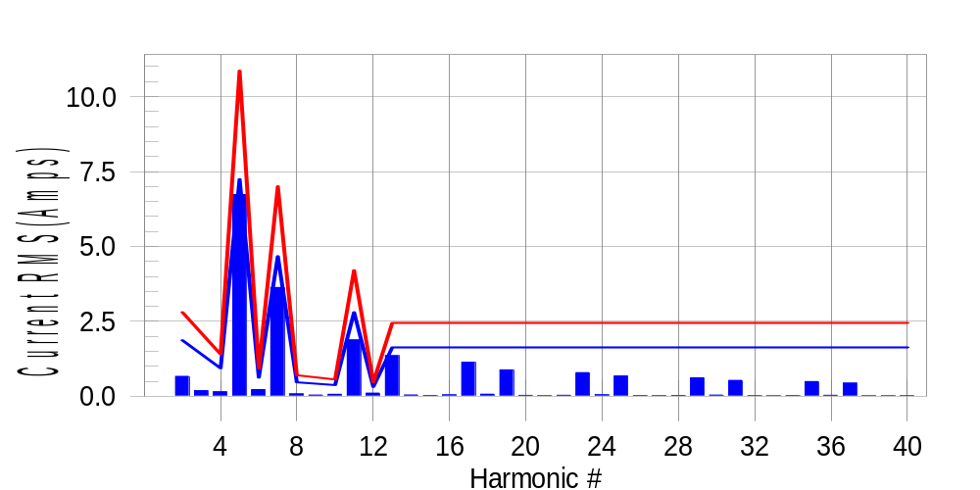

Test result: Fail Worst harmonic was #5 with 62.25 % of the limit.
Current Test Result Summary (Phase C-Run time)

EUT: Equipment under test Tested by: Tested by
Test category: Table:3, Rsce=250, Test Margin: 100
Test date: 2016/4/13 Start time: 15:02:15 End time: 15:05:08
Test duration (min): 2.5 Data file name: CTSMXH_H-000011.cts_data
Comment: Comment
Customer: Customer information

Test Result: Fail Measured I-ref: 23.533(Amps) Source: Normal
I-THC(%): 35.5 Limit(%): 37.0 PWHC(%): 42.4 PWHC Limit(%): 38.0

Highest parameter values during test:
V_RMS (Volts): 220.14 Frequency(Hz): 50.00
I_Peak (Amps): 47.453 I_RMS (Amps): 23.533
I_Fund (Amps): 21.819 Crest Factor: 2.033
Power (Watts): 4835 Power Factor: 0.934

Harm# Harms(avg) 100%Limit %of Limit Harms(max) 150%Limit %of Limit Status

2 0.666 1.870 35.6 0.700 2.804 25.0 Pass
3 0.123 N/A N/A 0.224 N/A N/A N/A
4 0.152 0.935 16.3 0.170 1.402 12.1 Pass
5 6.732 7.245 92.9 6.759 10.867 62.2 Pass
6 0.223 0.623 35.8 0.238 0.935 25.5 Pass
7 3.633 4.674 77.7 3.645 7.011 52.0 Pass
8 0.080 0.467 17.2 0.092 0.701 13.1 Pass
9 0.036 N/A N/A 0.055 N/A N/A N/A
10 0.066 0.374 17.6 0.076 0.561 13.6 Pass
11 1.882 2.804 67.1 1.898 4.206 45.1 Pass
12 0.107 0.312 34.4 0.116 0.467 24.9 Pass
13 1.357 1.636 83.0 1.370 2.454 55.8 Pass
14 0.044 N/A N/A 0.052 N/A N/A N/A
15 0.028 N/A N/A 0.038 N/A N/A N/A
16 0.046 N/A N/A 0.053 N/A N/A N/A
17 1.135 N/A N/A 1.147 N/A N/A N/A
18 0.070 N/A N/A 0.078 N/A N/A N/A
19 0.880 N/A N/A 0.890 N/A N/A N/A
20 0.030 N/A N/A 0.040 N/A N/A N/A
21 0.022 N/A N/A 0.030 N/A N/A N/A
22 0.035 N/A N/A 0.044 N/A N/A N/A
23 0.790 N/A N/A 0.803 N/A N/A N/A
24 0.051 N/A N/A 0.059 N/A N/A N/A
25 0.679 N/A N/A 0.688 N/A N/A N/A
26 0.023 N/A N/A 0.031 N/A N/A N/A
27 0.021 N/A N/A 0.030 N/A N/A N/A
28 0.029 N/A N/A 0.040 N/A N/A N/A
29 0.615 N/A N/A 0.622 N/A N/A N/A
30 0.042 N/A N/A 0.050 N/A N/A N/A
31 0.533 N/A N/A 0.541 N/A N/A N/A
32 0.020 N/A N/A 0.028 N/A N/A N/A
33 0.019 N/A N/A 0.028 N/A N/A N/A
34 0.025 N/A N/A 0.033 N/A N/A N/A
35 0.491 N/A N/A 0.504 N/A N/A N/A
36 0.035 N/A N/A 0.043 N/A N/A N/A
37 0.440 N/A N/A 0.449 N/A N/A N/A
38 0.017 N/A N/A 0.025 N/A N/A N/A
39 0.019 N/A N/A 0.028 N/A N/A N/A
40 0.022 N/A N/A 0.028 N/A N/A N/A

Note: Measured I-ref was applied for this test.

Voltage Source Verification Data (Phase C-Run time)

EUT: Equipment under test Tested by: Tested by
Test category: Table:3, Rsce=250, Test Margin: 100
Test date: 2016/4/13 Start time: 15:02:15 End time: 15:05:08
Test duration (min): 2.5 Data file name: CTSMXH_H-000011.cts_data
Comment: Comment
Customer: Customer information

Test Result: Fail Source qualification: Normal
Measured source distortion is within the requirements of the standards
Measurements are compliant with IEC/EN61000-3-12 Ed.4 & IEC/EN61000-4-7 Ed. 2.1

Highest parameter values during test:
Voltage (Vrms): 220.14 Frequency(Hz): 50.00
I_Peak (Amps): 47.453 I_RMS (Amps): 23.533
I_Fund (Amps): 21.819 Crest Factor: 2.033
Power (Watts): 4835 Power Factor: 0.934

Harm# Harmonics V-rms Limit V-rms % of Limit Status

2 0.171 0.880 19.45 OK
3 0.250 2.751 9.10 OK
4 0.120 0.880 13.65 OK
5 1.103 3.300 33.43 OK
6 0.123 0.880 13.95 OK
7 0.790 2.751 28.73 OK
8 0.117 0.880 13.31 OK
9 0.102 1.320 7.69 OK
10 0.113 0.880 12.85 OK
11 0.644 1.540 41.82 OK
12 0.111 0.660 16.83 OK
13 0.562 1.321 42.56 OK
14 0.096 0.660 14.56 OK
15 0.112 0.660 16.96 OK
16 0.107 0.660 16.23 OK
17 0.542 0.660 82.13 OK
18 0.106 0.660 16.08 OK
19 0.495 0.660 74.91 OK
20 0.130 0.660 19.67 OK
21 0.124 0.660 18.85 OK
22 0.089 0.660 13.45 OK
23 0.487 0.660 73.74 OK
24 0.101 0.660 15.33 OK
25 0.463 0.660 70.19 OK
26 0.106 0.660 16.12 OK
27 0.138 0.660 20.93 OK
28 0.094 0.660 14.23 OK
29 0.460 0.660 69.65 OK
30 0.112 0.660 16.89 OK
31 0.415 0.660 62.92 OK
32 0.094 0.660 14.17 OK
33 0.123 0.660 18.69 OK
34 0.088 0.660 13.39 OK
35 0.393 0.660 59.50 OK
36 0.108 0.660 16.29 OK
37 0.392 0.660 59.31 OK
38 0.095 0.660 14.42 OK
39 0.110 0.660 16.71 OK
40 0.113 0.660 17.11 OK

5th Harmonic Phase Angle and Magnitude for Phase A :
H-5_min_phase : 134.4 Degree (Leading)
H-5_max_phase : 135.1 Degree (Leading)
H-5_ave_phase : 134.7 Degree (Leading)

H-5_ave_vector_magnitude : 6.725 Amp
H-5_standard_ave_magnitude : 6.765 Amp
H-5_standard_max_magnitude : 6.759 Amp
Ratio of H-5_ave_vector / H-5_standard_ave : 0.999

Phase A = 111.131% of tested Rsce = 250.000, Rsce = 277.828
Phase B = 113.381% of tested Rsce = 250.000, Rsce = 283.453
Phase C = 111.672% of tested Rsce = 250.000, Rsce = 279.180
Minimum Rsce required: Rsce = 283.453

