Harmonics – Per EN/IEC61000-3-12, Ed. 2.0(Phase A-Run time)

EUT: Equipment under test Tested by: Tested by
Test category: Table:3, Rsce=250, Test Margin: 100
Test date: 2016/4/13 Start time: 15:18:54 End time: 15:21:46
Test duration (min): 2.5 Data file name: CTSMXH_H-000012.cts_data
Comment: Comment
Customer: Customer information

Test Result: Fail Source qualification: Distorted

Current & voltage waveforms

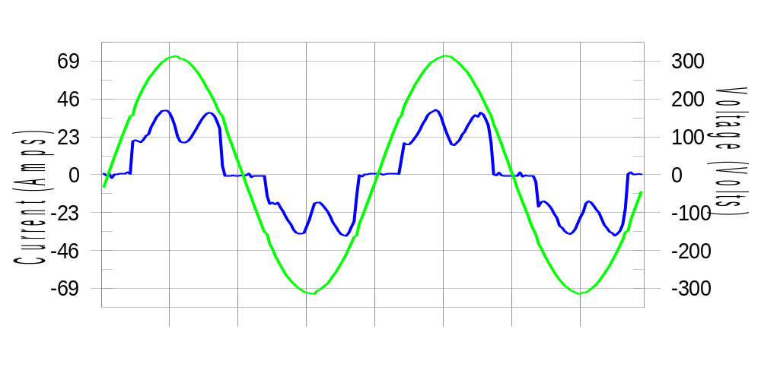

Harmonics and Class 3 limit line European Limits

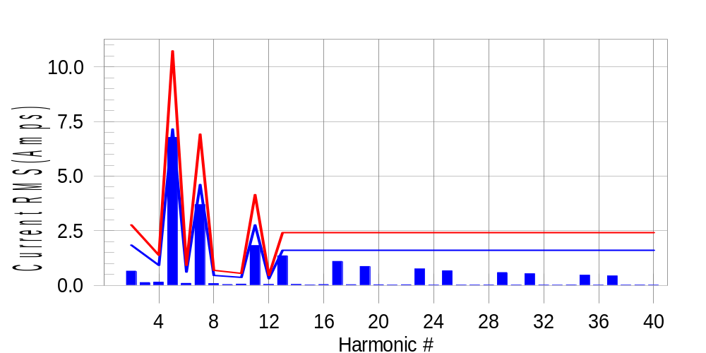

Test result: Fail Worst harmonic was #5 with 63.50 % of the limit.
Current Test Result Summary (Phase A-Run time)

EUT: Equipment under test Tested by: Tested by
Test category: Table:3, Rsce=250, Test Margin: 100
Test date: 2016/4/13 Start time: 15:18:54 End time: 15:21:46
Test duration (min): 2.5 Data file name: CTSMXH_H-000012.cts_data
Comment: Comment
Customer: Customer information

Test Result: Fail Measured I-ref: 23.293(Amps) Source: Distorted
I-THC(%): 36.1 Limit(%): 37.0 PWHC(%): 42.0 PWHC Limit(%): 38.0

Highest parameter values during test:
V_RMS (Volts): 220.44 Frequency(Hz): 50.00
I_Peak (Amps): 49.941 I_RMS (Amps): 23.293
I_Fund (Amps): 21.481 Crest Factor: 2.168
Power (Watts): 4773 Power Factor: 0.930

Harm# Harms(avg) 100%Limit %of Limit Harms(max) 150%Limit %of Limit Status

2 0.658 1.846 35.6 0.697 2.770 25.2 Pass
3 0.135 N/A N/A 0.170 N/A N/A N/A
4 0.154 0.923 16.7 0.171 1.385 12.3 Pass
5 6.776 7.155 94.7 6.800 10.733 63.4 Pass
6 0.097 0.615 15.8 0.107 0.923 11.6 Pass
7 3.698 4.616 80.1 3.712 6.924 53.6 Pass
8 0.084 0.462 18.2 0.096 0.692 13.9 Pass
9 0.042 N/A N/A 0.061 N/A N/A N/A
10 0.062 0.369 16.8 0.073 0.554 13.2 Pass
11 1.828 2.770 66.0 1.845 4.155 44.4 Pass
12 0.048 0.308 15.6 0.059 0.462 12.7 Pass
13 1.358 1.616 84.0 1.369 2.423 56.5 Pass
14 0.047 N/A N/A 0.056 N/A N/A N/A
15 0.027 N/A N/A 0.036 N/A N/A N/A
16 0.043 N/A N/A 0.053 N/A N/A N/A
17 1.103 N/A N/A 1.114 N/A N/A N/A
18 0.038 N/A N/A 0.046 N/A N/A N/A
19 0.871 N/A N/A 0.882 N/A N/A N/A
20 0.034 N/A N/A 0.047 N/A N/A N/A
21 0.023 N/A N/A 0.041 N/A N/A N/A
22 0.033 N/A N/A 0.044 N/A N/A N/A
23 0.756 N/A N/A 0.768 N/A N/A N/A
24 0.025 N/A N/A 0.034 N/A N/A N/A
25 0.675 N/A N/A 0.688 N/A N/A N/A
26 0.025 N/A N/A 0.033 N/A N/A N/A
27 0.025 N/A N/A 0.034 N/A N/A N/A
28 0.028 N/A N/A 0.037 N/A N/A N/A
29 0.593 N/A N/A 0.604 N/A N/A N/A
30 0.025 N/A N/A 0.033 N/A N/A N/A
31 0.537 N/A N/A 0.547 N/A N/A N/A
32 0.024 N/A N/A 0.037 N/A N/A N/A
33 0.019 N/A N/A 0.026 N/A N/A N/A
34 0.026 N/A N/A 0.035 N/A N/A N/A
35 0.469 N/A N/A 0.478 N/A N/A N/A
36 0.020 N/A N/A 0.032 N/A N/A N/A
37 0.439 N/A N/A 0.449 N/A N/A N/A
38 0.020 N/A N/A 0.029 N/A N/A N/A
39 0.023 N/A N/A 0.030 N/A N/A N/A
40 0.022 N/A N/A 0.029 N/A N/A N/A

Note: Measured I-ref was applied for this test.

Voltage Source Verification Data (Phase A-Run time)

EUT: Equipment under test Tested by: Tested by
Test category: Table:3, Rsce=250, Test Margin: 100
Test date: 2016/4/13 Start time: 15:18:54 End time: 15:21:46
Test duration (min): 2.5 Data file name: CTSMXH_H-000012.cts_data
Comment: Comment
Customer: Customer information

Test Result: Fail Source qualification: Distorted
Current harmonics are corrected for source distortion, and are within +/-5%
Measurements are compliant with IEC/EN61000-3-12 Ed.4 & IEC/EN61000-4-7

Highest parameter values during test:
Voltage (Vrms): 220.44 Frequency(Hz): 50.00
I_Peak (Amps): 49.941 I_RMS (Amps): 23.293
I_Fund (Amps): 21.481 Crest Factor: 2.168
Power (Watts): 4773 Power Factor: 0.930

Harm# Harmonics V-rms Limit V-rms % of Limit Status

2 0.185 0.881 20.95 OK
3 0.317 2.755 11.50 OK
4 0.110 0.881 12.51 OK
5 1.107 3.306 33.49 OK
6 0.087 0.881 9.91 OK
7 0.795 2.755 28.87 OK
8 0.109 0.881 12.33 OK
9 0.112 1.322 8.50 OK
10 0.112 0.881 12.68 OK
11 0.612 1.542 39.66 OK
12 0.097 0.661 14.69 OK
13 0.551 1.322 41.65 OK
14 0.111 0.661 16.74 OK
15 0.128 0.661 19.41 OK
16 0.104 0.661 15.70 OK
17 0.531 0.661 80.31 OK
18 0.107 0.661 16.21 OK
19 0.494 0.661 74.82 OK
20 0.187 0.661 28.35 OK
21 0.130 0.661 19.64 OK
22 0.103 0.661 15.51 OK
23 0.473 0.661 71.53 OK
24 0.088 0.661 13.32 OK
25 0.478 0.661 72.34 OK
26 0.081 0.661 12.31 OK
27 0.123 0.661 18.54 OK
28 0.112 0.661 16.93 OK
29 0.402 0.661 60.80 OK
30 0.102 0.661 15.41 OK
31 0.430 0.661 65.01 OK
32 0.088 0.661 13.31 OK
33 0.130 0.661 19.66 OK
34 0.102 0.661 15.41 OK
35 0.372 0.661 56.28 OK
36 0.095 0.661 14.42 OK
37 0.405 0.661 61.27 OK
38 0.119 0.661 17.97 OK
39 0.138 0.661 20.95 OK
40 0.152 0.661 22.94 OK

Harmonics – Per EN/IEC61000-3-12, Ed. 2.0(Phase B-Run time)

EUT: Equipment under test Tested by: Tested by
Test category: Table:3, Rsce=250, Test Margin: 100
Test date: 2016/4/13 Start time: 15:18:54 End time: 15:21:46
Test duration (min): 2.5 Data file name: CTSMXH_H-000012.cts_data
Comment: Comment
Customer: Customer information

Test Result: Fail Source qualification: Distorted

Current & voltage waveforms

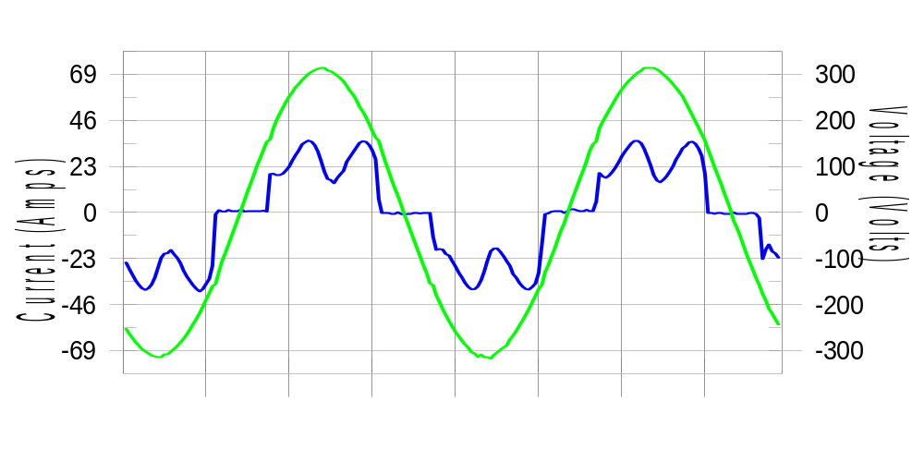

Harmonics and Class 3 limit line European Limits

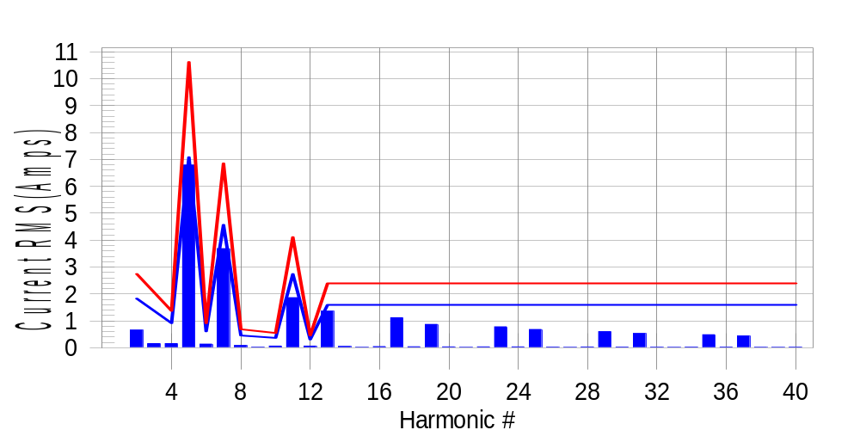

Test result: Fail Worst harmonic was #5 with 64.26 % of the limit.
Current Test Result Summary (Phase B-Run time)

EUT: Equipment under test Tested by: Tested by
Test category: Table:3, Rsce=250, Test Margin: 100
Test date: 2016/4/13 Start time: 15:18:54 End time: 15:21:46
Test duration (min): 2.5 Data file name: CTSMXH_H-000012.cts_data
Comment: Comment
Customer: Customer information

Test Result: Fail Measured I-ref: 23.035(Amps) Source: Distorted
I-THC(%): 36.6 Limit(%): 37.0 PWHC(%): 42.9 PWHC Limit(%): 38.0

Highest parameter values during test:
V_RMS (Volts): 220.25 Frequency(Hz): 50.00
I_Peak (Amps): 52.280 I_RMS (Amps): 23.035
I_Fund (Amps): 21.212 Crest Factor: 2.295
Power (Watts): 4706 Power Factor: 0.928

Harm# Harms(avg) 100%Limit %of Limit Harms(max) 150%Limit %of Limit Status

2 0.658 1.827 36.0 0.705 2.741 25.7 Pass
3 0.135 N/A N/A 0.188 N/A N/A N/A
4 0.154 0.914 16.9 0.172 1.370 12.6 Pass
5 6.787 7.081 95.9 6.808 10.621 64.1 Pass
6 0.137 0.609 22.5 0.151 0.914 16.6 Pass
7 3.683 4.568 80.6 3.696 6.852 53.9 Pass
8 0.084 0.457 18.4 0.094 0.685 13.6 Pass
9 0.042 N/A N/A 0.041 N/A N/A N/A
10 0.062 0.365 17.0 0.076 0.548 13.8 Pass
11 1.861 2.741 67.9 1.877 4.111 45.6 Pass
12 0.061 0.305 20.1 0.070 0.457 15.3 Pass
13 1.361 1.599 85.1 1.373 2.398 57.2 Pass
14 0.049 N/A N/A 0.061 N/A N/A N/A
15 0.019 N/A N/A 0.028 N/A N/A N/A
16 0.043 N/A N/A 0.053 N/A N/A N/A
17 1.117 N/A N/A 1.130 N/A N/A N/A
18 0.037 N/A N/A 0.047 N/A N/A N/A
19 0.868 N/A N/A 0.881 N/A N/A N/A
20 0.035 N/A N/A 0.046 N/A N/A N/A
21 0.018 N/A N/A 0.028 N/A N/A N/A
22 0.034 N/A N/A 0.052 N/A N/A N/A
23 0.778 N/A N/A 0.789 N/A N/A N/A
24 0.034 N/A N/A 0.043 N/A N/A N/A
25 0.680 N/A N/A 0.692 N/A N/A N/A
26 0.027 N/A N/A 0.035 N/A N/A N/A
27 0.017 N/A N/A 0.024 N/A N/A N/A
28 0.029 N/A N/A 0.038 N/A N/A N/A
29 0.600 N/A N/A 0.615 N/A N/A N/A
30 0.027 N/A N/A 0.038 N/A N/A N/A
31 0.531 N/A N/A 0.548 N/A N/A N/A
32 0.025 N/A N/A 0.036 N/A N/A N/A
33 0.018 N/A N/A 0.023 N/A N/A N/A
34 0.027 N/A N/A 0.039 N/A N/A N/A
35 0.484 N/A N/A 0.496 N/A N/A N/A
36 0.026 N/A N/A 0.052 N/A N/A N/A
37 0.441 N/A N/A 0.452 N/A N/A N/A
38 0.022 N/A N/A 0.030 N/A N/A N/A
39 0.018 N/A N/A 0.028 N/A N/A N/A
40 0.023 N/A N/A 0.033 N/A N/A N/A

Note: Measured I-ref was applied for this test.

Voltage Source Verification Data (Phase B-Run time)

EUT: Equipment under test Tested by: Tested by
Test category: Table:3, Rsce=250, Test Margin: 100
Test date: 2016/4/13 Start time: 15:18:54 End time: 15:21:46
Test duration (min): 2.5 Data file name: CTSMXH_H-000012.cts_data
Comment: Comment
Customer: Customer information

Test Result: Fail Source qualification: Distorted
Current harmonics are corrected for source distortion, and are within +/-5%
Measurements are compliant with IEC/EN61000-3-12 Ed.4 & IEC/EN61000-4-7

Highest parameter values during test:
Voltage (Vrms): 220.25 Frequency(Hz): 50.00
I_Peak (Amps): 52.280 I_RMS (Amps): 23.035
I_Fund (Amps): 21.212 Crest Factor: 2.295
Power (Watts): 4706 Power Factor: 0.928

Harm# Harmonics V-rms Limit V-rms % of Limit Status

2 0.221 0.881 25.09 OK
3 0.326 2.751 11.84 OK
4 0.138 0.881 15.65 OK
5 1.187 3.303 35.93 OK
6 0.123 0.881 14.00 OK
7 0.842 2.753 30.58 OK
8 0.120 0.881 13.59 OK
9 0.158 1.321 11.96 OK
10 0.122 0.881 13.82 OK
11 0.673 1.541 43.67 OK
12 0.114 0.660 17.21 OK
13 0.609 1.321 46.10 OK
14 0.136 0.661 20.60 OK
15 0.147 0.661 22.29 OK
16 0.113 0.660 17.06 OK
17 0.575 0.660 87.14 OK
18 0.124 0.661 18.71 OK
19 0.528 0.660 79.89 OK
20 0.162 0.660 24.48 OK
21 0.155 0.660 23.54 OK
22 0.120 0.660 18.12 OK
23 0.526 0.660 79.67 OK
24 0.108 0.661 16.38 OK
25 0.496 0.661 75.13 OK
26 0.131 0.660 19.82 OK
27 0.129 0.660 19.54 OK
28 0.138 0.661 20.87 OK
29 0.439 0.660 66.50 OK
30 0.136 0.660 20.61 OK
31 0.449 0.660 67.96 OK
32 0.114 0.660 17.22 OK
33 0.143 0.660 21.59 OK
34 0.134 0.661 20.29 OK
35 0.423 0.660 64.11 OK
36 0.121 0.661 18.31 OK
37 0.417 0.660 63.09 OK
38 0.136 0.660 20.56 OK
39 0.132 0.661 19.95 OK
40 0.129 0.661 19.49 OK

Harmonics – Per EN/IEC61000-3-12, Ed. 2.0(Phase C-Run time)

EUT: Equipment under test Tested by: Tested by
Test category: Table:3, Rsce=250, Test Margin: 100
Test date: 2016/4/13 Start time: 15:18:54 End time: 15:21:46
Test duration (min): 2.5 Data file name: CTSMXH_H-000012.cts_data
Comment: Comment
Customer: Customer information

Test Result: Fail Source qualification: Distorted

Current & voltage waveforms

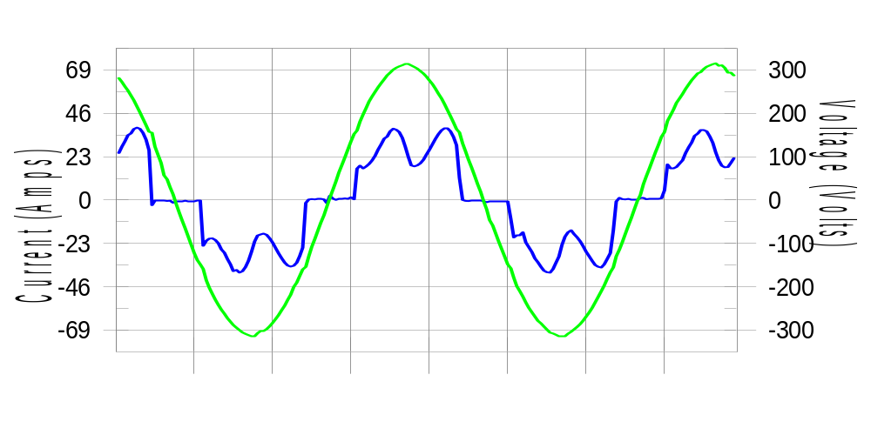

Harmonics and Class 3 limit line European Limits

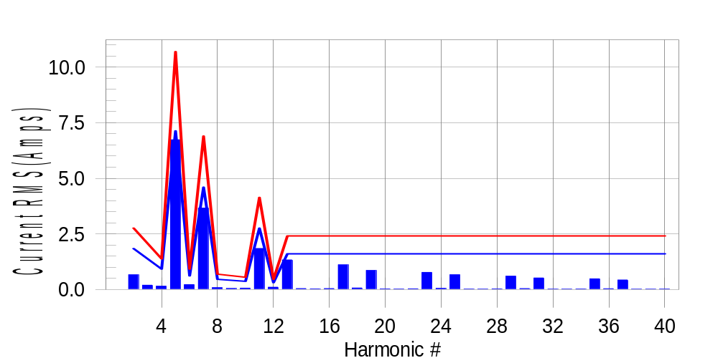

Test result: Fail Worst harmonic was #5 with 63.19 % of the limit.
Current Test Result Summary (Phase C-Run time)

EUT: Equipment under test Tested by: Tested by
Test category: Table:3, Rsce=250, Test Margin: 100
Test date: 2016/4/13 Start time: 15:18:54 End time: 15:21:46
Test duration (min): 2.5 Data file name: CTSMXH_H-000012.cts_data
Comment: Comment
Customer: Customer information

Test Result: Fail Measured I-ref: 23.208(Amps) Source: Distorted
I-THC(%): 36.0 Limit(%): 37.0 PWHC(%): 42.1 PWHC Limit(%): 38.0

Highest parameter values during test:
V_RMS (Volts): 220.13 Frequency(Hz): 50.00
I_Peak (Amps): 46.961 I_RMS (Amps): 23.208
I_Fund (Amps): 21.423 Crest Factor: 2.041
Power (Watts): 4756 Power Factor: 0.932

Harm# Harms(avg) 100%Limit %of Limit Harms(max) 150%Limit %of Limit Status

2 0.660 1.840 35.9 0.688 2.760 24.9 Pass
3 0.135 N/A N/A 0.229 N/A N/A N/A
4 0.150 0.920 16.4 0.166 1.380 12.0 Pass
5 6.731 7.129 94.4 6.756 10.693 63.2 Pass
6 0.221 0.613 36.0 0.231 0.920 25.2 Pass
7 3.660 4.599 79.6 3.676 6.899 53.3 Pass
8 0.081 0.460 17.7 0.092 0.690 13.3 Pass
9 0.042 N/A N/A 0.060 N/A N/A N/A
10 0.064 0.368 17.3 0.075 0.552 13.6 Pass
11 1.844 2.760 66.8 1.858 4.139 44.9 Pass
12 0.106 0.307 34.7 0.114 0.460 24.9 Pass
13 1.332 1.610 82.7 1.346 2.415 55.7 Pass
14 0.045 N/A N/A 0.052 N/A N/A N/A
15 0.029 N/A N/A 0.043 N/A N/A N/A
16 0.045 N/A N/A 0.056 N/A N/A N/A
17 1.108 N/A N/A 1.121 N/A N/A N/A
18 0.070 N/A N/A 0.081 N/A N/A N/A
19 0.858 N/A N/A 0.869 N/A N/A N/A
20 0.030 N/A N/A 0.039 N/A N/A N/A
21 0.024 N/A N/A 0.032 N/A N/A N/A
22 0.034 N/A N/A 0.041 N/A N/A N/A
23 0.772 N/A N/A 0.783 N/A N/A N/A
24 0.052 N/A N/A 0.060 N/A N/A N/A
25 0.663 N/A N/A 0.673 N/A N/A N/A
26 0.024 N/A N/A 0.031 N/A N/A N/A
27 0.021 N/A N/A 0.028 N/A N/A N/A
28 0.031 N/A N/A 0.040 N/A N/A N/A
29 0.601 N/A N/A 0.612 N/A N/A N/A
30 0.043 N/A N/A 0.072 N/A N/A N/A
31 0.521 N/A N/A 0.530 N/A N/A N/A
32 0.021 N/A N/A 0.028 N/A N/A N/A
33 0.020 N/A N/A 0.030 N/A N/A N/A
34 0.026 N/A N/A 0.035 N/A N/A N/A
35 0.481 N/A N/A 0.490 N/A N/A N/A
36 0.036 N/A N/A 0.045 N/A N/A N/A
37 0.430 N/A N/A 0.440 N/A N/A N/A
38 0.018 N/A N/A 0.030 N/A N/A N/A
39 0.019 N/A N/A 0.027 N/A N/A N/A
40 0.023 N/A N/A 0.035 N/A N/A N/A

Note: Measured I-ref was applied for this test.

Voltage Source Verification Data (Phase C-Run time)

EUT: Equipment under test Tested by: Tested by
Test category: Table:3, Rsce=250, Test Margin: 100
Test date: 2016/4/13 Start time: 15:18:54 End time: 15:21:46
Test duration (min): 2.5 Data file name: CTSMXH_H-000012.cts_data
Comment: Comment
Customer: Customer information

Test Result: Fail Source qualification: Distorted
Current harmonics are corrected for source distortion, and are within +/-5%
Measurements are compliant with IEC/EN61000-3-12 Ed.4 & IEC/EN61000-4-7

Highest parameter values during test:
Voltage (Vrms): 220.13 Frequency(Hz): 50.00
I_Peak (Amps): 46.961 I_RMS (Amps): 23.208
I_Fund (Amps): 21.423 Crest Factor: 2.041
Power (Watts): 4756 Power Factor: 0.932

Harm# Harmonics V-rms Limit V-rms % of Limit Status

2 0.197 0.880 22.35 OK
3 0.247 2.751 8.97 OK
4 0.114 0.880 12.99 OK
5 1.101 3.301 33.36 OK
6 0.135 0.880 15.36 OK
7 0.789 2.750 28.68 OK
8 0.122 0.880 13.83 OK
9 0.131 1.320 9.91 OK
10 0.113 0.880 12.82 OK
11 0.642 1.540 41.71 OK
12 0.120 0.660 18.23 OK
13 0.560 1.320 42.39 OK
14 0.109 0.660 16.58 OK
15 0.130 0.660 19.68 OK
16 0.101 0.660 15.27 OK
17 0.532 0.660 80.62 OK
18 0.120 0.660 18.20 OK
19 0.510 0.660 77.22 OK
20 0.121 0.660 18.26 OK
21 0.113 0.660 17.15 OK
22 0.113 0.660 17.05 OK
23 0.470 0.660 71.20 OK
24 0.120 0.660 18.14 OK
25 0.457 0.660 69.28 OK
26 0.130 0.660 19.63 OK
27 0.130 0.660 19.65 OK
28 0.113 0.660 17.08 OK
29 0.431 0.660 65.24 OK
30 0.111 0.660 16.79 OK
31 0.419 0.660 63.49 OK
32 0.097 0.660 14.75 OK
33 0.137 0.660 20.79 OK
34 0.096 0.660 14.56 OK
35 0.398 0.660 60.31 OK
36 0.118 0.660 17.89 OK
37 0.389 0.660 58.86 OK
38 0.092 0.660 13.90 OK
39 0.124 0.660 18.80 OK
40 0.121 0.660 18.28 OK

5th Harmonic Phase Angle and Magnitude for Phase A :
H-5_min_phase : 133.4 Degree (Leading)
H-5_max_phase : 134.2 Degree (Leading)
H-5_ave_phase : 133.8 Degree (Leading)

H-5_ave_vector_magnitude : 6.725 Amp
H-5_standard_ave_magnitude : 6.776 Amp
H-5_standard_max_magnitude : 6.756 Amp
Ratio of H-5_ave_vector / H-5_standard_ave : 0.999

Phase A = 110.506% of tested Rsce = 250.000, Rsce = 276.265
Phase B = 112.832% of tested Rsce = 250.000, Rsce = 282.079
Phase C = 110.823% of tested Rsce = 250.000, Rsce = 277.057
Minimum Rsce required: Rsce = 282.079

