Harmonics – Per EN/IEC61000-3-12, Ed. 2.0(Phase A-Run time)

EUT: Equipment under test Tested by: Tested by
Test category: Table:3, Rsce=250, Test Margin: 100
Test date: 2016/4/13 Start time: 15:31:20 End time: 15:34:12
Test duration (min): 2.5 Data file name: CTSMXH_H-000013.cts_data
Comment: Comment
Customer: Customer information

Test Result: Fail Source qualification: Normal

Current & voltage waveforms

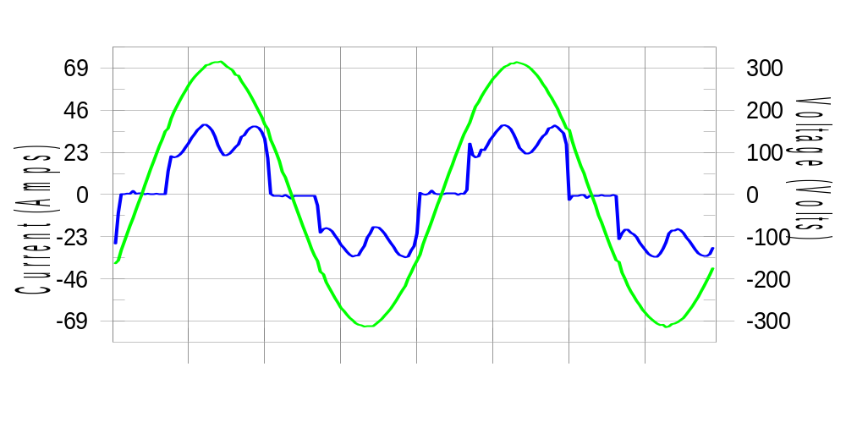

Harmonics and Class 3 limit line European Limits

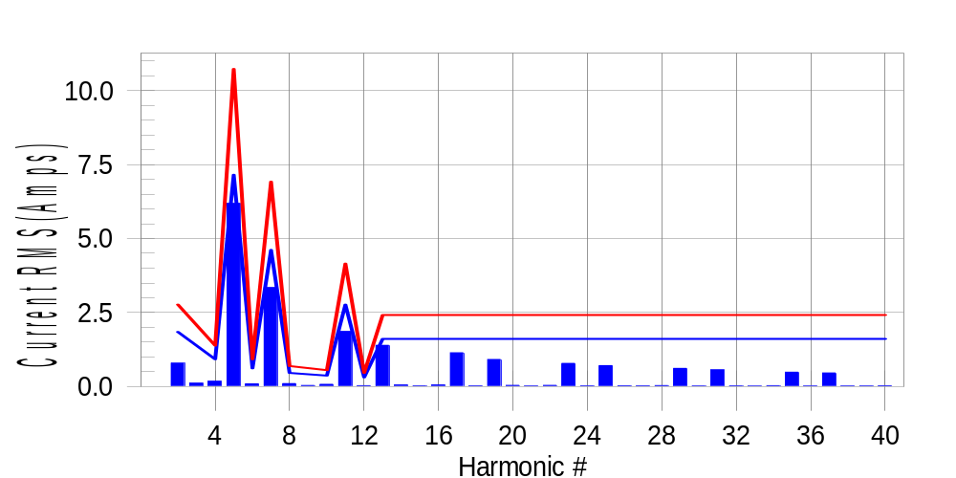

Test result: Fail Worst harmonic was #13 with 58.02 % of the limit.
Current Test Result Summary (Phase A-Run time)

EUT: Equipment under test Tested by: Tested by
Test category: Table:3, Rsce=250, Test Margin: 100
Test date: 2016/4/13 Start time: 15:31:20 End time: 15:34:12
Test duration (min): 2.5 Data file name: CTSMXH_H-000013.cts_data
Comment: Comment
Customer: Customer information

Test Result: Fail Measured I-ref: 23.311(Amps) Source: Normal
I-THC(%): 33.6 Limit(%): 37.0 PWHC(%): 43.8 PWHC Limit(%): 38.0

Highest parameter values during test:
V_RMS (Volts): 220.43 Frequency(Hz): 50.00
I_Peak (Amps): 48.091 I_RMS (Amps): 23.311
I_Fund (Amps): 21.682 Crest Factor: 2.078
Power (Watts): 4826 Power Factor: 0.939

Harm# Harms(avg) 100%Limit %of Limit Harms(max) 150%Limit %of Limit Status

2 0.791 1.846 42.9 0.838 2.770 30.3 Pass
3 0.115 N/A N/A 0.148 N/A N/A N/A
4 0.180 0.923 19.5 0.196 1.385 14.2 Pass
5 6.187 7.155 86.5 6.220 10.732 58.0 Pass
6 0.093 0.615 15.2 0.107 0.923 11.6 Pass
7 3.346 4.616 72.5 3.360 6.924 48.5 Pass
8 0.103 0.462 22.3 0.116 0.692 16.7 Pass
9 0.038 N/A N/A 0.051 N/A N/A N/A
10 0.076 0.369 20.6 0.086 0.554 15.6 Pass
11 1.862 2.770 67.2 1.877 4.154 45.2 Pass
12 0.032 0.308 10.5 0.041 0.462 9.0 Pass
13 1.394 1.616 86.3 1.406 2.423 58.0 Pass
14 0.053 N/A N/A 0.062 N/A N/A N/A
15 0.025 N/A N/A 0.038 N/A N/A N/A
16 0.053 N/A N/A 0.064 N/A N/A N/A
17 1.141 N/A N/A 1.152 N/A N/A N/A
18 0.024 N/A N/A 0.038 N/A N/A N/A
19 0.917 N/A N/A 0.928 N/A N/A N/A
20 0.039 N/A N/A 0.050 N/A N/A N/A
21 0.021 N/A N/A 0.031 N/A N/A N/A
22 0.041 N/A N/A 0.056 N/A N/A N/A
23 0.784 N/A N/A 0.792 N/A N/A N/A
24 0.024 N/A N/A 0.033 N/A N/A N/A
25 0.710 N/A N/A 0.724 N/A N/A N/A
26 0.029 N/A N/A 0.040 N/A N/A N/A
27 0.025 N/A N/A 0.033 N/A N/A N/A
28 0.035 N/A N/A 0.043 N/A N/A N/A
29 0.615 N/A N/A 0.638 N/A N/A N/A
30 0.022 N/A N/A 0.029 N/A N/A N/A
31 0.563 N/A N/A 0.572 N/A N/A N/A
32 0.025 N/A N/A 0.036 N/A N/A N/A
33 0.018 N/A N/A 0.028 N/A N/A N/A
34 0.031 N/A N/A 0.040 N/A N/A N/A
35 0.485 N/A N/A 0.495 N/A N/A N/A
36 0.021 N/A N/A 0.029 N/A N/A N/A
37 0.461 N/A N/A 0.471 N/A N/A N/A
38 0.022 N/A N/A 0.038 N/A N/A N/A
39 0.022 N/A N/A 0.031 N/A N/A N/A
40 0.027 N/A N/A 0.037 N/A N/A N/A

Note: Measured I-ref was applied for this test.

Voltage Source Verification Data (Phase A-Run time)

EUT: Equipment under test Tested by: Tested by
Test category: Table:3, Rsce=250, Test Margin: 100
Test date: 2016/4/13 Start time: 15:31:20 End time: 15:34:12
Test duration (min): 2.5 Data file name: CTSMXH_H-000013.cts_data
Comment: Comment
Customer: Customer information

Test Result: Fail Source qualification: Normal
Measured source distortion is within the requirements of the standards
Measurements are compliant with IEC/EN61000-3-12 Ed.4 & IEC/EN61000-4-7 Ed. 2.1

Highest parameter values during test:
Voltage (Vrms): 220.43 Frequency(Hz): 50.00
I_Peak (Amps): 48.091 I_RMS (Amps): 23.311
I_Fund (Amps): 21.682 Crest Factor: 2.078
Power (Watts): 4826 Power Factor: 0.939

Harm# Harmonics V-rms Limit V-rms % of Limit Status

2 0.150 0.881 17.05 OK
3 0.293 2.755 10.62 OK
4 0.123 0.881 13.93 OK
5 1.024 3.304 31.00 OK
6 0.107 0.881 12.15 OK
7 0.746 2.754 27.09 OK
8 0.114 0.881 12.88 OK
9 0.112 1.322 8.45 OK
10 0.114 0.882 12.88 OK
11 0.635 1.543 41.15 OK
12 0.085 0.661 12.87 OK
13 0.584 1.322 44.17 OK
14 0.083 0.661 12.61 OK
15 0.140 0.661 21.12 OK
16 0.105 0.661 15.91 OK
17 0.547 0.661 82.67 OK
18 0.093 0.661 14.02 OK
19 0.521 0.661 78.89 OK
20 0.187 0.661 28.33 OK
21 0.128 0.661 19.30 OK
22 0.097 0.661 14.62 OK
23 0.472 0.661 71.37 OK
24 0.080 0.661 12.17 OK
25 0.500 0.661 75.68 OK
26 0.107 0.661 16.24 OK
27 0.142 0.661 21.45 OK
28 0.100 0.661 15.20 OK
29 0.418 0.661 63.21 OK
30 0.092 0.661 13.86 OK
31 0.445 0.661 67.37 OK
32 0.110 0.661 16.67 OK
33 0.126 0.661 19.10 OK
34 0.108 0.661 16.29 OK
35 0.395 0.661 59.69 OK
36 0.095 0.661 14.43 OK
37 0.406 0.661 61.38 OK
38 0.105 0.661 15.82 OK
39 0.149 0.661 22.55 OK
40 0.147 0.661 22.30 OK

Harmonics – Per EN/IEC61000-3-12, Ed. 2.0(Phase B-Run time)

EUT: Equipment under test Tested by: Tested by
Test category: Table:3, Rsce=250, Test Margin: 100
Test date: 2016/4/13 Start time: 15:31:20 End time: 15:34:12
Test duration (min): 2.5 Data file name: CTSMXH_H-000013.cts_data
Comment: Comment
Customer: Customer information

Test Result: Fail Source qualification: Normal

Current & voltage waveforms

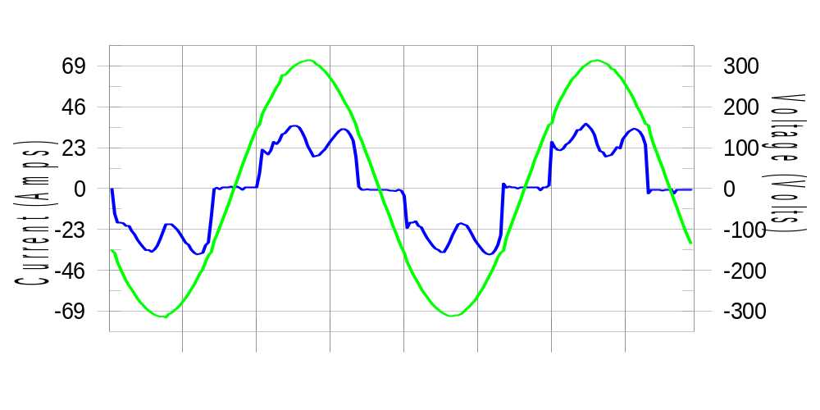

Harmonics and Class 3 limit line European Limits

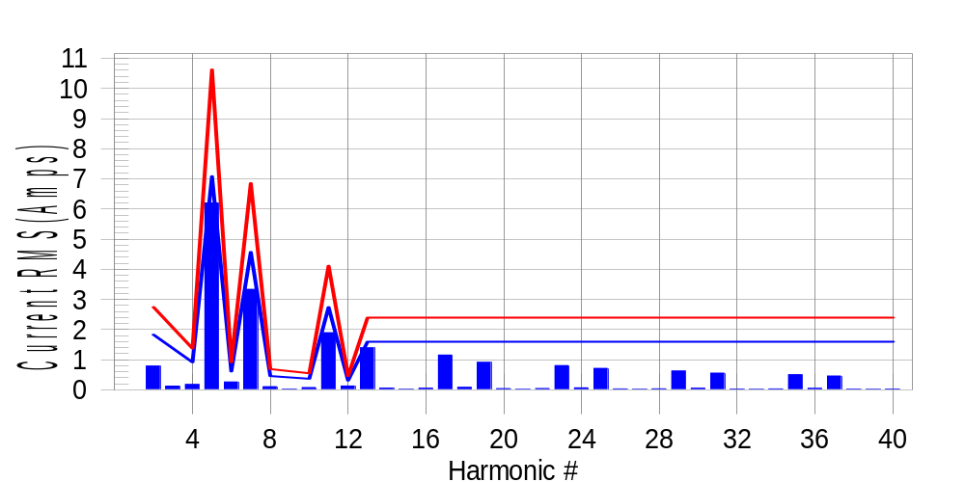

Test result: Fail Worst harmonic was #13 with 58.77 % of the limit.
Current Test Result Summary (Phase B-Run time)

EUT: Equipment under test Tested by: Tested by
Test category: Table:3, Rsce=250, Test Margin: 100
Test date: 2016/4/13 Start time: 15:31:20 End time: 15:34:12
Test duration (min): 2.5 Data file name: CTSMXH_H-000013.cts_data
Comment: Comment
Customer: Customer information

Test Result: Fail Measured I-ref: 23.060(Amps) Source: Normal
I-THC(%): 34.0 Limit(%): 37.0 PWHC(%): 44.6 PWHC Limit(%): 38.0

Highest parameter values during test:
V_RMS (Volts): 220.23 Frequency(Hz): 50.00
I_Peak (Amps): 47.862 I_RMS (Amps): 23.060
I_Fund (Amps): 21.456 Crest Factor: 2.096
Power (Watts): 4764 Power Factor: 0.939

Harm# Harms(avg) 100%Limit %of Limit Harms(max) 150%Limit %of Limit Status

2 0.790 1.828 43.2 0.831 2.743 30.3 Pass
3 0.115 N/A N/A 0.157 N/A N/A N/A
4 0.177 0.914 19.4 0.200 1.371 14.6 Pass
5 6.200 7.085 87.5 6.233 10.628 58.7 Pass
6 0.262 0.609 43.0 0.273 0.914 29.8 Pass
7 3.334 4.571 72.9 3.352 6.857 48.9 Pass
8 0.104 0.457 22.8 0.117 0.686 17.0 Pass
9 0.038 N/A N/A 0.032 N/A N/A N/A
10 0.075 0.366 20.6 0.091 0.549 16.6 Pass
11 1.894 2.743 69.1 1.906 4.114 46.3 Pass
12 0.126 0.305 41.4 0.137 0.457 30.1 Pass
13 1.394 1.600 87.1 1.410 2.400 58.7 Pass
14 0.057 N/A N/A 0.068 N/A N/A N/A
15 0.018 N/A N/A 0.026 N/A N/A N/A
16 0.052 N/A N/A 0.061 N/A N/A N/A
17 1.153 N/A N/A 1.165 N/A N/A N/A
18 0.082 N/A N/A 0.094 N/A N/A N/A
19 0.910 N/A N/A 0.922 N/A N/A N/A
20 0.041 N/A N/A 0.052 N/A N/A N/A
21 0.018 N/A N/A 0.026 N/A N/A N/A
22 0.042 N/A N/A 0.056 N/A N/A N/A
23 0.805 N/A N/A 0.816 N/A N/A N/A
24 0.065 N/A N/A 0.075 N/A N/A N/A
25 0.712 N/A N/A 0.722 N/A N/A N/A
26 0.030 N/A N/A 0.047 N/A N/A N/A
27 0.017 N/A N/A 0.023 N/A N/A N/A
28 0.033 N/A N/A 0.043 N/A N/A N/A
29 0.621 N/A N/A 0.631 N/A N/A N/A
30 0.052 N/A N/A 0.066 N/A N/A N/A
31 0.555 N/A N/A 0.564 N/A N/A N/A
32 0.028 N/A N/A 0.043 N/A N/A N/A
33 0.016 N/A N/A 0.026 N/A N/A N/A
34 0.031 N/A N/A 0.041 N/A N/A N/A
35 0.500 N/A N/A 0.509 N/A N/A N/A
36 0.045 N/A N/A 0.055 N/A N/A N/A
37 0.459 N/A N/A 0.469 N/A N/A N/A
38 0.024 N/A N/A 0.033 N/A N/A N/A
39 0.018 N/A N/A 0.025 N/A N/A N/A
40 0.027 N/A N/A 0.037 N/A N/A N/A

Note: Measured I-ref was applied for this test.

Voltage Source Verification Data (Phase B-Run time)

EUT: Equipment under test Tested by: Tested by
Test category: Table:3, Rsce=250, Test Margin: 100
Test date: 2016/4/13 Start time: 15:31:20 End time: 15:34:12
Test duration (min): 2.5 Data file name: CTSMXH_H-000013.cts_data
Comment: Comment
Customer: Customer information

Test Result: Fail Source qualification: Normal
Measured source distortion is within the requirements of the standards
Measurements are compliant with IEC/EN61000-3-12 Ed.4 & IEC/EN61000-4-7 Ed. 2.1

Highest parameter values during test:
Voltage (Vrms): 220.23 Frequency(Hz): 50.00
I_Peak (Amps): 47.862 I_RMS (Amps): 23.060
I_Fund (Amps): 21.456 Crest Factor: 2.096
Power (Watts): 4764 Power Factor: 0.939

Harm# Harmonics V-rms Limit V-rms % of Limit Status

2 0.211 0.880 23.96 OK
3 0.302 2.752 10.99 OK
4 0.150 0.880 17.00 OK
5 1.099 3.302 33.28 OK
6 0.153 0.880 17.32 OK
7 0.775 2.751 28.18 OK
8 0.133 0.880 15.08 OK
9 0.133 1.321 10.07 OK
10 0.130 0.881 14.77 OK
11 0.697 1.541 45.23 OK
12 0.128 0.661 19.36 OK
13 0.605 1.321 45.81 OK
14 0.118 0.660 17.94 OK
15 0.142 0.661 21.46 OK
16 0.113 0.661 17.10 OK
17 0.583 0.660 88.36 OK
18 0.141 0.660 21.34 OK
19 0.529 0.660 80.16 OK
20 0.134 0.660 20.36 OK
21 0.136 0.660 20.57 OK
22 0.105 0.660 15.84 OK
23 0.528 0.660 79.97 OK
24 0.128 0.660 19.34 OK
25 0.499 0.660 75.55 OK
26 0.111 0.660 16.85 OK
27 0.145 0.661 21.91 OK
28 0.116 0.660 17.62 OK
29 0.457 0.660 69.24 OK
30 0.145 0.660 21.93 OK
31 0.454 0.660 68.77 OK
32 0.139 0.660 21.05 OK
33 0.166 0.660 25.14 OK
34 0.096 0.660 14.53 OK
35 0.414 0.660 62.65 OK
36 0.105 0.660 15.88 OK
37 0.437 0.660 66.25 OK
38 0.132 0.660 19.97 OK
39 0.137 0.660 20.78 OK
40 0.125 0.660 18.89 OK

Harmonics – Per EN/IEC61000-3-12, Ed. 2.0(Phase C-Run time)

EUT: Equipment under test Tested by: Tested by
Test category: Table:3, Rsce=250, Test Margin: 100
Test date: 2016/4/13 Start time: 15:31:20 End time: 15:34:12
Test duration (min): 2.5 Data file name: CTSMXH_H-000013.cts_data
Comment: Comment
Customer: Customer information

Test Result: Fail Source qualification: Normal

Current & voltage waveforms

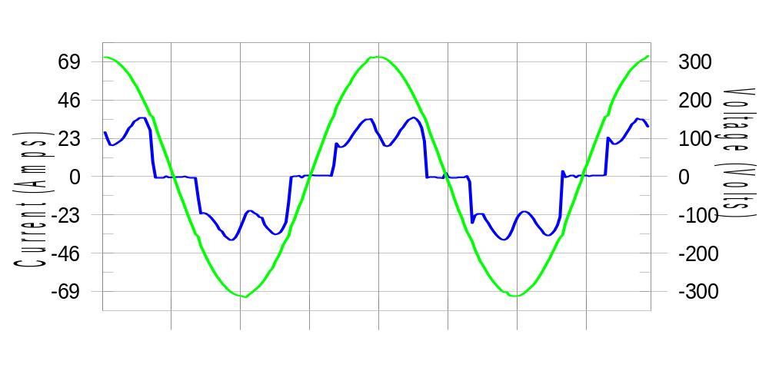

Harmonics and Class 3 limit line European Limits

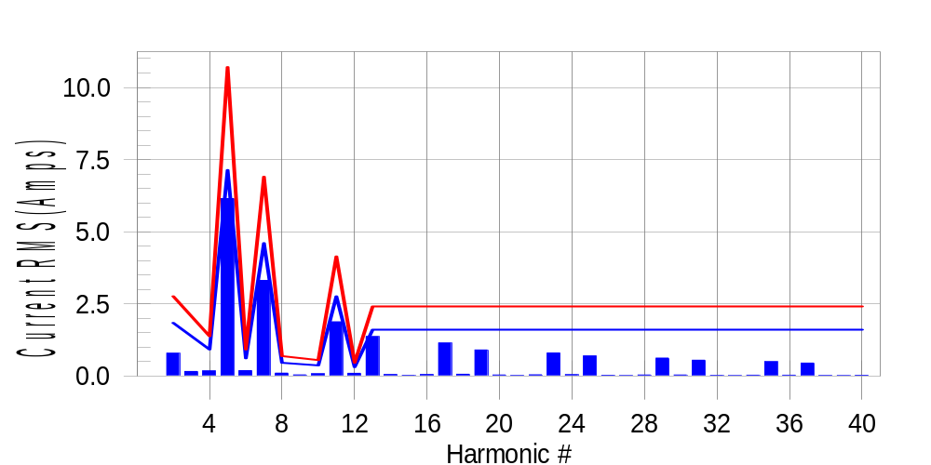

Test result: Fail Worst harmonic was #5 with 57.69 % of the limit.
Current Test Result Summary (Phase C-Run time)

EUT: Equipment under test Tested by: Tested by
Test category: Table:3, Rsce=250, Test Margin: 100
Test date: 2016/4/13 Start time: 15:31:20 End time: 15:34:12
Test duration (min): 2.5 Data file name: CTSMXH_H-000013.cts_data
Comment: Comment
Customer: Customer information

Test Result: Fail Measured I-ref: 23.260(Amps) Source: Normal
I-THC(%): 33.5 Limit(%): 37.0 PWHC(%): 43.9 PWHC Limit(%): 38.0

Highest parameter values during test:
V_RMS (Volts): 220.13 Frequency(Hz): 50.00
I_Peak (Amps): 45.920 I_RMS (Amps): 23.260
I_Fund (Amps): 21.659 Crest Factor: 1.986
Power (Watts): 4815 Power Factor: 0.941

Harm# Harms(avg) 100%Limit %of Limit Harms(max) 150%Limit %of Limit Status

2 0.792 1.842 43.0 0.822 2.764 29.7 Pass
3 0.115 N/A N/A 0.193 N/A N/A N/A
4 0.178 0.921 19.3 0.195 1.382 14.1 Pass
5 6.152 7.139 86.2 6.177 10.709 57.7 Pass
6 0.189 0.614 30.8 0.201 0.921 21.8 Pass
7 3.315 4.606 72.0 3.330 6.909 48.2 Pass
8 0.102 0.461 22.2 0.115 0.691 16.7 Pass
9 0.038 N/A N/A 0.050 N/A N/A N/A
10 0.080 0.368 21.6 0.089 0.553 16.1 Pass
11 1.880 2.764 68.0 1.896 4.145 45.7 Pass
12 0.096 0.307 31.3 0.103 0.461 22.4 Pass
13 1.368 1.612 84.9 1.381 2.418 57.1 Pass
14 0.054 N/A N/A 0.063 N/A N/A N/A
15 0.025 N/A N/A 0.035 N/A N/A N/A
16 0.054 N/A N/A 0.064 N/A N/A N/A
17 1.146 N/A N/A 1.158 N/A N/A N/A
18 0.064 N/A N/A 0.075 N/A N/A N/A
19 0.904 N/A N/A 0.913 N/A N/A N/A
20 0.038 N/A N/A 0.047 N/A N/A N/A
21 0.021 N/A N/A 0.031 N/A N/A N/A
22 0.042 N/A N/A 0.053 N/A N/A N/A
23 0.801 N/A N/A 0.811 N/A N/A N/A
24 0.047 N/A N/A 0.055 N/A N/A N/A
25 0.697 N/A N/A 0.705 N/A N/A N/A
26 0.029 N/A N/A 0.036 N/A N/A N/A
27 0.019 N/A N/A 0.036 N/A N/A N/A
28 0.036 N/A N/A 0.052 N/A N/A N/A
29 0.624 N/A N/A 0.634 N/A N/A N/A
30 0.038 N/A N/A 0.047 N/A N/A N/A
31 0.548 N/A N/A 0.559 N/A N/A N/A
32 0.025 N/A N/A 0.032 N/A N/A N/A
33 0.018 N/A N/A 0.027 N/A N/A N/A
34 0.030 N/A N/A 0.039 N/A N/A N/A
35 0.497 N/A N/A 0.505 N/A N/A N/A
36 0.032 N/A N/A 0.040 N/A N/A N/A
37 0.450 N/A N/A 0.459 N/A N/A N/A
38 0.021 N/A N/A 0.033 N/A N/A N/A
39 0.017 N/A N/A 0.027 N/A N/A N/A
40 0.026 N/A N/A 0.046 N/A N/A N/A

Note: Measured I-ref was applied for this test.

Voltage Source Verification Data (Phase C-Run time)

EUT: Equipment under test Tested by: Tested by
Test category: Table:3, Rsce=250, Test Margin: 100
Test date: 2016/4/13 Start time: 15:31:20 End time: 15:34:12
Test duration (min): 2.5 Data file name: CTSMXH_H-000013.cts_data
Comment: Comment
Customer: Customer information

Test Result: Fail Source qualification: Normal
Measured source distortion is within the requirements of the standards
Measurements are compliant with IEC/EN61000-3-12 Ed.4 & IEC/EN61000-4-7 Ed. 2.1

Highest parameter values during test:
Voltage (Vrms): 220.13 Frequency(Hz): 50.00
I_Peak (Amps): 45.920 I_RMS (Amps): 23.260
I_Fund (Amps): 21.659 Crest Factor: 1.986
Power (Watts): 4815 Power Factor: 0.941

Harm# Harmonics V-rms Limit V-rms % of Limit Status

2 0.188 0.880 21.31 OK
3 0.286 2.750 10.39 OK
4 0.117 0.880 13.29 OK
5 1.015 3.300 30.74 OK
6 0.109 0.880 12.43 OK
7 0.758 2.750 27.57 OK
8 0.103 0.880 11.65 OK
9 0.128 1.320 9.66 OK
10 0.119 0.880 13.52 OK
11 0.657 1.541 42.65 OK
12 0.109 0.660 16.55 OK
13 0.574 1.321 43.48 OK
14 0.107 0.660 16.24 OK
15 0.122 0.660 18.46 OK
16 0.125 0.660 18.98 OK
17 0.562 0.660 85.11 OK
18 0.119 0.660 17.99 OK
19 0.507 0.660 76.73 OK
20 0.110 0.660 16.69 OK
21 0.117 0.660 17.68 OK
22 0.122 0.660 18.54 OK
23 0.494 0.660 74.88 OK
24 0.114 0.660 17.25 OK
25 0.483 0.660 73.16 OK
26 0.103 0.660 15.61 OK
27 0.117 0.660 17.67 OK
28 0.100 0.660 15.20 OK
29 0.432 0.660 65.41 OK
30 0.105 0.660 15.92 OK
31 0.433 0.660 65.60 OK
32 0.100 0.660 15.22 OK
33 0.120 0.660 18.24 OK
34 0.095 0.660 14.32 OK
35 0.397 0.660 60.11 OK
36 0.095 0.660 14.42 OK
37 0.405 0.660 61.35 OK
38 0.092 0.660 13.91 OK
39 0.116 0.660 17.58 OK
40 0.110 0.660 16.61 OK

5th Harmonic Phase Angle and Magnitude for Phase A :
H-5_min_phase : 138.0 Degree (Leading)
H-5_max_phase : 138.9 Degree (Leading)
H-5_ave_phase : 138.4 Degree (Leading)

H-5_ave_vector_magnitude : 6.146 Amp
H-5_standard_ave_magnitude : 6.187 Amp
H-5_standard_max_magnitude : 6.177 Amp
Ratio of H-5_ave_vector / H-5_standard_ave : 0.999

Phase A = 115.277% of tested Rsce = 250.000, Rsce = 288.192
Phase B = 117.382% of tested Rsce = 250.000, Rsce = 293.454
Phase C = 115.458% of tested Rsce = 250.000, Rsce = 288.646
Minimum Rsce required: Rsce = 293.454

