Harmonics – Per EN/IEC61000-3-12, Ed. 2.0(Phase A-Run time)

EUT: Equipment under test Tested by: Tested by
Test category: Table:3, Rsce=250, Test Margin: 100
Test date: 2016/4/13 Start time: 15:41:15 End time: 15:44:08
Test duration (min): 2.5 Data file name: CTSMXH_H-000014.cts_data
Comment: Comment
Customer: Customer information

Test Result: Fail Source qualification: Normal

Current & voltage waveforms

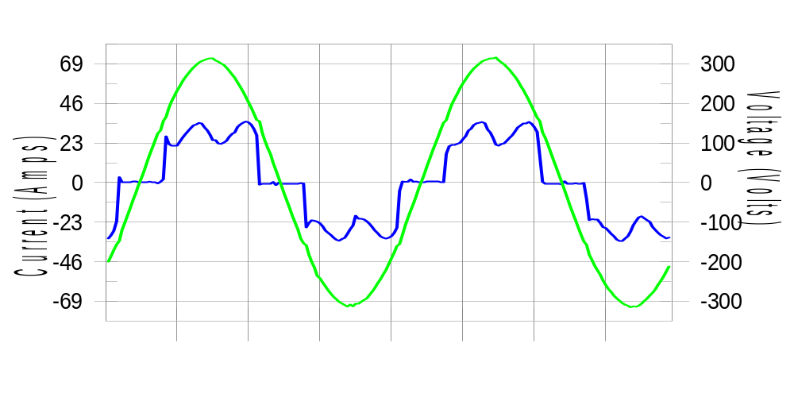

Harmonics and Class 3 limit line European Limits

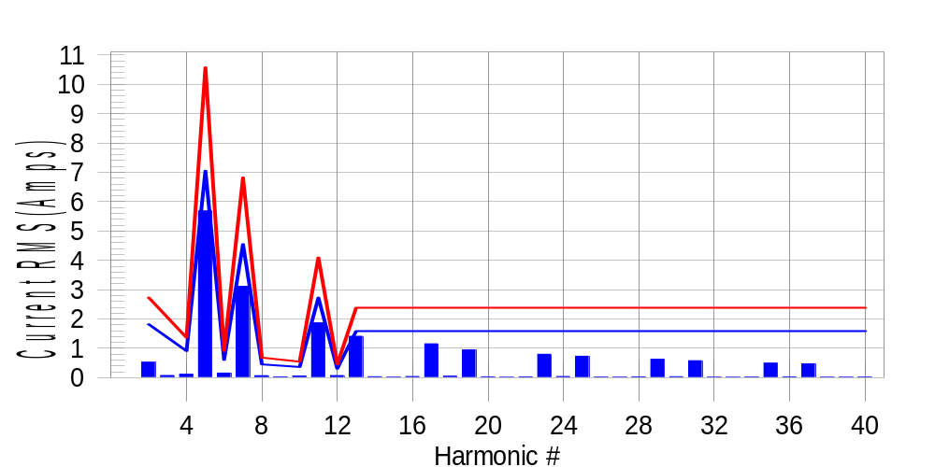

Test result: Fail Worst harmonic was #13 with 60.07 % of the limit.
Current Test Result Summary (Phase A-Run time)

EUT: Equipment under test Tested by: Tested by
Test category: Table:3, Rsce=250, Test Margin: 100
Test date: 2016/4/13 Start time: 15:41:15 End time: 15:44:08
Test duration (min): 2.5 Data file name: CTSMXH_H-000014.cts_data
Comment: Comment
Customer: Customer information

Test Result: Fail Measured I-ref: 22.992(Amps) Source: Normal
I-THC(%): 31.8 Limit(%): 37.0 PWHC(%): 45.4 PWHC Limit(%): 38.0

Highest parameter values during test:
V_RMS (Volts): 220.44 Frequency(Hz): 50.00
I_Peak (Amps): 45.377 I_RMS (Amps): 22.992
I_Fund (Amps): 21.525 Crest Factor: 1.981
Power (Watts): 4795 Power Factor: 0.947

Harm# Harms(avg) 100%Limit %of Limit Harms(max) 150%Limit %of Limit Status

2 0.527 1.820 28.9 0.561 2.730 20.5 Pass
3 0.075 N/A N/A 0.105 N/A N/A N/A
4 0.117 0.910 12.9 0.150 1.365 11.0 Pass
5 5.679 7.052 80.5 5.713 10.577 54.0 Pass
6 0.158 0.607 26.1 0.168 0.910 18.5 Pass
7 3.115 4.549 68.5 3.135 6.824 45.9 Pass
8 0.069 0.455 15.2 0.081 0.682 11.8 Pass
9 0.031 N/A N/A 0.051 N/A N/A N/A
10 0.055 0.364 15.2 0.069 0.546 12.7 Pass
11 1.870 2.730 68.5 1.885 4.094 46.0 Pass
12 0.072 0.303 23.7 0.080 0.455 17.6 Pass
13 1.413 1.592 88.8 1.435 2.388 60.1 Pass
14 0.034 N/A N/A 0.044 N/A N/A N/A
15 0.022 N/A N/A 0.031 N/A N/A N/A
16 0.040 N/A N/A 0.048 N/A N/A N/A
17 1.154 N/A N/A 1.168 N/A N/A N/A
18 0.048 N/A N/A 0.062 N/A N/A N/A
19 0.945 N/A N/A 0.957 N/A N/A N/A
20 0.030 N/A N/A 0.039 N/A N/A N/A
21 0.019 N/A N/A 0.027 N/A N/A N/A
22 0.031 N/A N/A 0.041 N/A N/A N/A
23 0.797 N/A N/A 0.808 N/A N/A N/A
24 0.041 N/A N/A 0.050 N/A N/A N/A
25 0.730 N/A N/A 0.740 N/A N/A N/A
26 0.023 N/A N/A 0.031 N/A N/A N/A
27 0.022 N/A N/A 0.031 N/A N/A N/A
28 0.031 N/A N/A 0.042 N/A N/A N/A
29 0.627 N/A N/A 0.637 N/A N/A N/A
30 0.035 N/A N/A 0.045 N/A N/A N/A
31 0.578 N/A N/A 0.588 N/A N/A N/A
32 0.021 N/A N/A 0.029 N/A N/A N/A
33 0.018 N/A N/A 0.027 N/A N/A N/A
34 0.025 N/A N/A 0.033 N/A N/A N/A
35 0.495 N/A N/A 0.515 N/A N/A N/A
36 0.031 N/A N/A 0.040 N/A N/A N/A
37 0.471 N/A N/A 0.482 N/A N/A N/A
38 0.021 N/A N/A 0.030 N/A N/A N/A
39 0.021 N/A N/A 0.031 N/A N/A N/A
40 0.024 N/A N/A 0.033 N/A N/A N/A

Note: Measured I-ref was applied for this test.

Voltage Source Verification Data (Phase A-Run time)

EUT: Equipment under test Tested by: Tested by
Test category: Table:3, Rsce=250, Test Margin: 100
Test date: 2016/4/13 Start time: 15:41:15 End time: 15:44:08
Test duration (min): 2.5 Data file name: CTSMXH_H-000014.cts_data
Comment: Comment
Customer: Customer information

Test Result: Fail Source qualification: Normal
Measured source distortion is within the requirements of the standards
Measurements are compliant with IEC/EN61000-3-12 Ed.4 & IEC/EN61000-4-7 Ed. 2.1

Highest parameter values during test:
Voltage (Vrms): 220.44 Frequency(Hz): 50.00
I_Peak (Amps): 45.377 I_RMS (Amps): 22.992
I_Fund (Amps): 21.525 Crest Factor: 1.981
Power (Watts): 4795 Power Factor: 0.947

Harm# Harmonics V-rms Limit V-rms % of Limit Status

2 0.142 0.881 16.09 OK
3 0.303 2.755 11.01 OK
4 0.113 0.881 12.80 OK
5 0.940 3.305 28.43 OK
6 0.112 0.881 12.68 OK
7 0.717 2.755 26.02 OK
8 0.095 0.881 10.83 OK
9 0.115 1.322 8.72 OK
10 0.104 0.881 11.86 OK
11 0.625 1.542 40.52 OK
12 0.096 0.661 14.57 OK
13 0.579 1.322 43.81 OK
14 0.104 0.661 15.69 OK
15 0.137 0.661 20.73 OK
16 0.094 0.661 14.19 OK
17 0.568 0.661 85.87 OK
18 0.101 0.661 15.26 OK
19 0.537 0.661 81.25 OK
20 0.178 0.661 26.92 OK
21 0.131 0.661 19.75 OK
22 0.103 0.661 15.59 OK
23 0.493 0.661 74.54 OK
24 0.099 0.661 15.04 OK
25 0.497 0.661 75.25 OK
26 0.088 0.661 13.28 OK
27 0.146 0.661 22.06 OK
28 0.124 0.661 18.80 OK
29 0.437 0.661 66.17 OK
30 0.102 0.661 15.49 OK
31 0.457 0.661 69.07 OK
32 0.105 0.661 15.83 OK
33 0.133 0.661 20.19 OK
34 0.095 0.661 14.36 OK
35 0.400 0.661 60.44 OK
36 0.088 0.661 13.32 OK
37 0.422 0.661 63.86 OK
38 0.096 0.661 14.56 OK
39 0.129 0.661 19.53 OK
40 0.142 0.661 21.43 OK

Harmonics – Per EN/IEC61000-3-12, Ed. 2.0(Phase B-Run time)

EUT: Equipment under test Tested by: Tested by
Test category: Table:3, Rsce=250, Test Margin: 100
Test date: 2016/4/13 Start time: 15:41:15 End time: 15:44:08
Test duration (min): 2.5 Data file name: CTSMXH_H-000014.cts_data
Comment: Comment
Customer: Customer information

Test Result: Fail Source qualification: Normal

Current & voltage waveforms

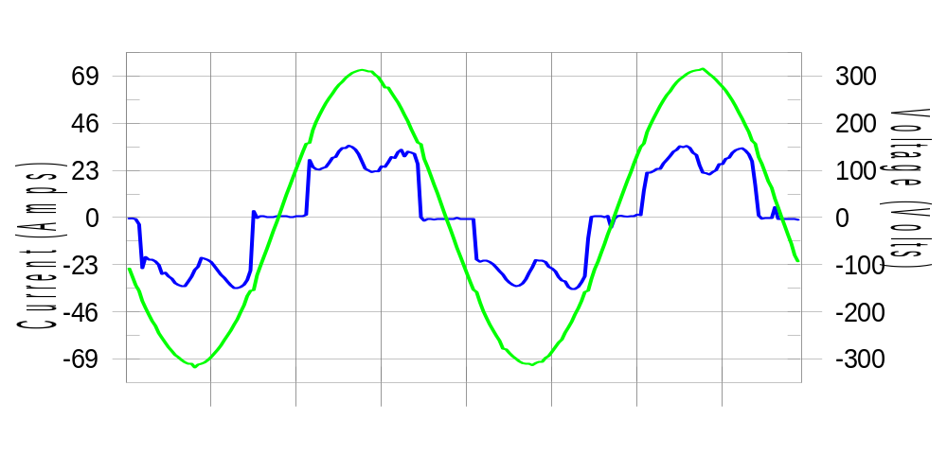

Harmonics and Class 3 limit line European Limits

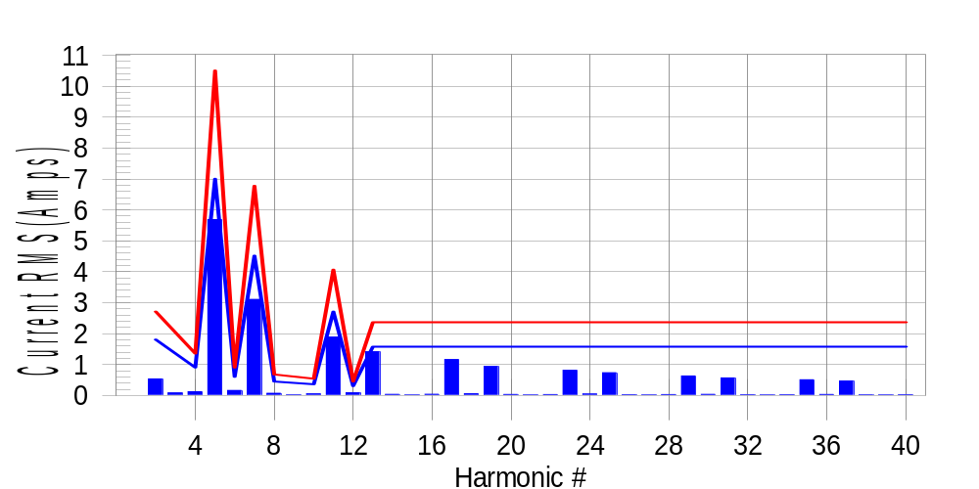

Test result: Fail Worst harmonic was #13 with 60.32 % of the limit.
Current Test Result Summary (Phase B-Run time)

EUT: Equipment under test Tested by: Tested by
Test category: Table:3, Rsce=250, Test Margin: 100
Test date: 2016/4/13 Start time: 15:41:15 End time: 15:44:08
Test duration (min): 2.5 Data file name: CTSMXH_H-000014.cts_data
Comment: Comment
Customer: Customer information

Test Result: Fail Measured I-ref: 22.883(Amps) Source: Normal
I-THC(%): 32.1 Limit(%): 37.0 PWHC(%): 45.9 PWHC Limit(%): 38.0

Highest parameter values during test:
V_RMS (Volts): 220.21 Frequency(Hz): 50.00
I_Peak (Amps): 51.260 I_RMS (Amps): 22.883
I_Fund (Amps): 21.370 Crest Factor: 2.251
Power (Watts): 4764 Power Factor: 0.946

Harm# Harms(avg) 100%Limit %of Limit Harms(max) 150%Limit %of Limit Status

2 0.536 1.808 29.6 0.566 2.712 20.9 Pass
3 0.075 N/A N/A 0.114 N/A N/A N/A
4 0.122 0.904 13.5 0.146 1.356 10.8 Pass
5 5.688 7.007 81.2 5.720 10.511 54.4 Pass
6 0.164 0.603 27.1 0.177 0.904 19.6 Pass
7 3.109 4.521 68.8 3.129 6.781 46.1 Pass
8 0.072 0.452 16.0 0.083 0.678 12.2 Pass
9 0.031 N/A N/A 0.029 N/A N/A N/A
10 0.053 0.362 14.7 0.064 0.542 11.8 Pass
11 1.891 2.712 69.7 1.911 4.069 47.0 Pass
12 0.087 0.301 29.0 0.099 0.452 22.0 Pass
13 1.416 1.582 89.5 1.431 2.373 60.3 Pass
14 0.036 N/A N/A 0.047 N/A N/A N/A
15 0.018 N/A N/A 0.026 N/A N/A N/A
16 0.038 N/A N/A 0.046 N/A N/A N/A
17 1.161 N/A N/A 1.175 N/A N/A N/A
18 0.054 N/A N/A 0.065 N/A N/A N/A
19 0.937 N/A N/A 0.951 N/A N/A N/A
20 0.032 N/A N/A 0.043 N/A N/A N/A
21 0.018 N/A N/A 0.032 N/A N/A N/A
22 0.031 N/A N/A 0.041 N/A N/A N/A
23 0.815 N/A N/A 0.829 N/A N/A N/A
24 0.046 N/A N/A 0.055 N/A N/A N/A
25 0.734 N/A N/A 0.751 N/A N/A N/A
26 0.025 N/A N/A 0.050 N/A N/A N/A
27 0.018 N/A N/A 0.025 N/A N/A N/A
28 0.031 N/A N/A 0.047 N/A N/A N/A
29 0.630 N/A N/A 0.641 N/A N/A N/A
30 0.036 N/A N/A 0.046 N/A N/A N/A
31 0.569 N/A N/A 0.580 N/A N/A N/A
32 0.023 N/A N/A 0.034 N/A N/A N/A
33 0.016 N/A N/A 0.024 N/A N/A N/A
34 0.024 N/A N/A 0.035 N/A N/A N/A
35 0.507 N/A N/A 0.519 N/A N/A N/A
36 0.033 N/A N/A 0.043 N/A N/A N/A
37 0.470 N/A N/A 0.481 N/A N/A N/A
38 0.022 N/A N/A 0.030 N/A N/A N/A
39 0.017 N/A N/A 0.025 N/A N/A N/A
40 0.023 N/A N/A 0.031 N/A N/A N/A

Note: Measured I-ref was applied for this test.

Voltage Source Verification Data (Phase B-Run time)

EUT: Equipment under test Tested by: Tested by
Test category: Table:3, Rsce=250, Test Margin: 100
Test date: 2016/4/13 Start time: 15:41:15 End time: 15:44:08
Test duration (min): 2.5 Data file name: CTSMXH_H-000014.cts_data
Comment: Comment
Customer: Customer information

Test Result: Fail Source qualification: Normal
Measured source distortion is within the requirements of the standards
Measurements are compliant with IEC/EN61000-3-12 Ed.4 & IEC/EN61000-4-7 Ed. 2.1

Highest parameter values during test:
Voltage (Vrms): 220.21 Frequency(Hz): 50.00
I_Peak (Amps): 51.260 I_RMS (Amps): 22.883
I_Fund (Amps): 21.370 Crest Factor: 2.251
Power (Watts): 4764 Power Factor: 0.946

Harm# Harmonics V-rms Limit V-rms % of Limit Status

2 0.178 0.881 20.21 OK
3 0.326 2.751 11.85 OK
4 0.129 0.881 14.66 OK
5 1.003 3.303 30.36 OK
6 0.122 0.880 13.91 OK
7 0.741 2.751 26.94 OK
8 0.137 0.881 15.61 OK
9 0.136 1.321 10.26 OK
10 0.122 0.880 13.83 OK
11 0.682 1.541 44.23 OK
12 0.153 0.660 23.16 OK
13 0.620 1.321 46.90 OK
14 0.120 0.660 18.15 OK
15 0.151 0.660 22.92 OK
16 0.119 0.661 18.03 OK
17 0.574 0.661 86.94 OK
18 0.140 0.660 21.26 OK
19 0.562 0.660 85.02 OK
20 0.138 0.660 20.84 OK
21 0.131 0.660 19.79 OK
22 0.114 0.660 17.26 OK
23 0.518 0.660 78.43 OK
24 0.116 0.660 17.49 OK
25 0.530 0.660 80.25 OK
26 0.119 0.661 18.05 OK
27 0.139 0.660 21.05 OK
28 0.130 0.660 19.68 OK
29 0.488 0.660 73.95 OK
30 0.142 0.661 21.55 OK
31 0.471 0.660 71.37 OK
32 0.130 0.660 19.69 OK
33 0.155 0.660 23.42 OK
34 0.128 0.660 19.34 OK
35 0.410 0.660 62.07 OK
36 0.114 0.660 17.29 OK
37 0.433 0.660 65.51 OK
38 0.117 0.660 17.66 OK
39 0.154 0.660 23.36 OK
40 0.145 0.661 21.94 OK

Harmonics – Per EN/IEC61000-3-12, Ed. 2.0(Phase C-Run time)

EUT: Equipment under test Tested by: Tested by
Test category: Table:3, Rsce=250, Test Margin: 100
Test date: 2016/4/13 Start time: 15:41:15 End time: 15:44:08
Test duration (min): 2.5 Data file name: CTSMXH_H-000014.cts_data
Comment: Comment
Customer: Customer information

Test Result: Fail Source qualification: Normal

Current & voltage waveforms

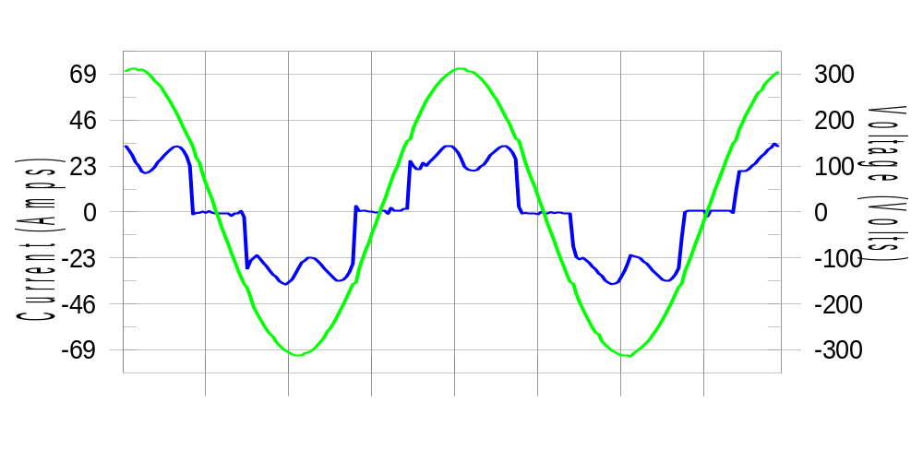

Harmonics and Class 3 limit line European Limits

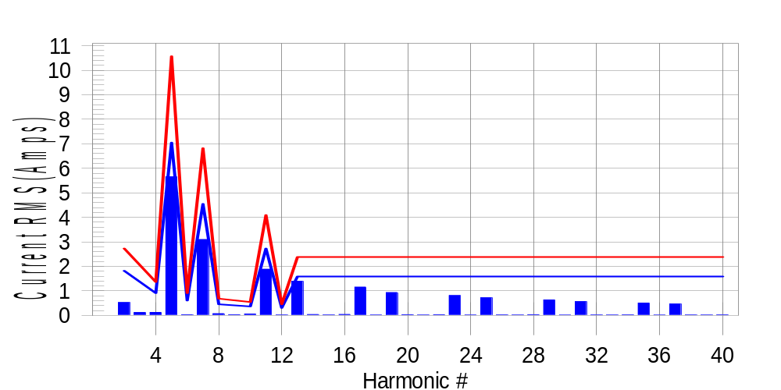

Test result: Fail Worst harmonic was #13 with 59.05 % of the limit.
Current Test Result Summary (Phase C-Run time)

EUT: Equipment under test Tested by: Tested by
Test category: Table:3, Rsce=250, Test Margin: 100
Test date: 2016/4/13 Start time: 15:41:15 End time: 15:44:08
Test duration (min): 2.5 Data file name: CTSMXH_H-000014.cts_data
Comment: Comment
Customer: Customer information

Test Result: Fail Measured I-ref: 22.997(Amps) Source: Normal
I-THC(%): 31.7 Limit(%): 37.0 PWHC(%): 45.3 PWHC Limit(%): 38.0

Highest parameter values during test:
V_RMS (Volts): 220.14 Frequency(Hz): 50.00
I_Peak (Amps): 44.782 I_RMS (Amps): 22.997
I_Fund (Amps): 21.516 Crest Factor: 1.971
Power (Watts): 4792 Power Factor: 0.947

Harm# Harms(avg) 100%Limit %of Limit Harms(max) 150%Limit %of Limit Status

2 0.527 1.819 29.0 0.559 2.728 20.5 Pass
3 0.075 N/A N/A 0.154 N/A N/A N/A
4 0.121 0.909 13.3 0.137 1.364 10.1 Pass
5 5.655 7.048 80.2 5.686 10.572 53.8 Pass
6 0.031 0.606 5.0 0.040 0.909 4.4 Pass
7 3.098 4.547 68.1 3.114 6.821 45.7 Pass
8 0.070 0.455 15.4 0.079 0.682 11.5 Pass
9 0.031 N/A N/A 0.038 N/A N/A N/A
10 0.056 0.364 15.4 0.069 0.546 12.7 Pass
11 1.884 2.728 69.0 1.905 4.092 46.6 Pass
12 0.020 0.303 6.7 0.028 0.455 6.2 Pass
13 1.395 1.592 87.6 1.408 2.387 59.0 Pass
14 0.037 N/A N/A 0.047 N/A N/A N/A
15 0.020 N/A N/A 0.029 N/A N/A N/A
16 0.039 N/A N/A 0.047 N/A N/A N/A
17 1.155 N/A N/A 1.170 N/A N/A N/A
18 0.017 N/A N/A 0.023 N/A N/A N/A
19 0.935 N/A N/A 0.945 N/A N/A N/A
20 0.029 N/A N/A 0.036 N/A N/A N/A
21 0.019 N/A N/A 0.025 N/A N/A N/A
22 0.031 N/A N/A 0.041 N/A N/A N/A
23 0.811 N/A N/A 0.822 N/A N/A N/A
24 0.016 N/A N/A 0.023 N/A N/A N/A
25 0.721 N/A N/A 0.733 N/A N/A N/A
26 0.023 N/A N/A 0.032 N/A N/A N/A
27 0.017 N/A N/A 0.041 N/A N/A N/A
28 0.030 N/A N/A 0.042 N/A N/A N/A
29 0.633 N/A N/A 0.644 N/A N/A N/A
30 0.015 N/A N/A 0.022 N/A N/A N/A
31 0.566 N/A N/A 0.573 N/A N/A N/A
32 0.021 N/A N/A 0.027 N/A N/A N/A
33 0.017 N/A N/A 0.026 N/A N/A N/A
34 0.023 N/A N/A 0.031 N/A N/A N/A
35 0.504 N/A N/A 0.515 N/A N/A N/A
36 0.015 N/A N/A 0.022 N/A N/A N/A
37 0.465 N/A N/A 0.480 N/A N/A N/A
38 0.020 N/A N/A 0.027 N/A N/A N/A
39 0.016 N/A N/A 0.026 N/A N/A N/A
40 0.023 N/A N/A 0.030 N/A N/A N/A

Note: Measured I-ref was applied for this test.

Voltage Source Verification Data (Phase C-Run time)

EUT: Equipment under test Tested by: Tested by
Test category: Table:3, Rsce=250, Test Margin: 100
Test date: 2016/4/13 Start time: 15:41:15 End time: 15:44:08
Test duration (min): 2.5 Data file name: CTSMXH_H-000014.cts_data
Comment: Comment
Customer: Customer information

Test Result: Fail Source qualification: Normal
Measured source distortion is within the requirements of the standards
Measurements are compliant with IEC/EN61000-3-12 Ed.4 & IEC/EN61000-4-7 Ed. 2.1

Highest parameter values during test:
Voltage (Vrms): 220.14 Frequency(Hz): 50.00
I_Peak (Amps): 44.782 I_RMS (Amps): 22.997
I_Fund (Amps): 21.516 Crest Factor: 1.971
Power (Watts): 4792 Power Factor: 0.947

Harm# Harmonics V-rms Limit V-rms % of Limit Status

2 0.166 0.880 18.83 OK
3 0.277 2.751 10.06 OK
4 0.142 0.880 16.12 OK
5 0.954 3.302 28.88 OK
6 0.095 0.880 10.82 OK
7 0.725 2.751 26.36 OK
8 0.114 0.880 12.97 OK
9 0.127 1.320 9.60 OK
10 0.105 0.880 11.92 OK
11 0.641 1.541 41.59 OK
12 0.091 0.660 13.75 OK
13 0.567 1.320 42.92 OK
14 0.094 0.660 14.22 OK
15 0.115 0.660 17.41 OK
16 0.105 0.660 15.92 OK
17 0.563 0.660 85.26 OK
18 0.111 0.660 16.75 OK
19 0.530 0.660 80.31 OK
20 0.108 0.660 16.42 OK
21 0.120 0.660 18.12 OK
22 0.124 0.660 18.76 OK
23 0.484 0.660 73.38 OK
24 0.113 0.660 17.08 OK
25 0.486 0.660 73.61 OK
26 0.104 0.660 15.80 OK
27 0.122 0.660 18.41 OK
28 0.114 0.660 17.24 OK
29 0.436 0.660 66.12 OK
30 0.104 0.660 15.78 OK
31 0.455 0.660 68.92 OK
32 0.098 0.660 14.86 OK
33 0.110 0.660 16.64 OK
34 0.100 0.660 15.16 OK
35 0.398 0.660 60.29 OK
36 0.106 0.660 16.01 OK
37 0.430 0.660 65.16 OK
38 0.092 0.660 13.90 OK
39 0.117 0.660 17.78 OK
40 0.109 0.660 16.58 OK

5th Harmonic Phase Angle and Magnitude for Phase A :
H-5_min_phase : 142.1 Degree (Leading)
H-5_max_phase : 143.0 Degree (Leading)
H-5_ave_phase : 142.5 Degree (Leading)

H-5_ave_vector_magnitude : 5.649 Amp
H-5_standard_ave_magnitude : 5.679 Amp
H-5_standard_max_magnitude : 5.686 Amp
Ratio of H-5_ave_vector / H-5_standard_ave : 0.999

Phase A = 119.384% of tested Rsce = 250.000, Rsce = 298.459
Phase B = 120.749% of tested Rsce = 250.000, Rsce = 301.872
Phase C = 119.197% of tested Rsce = 250.000, Rsce = 297.993
Minimum Rsce required: Rsce = 301.872

