Harmonics – Per EN/IEC61000-3-12, Ed. 2.0(Phase A-Run time)

EUT: Equipment under test Tested by: Tested by
Test category: Table:3, Rsce=250, Test Margin: 100
Test date: 2016/4/13 Start time: 15:51:04 End time: 15:53:56
Test duration (min): 2.5 Data file name: CTSMXH_H-000015.cts_data
Comment: Comment
Customer: Customer information

Test Result: Fail Source qualification: Normal

Current & voltage waveforms

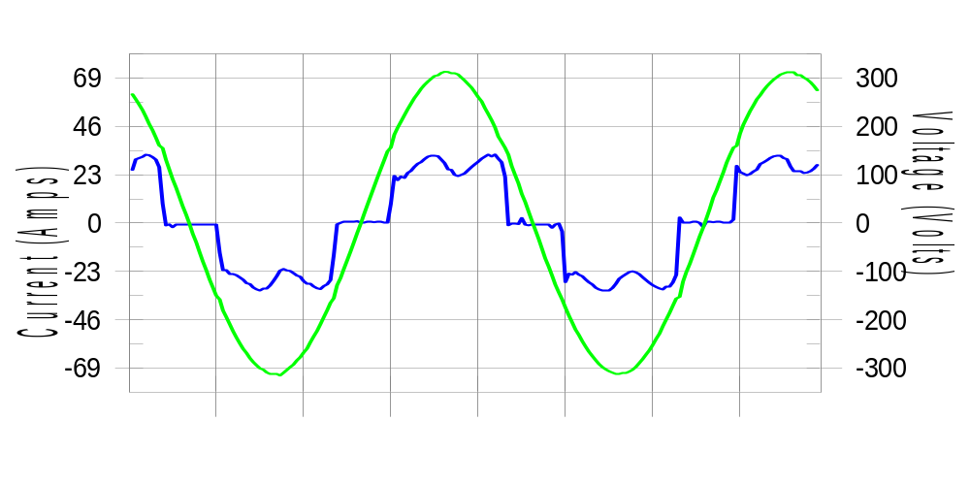

Harmonics and Class 3 limit line European Limits

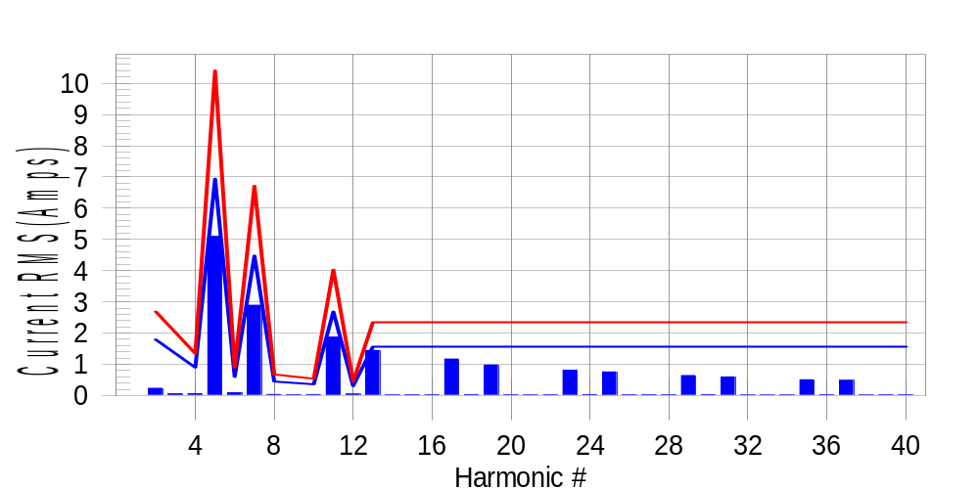

Test result: Fail Worst harmonic was #13 with 61.90 % of the limit.
Current Test Result Summary (Phase A-Run time)

EUT: Equipment under test Tested by: Tested by
Test category: Table:3, Rsce=250, Test Margin: 100
Test date: 2016/4/13 Start time: 15:51:04 End time: 15:53:56
Test duration (min): 2.5 Data file name: CTSMXH_H-000015.cts_data
Comment: Comment
Customer: Customer information

Test Result: Fail Measured I-ref: 22.592(Amps) Source: Normal
I-THC(%): 29.9 Limit(%): 37.0 PWHC(%): 47.0 PWHC Limit(%): 38.0

Highest parameter values during test:
V_RMS (Volts): 220.44 Frequency(Hz): 50.00
I_Peak (Amps): 46.105 I_RMS (Amps): 22.592
I_Fund (Amps): 21.324 Crest Factor: 2.056
Power (Watts): 4743 Power Factor: 0.954

Harm# Harms(avg) 100%Limit %of Limit Harms(max) 150%Limit %of Limit Status

2 0.230 1.791 12.8 0.258 2.686 9.6 Pass
3 0.054 N/A N/A 0.081 N/A N/A N/A
4 0.054 0.895 6.1 0.072 1.343 5.4 Pass
5 5.095 6.939 73.4 5.129 10.408 49.3 Pass
6 0.085 0.597 14.2 0.095 0.895 10.7 Pass
7 2.891 4.477 64.6 2.911 6.715 43.3 Pass
8 0.034 0.448 7.7 0.045 0.672 6.7 Pass
9 0.025 N/A N/A 0.037 N/A N/A N/A
10 0.029 0.358 8.2 0.039 0.537 7.3 Pass
11 1.873 2.686 69.7 1.889 4.029 46.9 Pass
12 0.044 0.298 14.7 0.053 0.448 11.8 Pass
13 1.441 1.567 92.0 1.454 2.350 61.9 Pass
14 0.019 N/A N/A 0.038 N/A N/A N/A
15 0.023 N/A N/A 0.031 N/A N/A N/A
16 0.024 N/A N/A 0.033 N/A N/A N/A
17 1.167 N/A N/A 1.184 N/A N/A N/A
18 0.030 N/A N/A 0.039 N/A N/A N/A
19 0.975 N/A N/A 0.986 N/A N/A N/A
20 0.019 N/A N/A 0.030 N/A N/A N/A
21 0.018 N/A N/A 0.025 N/A N/A N/A
22 0.020 N/A N/A 0.029 N/A N/A N/A
23 0.808 N/A N/A 0.816 N/A N/A N/A
24 0.028 N/A N/A 0.041 N/A N/A N/A
25 0.753 N/A N/A 0.764 N/A N/A N/A
26 0.019 N/A N/A 0.026 N/A N/A N/A
27 0.023 N/A N/A 0.038 N/A N/A N/A
28 0.021 N/A N/A 0.029 N/A N/A N/A
29 0.636 N/A N/A 0.650 N/A N/A N/A
30 0.026 N/A N/A 0.034 N/A N/A N/A
31 0.594 N/A N/A 0.606 N/A N/A N/A
32 0.017 N/A N/A 0.026 N/A N/A N/A
33 0.016 N/A N/A 0.025 N/A N/A N/A
34 0.018 N/A N/A 0.027 N/A N/A N/A
35 0.502 N/A N/A 0.511 N/A N/A N/A
36 0.025 N/A N/A 0.035 N/A N/A N/A
37 0.484 N/A N/A 0.494 N/A N/A N/A
38 0.018 N/A N/A 0.024 N/A N/A N/A
39 0.020 N/A N/A 0.028 N/A N/A N/A
40 0.019 N/A N/A 0.026 N/A N/A N/A

Note: Measured I-ref was applied for this test.

Voltage Source Verification Data (Phase A-Run time)

EUT: Equipment under test Tested by: Tested by
Test category: Table:3, Rsce=250, Test Margin: 100
Test date: 2016/4/13 Start time: 15:51:04 End time: 15:53:56
Test duration (min): 2.5 Data file name: CTSMXH_H-000015.cts_data
Comment: Comment
Customer: Customer information

Test Result: Fail Source qualification: Normal
Measured source distortion is within the requirements of the standards
Measurements are compliant with IEC/EN61000-3-12 Ed.4 & IEC/EN61000-4-7 Ed. 2.1

Highest parameter values during test:
Voltage (Vrms): 220.44 Frequency(Hz): 50.00
I_Peak (Amps): 46.105 I_RMS (Amps): 22.592
I_Fund (Amps): 21.324 Crest Factor: 2.056
Power (Watts): 4743 Power Factor: 0.954

Harm# Harmonics V-rms Limit V-rms % of Limit Status

2 0.156 0.881 17.75 OK
3 0.295 2.755 10.71 OK
4 0.119 0.881 13.50 OK
5 0.868 3.306 26.27 OK
6 0.098 0.881 11.13 OK
7 0.673 2.755 24.44 OK
8 0.087 0.881 9.83 OK
9 0.128 1.322 9.66 OK
10 0.092 0.881 10.46 OK
11 0.623 1.543 40.39 OK
12 0.093 0.661 14.03 OK
13 0.585 1.322 44.26 OK
14 0.084 0.661 12.77 OK
15 0.117 0.661 17.67 OK
16 0.084 0.661 12.76 OK
17 0.557 0.661 84.33 OK
18 0.081 0.661 12.20 OK
19 0.535 0.661 80.93 OK
20 0.171 0.661 25.80 OK
21 0.121 0.661 18.35 OK
22 0.084 0.661 12.73 OK
23 0.490 0.661 74.08 OK
24 0.083 0.661 12.57 OK
25 0.512 0.661 77.38 OK
26 0.083 0.661 12.58 OK
27 0.138 0.661 20.92 OK
28 0.093 0.661 14.00 OK
29 0.432 0.661 65.31 OK
30 0.110 0.661 16.64 OK
31 0.459 0.661 69.38 OK
32 0.080 0.661 12.06 OK
33 0.129 0.661 19.48 OK
34 0.077 0.661 11.61 OK
35 0.395 0.661 59.74 OK
36 0.091 0.661 13.78 OK
37 0.434 0.661 65.60 OK
38 0.087 0.661 13.15 OK
39 0.122 0.661 18.48 OK
40 0.149 0.661 22.54 OK

Harmonics – Per EN/IEC61000-3-12, Ed. 2.0(Phase B-Run time)

EUT: Equipment under test Tested by: Tested by
Test category: Table:3, Rsce=250, Test Margin: 100
Test date: 2016/4/13 Start time: 15:51:04 End time: 15:53:56
Test duration (min): 2.5 Data file name: CTSMXH_H-000015.cts_data
Comment: Comment
Customer: Customer information

Test Result: Fail Source qualification: Normal

Current & voltage waveforms

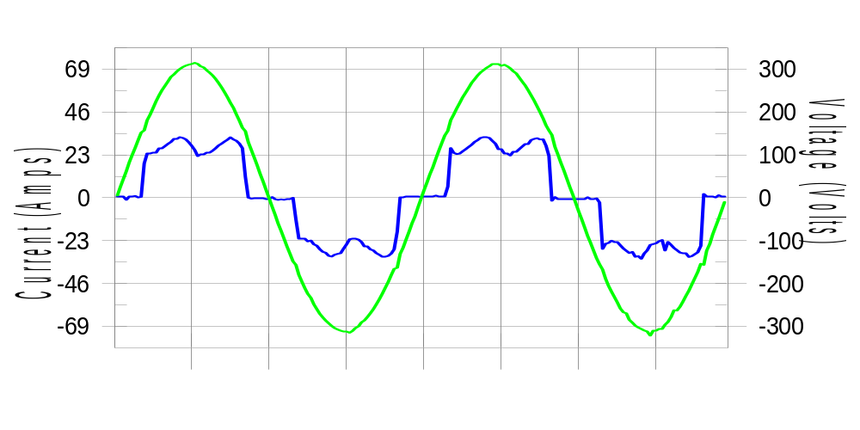

Harmonics and Class 3 limit line European Limits

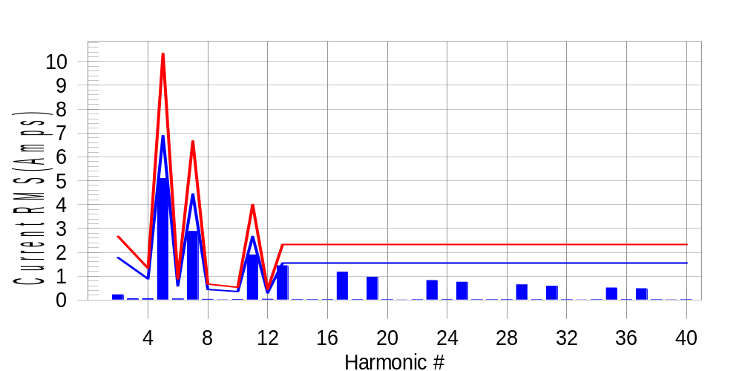

Test result: Fail Worst harmonic was #13 with 62.40 % of the limit.
Current Test Result Summary (Phase B-Run time)

EUT: Equipment under test Tested by: Tested by
Test category: Table:3, Rsce=250, Test Margin: 100
Test date: 2016/4/13 Start time: 15:51:04 End time: 15:53:56
Test duration (min): 2.5 Data file name: CTSMXH_H-000015.cts_data
Comment: Comment
Customer: Customer information

Test Result: Fail Measured I-ref: 22.504(Amps) Source: Normal
I-THC(%): 30.1 Limit(%): 37.0 PWHC(%): 47.2 PWHC Limit(%): 38.0

Highest parameter values during test:
V_RMS (Volts): 220.22 Frequency(Hz): 50.00
I_Peak (Amps): 43.017 I_RMS (Amps): 22.504
I_Fund (Amps): 21.166 Crest Factor: 1.926
Power (Watts): 4720 Power Factor: 0.953

Harm# Harms(avg) 100%Limit %of Limit Harms(max) 150%Limit %of Limit Status

2 0.223 1.778 12.5 0.252 2.667 9.4 Pass
3 0.054 N/A N/A 0.082 N/A N/A N/A
4 0.054 0.889 6.1 0.067 1.334 5.0 Pass
5 5.094 6.890 73.9 5.125 10.336 49.6 Pass
6 0.044 0.593 7.4 0.055 0.889 6.2 Pass
7 2.877 4.445 64.7 2.895 6.668 43.4 Pass
8 0.034 0.445 7.7 0.045 0.667 6.8 Pass
9 0.025 N/A N/A 0.027 N/A N/A N/A
10 0.025 0.356 7.0 0.032 0.533 6.1 Pass
11 1.889 2.667 70.8 1.906 4.001 47.6 Pass
12 0.035 0.296 11.8 0.041 0.445 9.2 Pass
13 1.438 1.556 92.4 1.456 2.334 62.4 Pass
14 0.016 N/A N/A 0.022 N/A N/A N/A
15 0.015 N/A N/A 0.022 N/A N/A N/A
16 0.020 N/A N/A 0.026 N/A N/A N/A
17 1.168 N/A N/A 1.178 N/A N/A N/A
18 0.018 N/A N/A 0.026 N/A N/A N/A
19 0.961 N/A N/A 0.978 N/A N/A N/A
20 0.018 N/A N/A 0.027 N/A N/A N/A
21 0.009 N/A N/A 0.017 N/A N/A N/A
22 0.015 N/A N/A 0.022 N/A N/A N/A
23 0.821 N/A N/A 0.834 N/A N/A N/A
24 0.021 N/A N/A 0.028 N/A N/A N/A
25 0.750 N/A N/A 0.763 N/A N/A N/A
26 0.015 N/A N/A 0.024 N/A N/A N/A
27 0.014 N/A N/A 0.022 N/A N/A N/A
28 0.016 N/A N/A 0.023 N/A N/A N/A
29 0.637 N/A N/A 0.645 N/A N/A N/A
30 0.015 N/A N/A 0.024 N/A N/A N/A
31 0.580 N/A N/A 0.594 N/A N/A N/A
32 0.013 N/A N/A 0.021 N/A N/A N/A
33 0.009 N/A N/A 0.018 N/A N/A N/A
34 0.014 N/A N/A 0.021 N/A N/A N/A
35 0.510 N/A N/A 0.523 N/A N/A N/A
36 0.016 N/A N/A 0.023 N/A N/A N/A
37 0.478 N/A N/A 0.491 N/A N/A N/A
38 0.014 N/A N/A 0.021 N/A N/A N/A
39 0.010 N/A N/A 0.018 N/A N/A N/A
40 0.013 N/A N/A 0.020 N/A N/A N/A

Note: Measured I-ref was applied for this test.

Voltage Source Verification Data (Phase B-Run time)

EUT: Equipment under test Tested by: Tested by
Test category: Table:3, Rsce=250, Test Margin: 100
Test date: 2016/4/13 Start time: 15:51:04 End time: 15:53:56
Test duration (min): 2.5 Data file name: CTSMXH_H-000015.cts_data
Comment: Comment
Customer: Customer information

Test Result: Fail Source qualification: Normal
Measured source distortion is within the requirements of the standards
Measurements are compliant with IEC/EN61000-3-12 Ed.4 & IEC/EN61000-4-7 Ed. 2.1

Highest parameter values during test:
Voltage (Vrms): 220.22 Frequency(Hz): 50.00
I_Peak (Amps): 43.017 I_RMS (Amps): 22.504
I_Fund (Amps): 21.166 Crest Factor: 1.926
Power (Watts): 4720 Power Factor: 0.953

Harm# Harmonics V-rms Limit V-rms % of Limit Status

2 0.147 0.880 16.71 OK
3 0.292 2.752 10.60 OK
4 0.133 0.881 15.14 OK
5 0.919 3.303 27.83 OK
6 0.104 0.881 11.78 OK
7 0.714 2.752 25.93 OK
8 0.107 0.881 12.16 OK
9 0.143 1.321 10.86 OK
10 0.097 0.881 11.00 OK
11 0.660 1.541 42.79 OK
12 0.103 0.660 15.59 OK
13 0.615 1.321 46.59 OK
14 0.124 0.660 18.74 OK
15 0.126 0.660 19.01 OK
16 0.108 0.660 16.28 OK
17 0.588 0.660 89.07 OK
18 0.100 0.660 15.18 OK
19 0.552 0.660 83.64 OK
20 0.124 0.660 18.73 OK
21 0.132 0.660 20.06 OK
22 0.109 0.660 16.53 OK
23 0.522 0.660 79.07 OK
24 0.094 0.660 14.24 OK
25 0.524 0.661 79.27 OK
26 0.117 0.660 17.78 OK
27 0.130 0.660 19.66 OK
28 0.103 0.660 15.65 OK
29 0.467 0.660 70.76 OK
30 0.099 0.660 15.01 OK
31 0.465 0.660 70.34 OK
32 0.106 0.660 16.03 OK
33 0.141 0.660 21.35 OK
34 0.115 0.660 17.49 OK
35 0.420 0.660 63.55 OK
36 0.105 0.660 15.96 OK
37 0.431 0.660 65.33 OK
38 0.113 0.660 17.17 OK
39 0.136 0.660 20.52 OK
40 0.115 0.660 17.42 OK

Harmonics – Per EN/IEC61000-3-12, Ed. 2.0(Phase C-Run time)

EUT: Equipment under test Tested by: Tested by
Test category: Table:3, Rsce=250, Test Margin: 100
Test date: 2016/4/13 Start time: 15:51:04 End time: 15:53:56
Test duration (min): 2.5 Data file name: CTSMXH_H-000015.cts_data
Comment: Comment
Customer: Customer information

Test Result: Fail Source qualification: Normal

Current & voltage waveforms

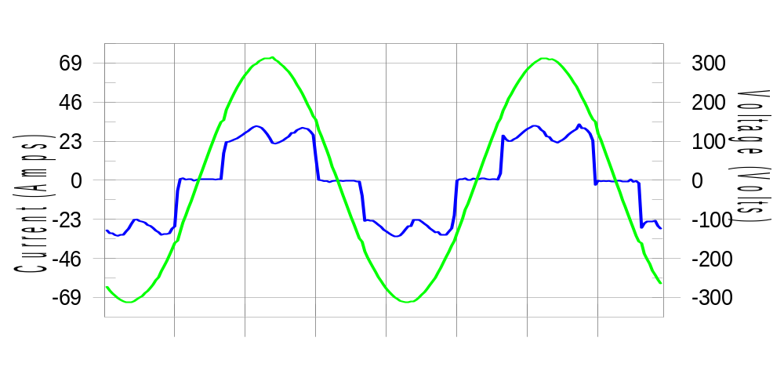

Harmonics and Class 3 limit line European Limits

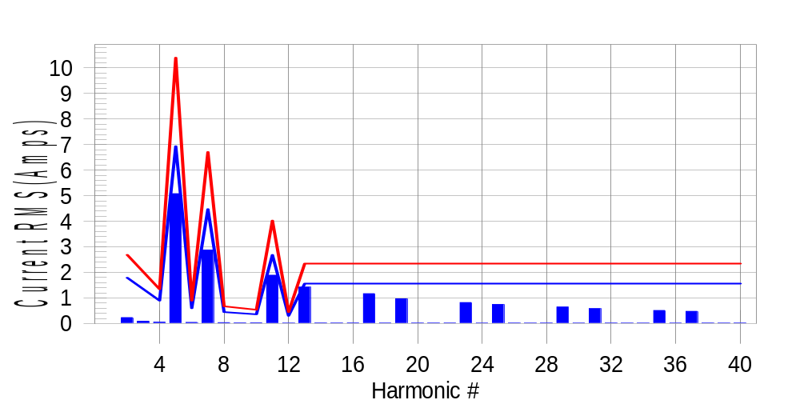

Test result: Fail Worst harmonic was #13 with 61.16 % of the limit.
Current Test Result Summary (Phase C-Run time)

EUT: Equipment under test Tested by: Tested by
Test category: Table:3, Rsce=250, Test Margin: 100
Test date: 2016/4/13 Start time: 15:51:04 End time: 15:53:56
Test duration (min): 2.5 Data file name: CTSMXH_H-000015.cts_data
Comment: Comment
Customer: Customer information

Test Result: Fail Measured I-ref: 22.601(Amps) Source: Normal
I-THC(%): 29.8 Limit(%): 37.0 PWHC(%): 46.9 PWHC Limit(%): 38.0

Highest parameter values during test:
V_RMS (Volts): 220.15 Frequency(Hz): 50.00
I_Peak (Amps): 41.263 I_RMS (Amps): 22.601
I_Fund (Amps): 21.321 Crest Factor: 1.847
Power (Watts): 4744 Power Factor: 0.954

Harm# Harms(avg) 100%Limit %of Limit Harms(max) 150%Limit %of Limit Status

2 0.231 1.790 12.9 0.255 2.685 9.5 Pass
3 0.054 N/A N/A 0.118 N/A N/A N/A
4 0.050 0.895 5.6 0.066 1.342 4.9 Pass
5 5.079 6.936 73.2 5.106 10.404 49.1 Pass
6 0.042 0.597 7.0 0.050 0.895 5.5 Pass
7 2.875 4.475 64.2 2.897 6.712 43.2 Pass
8 0.034 0.447 7.6 0.043 0.671 6.4 Pass
9 0.025 N/A N/A 0.033 N/A N/A N/A
10 0.028 0.358 7.8 0.036 0.537 6.7 Pass
11 1.889 2.685 70.3 1.904 4.027 47.3 Pass
12 0.015 0.298 5.1 0.023 0.447 5.1 Pass
13 1.423 1.566 90.8 1.437 2.349 61.2 Pass
14 0.019 N/A N/A 0.029 N/A N/A N/A
15 0.016 N/A N/A 0.023 N/A N/A N/A
16 0.021 N/A N/A 0.030 N/A N/A N/A
17 1.167 N/A N/A 1.179 N/A N/A N/A
18 0.017 N/A N/A 0.025 N/A N/A N/A
19 0.965 N/A N/A 0.976 N/A N/A N/A
20 0.018 N/A N/A 0.025 N/A N/A N/A
21 0.016 N/A N/A 0.022 N/A N/A N/A
22 0.017 N/A N/A 0.023 N/A N/A N/A
23 0.820 N/A N/A 0.832 N/A N/A N/A
24 0.013 N/A N/A 0.019 N/A N/A N/A
25 0.743 N/A N/A 0.752 N/A N/A N/A
26 0.017 N/A N/A 0.025 N/A N/A N/A
27 0.014 N/A N/A 0.021 N/A N/A N/A
28 0.018 N/A N/A 0.026 N/A N/A N/A
29 0.642 N/A N/A 0.651 N/A N/A N/A
30 0.015 N/A N/A 0.023 N/A N/A N/A
31 0.581 N/A N/A 0.593 N/A N/A N/A
32 0.016 N/A N/A 0.024 N/A N/A N/A
33 0.015 N/A N/A 0.023 N/A N/A N/A
34 0.015 N/A N/A 0.023 N/A N/A N/A
35 0.510 N/A N/A 0.519 N/A N/A N/A
36 0.014 N/A N/A 0.021 N/A N/A N/A
37 0.475 N/A N/A 0.485 N/A N/A N/A
38 0.016 N/A N/A 0.025 N/A N/A N/A
39 0.014 N/A N/A 0.021 N/A N/A N/A
40 0.016 N/A N/A 0.024 N/A N/A N/A

Note: Measured I-ref was applied for this test.

Voltage Source Verification Data (Phase C-Run time)

EUT: Equipment under test Tested by: Tested by
Test category: Table:3, Rsce=250, Test Margin: 100
Test date: 2016/4/13 Start time: 15:51:04 End time: 15:53:56
Test duration (min): 2.5 Data file name: CTSMXH_H-000015.cts_data
Comment: Comment
Customer: Customer information

Test Result: Fail Source qualification: Normal
Measured source distortion is within the requirements of the standards
Measurements are compliant with IEC/EN61000-3-12 Ed.4 & IEC/EN61000-4-7 Ed. 2.1

Highest parameter values during test:
Voltage (Vrms): 220.15 Frequency(Hz): 50.00
I_Peak (Amps): 41.263 I_RMS (Amps): 22.601
I_Fund (Amps): 21.321 Crest Factor: 1.847
Power (Watts): 4744 Power Factor: 0.954

Harm# Harmonics V-rms Limit V-rms % of Limit Status

2 0.173 0.881 19.68 OK
3 0.263 2.751 9.55 OK
4 0.106 0.881 12.09 OK
5 0.860 3.300 26.05 OK
6 0.095 0.880 10.82 OK
7 0.686 2.751 24.93 OK
8 0.096 0.880 10.88 OK
9 0.110 1.320 8.31 OK
10 0.090 0.880 10.24 OK
11 0.647 1.541 41.97 OK
12 0.100 0.660 15.20 OK
13 0.593 1.320 44.92 OK
14 0.108 0.660 16.28 OK
15 0.132 0.660 19.98 OK
16 0.091 0.660 13.83 OK
17 0.575 0.660 87.13 OK
18 0.099 0.660 15.00 OK
19 0.529 0.660 80.08 OK
20 0.135 0.660 20.50 OK
21 0.118 0.660 17.80 OK
22 0.090 0.660 13.58 OK
23 0.494 0.660 74.87 OK
24 0.088 0.660 13.33 OK
25 0.511 0.660 77.47 OK
26 0.085 0.660 12.87 OK
27 0.130 0.660 19.64 OK
28 0.093 0.660 14.15 OK
29 0.440 0.660 66.66 OK
30 0.093 0.660 14.14 OK
31 0.466 0.660 70.58 OK
32 0.101 0.660 15.32 OK
33 0.127 0.660 19.18 OK
34 0.088 0.660 13.33 OK
35 0.394 0.660 59.72 OK
36 0.091 0.660 13.73 OK
37 0.426 0.660 64.57 OK
38 0.096 0.660 14.55 OK
39 0.122 0.660 18.43 OK
40 0.110 0.660 16.72 OK

5th Harmonic Phase Angle and Magnitude for Phase A :
H-5_min_phase : 149.0 Degree (Leading)
H-5_max_phase : 150.0 Degree (Leading)
H-5_ave_phase : 149.5 Degree (Leading)

H-5_ave_vector_magnitude : 5.073 Amp
H-5_standard_ave_magnitude : 5.095 Amp
H-5_standard_max_magnitude : 5.106 Amp
Ratio of H-5_ave_vector / H-5_standard_ave : 0.999

Phase A = 123.743% of tested Rsce = 250.000, Rsce = 309.358
Phase B = 124.259% of tested Rsce = 250.000, Rsce = 310.647
Phase C = 123.413% of tested Rsce = 250.000, Rsce = 308.533
Minimum Rsce required: Rsce = 310.647

