Harmonics – Per EN/IEC61000-3-12, Ed. 2.0(Phase A-Run time)

EUT: Equipment under test Tested by: Tested by
Test category: Table:3, Rsce=250, Test Margin: 100
Test date: 2016/4/13 Start time: 16:33:52 End time: 16:36:44
Test duration (min): 2.5 Data file name: CTSMXH_H-000016.cts_data
Comment: Comment
Customer: Customer information

Test Result: Fail Source qualification: Normal

Current & voltage waveforms

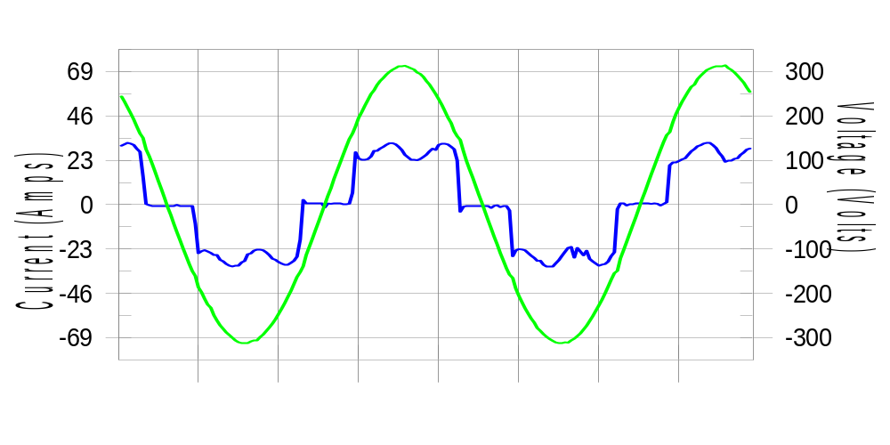

Harmonics and Class 3 limit line European Limits

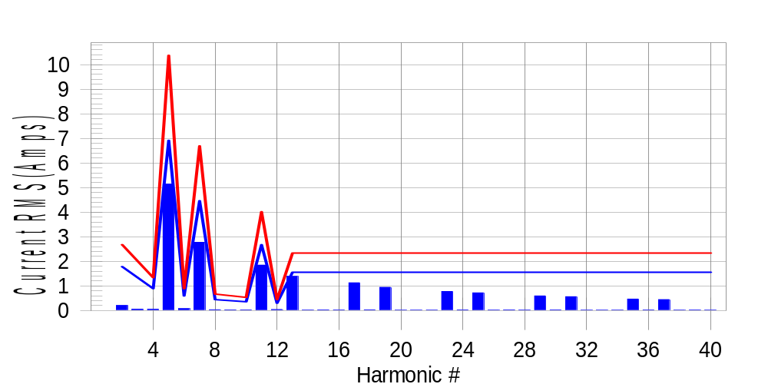

Test result: Fail Worst harmonic was #13 with 60.31 % of the limit.
Current Test Result Summary (Phase A-Run time)

EUT: Equipment under test Tested by: Tested by
Test category: Table:3, Rsce=250, Test Margin: 100
Test date: 2016/4/13 Start time: 16:33:52 End time: 16:36:44
Test duration (min): 2.5 Data file name: CTSMXH_H-000016.cts_data
Comment: Comment
Customer: Customer information

Test Result: Fail Measured I-ref: 22.414(Amps) Source: Normal
I-THC(%): 29.7 Limit(%): 37.0 PWHC(%): 44.9 PWHC Limit(%): 38.0

Highest parameter values during test:
V_RMS (Volts): 220.44 Frequency(Hz): 50.00
I_Peak (Amps): 44.397 I_RMS (Amps): 22.414
I_Fund (Amps): 21.280 Crest Factor: 1.984
Power (Watts): 4711 Power Factor: 0.954

Harm# Harms(avg) 100%Limit %of Limit Harms(max) 150%Limit %of Limit Status

2 0.207 1.785 11.6 0.234 2.678 8.7 Pass
3 0.055 N/A N/A 0.084 N/A N/A N/A
4 0.050 0.893 5.6 0.064 1.339 4.8 Pass
5 5.141 6.917 74.3 5.155 10.376 49.7 Pass
6 0.078 0.595 13.2 0.089 0.893 10.0 Pass
7 2.774 4.463 62.2 2.791 6.694 41.7 Pass
8 0.032 0.446 7.1 0.041 0.669 6.2 Pass
9 0.026 N/A N/A 0.036 N/A N/A N/A
10 0.027 0.357 7.6 0.036 0.536 6.8 Pass
11 1.846 2.678 69.0 1.857 4.016 46.2 Pass
12 0.041 0.298 13.9 0.051 0.446 11.4 Pass
13 1.392 1.562 89.1 1.407 2.343 60.0 Pass
14 0.019 N/A N/A 0.026 N/A N/A N/A
15 0.027 N/A N/A 0.036 N/A N/A N/A
16 0.023 N/A N/A 0.031 N/A N/A N/A
17 1.128 N/A N/A 1.136 N/A N/A N/A
18 0.029 N/A N/A 0.037 N/A N/A N/A
19 0.945 N/A N/A 0.954 N/A N/A N/A
20 0.018 N/A N/A 0.026 N/A N/A N/A
21 0.018 N/A N/A 0.026 N/A N/A N/A
22 0.018 N/A N/A 0.033 N/A N/A N/A
23 0.775 N/A N/A 0.781 N/A N/A N/A
24 0.027 N/A N/A 0.038 N/A N/A N/A
25 0.719 N/A N/A 0.726 N/A N/A N/A
26 0.019 N/A N/A 0.025 N/A N/A N/A
27 0.026 N/A N/A 0.033 N/A N/A N/A
28 0.020 N/A N/A 0.042 N/A N/A N/A
29 0.596 N/A N/A 0.606 N/A N/A N/A
30 0.025 N/A N/A 0.034 N/A N/A N/A
31 0.564 N/A N/A 0.571 N/A N/A N/A
32 0.016 N/A N/A 0.023 N/A N/A N/A
33 0.018 N/A N/A 0.038 N/A N/A N/A
34 0.017 N/A N/A 0.025 N/A N/A N/A
35 0.468 N/A N/A 0.477 N/A N/A N/A
36 0.024 N/A N/A 0.032 N/A N/A N/A
37 0.444 N/A N/A 0.453 N/A N/A N/A
38 0.018 N/A N/A 0.028 N/A N/A N/A
39 0.022 N/A N/A 0.028 N/A N/A N/A
40 0.017 N/A N/A 0.026 N/A N/A N/A

Note: Measured I-ref was applied for this test.

Voltage Source Verification Data (Phase A-Run time)

EUT: Equipment under test Tested by: Tested by
Test category: Table:3, Rsce=250, Test Margin: 100
Test date: 2016/4/13 Start time: 16:33:52 End time: 16:36:44
Test duration (min): 2.5 Data file name: CTSMXH_H-000016.cts_data
Comment: Comment
Customer: Customer information

Test Result: Fail Source qualification: Normal
Measured source distortion is within the requirements of the standards
Measurements are compliant with IEC/EN61000-3-12 Ed.4 & IEC/EN61000-4-7 Ed. 2.1

Highest parameter values during test:
Voltage (Vrms): 220.44 Frequency(Hz): 50.00
I_Peak (Amps): 44.397 I_RMS (Amps): 22.414
I_Fund (Amps): 21.280 Crest Factor: 1.984
Power (Watts): 4711 Power Factor: 0.954

Harm# Harmonics V-rms Limit V-rms % of Limit Status

2 0.164 0.881 18.64 OK
3 0.288 2.755 10.44 OK
4 0.117 0.881 13.24 OK
5 0.865 3.306 26.17 OK
6 0.095 0.882 10.76 OK
7 0.655 2.754 23.78 OK
8 0.087 0.881 9.83 OK
9 0.135 1.322 10.18 OK
10 0.079 0.882 8.93 OK
11 0.618 1.543 40.04 OK
12 0.083 0.661 12.54 OK
13 0.561 1.322 42.47 OK
14 0.078 0.661 11.75 OK
15 0.129 0.661 19.58 OK
16 0.076 0.661 11.56 OK
17 0.545 0.661 82.39 OK
18 0.088 0.661 13.33 OK
19 0.517 0.661 78.23 OK
20 0.163 0.661 24.66 OK
21 0.127 0.661 19.20 OK
22 0.088 0.661 13.31 OK
23 0.445 0.661 67.35 OK
24 0.080 0.661 12.16 OK
25 0.489 0.661 73.89 OK
26 0.094 0.661 14.24 OK
27 0.125 0.661 18.92 OK
28 0.076 0.661 11.55 OK
29 0.396 0.661 59.82 OK
30 0.089 0.661 13.41 OK
31 0.439 0.661 66.37 OK
32 0.085 0.661 12.86 OK
33 0.118 0.661 17.86 OK
34 0.091 0.661 13.80 OK
35 0.362 0.661 54.71 OK
36 0.088 0.661 13.28 OK
37 0.397 0.661 60.07 OK
38 0.093 0.661 14.14 OK
39 0.123 0.661 18.64 OK
40 0.138 0.661 20.94 OK

Harmonics – Per EN/IEC61000-3-12, Ed. 2.0(Phase B-Run time)

EUT: Equipment under test Tested by: Tested by
Test category: Table:3, Rsce=250, Test Margin: 100
Test date: 2016/4/13 Start time: 16:33:52 End time: 16:36:44
Test duration (min): 2.5 Data file name: CTSMXH_H-000016.cts_data
Comment: Comment
Customer: Customer information

Test Result: Fail Source qualification: Normal

Current & voltage waveforms

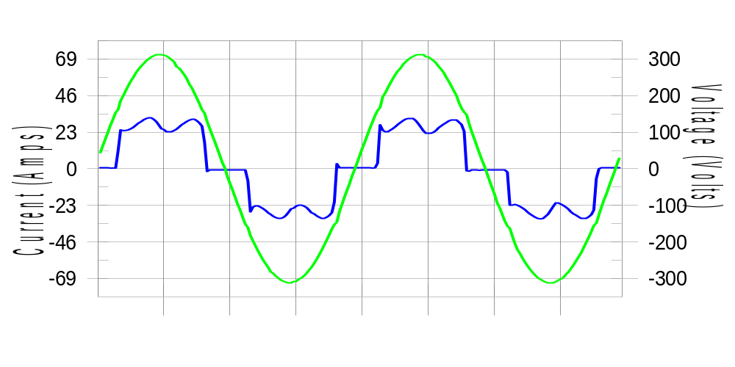

Harmonics and Class 3 limit line European Limits

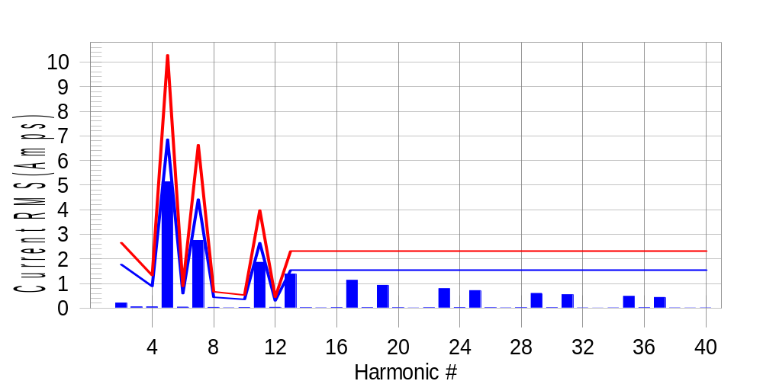

Test result: Fail Worst harmonic was #13 with 59.98 % of the limit.
Current Test Result Summary (Phase B-Run time)

EUT: Equipment under test Tested by: Tested by
Test category: Table:3, Rsce=250, Test Margin: 100
Test date: 2016/4/13 Start time: 16:33:52 End time: 16:36:44
Test duration (min): 2.5 Data file name: CTSMXH_H-000016.cts_data
Comment: Comment
Customer: Customer information

Test Result: Fail Measured I-ref: 22.311(Amps) Source: Normal
I-THC(%): 29.9 Limit(%): 37.0 PWHC(%): 45.2 PWHC Limit(%): 38.0

Highest parameter values during test:
V_RMS (Volts): 220.23 Frequency(Hz): 50.00
I_Peak (Amps): 42.913 I_RMS (Amps): 22.311
I_Fund (Amps): 21.098 Crest Factor: 1.934
Power (Watts): 4683 Power Factor: 0.953

Harm# Harms(avg) 100%Limit %of Limit Harms(max) 150%Limit %of Limit Status

2 0.209 1.771 11.8 0.223 2.656 8.4 Pass
3 0.055 N/A N/A 0.068 N/A N/A N/A
4 0.050 0.885 5.6 0.056 1.328 4.2 Pass
5 5.136 6.861 74.9 5.153 10.291 50.1 Pass
6 0.043 0.590 7.2 0.048 0.885 5.4 Pass
7 2.752 4.426 62.2 2.762 6.640 41.6 Pass
8 0.030 0.443 6.8 0.036 0.664 5.4 Pass
9 0.026 N/A N/A 0.017 N/A N/A N/A
10 0.022 0.354 6.3 0.029 0.531 5.5 Pass
11 1.863 2.656 70.2 1.869 3.984 46.9 Pass
12 0.032 0.295 10.8 0.037 0.443 8.3 Pass
13 1.386 1.549 89.5 1.392 2.324 59.9 Pass
14 0.014 N/A N/A 0.022 N/A N/A N/A
15 0.012 N/A N/A 0.017 N/A N/A N/A
16 0.018 N/A N/A 0.023 N/A N/A N/A
17 1.133 N/A N/A 1.137 N/A N/A N/A
18 0.017 N/A N/A 0.021 N/A N/A N/A
19 0.927 N/A N/A 0.933 N/A N/A N/A
20 0.015 N/A N/A 0.019 N/A N/A N/A
21 0.007 N/A N/A 0.015 N/A N/A N/A
22 0.013 N/A N/A 0.019 N/A N/A N/A
23 0.790 N/A N/A 0.797 N/A N/A N/A
24 0.019 N/A N/A 0.023 N/A N/A N/A
25 0.713 N/A N/A 0.718 N/A N/A N/A
26 0.013 N/A N/A 0.017 N/A N/A N/A
27 0.011 N/A N/A 0.016 N/A N/A N/A
28 0.013 N/A N/A 0.019 N/A N/A N/A
29 0.598 N/A N/A 0.604 N/A N/A N/A
30 0.015 N/A N/A 0.021 N/A N/A N/A
31 0.548 N/A N/A 0.558 N/A N/A N/A
32 0.010 N/A N/A 0.017 N/A N/A N/A
33 0.006 N/A N/A 0.011 N/A N/A N/A
34 0.012 N/A N/A 0.017 N/A N/A N/A
35 0.478 N/A N/A 0.483 N/A N/A N/A
36 0.013 N/A N/A 0.019 N/A N/A N/A
37 0.434 N/A N/A 0.442 N/A N/A N/A
38 0.012 N/A N/A 0.018 N/A N/A N/A
39 0.008 N/A N/A 0.014 N/A N/A N/A
40 0.011 N/A N/A 0.016 N/A N/A N/A

Note: Measured I-ref was applied for this test.

Voltage Source Verification Data (Phase B-Run time)

EUT: Equipment under test Tested by: Tested by
Test category: Table:3, Rsce=250, Test Margin: 100
Test date: 2016/4/13 Start time: 16:33:52 End time: 16:36:44
Test duration (min): 2.5 Data file name: CTSMXH_H-000016.cts_data
Comment: Comment
Customer: Customer information

Test Result: Fail Source qualification: Normal
Measured source distortion is within the requirements of the standards
Measurements are compliant with IEC/EN61000-3-12 Ed.4 & IEC/EN61000-4-7 Ed. 2.1

Highest parameter values during test:
Voltage (Vrms): 220.23 Frequency(Hz): 50.00
I_Peak (Amps): 42.913 I_RMS (Amps): 22.311
I_Fund (Amps): 21.098 Crest Factor: 1.934
Power (Watts): 4683 Power Factor: 0.953

Harm# Harmonics V-rms Limit V-rms % of Limit Status

2 0.159 0.881 18.09 OK
3 0.319 2.751 11.60 OK
4 0.116 0.881 13.22 OK
5 0.928 3.302 28.11 OK
6 0.123 0.880 13.96 OK
7 0.689 2.752 25.03 OK
8 0.111 0.881 12.63 OK
9 0.128 1.321 9.71 OK
10 0.113 0.881 12.86 OK
11 0.657 1.540 42.63 OK
12 0.099 0.660 15.06 OK
13 0.592 1.321 44.85 OK
14 0.102 0.660 15.52 OK
15 0.134 0.660 20.23 OK
16 0.120 0.660 18.12 OK
17 0.578 0.660 87.51 OK
18 0.096 0.660 14.56 OK
19 0.538 0.660 81.39 OK
20 0.127 0.660 19.20 OK
21 0.134 0.660 20.33 OK
22 0.098 0.660 14.87 OK
23 0.503 0.660 76.11 OK
24 0.103 0.660 15.56 OK
25 0.496 0.660 75.11 OK
26 0.106 0.661 16.11 OK
27 0.119 0.660 18.00 OK
28 0.104 0.660 15.82 OK
29 0.411 0.660 62.29 OK
30 0.105 0.661 15.83 OK
31 0.461 0.660 69.82 OK
32 0.107 0.661 16.21 OK
33 0.155 0.660 23.49 OK
34 0.094 0.660 14.28 OK
35 0.394 0.660 59.60 OK
36 0.088 0.660 13.26 OK
37 0.414 0.660 62.72 OK
38 0.117 0.660 17.79 OK
39 0.138 0.660 20.89 OK
40 0.110 0.660 16.62 OK

Harmonics – Per EN/IEC61000-3-12, Ed. 2.0(Phase C-Run time)

EUT: Equipment under test Tested by: Tested by
Test category: Table:3, Rsce=250, Test Margin: 100
Test date: 2016/4/13 Start time: 16:33:52 End time: 16:36:44
Test duration (min): 2.5 Data file name: CTSMXH_H-000016.cts_data
Comment: Comment
Customer: Customer information

Test Result: Fail Source qualification: Normal

Current & voltage waveforms

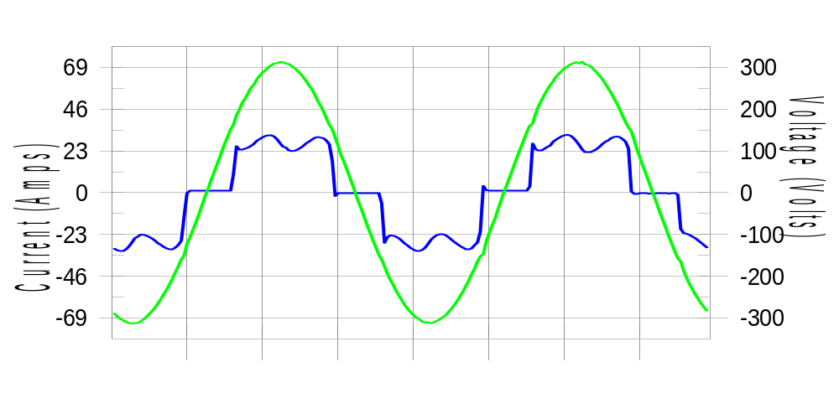

Harmonics and Class 3 limit line European Limits

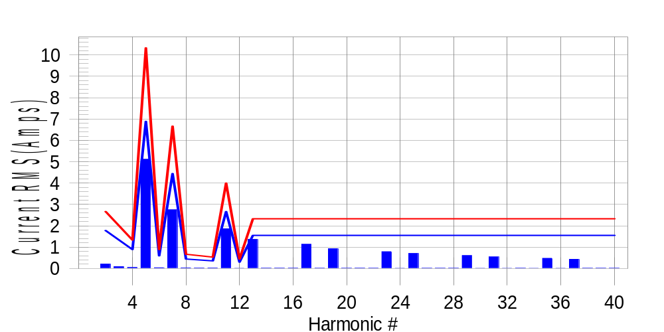

Test result: Fail Worst harmonic was #13 with 58.98 % of the limit.
Current Test Result Summary (Phase C-Run time)

EUT: Equipment under test Tested by: Tested by
Test category: Table:3, Rsce=250, Test Margin: 100
Test date: 2016/4/13 Start time: 16:33:52 End time: 16:36:44
Test duration (min): 2.5 Data file name: CTSMXH_H-000016.cts_data
Comment: Comment
Customer: Customer information

Test Result: Fail Measured I-ref: 22.398(Amps) Source: Normal
I-THC(%): 29.7 Limit(%): 37.0 PWHC(%): 44.9 PWHC Limit(%): 38.0

Highest parameter values during test:
V_RMS (Volts): 220.15 Frequency(Hz): 50.00
I_Peak (Amps): 42.653 I_RMS (Amps): 22.398
I_Fund (Amps): 21.204 Crest Factor: 1.910
Power (Watts): 4705 Power Factor: 0.954

Harm# Harms(avg) 100%Limit %of Limit Harms(max) 150%Limit %of Limit Status

2 0.206 1.778 11.6 0.226 2.667 8.5 Pass
3 0.055 N/A N/A 0.107 N/A N/A N/A
4 0.049 0.889 5.5 0.060 1.334 4.5 Pass
5 5.114 6.890 74.2 5.137 10.336 49.7 Pass
6 0.036 0.593 6.1 0.042 0.889 4.8 Pass
7 2.748 4.445 61.8 2.760 6.668 41.4 Pass
8 0.029 0.445 6.6 0.035 0.667 5.2 Pass
9 0.026 N/A N/A 0.032 N/A N/A N/A
10 0.025 0.356 7.0 0.032 0.533 6.1 Pass
11 1.863 2.667 69.8 1.872 4.001 46.8 Pass
12 0.011 0.296 3.6 0.017 0.445 3.9 Pass
13 1.368 1.556 87.9 1.375 2.334 58.9 Pass
14 0.017 N/A N/A 0.023 N/A N/A N/A
15 0.018 N/A N/A 0.023 N/A N/A N/A
16 0.018 N/A N/A 0.024 N/A N/A N/A
17 1.134 N/A N/A 1.142 N/A N/A N/A
18 0.013 N/A N/A 0.018 N/A N/A N/A
19 0.927 N/A N/A 0.934 N/A N/A N/A
20 0.015 N/A N/A 0.021 N/A N/A N/A
21 0.017 N/A N/A 0.022 N/A N/A N/A
22 0.015 N/A N/A 0.020 N/A N/A N/A
23 0.789 N/A N/A 0.795 N/A N/A N/A
24 0.010 N/A N/A 0.017 N/A N/A N/A
25 0.704 N/A N/A 0.711 N/A N/A N/A
26 0.014 N/A N/A 0.021 N/A N/A N/A
27 0.015 N/A N/A 0.021 N/A N/A N/A
28 0.015 N/A N/A 0.021 N/A N/A N/A
29 0.606 N/A N/A 0.613 N/A N/A N/A
30 0.011 N/A N/A 0.017 N/A N/A N/A
31 0.544 N/A N/A 0.550 N/A N/A N/A
32 0.012 N/A N/A 0.019 N/A N/A N/A
33 0.015 N/A N/A 0.020 N/A N/A N/A
34 0.012 N/A N/A 0.018 N/A N/A N/A
35 0.477 N/A N/A 0.483 N/A N/A N/A
36 0.010 N/A N/A 0.018 N/A N/A N/A
37 0.430 N/A N/A 0.436 N/A N/A N/A
38 0.013 N/A N/A 0.018 N/A N/A N/A
39 0.014 N/A N/A 0.019 N/A N/A N/A
40 0.013 N/A N/A 0.019 N/A N/A N/A

Note: Measured I-ref was applied for this test.

Voltage Source Verification Data (Phase C-Run time)

EUT: Equipment under test Tested by: Tested by
Test category: Table:3, Rsce=250, Test Margin: 100
Test date: 2016/4/13 Start time: 16:33:52 End time: 16:36:44
Test duration (min): 2.5 Data file name: CTSMXH_H-000016.cts_data
Comment: Comment
Customer: Customer information

Test Result: Fail Source qualification: Normal
Measured source distortion is within the requirements of the standards
Measurements are compliant with IEC/EN61000-3-12 Ed.4 & IEC/EN61000-4-7 Ed. 2.1

Highest parameter values during test:
Voltage (Vrms): 220.15 Frequency(Hz): 50.00
I_Peak (Amps): 42.653 I_RMS (Amps): 22.398
I_Fund (Amps): 21.204 Crest Factor: 1.910
Power (Watts): 4705 Power Factor: 0.954

Harm# Harmonics V-rms Limit V-rms % of Limit Status

2 0.156 0.880 17.69 OK
3 0.272 2.750 9.89 OK
4 0.097 0.880 11.05 OK
5 0.888 3.301 26.90 OK
6 0.095 0.880 10.84 OK
7 0.639 2.750 23.22 OK
8 0.085 0.880 9.67 OK
9 0.105 1.321 7.97 OK
10 0.092 0.880 10.45 OK
11 0.650 1.540 42.21 OK
12 0.090 0.660 13.59 OK
13 0.559 1.320 42.33 OK
14 0.090 0.660 13.67 OK
15 0.125 0.660 18.98 OK
16 0.086 0.660 13.07 OK
17 0.541 0.660 81.93 OK
18 0.094 0.660 14.22 OK
19 0.503 0.660 76.21 OK
20 0.100 0.660 15.11 OK
21 0.121 0.660 18.31 OK
22 0.078 0.660 11.75 OK
23 0.457 0.660 69.23 OK
24 0.092 0.660 13.94 OK
25 0.471 0.660 71.30 OK
26 0.086 0.660 13.10 OK
27 0.117 0.660 17.65 OK
28 0.076 0.660 11.44 OK
29 0.425 0.660 64.41 OK
30 0.087 0.660 13.19 OK
31 0.443 0.660 67.02 OK
32 0.102 0.660 15.43 OK
33 0.126 0.660 19.05 OK
34 0.092 0.660 13.98 OK
35 0.368 0.660 55.72 OK
36 0.090 0.660 13.60 OK
37 0.399 0.660 60.38 OK
38 0.086 0.660 13.01 OK
39 0.118 0.660 17.80 OK
40 0.109 0.660 16.54 OK

5th Harmonic Phase Angle and Magnitude for Phase A :
H-5_min_phase : 146.5 Degree (Leading)
H-5_max_phase : 147.5 Degree (Leading)
H-5_ave_phase : 146.8 Degree (Leading)

H-5_ave_vector_magnitude : 5.109 Amp
H-5_standard_ave_magnitude : 5.141 Amp
H-5_standard_max_magnitude : 5.137 Amp
Ratio of H-5_ave_vector / H-5_standard_ave : 0.999

Phase A = 118.264% of tested Rsce = 250.000, Rsce = 295.659
Phase B = 118.895% of tested Rsce = 250.000, Rsce = 297.237
Phase C = 118.175% of tested Rsce = 250.000, Rsce = 295.437
Minimum Rsce required: Rsce = 297.237

