Harmonics – Per EN/IEC61000-3-12, Ed. 2.0(Phase A-Run time)

EUT: Equipment under test Tested by: Tested by
Test category: Table:3, Rsce=250, Test Margin: 100
Test date: 2016/4/13 Start time: 16:43:37 End time: 16:46:30
Test duration (min): 2.5 Data file name: CTSMXH_H-000017.cts_data
Comment: Comment
Customer: Customer information

Test Result: Fail Source qualification: Normal

Current & voltage waveforms

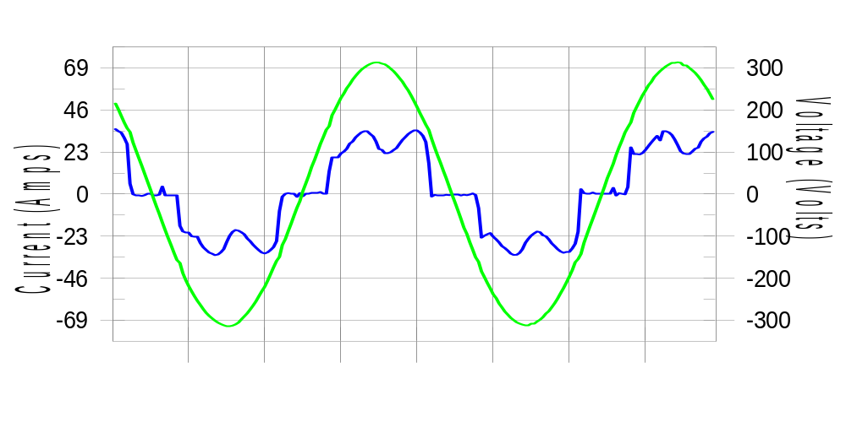

Harmonics and Class 3 limit line European Limits

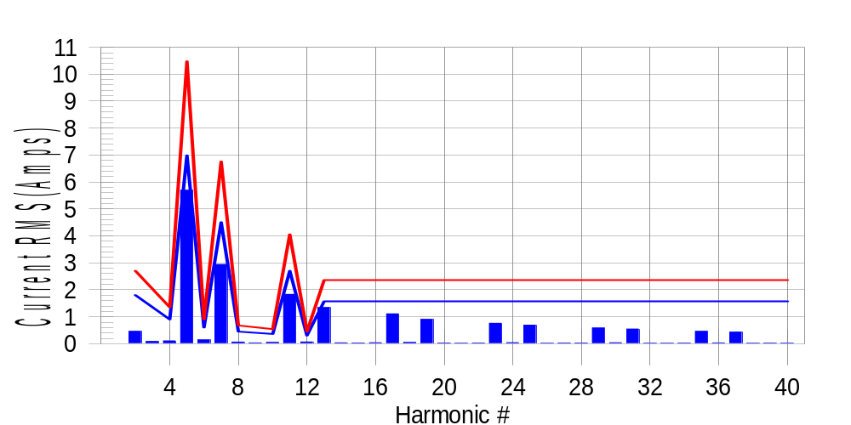

Test result: Fail Worst harmonic was #13 with 57.34 % of the limit.
Current Test Result Summary (Phase A-Run time)

EUT: Equipment under test Tested by: Tested by
Test category: Table:3, Rsce=250, Test Margin: 100
Test date: 2016/4/13 Start time: 16:43:37 End time: 16:46:30
Test duration (min): 2.5 Data file name: CTSMXH_H-000017.cts_data
Comment: Comment
Customer: Customer information

Test Result: Fail Measured I-ref: 22.769(Amps) Source: Normal
I-THC(%): 31.6 Limit(%): 37.0 PWHC(%): 43.3 PWHC Limit(%): 38.0

Highest parameter values during test:
V_RMS (Volts): 220.45 Frequency(Hz): 50.00
I_Peak (Amps): 47.267 I_RMS (Amps): 22.769
I_Fund (Amps): 21.356 Crest Factor: 2.094
Power (Watts): 4751 Power Factor: 0.947

Harm# Harms(avg) 100%Limit %of Limit Harms(max) 150%Limit %of Limit Status

2 0.459 1.803 25.5 0.493 2.705 18.2 Pass
3 0.084 N/A N/A 0.119 N/A N/A N/A
4 0.105 0.902 11.7 0.122 1.352 9.0 Pass
5 5.696 6.987 81.5 5.726 10.481 54.6 Pass
6 0.139 0.601 23.2 0.147 0.902 16.4 Pass
7 2.942 4.508 65.3 2.963 6.762 43.8 Pass
8 0.063 0.451 13.9 0.080 0.676 11.9 Pass
9 0.031 N/A N/A 0.041 N/A N/A N/A
10 0.049 0.361 13.6 0.063 0.541 11.6 Pass
11 1.831 2.705 67.7 1.850 4.057 45.6 Pass
12 0.065 0.301 21.6 0.072 0.451 15.9 Pass
13 1.343 1.578 85.1 1.355 2.367 57.2 Pass
14 0.032 N/A N/A 0.040 N/A N/A N/A
15 0.028 N/A N/A 0.036 N/A N/A N/A
16 0.036 N/A N/A 0.046 N/A N/A N/A
17 1.109 N/A N/A 1.120 N/A N/A N/A
18 0.046 N/A N/A 0.055 N/A N/A N/A
19 0.904 N/A N/A 0.915 N/A N/A N/A
20 0.027 N/A N/A 0.036 N/A N/A N/A
21 0.019 N/A N/A 0.027 N/A N/A N/A
22 0.028 N/A N/A 0.038 N/A N/A N/A
23 0.758 N/A N/A 0.768 N/A N/A N/A
24 0.039 N/A N/A 0.047 N/A N/A N/A
25 0.690 N/A N/A 0.698 N/A N/A N/A
26 0.022 N/A N/A 0.030 N/A N/A N/A
27 0.027 N/A N/A 0.038 N/A N/A N/A
28 0.027 N/A N/A 0.037 N/A N/A N/A
29 0.582 N/A N/A 0.608 N/A N/A N/A
30 0.035 N/A N/A 0.043 N/A N/A N/A
31 0.545 N/A N/A 0.556 N/A N/A N/A
32 0.020 N/A N/A 0.027 N/A N/A N/A
33 0.019 N/A N/A 0.027 N/A N/A N/A
34 0.023 N/A N/A 0.034 N/A N/A N/A
35 0.458 N/A N/A 0.467 N/A N/A N/A
36 0.030 N/A N/A 0.040 N/A N/A N/A
37 0.431 N/A N/A 0.442 N/A N/A N/A
38 0.020 N/A N/A 0.029 N/A N/A N/A
39 0.023 N/A N/A 0.033 N/A N/A N/A
40 0.022 N/A N/A 0.030 N/A N/A N/A

Note: Measured I-ref was applied for this test.

Voltage Source Verification Data (Phase A-Run time)

EUT: Equipment under test Tested by: Tested by
Test category: Table:3, Rsce=250, Test Margin: 100
Test date: 2016/4/13 Start time: 16:43:37 End time: 16:46:30
Test duration (min): 2.5 Data file name: CTSMXH_H-000017.cts_data
Comment: Comment
Customer: Customer information

Test Result: Fail Source qualification: Normal
Measured source distortion is within the requirements of the standards
Measurements are compliant with IEC/EN61000-3-12 Ed.4 & IEC/EN61000-4-7 Ed. 2.1

Highest parameter values during test:
Voltage (Vrms): 220.45 Frequency(Hz): 50.00
I_Peak (Amps): 47.267 I_RMS (Amps): 22.769
I_Fund (Amps): 21.356 Crest Factor: 2.094
Power (Watts): 4751 Power Factor: 0.947

Harm# Harmonics V-rms Limit V-rms % of Limit Status

2 0.143 0.881 16.25 OK
3 0.313 2.754 11.35 OK
4 0.121 0.881 13.70 OK
5 0.949 3.305 28.70 OK
6 0.119 0.882 13.45 OK
7 0.666 2.755 24.20 OK
8 0.099 0.881 11.24 OK
9 0.120 1.322 9.11 OK
10 0.073 0.881 8.33 OK
11 0.618 1.542 40.09 OK
12 0.098 0.661 14.79 OK
13 0.538 1.322 40.66 OK
14 0.082 0.661 12.37 OK
15 0.141 0.661 21.32 OK
16 0.083 0.661 12.50 OK
17 0.518 0.661 78.35 OK
18 0.098 0.661 14.87 OK
19 0.513 0.661 77.57 OK
20 0.171 0.661 25.89 OK
21 0.131 0.661 19.75 OK
22 0.084 0.661 12.72 OK
23 0.444 0.661 67.21 OK
24 0.090 0.661 13.54 OK
25 0.469 0.661 70.88 OK
26 0.098 0.661 14.90 OK
27 0.136 0.661 20.51 OK
28 0.098 0.661 14.80 OK
29 0.392 0.661 59.28 OK
30 0.090 0.661 13.56 OK
31 0.439 0.661 66.39 OK
32 0.102 0.661 15.50 OK
33 0.146 0.661 22.06 OK
34 0.069 0.661 10.51 OK
35 0.363 0.661 54.91 OK
36 0.079 0.661 12.00 OK
37 0.385 0.661 58.22 OK
38 0.086 0.661 13.07 OK
39 0.139 0.661 21.06 OK
40 0.142 0.661 21.43 OK

Harmonics – Per EN/IEC61000-3-12, Ed. 2.0(Phase B-Run time)

EUT: Equipment under test Tested by: Tested by
Test category: Table:3, Rsce=250, Test Margin: 100
Test date: 2016/4/13 Start time: 16:43:37 End time: 16:46:30
Test duration (min): 2.5 Data file name: CTSMXH_H-000017.cts_data
Comment: Comment
Customer: Customer information

Test Result: Fail Source qualification: Normal

Current & voltage waveforms

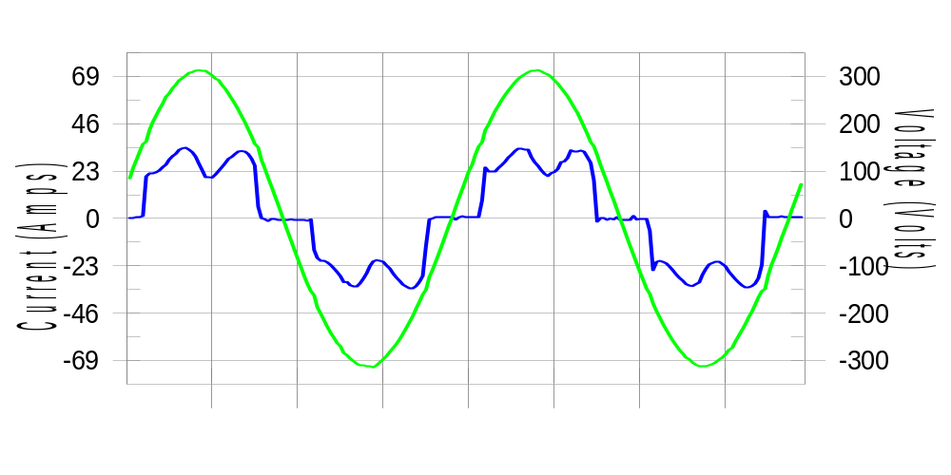

Harmonics and Class 3 limit line European Limits

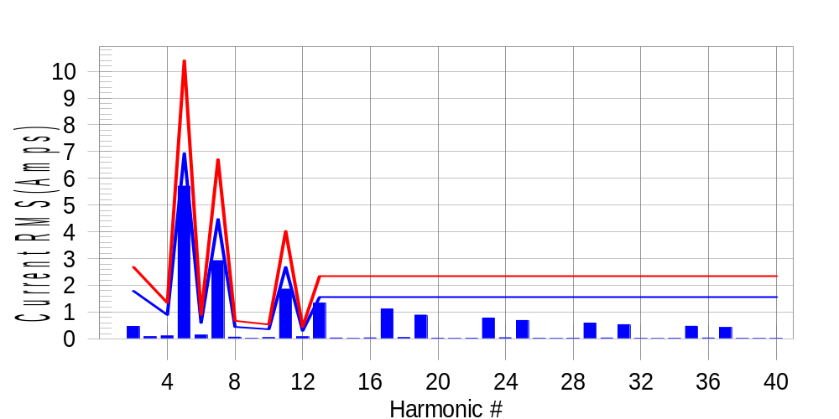

Test result: Fail Worst harmonic was #13 with 57.65 % of the limit.
Current Test Result Summary (Phase B-Run time)

EUT: Equipment under test Tested by: Tested by
Test category: Table:3, Rsce=250, Test Margin: 100
Test date: 2016/4/13 Start time: 16:43:37 End time: 16:46:30
Test duration (min): 2.5 Data file name: CTSMXH_H-000017.cts_data
Comment: Comment
Customer: Customer information

Test Result: Fail Measured I-ref: 22.618(Amps) Source: Normal
I-THC(%): 31.9 Limit(%): 37.0 PWHC(%): 43.7 PWHC Limit(%): 38.0

Highest parameter values during test:
V_RMS (Volts): 220.21 Frequency(Hz): 50.00
I_Peak (Amps): 48.605 I_RMS (Amps): 22.618
I_Fund (Amps): 21.186 Crest Factor: 2.154
Power (Watts): 4711 Power Factor: 0.947

Harm# Harms(avg) 100%Limit %of Limit Harms(max) 150%Limit %of Limit Status

2 0.464 1.791 25.9 0.498 2.686 18.5 Pass
3 0.084 N/A N/A 0.117 N/A N/A N/A
4 0.107 0.895 12.0 0.121 1.343 9.0 Pass
5 5.709 6.939 82.3 5.742 10.408 55.2 Pass
6 0.141 0.597 23.6 0.155 0.895 17.3 Pass
7 2.925 4.477 65.3 2.944 6.715 43.8 Pass
8 0.063 0.448 14.0 0.073 0.671 10.8 Pass
9 0.031 N/A N/A 0.028 N/A N/A N/A
10 0.048 0.358 13.4 0.066 0.537 12.3 Pass
11 1.859 2.686 69.2 1.875 4.029 46.5 Pass
12 0.077 0.298 25.7 0.088 0.448 19.7 Pass
13 1.340 1.567 85.5 1.355 2.350 57.6 Pass
14 0.033 N/A N/A 0.043 N/A N/A N/A
15 0.016 N/A N/A 0.024 N/A N/A N/A
16 0.035 N/A N/A 0.042 N/A N/A N/A
17 1.118 N/A N/A 1.131 N/A N/A N/A
18 0.048 N/A N/A 0.057 N/A N/A N/A
19 0.889 N/A N/A 0.902 N/A N/A N/A
20 0.028 N/A N/A 0.043 N/A N/A N/A
21 0.016 N/A N/A 0.024 N/A N/A N/A
22 0.028 N/A N/A 0.040 N/A N/A N/A
23 0.779 N/A N/A 0.789 N/A N/A N/A
24 0.042 N/A N/A 0.053 N/A N/A N/A
25 0.687 N/A N/A 0.700 N/A N/A N/A
26 0.023 N/A N/A 0.032 N/A N/A N/A
27 0.017 N/A N/A 0.024 N/A N/A N/A
28 0.026 N/A N/A 0.035 N/A N/A N/A
29 0.589 N/A N/A 0.598 N/A N/A N/A
30 0.034 N/A N/A 0.044 N/A N/A N/A
31 0.532 N/A N/A 0.543 N/A N/A N/A
32 0.021 N/A N/A 0.029 N/A N/A N/A
33 0.015 N/A N/A 0.022 N/A N/A N/A
34 0.023 N/A N/A 0.033 N/A N/A N/A
35 0.471 N/A N/A 0.480 N/A N/A N/A
36 0.032 N/A N/A 0.039 N/A N/A N/A
37 0.426 N/A N/A 0.437 N/A N/A N/A
38 0.021 N/A N/A 0.029 N/A N/A N/A
39 0.016 N/A N/A 0.021 N/A N/A N/A
40 0.021 N/A N/A 0.028 N/A N/A N/A

Note: Measured I-ref was applied for this test.

Voltage Source Verification Data (Phase B-Run time)

EUT: Equipment under test Tested by: Tested by
Test category: Table:3, Rsce=250, Test Margin: 100
Test date: 2016/4/13 Start time: 16:43:37 End time: 16:46:30
Test duration (min): 2.5 Data file name: CTSMXH_H-000017.cts_data
Comment: Comment
Customer: Customer information

Test Result: Fail Source qualification: Normal
Measured source distortion is within the requirements of the standards
Measurements are compliant with IEC/EN61000-3-12 Ed.4 & IEC/EN61000-4-7 Ed. 2.1

Highest parameter values during test:
Voltage (Vrms): 220.21 Frequency(Hz): 50.00
I_Peak (Amps): 48.605 I_RMS (Amps): 22.618
I_Fund (Amps): 21.186 Crest Factor: 2.154
Power (Watts): 4711 Power Factor: 0.947

Harm# Harmonics V-rms Limit V-rms % of Limit Status

2 0.206 0.880 23.42 OK
3 0.297 2.752 10.80 OK
4 0.116 0.880 13.13 OK
5 1.010 3.301 30.60 OK
6 0.118 0.880 13.35 OK
7 0.701 2.751 25.49 OK
8 0.109 0.881 12.38 OK
9 0.136 1.321 10.26 OK
10 0.094 0.881 10.73 OK
11 0.676 1.541 43.87 OK
12 0.123 0.660 18.66 OK
13 0.581 1.321 43.97 OK
14 0.111 0.660 16.83 OK
15 0.137 0.660 20.81 OK
16 0.099 0.660 15.04 OK
17 0.563 0.660 85.20 OK
18 0.119 0.660 18.08 OK
19 0.518 0.661 78.45 OK
20 0.134 0.660 20.26 OK
21 0.134 0.660 20.25 OK
22 0.106 0.660 16.10 OK
23 0.473 0.660 71.55 OK
24 0.135 0.661 20.45 OK
25 0.508 0.660 76.99 OK
26 0.106 0.660 15.99 OK
27 0.129 0.660 19.50 OK
28 0.119 0.660 18.07 OK
29 0.437 0.660 66.12 OK
30 0.116 0.660 17.56 OK
31 0.435 0.660 65.82 OK
32 0.111 0.660 16.82 OK
33 0.111 0.660 16.78 OK
34 0.090 0.660 13.67 OK
35 0.396 0.661 59.91 OK
36 0.114 0.660 17.28 OK
37 0.412 0.660 62.31 OK
38 0.103 0.660 15.67 OK
39 0.130 0.660 19.75 OK
40 0.114 0.660 17.34 OK

Harmonics – Per EN/IEC61000-3-12, Ed. 2.0(Phase C-Run time)

EUT: Equipment under test Tested by: Tested by
Test category: Table:3, Rsce=250, Test Margin: 100
Test date: 2016/4/13 Start time: 16:43:37 End time: 16:46:30
Test duration (min): 2.5 Data file name: CTSMXH_H-000017.cts_data
Comment: Comment
Customer: Customer information

Test Result: Fail Source qualification: Normal

Current & voltage waveforms

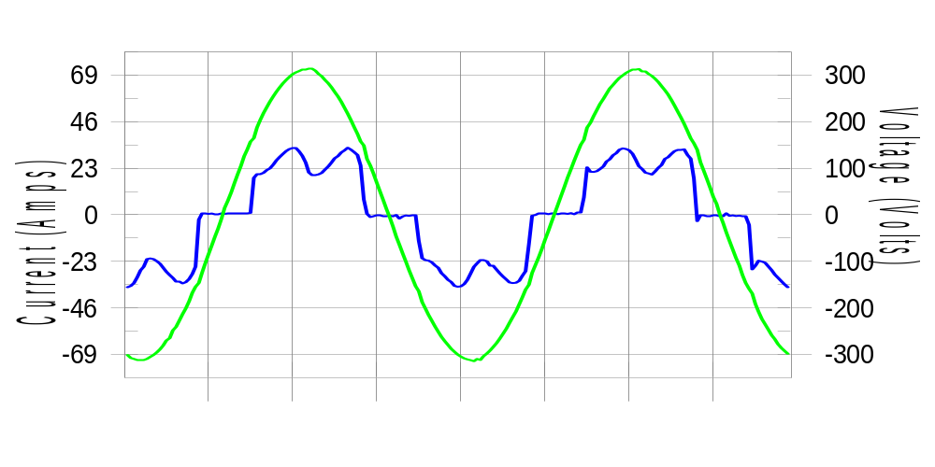

Harmonics and Class 3 limit line European Limits

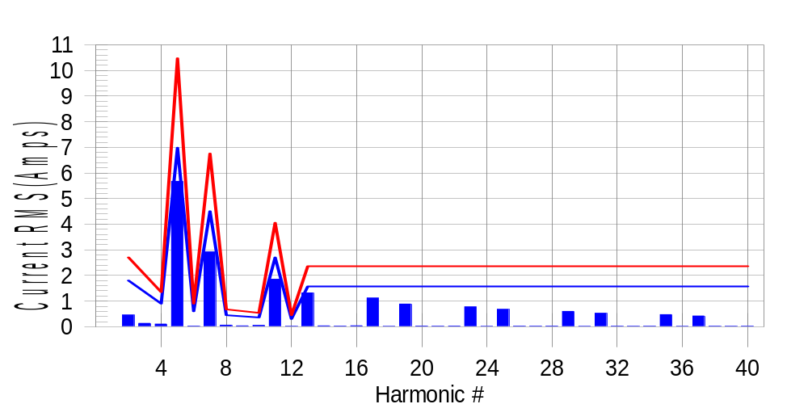

Test result: Fail Worst harmonic was #13 with 56.34 % of the limit.
Current Test Result Summary (Phase C-Run time)

EUT: Equipment under test Tested by: Tested by
Test category: Table:3, Rsce=250, Test Margin: 100
Test date: 2016/4/13 Start time: 16:43:37 End time: 16:46:30
Test duration (min): 2.5 Data file name: CTSMXH_H-000017.cts_data
Comment: Comment
Customer: Customer information

Test Result: Fail Measured I-ref: 22.771(Amps) Source: Normal
I-THC(%): 31.5 Limit(%): 37.0 PWHC(%): 43.2 PWHC Limit(%): 38.0

Highest parameter values during test:
V_RMS (Volts): 220.14 Frequency(Hz): 50.00
I_Peak (Amps): 43.527 I_RMS (Amps): 22.771
I_Fund (Amps): 21.350 Crest Factor: 1.923
Power (Watts): 4749 Power Factor: 0.948

Harm# Harms(avg) 100%Limit %of Limit Harms(max) 150%Limit %of Limit Status

2 0.457 1.802 25.3 0.492 2.704 18.2 Pass
3 0.084 N/A N/A 0.161 N/A N/A N/A
4 0.102 0.901 11.4 0.120 1.352 8.9 Pass
5 5.675 6.985 81.3 5.712 10.477 54.5 Pass
6 0.024 0.601 4.0 0.033 0.901 3.7 Pass
7 2.918 4.506 64.8 2.937 6.759 43.5 Pass
8 0.062 0.451 13.8 0.070 0.676 10.4 Pass
9 0.031 N/A N/A 0.051 N/A N/A N/A
10 0.051 0.360 14.0 0.061 0.541 11.3 Pass
11 1.852 2.704 68.5 1.867 4.056 46.0 Pass
12 0.016 0.300 5.3 0.023 0.451 5.1 Pass
13 1.319 1.577 83.6 1.331 2.366 56.3 Pass
14 0.034 N/A N/A 0.042 N/A N/A N/A
15 0.024 N/A N/A 0.031 N/A N/A N/A
16 0.035 N/A N/A 0.055 N/A N/A N/A
17 1.118 N/A N/A 1.130 N/A N/A N/A
18 0.014 N/A N/A 0.020 N/A N/A N/A
19 0.885 N/A N/A 0.896 N/A N/A N/A
20 0.027 N/A N/A 0.035 N/A N/A N/A
21 0.021 N/A N/A 0.029 N/A N/A N/A
22 0.028 N/A N/A 0.041 N/A N/A N/A
23 0.775 N/A N/A 0.785 N/A N/A N/A
24 0.014 N/A N/A 0.021 N/A N/A N/A
25 0.675 N/A N/A 0.683 N/A N/A N/A
26 0.023 N/A N/A 0.048 N/A N/A N/A
27 0.019 N/A N/A 0.026 N/A N/A N/A
28 0.025 N/A N/A 0.035 N/A N/A N/A
29 0.596 N/A N/A 0.607 N/A N/A N/A
30 0.013 N/A N/A 0.018 N/A N/A N/A
31 0.524 N/A N/A 0.535 N/A N/A N/A
32 0.020 N/A N/A 0.027 N/A N/A N/A
33 0.018 N/A N/A 0.029 N/A N/A N/A
34 0.022 N/A N/A 0.030 N/A N/A N/A
35 0.471 N/A N/A 0.480 N/A N/A N/A
36 0.013 N/A N/A 0.018 N/A N/A N/A
37 0.419 N/A N/A 0.435 N/A N/A N/A
38 0.019 N/A N/A 0.026 N/A N/A N/A
39 0.018 N/A N/A 0.024 N/A N/A N/A
40 0.021 N/A N/A 0.028 N/A N/A N/A

Note: Measured I-ref was applied for this test.

Voltage Source Verification Data (Phase C-Run time)

EUT: Equipment under test Tested by: Tested by
Test category: Table:3, Rsce=250, Test Margin: 100
Test date: 2016/4/13 Start time: 16:43:37 End time: 16:46:30
Test duration (min): 2.5 Data file name: CTSMXH_H-000017.cts_data
Comment: Comment
Customer: Customer information

Test Result: Fail Source qualification: Normal
Measured source distortion is within the requirements of the standards
Measurements are compliant with IEC/EN61000-3-12 Ed.4 & IEC/EN61000-4-7 Ed. 2.1

Highest parameter values during test:
Voltage (Vrms): 220.14 Frequency(Hz): 50.00
I_Peak (Amps): 43.527 I_RMS (Amps): 22.771
I_Fund (Amps): 21.350 Crest Factor: 1.923
Power (Watts): 4749 Power Factor: 0.948

Harm# Harmonics V-rms Limit V-rms % of Limit Status

2 0.170 0.880 19.34 OK
3 0.262 2.750 9.53 OK
4 0.143 0.880 16.27 OK
5 0.948 3.301 28.72 OK
6 0.087 0.880 9.88 OK
7 0.672 2.751 24.44 OK
8 0.096 0.880 10.87 OK
9 0.113 1.320 8.53 OK
10 0.100 0.880 11.35 OK
11 0.645 1.540 41.87 OK
12 0.097 0.660 14.74 OK
13 0.540 1.321 40.90 OK
14 0.084 0.660 12.68 OK
15 0.120 0.660 18.13 OK
16 0.095 0.660 14.42 OK
17 0.526 0.660 79.69 OK
18 0.090 0.660 13.67 OK
19 0.496 0.660 75.11 OK
20 0.106 0.660 15.99 OK
21 0.104 0.660 15.82 OK
22 0.106 0.660 16.00 OK
23 0.457 0.660 69.17 OK
24 0.099 0.660 14.93 OK
25 0.478 0.660 72.50 OK
26 0.083 0.660 12.49 OK
27 0.117 0.660 17.78 OK
28 0.106 0.660 16.00 OK
29 0.402 0.660 60.91 OK
30 0.085 0.660 12.89 OK
31 0.412 0.660 62.34 OK
32 0.086 0.660 12.98 OK
33 0.115 0.660 17.41 OK
34 0.081 0.660 12.27 OK
35 0.371 0.660 56.17 OK
36 0.093 0.660 14.06 OK
37 0.379 0.660 57.43 OK
38 0.081 0.660 12.25 OK
39 0.143 0.660 21.65 OK
40 0.087 0.660 13.11 OK

5th Harmonic Phase Angle and Magnitude for Phase A :
H-5_min_phase : 140.1 Degree (Leading)
H-5_max_phase : 141.0 Degree (Leading)
H-5_ave_phase : 140.5 Degree (Leading)

H-5_ave_vector_magnitude : 5.670 Amp
H-5_standard_ave_magnitude : 5.696 Amp
H-5_standard_max_magnitude : 5.712 Amp
Ratio of H-5_ave_vector / H-5_standard_ave : 0.999

Phase A = 113.928% of tested Rsce = 250.000, Rsce = 284.820
Phase B = 115.087% of tested Rsce = 250.000, Rsce = 287.717
Phase C = 113.636% of tested Rsce = 250.000, Rsce = 284.091
Minimum Rsce required: Rsce = 287.717

