Harmonics – Per EN/IEC61000-3-12, Ed. 2.0(Phase A-Run time)

EUT: Equipment under test Tested by: Tested by
Test category: Table:3, Rsce=250, Test Margin: 100
Test date: 2016/4/13 Start time: 16:51:26 End time: 16:54:18
Test duration (min): 2.5 Data file name: CTSMXH_H-000018.cts_data
Comment: Comment
Customer: Customer information

Test Result: Fail Source qualification: Distorted

Current & voltage waveforms

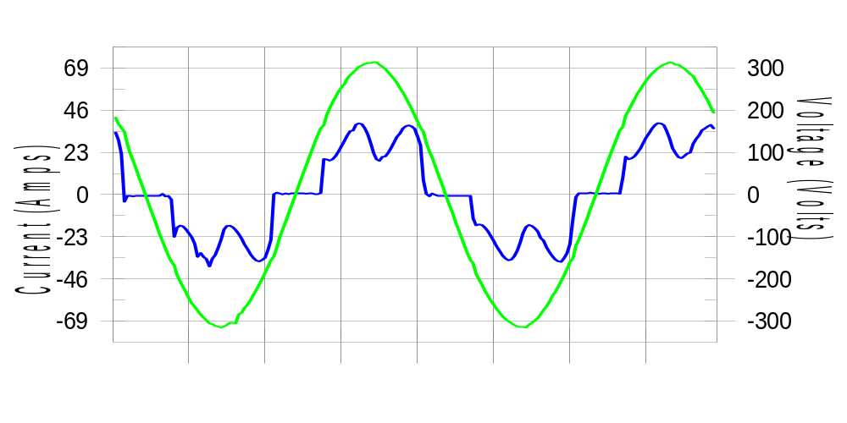

Harmonics and Class 3 limit line European Limits

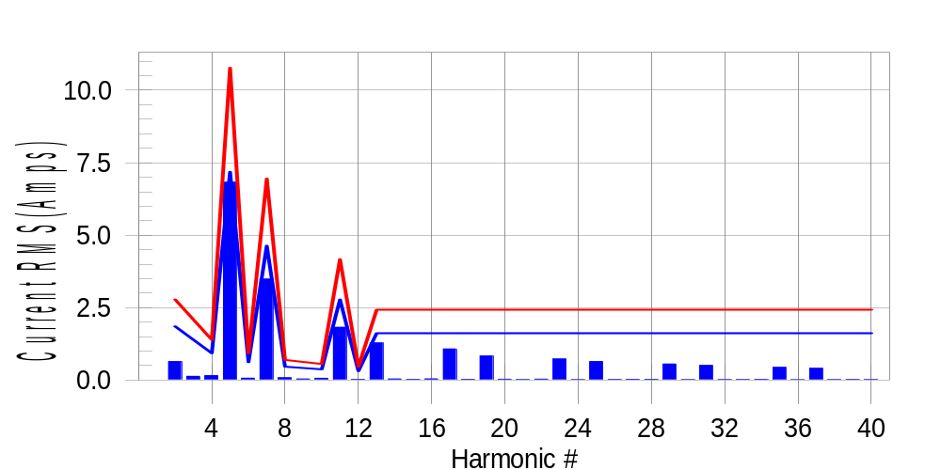

Test result: Fail Worst harmonic was #5 with 63.56 % of the limit.
Current Test Result Summary (Phase A-Run time)

EUT: Equipment under test Tested by: Tested by
Test category: Table:3, Rsce=250, Test Margin: 100
Test date: 2016/4/13 Start time: 16:51:26 End time: 16:54:18
Test duration (min): 2.5 Data file name: CTSMXH_H-000018.cts_data
Comment: Comment
Customer: Customer information

Test Result: Fail Measured I-ref: 23.354(Amps) Source: Distorted
I-THC(%): 35.6 Limit(%): 37.0 PWHC(%): 39.9 PWHC Limit(%): 38.0

Highest parameter values during test:
V_RMS (Volts): 220.43 Frequency(Hz): 50.00
I_Peak (Amps): 48.870 I_RMS (Amps): 23.354
I_Fund (Amps): 21.626 Crest Factor: 2.112
Power (Watts): 4794 Power Factor: 0.932

Harm# Harms(avg) 100%Limit %of Limit Harms(max) 150%Limit %of Limit Status

2 0.639 1.854 34.5 0.677 2.781 24.4 Pass
3 0.132 N/A N/A 0.167 N/A N/A N/A
4 0.155 0.927 16.7 0.170 1.391 12.2 Pass
5 6.825 7.185 95.0 6.843 10.778 63.5 Pass
6 0.065 0.618 10.5 0.076 0.927 8.2 Pass
7 3.484 4.636 75.2 3.495 6.953 50.3 Pass
8 0.080 0.464 17.4 0.092 0.695 13.2 Pass
9 0.039 N/A N/A 0.052 N/A N/A N/A
10 0.062 0.371 16.7 0.073 0.556 13.0 Pass
11 1.823 2.781 65.5 1.834 4.172 43.9 Pass
12 0.029 0.309 9.4 0.038 0.464 8.2 Pass
13 1.283 1.622 79.1 1.296 2.434 53.3 Pass
14 0.042 N/A N/A 0.051 N/A N/A N/A
15 0.029 N/A N/A 0.039 N/A N/A N/A
16 0.043 N/A N/A 0.052 N/A N/A N/A
17 1.074 N/A N/A 1.086 N/A N/A N/A
18 0.026 N/A N/A 0.035 N/A N/A N/A
19 0.833 N/A N/A 0.842 N/A N/A N/A
20 0.032 N/A N/A 0.040 N/A N/A N/A
21 0.022 N/A N/A 0.029 N/A N/A N/A
22 0.035 N/A N/A 0.044 N/A N/A N/A
23 0.728 N/A N/A 0.737 N/A N/A N/A
24 0.018 N/A N/A 0.025 N/A N/A N/A
25 0.640 N/A N/A 0.650 N/A N/A N/A
26 0.023 N/A N/A 0.031 N/A N/A N/A
27 0.028 N/A N/A 0.036 N/A N/A N/A
28 0.027 N/A N/A 0.036 N/A N/A N/A
29 0.557 N/A N/A 0.564 N/A N/A N/A
30 0.019 N/A N/A 0.038 N/A N/A N/A
31 0.508 N/A N/A 0.519 N/A N/A N/A
32 0.021 N/A N/A 0.034 N/A N/A N/A
33 0.021 N/A N/A 0.029 N/A N/A N/A
34 0.026 N/A N/A 0.035 N/A N/A N/A
35 0.440 N/A N/A 0.450 N/A N/A N/A
36 0.016 N/A N/A 0.023 N/A N/A N/A
37 0.407 N/A N/A 0.418 N/A N/A N/A
38 0.019 N/A N/A 0.027 N/A N/A N/A
39 0.024 N/A N/A 0.032 N/A N/A N/A
40 0.022 N/A N/A 0.030 N/A N/A N/A

Note: Measured I-ref was applied for this test.

Voltage Source Verification Data (Phase A-Run time)

EUT: Equipment under test Tested by: Tested by
Test category: Table:3, Rsce=250, Test Margin: 100
Test date: 2016/4/13 Start time: 16:51:26 End time: 16:54:18
Test duration (min): 2.5 Data file name: CTSMXH_H-000018.cts_data
Comment: Comment
Customer: Customer information

Test Result: Fail Source qualification: Distorted
Current harmonics are corrected for source distortion, and are within +/-5%
Measurements are compliant with IEC/EN61000-3-12 Ed.4 & IEC/EN61000-4-7

Highest parameter values during test:
Voltage (Vrms): 220.43 Frequency(Hz): 50.00
I_Peak (Amps): 48.870 I_RMS (Amps): 23.354
I_Fund (Amps): 21.626 Crest Factor: 2.112
Power (Watts): 4794 Power Factor: 0.932

Harm# Harmonics V-rms Limit V-rms % of Limit Status

2 0.175 0.881 19.90 OK
3 0.291 2.755 10.57 OK
4 0.126 0.882 14.27 OK
5 1.110 3.306 33.59 OK
6 0.081 0.882 9.21 OK
7 0.745 2.754 27.04 OK
8 0.083 0.881 9.41 OK
9 0.117 1.322 8.87 OK
10 0.089 0.881 10.15 OK
11 0.606 1.542 39.31 OK
12 0.075 0.661 11.41 OK
13 0.526 1.322 39.83 OK
14 0.072 0.661 10.94 OK
15 0.122 0.661 18.41 OK
16 0.099 0.661 15.01 OK
17 0.501 0.661 75.74 OK
18 0.077 0.661 11.72 OK
19 0.475 0.661 71.84 OK
20 0.156 0.661 23.57 OK
21 0.126 0.661 19.03 OK
22 0.085 0.661 12.91 OK
23 0.439 0.661 66.40 OK
24 0.088 0.661 13.24 OK
25 0.437 0.661 66.14 OK
26 0.083 0.661 12.49 OK
27 0.139 0.661 21.07 OK
28 0.098 0.661 14.81 OK
29 0.381 0.661 57.68 OK
30 0.082 0.661 12.37 OK
31 0.405 0.661 61.31 OK
32 0.084 0.661 12.71 OK
33 0.122 0.661 18.43 OK
34 0.078 0.661 11.75 OK
35 0.347 0.661 52.44 OK
36 0.074 0.661 11.22 OK
37 0.384 0.661 58.08 OK
38 0.084 0.661 12.74 OK
39 0.138 0.661 20.82 OK
40 0.133 0.661 20.15 OK

Harmonics – Per EN/IEC61000-3-12, Ed. 2.0(Phase B-Run time)

EUT: Equipment under test Tested by: Tested by
Test category: Table:3, Rsce=250, Test Margin: 100
Test date: 2016/4/13 Start time: 16:51:26 End time: 16:54:18
Test duration (min): 2.5 Data file name: CTSMXH_H-000018.cts_data
Comment: Comment
Customer: Customer information

Test Result: Fail Source qualification: Distorted

Current & voltage waveforms

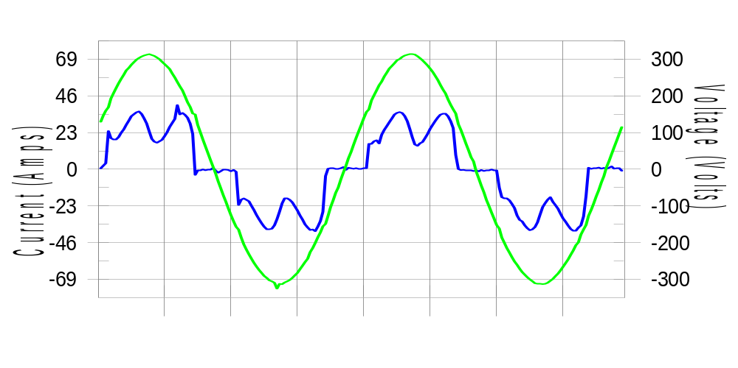

Harmonics and Class 3 limit line European Limits

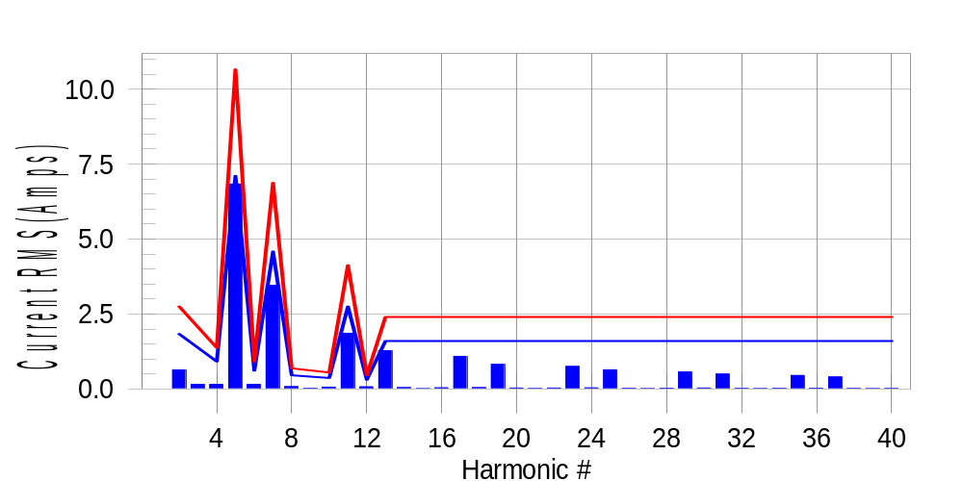

Test result: Fail Worst harmonic was #5 with 64.40 % of the limit.
Current Test Result Summary (Phase B-Run time)

EUT: Equipment under test Tested by: Tested by
Test category: Table:3, Rsce=250, Test Margin: 100
Test date: 2016/4/13 Start time: 16:51:26 End time: 16:54:18
Test duration (min): 2.5 Data file name: CTSMXH_H-000018.cts_data
Comment: Comment
Customer: Customer information

Test Result: Fail Measured I-ref: 23.091(Amps) Source: Distorted
I-THC(%): 36.0 Limit(%): 37.0 PWHC(%): 40.6 PWHC Limit(%): 38.0

Highest parameter values during test:
V_RMS (Volts): 220.23 Frequency(Hz): 50.00
I_Peak (Amps): 49.412 I_RMS (Amps): 23.091
I_Fund (Amps): 21.349 Crest Factor: 2.151
Power (Watts): 4727 Power Factor: 0.930

Harm# Harms(avg) 100%Limit %of Limit Harms(max) 150%Limit %of Limit Status

2 0.638 1.834 34.8 0.673 2.751 24.5 Pass
3 0.132 N/A N/A 0.181 N/A N/A N/A
4 0.154 0.917 16.8 0.177 1.375 12.9 Pass
5 6.836 7.107 96.2 6.855 10.660 64.3 Pass
6 0.155 0.611 25.4 0.166 0.917 18.1 Pass
7 3.457 4.585 75.4 3.469 6.877 50.4 Pass
8 0.080 0.458 17.5 0.090 0.688 13.1 Pass
9 0.039 N/A N/A 0.033 N/A N/A N/A
10 0.063 0.367 17.1 0.072 0.550 13.0 Pass
11 1.858 2.751 67.5 1.871 4.126 45.3 Pass
12 0.074 0.306 24.1 0.083 0.458 18.0 Pass
13 1.277 1.605 79.6 1.287 2.407 53.5 Pass
14 0.046 N/A N/A 0.055 N/A N/A N/A
15 0.016 N/A N/A 0.027 N/A N/A N/A
16 0.042 N/A N/A 0.050 N/A N/A N/A
17 1.089 N/A N/A 1.099 N/A N/A N/A
18 0.046 N/A N/A 0.054 N/A N/A N/A
19 0.822 N/A N/A 0.834 N/A N/A N/A
20 0.033 N/A N/A 0.043 N/A N/A N/A
21 0.017 N/A N/A 0.025 N/A N/A N/A
22 0.035 N/A N/A 0.043 N/A N/A N/A
23 0.752 N/A N/A 0.765 N/A N/A N/A
24 0.040 N/A N/A 0.049 N/A N/A N/A
25 0.639 N/A N/A 0.647 N/A N/A N/A
26 0.024 N/A N/A 0.033 N/A N/A N/A
27 0.016 N/A N/A 0.021 N/A N/A N/A
28 0.027 N/A N/A 0.036 N/A N/A N/A
29 0.568 N/A N/A 0.578 N/A N/A N/A
30 0.033 N/A N/A 0.052 N/A N/A N/A
31 0.499 N/A N/A 0.509 N/A N/A N/A
32 0.023 N/A N/A 0.033 N/A N/A N/A
33 0.015 N/A N/A 0.022 N/A N/A N/A
34 0.025 N/A N/A 0.033 N/A N/A N/A
35 0.455 N/A N/A 0.464 N/A N/A N/A
36 0.028 N/A N/A 0.037 N/A N/A N/A
37 0.402 N/A N/A 0.411 N/A N/A N/A
38 0.020 N/A N/A 0.028 N/A N/A N/A
39 0.015 N/A N/A 0.022 N/A N/A N/A
40 0.022 N/A N/A 0.032 N/A N/A N/A

Note: Measured I-ref was applied for this test.

Voltage Source Verification Data (Phase B-Run time)

EUT: Equipment under test Tested by: Tested by
Test category: Table:3, Rsce=250, Test Margin: 100
Test date: 2016/4/13 Start time: 16:51:26 End time: 16:54:18
Test duration (min): 2.5 Data file name: CTSMXH_H-000018.cts_data
Comment: Comment
Customer: Customer information

Test Result: Fail Source qualification: Distorted
Current harmonics are corrected for source distortion, and are within +/-5%
Measurements are compliant with IEC/EN61000-3-12 Ed.4 & IEC/EN61000-4-7

Highest parameter values during test:
Voltage (Vrms): 220.23 Frequency(Hz): 50.00
I_Peak (Amps): 49.412 I_RMS (Amps): 23.091
I_Fund (Amps): 21.349 Crest Factor: 2.151
Power (Watts): 4727 Power Factor: 0.930

Harm# Harmonics V-rms Limit V-rms % of Limit Status

2 0.178 0.881 20.19 OK
3 0.292 2.752 10.61 OK
4 0.161 0.880 18.34 OK
5 1.168 3.302 35.38 OK
6 0.102 0.881 11.58 OK
7 0.777 2.752 28.23 OK
8 0.100 0.880 11.32 OK
9 0.134 1.321 10.13 OK
10 0.097 0.881 11.05 OK
11 0.671 1.541 43.57 OK
12 0.112 0.661 16.96 OK
13 0.553 1.321 41.84 OK
14 0.124 0.660 18.70 OK
15 0.140 0.660 21.19 OK
16 0.109 0.661 16.49 OK
17 0.548 0.660 83.01 OK
18 0.106 0.661 16.09 OK
19 0.491 0.660 74.39 OK
20 0.144 0.660 21.77 OK
21 0.136 0.660 20.64 OK
22 0.118 0.660 17.90 OK
23 0.485 0.661 73.50 OK
24 0.110 0.661 16.67 OK
25 0.471 0.660 71.36 OK
26 0.113 0.660 17.16 OK
27 0.129 0.660 19.46 OK
28 0.111 0.660 16.77 OK
29 0.414 0.660 62.69 OK
30 0.108 0.660 16.38 OK
31 0.413 0.661 62.52 OK
32 0.104 0.660 15.68 OK
33 0.155 0.661 23.43 OK
34 0.098 0.661 14.82 OK
35 0.396 0.660 59.98 OK
36 0.099 0.661 15.06 OK
37 0.386 0.660 58.47 OK
38 0.100 0.660 15.11 OK
39 0.122 0.660 18.51 OK
40 0.112 0.660 16.97 OK

Harmonics – Per EN/IEC61000-3-12, Ed. 2.0(Phase C-Run time)

EUT: Equipment under test Tested by: Tested by
Test category: Table:3, Rsce=250, Test Margin: 100
Test date: 2016/4/13 Start time: 16:51:26 End time: 16:54:18
Test duration (min): 2.5 Data file name: CTSMXH_H-000018.cts_data
Comment: Comment
Customer: Customer information

Test Result: Fail Source qualification: Distorted

Current & voltage waveforms

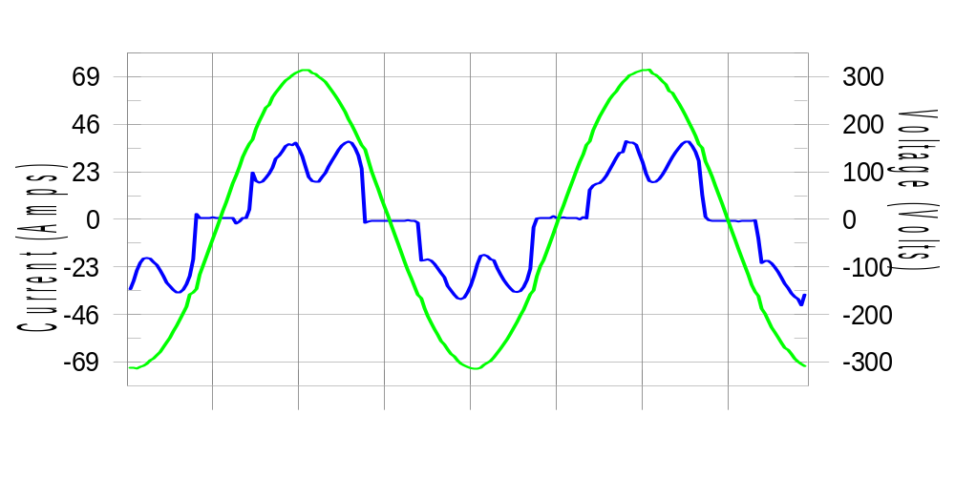

Harmonics and Class 3 limit line European Limits

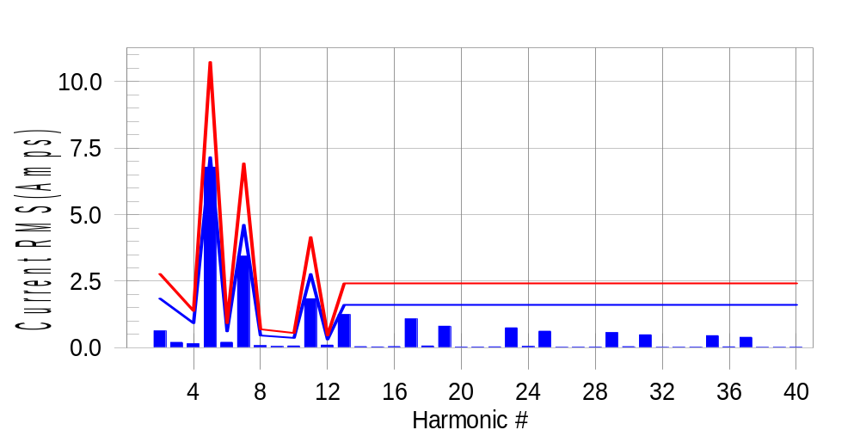

Test result: Fail Worst harmonic was #5 with 63.41 % of the limit.
Current Test Result Summary (Phase C-Run time)

EUT: Equipment under test Tested by: Tested by
Test category: Table:3, Rsce=250, Test Margin: 100
Test date: 2016/4/13 Start time: 16:51:26 End time: 16:54:18
Test duration (min): 2.5 Data file name: CTSMXH_H-000018.cts_data
Comment: Comment
Customer: Customer information

Test Result: Fail Measured I-ref: 23.244(Amps) Source: Distorted
I-THC(%): 35.5 Limit(%): 37.0 PWHC(%): 39.9 PWHC Limit(%): 38.0

Highest parameter values during test:
V_RMS (Volts): 220.13 Frequency(Hz): 50.00
I_Peak (Amps): 45.403 I_RMS (Amps): 23.244
I_Fund (Amps): 21.570 Crest Factor: 1.975
Power (Watts): 4774 Power Factor: 0.933

Harm# Harms(avg) 100%Limit %of Limit Harms(max) 150%Limit %of Limit Status

2 0.633 1.848 34.2 0.662 2.771 23.9 Pass
3 0.132 N/A N/A 0.237 N/A N/A N/A
4 0.150 0.924 16.3 0.167 1.386 12.0 Pass
5 6.784 7.160 94.8 6.803 10.739 63.3 Pass
6 0.205 0.616 33.3 0.214 0.924 23.2 Pass
7 3.442 4.619 74.5 3.454 6.929 49.8 Pass
8 0.078 0.462 16.8 0.086 0.693 12.5 Pass
9 0.039 N/A N/A 0.073 N/A N/A N/A
10 0.065 0.370 17.7 0.073 0.554 13.1 Pass
11 1.842 2.771 66.5 1.856 4.157 44.6 Pass
12 0.099 0.308 32.2 0.108 0.462 23.5 Pass
13 1.250 1.617 77.3 1.258 2.425 51.9 Pass
14 0.041 N/A N/A 0.048 N/A N/A N/A
15 0.031 N/A N/A 0.038 N/A N/A N/A
16 0.045 N/A N/A 0.051 N/A N/A N/A
17 1.085 N/A N/A 1.098 N/A N/A N/A
18 0.066 N/A N/A 0.077 N/A N/A N/A
19 0.811 N/A N/A 0.820 N/A N/A N/A
20 0.028 N/A N/A 0.036 N/A N/A N/A
21 0.026 N/A N/A 0.033 N/A N/A N/A
22 0.035 N/A N/A 0.045 N/A N/A N/A
23 0.747 N/A N/A 0.757 N/A N/A N/A
24 0.049 N/A N/A 0.058 N/A N/A N/A
25 0.622 N/A N/A 0.630 N/A N/A N/A
26 0.022 N/A N/A 0.033 N/A N/A N/A
27 0.023 N/A N/A 0.031 N/A N/A N/A
28 0.029 N/A N/A 0.037 N/A N/A N/A
29 0.572 N/A N/A 0.579 N/A N/A N/A
30 0.040 N/A N/A 0.047 N/A N/A N/A
31 0.487 N/A N/A 0.493 N/A N/A N/A
32 0.019 N/A N/A 0.025 N/A N/A N/A
33 0.022 N/A N/A 0.031 N/A N/A N/A
34 0.025 N/A N/A 0.031 N/A N/A N/A
35 0.454 N/A N/A 0.465 N/A N/A N/A
36 0.034 N/A N/A 0.042 N/A N/A N/A
37 0.392 N/A N/A 0.399 N/A N/A N/A
38 0.017 N/A N/A 0.027 N/A N/A N/A
39 0.019 N/A N/A 0.026 N/A N/A N/A
40 0.022 N/A N/A 0.030 N/A N/A N/A

Note: Measured I-ref was applied for this test.

Voltage Source Verification Data (Phase C-Run time)

EUT: Equipment under test Tested by: Tested by
Test category: Table:3, Rsce=250, Test Margin: 100
Test date: 2016/4/13 Start time: 16:51:26 End time: 16:54:18
Test duration (min): 2.5 Data file name: CTSMXH_H-000018.cts_data
Comment: Comment
Customer: Customer information

Test Result: Fail Source qualification: Distorted
Current harmonics are corrected for source distortion, and are within +/-5%
Measurements are compliant with IEC/EN61000-3-12 Ed.4 & IEC/EN61000-4-7

Highest parameter values during test:
Voltage (Vrms): 220.13 Frequency(Hz): 50.00
I_Peak (Amps): 45.403 I_RMS (Amps): 23.244
I_Fund (Amps): 21.570 Crest Factor: 1.975
Power (Watts): 4774 Power Factor: 0.933

Harm# Harmonics V-rms Limit V-rms % of Limit Status

2 0.206 0.880 23.37 OK
3 0.255 2.751 9.25 OK
4 0.113 0.880 12.88 OK
5 1.100 3.301 33.33 OK
6 0.107 0.880 12.15 OK
7 0.752 2.751 27.32 OK
8 0.093 0.880 10.55 OK
9 0.111 1.321 8.42 OK
10 0.096 0.880 10.94 OK
11 0.624 1.541 40.52 OK
12 0.113 0.660 17.17 OK
13 0.524 1.321 39.69 OK
14 0.086 0.660 13.02 OK
15 0.107 0.660 16.14 OK
16 0.101 0.660 15.26 OK
17 0.531 0.660 80.42 OK
18 0.110 0.660 16.61 OK
19 0.471 0.660 71.35 OK
20 0.103 0.660 15.62 OK
21 0.105 0.660 15.89 OK
22 0.099 0.660 15.00 OK
23 0.497 0.660 75.23 OK
24 0.101 0.660 15.34 OK
25 0.432 0.660 65.43 OK
26 0.099 0.660 14.99 OK
27 0.121 0.660 18.34 OK
28 0.096 0.660 14.49 OK
29 0.412 0.660 62.37 OK
30 0.128 0.660 19.45 OK
31 0.397 0.660 60.20 OK
32 0.107 0.660 16.19 OK
33 0.113 0.660 17.14 OK
34 0.087 0.660 13.20 OK
35 0.354 0.660 53.62 OK
36 0.092 0.660 13.91 OK
37 0.364 0.660 55.20 OK
38 0.094 0.660 14.28 OK
39 0.100 0.660 15.10 OK
40 0.103 0.660 15.59 OK

5th Harmonic Phase Angle and Magnitude for Phase A :
H-5_min_phase : 132.4 Degree (Leading)
H-5_max_phase : 133.0 Degree (Leading)
H-5_ave_phase : 132.7 Degree (Leading)

H-5_ave_vector_magnitude : 6.778 Amp
H-5_standard_ave_magnitude : 6.825 Amp
H-5_standard_max_magnitude : 6.803 Amp
Ratio of H-5_ave_vector / H-5_standard_ave : 0.999

Phase A = 104.934% of tested Rsce = 250.000, Rsce = 262.335
Phase B = 106.963% of tested Rsce = 250.000, Rsce = 267.407
Phase C = 105.108% of tested Rsce = 250.000, Rsce = 262.770
Minimum Rsce required: Rsce = 267.407

