Harmonics – Per EN/IEC61000-3-12, Ed. 2.0(Phase A-Run time)

EUT: Equipment under test Tested by: Tested by
Test category: Table:3, Rsce=250, Test Margin: 100
Test date: 2016/4/13 Start time: 17:00:15 End time: 17:03:07
Test duration (min): 2.5 Data file name: CTSMXH_H-000019.cts_data
Comment: Comment
Customer: Customer information

Test Result: Fail Source qualification: Distorted

Current & voltage waveforms

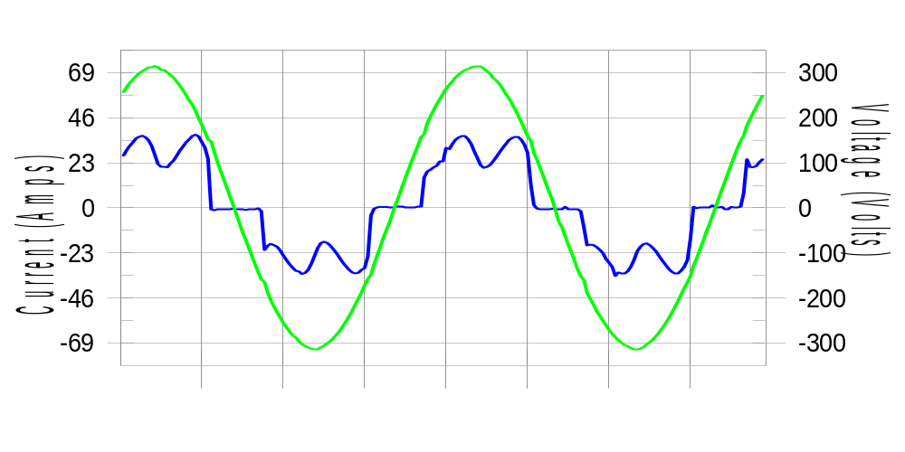

Harmonics and Class 3 limit line European Limits

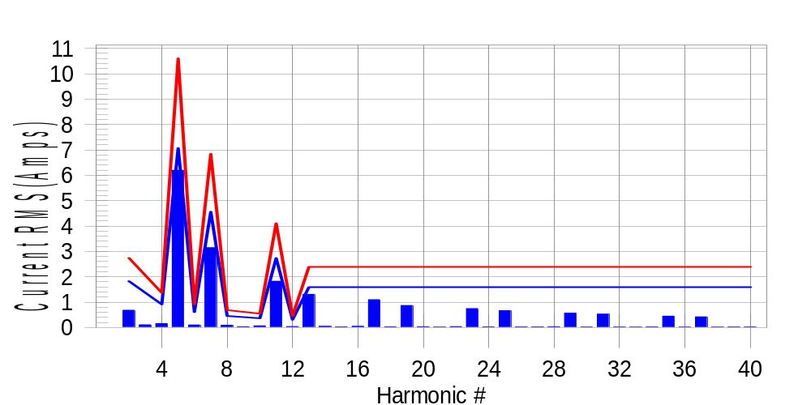

Test result: Fail Worst harmonic was #5 with 58.76 % of the limit.
Current Test Result Summary (Phase A-Run time)

EUT: Equipment under test Tested by: Tested by
Test category: Table:3, Rsce=250, Test Margin: 100
Test date: 2016/4/13 Start time: 17:00:15 End time: 17:03:07
Test duration (min): 2.5 Data file name: CTSMXH_H-000019.cts_data
Comment: Comment
Customer: Customer information

Test Result: Fail Measured I-ref: 23.012(Amps) Source: Distorted
I-THC(%): 33.3 Limit(%): 37.0 PWHC(%): 41.6 PWHC Limit(%): 38.0

Highest parameter values during test:
V_RMS (Volts): 220.44 Frequency(Hz): 50.00
I_Peak (Amps): 46.806 I_RMS (Amps): 23.012
I_Fund (Amps): 21.458 Crest Factor: 2.052
Power (Watts): 4766 Power Factor: 0.940

Harm# Harms(avg) 100%Limit %of Limit Harms(max) 150%Limit %of Limit Status

2 0.682 1.824 37.4 0.722 2.737 26.4 Pass
3 0.108 N/A N/A 0.155 N/A N/A N/A
4 0.154 0.912 16.9 0.170 1.368 12.4 Pass
5 6.196 7.070 87.6 6.227 10.604 58.7 Pass
6 0.099 0.608 16.3 0.109 0.912 12.0 Pass
7 3.143 4.561 68.9 3.162 6.842 46.2 Pass
8 0.088 0.456 19.3 0.099 0.684 14.5 Pass
9 0.035 N/A N/A 0.045 N/A N/A N/A
10 0.067 0.365 18.5 0.082 0.547 15.0 Pass
11 1.825 2.737 66.7 1.842 4.105 44.9 Pass
12 0.041 0.304 13.6 0.063 0.456 13.9 Pass
13 1.306 1.596 81.8 1.317 2.395 55.0 Pass
14 0.046 N/A N/A 0.053 N/A N/A N/A
15 0.028 N/A N/A 0.036 N/A N/A N/A
16 0.047 N/A N/A 0.058 N/A N/A N/A
17 1.095 N/A N/A 1.107 N/A N/A N/A
18 0.029 N/A N/A 0.038 N/A N/A N/A
19 0.865 N/A N/A 0.878 N/A N/A N/A
20 0.034 N/A N/A 0.045 N/A N/A N/A
21 0.021 N/A N/A 0.028 N/A N/A N/A
22 0.037 N/A N/A 0.046 N/A N/A N/A
23 0.745 N/A N/A 0.755 N/A N/A N/A
24 0.026 N/A N/A 0.034 N/A N/A N/A
25 0.664 N/A N/A 0.675 N/A N/A N/A
26 0.027 N/A N/A 0.038 N/A N/A N/A
27 0.027 N/A N/A 0.039 N/A N/A N/A
28 0.032 N/A N/A 0.039 N/A N/A N/A
29 0.569 N/A N/A 0.581 N/A N/A N/A
30 0.024 N/A N/A 0.032 N/A N/A N/A
31 0.526 N/A N/A 0.535 N/A N/A N/A
32 0.023 N/A N/A 0.031 N/A N/A N/A
33 0.020 N/A N/A 0.027 N/A N/A N/A
34 0.028 N/A N/A 0.039 N/A N/A N/A
35 0.449 N/A N/A 0.467 N/A N/A N/A
36 0.021 N/A N/A 0.031 N/A N/A N/A
37 0.419 N/A N/A 0.427 N/A N/A N/A
38 0.022 N/A N/A 0.030 N/A N/A N/A
39 0.023 N/A N/A 0.031 N/A N/A N/A
40 0.025 N/A N/A 0.033 N/A N/A N/A

Note: Measured I-ref was applied for this test.

Voltage Source Verification Data (Phase A-Run time)

EUT: Equipment under test Tested by: Tested by
Test category: Table:3, Rsce=250, Test Margin: 100
Test date: 2016/4/13 Start time: 17:00:15 End time: 17:03:07
Test duration (min): 2.5 Data file name: CTSMXH_H-000019.cts_data
Comment: Comment
Customer: Customer information

Test Result: Fail Source qualification: Distorted
Current harmonics are corrected for source distortion, and are within +/-5%
Measurements are compliant with IEC/EN61000-3-12 Ed.4 & IEC/EN61000-4-7

Highest parameter values during test:
Voltage (Vrms): 220.44 Frequency(Hz): 50.00
I_Peak (Amps): 46.806 I_RMS (Amps): 23.012
I_Fund (Amps): 21.458 Crest Factor: 2.052
Power (Watts): 4766 Power Factor: 0.940

Harm# Harmonics V-rms Limit V-rms % of Limit Status

2 0.152 0.881 17.20 OK
3 0.291 2.755 10.57 OK
4 0.105 0.882 11.91 OK
5 1.020 3.306 30.85 OK
6 0.098 0.881 11.08 OK
7 0.709 2.754 25.73 OK
8 0.096 0.881 10.86 OK
9 0.129 1.322 9.76 OK
10 0.096 0.881 10.88 OK
11 0.613 1.542 39.77 OK
12 0.086 0.661 12.98 OK
13 0.532 1.322 40.23 OK
14 0.098 0.661 14.87 OK
15 0.132 0.661 19.91 OK
16 0.078 0.661 11.75 OK
17 0.517 0.661 78.19 OK
18 0.081 0.661 12.22 OK
19 0.499 0.661 75.41 OK
20 0.162 0.661 24.57 OK
21 0.121 0.661 18.36 OK
22 0.086 0.661 13.02 OK
23 0.448 0.661 67.75 OK
24 0.124 0.661 18.70 OK
25 0.455 0.661 68.88 OK
26 0.090 0.661 13.67 OK
27 0.126 0.661 19.10 OK
28 0.106 0.661 16.05 OK
29 0.391 0.661 59.22 OK
30 0.073 0.661 11.06 OK
31 0.428 0.661 64.76 OK
32 0.084 0.661 12.69 OK
33 0.127 0.661 19.20 OK
34 0.090 0.661 13.64 OK
35 0.344 0.661 52.05 OK
36 0.073 0.661 11.09 OK
37 0.374 0.661 56.50 OK
38 0.089 0.661 13.40 OK
39 0.137 0.661 20.70 OK
40 0.158 0.661 23.96 OK

Harmonics – Per EN/IEC61000-3-12, Ed. 2.0(Phase B-Run time)

EUT: Equipment under test Tested by: Tested by
Test category: Table:3, Rsce=250, Test Margin: 100
Test date: 2016/4/13 Start time: 17:00:15 End time: 17:03:07
Test duration (min): 2.5 Data file name: CTSMXH_H-000019.cts_data
Comment: Comment
Customer: Customer information

Test Result: Fail Source qualification: Distorted

Current & voltage waveforms

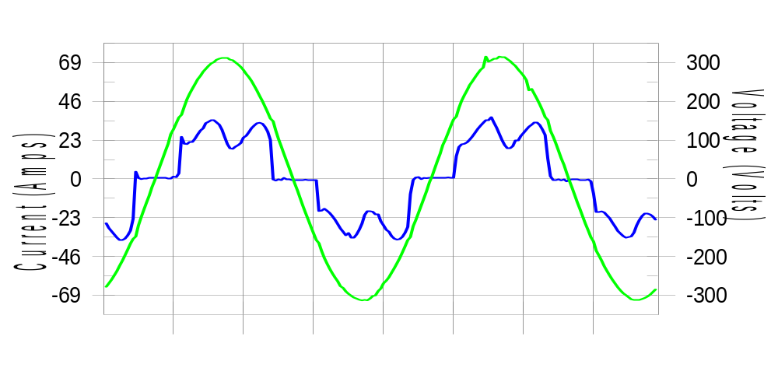

Harmonics and Class 3 limit line European Limits

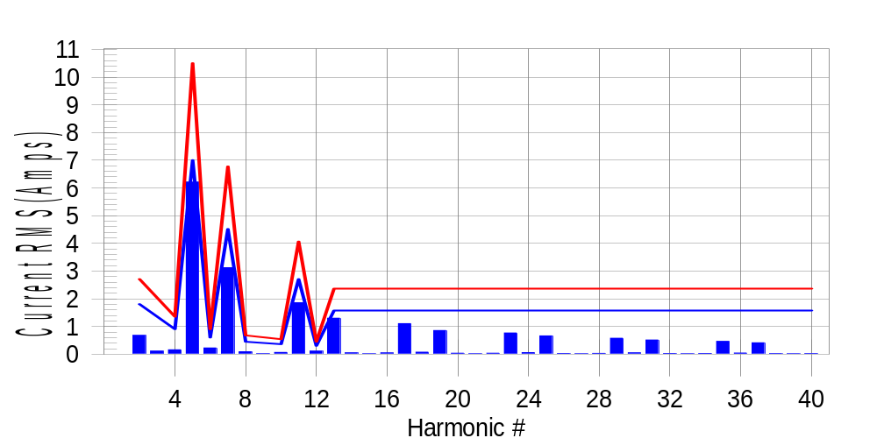

Test result: Fail Worst harmonic was #5 with 59.47 % of the limit.
Current Test Result Summary (Phase B-Run time)

EUT: Equipment under test Tested by: Tested by
Test category: Table:3, Rsce=250, Test Margin: 100
Test date: 2016/4/13 Start time: 17:00:15 End time: 17:03:07
Test duration (min): 2.5 Data file name: CTSMXH_H-000019.cts_data
Comment: Comment
Customer: Customer information

Test Result: Fail Measured I-ref: 22.812(Amps) Source: Distorted
I-THC(%): 33.7 Limit(%): 37.0 PWHC(%): 42.3 PWHC Limit(%): 38.0

Highest parameter values during test:
V_RMS (Volts): 220.24 Frequency(Hz): 50.00
I_Peak (Amps): 49.050 I_RMS (Amps): 22.812
I_Fund (Amps): 21.239 Crest Factor: 2.175
Power (Watts): 4719 Power Factor: 0.940

Harm# Harms(avg) 100%Limit %of Limit Harms(max) 150%Limit %of Limit Status

2 0.679 1.807 37.6 0.722 2.711 26.6 Pass
3 0.108 N/A N/A 0.148 N/A N/A N/A
4 0.159 0.904 17.6 0.175 1.356 12.9 Pass
5 6.212 7.003 88.7 6.239 10.505 59.4 Pass
6 0.227 0.602 37.7 0.238 0.904 26.3 Pass
7 3.122 4.518 69.1 3.138 6.778 46.3 Pass
8 0.091 0.452 20.0 0.102 0.678 15.0 Pass
9 0.035 N/A N/A 0.031 N/A N/A N/A
10 0.066 0.361 18.2 0.076 0.542 14.0 Pass
11 1.857 2.711 68.5 1.873 4.067 46.1 Pass
12 0.113 0.301 37.4 0.125 0.452 27.7 Pass
13 1.302 1.581 82.3 1.315 2.372 55.4 Pass
14 0.049 N/A N/A 0.057 N/A N/A N/A
15 0.016 N/A N/A 0.024 N/A N/A N/A
16 0.046 N/A N/A 0.056 N/A N/A N/A
17 1.105 N/A N/A 1.119 N/A N/A N/A
18 0.074 N/A N/A 0.083 N/A N/A N/A
19 0.854 N/A N/A 0.875 N/A N/A N/A
20 0.036 N/A N/A 0.049 N/A N/A N/A
21 0.017 N/A N/A 0.023 N/A N/A N/A
22 0.037 N/A N/A 0.045 N/A N/A N/A
23 0.766 N/A N/A 0.781 N/A N/A N/A
24 0.058 N/A N/A 0.067 N/A N/A N/A
25 0.662 N/A N/A 0.672 N/A N/A N/A
26 0.028 N/A N/A 0.038 N/A N/A N/A
27 0.016 N/A N/A 0.024 N/A N/A N/A
28 0.030 N/A N/A 0.038 N/A N/A N/A
29 0.578 N/A N/A 0.589 N/A N/A N/A
30 0.049 N/A N/A 0.059 N/A N/A N/A
31 0.514 N/A N/A 0.525 N/A N/A N/A
32 0.027 N/A N/A 0.038 N/A N/A N/A
33 0.016 N/A N/A 0.022 N/A N/A N/A
34 0.027 N/A N/A 0.048 N/A N/A N/A
35 0.463 N/A N/A 0.479 N/A N/A N/A
36 0.042 N/A N/A 0.062 N/A N/A N/A
37 0.414 N/A N/A 0.423 N/A N/A N/A
38 0.023 N/A N/A 0.030 N/A N/A N/A
39 0.016 N/A N/A 0.022 N/A N/A N/A
40 0.024 N/A N/A 0.033 N/A N/A N/A

Note: Measured I-ref was applied for this test.

Voltage Source Verification Data (Phase B-Run time)

EUT: Equipment under test Tested by: Tested by
Test category: Table:3, Rsce=250, Test Margin: 100
Test date: 2016/4/13 Start time: 17:00:15 End time: 17:03:07
Test duration (min): 2.5 Data file name: CTSMXH_H-000019.cts_data
Comment: Comment
Customer: Customer information

Test Result: Fail Source qualification: Distorted
Current harmonics are corrected for source distortion, and are within +/-5%
Measurements are compliant with IEC/EN61000-3-12 Ed.4 & IEC/EN61000-4-7

Highest parameter values during test:
Voltage (Vrms): 220.24 Frequency(Hz): 50.00
I_Peak (Amps): 49.050 I_RMS (Amps): 22.812
I_Fund (Amps): 21.239 Crest Factor: 2.175
Power (Watts): 4719 Power Factor: 0.940

Harm# Harmonics V-rms Limit V-rms % of Limit Status

2 0.205 0.881 23.31 OK
3 0.307 2.752 11.15 OK
4 0.127 0.880 14.45 OK
5 1.068 3.302 32.35 OK
6 0.122 0.881 13.85 OK
7 0.735 2.752 26.72 OK
8 0.108 0.880 12.26 OK
9 0.144 1.321 10.88 OK
10 0.131 0.881 14.89 OK
11 0.663 1.541 43.03 OK
12 0.113 0.660 17.16 OK
13 0.564 1.321 42.72 OK
14 0.110 0.660 16.58 OK
15 0.157 0.660 23.81 OK
16 0.112 0.660 17.03 OK
17 0.557 0.660 84.39 OK
18 0.113 0.661 17.14 OK
19 0.502 0.660 76.07 OK
20 0.137 0.660 20.73 OK
21 0.140 0.660 21.21 OK
22 0.107 0.660 16.14 OK
23 0.467 0.660 70.77 OK
24 0.134 0.661 20.22 OK
25 0.474 0.660 71.77 OK
26 0.111 0.661 16.86 OK
27 0.133 0.661 20.15 OK
28 0.110 0.660 16.65 OK
29 0.408 0.660 61.72 OK
30 0.116 0.661 17.54 OK
31 0.425 0.660 64.43 OK
32 0.107 0.661 16.25 OK
33 0.141 0.660 21.29 OK
34 0.107 0.660 16.14 OK
35 0.372 0.660 56.38 OK
36 0.120 0.660 18.10 OK
37 0.394 0.660 59.71 OK
38 0.103 0.660 15.53 OK
39 0.121 0.660 18.35 OK
40 0.108 0.660 16.33 OK

Harmonics – Per EN/IEC61000-3-12, Ed. 2.0(Phase C-Run time)

EUT: Equipment under test Tested by: Tested by
Test category: Table:3, Rsce=250, Test Margin: 100
Test date: 2016/4/13 Start time: 17:00:15 End time: 17:03:07
Test duration (min): 2.5 Data file name: CTSMXH_H-000019.cts_data
Comment: Comment
Customer: Customer information

Test Result: Fail Source qualification: Distorted

Current & voltage waveforms

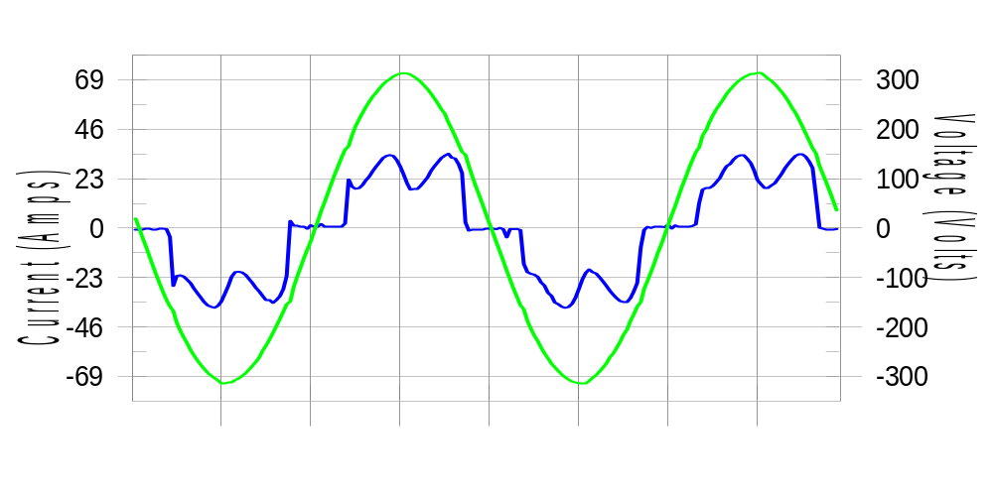

Harmonics and Class 3 limit line European Limits

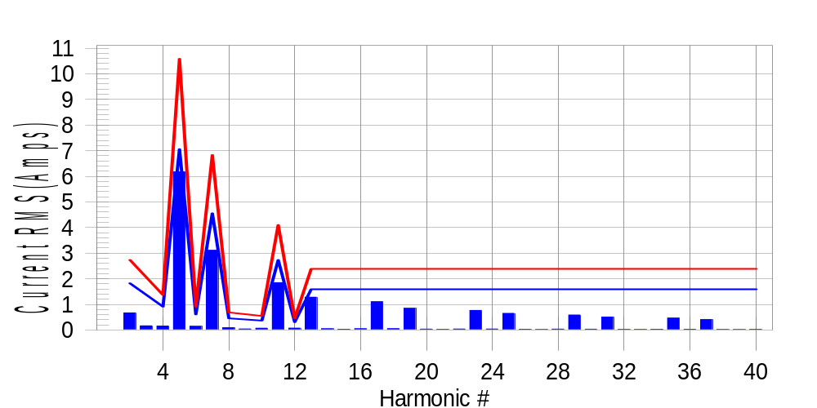

Test result: Fail Worst harmonic was #5 with 58.63 % of the limit.
Current Test Result Summary (Phase C-Run time)

EUT: Equipment under test Tested by: Tested by
Test category: Table:3, Rsce=250, Test Margin: 100
Test date: 2016/4/13 Start time: 17:00:15 End time: 17:03:07
Test duration (min): 2.5 Data file name: CTSMXH_H-000019.cts_data
Comment: Comment
Customer: Customer information

Test Result: Fail Measured I-ref: 22.984(Amps) Source: Distorted
I-THC(%): 33.3 Limit(%): 37.0 PWHC(%): 41.7 PWHC Limit(%): 38.0

Highest parameter values during test:
V_RMS (Volts): 220.16 Frequency(Hz): 50.00
I_Peak (Amps): 46.302 I_RMS (Amps): 22.984
I_Fund (Amps): 21.431 Crest Factor: 2.022
Power (Watts): 4762 Power Factor: 0.942

Harm# Harms(avg) 100%Limit %of Limit Harms(max) 150%Limit %of Limit Status

2 0.666 1.821 36.6 0.709 2.731 26.0 Pass
3 0.108 N/A N/A 0.200 N/A N/A N/A
4 0.152 0.910 16.7 0.170 1.366 12.5 Pass
5 6.170 7.056 87.4 6.201 10.584 58.6 Pass
6 0.143 0.607 23.6 0.152 0.910 16.7 Pass
7 3.111 4.552 68.3 3.129 6.828 45.8 Pass
8 0.088 0.455 19.3 0.098 0.683 14.3 Pass
9 0.035 N/A N/A 0.050 N/A N/A N/A
10 0.069 0.364 18.8 0.077 0.546 14.1 Pass
11 1.847 2.731 67.6 1.861 4.097 45.4 Pass
12 0.072 0.303 23.9 0.081 0.455 17.8 Pass
13 1.278 1.593 80.2 1.293 2.390 54.1 Pass
14 0.047 N/A N/A 0.053 N/A N/A N/A
15 0.027 N/A N/A 0.046 N/A N/A N/A
16 0.047 N/A N/A 0.054 N/A N/A N/A
17 1.104 N/A N/A 1.114 N/A N/A N/A
18 0.049 N/A N/A 0.056 N/A N/A N/A
19 0.845 N/A N/A 0.858 N/A N/A N/A
20 0.033 N/A N/A 0.041 N/A N/A N/A
21 0.023 N/A N/A 0.033 N/A N/A N/A
22 0.037 N/A N/A 0.045 N/A N/A N/A
23 0.763 N/A N/A 0.771 N/A N/A N/A
24 0.036 N/A N/A 0.047 N/A N/A N/A
25 0.648 N/A N/A 0.657 N/A N/A N/A
26 0.026 N/A N/A 0.034 N/A N/A N/A
27 0.022 N/A N/A 0.030 N/A N/A N/A
28 0.032 N/A N/A 0.042 N/A N/A N/A
29 0.585 N/A N/A 0.593 N/A N/A N/A
30 0.030 N/A N/A 0.043 N/A N/A N/A
31 0.505 N/A N/A 0.512 N/A N/A N/A
32 0.023 N/A N/A 0.030 N/A N/A N/A
33 0.021 N/A N/A 0.028 N/A N/A N/A
34 0.027 N/A N/A 0.034 N/A N/A N/A
35 0.462 N/A N/A 0.469 N/A N/A N/A
36 0.026 N/A N/A 0.032 N/A N/A N/A
37 0.406 N/A N/A 0.415 N/A N/A N/A
38 0.020 N/A N/A 0.027 N/A N/A N/A
39 0.019 N/A N/A 0.025 N/A N/A N/A
40 0.024 N/A N/A 0.030 N/A N/A N/A

Note: Measured I-ref was applied for this test.

Voltage Source Verification Data (Phase C-Run time)

EUT: Equipment under test Tested by: Tested by
Test category: Table:3, Rsce=250, Test Margin: 100
Test date: 2016/4/13 Start time: 17:00:15 End time: 17:03:07
Test duration (min): 2.5 Data file name: CTSMXH_H-000019.cts_data
Comment: Comment
Customer: Customer information

Test Result: Fail Source qualification: Distorted
Current harmonics are corrected for source distortion, and are within +/-5%
Measurements are compliant with IEC/EN61000-3-12 Ed.4 & IEC/EN61000-4-7

Highest parameter values during test:
Voltage (Vrms): 220.16 Frequency(Hz): 50.00
I_Peak (Amps): 46.302 I_RMS (Amps): 22.984
I_Fund (Amps): 21.431 Crest Factor: 2.022
Power (Watts): 4762 Power Factor: 0.942

Harm# Harmonics V-rms Limit V-rms % of Limit Status

2 0.181 0.880 20.55 OK
3 0.255 2.751 9.28 OK
4 0.126 0.880 14.36 OK
5 1.023 3.300 31.00 OK
6 0.101 0.880 11.53 OK
7 0.689 2.751 25.04 OK
8 0.094 0.880 10.72 OK
9 0.116 1.321 8.78 OK
10 0.097 0.880 10.97 OK
11 0.622 1.541 40.38 OK
12 0.098 0.660 14.91 OK
13 0.529 1.320 40.10 OK
14 0.094 0.660 14.27 OK
15 0.109 0.660 16.47 OK
16 0.104 0.660 15.79 OK
17 0.536 0.660 81.24 OK
18 0.088 0.660 13.28 OK
19 0.477 0.660 72.20 OK
20 0.108 0.660 16.32 OK
21 0.118 0.660 17.94 OK
22 0.090 0.660 13.56 OK
23 0.458 0.660 69.33 OK
24 0.095 0.660 14.41 OK
25 0.445 0.660 67.39 OK
26 0.108 0.660 16.35 OK
27 0.121 0.660 18.25 OK
28 0.121 0.660 18.41 OK
29 0.405 0.660 61.41 OK
30 0.099 0.660 15.04 OK
31 0.404 0.660 61.25 OK
32 0.087 0.660 13.19 OK
33 0.114 0.660 17.31 OK
34 0.090 0.660 13.66 OK
35 0.361 0.660 54.62 OK
36 0.103 0.660 15.59 OK
37 0.374 0.660 56.60 OK
38 0.101 0.660 15.22 OK
39 0.138 0.660 20.85 OK
40 0.100 0.660 15.16 OK

5th Harmonic Phase Angle and Magnitude for Phase A :
H-5_min_phase : 136.2 Degree (Leading)
H-5_max_phase : 137.0 Degree (Leading)
H-5_ave_phase : 136.6 Degree (Leading)

H-5_ave_vector_magnitude : 6.164 Amp
H-5_standard_ave_magnitude : 6.196 Amp
H-5_standard_max_magnitude : 6.201 Amp
Ratio of H-5_ave_vector / H-5_standard_ave : 0.999

Phase A = 109.586% of tested Rsce = 250.000, Rsce = 273.965
Phase B = 111.421% of tested Rsce = 250.000, Rsce = 278.552
Phase C = 109.703% of tested Rsce = 250.000, Rsce = 274.258
Minimum Rsce required: Rsce = 278.552

