Harmonics – Per EN/IEC61000-3-12, Ed. 2.0(Phase A-Run time)

EUT: Equipment under test Tested by: Tested by
Test category: Table:3, Rsce=250, Test Margin: 100
Test date: 2016/4/13 Start time: 17:07:56 End time: 17:10:49
Test duration (min): 2.5 Data file name: CTSMXH_H-000020.cts_data
Comment: Comment
Customer: Customer information

Test Result: Fail Source qualification: Distorted

Current & voltage waveforms

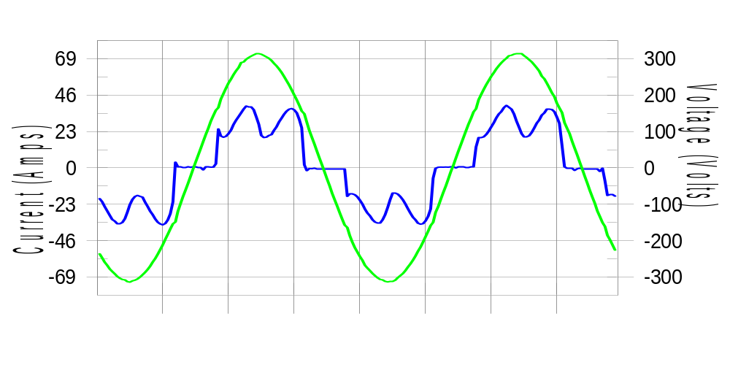

Harmonics and Class 3 limit line European Limits

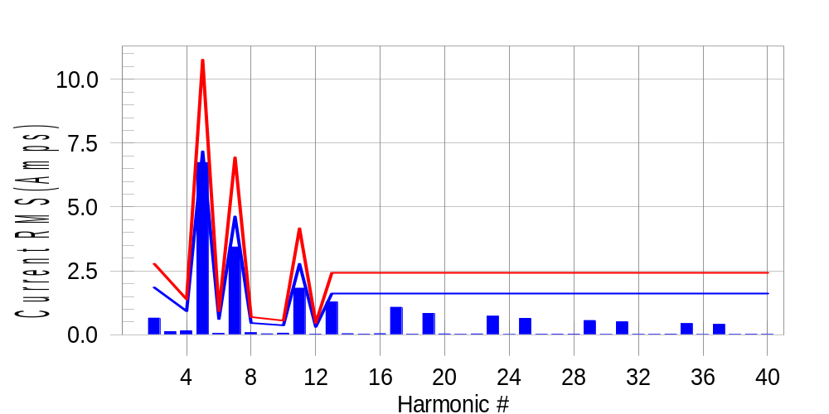

Test result: Fail Worst harmonic was #5 with 62.88 % of the limit.
Current Test Result Summary (Phase A-Run time)

EUT: Equipment under test Tested by: Tested by
Test category: Table:3, Rsce=250, Test Margin: 100
Test date: 2016/4/13 Start time: 17:07:56 End time: 17:10:49
Test duration (min): 2.5 Data file name: CTSMXH_H-000020.cts_data
Comment: Comment
Customer: Customer information

Test Result: Fail Measured I-ref: 23.357(Amps) Source: Distorted
I-THC(%): 35.2 Limit(%): 37.0 PWHC(%): 40.1 PWHC Limit(%): 38.0

Highest parameter values during test:
V_RMS (Volts): 220.43 Frequency(Hz): 50.00
I_Peak (Amps): 49.182 I_RMS (Amps): 23.357
I_Fund (Amps): 21.626 Crest Factor: 2.124
Power (Watts): 4799 Power Factor: 0.933

Harm# Harms(avg) 100%Limit %of Limit Harms(max) 150%Limit %of Limit Status

2 0.654 1.852 35.3 0.688 2.778 24.8 Pass
3 0.125 N/A N/A 0.162 N/A N/A N/A
4 0.156 0.926 16.8 0.171 1.389 12.3 Pass
5 6.741 7.176 93.9 6.768 10.764 62.9 Pass
6 0.058 0.617 9.5 0.069 0.926 7.5 Pass
7 3.434 4.630 74.2 3.446 6.945 49.6 Pass
8 0.082 0.463 17.6 0.093 0.694 13.4 Pass
9 0.038 N/A N/A 0.054 N/A N/A N/A
10 0.062 0.370 16.7 0.072 0.556 13.0 Pass
11 1.825 2.778 65.7 1.838 4.167 44.1 Pass
12 0.024 0.309 7.9 0.033 0.463 7.1 Pass
13 1.286 1.620 79.4 1.295 2.431 53.3 Pass
14 0.043 N/A N/A 0.051 N/A N/A N/A
15 0.029 N/A N/A 0.039 N/A N/A N/A
16 0.044 N/A N/A 0.055 N/A N/A N/A
17 1.078 N/A N/A 1.089 N/A N/A N/A
18 0.024 N/A N/A 0.033 N/A N/A N/A
19 0.837 N/A N/A 0.849 N/A N/A N/A
20 0.033 N/A N/A 0.055 N/A N/A N/A
21 0.022 N/A N/A 0.029 N/A N/A N/A
22 0.034 N/A N/A 0.044 N/A N/A N/A
23 0.732 N/A N/A 0.743 N/A N/A N/A
24 0.016 N/A N/A 0.023 N/A N/A N/A
25 0.642 N/A N/A 0.651 N/A N/A N/A
26 0.023 N/A N/A 0.031 N/A N/A N/A
27 0.028 N/A N/A 0.039 N/A N/A N/A
28 0.029 N/A N/A 0.038 N/A N/A N/A
29 0.559 N/A N/A 0.569 N/A N/A N/A
30 0.017 N/A N/A 0.025 N/A N/A N/A
31 0.511 N/A N/A 0.520 N/A N/A N/A
32 0.022 N/A N/A 0.029 N/A N/A N/A
33 0.020 N/A N/A 0.029 N/A N/A N/A
34 0.026 N/A N/A 0.036 N/A N/A N/A
35 0.441 N/A N/A 0.451 N/A N/A N/A
36 0.016 N/A N/A 0.025 N/A N/A N/A
37 0.409 N/A N/A 0.424 N/A N/A N/A
38 0.019 N/A N/A 0.026 N/A N/A N/A
39 0.024 N/A N/A 0.031 N/A N/A N/A
40 0.022 N/A N/A 0.034 N/A N/A N/A

Note: Measured I-ref was applied for this test.

Voltage Source Verification Data (Phase A-Run time)

EUT: Equipment under test Tested by: Tested by
Test category: Table:3, Rsce=250, Test Margin: 100
Test date: 2016/4/13 Start time: 17:07:56 End time: 17:10:49
Test duration (min): 2.5 Data file name: CTSMXH_H-000020.cts_data
Comment: Comment
Customer: Customer information

Test Result: Fail Source qualification: Distorted
Current harmonics are corrected for source distortion, and are within +/-5%
Measurements are compliant with IEC/EN61000-3-12 Ed.4 & IEC/EN61000-4-7

Highest parameter values during test:
Voltage (Vrms): 220.43 Frequency(Hz): 50.00
I_Peak (Amps): 49.182 I_RMS (Amps): 23.357
I_Fund (Amps): 21.626 Crest Factor: 2.124
Power (Watts): 4799 Power Factor: 0.933

Harm# Harmonics V-rms Limit V-rms % of Limit Status

2 0.170 0.881 19.23 OK
3 0.297 2.755 10.79 OK
4 0.101 0.881 11.43 OK
5 1.103 3.305 33.39 OK
6 0.084 0.882 9.56 OK
7 0.766 2.754 27.81 OK
8 0.096 0.881 10.91 OK
9 0.138 1.322 10.45 OK
10 0.086 0.881 9.78 OK
11 0.605 1.542 39.25 OK
12 0.087 0.661 13.22 OK
13 0.530 1.322 40.09 OK
14 0.081 0.661 12.31 OK
15 0.130 0.661 19.70 OK
16 0.100 0.661 15.20 OK
17 0.510 0.661 77.11 OK
18 0.095 0.661 14.40 OK
19 0.485 0.661 73.34 OK
20 0.174 0.661 26.27 OK
21 0.147 0.661 22.29 OK
22 0.089 0.661 13.48 OK
23 0.457 0.661 69.12 OK
24 0.072 0.661 10.90 OK
25 0.455 0.661 68.89 OK
26 0.084 0.661 12.71 OK
27 0.130 0.661 19.62 OK
28 0.108 0.661 16.29 OK
29 0.381 0.661 57.71 OK
30 0.091 0.661 13.72 OK
31 0.401 0.661 60.65 OK
32 0.085 0.661 12.81 OK
33 0.128 0.661 19.35 OK
34 0.093 0.661 14.05 OK
35 0.336 0.661 50.86 OK
36 0.090 0.661 13.69 OK
37 0.377 0.661 57.01 OK
38 0.084 0.661 12.69 OK
39 0.138 0.661 20.95 OK
40 0.143 0.661 21.70 OK

Harmonics – Per EN/IEC61000-3-12, Ed. 2.0(Phase B-Run time)

EUT: Equipment under test Tested by: Tested by
Test category: Table:3, Rsce=250, Test Margin: 100
Test date: 2016/4/13 Start time: 17:07:56 End time: 17:10:49
Test duration (min): 2.5 Data file name: CTSMXH_H-000020.cts_data
Comment: Comment
Customer: Customer information

Test Result: Fail Source qualification: Distorted

Current & voltage waveforms

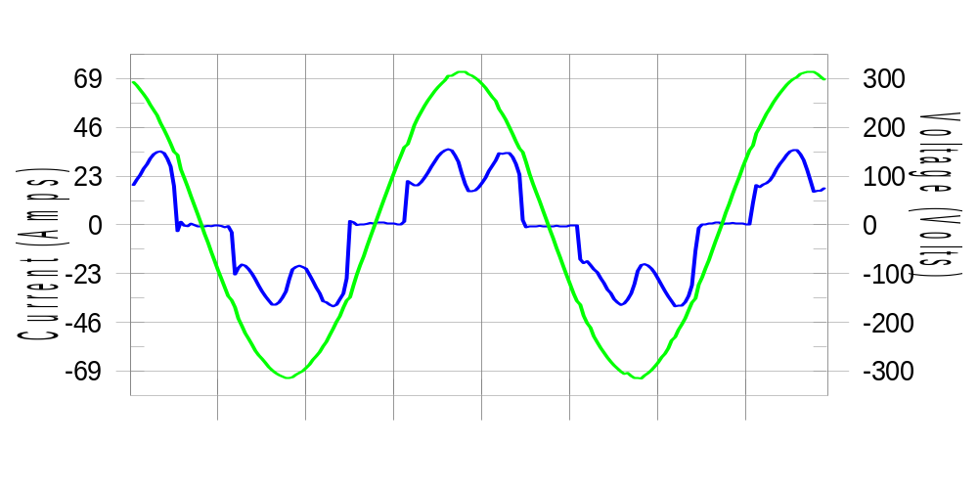

Harmonics and Class 3 limit line European Limits

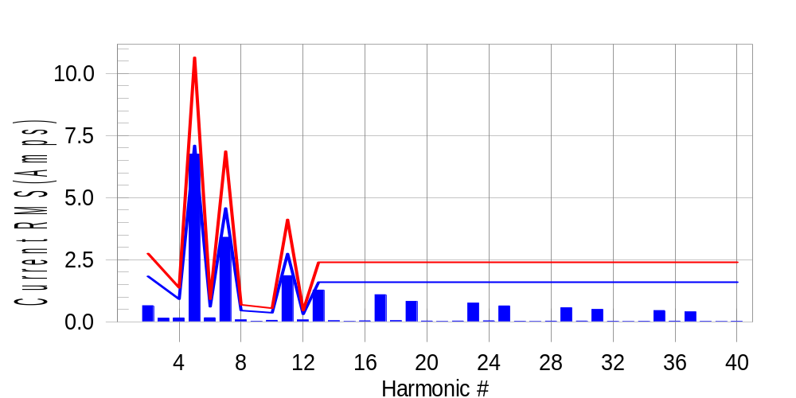

Test result: Fail Worst harmonic was #5 with 63.67 % of the limit.
Current Test Result Summary (Phase B-Run time)

EUT: Equipment under test Tested by: Tested by
Test category: Table:3, Rsce=250, Test Margin: 100
Test date: 2016/4/13 Start time: 17:07:56 End time: 17:10:49
Test duration (min): 2.5 Data file name: CTSMXH_H-000020.cts_data
Comment: Comment
Customer: Customer information

Test Result: Fail Measured I-ref: 23.103(Amps) Source: Distorted
I-THC(%): 35.7 Limit(%): 37.0 PWHC(%): 40.9 PWHC Limit(%): 38.0

Highest parameter values during test:
V_RMS (Volts): 220.24 Frequency(Hz): 50.00
I_Peak (Amps): 53.514 I_RMS (Amps): 23.103
I_Fund (Amps): 21.358 Crest Factor: 2.328
Power (Watts): 4736 Power Factor: 0.932

Harm# Harms(avg) 100%Limit %of Limit Harms(max) 150%Limit %of Limit Status

2 0.652 1.832 35.6 0.684 2.748 24.9 Pass
3 0.125 N/A N/A 0.181 N/A N/A N/A
4 0.159 0.916 17.4 0.174 1.374 12.7 Pass
5 6.755 7.100 95.2 6.774 10.649 63.6 Pass
6 0.165 0.611 27.1 0.176 0.916 19.2 Pass
7 3.408 4.580 74.4 3.428 6.871 49.9 Pass
8 0.082 0.458 17.8 0.094 0.687 13.7 Pass
9 0.038 N/A N/A 0.033 N/A N/A N/A
10 0.063 0.366 17.2 0.075 0.550 13.6 Pass
11 1.859 2.748 67.7 1.871 4.122 45.4 Pass
12 0.078 0.305 25.6 0.088 0.458 19.2 Pass
13 1.281 1.603 79.9 1.292 2.405 53.7 Pass
14 0.046 N/A N/A 0.056 N/A N/A N/A
15 0.017 N/A N/A 0.025 N/A N/A N/A
16 0.042 N/A N/A 0.051 N/A N/A N/A
17 1.093 N/A N/A 1.104 N/A N/A N/A
18 0.050 N/A N/A 0.059 N/A N/A N/A
19 0.826 N/A N/A 0.837 N/A N/A N/A
20 0.033 N/A N/A 0.046 N/A N/A N/A
21 0.017 N/A N/A 0.028 N/A N/A N/A
22 0.035 N/A N/A 0.045 N/A N/A N/A
23 0.755 N/A N/A 0.777 N/A N/A N/A
24 0.042 N/A N/A 0.050 N/A N/A N/A
25 0.642 N/A N/A 0.650 N/A N/A N/A
26 0.024 N/A N/A 0.032 N/A N/A N/A
27 0.016 N/A N/A 0.021 N/A N/A N/A
28 0.029 N/A N/A 0.042 N/A N/A N/A
29 0.569 N/A N/A 0.580 N/A N/A N/A
30 0.035 N/A N/A 0.044 N/A N/A N/A
31 0.502 N/A N/A 0.511 N/A N/A N/A
32 0.024 N/A N/A 0.034 N/A N/A N/A
33 0.016 N/A N/A 0.025 N/A N/A N/A
34 0.025 N/A N/A 0.034 N/A N/A N/A
35 0.457 N/A N/A 0.466 N/A N/A N/A
36 0.031 N/A N/A 0.041 N/A N/A N/A
37 0.404 N/A N/A 0.413 N/A N/A N/A
38 0.020 N/A N/A 0.028 N/A N/A N/A
39 0.016 N/A N/A 0.023 N/A N/A N/A
40 0.023 N/A N/A 0.031 N/A N/A N/A

Note: Measured I-ref was applied for this test.

Voltage Source Verification Data (Phase B-Run time)

EUT: Equipment under test Tested by: Tested by
Test category: Table:3, Rsce=250, Test Margin: 100
Test date: 2016/4/13 Start time: 17:07:56 End time: 17:10:49
Test duration (min): 2.5 Data file name: CTSMXH_H-000020.cts_data
Comment: Comment
Customer: Customer information

Test Result: Fail Source qualification: Distorted
Current harmonics are corrected for source distortion, and are within +/-5%
Measurements are compliant with IEC/EN61000-3-12 Ed.4 & IEC/EN61000-4-7

Highest parameter values during test:
Voltage (Vrms): 220.24 Frequency(Hz): 50.00
I_Peak (Amps): 53.514 I_RMS (Amps): 23.103
I_Fund (Amps): 21.358 Crest Factor: 2.328
Power (Watts): 4736 Power Factor: 0.932

Harm# Harmonics V-rms Limit V-rms % of Limit Status

2 0.195 0.881 22.14 OK
3 0.317 2.752 11.53 OK
4 0.131 0.881 14.85 OK
5 1.169 3.302 35.39 OK
6 0.132 0.881 15.01 OK
7 0.776 2.752 28.18 OK
8 0.123 0.881 13.93 OK
9 0.130 1.321 9.85 OK
10 0.103 0.881 11.73 OK
11 0.662 1.541 42.98 OK
12 0.124 0.661 18.84 OK
13 0.569 1.321 43.06 OK
14 0.101 0.660 15.37 OK
15 0.137 0.661 20.68 OK
16 0.109 0.661 16.48 OK
17 0.559 0.660 84.67 OK
18 0.110 0.660 16.70 OK
19 0.501 0.660 75.82 OK
20 0.122 0.660 18.50 OK
21 0.137 0.660 20.69 OK
22 0.106 0.660 16.12 OK
23 0.460 0.660 69.64 OK
24 0.103 0.660 15.63 OK
25 0.475 0.660 71.86 OK
26 0.101 0.661 15.32 OK
27 0.124 0.660 18.74 OK
28 0.134 0.660 20.22 OK
29 0.407 0.660 61.70 OK
30 0.125 0.660 18.92 OK
31 0.420 0.660 63.54 OK
32 0.113 0.660 17.05 OK
33 0.153 0.660 23.24 OK
34 0.091 0.660 13.78 OK
35 0.378 0.660 57.25 OK
36 0.102 0.661 15.37 OK
37 0.408 0.660 61.75 OK
38 0.098 0.661 14.85 OK
39 0.149 0.660 22.54 OK
40 0.105 0.660 15.91 OK

Harmonics – Per EN/IEC61000-3-12, Ed. 2.0(Phase C-Run time)

EUT: Equipment under test Tested by: Tested by
Test category: Table:3, Rsce=250, Test Margin: 100
Test date: 2016/4/13 Start time: 17:07:56 End time: 17:10:49
Test duration (min): 2.5 Data file name: CTSMXH_H-000020.cts_data
Comment: Comment
Customer: Customer information

Test Result: Fail Source qualification: Distorted

Current & voltage waveforms

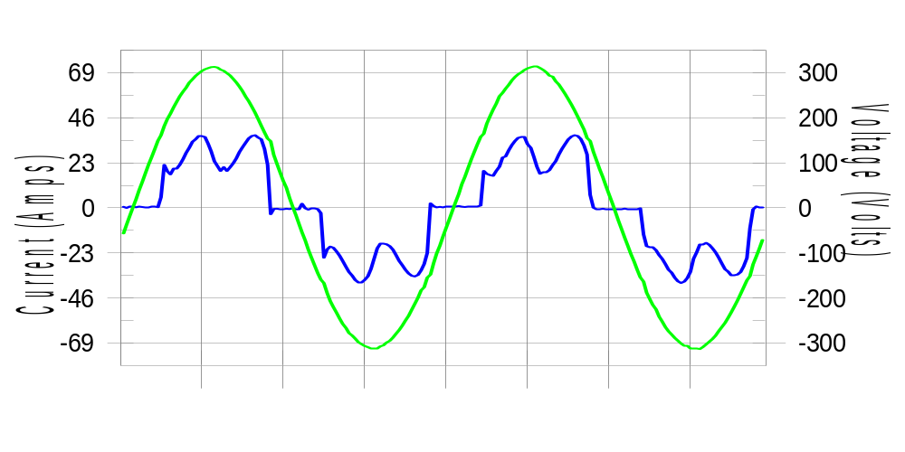

Harmonics and Class 3 limit line European Limits

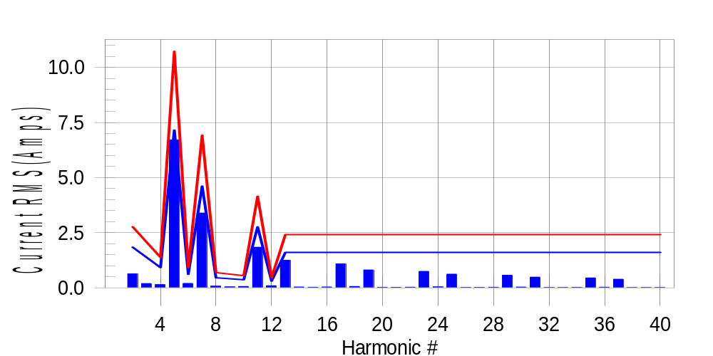

Test result: Fail Worst harmonic was #5 with 62.77 % of the limit.
Current Test Result Summary (Phase C-Run time)

EUT: Equipment under test Tested by: Tested by
Test category: Table:3, Rsce=250, Test Margin: 100
Test date: 2016/4/13 Start time: 17:07:56 End time: 17:10:49
Test duration (min): 2.5 Data file name: CTSMXH_H-000020.cts_data
Comment: Comment
Customer: Customer information

Test Result: Fail Measured I-ref: 23.273(Amps) Source: Distorted
I-THC(%): 35.2 Limit(%): 37.0 PWHC(%): 40.2 PWHC Limit(%): 38.0

Highest parameter values during test:
V_RMS (Volts): 220.15 Frequency(Hz): 50.00
I_Peak (Amps): 47.608 I_RMS (Amps): 23.273
I_Fund (Amps): 21.566 Crest Factor: 2.064
Power (Watts): 4787 Power Factor: 0.935

Harm# Harms(avg) 100%Limit %of Limit Harms(max) 150%Limit %of Limit Status

2 0.636 1.845 34.5 0.673 2.768 24.3 Pass
3 0.125 N/A N/A 0.243 N/A N/A N/A
4 0.149 0.923 16.1 0.168 1.384 12.2 Pass
5 6.709 7.150 93.8 6.732 10.725 62.8 Pass
6 0.205 0.615 33.3 0.214 0.923 23.2 Pass
7 3.393 4.613 73.6 3.404 6.919 49.2 Pass
8 0.078 0.461 16.8 0.088 0.692 12.7 Pass
9 0.038 N/A N/A 0.061 N/A N/A N/A
10 0.066 0.369 18.0 0.074 0.554 13.3 Pass
11 1.844 2.768 66.6 1.860 4.151 44.8 Pass
12 0.099 0.308 32.1 0.109 0.461 23.7 Pass
13 1.255 1.614 77.8 1.270 2.422 52.4 Pass
14 0.042 N/A N/A 0.054 N/A N/A N/A
15 0.031 N/A N/A 0.038 N/A N/A N/A
16 0.045 N/A N/A 0.059 N/A N/A N/A
17 1.090 N/A N/A 1.099 N/A N/A N/A
18 0.066 N/A N/A 0.073 N/A N/A N/A
19 0.815 N/A N/A 0.824 N/A N/A N/A
20 0.029 N/A N/A 0.036 N/A N/A N/A
21 0.026 N/A N/A 0.035 N/A N/A N/A
22 0.035 N/A N/A 0.043 N/A N/A N/A
23 0.750 N/A N/A 0.758 N/A N/A N/A
24 0.048 N/A N/A 0.056 N/A N/A N/A
25 0.625 N/A N/A 0.635 N/A N/A N/A
26 0.022 N/A N/A 0.029 N/A N/A N/A
27 0.023 N/A N/A 0.030 N/A N/A N/A
28 0.030 N/A N/A 0.065 N/A N/A N/A
29 0.575 N/A N/A 0.584 N/A N/A N/A
30 0.039 N/A N/A 0.048 N/A N/A N/A
31 0.488 N/A N/A 0.510 N/A N/A N/A
32 0.020 N/A N/A 0.027 N/A N/A N/A
33 0.022 N/A N/A 0.036 N/A N/A N/A
34 0.026 N/A N/A 0.033 N/A N/A N/A
35 0.455 N/A N/A 0.463 N/A N/A N/A
36 0.034 N/A N/A 0.042 N/A N/A N/A
37 0.394 N/A N/A 0.402 N/A N/A N/A
38 0.017 N/A N/A 0.022 N/A N/A N/A
39 0.020 N/A N/A 0.027 N/A N/A N/A
40 0.022 N/A N/A 0.030 N/A N/A N/A

Note: Measured I-ref was applied for this test.

Voltage Source Verification Data (Phase C-Run time)

EUT: Equipment under test Tested by: Tested by
Test category: Table:3, Rsce=250, Test Margin: 100
Test date: 2016/4/13 Start time: 17:07:56 End time: 17:10:49
Test duration (min): 2.5 Data file name: CTSMXH_H-000020.cts_data
Comment: Comment
Customer: Customer information

Test Result: Fail Source qualification: Distorted
Current harmonics are corrected for source distortion, and are within +/-5%
Measurements are compliant with IEC/EN61000-3-12 Ed.4 & IEC/EN61000-4-7

Highest parameter values during test:
Voltage (Vrms): 220.15 Frequency(Hz): 50.00
I_Peak (Amps): 47.608 I_RMS (Amps): 23.273
I_Fund (Amps): 21.566 Crest Factor: 2.064
Power (Watts): 4787 Power Factor: 0.935

Harm# Harmonics V-rms Limit V-rms % of Limit Status

2 0.183 0.880 20.75 OK
3 0.272 2.751 9.88 OK
4 0.135 0.880 15.34 OK
5 1.089 3.301 33.00 OK
6 0.119 0.880 13.49 OK
7 0.747 2.751 27.14 OK
8 0.090 0.880 10.18 OK
9 0.109 1.320 8.24 OK
10 0.108 0.880 12.29 OK
11 0.629 1.541 40.81 OK
12 0.093 0.660 14.08 OK
13 0.532 1.320 40.30 OK
14 0.087 0.660 13.25 OK
15 0.108 0.660 16.29 OK
16 0.102 0.660 15.41 OK
17 0.515 0.660 78.06 OK
18 0.109 0.660 16.54 OK
19 0.462 0.660 70.02 OK
20 0.130 0.660 19.70 OK
21 0.106 0.660 16.10 OK
22 0.087 0.660 13.14 OK
23 0.451 0.660 68.34 OK
24 0.099 0.660 14.92 OK
25 0.440 0.660 66.67 OK
26 0.084 0.660 12.66 OK
27 0.119 0.660 18.07 OK
28 0.136 0.660 20.55 OK
29 0.387 0.660 58.68 OK
30 0.098 0.660 14.79 OK
31 0.391 0.660 59.17 OK
32 0.087 0.660 13.17 OK
33 0.116 0.660 17.52 OK
34 0.084 0.660 12.78 OK
35 0.352 0.660 53.34 OK
36 0.094 0.660 14.27 OK
37 0.379 0.660 57.41 OK
38 0.094 0.660 14.25 OK
39 0.112 0.660 16.91 OK
40 0.129 0.660 19.50 OK

5th Harmonic Phase Angle and Magnitude for Phase A :
H-5_min_phase : 132.8 Degree (Leading)
H-5_max_phase : 133.5 Degree (Leading)
H-5_ave_phase : 133.2 Degree (Leading)

H-5_ave_vector_magnitude : 6.703 Amp
H-5_standard_ave_magnitude : 6.741 Amp
H-5_standard_max_magnitude : 6.732 Amp
Ratio of H-5_ave_vector / H-5_standard_ave : 0.999

Phase A = 105.476% of tested Rsce = 250.000, Rsce = 263.690
Phase B = 107.581% of tested Rsce = 250.000, Rsce = 268.953
Phase C = 105.847% of tested Rsce = 250.000, Rsce = 264.618
Minimum Rsce required: Rsce = 268.953

