Harmonics – Per EN/IEC61000-3-12, Ed. 2.0(Phase A-Run time)

EUT: Equipment under test Tested by: Tested by
Test category: Table:3, Rsce=250, Test Margin: 100
Test date: 2016/4/13 Start time: 17:17:22 End time: 17:20:14
Test duration (min): 2.5 Data file name: CTSMXH_H-000021.cts_data
Comment: Comment
Customer: Customer information

Test Result: Fail Source qualification: Distorted

Current & voltage waveforms

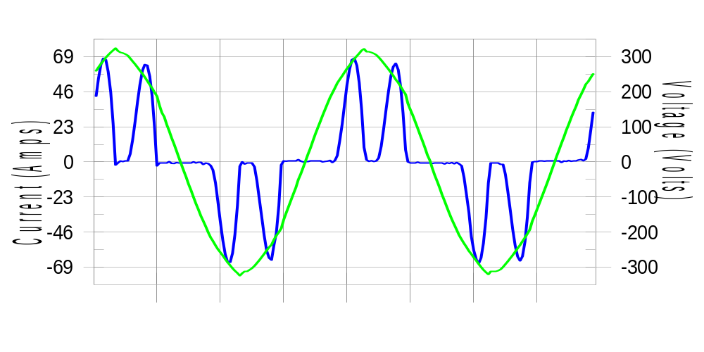

Harmonics and Class 3 limit line European Limits

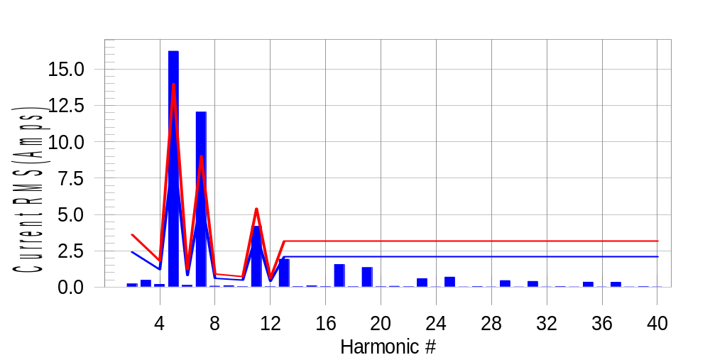

Test result: Fail Worst harmonic was #7 with 134.15 % of the limit.
Current Test Result Summary (Phase A-Run time)

EUT: Equipment under test Tested by: Tested by
Test category: Table:3, Rsce=250, Test Margin: 100
Test date: 2016/4/13 Start time: 17:17:22 End time: 17:20:14
Test duration (min): 2.5 Data file name: CTSMXH_H-000021.cts_data
Comment: Comment
Customer: Customer information

Test Result: Fail Measured I-ref: 30.337(Amps) Source: Distorted
I-THC(%): 69.3 Limit(%): 37.0 PWHC(%): 35.5 PWHC Limit(%): 38.0

Highest parameter values during test:
V_RMS (Volts): 220.43 Frequency(Hz): 50.00
I_Peak (Amps): 79.777 I_RMS (Amps): 30.337
I_Fund (Amps): 21.697 Crest Factor: 2.655
Power (Watts): 4808 Power Factor: 0.720

Harm# Harms(avg) 100%Limit %of Limit Harms(max) 150%Limit %of Limit Status

2 0.220 2.408 9.1 0.254 3.613 7.0 Pass
3 0.470 N/A N/A 0.533 N/A N/A N/A
4 0.186 1.204 15.4 0.214 1.806 11.9 Pass
5 16.232 9.333 173.9 16.265 13.999 116.2 Fail
6 0.122 0.803 15.1 0.134 1.204 11.2 Pass
7 12.038 6.021 199.9 12.064 9.032 133.6 Fail
8 0.068 0.602 11.4 0.087 0.903 9.7 Pass
9 0.095 N/A N/A 0.111 N/A N/A N/A
10 0.025 0.482 5.1 0.036 0.723 4.9 Pass
11 4.178 3.613 115.6 4.193 5.419 77.4 Fail
12 0.020 0.401 5.0 0.029 0.602 4.8 Pass
13 1.918 2.107 91.0 1.931 3.161 61.1 Pass
14 0.031 N/A N/A 0.042 N/A N/A N/A
15 0.091 N/A N/A 0.104 N/A N/A N/A
16 0.027 N/A N/A 0.038 N/A N/A N/A
17 1.557 N/A N/A 1.568 N/A N/A N/A
18 0.020 N/A N/A 0.030 N/A N/A N/A
19 1.340 N/A N/A 1.352 N/A N/A N/A
20 0.024 N/A N/A 0.036 N/A N/A N/A
21 0.055 N/A N/A 0.070 N/A N/A N/A
22 0.021 N/A N/A 0.031 N/A N/A N/A
23 0.582 N/A N/A 0.593 N/A N/A N/A
24 0.018 N/A N/A 0.028 N/A N/A N/A
25 0.688 N/A N/A 0.699 N/A N/A N/A
26 0.017 N/A N/A 0.027 N/A N/A N/A
27 0.036 N/A N/A 0.046 N/A N/A N/A
28 0.017 N/A N/A 0.023 N/A N/A N/A
29 0.448 N/A N/A 0.459 N/A N/A N/A
30 0.018 N/A N/A 0.026 N/A N/A N/A
31 0.393 N/A N/A 0.401 N/A N/A N/A
32 0.017 N/A N/A 0.027 N/A N/A N/A
33 0.037 N/A N/A 0.046 N/A N/A N/A
34 0.017 N/A N/A 0.024 N/A N/A N/A
35 0.341 N/A N/A 0.356 N/A N/A N/A
36 0.016 N/A N/A 0.022 N/A N/A N/A
37 0.333 N/A N/A 0.341 N/A N/A N/A
38 0.016 N/A N/A 0.023 N/A N/A N/A
39 0.033 N/A N/A 0.041 N/A N/A N/A
40 0.017 N/A N/A 0.037 N/A N/A N/A

Note: Measured I-ref was applied for this test.

Voltage Source Verification Data (Phase A-Run time)

EUT: Equipment under test Tested by: Tested by
Test category: Table:3, Rsce=250, Test Margin: 100
Test date: 2016/4/13 Start time: 17:17:22 End time: 17:20:14
Test duration (min): 2.5 Data file name: CTSMXH_H-000021.cts_data
Comment: Comment
Customer: Customer information

Test Result: Fail Source qualification: Distorted
Current harmonics are corrected for source distortion, and are within +/-5%
Measurements are compliant with IEC/EN61000-3-12 Ed.4 & IEC/EN61000-4-7

Highest parameter values during test:
Voltage (Vrms): 220.43 Frequency(Hz): 50.00
I_Peak (Amps): 79.777 I_RMS (Amps): 30.337
I_Fund (Amps): 21.697 Crest Factor: 2.655
Power (Watts): 4808 Power Factor: 0.720

Harm# Harmonics V-rms Limit V-rms % of Limit Status

2 0.161 0.882 18.30 OK
3 0.236 2.755 8.56 OK
4 0.090 0.881 10.19 OK
5 2.414 3.306 73.02 OK
6 0.114 0.881 12.97 OK
7 2.394 2.755 86.90 OK
8 0.095 0.882 10.79 OK
9 0.132 1.322 10.01 OK
10 0.091 0.882 10.36 OK
11 1.190 1.543 77.15 OK
12 0.088 0.661 13.31 OK
13 0.665 1.322 50.29 OK
14 0.081 0.661 12.30 OK
15 0.090 0.661 13.68 OK
16 0.082 0.661 12.34 OK
17 0.722 0.661 109.24 Marg.
18 0.079 0.661 11.93 OK
19 0.651 0.661 98.45 OK
20 0.145 0.661 21.94 OK
21 0.081 0.661 12.27 OK
22 0.078 0.661 11.82 OK
23 0.368 0.661 55.63 OK
24 0.080 0.661 12.08 OK
25 0.445 0.661 67.27 OK
26 0.096 0.661 14.55 OK
27 0.093 0.661 14.01 OK
28 0.071 0.661 10.79 OK
29 0.319 0.661 48.31 OK
30 0.106 0.661 15.98 OK
31 0.295 0.661 44.57 OK
32 0.084 0.661 12.65 OK
33 0.077 0.661 11.64 OK
34 0.078 0.661 11.85 OK
35 0.317 0.661 48.00 OK
36 0.075 0.661 11.38 OK
37 0.288 0.661 43.56 OK
38 0.079 0.661 11.95 OK
39 0.091 0.661 13.78 OK
40 0.139 0.661 21.10 OK

Harmonics – Per EN/IEC61000-3-12, Ed. 2.0(Phase B-Run time)

EUT: Equipment under test Tested by: Tested by
Test category: Table:3, Rsce=250, Test Margin: 100
Test date: 2016/4/13 Start time: 17:17:22 End time: 17:20:14
Test duration (min): 2.5 Data file name: CTSMXH_H-000021.cts_data
Comment: Comment
Customer: Customer information

Test Result: Fail Source qualification: Distorted

Current & voltage waveforms

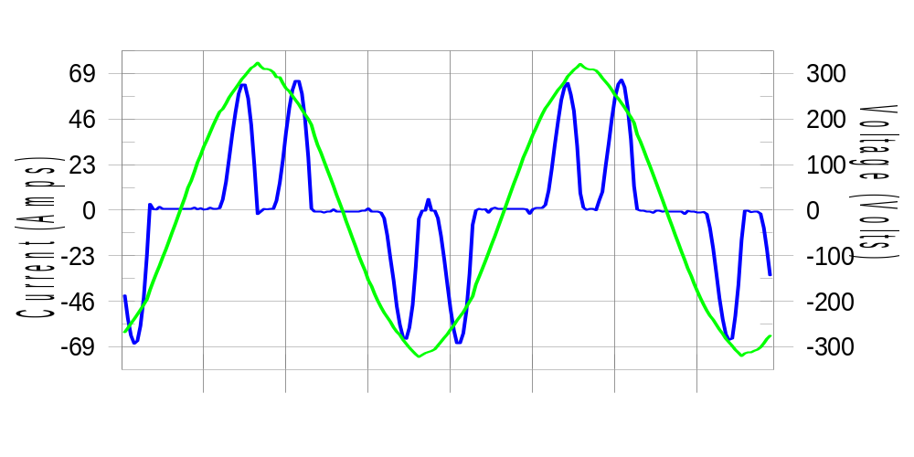

Harmonics and Class 3 limit line European Limits

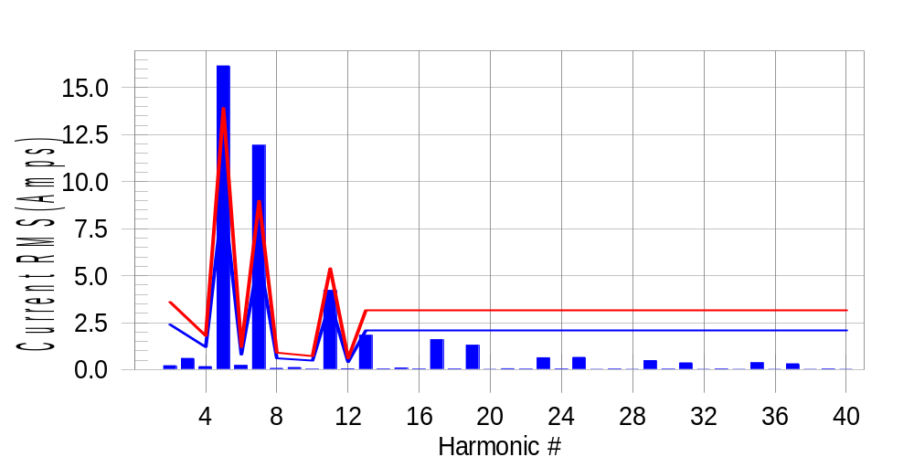

Test result: Fail Worst harmonic was #7 with 133.56 % of the limit.
Current Test Result Summary (Phase B-Run time)

EUT: Equipment under test Tested by: Tested by
Test category: Table:3, Rsce=250, Test Margin: 100
Test date: 2016/4/13 Start time: 17:17:22 End time: 17:20:14
Test duration (min): 2.5 Data file name: CTSMXH_H-000021.cts_data
Comment: Comment
Customer: Customer information

Test Result: Fail Measured I-ref: 30.161(Amps) Source: Distorted
I-THC(%): 69.4 Limit(%): 37.0 PWHC(%): 35.7 PWHC Limit(%): 38.0

Highest parameter values during test:
V_RMS (Volts): 220.23 Frequency(Hz): 50.00
I_Peak (Amps): 77.997 I_RMS (Amps): 30.161
I_Fund (Amps): 21.562 Crest Factor: 2.606
Power (Watts): 4752 Power Factor: 0.717

Harm# Harms(avg) 100%Limit %of Limit Harms(max) 150%Limit %of Limit Status

2 0.208 2.395 8.7 0.235 3.592 6.5 Pass
3 0.470 N/A N/A 0.635 N/A N/A N/A
4 0.158 1.197 13.2 0.178 1.796 9.9 Pass
5 16.164 9.280 174.2 16.221 13.920 116.5 Fail
6 0.223 0.798 27.9 0.234 1.197 19.5 Pass
7 11.937 5.987 199.4 11.965 8.980 133.2 Fail
8 0.065 0.599 10.8 0.080 0.898 8.9 Pass
9 0.095 N/A N/A 0.125 N/A N/A N/A
10 0.020 0.479 4.2 0.027 0.718 3.8 Pass
11 4.215 3.592 117.3 4.231 5.388 78.5 Fail
12 0.043 0.399 10.6 0.053 0.599 8.8 Pass
13 1.828 2.095 87.2 1.839 3.143 58.5 Pass
14 0.031 N/A N/A 0.042 N/A N/A N/A
15 0.082 N/A N/A 0.095 N/A N/A N/A
16 0.026 N/A N/A 0.038 N/A N/A N/A
17 1.593 N/A N/A 1.603 N/A N/A N/A
18 0.031 N/A N/A 0.043 N/A N/A N/A
19 1.297 N/A N/A 1.309 N/A N/A N/A
20 0.019 N/A N/A 0.032 N/A N/A N/A
21 0.045 N/A N/A 0.057 N/A N/A N/A
22 0.021 N/A N/A 0.035 N/A N/A N/A
23 0.629 N/A N/A 0.639 N/A N/A N/A
24 0.031 N/A N/A 0.044 N/A N/A N/A
25 0.651 N/A N/A 0.662 N/A N/A N/A
26 0.018 N/A N/A 0.024 N/A N/A N/A
27 0.029 N/A N/A 0.037 N/A N/A N/A
28 0.018 N/A N/A 0.024 N/A N/A N/A
29 0.480 N/A N/A 0.488 N/A N/A N/A
30 0.024 N/A N/A 0.032 N/A N/A N/A
31 0.356 N/A N/A 0.371 N/A N/A N/A
32 0.018 N/A N/A 0.026 N/A N/A N/A
33 0.033 N/A N/A 0.042 N/A N/A N/A
34 0.017 N/A N/A 0.026 N/A N/A N/A
35 0.364 N/A N/A 0.375 N/A N/A N/A
36 0.019 N/A N/A 0.027 N/A N/A N/A
37 0.308 N/A N/A 0.323 N/A N/A N/A
38 0.017 N/A N/A 0.032 N/A N/A N/A
39 0.030 N/A N/A 0.041 N/A N/A N/A
40 0.016 N/A N/A 0.022 N/A N/A N/A

Note: Measured I-ref was applied for this test.

Voltage Source Verification Data (Phase B-Run time)

EUT: Equipment under test Tested by: Tested by
Test category: Table:3, Rsce=250, Test Margin: 100
Test date: 2016/4/13 Start time: 17:17:22 End time: 17:20:14
Test duration (min): 2.5 Data file name: CTSMXH_H-000021.cts_data
Comment: Comment
Customer: Customer information

Test Result: Fail Source qualification: Distorted
Current harmonics are corrected for source distortion, and are within +/-5%
Measurements are compliant with IEC/EN61000-3-12 Ed.4 & IEC/EN61000-4-7

Highest parameter values during test:
Voltage (Vrms): 220.23 Frequency(Hz): 50.00
I_Peak (Amps): 77.997 I_RMS (Amps): 30.161
I_Fund (Amps): 21.562 Crest Factor: 2.606
Power (Watts): 4752 Power Factor: 0.717

Harm# Harmonics V-rms Limit V-rms % of Limit Status

2 0.172 0.881 19.51 OK
3 0.324 2.752 11.78 OK
4 0.116 0.881 13.20 OK
5 2.535 3.302 76.76 OK
6 0.101 0.881 11.51 OK
7 2.493 2.752 90.58 OK
8 0.100 0.881 11.34 OK
9 0.109 1.321 8.22 OK
10 0.093 0.881 10.54 OK
11 1.268 1.541 82.30 OK
12 0.119 0.660 18.03 OK
13 0.639 1.321 48.36 OK
14 0.101 0.661 15.34 OK
15 0.154 0.661 23.38 OK
16 0.101 0.660 15.28 OK
17 0.771 0.660 116.66 Dist.
18 0.103 0.660 15.63 OK
19 0.658 0.661 99.62 OK
20 0.127 0.660 19.18 OK
21 0.132 0.660 19.99 OK
22 0.094 0.660 14.16 OK
23 0.440 0.661 66.58 OK
24 0.089 0.661 13.47 OK
25 0.445 0.660 67.43 OK
26 0.092 0.660 13.88 OK
27 0.135 0.660 20.40 OK
28 0.099 0.660 14.93 OK
29 0.366 0.660 55.48 OK
30 0.104 0.660 15.81 OK
31 0.288 0.661 43.63 OK
32 0.097 0.661 14.71 OK
33 0.132 0.660 19.96 OK
34 0.094 0.661 14.23 OK
35 0.340 0.661 51.44 OK
36 0.088 0.661 13.29 OK
37 0.284 0.660 43.00 OK
38 0.095 0.660 14.41 OK
39 0.139 0.660 21.04 OK
40 0.126 0.661 19.10 OK

Harmonics – Per EN/IEC61000-3-12, Ed. 2.0(Phase C-Run time)

EUT: Equipment under test Tested by: Tested by
Test category: Table:3, Rsce=250, Test Margin: 100
Test date: 2016/4/13 Start time: 17:17:22 End time: 17:20:14
Test duration (min): 2.5 Data file name: CTSMXH_H-000021.cts_data
Comment: Comment
Customer: Customer information

Test Result: Fail Source qualification: Distorted

Current & voltage waveforms

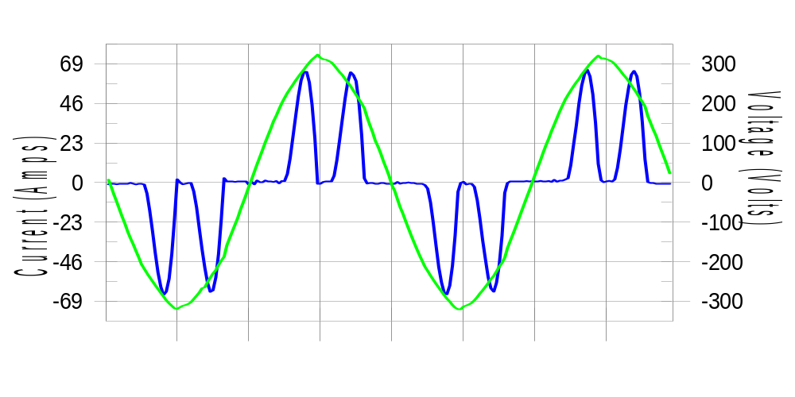

Harmonics and Class 3 limit line European Limits

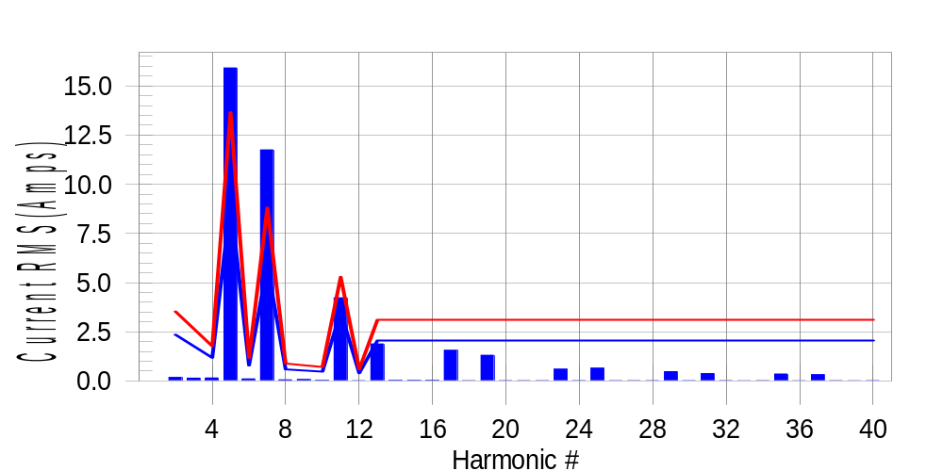

Test result: Fail Worst harmonic was #7 with 133.76 % of the limit.
Current Test Result Summary (Phase C-Run time)

EUT: Equipment under test Tested by: Tested by
Test category: Table:3, Rsce=250, Test Margin: 100
Test date: 2016/4/13 Start time: 17:17:22 End time: 17:20:14
Test duration (min): 2.5 Data file name: CTSMXH_H-000021.cts_data
Comment: Comment
Customer: Customer information

Test Result: Fail Measured I-ref: 29.623(Amps) Source: Distorted
I-THC(%): 69.6 Limit(%): 37.0 PWHC(%): 35.9 PWHC Limit(%): 38.0

Highest parameter values during test:
V_RMS (Volts): 220.14 Frequency(Hz): 50.00
I_Peak (Amps): 74.491 I_RMS (Amps): 29.623
I_Fund (Amps): 21.102 Crest Factor: 2.539
Power (Watts): 4667 Power Factor: 0.716

Harm# Harms(avg) 100%Limit %of Limit Harms(max) 150%Limit %of Limit Status

2 0.178 2.351 7.6 0.216 3.527 6.1 Pass
3 0.470 N/A N/A 0.189 N/A N/A N/A
4 0.150 1.176 12.8 0.171 1.763 9.7 Pass
5 15.919 9.111 174.7 15.965 13.666 116.8 Fail
6 0.104 0.784 13.3 0.121 1.176 10.3 Pass
7 11.747 5.878 199.9 11.769 8.817 133.5 Fail
8 0.055 0.588 9.3 0.071 0.882 8.0 Pass
9 0.095 N/A N/A 0.085 N/A N/A N/A
10 0.026 0.470 5.5 0.035 0.705 4.9 Pass
11 4.227 3.527 119.8 4.237 5.290 80.1 Fail
12 0.019 0.392 4.9 0.027 0.588 4.6 Pass
13 1.881 2.057 91.5 1.890 3.086 61.3 Pass
14 0.027 N/A N/A 0.037 N/A N/A N/A
15 0.021 N/A N/A 0.030 N/A N/A N/A
16 0.025 N/A N/A 0.034 N/A N/A N/A
17 1.554 N/A N/A 1.574 N/A N/A N/A
18 0.018 N/A N/A 0.028 N/A N/A N/A
19 1.305 N/A N/A 1.318 N/A N/A N/A
20 0.019 N/A N/A 0.028 N/A N/A N/A
21 0.017 N/A N/A 0.027 N/A N/A N/A
22 0.019 N/A N/A 0.029 N/A N/A N/A
23 0.597 N/A N/A 0.605 N/A N/A N/A
24 0.018 N/A N/A 0.030 N/A N/A N/A
25 0.647 N/A N/A 0.658 N/A N/A N/A
26 0.017 N/A N/A 0.026 N/A N/A N/A
27 0.015 N/A N/A 0.020 N/A N/A N/A
28 0.015 N/A N/A 0.021 N/A N/A N/A
29 0.472 N/A N/A 0.480 N/A N/A N/A
30 0.015 N/A N/A 0.023 N/A N/A N/A
31 0.371 N/A N/A 0.379 N/A N/A N/A
32 0.016 N/A N/A 0.023 N/A N/A N/A
33 0.014 N/A N/A 0.022 N/A N/A N/A
34 0.015 N/A N/A 0.019 N/A N/A N/A
35 0.351 N/A N/A 0.358 N/A N/A N/A
36 0.014 N/A N/A 0.020 N/A N/A N/A
37 0.317 N/A N/A 0.326 N/A N/A N/A
38 0.015 N/A N/A 0.020 N/A N/A N/A
39 0.013 N/A N/A 0.018 N/A N/A N/A
40 0.015 N/A N/A 0.022 N/A N/A N/A

Note: Measured I-ref was applied for this test.

Voltage Source Verification Data (Phase C-Run time)

EUT: Equipment under test Tested by: Tested by
Test category: Table:3, Rsce=250, Test Margin: 100
Test date: 2016/4/13 Start time: 17:17:22 End time: 17:20:14
Test duration (min): 2.5 Data file name: CTSMXH_H-000021.cts_data
Comment: Comment
Customer: Customer information

Test Result: Fail Source qualification: Distorted
Current harmonics are corrected for source distortion, and are within +/-5%
Measurements are compliant with IEC/EN61000-3-12 Ed.4 & IEC/EN61000-4-7

Highest parameter values during test:
Voltage (Vrms): 220.14 Frequency(Hz): 50.00
I_Peak (Amps): 74.491 I_RMS (Amps): 29.623
I_Fund (Amps): 21.102 Crest Factor: 2.539
Power (Watts): 4667 Power Factor: 0.716

Harm# Harmonics V-rms Limit V-rms % of Limit Status

2 0.148 0.880 16.82 OK
3 0.247 2.751 8.96 OK
4 0.120 0.880 13.69 OK
5 2.374 3.300 71.94 OK
6 0.095 0.880 10.83 OK
7 2.332 2.751 84.80 OK
8 0.124 0.880 14.13 OK
9 0.127 1.320 9.60 OK
10 0.088 0.881 10.00 OK
11 1.225 1.541 79.52 OK
12 0.088 0.660 13.36 OK
13 0.617 1.320 46.73 OK
14 0.085 0.660 12.85 OK
15 0.107 0.660 16.26 OK
16 0.086 0.660 13.07 OK
17 0.739 0.660 111.99 Dist.
18 0.096 0.660 14.51 OK
19 0.635 0.660 96.26 OK
20 0.095 0.660 14.33 OK
21 0.082 0.660 12.45 OK
22 0.082 0.660 12.43 OK
23 0.370 0.660 56.10 OK
24 0.086 0.660 13.01 OK
25 0.439 0.660 66.49 OK
26 0.086 0.660 12.96 OK
27 0.100 0.660 15.13 OK
28 0.100 0.660 15.07 OK
29 0.347 0.660 52.63 OK
30 0.103 0.660 15.66 OK
31 0.269 0.660 40.81 OK
32 0.084 0.660 12.68 OK
33 0.102 0.660 15.46 OK
34 0.087 0.660 13.20 OK
35 0.311 0.660 47.18 OK
36 0.088 0.660 13.30 OK
37 0.267 0.660 40.43 OK
38 0.080 0.660 12.18 OK
39 0.111 0.660 16.78 OK
40 0.106 0.660 16.01 OK

5th Harmonic Phase Angle and Magnitude for Phase A :
H-5_min_phase : 140.0 Degree (Leading)
H-5_max_phase : 140.5 Degree (Leading)
H-5_ave_phase : 140.3 Degree (Leading)

H-5_ave_vector_magnitude : 15.902 Amp
H-5_standard_ave_magnitude : 16.232 Amp
H-5_standard_max_magnitude : 15.965 Amp
Ratio of H-5_ave_vector / H-5_standard_ave : 0.999

Phase A = 199.936% of tested Rsce = 250.000, Rsce = 499.840
Phase B = 199.391% of tested Rsce = 250.000, Rsce = 498.479
Phase C = 199.869% of tested Rsce = 250.000, Rsce = 499.673
Minimum Rsce required: Rsce = 499.840

