Harmonics – Per EN/IEC61000-3-12, Ed. 2.0(Phase A-Run time)

EUT: Equipment under test Tested by: Tested by
Test category: Table:3, Rsce=250, Test Margin: 100
Test date: 2016/4/13 Start time: 17:31:42 End time: 17:34:35
Test duration (min): 2.5 Data file name: CTSMXH_H-000022.cts_data
Comment: Comment
Customer: Customer information

Test Result: Fail Source qualification: Distorted

Current & voltage waveforms

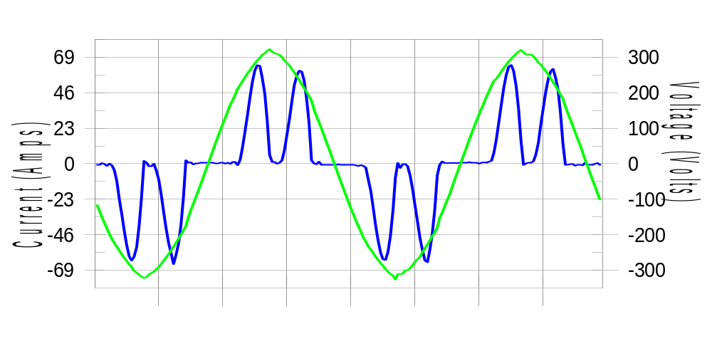

Harmonics and Class 3 limit line European Limits

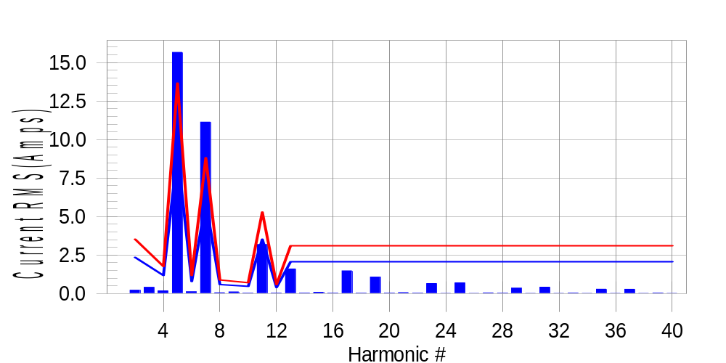

Test result: Fail Worst harmonic was #7 with 126.97 % of the limit.
Current Test Result Summary (Phase A-Run time)

EUT: Equipment under test Tested by: Tested by
Test category: Table:3, Rsce=250, Test Margin: 100
Test date: 2016/4/13 Start time: 17:31:42 End time: 17:34:35
Test duration (min): 2.5 Data file name: CTSMXH_H-000022.cts_data
Comment: Comment
Customer: Customer information

Test Result: Fail Measured I-ref: 29.732(Amps) Source: Distorted
I-THC(%): 67.0 Limit(%): 37.0 PWHC(%): 33.4 PWHC Limit(%): 38.0

Highest parameter values during test:
V_RMS (Volts): 220.43 Frequency(Hz): 50.00
I_Peak (Amps): 73.857 I_RMS (Amps): 29.732
I_Fund (Amps): 21.825 Crest Factor: 2.496
Power (Watts): 4848 Power Factor: 0.740

Harm# Harms(avg) 100%Limit %of Limit Harms(max) 150%Limit %of Limit Status

2 0.220 2.351 9.4 0.255 3.526 7.2 Pass
3 0.408 N/A N/A 0.461 N/A N/A N/A
4 0.176 1.175 14.9 0.202 1.763 11.4 Pass
5 15.664 9.110 172.0 15.767 13.665 115.4 Fail
6 0.116 0.784 14.7 0.126 1.175 10.7 Pass
7 11.130 5.877 189.4 11.190 8.816 126.9 Fail
8 0.053 0.588 9.0 0.067 0.882 7.6 Pass
9 0.109 N/A N/A 0.128 N/A N/A N/A
10 0.020 0.470 4.3 0.035 0.705 5.0 Pass
11 3.181 3.526 90.2 3.192 5.290 60.3 Pass
12 0.027 0.392 6.8 0.036 0.588 6.1 Pass
13 1.600 2.057 77.8 1.609 3.086 52.1 Pass
14 0.029 N/A N/A 0.039 N/A N/A N/A
15 0.087 N/A N/A 0.102 N/A N/A N/A
16 0.023 N/A N/A 0.034 N/A N/A N/A
17 1.480 N/A N/A 1.494 N/A N/A N/A
18 0.020 N/A N/A 0.032 N/A N/A N/A
19 1.073 N/A N/A 1.089 N/A N/A N/A
20 0.024 N/A N/A 0.036 N/A N/A N/A
21 0.064 N/A N/A 0.074 N/A N/A N/A
22 0.022 N/A N/A 0.034 N/A N/A N/A
23 0.652 N/A N/A 0.664 N/A N/A N/A
24 0.018 N/A N/A 0.026 N/A N/A N/A
25 0.698 N/A N/A 0.709 N/A N/A N/A
26 0.017 N/A N/A 0.025 N/A N/A N/A
27 0.046 N/A N/A 0.054 N/A N/A N/A
28 0.020 N/A N/A 0.028 N/A N/A N/A
29 0.353 N/A N/A 0.360 N/A N/A N/A
30 0.018 N/A N/A 0.025 N/A N/A N/A
31 0.417 N/A N/A 0.426 N/A N/A N/A
32 0.016 N/A N/A 0.026 N/A N/A N/A
33 0.037 N/A N/A 0.048 N/A N/A N/A
34 0.017 N/A N/A 0.023 N/A N/A N/A
35 0.285 N/A N/A 0.293 N/A N/A N/A
36 0.017 N/A N/A 0.024 N/A N/A N/A
37 0.282 N/A N/A 0.291 N/A N/A N/A
38 0.017 N/A N/A 0.026 N/A N/A N/A
39 0.036 N/A N/A 0.044 N/A N/A N/A
40 0.016 N/A N/A 0.025 N/A N/A N/A

Note: Measured I-ref was applied for this test.

Voltage Source Verification Data (Phase A-Run time)

EUT: Equipment under test Tested by: Tested by
Test category: Table:3, Rsce=250, Test Margin: 100
Test date: 2016/4/13 Start time: 17:31:42 End time: 17:34:35
Test duration (min): 2.5 Data file name: CTSMXH_H-000022.cts_data
Comment: Comment
Customer: Customer information

Test Result: Fail Source qualification: Distorted
Current harmonics are corrected for source distortion, and are within +/-5%
Measurements are compliant with IEC/EN61000-3-12 Ed.4 & IEC/EN61000-4-7

Highest parameter values during test:
Voltage (Vrms): 220.43 Frequency(Hz): 50.00
I_Peak (Amps): 73.857 I_RMS (Amps): 29.732
I_Fund (Amps): 21.825 Crest Factor: 2.496
Power (Watts): 4848 Power Factor: 0.740

Harm# Harmonics V-rms Limit V-rms % of Limit Status

2 0.151 0.881 17.11 OK
3 0.232 2.755 8.41 OK
4 0.091 0.882 10.35 OK
5 2.359 3.305 71.37 OK
6 0.105 0.881 11.89 OK
7 2.210 2.754 80.23 OK
8 0.080 0.881 9.05 OK
9 0.129 1.322 9.75 OK
10 0.080 0.881 9.03 OK
11 0.907 1.542 58.82 OK
12 0.082 0.661 12.33 OK
13 0.599 1.322 45.33 OK
14 0.086 0.661 13.04 OK
15 0.109 0.661 16.48 OK
16 0.105 0.661 15.95 OK
17 0.673 0.661 101.79 Marg.
18 0.086 0.661 12.95 OK
19 0.532 0.661 80.41 OK
20 0.156 0.661 23.62 OK
21 0.076 0.661 11.45 OK
22 0.101 0.661 15.25 OK
23 0.426 0.661 64.40 OK
24 0.081 0.661 12.32 OK
25 0.428 0.661 64.81 OK
26 0.098 0.661 14.84 OK
27 0.090 0.661 13.60 OK
28 0.102 0.661 15.38 OK
29 0.274 0.661 41.48 OK
30 0.081 0.661 12.29 OK
31 0.332 0.661 50.25 OK
32 0.080 0.661 12.18 OK
33 0.089 0.661 13.40 OK
34 0.081 0.661 12.23 OK
35 0.256 0.661 38.76 OK
36 0.085 0.661 12.91 OK
37 0.256 0.661 38.78 OK
38 0.073 0.661 11.07 OK
39 0.077 0.661 11.67 OK
40 0.132 0.661 20.00 OK

Harmonics – Per EN/IEC61000-3-12, Ed. 2.0(Phase B-Run time)

EUT: Equipment under test Tested by: Tested by
Test category: Table:3, Rsce=250, Test Margin: 100
Test date: 2016/4/13 Start time: 17:31:42 End time: 17:34:35
Test duration (min): 2.5 Data file name: CTSMXH_H-000022.cts_data
Comment: Comment
Customer: Customer information

Test Result: Fail Source qualification: Distorted

Current & voltage waveforms

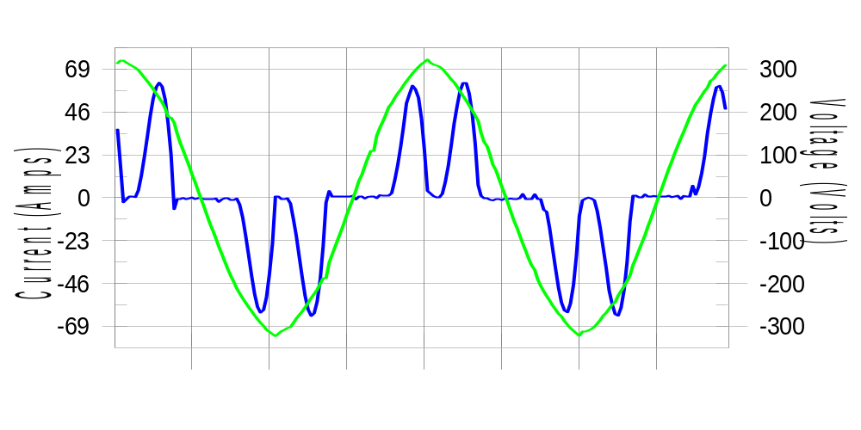

Harmonics and Class 3 limit line European Limits

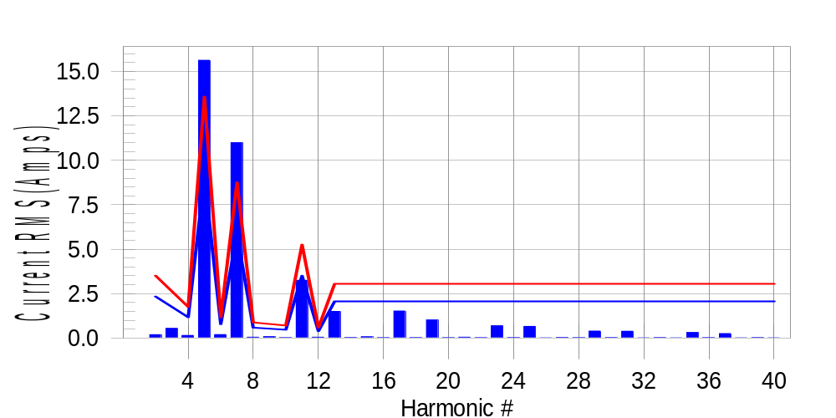

Test result: Fail Worst harmonic was #7 with 126.15 % of the limit.
Current Test Result Summary (Phase B-Run time)

EUT: Equipment under test Tested by: Tested by
Test category: Table:3, Rsce=250, Test Margin: 100
Test date: 2016/4/13 Start time: 17:31:42 End time: 17:34:35
Test duration (min): 2.5 Data file name: CTSMXH_H-000022.cts_data
Comment: Comment
Customer: Customer information

Test Result: Fail Measured I-ref: 29.558(Amps) Source: Distorted
I-THC(%): 67.0 Limit(%): 37.0 PWHC(%): 33.6 PWHC Limit(%): 38.0

Highest parameter values during test:
V_RMS (Volts): 220.21 Frequency(Hz): 50.00
I_Peak (Amps): 73.547 I_RMS (Amps): 29.558
I_Fund (Amps): 21.665 Crest Factor: 2.519
Power (Watts): 4791 Power Factor: 0.737

Harm# Harms(avg) 100%Limit %of Limit Harms(max) 150%Limit %of Limit Status

2 0.190 2.336 8.1 0.225 3.504 6.4 Pass
3 0.408 N/A N/A 0.601 N/A N/A N/A
4 0.149 1.168 12.8 0.164 1.752 9.4 Pass
5 15.626 9.052 172.6 15.731 13.578 115.9 Fail
6 0.196 0.779 25.1 0.213 1.168 18.2 Pass
7 10.988 5.840 188.2 11.049 8.760 126.1 Fail
8 0.049 0.584 8.4 0.061 0.876 6.9 Pass
9 0.109 N/A N/A 0.101 N/A N/A N/A
10 0.020 0.467 4.4 0.029 0.701 4.2 Pass
11 3.245 3.504 92.6 3.259 5.256 62.0 Pass
12 0.051 0.389 13.2 0.061 0.584 10.4 Pass
13 1.500 2.044 73.4 1.512 3.066 49.3 Pass
14 0.029 N/A N/A 0.039 N/A N/A N/A
15 0.070 N/A N/A 0.085 N/A N/A N/A
16 0.023 N/A N/A 0.033 N/A N/A N/A
17 1.521 N/A N/A 1.530 N/A N/A N/A
18 0.027 N/A N/A 0.039 N/A N/A N/A
19 1.019 N/A N/A 1.031 N/A N/A N/A
20 0.020 N/A N/A 0.029 N/A N/A N/A
21 0.051 N/A N/A 0.064 N/A N/A N/A
22 0.022 N/A N/A 0.029 N/A N/A N/A
23 0.692 N/A N/A 0.701 N/A N/A N/A
24 0.027 N/A N/A 0.036 N/A N/A N/A
25 0.658 N/A N/A 0.670 N/A N/A N/A
26 0.017 N/A N/A 0.024 N/A N/A N/A
27 0.033 N/A N/A 0.045 N/A N/A N/A
28 0.022 N/A N/A 0.034 N/A N/A N/A
29 0.393 N/A N/A 0.401 N/A N/A N/A
30 0.025 N/A N/A 0.033 N/A N/A N/A
31 0.382 N/A N/A 0.398 N/A N/A N/A
32 0.017 N/A N/A 0.026 N/A N/A N/A
33 0.027 N/A N/A 0.039 N/A N/A N/A
34 0.017 N/A N/A 0.027 N/A N/A N/A
35 0.315 N/A N/A 0.332 N/A N/A N/A
36 0.021 N/A N/A 0.033 N/A N/A N/A
37 0.252 N/A N/A 0.262 N/A N/A N/A
38 0.017 N/A N/A 0.024 N/A N/A N/A
39 0.028 N/A N/A 0.036 N/A N/A N/A
40 0.017 N/A N/A 0.024 N/A N/A N/A

Note: Measured I-ref was applied for this test.

Voltage Source Verification Data (Phase B-Run time)

EUT: Equipment under test Tested by: Tested by
Test category: Table:3, Rsce=250, Test Margin: 100
Test date: 2016/4/13 Start time: 17:31:42 End time: 17:34:35
Test duration (min): 2.5 Data file name: CTSMXH_H-000022.cts_data
Comment: Comment
Customer: Customer information

Test Result: Fail Source qualification: Distorted
Current harmonics are corrected for source distortion, and are within +/-5%
Measurements are compliant with IEC/EN61000-3-12 Ed.4 & IEC/EN61000-4-7

Highest parameter values during test:
Voltage (Vrms): 220.21 Frequency(Hz): 50.00
I_Peak (Amps): 73.547 I_RMS (Amps): 29.558
I_Fund (Amps): 21.665 Crest Factor: 2.519
Power (Watts): 4791 Power Factor: 0.737

Harm# Harmonics V-rms Limit V-rms % of Limit Status

2 0.165 0.881 18.76 OK
3 0.332 2.752 12.06 OK
4 0.143 0.881 16.20 OK
5 2.473 3.302 74.89 OK
6 0.098 0.881 11.09 OK
7 2.286 2.752 83.08 OK
8 0.120 0.881 13.63 OK
9 0.116 1.321 8.82 OK
10 0.095 0.881 10.82 OK
11 0.995 1.541 64.57 OK
12 0.100 0.660 15.17 OK
13 0.576 1.321 43.58 OK
14 0.102 0.660 15.49 OK
15 0.156 0.661 23.55 OK
16 0.101 0.660 15.33 OK
17 0.730 0.660 110.58 Dist.
18 0.127 0.661 19.28 OK
19 0.510 0.660 77.17 OK
20 0.125 0.660 18.89 OK
21 0.141 0.661 21.35 OK
22 0.110 0.660 16.62 OK
23 0.466 0.661 70.54 OK
24 0.109 0.660 16.51 OK
25 0.428 0.660 64.79 OK
26 0.104 0.660 15.69 OK
27 0.116 0.660 17.58 OK
28 0.120 0.660 18.10 OK
29 0.322 0.660 48.74 OK
30 0.115 0.660 17.43 OK
31 0.319 0.660 48.27 OK
32 0.100 0.660 15.15 OK
33 0.152 0.660 23.06 OK
34 0.109 0.660 16.49 OK
35 0.303 0.660 45.91 OK
36 0.099 0.660 14.93 OK
37 0.255 0.660 38.62 OK
38 0.103 0.660 15.66 OK
39 0.143 0.660 21.69 OK
40 0.105 0.660 15.87 OK

Harmonics – Per EN/IEC61000-3-12, Ed. 2.0(Phase C-Run time)

EUT: Equipment under test Tested by: Tested by
Test category: Table:3, Rsce=250, Test Margin: 100
Test date: 2016/4/13 Start time: 17:31:42 End time: 17:34:35
Test duration (min): 2.5 Data file name: CTSMXH_H-000022.cts_data
Comment: Comment
Customer: Customer information

Test Result: Fail Source qualification: Distorted

Current & voltage waveforms

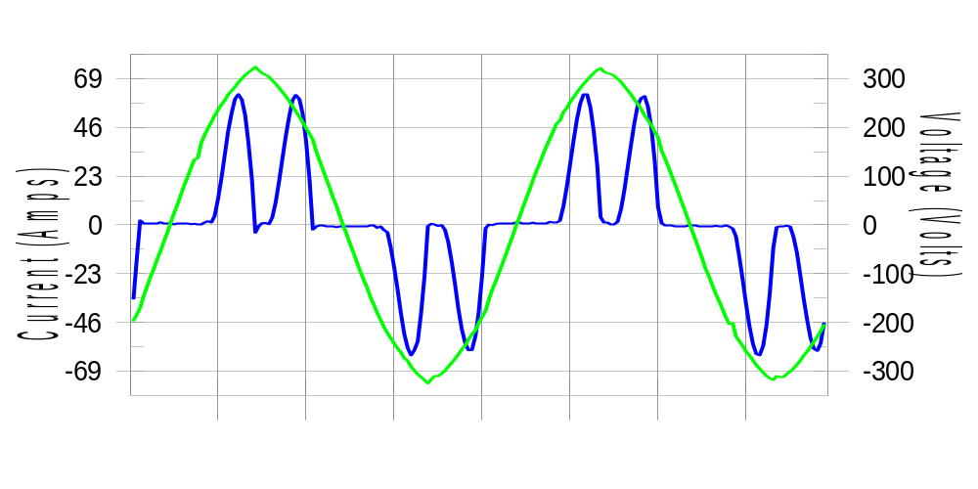

Harmonics and Class 3 limit line European Limits

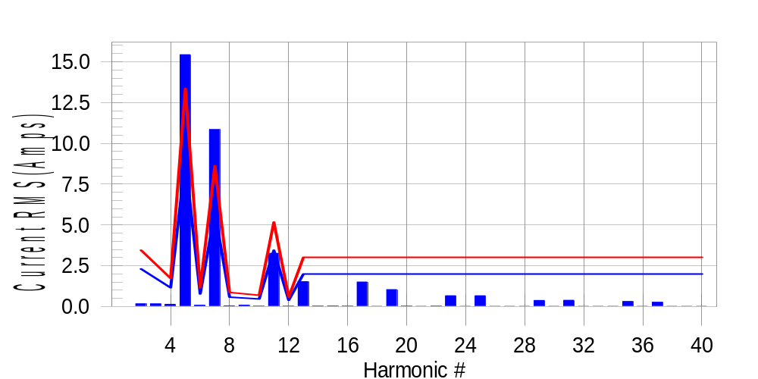

Test result: Fail Worst harmonic was #7 with 126.48 % of the limit.
Current Test Result Summary (Phase C-Run time)

EUT: Equipment under test Tested by: Tested by
Test category: Table:3, Rsce=250, Test Margin: 100
Test date: 2016/4/13 Start time: 17:31:42 End time: 17:34:35
Test duration (min): 2.5 Data file name: CTSMXH_H-000022.cts_data
Comment: Comment
Customer: Customer information

Test Result: Fail Measured I-ref: 29.097(Amps) Source: Distorted
I-THC(%): 67.3 Limit(%): 37.0 PWHC(%): 33.9 PWHC Limit(%): 38.0

Highest parameter values during test:
V_RMS (Volts): 220.15 Frequency(Hz): 50.00
I_Peak (Amps): 70.442 I_RMS (Amps): 29.097
I_Fund (Amps): 21.276 Crest Factor: 2.439
Power (Watts): 4715 Power Factor: 0.737

Harm# Harms(avg) 100%Limit %of Limit Harms(max) 150%Limit %of Limit Status

2 0.166 2.300 7.2 0.200 3.450 5.8 Pass
3 0.408 N/A N/A 0.211 N/A N/A N/A
4 0.138 1.150 12.0 0.157 1.725 9.1 Pass
5 15.440 8.913 173.2 15.547 13.370 116.3 Fail
6 0.082 0.767 10.7 0.094 1.150 8.2 Pass
7 10.847 5.751 188.6 10.910 8.626 126.5 Fail
8 0.042 0.575 7.3 0.060 0.863 6.9 Pass
9 0.109 N/A N/A 0.100 N/A N/A N/A
10 0.023 0.460 5.0 0.034 0.690 4.9 Pass
11 3.264 3.450 94.6 3.277 5.175 63.3 Pass
12 0.019 0.383 4.9 0.026 0.575 4.5 Pass
13 1.525 2.013 75.8 1.538 3.019 51.0 Pass
14 0.025 N/A N/A 0.035 N/A N/A N/A
15 0.028 N/A N/A 0.038 N/A N/A N/A
16 0.022 N/A N/A 0.034 N/A N/A N/A
17 1.504 N/A N/A 1.514 N/A N/A N/A
18 0.017 N/A N/A 0.027 N/A N/A N/A
19 1.040 N/A N/A 1.053 N/A N/A N/A
20 0.020 N/A N/A 0.033 N/A N/A N/A
21 0.018 N/A N/A 0.027 N/A N/A N/A
22 0.020 N/A N/A 0.028 N/A N/A N/A
23 0.662 N/A N/A 0.675 N/A N/A N/A
24 0.015 N/A N/A 0.022 N/A N/A N/A
25 0.662 N/A N/A 0.673 N/A N/A N/A
26 0.016 N/A N/A 0.025 N/A N/A N/A
27 0.018 N/A N/A 0.028 N/A N/A N/A
28 0.018 N/A N/A 0.029 N/A N/A N/A
29 0.376 N/A N/A 0.383 N/A N/A N/A
30 0.015 N/A N/A 0.022 N/A N/A N/A
31 0.385 N/A N/A 0.393 N/A N/A N/A
32 0.015 N/A N/A 0.029 N/A N/A N/A
33 0.017 N/A N/A 0.023 N/A N/A N/A
34 0.015 N/A N/A 0.022 N/A N/A N/A
35 0.310 N/A N/A 0.319 N/A N/A N/A
36 0.014 N/A N/A 0.021 N/A N/A N/A
37 0.261 N/A N/A 0.269 N/A N/A N/A
38 0.015 N/A N/A 0.021 N/A N/A N/A
39 0.015 N/A N/A 0.022 N/A N/A N/A
40 0.015 N/A N/A 0.029 N/A N/A N/A

Note: Measured I-ref was applied for this test.

Voltage Source Verification Data (Phase C-Run time)

EUT: Equipment under test Tested by: Tested by
Test category: Table:3, Rsce=250, Test Margin: 100
Test date: 2016/4/13 Start time: 17:31:42 End time: 17:34:35
Test duration (min): 2.5 Data file name: CTSMXH_H-000022.cts_data
Comment: Comment
Customer: Customer information

Test Result: Fail Source qualification: Distorted
Current harmonics are corrected for source distortion, and are within +/-5%
Measurements are compliant with IEC/EN61000-3-12 Ed.4 & IEC/EN61000-4-7

Highest parameter values during test:
Voltage (Vrms): 220.15 Frequency(Hz): 50.00
I_Peak (Amps): 70.442 I_RMS (Amps): 29.097
I_Fund (Amps): 21.276 Crest Factor: 2.439
Power (Watts): 4715 Power Factor: 0.737

Harm# Harmonics V-rms Limit V-rms % of Limit Status

2 0.142 0.880 16.11 OK
3 0.246 2.751 8.95 OK
4 0.114 0.880 12.96 OK
5 2.374 3.300 71.93 OK
6 0.101 0.880 11.48 OK
7 2.162 2.750 78.60 OK
8 0.082 0.880 9.27 OK
9 0.113 1.320 8.60 OK
10 0.086 0.880 9.80 OK
11 0.936 1.541 60.75 OK
12 0.085 0.660 12.84 OK
13 0.557 1.321 42.21 OK
14 0.092 0.660 13.93 OK
15 0.109 0.660 16.57 OK
16 0.081 0.660 12.28 OK
17 0.702 0.660 106.31 Marg.
18 0.098 0.660 14.80 OK
19 0.507 0.660 76.71 OK
20 0.110 0.660 16.65 OK
21 0.105 0.660 15.95 OK
22 0.095 0.660 14.45 OK
23 0.436 0.660 65.99 OK
24 0.114 0.660 17.32 OK
25 0.423 0.660 64.05 OK
26 0.098 0.660 14.83 OK
27 0.120 0.660 18.12 OK
28 0.105 0.660 15.84 OK
29 0.306 0.660 46.28 OK
30 0.086 0.660 13.04 OK
31 0.311 0.660 47.04 OK
32 0.085 0.660 12.92 OK
33 0.114 0.660 17.26 OK
34 0.087 0.660 13.24 OK
35 0.280 0.660 42.47 OK
36 0.094 0.660 14.24 OK
37 0.251 0.660 38.00 OK
38 0.099 0.660 14.97 OK
39 0.101 0.660 15.25 OK
40 0.109 0.660 16.58 OK

5th Harmonic Phase Angle and Magnitude for Phase A :
H-5_min_phase : 134.0 Degree (Leading)
H-5_max_phase : 134.6 Degree (Leading)
H-5_ave_phase : 134.3 Degree (Leading)

H-5_ave_vector_magnitude : 15.426 Amp
H-5_standard_ave_magnitude : 15.664 Amp
H-5_standard_max_magnitude : 15.547 Amp
Ratio of H-5_ave_vector / H-5_standard_ave : 0.999

Phase A = 189.404% of tested Rsce = 250.000, Rsce = 473.509
Phase B = 188.173% of tested Rsce = 250.000, Rsce = 470.433
Phase C = 188.648% of tested Rsce = 250.000, Rsce = 471.619
Minimum Rsce required: Rsce = 473.509

