Harmonics – Per EN/IEC61000-3-12, Ed. 2.0(Phase A-Run time)

EUT: Equipment under test Tested by: Tested by
Test category: Table:3, Rsce=250, Test Margin: 100
Test date: 2016/4/13 Start time: 17:39:54 End time: 17:42:47
Test duration (min): 2.5 Data file name: CTSMXH_H-000023.cts_data
Comment: Comment
Customer: Customer information

Test Result: Fail Source qualification: Normal

Current & voltage waveforms

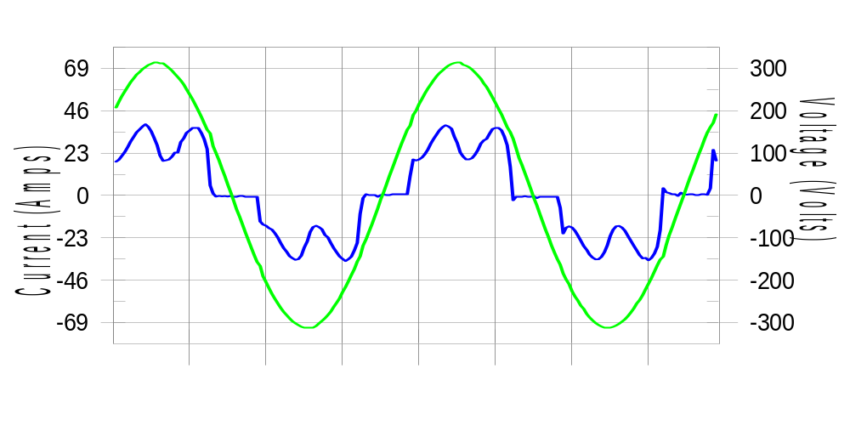

Harmonics and Class 3 limit line European Limits

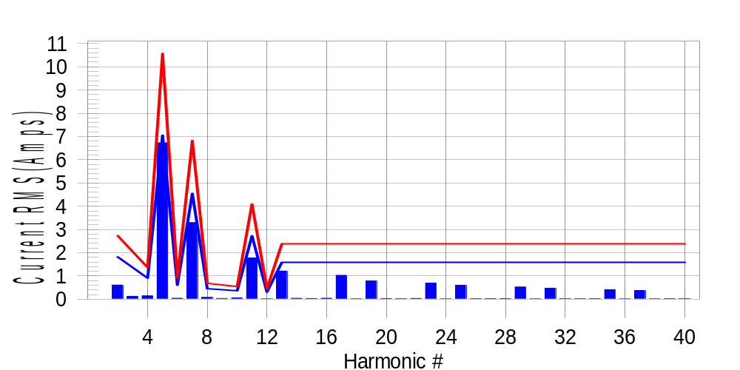

Test result: Fail Worst harmonic was #5 with 63.92 % of the limit.
Current Test Result Summary (Phase A-Run time)

EUT: Equipment under test Tested by: Tested by
Test category: Table:3, Rsce=250, Test Margin: 100
Test date: 2016/4/13 Start time: 17:39:54 End time: 17:42:47
Test duration (min): 2.5 Data file name: CTSMXH_H-000023.cts_data
Comment: Comment
Customer: Customer information

Test Result: Fail Measured I-ref: 22.985(Amps) Source: Normal
I-THC(%): 35.3 Limit(%): 37.0 PWHC(%): 38.5 PWHC Limit(%): 38.0

Highest parameter values during test:
V_RMS (Volts): 220.43 Frequency(Hz): 50.00
I_Peak (Amps): 49.396 I_RMS (Amps): 22.985
I_Fund (Amps): 21.240 Crest Factor: 2.160
Power (Watts): 4721 Power Factor: 0.932

Harm# Harms(avg) 100%Limit %of Limit Harms(max) 150%Limit %of Limit Status

2 0.611 1.819 33.6 0.649 2.729 23.8 Pass
3 0.127 N/A N/A 0.155 N/A N/A N/A
4 0.146 0.910 16.0 0.162 1.365 11.9 Pass
5 6.727 7.050 95.4 6.753 10.575 63.9 Pass
6 0.044 0.606 7.3 0.053 0.910 5.9 Pass
7 3.293 4.549 72.4 3.304 6.823 48.4 Pass
8 0.077 0.455 16.9 0.092 0.682 13.5 Pass
9 0.035 N/A N/A 0.046 N/A N/A N/A
10 0.060 0.364 16.4 0.070 0.546 12.8 Pass
11 1.779 2.729 65.2 1.794 4.094 43.8 Pass
12 0.018 0.303 5.8 0.026 0.455 5.7 Pass
13 1.210 1.592 76.0 1.219 2.388 51.0 Pass
14 0.041 N/A N/A 0.050 N/A N/A N/A
15 0.029 N/A N/A 0.036 N/A N/A N/A
16 0.042 N/A N/A 0.050 N/A N/A N/A
17 1.031 N/A N/A 1.041 N/A N/A N/A
18 0.018 N/A N/A 0.024 N/A N/A N/A
19 0.787 N/A N/A 0.797 N/A N/A N/A
20 0.031 N/A N/A 0.041 N/A N/A N/A
21 0.022 N/A N/A 0.031 N/A N/A N/A
22 0.034 N/A N/A 0.045 N/A N/A N/A
23 0.694 N/A N/A 0.704 N/A N/A N/A
24 0.015 N/A N/A 0.029 N/A N/A N/A
25 0.603 N/A N/A 0.612 N/A N/A N/A
26 0.023 N/A N/A 0.037 N/A N/A N/A
27 0.028 N/A N/A 0.037 N/A N/A N/A
28 0.027 N/A N/A 0.039 N/A N/A N/A
29 0.522 N/A N/A 0.532 N/A N/A N/A
30 0.017 N/A N/A 0.039 N/A N/A N/A
31 0.477 N/A N/A 0.495 N/A N/A N/A
32 0.022 N/A N/A 0.039 N/A N/A N/A
33 0.021 N/A N/A 0.031 N/A N/A N/A
34 0.025 N/A N/A 0.033 N/A N/A N/A
35 0.412 N/A N/A 0.423 N/A N/A N/A
36 0.015 N/A N/A 0.021 N/A N/A N/A
37 0.376 N/A N/A 0.385 N/A N/A N/A
38 0.019 N/A N/A 0.027 N/A N/A N/A
39 0.025 N/A N/A 0.048 N/A N/A N/A
40 0.022 N/A N/A 0.032 N/A N/A N/A

Note: Measured I-ref was applied for this test.

Voltage Source Verification Data (Phase A-Run time)

EUT: Equipment under test Tested by: Tested by
Test category: Table:3, Rsce=250, Test Margin: 100
Test date: 2016/4/13 Start time: 17:39:54 End time: 17:42:47
Test duration (min): 2.5 Data file name: CTSMXH_H-000023.cts_data
Comment: Comment
Customer: Customer information

Test Result: Fail Source qualification: Normal
Measured source distortion is within the requirements of the standards
Measurements are compliant with IEC/EN61000-3-12 Ed.4 & IEC/EN61000-4-7 Ed. 2.1

Highest parameter values during test:
Voltage (Vrms): 220.43 Frequency(Hz): 50.00
I_Peak (Amps): 49.396 I_RMS (Amps): 22.985
I_Fund (Amps): 21.240 Crest Factor: 2.160
Power (Watts): 4721 Power Factor: 0.932

Harm# Harmonics V-rms Limit V-rms % of Limit Status

2 0.172 0.881 19.54 OK
3 0.284 2.755 10.30 OK
4 0.117 0.882 13.32 OK
5 1.088 3.304 32.94 OK
6 0.084 0.882 9.49 OK
7 0.715 2.754 25.97 OK
8 0.105 0.881 11.88 OK
9 0.132 1.322 10.02 OK
10 0.092 0.881 10.46 OK
11 0.615 1.542 39.87 OK
12 0.104 0.661 15.71 OK
13 0.501 1.322 37.91 OK
14 0.088 0.661 13.31 OK
15 0.118 0.661 17.92 OK
16 0.105 0.661 15.90 OK
17 0.490 0.661 74.10 OK
18 0.084 0.661 12.66 OK
19 0.462 0.661 69.83 OK
20 0.163 0.661 24.65 OK
21 0.137 0.661 20.78 OK
22 0.103 0.661 15.65 OK
23 0.430 0.661 65.08 OK
24 0.076 0.661 11.45 OK
25 0.431 0.661 65.23 OK
26 0.083 0.661 12.55 OK
27 0.134 0.661 20.30 OK
28 0.091 0.661 13.73 OK
29 0.352 0.661 53.27 OK
30 0.081 0.661 12.31 OK
31 0.379 0.661 57.36 OK
32 0.082 0.661 12.39 OK
33 0.122 0.661 18.52 OK
34 0.097 0.661 14.65 OK
35 0.321 0.661 48.62 OK
36 0.095 0.661 14.43 OK
37 0.355 0.661 53.67 OK
38 0.092 0.661 13.91 OK
39 0.139 0.661 21.07 OK
40 0.148 0.661 22.40 OK

Harmonics – Per EN/IEC61000-3-12, Ed. 2.0(Phase B-Run time)

EUT: Equipment under test Tested by: Tested by
Test category: Table:3, Rsce=250, Test Margin: 100
Test date: 2016/4/13 Start time: 17:39:54 End time: 17:42:47
Test duration (min): 2.5 Data file name: CTSMXH_H-000023.cts_data
Comment: Comment
Customer: Customer information

Test Result: Fail Source qualification: Normal

Current & voltage waveforms

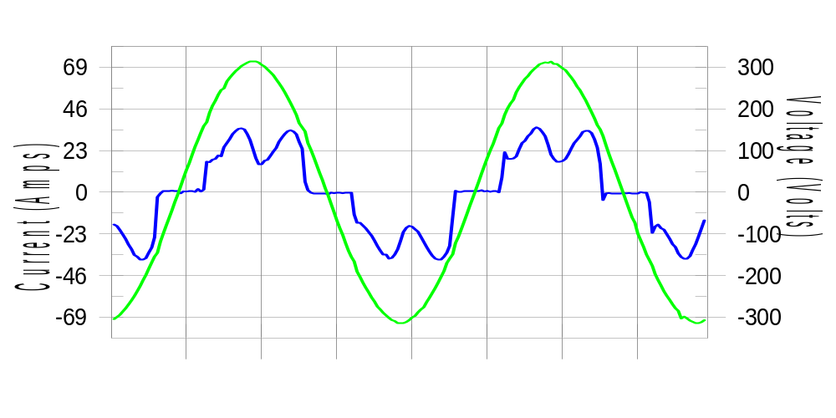

Harmonics and Class 3 limit line European Limits

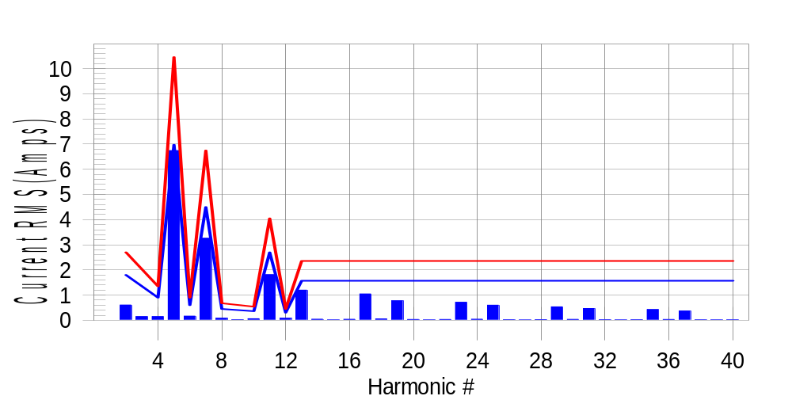

Test result: Fail Worst harmonic was #5 with 64.80 % of the limit.
Current Test Result Summary (Phase B-Run time)

EUT: Equipment under test Tested by: Tested by
Test category: Table:3, Rsce=250, Test Margin: 100
Test date: 2016/4/13 Start time: 17:39:54 End time: 17:42:47
Test duration (min): 2.5 Data file name: CTSMXH_H-000023.cts_data
Comment: Comment
Customer: Customer information

Test Result: Fail Measured I-ref: 22.708(Amps) Source: Normal
I-THC(%): 35.8 Limit(%): 37.0 PWHC(%): 39.1 PWHC Limit(%): 38.0

Highest parameter values during test:
V_RMS (Volts): 220.24 Frequency(Hz): 50.00
I_Peak (Amps): 48.004 I_RMS (Amps): 22.708
I_Fund (Amps): 20.969 Crest Factor: 2.146
Power (Watts): 4653 Power Factor: 0.931

Harm# Harms(avg) 100%Limit %of Limit Harms(max) 150%Limit %of Limit Status

2 0.605 1.799 33.6 0.644 2.699 23.9 Pass
3 0.127 N/A N/A 0.179 N/A N/A N/A
4 0.146 0.900 16.3 0.170 1.349 12.6 Pass
5 6.742 6.972 96.7 6.770 10.458 64.7 Pass
6 0.166 0.600 27.8 0.180 0.900 20.0 Pass
7 3.260 4.498 72.5 3.275 6.747 48.5 Pass
8 0.080 0.450 17.8 0.090 0.675 13.4 Pass
9 0.035 N/A N/A 0.035 N/A N/A N/A
10 0.061 0.360 16.9 0.070 0.540 13.0 Pass
11 1.811 2.699 67.1 1.825 4.048 45.1 Pass
12 0.080 0.300 26.8 0.093 0.450 20.7 Pass
13 1.199 1.574 76.2 1.210 2.361 51.3 Pass
14 0.044 N/A N/A 0.054 N/A N/A N/A
15 0.016 N/A N/A 0.023 N/A N/A N/A
16 0.040 N/A N/A 0.050 N/A N/A N/A
17 1.046 N/A N/A 1.058 N/A N/A N/A
18 0.052 N/A N/A 0.061 N/A N/A N/A
19 0.775 N/A N/A 0.789 N/A N/A N/A
20 0.033 N/A N/A 0.042 N/A N/A N/A
21 0.018 N/A N/A 0.025 N/A N/A N/A
22 0.033 N/A N/A 0.041 N/A N/A N/A
23 0.715 N/A N/A 0.726 N/A N/A N/A
24 0.044 N/A N/A 0.057 N/A N/A N/A
25 0.598 N/A N/A 0.607 N/A N/A N/A
26 0.025 N/A N/A 0.033 N/A N/A N/A
27 0.015 N/A N/A 0.023 N/A N/A N/A
28 0.027 N/A N/A 0.036 N/A N/A N/A
29 0.532 N/A N/A 0.541 N/A N/A N/A
30 0.036 N/A N/A 0.046 N/A N/A N/A
31 0.467 N/A N/A 0.479 N/A N/A N/A
32 0.024 N/A N/A 0.037 N/A N/A N/A
33 0.016 N/A N/A 0.021 N/A N/A N/A
34 0.024 N/A N/A 0.032 N/A N/A N/A
35 0.426 N/A N/A 0.435 N/A N/A N/A
36 0.033 N/A N/A 0.044 N/A N/A N/A
37 0.370 N/A N/A 0.380 N/A N/A N/A
38 0.021 N/A N/A 0.027 N/A N/A N/A
39 0.016 N/A N/A 0.022 N/A N/A N/A
40 0.022 N/A N/A 0.045 N/A N/A N/A

Note: Measured I-ref was applied for this test.

Voltage Source Verification Data (Phase B-Run time)

EUT: Equipment under test Tested by: Tested by
Test category: Table:3, Rsce=250, Test Margin: 100
Test date: 2016/4/13 Start time: 17:39:54 End time: 17:42:47
Test duration (min): 2.5 Data file name: CTSMXH_H-000023.cts_data
Comment: Comment
Customer: Customer information

Test Result: Fail Source qualification: Normal
Measured source distortion is within the requirements of the standards
Measurements are compliant with IEC/EN61000-3-12 Ed.4 & IEC/EN61000-4-7 Ed. 2.1

Highest parameter values during test:
Voltage (Vrms): 220.24 Frequency(Hz): 50.00
I_Peak (Amps): 48.004 I_RMS (Amps): 22.708
I_Fund (Amps): 20.969 Crest Factor: 2.146
Power (Watts): 4653 Power Factor: 0.931

Harm# Harmonics V-rms Limit V-rms % of Limit Status

2 0.182 0.881 20.65 OK
3 0.328 2.752 11.90 OK
4 0.126 0.881 14.31 OK
5 1.145 3.303 34.67 OK
6 0.125 0.881 14.21 OK
7 0.743 2.752 26.99 OK
8 0.137 0.881 15.56 OK
9 0.133 1.321 10.03 OK
10 0.109 0.880 12.34 OK
11 0.654 1.541 42.44 OK
12 0.118 0.660 17.87 OK
13 0.525 1.321 39.73 OK
14 0.109 0.661 16.56 OK
15 0.144 0.661 21.81 OK
16 0.114 0.661 17.28 OK
17 0.530 0.661 80.30 OK
18 0.120 0.661 18.11 OK
19 0.487 0.661 73.75 OK
20 0.140 0.660 21.23 OK
21 0.143 0.660 21.67 OK
22 0.109 0.660 16.52 OK
23 0.440 0.660 66.61 OK
24 0.101 0.660 15.25 OK
25 0.448 0.660 67.79 OK
26 0.102 0.660 15.45 OK
27 0.131 0.661 19.83 OK
28 0.117 0.660 17.65 OK
29 0.383 0.660 58.04 OK
30 0.107 0.661 16.23 OK
31 0.402 0.661 60.87 OK
32 0.105 0.660 15.83 OK
33 0.160 0.660 24.27 OK
34 0.100 0.660 15.09 OK
35 0.343 0.660 52.00 OK
36 0.105 0.660 15.96 OK
37 0.373 0.660 56.53 OK
38 0.117 0.660 17.69 OK
39 0.132 0.660 20.06 OK
40 0.105 0.660 15.94 OK

Harmonics – Per EN/IEC61000-3-12, Ed. 2.0(Phase C-Run time)

EUT: Equipment under test Tested by: Tested by
Test category: Table:3, Rsce=250, Test Margin: 100
Test date: 2016/4/13 Start time: 17:39:54 End time: 17:42:47
Test duration (min): 2.5 Data file name: CTSMXH_H-000023.cts_data
Comment: Comment
Customer: Customer information

Test Result: Fail Source qualification: Normal

Current & voltage waveforms

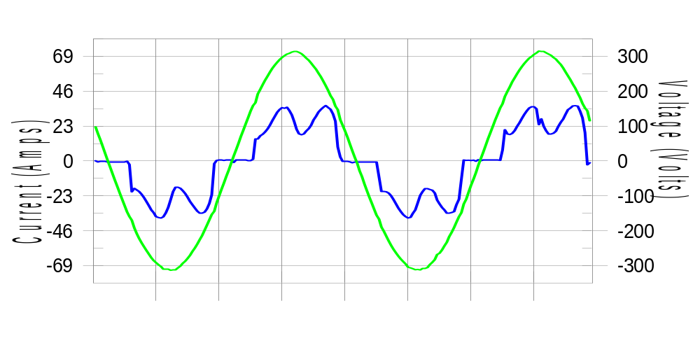

Harmonics and Class 3 limit line European Limits

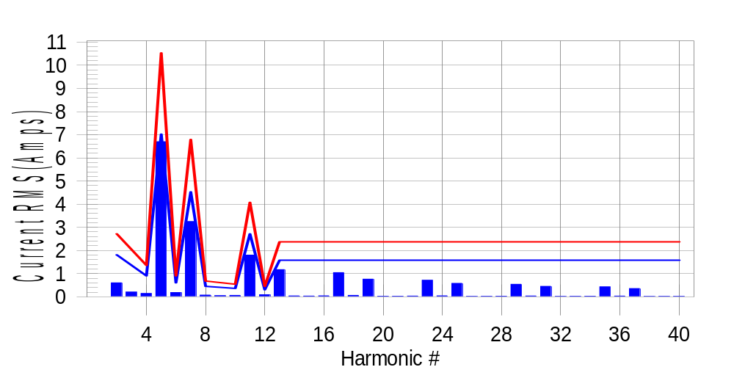

Test result: Fail Worst harmonic was #5 with 63.90 % of the limit.
Current Test Result Summary (Phase C-Run time)

EUT: Equipment under test Tested by: Tested by
Test category: Table:3, Rsce=250, Test Margin: 100
Test date: 2016/4/13 Start time: 17:39:54 End time: 17:42:47
Test duration (min): 2.5 Data file name: CTSMXH_H-000023.cts_data
Comment: Comment
Customer: Customer information

Test Result: Fail Measured I-ref: 22.898(Amps) Source: Normal
I-THC(%): 35.3 Limit(%): 37.0 PWHC(%): 38.6 PWHC Limit(%): 38.0

Highest parameter values during test:
V_RMS (Volts): 220.14 Frequency(Hz): 50.00
I_Peak (Amps): 46.522 I_RMS (Amps): 22.898
I_Fund (Amps): 21.170 Crest Factor: 2.051
Power (Watts): 4705 Power Factor: 0.934

Harm# Harms(avg) 100%Limit %of Limit Harms(max) 150%Limit %of Limit Status

2 0.603 1.812 33.3 0.636 2.718 23.4 Pass
3 0.127 N/A N/A 0.239 N/A N/A N/A
4 0.141 0.906 15.6 0.158 1.359 11.6 Pass
5 6.700 7.022 95.4 6.729 10.533 63.9 Pass
6 0.186 0.604 30.7 0.195 0.906 21.6 Pass
7 3.247 4.530 71.7 3.261 6.795 48.0 Pass
8 0.076 0.453 16.7 0.086 0.680 12.6 Pass
9 0.035 N/A N/A 0.058 N/A N/A N/A
10 0.063 0.362 17.3 0.072 0.544 13.3 Pass
11 1.801 2.718 66.3 1.819 4.077 44.6 Pass
12 0.090 0.302 29.7 0.097 0.453 21.4 Pass
13 1.174 1.586 74.0 1.184 2.378 49.8 Pass
14 0.041 N/A N/A 0.048 N/A N/A N/A
15 0.033 N/A N/A 0.041 N/A N/A N/A
16 0.043 N/A N/A 0.061 N/A N/A N/A
17 1.046 N/A N/A 1.055 N/A N/A N/A
18 0.061 N/A N/A 0.069 N/A N/A N/A
19 0.763 N/A N/A 0.774 N/A N/A N/A
20 0.028 N/A N/A 0.035 N/A N/A N/A
21 0.028 N/A N/A 0.035 N/A N/A N/A
22 0.034 N/A N/A 0.042 N/A N/A N/A
23 0.715 N/A N/A 0.725 N/A N/A N/A
24 0.044 N/A N/A 0.051 N/A N/A N/A
25 0.581 N/A N/A 0.595 N/A N/A N/A
26 0.022 N/A N/A 0.033 N/A N/A N/A
27 0.025 N/A N/A 0.032 N/A N/A N/A
28 0.028 N/A N/A 0.037 N/A N/A N/A
29 0.540 N/A N/A 0.552 N/A N/A N/A
30 0.038 N/A N/A 0.045 N/A N/A N/A
31 0.453 N/A N/A 0.460 N/A N/A N/A
32 0.020 N/A N/A 0.026 N/A N/A N/A
33 0.024 N/A N/A 0.031 N/A N/A N/A
34 0.026 N/A N/A 0.033 N/A N/A N/A
35 0.428 N/A N/A 0.436 N/A N/A N/A
36 0.033 N/A N/A 0.041 N/A N/A N/A
37 0.357 N/A N/A 0.366 N/A N/A N/A
38 0.018 N/A N/A 0.026 N/A N/A N/A
39 0.022 N/A N/A 0.028 N/A N/A N/A
40 0.022 N/A N/A 0.030 N/A N/A N/A

Note: Measured I-ref was applied for this test.

Voltage Source Verification Data (Phase C-Run time)

EUT: Equipment under test Tested by: Tested by
Test category: Table:3, Rsce=250, Test Margin: 100
Test date: 2016/4/13 Start time: 17:39:54 End time: 17:42:47
Test duration (min): 2.5 Data file name: CTSMXH_H-000023.cts_data
Comment: Comment
Customer: Customer information

Test Result: Fail Source qualification: Normal
Measured source distortion is within the requirements of the standards
Measurements are compliant with IEC/EN61000-3-12 Ed.4 & IEC/EN61000-4-7 Ed. 2.1

Highest parameter values during test:
Voltage (Vrms): 220.14 Frequency(Hz): 50.00
I_Peak (Amps): 46.522 I_RMS (Amps): 22.898
I_Fund (Amps): 21.170 Crest Factor: 2.051
Power (Watts): 4705 Power Factor: 0.934

Harm# Harmonics V-rms Limit V-rms % of Limit Status

2 0.170 0.880 19.30 OK
3 0.272 2.751 9.88 OK
4 0.130 0.880 14.81 OK
5 1.096 3.301 33.20 OK
6 0.118 0.880 13.36 OK
7 0.724 2.751 26.33 OK
8 0.101 0.880 11.51 OK
9 0.109 1.320 8.25 OK
10 0.097 0.880 10.99 OK
11 0.607 1.540 39.40 OK
12 0.101 0.660 15.27 OK
13 0.507 1.320 38.44 OK
14 0.087 0.660 13.23 OK
15 0.114 0.660 17.19 OK
16 0.117 0.660 17.74 OK
17 0.518 0.660 78.41 OK
18 0.101 0.660 15.32 OK
19 0.441 0.660 66.86 OK
20 0.113 0.660 17.18 OK
21 0.122 0.660 18.45 OK
22 0.092 0.660 13.99 OK
23 0.446 0.660 67.54 OK
24 0.109 0.660 16.50 OK
25 0.420 0.660 63.62 OK
26 0.097 0.660 14.67 OK
27 0.123 0.660 18.64 OK
28 0.100 0.660 15.12 OK
29 0.392 0.660 59.31 OK
30 0.096 0.660 14.49 OK
31 0.377 0.660 57.17 OK
32 0.089 0.660 13.50 OK
33 0.118 0.660 17.80 OK
34 0.101 0.660 15.34 OK
35 0.342 0.660 51.87 OK
36 0.098 0.660 14.85 OK
37 0.332 0.660 50.34 OK
38 0.098 0.660 14.81 OK
39 0.104 0.660 15.74 OK
40 0.101 0.660 15.26 OK

5th Harmonic Phase Angle and Magnitude for Phase A :
H-5_min_phase : 131.1 Degree (Leading)
H-5_max_phase : 131.9 Degree (Leading)
H-5_ave_phase : 131.5 Degree (Leading)

H-5_ave_vector_magnitude : 6.694 Amp
H-5_standard_ave_magnitude : 6.727 Amp
H-5_standard_max_magnitude : 6.729 Amp
Ratio of H-5_ave_vector / H-5_standard_ave : 0.999

Phase A = 101.210% of tested Rsce = 250.000, Rsce = 253.026
Phase B = 102.997% of tested Rsce = 250.000, Rsce = 257.492
Phase C = 101.452% of tested Rsce = 250.000, Rsce = 253.631
Minimum Rsce required: Rsce = 257.492

