Harmonics – Per EN/IEC61000-3-12, Ed. 2.0(Phase A-Run time)

EUT: Equipment under test Tested by: Tested by
Test category: Table:3, Rsce=250, Test Margin: 100
Test date: 2016/4/13 Start time: 17:48:49 End time: 17:51:42
Test duration (min): 2.5 Data file name: CTSMXH_H-000024.cts_data
Comment: Comment
Customer: Customer information

Test Result: Fail Source qualification: Distorted

Current & voltage waveforms

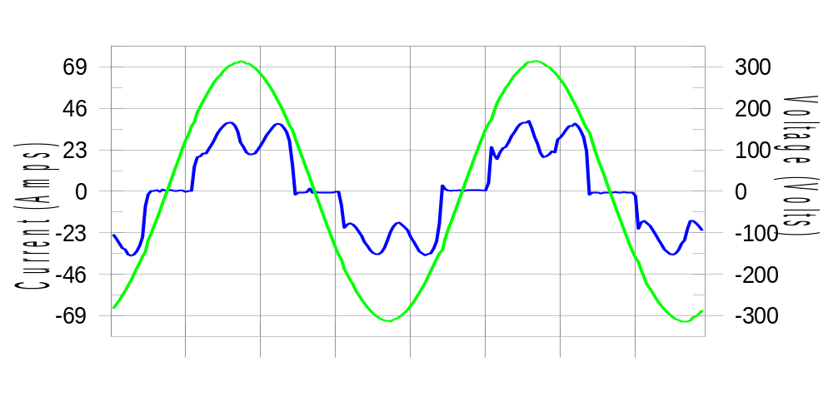

Harmonics and Class 3 limit line European Limits

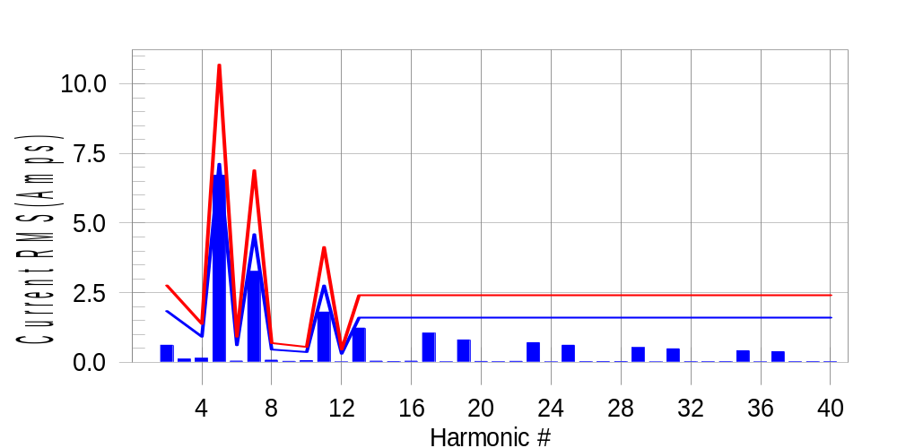

Test result: Fail Worst harmonic was #5 with 63.06 % of the limit.
Current Test Result Summary (Phase A-Run time)

EUT: Equipment under test Tested by: Tested by
Test category: Table:3, Rsce=250, Test Margin: 100
Test date: 2016/4/13 Start time: 17:48:49 End time: 17:51:42
Test duration (min): 2.5 Data file name: CTSMXH_H-000024.cts_data
Comment: Comment
Customer: Customer information

Test Result: Fail Measured I-ref: 23.205(Amps) Source: Distorted
I-THC(%): 34.9 Limit(%): 37.0 PWHC(%): 38.6 PWHC Limit(%): 38.0

Highest parameter values during test:
V_RMS (Volts): 220.43 Frequency(Hz): 50.00
I_Peak (Amps): 49.850 I_RMS (Amps): 23.205
I_Fund (Amps): 21.503 Crest Factor: 2.177
Power (Watts): 4774 Power Factor: 0.934

Harm# Harms(avg) 100%Limit %of Limit Harms(max) 150%Limit %of Limit Status

2 0.614 1.839 33.4 0.646 2.758 23.4 Pass
3 0.116 N/A N/A 0.156 N/A N/A N/A
4 0.145 0.919 15.8 0.163 1.379 11.8 Pass
5 6.710 7.125 94.2 6.734 10.688 63.0 Pass
6 0.042 0.613 6.9 0.051 0.919 5.6 Pass
7 3.263 4.597 71.0 3.277 6.895 47.5 Pass
8 0.076 0.460 16.6 0.088 0.690 12.8 Pass
9 0.033 N/A N/A 0.044 N/A N/A N/A
10 0.059 0.368 16.2 0.069 0.552 12.5 Pass
11 1.803 2.758 65.4 1.816 4.137 43.9 Pass
12 0.015 0.306 5.0 0.021 0.460 4.6 Pass
13 1.227 1.609 76.2 1.240 2.413 51.4 Pass
14 0.041 N/A N/A 0.048 N/A N/A N/A
15 0.028 N/A N/A 0.036 N/A N/A N/A
16 0.041 N/A N/A 0.051 N/A N/A N/A
17 1.047 N/A N/A 1.059 N/A N/A N/A
18 0.017 N/A N/A 0.024 N/A N/A N/A
19 0.802 N/A N/A 0.814 N/A N/A N/A
20 0.030 N/A N/A 0.038 N/A N/A N/A
21 0.022 N/A N/A 0.029 N/A N/A N/A
22 0.033 N/A N/A 0.039 N/A N/A N/A
23 0.706 N/A N/A 0.716 N/A N/A N/A
24 0.015 N/A N/A 0.021 N/A N/A N/A
25 0.612 N/A N/A 0.622 N/A N/A N/A
26 0.023 N/A N/A 0.033 N/A N/A N/A
27 0.027 N/A N/A 0.035 N/A N/A N/A
28 0.026 N/A N/A 0.034 N/A N/A N/A
29 0.528 N/A N/A 0.538 N/A N/A N/A
30 0.016 N/A N/A 0.022 N/A N/A N/A
31 0.485 N/A N/A 0.495 N/A N/A N/A
32 0.021 N/A N/A 0.029 N/A N/A N/A
33 0.021 N/A N/A 0.030 N/A N/A N/A
34 0.025 N/A N/A 0.044 N/A N/A N/A
35 0.417 N/A N/A 0.426 N/A N/A N/A
36 0.014 N/A N/A 0.020 N/A N/A N/A
37 0.381 N/A N/A 0.390 N/A N/A N/A
38 0.020 N/A N/A 0.027 N/A N/A N/A
39 0.024 N/A N/A 0.031 N/A N/A N/A
40 0.022 N/A N/A 0.028 N/A N/A N/A

Note: Measured I-ref was applied for this test.

Voltage Source Verification Data (Phase A-Run time)

EUT: Equipment under test Tested by: Tested by
Test category: Table:3, Rsce=250, Test Margin: 100
Test date: 2016/4/13 Start time: 17:48:49 End time: 17:51:42
Test duration (min): 2.5 Data file name: CTSMXH_H-000024.cts_data
Comment: Comment
Customer: Customer information

Test Result: Fail Source qualification: Distorted
Current harmonics are corrected for source distortion, and are within +/-5%
Measurements are compliant with IEC/EN61000-3-12 Ed.4 & IEC/EN61000-4-7

Highest parameter values during test:
Voltage (Vrms): 220.43 Frequency(Hz): 50.00
I_Peak (Amps): 49.850 I_RMS (Amps): 23.205
I_Fund (Amps): 21.503 Crest Factor: 2.177
Power (Watts): 4774 Power Factor: 0.934

Harm# Harmonics V-rms Limit V-rms % of Limit Status

2 0.154 0.881 17.47 OK
3 0.303 2.754 10.99 OK
4 0.104 0.881 11.80 OK
5 1.095 3.305 33.13 OK
6 0.077 0.882 8.69 OK
7 0.715 2.755 25.94 OK
8 0.089 0.881 10.07 OK
9 0.128 1.322 9.67 OK
10 0.089 0.881 10.05 OK
11 0.602 1.542 39.04 OK
12 0.111 0.661 16.82 OK
13 0.520 1.322 39.37 OK
14 0.101 0.661 15.26 OK
15 0.125 0.661 18.98 OK
16 0.080 0.661 12.07 OK
17 0.507 0.661 76.72 OK
18 0.076 0.661 11.45 OK
19 0.468 0.661 70.80 OK
20 0.173 0.661 26.23 OK
21 0.129 0.661 19.48 OK
22 0.090 0.661 13.60 OK
23 0.417 0.661 63.07 OK
24 0.080 0.661 12.07 OK
25 0.429 0.661 64.91 OK
26 0.079 0.661 11.90 OK
27 0.130 0.661 19.60 OK
28 0.088 0.661 13.25 OK
29 0.357 0.661 53.98 OK
30 0.079 0.661 11.98 OK
31 0.398 0.661 60.18 OK
32 0.090 0.661 13.64 OK
33 0.130 0.661 19.68 OK
34 0.086 0.661 13.04 OK
35 0.323 0.661 48.84 OK
36 0.069 0.661 10.43 OK
37 0.351 0.661 53.09 OK
38 0.085 0.661 12.91 OK
39 0.144 0.661 21.77 OK
40 0.148 0.661 22.33 OK

Harmonics – Per EN/IEC61000-3-12, Ed. 2.0(Phase B-Run time)

EUT: Equipment under test Tested by: Tested by
Test category: Table:3, Rsce=250, Test Margin: 100
Test date: 2016/4/13 Start time: 17:48:49 End time: 17:51:42
Test duration (min): 2.5 Data file name: CTSMXH_H-000024.cts_data
Comment: Comment
Customer: Customer information

Test Result: Fail Source qualification: Distorted

Current & voltage waveforms

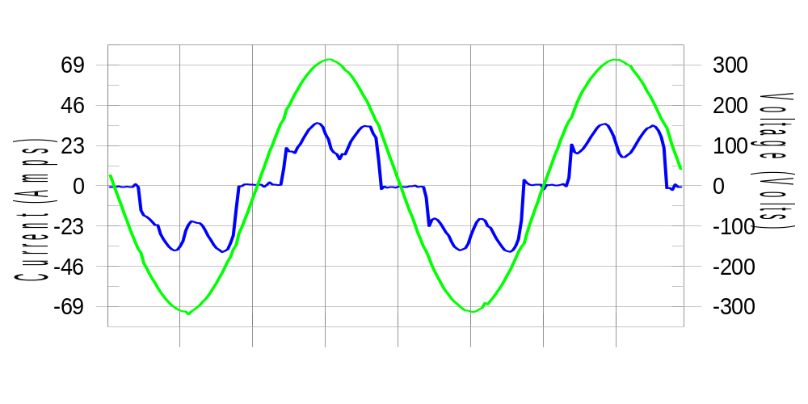

Harmonics and Class 3 limit line European Limits

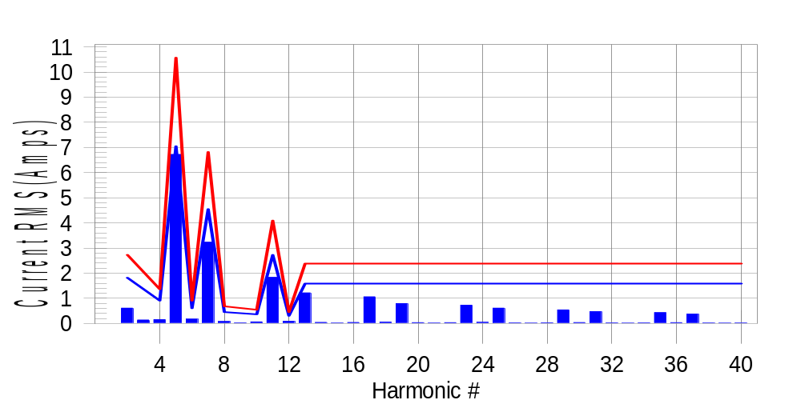

Test result: Fail Worst harmonic was #5 with 63.91 % of the limit.
Current Test Result Summary (Phase B-Run time)

EUT: Equipment under test Tested by: Tested by
Test category: Table:3, Rsce=250, Test Margin: 100
Test date: 2016/4/13 Start time: 17:48:49 End time: 17:51:42
Test duration (min): 2.5 Data file name: CTSMXH_H-000024.cts_data
Comment: Comment
Customer: Customer information

Test Result: Fail Measured I-ref: 22.962(Amps) Source: Distorted
I-THC(%): 35.3 Limit(%): 37.0 PWHC(%): 39.4 PWHC Limit(%): 38.0

Highest parameter values during test:
V_RMS (Volts): 220.23 Frequency(Hz): 50.00
I_Peak (Amps): 49.012 I_RMS (Amps): 22.962
I_Fund (Amps): 21.236 Crest Factor: 2.144
Power (Watts): 4714 Power Factor: 0.933

Harm# Harms(avg) 100%Limit %of Limit Harms(max) 150%Limit %of Limit Status

2 0.609 1.819 33.5 0.643 2.728 23.6 Pass
3 0.116 N/A N/A 0.167 N/A N/A N/A
4 0.150 0.909 16.4 0.168 1.364 12.3 Pass
5 6.722 7.047 95.4 6.755 10.571 63.9 Pass
6 0.172 0.606 28.3 0.182 0.909 20.1 Pass
7 3.232 4.547 71.1 3.246 6.820 47.6 Pass
8 0.078 0.455 17.2 0.088 0.682 12.9 Pass
9 0.033 N/A N/A 0.033 N/A N/A N/A
10 0.061 0.364 16.8 0.087 0.546 16.0 Pass
11 1.835 2.728 67.3 1.848 4.092 45.2 Pass
12 0.083 0.303 27.3 0.090 0.455 19.9 Pass
13 1.216 1.591 76.4 1.229 2.387 51.5 Pass
14 0.044 N/A N/A 0.053 N/A N/A N/A
15 0.016 N/A N/A 0.025 N/A N/A N/A
16 0.039 N/A N/A 0.048 N/A N/A N/A
17 1.062 N/A N/A 1.072 N/A N/A N/A
18 0.054 N/A N/A 0.063 N/A N/A N/A
19 0.789 N/A N/A 0.800 N/A N/A N/A
20 0.032 N/A N/A 0.047 N/A N/A N/A
21 0.017 N/A N/A 0.025 N/A N/A N/A
22 0.033 N/A N/A 0.041 N/A N/A N/A
23 0.727 N/A N/A 0.735 N/A N/A N/A
24 0.045 N/A N/A 0.053 N/A N/A N/A
25 0.609 N/A N/A 0.626 N/A N/A N/A
26 0.025 N/A N/A 0.035 N/A N/A N/A
27 0.015 N/A N/A 0.022 N/A N/A N/A
28 0.026 N/A N/A 0.049 N/A N/A N/A
29 0.540 N/A N/A 0.550 N/A N/A N/A
30 0.038 N/A N/A 0.048 N/A N/A N/A
31 0.474 N/A N/A 0.492 N/A N/A N/A
32 0.024 N/A N/A 0.032 N/A N/A N/A
33 0.015 N/A N/A 0.021 N/A N/A N/A
34 0.024 N/A N/A 0.032 N/A N/A N/A
35 0.431 N/A N/A 0.441 N/A N/A N/A
36 0.033 N/A N/A 0.046 N/A N/A N/A
37 0.375 N/A N/A 0.384 N/A N/A N/A
38 0.020 N/A N/A 0.027 N/A N/A N/A
39 0.015 N/A N/A 0.021 N/A N/A N/A
40 0.022 N/A N/A 0.029 N/A N/A N/A

Note: Measured I-ref was applied for this test.

Voltage Source Verification Data (Phase B-Run time)

EUT: Equipment under test Tested by: Tested by
Test category: Table:3, Rsce=250, Test Margin: 100
Test date: 2016/4/13 Start time: 17:48:49 End time: 17:51:42
Test duration (min): 2.5 Data file name: CTSMXH_H-000024.cts_data
Comment: Comment
Customer: Customer information

Test Result: Fail Source qualification: Distorted
Current harmonics are corrected for source distortion, and are within +/-5%
Measurements are compliant with IEC/EN61000-3-12 Ed.4 & IEC/EN61000-4-7

Highest parameter values during test:
Voltage (Vrms): 220.23 Frequency(Hz): 50.00
I_Peak (Amps): 49.012 I_RMS (Amps): 22.962
I_Fund (Amps): 21.236 Crest Factor: 2.144
Power (Watts): 4714 Power Factor: 0.933

Harm# Harmonics V-rms Limit V-rms % of Limit Status

2 0.191 0.880 21.74 OK
3 0.299 2.752 10.88 OK
4 0.119 0.880 13.53 OK
5 1.155 3.301 34.99 OK
6 0.120 0.880 13.60 OK
7 0.746 2.752 27.13 OK
8 0.116 0.880 13.20 OK
9 0.126 1.321 9.57 OK
10 0.104 0.880 11.77 OK
11 0.652 1.541 42.34 OK
12 0.102 0.660 15.50 OK
13 0.568 1.321 42.98 OK
14 0.109 0.660 16.46 OK
15 0.138 0.660 20.92 OK
16 0.101 0.660 15.35 OK
17 0.533 0.660 80.78 OK
18 0.114 0.660 17.28 OK
19 0.493 0.661 74.67 OK
20 0.135 0.660 20.40 OK
21 0.146 0.660 22.07 OK
22 0.094 0.661 14.20 OK
23 0.450 0.660 68.19 OK
24 0.115 0.661 17.41 OK
25 0.453 0.660 68.56 OK
26 0.134 0.660 20.26 OK
27 0.135 0.660 20.42 OK
28 0.123 0.660 18.59 OK
29 0.385 0.660 58.28 OK
30 0.104 0.660 15.70 OK
31 0.405 0.660 61.26 OK
32 0.105 0.660 15.93 OK
33 0.137 0.660 20.71 OK
34 0.100 0.660 15.09 OK
35 0.351 0.660 53.12 OK
36 0.107 0.660 16.25 OK
37 0.367 0.660 55.61 OK
38 0.116 0.660 17.63 OK
39 0.131 0.660 19.88 OK
40 0.112 0.660 16.89 OK

Harmonics – Per EN/IEC61000-3-12, Ed. 2.0(Phase C-Run time)

EUT: Equipment under test Tested by: Tested by
Test category: Table:3, Rsce=250, Test Margin: 100
Test date: 2016/4/13 Start time: 17:48:49 End time: 17:51:42
Test duration (min): 2.5 Data file name: CTSMXH_H-000024.cts_data
Comment: Comment
Customer: Customer information

Test Result: Fail Source qualification: Distorted

Current & voltage waveforms

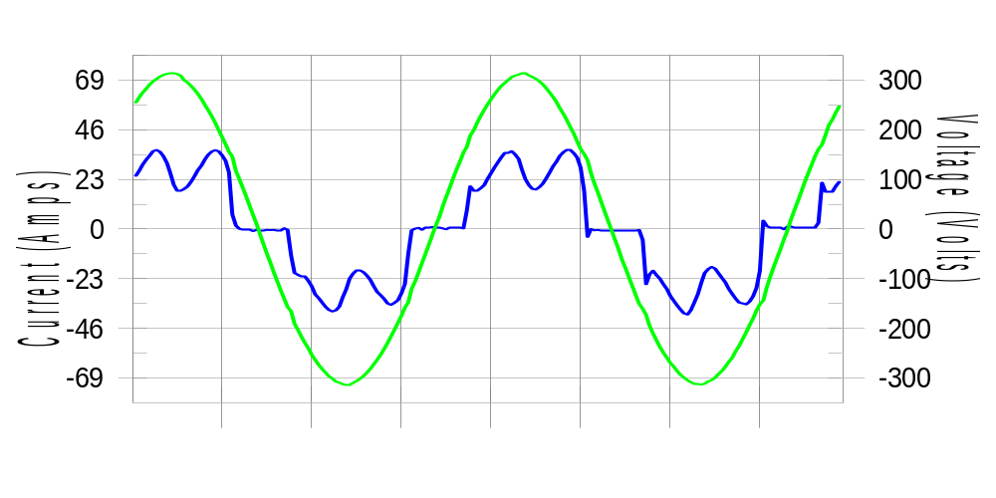

Harmonics and Class 3 limit line European Limits

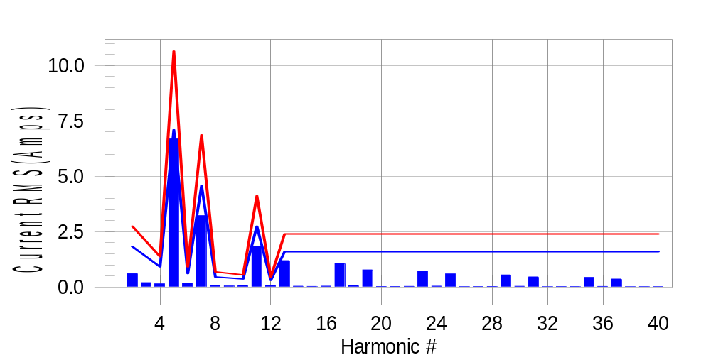

Test result: Fail Worst harmonic was #5 with 63.06 % of the limit.
Current Test Result Summary (Phase C-Run time)

EUT: Equipment under test Tested by: Tested by
Test category: Table:3, Rsce=250, Test Margin: 100
Test date: 2016/4/13 Start time: 17:48:49 End time: 17:51:42
Test duration (min): 2.5 Data file name: CTSMXH_H-000024.cts_data
Comment: Comment
Customer: Customer information

Test Result: Fail Measured I-ref: 23.121(Amps) Source: Distorted
I-THC(%): 34.9 Limit(%): 37.0 PWHC(%): 38.8 PWHC Limit(%): 38.0

Highest parameter values during test:
V_RMS (Volts): 220.14 Frequency(Hz): 50.00
I_Peak (Amps): 47.097 I_RMS (Amps): 23.121
I_Fund (Amps): 21.436 Crest Factor: 2.067
Power (Watts): 4758 Power Factor: 0.935

Harm# Harms(avg) 100%Limit %of Limit Harms(max) 150%Limit %of Limit Status

2 0.600 1.832 32.7 0.633 2.748 23.0 Pass
3 0.116 N/A N/A 0.230 N/A N/A N/A
4 0.142 0.916 15.5 0.159 1.374 11.6 Pass
5 6.684 7.098 94.2 6.710 10.647 63.0 Pass
6 0.181 0.611 29.7 0.190 0.916 20.7 Pass
7 3.221 4.579 70.3 3.232 6.869 47.1 Pass
8 0.075 0.458 16.3 0.084 0.687 12.2 Pass
9 0.033 N/A N/A 0.058 N/A N/A N/A
10 0.062 0.366 17.0 0.072 0.550 13.2 Pass
11 1.825 2.748 66.4 1.837 4.121 44.6 Pass
12 0.087 0.305 28.4 0.101 0.458 22.1 Pass
13 1.193 1.603 74.4 1.202 2.404 50.0 Pass
14 0.041 N/A N/A 0.050 N/A N/A N/A
15 0.032 N/A N/A 0.040 N/A N/A N/A
16 0.042 N/A N/A 0.051 N/A N/A N/A
17 1.063 N/A N/A 1.075 N/A N/A N/A
18 0.059 N/A N/A 0.085 N/A N/A N/A
19 0.777 N/A N/A 0.787 N/A N/A N/A
20 0.028 N/A N/A 0.036 N/A N/A N/A
21 0.028 N/A N/A 0.039 N/A N/A N/A
22 0.034 N/A N/A 0.044 N/A N/A N/A
23 0.727 N/A N/A 0.735 N/A N/A N/A
24 0.042 N/A N/A 0.049 N/A N/A N/A
25 0.591 N/A N/A 0.600 N/A N/A N/A
26 0.021 N/A N/A 0.029 N/A N/A N/A
27 0.024 N/A N/A 0.032 N/A N/A N/A
28 0.027 N/A N/A 0.035 N/A N/A N/A
29 0.548 N/A N/A 0.555 N/A N/A N/A
30 0.036 N/A N/A 0.043 N/A N/A N/A
31 0.461 N/A N/A 0.471 N/A N/A N/A
32 0.019 N/A N/A 0.026 N/A N/A N/A
33 0.024 N/A N/A 0.031 N/A N/A N/A
34 0.024 N/A N/A 0.031 N/A N/A N/A
35 0.434 N/A N/A 0.447 N/A N/A N/A
36 0.031 N/A N/A 0.039 N/A N/A N/A
37 0.363 N/A N/A 0.378 N/A N/A N/A
38 0.017 N/A N/A 0.023 N/A N/A N/A
39 0.021 N/A N/A 0.027 N/A N/A N/A
40 0.022 N/A N/A 0.028 N/A N/A N/A

Note: Measured I-ref was applied for this test.

Voltage Source Verification Data (Phase C-Run time)

EUT: Equipment under test Tested by: Tested by
Test category: Table:3, Rsce=250, Test Margin: 100
Test date: 2016/4/13 Start time: 17:48:49 End time: 17:51:42
Test duration (min): 2.5 Data file name: CTSMXH_H-000024.cts_data
Comment: Comment
Customer: Customer information

Test Result: Fail Source qualification: Distorted
Current harmonics are corrected for source distortion, and are within +/-5%
Measurements are compliant with IEC/EN61000-3-12 Ed.4 & IEC/EN61000-4-7

Highest parameter values during test:
Voltage (Vrms): 220.14 Frequency(Hz): 50.00
I_Peak (Amps): 47.097 I_RMS (Amps): 23.121
I_Fund (Amps): 21.436 Crest Factor: 2.067
Power (Watts): 4758 Power Factor: 0.935

Harm# Harmonics V-rms Limit V-rms % of Limit Status

2 0.157 0.880 17.84 OK
3 0.262 2.751 9.52 OK
4 0.108 0.880 12.28 OK
5 1.078 3.301 32.67 OK
6 0.108 0.880 12.29 OK
7 0.714 2.751 25.96 OK
8 0.094 0.880 10.63 OK
9 0.102 1.320 7.71 OK
10 0.087 0.880 9.89 OK
11 0.615 1.540 39.94 OK
12 0.133 0.660 20.21 OK
13 0.514 1.320 38.94 OK
14 0.095 0.660 14.40 OK
15 0.109 0.660 16.44 OK
16 0.101 0.660 15.27 OK
17 0.512 0.660 77.54 OK
18 0.092 0.660 13.89 OK
19 0.453 0.660 68.64 OK
20 0.105 0.660 15.90 OK
21 0.112 0.660 17.02 OK
22 0.094 0.660 14.31 OK
23 0.450 0.660 68.11 OK
24 0.092 0.660 13.89 OK
25 0.423 0.660 64.08 OK
26 0.103 0.660 15.65 OK
27 0.104 0.660 15.76 OK
28 0.080 0.660 12.08 OK
29 0.373 0.660 56.56 OK
30 0.093 0.660 14.10 OK
31 0.384 0.660 58.21 OK
32 0.092 0.660 13.99 OK
33 0.107 0.660 16.28 OK
34 0.085 0.660 12.85 OK
35 0.344 0.660 52.03 OK
36 0.089 0.660 13.47 OK
37 0.337 0.660 51.05 OK
38 0.079 0.660 11.97 OK
39 0.099 0.660 14.98 OK
40 0.098 0.660 14.85 OK

5th Harmonic Phase Angle and Magnitude for Phase A :
H-5_min_phase : 131.8 Degree (Leading)
H-5_max_phase : 132.5 Degree (Leading)
H-5_ave_phase : 132.1 Degree (Leading)

H-5_ave_vector_magnitude : 6.678 Amp
H-5_standard_ave_magnitude : 6.710 Amp
H-5_standard_max_magnitude : 6.710 Amp
Ratio of H-5_ave_vector / H-5_standard_ave : 0.999

Phase A = 101.632% of tested Rsce = 250.000, Rsce = 254.080
Phase B = 103.573% of tested Rsce = 250.000, Rsce = 258.932
Phase C = 102.055% of tested Rsce = 250.000, Rsce = 255.138
Minimum Rsce required: Rsce = 258.932

