Harmonics – Per EN/IEC61000-3-12, Ed. 2.0(Phase A-Run time)

EUT: Equipment under test Tested by: Tested by
Test category: Table:3, Rsce=250, Test Margin: 100
Test date: 2016/4/13 Start time: 17:58:54 End time: 18:01:47
Test duration (min): 2.5 Data file name: CTSMXH_H-000025.cts_data
Comment: Comment
Customer: Customer information

Test Result: Fail Source qualification: Distorted

Current & voltage waveforms

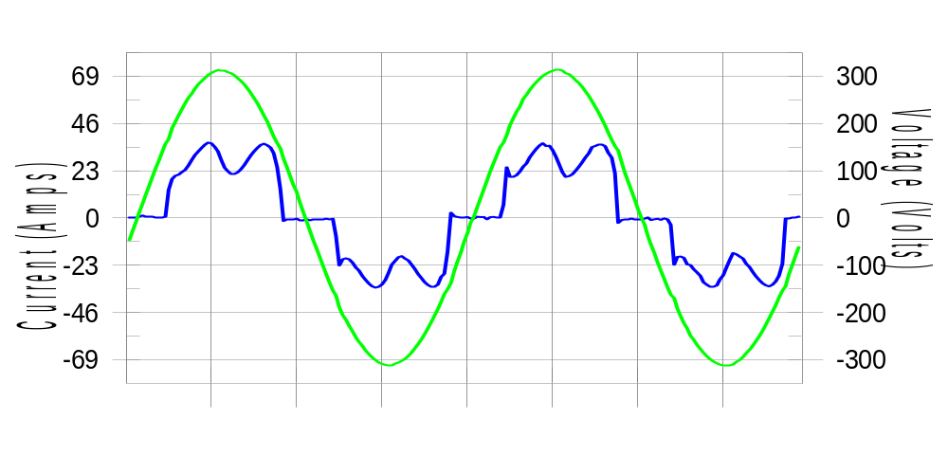

Harmonics and Class 3 limit line European Limits

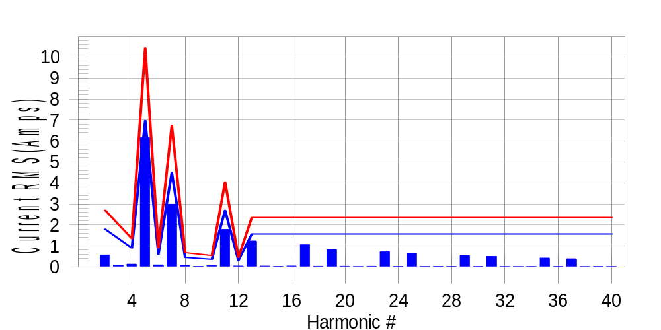

Test result: Fail Worst harmonic was #5 with 59.11 % of the limit.
Current Test Result Summary (Phase A-Run time)

EUT: Equipment under test Tested by: Tested by
Test category: Table:3, Rsce=250, Test Margin: 100
Test date: 2016/4/13 Start time: 17:58:54 End time: 18:01:47
Test duration (min): 2.5 Data file name: CTSMXH_H-000025.cts_data
Comment: Comment
Customer: Customer information

Test Result: Fail Measured I-ref: 22.723(Amps) Source: Distorted
I-THC(%): 33.1 Limit(%): 37.0 PWHC(%): 40.1 PWHC Limit(%): 38.0

Highest parameter values during test:
V_RMS (Volts): 220.44 Frequency(Hz): 50.00
I_Peak (Amps): 48.072 I_RMS (Amps): 22.723
I_Fund (Amps): 21.171 Crest Factor: 2.138
Power (Watts): 4712 Power Factor: 0.941

Harm# Harms(avg) 100%Limit %of Limit Harms(max) 150%Limit %of Limit Status

2 0.563 1.798 31.3 0.599 2.697 22.2 Pass
3 0.088 N/A N/A 0.120 N/A N/A N/A
4 0.129 0.899 14.3 0.147 1.348 10.9 Pass
5 6.149 6.967 88.3 6.178 10.451 59.1 Pass
6 0.096 0.599 16.1 0.106 0.899 11.8 Pass
7 2.985 4.495 66.4 2.998 6.742 44.5 Pass
8 0.073 0.449 16.3 0.088 0.674 13.0 Pass
9 0.028 N/A N/A 0.038 N/A N/A N/A
10 0.056 0.360 15.5 0.065 0.539 12.0 Pass
11 1.786 2.697 66.2 1.803 4.045 44.6 Pass
12 0.043 0.300 14.4 0.055 0.449 12.2 Pass
13 1.239 1.573 78.8 1.252 2.360 53.1 Pass
14 0.038 N/A N/A 0.046 N/A N/A N/A
15 0.026 N/A N/A 0.037 N/A N/A N/A
16 0.041 N/A N/A 0.059 N/A N/A N/A
17 1.053 N/A N/A 1.063 N/A N/A N/A
18 0.029 N/A N/A 0.037 N/A N/A N/A
19 0.823 N/A N/A 0.836 N/A N/A N/A
20 0.029 N/A N/A 0.040 N/A N/A N/A
21 0.020 N/A N/A 0.028 N/A N/A N/A
22 0.031 N/A N/A 0.041 N/A N/A N/A
23 0.711 N/A N/A 0.720 N/A N/A N/A
24 0.028 N/A N/A 0.042 N/A N/A N/A
25 0.627 N/A N/A 0.642 N/A N/A N/A
26 0.023 N/A N/A 0.030 N/A N/A N/A
27 0.026 N/A N/A 0.035 N/A N/A N/A
28 0.027 N/A N/A 0.037 N/A N/A N/A
29 0.535 N/A N/A 0.548 N/A N/A N/A
30 0.024 N/A N/A 0.032 N/A N/A N/A
31 0.495 N/A N/A 0.505 N/A N/A N/A
32 0.021 N/A N/A 0.043 N/A N/A N/A
33 0.021 N/A N/A 0.028 N/A N/A N/A
34 0.024 N/A N/A 0.038 N/A N/A N/A
35 0.419 N/A N/A 0.428 N/A N/A N/A
36 0.023 N/A N/A 0.034 N/A N/A N/A
37 0.386 N/A N/A 0.394 N/A N/A N/A
38 0.020 N/A N/A 0.028 N/A N/A N/A
39 0.023 N/A N/A 0.032 N/A N/A N/A
40 0.022 N/A N/A 0.031 N/A N/A N/A

Note: Measured I-ref was applied for this test.

Voltage Source Verification Data (Phase A-Run time)

EUT: Equipment under test Tested by: Tested by
Test category: Table:3, Rsce=250, Test Margin: 100
Test date: 2016/4/13 Start time: 17:58:54 End time: 18:01:47
Test duration (min): 2.5 Data file name: CTSMXH_H-000025.cts_data
Comment: Comment
Customer: Customer information

Test Result: Fail Source qualification: Distorted
Current harmonics are corrected for source distortion, and are within +/-5%
Measurements are compliant with IEC/EN61000-3-12 Ed.4 & IEC/EN61000-4-7

Highest parameter values during test:
Voltage (Vrms): 220.44 Frequency(Hz): 50.00
I_Peak (Amps): 48.072 I_RMS (Amps): 22.723
I_Fund (Amps): 21.171 Crest Factor: 2.138
Power (Watts): 4712 Power Factor: 0.941

Harm# Harmonics V-rms Limit V-rms % of Limit Status

2 0.138 0.881 15.69 OK
3 0.293 2.754 10.64 OK
4 0.113 0.881 12.84 OK
5 1.026 3.305 31.05 OK
6 0.092 0.882 10.46 OK
7 0.675 2.755 24.52 OK
8 0.100 0.882 11.34 OK
9 0.125 1.322 9.42 OK
10 0.095 0.881 10.83 OK
11 0.589 1.543 38.19 OK
12 0.108 0.661 16.38 OK
13 0.523 1.322 39.55 OK
14 0.080 0.661 12.11 OK
15 0.128 0.661 19.29 OK
16 0.084 0.661 12.74 OK
17 0.491 0.661 74.27 OK
18 0.081 0.661 12.26 OK
19 0.479 0.661 72.53 OK
20 0.165 0.661 24.93 OK
21 0.129 0.661 19.57 OK
22 0.101 0.661 15.33 OK
23 0.419 0.661 63.37 OK
24 0.084 0.661 12.78 OK
25 0.434 0.661 65.63 OK
26 0.094 0.661 14.16 OK
27 0.131 0.661 19.74 OK
28 0.079 0.661 11.92 OK
29 0.374 0.661 56.52 OK
30 0.090 0.661 13.63 OK
31 0.395 0.661 59.69 OK
32 0.080 0.661 12.10 OK
33 0.135 0.661 20.39 OK
34 0.086 0.661 13.03 OK
35 0.319 0.661 48.30 OK
36 0.085 0.661 12.79 OK
37 0.384 0.661 58.02 OK
38 0.094 0.661 14.23 OK
39 0.132 0.661 20.00 OK
40 0.140 0.661 21.16 OK

Harmonics – Per EN/IEC61000-3-12, Ed. 2.0(Phase B-Run time)

EUT: Equipment under test Tested by: Tested by
Test category: Table:3, Rsce=250, Test Margin: 100
Test date: 2016/4/13 Start time: 17:58:54 End time: 18:01:47
Test duration (min): 2.5 Data file name: CTSMXH_H-000025.cts_data
Comment: Comment
Customer: Customer information

Test Result: Fail Source qualification: Distorted

Current & voltage waveforms

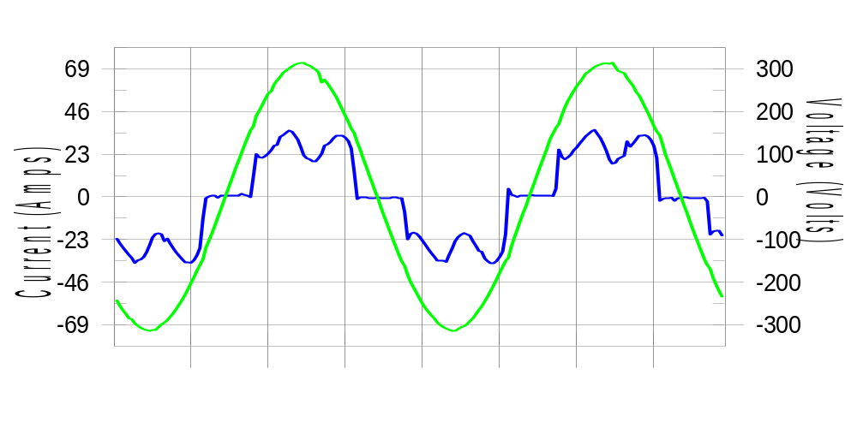

Harmonics and Class 3 limit line European Limits

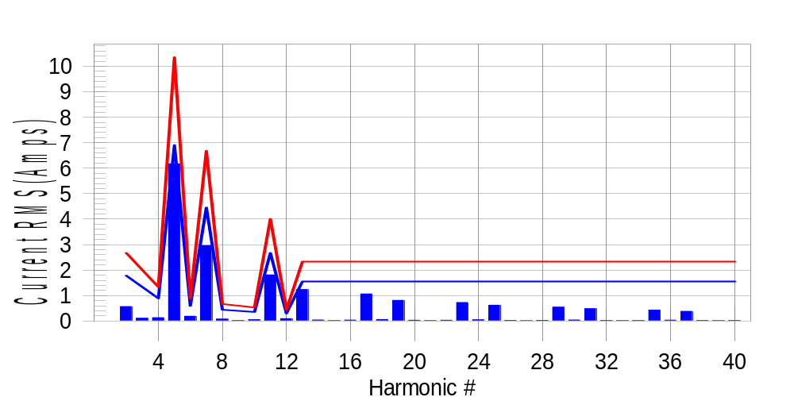

Test result: Fail Worst harmonic was #5 with 59.91 % of the limit.
Current Test Result Summary (Phase B-Run time)

EUT: Equipment under test Tested by: Tested by
Test category: Table:3, Rsce=250, Test Margin: 100
Test date: 2016/4/13 Start time: 17:58:54 End time: 18:01:47
Test duration (min): 2.5 Data file name: CTSMXH_H-000025.cts_data
Comment: Comment
Customer: Customer information

Test Result: Fail Measured I-ref: 22.527(Amps) Source: Distorted
I-THC(%): 33.5 Limit(%): 37.0 PWHC(%): 40.7 PWHC Limit(%): 38.0

Highest parameter values during test:
V_RMS (Volts): 220.23 Frequency(Hz): 50.00
I_Peak (Amps): 46.660 I_RMS (Amps): 22.527
I_Fund (Amps): 20.954 Crest Factor: 2.091
Power (Watts): 4662 Power Factor: 0.940

Harm# Harms(avg) 100%Limit %of Limit Harms(max) 150%Limit %of Limit Status

2 0.568 1.781 31.9 0.603 2.672 22.6 Pass
3 0.088 N/A N/A 0.147 N/A N/A N/A
4 0.132 0.891 14.8 0.148 1.336 11.1 Pass
5 6.171 6.903 89.4 6.199 10.355 59.9 Pass
6 0.190 0.594 32.0 0.198 0.891 22.3 Pass
7 2.961 4.454 66.5 2.976 6.680 44.5 Pass
8 0.075 0.445 16.9 0.102 0.668 15.3 Pass
9 0.028 N/A N/A 0.035 N/A N/A N/A
10 0.056 0.356 15.6 0.066 0.534 12.4 Pass
11 1.813 2.672 67.9 1.830 4.008 45.7 Pass
12 0.095 0.297 32.0 0.104 0.445 23.3 Pass
13 1.234 1.559 79.2 1.244 2.338 53.2 Pass
14 0.041 N/A N/A 0.051 N/A N/A N/A
15 0.017 N/A N/A 0.024 N/A N/A N/A
16 0.038 N/A N/A 0.050 N/A N/A N/A
17 1.065 N/A N/A 1.077 N/A N/A N/A
18 0.062 N/A N/A 0.071 N/A N/A N/A
19 0.811 N/A N/A 0.822 N/A N/A N/A
20 0.032 N/A N/A 0.038 N/A N/A N/A
21 0.017 N/A N/A 0.024 N/A N/A N/A
22 0.032 N/A N/A 0.051 N/A N/A N/A
23 0.729 N/A N/A 0.738 N/A N/A N/A
24 0.050 N/A N/A 0.080 N/A N/A N/A
25 0.623 N/A N/A 0.632 N/A N/A N/A
26 0.025 N/A N/A 0.032 N/A N/A N/A
27 0.015 N/A N/A 0.030 N/A N/A N/A
28 0.027 N/A N/A 0.035 N/A N/A N/A
29 0.543 N/A N/A 0.555 N/A N/A N/A
30 0.042 N/A N/A 0.052 N/A N/A N/A
31 0.485 N/A N/A 0.494 N/A N/A N/A
32 0.023 N/A N/A 0.031 N/A N/A N/A
33 0.016 N/A N/A 0.023 N/A N/A N/A
34 0.024 N/A N/A 0.038 N/A N/A N/A
35 0.433 N/A N/A 0.442 N/A N/A N/A
36 0.037 N/A N/A 0.046 N/A N/A N/A
37 0.382 N/A N/A 0.397 N/A N/A N/A
38 0.022 N/A N/A 0.041 N/A N/A N/A
39 0.016 N/A N/A 0.024 N/A N/A N/A
40 0.022 N/A N/A 0.032 N/A N/A N/A

Note: Measured I-ref was applied for this test.

Voltage Source Verification Data (Phase B-Run time)

EUT: Equipment under test Tested by: Tested by
Test category: Table:3, Rsce=250, Test Margin: 100
Test date: 2016/4/13 Start time: 17:58:54 End time: 18:01:47
Test duration (min): 2.5 Data file name: CTSMXH_H-000025.cts_data
Comment: Comment
Customer: Customer information

Test Result: Fail Source qualification: Distorted
Current harmonics are corrected for source distortion, and are within +/-5%
Measurements are compliant with IEC/EN61000-3-12 Ed.4 & IEC/EN61000-4-7

Highest parameter values during test:
Voltage (Vrms): 220.23 Frequency(Hz): 50.00
I_Peak (Amps): 46.660 I_RMS (Amps): 22.527
I_Fund (Amps): 20.954 Crest Factor: 2.091
Power (Watts): 4662 Power Factor: 0.940

Harm# Harmonics V-rms Limit V-rms % of Limit Status

2 0.158 0.880 17.94 OK
3 0.312 2.751 11.35 OK
4 0.133 0.881 15.06 OK
5 1.083 3.303 32.79 OK
6 0.119 0.881 13.51 OK
7 0.708 2.752 25.71 OK
8 0.123 0.881 14.00 OK
9 0.139 1.321 10.49 OK
10 0.100 0.881 11.38 OK
11 0.653 1.541 42.36 OK
12 0.129 0.660 19.52 OK
13 0.547 1.321 41.43 OK
14 0.111 0.661 16.78 OK
15 0.145 0.660 22.00 OK
16 0.108 0.660 16.41 OK
17 0.539 0.661 81.59 OK
18 0.111 0.660 16.79 OK
19 0.493 0.660 74.66 OK
20 0.126 0.660 19.14 OK
21 0.132 0.660 20.00 OK
22 0.096 0.660 14.52 OK
23 0.452 0.660 68.42 OK
24 0.111 0.661 16.78 OK
25 0.455 0.660 68.84 OK
26 0.114 0.660 17.31 OK
27 0.142 0.661 21.52 OK
28 0.119 0.660 18.04 OK
29 0.385 0.660 58.22 OK
30 0.107 0.660 16.20 OK
31 0.397 0.660 60.11 OK
32 0.123 0.660 18.60 OK
33 0.139 0.660 21.05 OK
34 0.094 0.660 14.30 OK
35 0.356 0.660 53.92 OK
36 0.122 0.660 18.45 OK
37 0.382 0.661 57.86 OK
38 0.104 0.660 15.72 OK
39 0.137 0.660 20.67 OK
40 0.108 0.660 16.42 OK

Harmonics – Per EN/IEC61000-3-12, Ed. 2.0(Phase C-Run time)

EUT: Equipment under test Tested by: Tested by
Test category: Table:3, Rsce=250, Test Margin: 100
Test date: 2016/4/13 Start time: 17:58:54 End time: 18:01:47
Test duration (min): 2.5 Data file name: CTSMXH_H-000025.cts_data
Comment: Comment
Customer: Customer information

Test Result: Fail Source qualification: Distorted

Current & voltage waveforms

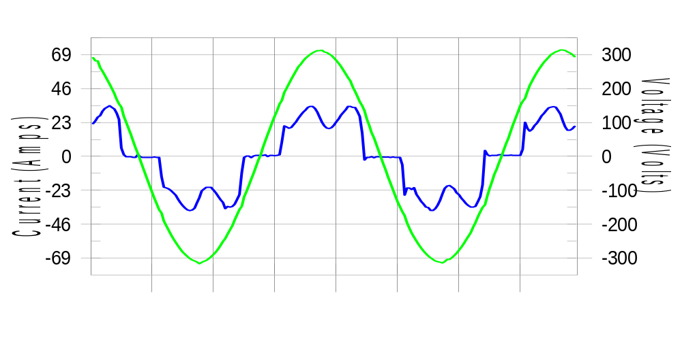

Harmonics and Class 3 limit line European Limits

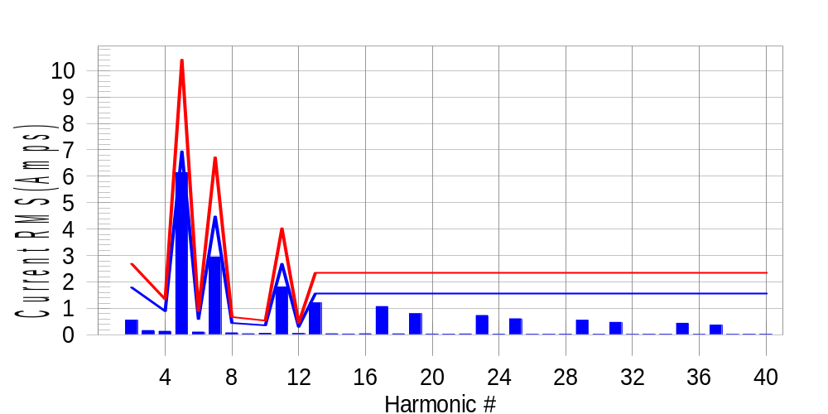

Test result: Fail Worst harmonic was #5 with 59.23 % of the limit.
Current Test Result Summary (Phase C-Run time)

EUT: Equipment under test Tested by: Tested by
Test category: Table:3, Rsce=250, Test Margin: 100
Test date: 2016/4/13 Start time: 17:58:54 End time: 18:01:47
Test duration (min): 2.5 Data file name: CTSMXH_H-000025.cts_data
Comment: Comment
Customer: Customer information

Test Result: Fail Measured I-ref: 22.671(Amps) Source: Distorted
I-THC(%): 33.2 Limit(%): 37.0 PWHC(%): 40.2 PWHC Limit(%): 38.0

Highest parameter values during test:
V_RMS (Volts): 220.14 Frequency(Hz): 50.00
I_Peak (Amps): 45.435 I_RMS (Amps): 22.671
I_Fund (Amps): 21.102 Crest Factor: 2.025
Power (Watts): 4699 Power Factor: 0.942

Harm# Harms(avg) 100%Limit %of Limit Harms(max) 150%Limit %of Limit Status

2 0.556 1.792 31.0 0.585 2.688 21.8 Pass
3 0.088 N/A N/A 0.189 N/A N/A N/A
4 0.132 0.896 14.7 0.144 1.344 10.7 Pass
5 6.142 6.944 88.4 6.162 10.416 59.2 Pass
6 0.105 0.597 17.6 0.115 0.896 12.9 Pass
7 2.949 4.480 65.8 2.966 6.720 44.1 Pass
8 0.073 0.448 16.3 0.081 0.672 12.0 Pass
9 0.028 N/A N/A 0.050 N/A N/A N/A
10 0.059 0.358 16.5 0.066 0.538 12.3 Pass
11 1.812 2.688 67.4 1.828 4.032 45.3 Pass
12 0.053 0.299 17.7 0.064 0.448 14.2 Pass
13 1.211 1.568 77.2 1.220 2.352 51.9 Pass
14 0.040 N/A N/A 0.051 N/A N/A N/A
15 0.030 N/A N/A 0.039 N/A N/A N/A
16 0.040 N/A N/A 0.049 N/A N/A N/A
17 1.069 N/A N/A 1.078 N/A N/A N/A
18 0.036 N/A N/A 0.042 N/A N/A N/A
19 0.801 N/A N/A 0.809 N/A N/A N/A
20 0.029 N/A N/A 0.036 N/A N/A N/A
21 0.026 N/A N/A 0.035 N/A N/A N/A
22 0.032 N/A N/A 0.041 N/A N/A N/A
23 0.733 N/A N/A 0.743 N/A N/A N/A
24 0.027 N/A N/A 0.038 N/A N/A N/A
25 0.608 N/A N/A 0.618 N/A N/A N/A
26 0.023 N/A N/A 0.029 N/A N/A N/A
27 0.024 N/A N/A 0.038 N/A N/A N/A
28 0.027 N/A N/A 0.033 N/A N/A N/A
29 0.552 N/A N/A 0.561 N/A N/A N/A
30 0.023 N/A N/A 0.030 N/A N/A N/A
31 0.472 N/A N/A 0.479 N/A N/A N/A
32 0.021 N/A N/A 0.029 N/A N/A N/A
33 0.023 N/A N/A 0.032 N/A N/A N/A
34 0.024 N/A N/A 0.030 N/A N/A N/A
35 0.437 N/A N/A 0.446 N/A N/A N/A
36 0.021 N/A N/A 0.035 N/A N/A N/A
37 0.370 N/A N/A 0.377 N/A N/A N/A
38 0.019 N/A N/A 0.025 N/A N/A N/A
39 0.022 N/A N/A 0.028 N/A N/A N/A
40 0.022 N/A N/A 0.028 N/A N/A N/A

Note: Measured I-ref was applied for this test.

Voltage Source Verification Data (Phase C-Run time)

EUT: Equipment under test Tested by: Tested by
Test category: Table:3, Rsce=250, Test Margin: 100
Test date: 2016/4/13 Start time: 17:58:54 End time: 18:01:47
Test duration (min): 2.5 Data file name: CTSMXH_H-000025.cts_data
Comment: Comment
Customer: Customer information

Test Result: Fail Source qualification: Distorted
Current harmonics are corrected for source distortion, and are within +/-5%
Measurements are compliant with IEC/EN61000-3-12 Ed.4 & IEC/EN61000-4-7

Highest parameter values during test:
Voltage (Vrms): 220.14 Frequency(Hz): 50.00
I_Peak (Amps): 45.435 I_RMS (Amps): 22.671
I_Fund (Amps): 21.102 Crest Factor: 2.025
Power (Watts): 4699 Power Factor: 0.942

Harm# Harmonics V-rms Limit V-rms % of Limit Status

2 0.156 0.880 17.72 OK
3 0.260 2.751 9.45 OK
4 0.115 0.880 13.08 OK
5 1.023 3.301 30.98 OK
6 0.117 0.880 13.31 OK
7 0.658 2.751 23.92 OK
8 0.110 0.880 12.51 OK
9 0.105 1.321 7.93 OK
10 0.093 0.880 10.53 OK
11 0.615 1.541 39.91 OK
12 0.095 0.660 14.38 OK
13 0.505 1.320 38.24 OK
14 0.093 0.660 14.02 OK
15 0.114 0.660 17.20 OK
16 0.091 0.660 13.81 OK
17 0.519 0.660 78.55 OK
18 0.089 0.660 13.43 OK
19 0.469 0.660 71.02 OK
20 0.119 0.660 18.05 OK
21 0.119 0.660 18.06 OK
22 0.086 0.660 12.96 OK
23 0.448 0.660 67.90 OK
24 0.087 0.660 13.12 OK
25 0.424 0.660 64.17 OK
26 0.099 0.660 14.99 OK
27 0.117 0.660 17.65 OK
28 0.095 0.660 14.36 OK
29 0.380 0.660 57.53 OK
30 0.106 0.660 16.12 OK
31 0.396 0.660 60.06 OK
32 0.079 0.660 11.95 OK
33 0.109 0.660 16.56 OK
34 0.086 0.660 12.98 OK
35 0.360 0.660 54.51 OK
36 0.091 0.660 13.80 OK
37 0.360 0.660 54.54 OK
38 0.083 0.660 12.51 OK
39 0.114 0.660 17.21 OK
40 0.109 0.660 16.49 OK

5th Harmonic Phase Angle and Magnitude for Phase A :
H-5_min_phase : 134.9 Degree (Leading)
H-5_max_phase : 135.7 Degree (Leading)
H-5_ave_phase : 135.3 Degree (Leading)

H-5_ave_vector_magnitude : 6.136 Amp
H-5_standard_ave_magnitude : 6.149 Amp
H-5_standard_max_magnitude : 6.162 Amp
Ratio of H-5_ave_vector / H-5_standard_ave : 0.999

Phase A = 105.443% of tested Rsce = 250.000, Rsce = 263.608
Phase B = 107.055% of tested Rsce = 250.000, Rsce = 267.636
Phase C = 105.719% of tested Rsce = 250.000, Rsce = 264.298
Minimum Rsce required: Rsce = 267.636

