Harmonics – Per EN/IEC61000-3-12, Ed. 2.0(Phase A-Run time)

EUT: Equipment under test Tested by: Tested by
Test category: Table:3, Rsce=250, Test Margin: 100
Test date: 2016/4/13 Start time: 18:25:31 End time: 18:28:23
Test duration (min): 2.5 Data file name: CTSMXH_H-000026.cts_data
Comment: Comment
Customer: Customer information

Test Result: Fail Source qualification: Distorted

Current & voltage waveforms

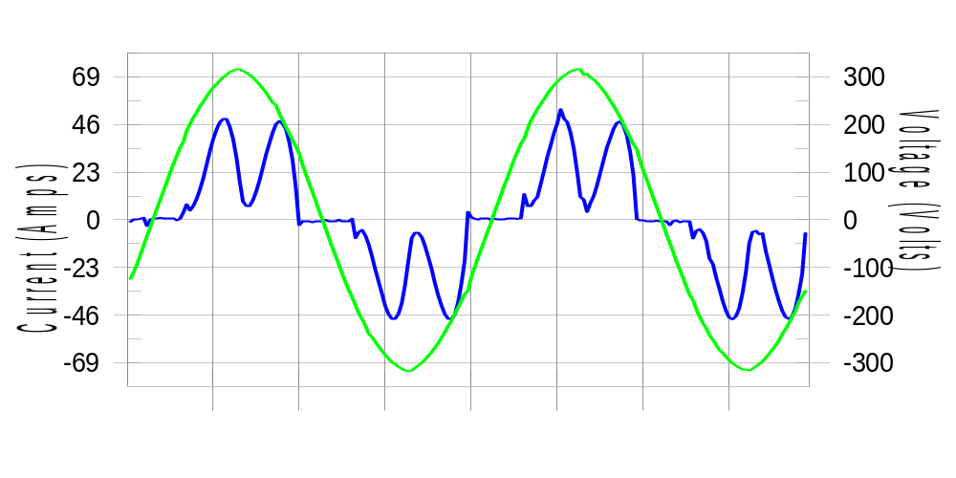

Harmonics and Class 3 limit line European Limits

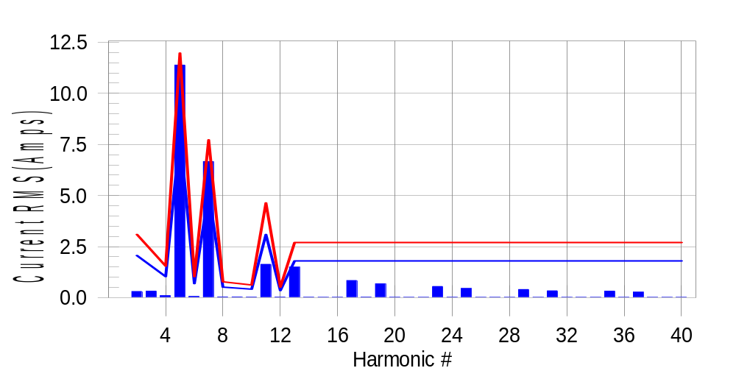

Test result: Fail Worst harmonic was #5 with 95.38 % of the limit.
Current Test Result Summary (Phase A-Run time)

EUT: Equipment under test Tested by: Tested by
Test category: Table:3, Rsce=250, Test Margin: 100
Test date: 2016/4/13 Start time: 18:25:31 End time: 18:28:23
Test duration (min): 2.5 Data file name: CTSMXH_H-000026.cts_data
Comment: Comment
Customer: Customer information

Test Result: Fail Measured I-ref: 25.878(Amps) Source: Distorted
I-THC(%): 52.3 Limit(%): 37.0 PWHC(%): 26.5 PWHC Limit(%): 38.0

Highest parameter values during test:
V_RMS (Volts): 220.43 Frequency(Hz): 50.00
I_Peak (Amps): 59.244 I_RMS (Amps): 25.878
I_Fund (Amps): 21.936 Crest Factor: 2.303
Power (Watts): 4818 Power Factor: 0.845

Harm# Harms(avg) 100%Limit %of Limit Harms(max) 150%Limit %of Limit Status

2 0.301 2.060 14.6 0.333 3.090 10.8 Pass
3 0.319 N/A N/A 0.369 N/A N/A N/A
4 0.096 1.030 9.3 0.111 1.545 7.2 Pass
5 11.384 7.982 142.6 11.416 11.973 95.3 Fail
6 0.060 0.687 8.8 0.073 1.030 7.1 Pass
7 6.659 5.150 129.3 6.675 7.725 86.4 Fail
8 0.033 0.515 6.5 0.049 0.772 6.4 Pass
9 0.034 N/A N/A 0.046 N/A N/A N/A
10 0.026 0.412 6.4 0.035 0.618 5.7 Pass
11 1.631 3.090 52.8 1.647 4.635 35.5 Pass
12 0.031 0.343 9.0 0.043 0.515 8.4 Pass
13 1.492 1.802 82.8 1.502 2.704 55.5 Pass
14 0.023 N/A N/A 0.031 N/A N/A N/A
15 0.017 N/A N/A 0.026 N/A N/A N/A
16 0.019 N/A N/A 0.027 N/A N/A N/A
17 0.837 N/A N/A 0.848 N/A N/A N/A
18 0.026 N/A N/A 0.038 N/A N/A N/A
19 0.674 N/A N/A 0.686 N/A N/A N/A
20 0.020 N/A N/A 0.030 N/A N/A N/A
21 0.016 N/A N/A 0.024 N/A N/A N/A
22 0.018 N/A N/A 0.025 N/A N/A N/A
23 0.546 N/A N/A 0.557 N/A N/A N/A
24 0.019 N/A N/A 0.026 N/A N/A N/A
25 0.448 N/A N/A 0.456 N/A N/A N/A
26 0.017 N/A N/A 0.024 N/A N/A N/A
27 0.016 N/A N/A 0.024 N/A N/A N/A
28 0.018 N/A N/A 0.026 N/A N/A N/A
29 0.399 N/A N/A 0.407 N/A N/A N/A
30 0.018 N/A N/A 0.030 N/A N/A N/A
31 0.334 N/A N/A 0.342 N/A N/A N/A
32 0.017 N/A N/A 0.029 N/A N/A N/A
33 0.016 N/A N/A 0.023 N/A N/A N/A
34 0.016 N/A N/A 0.028 N/A N/A N/A
35 0.318 N/A N/A 0.325 N/A N/A N/A
36 0.018 N/A N/A 0.023 N/A N/A N/A
37 0.270 N/A N/A 0.282 N/A N/A N/A
38 0.016 N/A N/A 0.024 N/A N/A N/A
39 0.016 N/A N/A 0.022 N/A N/A N/A
40 0.015 N/A N/A 0.023 N/A N/A N/A

Note: Measured I-ref was applied for this test.

Voltage Source Verification Data (Phase A-Run time)

EUT: Equipment under test Tested by: Tested by
Test category: Table:3, Rsce=250, Test Margin: 100
Test date: 2016/4/13 Start time: 18:25:31 End time: 18:28:23
Test duration (min): 2.5 Data file name: CTSMXH_H-000026.cts_data
Comment: Comment
Customer: Customer information

Test Result: Fail Source qualification: Distorted
Current harmonics are corrected for source distortion, and are within +/-5%
Measurements are compliant with IEC/EN61000-3-12 Ed.4 & IEC/EN61000-4-7

Highest parameter values during test:
Voltage (Vrms): 220.43 Frequency(Hz): 50.00
I_Peak (Amps): 59.244 I_RMS (Amps): 25.878
I_Fund (Amps): 21.936 Crest Factor: 2.303
Power (Watts): 4818 Power Factor: 0.845

Harm# Harmonics V-rms Limit V-rms % of Limit Status

2 0.162 0.882 18.32 OK
3 0.304 2.755 11.02 OK
4 0.110 0.881 12.47 OK
5 1.763 3.306 53.32 OK
6 0.088 0.882 9.96 OK
7 1.307 2.754 47.45 OK
8 0.088 0.881 9.93 OK
9 0.112 1.322 8.43 OK
10 0.078 0.881 8.90 OK
11 0.549 1.543 35.57 OK
12 0.100 0.661 15.07 OK
13 0.578 1.322 43.72 OK
14 0.077 0.661 11.67 OK
15 0.109 0.661 16.42 OK
16 0.089 0.661 13.45 OK
17 0.412 0.661 62.25 OK
18 0.085 0.661 12.92 OK
19 0.392 0.661 59.33 OK
20 0.162 0.661 24.50 OK
21 0.113 0.661 17.03 OK
22 0.079 0.661 11.99 OK
23 0.368 0.661 55.63 OK
24 0.097 0.661 14.69 OK
25 0.336 0.661 50.89 OK
26 0.085 0.661 12.91 OK
27 0.122 0.661 18.41 OK
28 0.096 0.661 14.48 OK
29 0.302 0.661 45.62 OK
30 0.090 0.661 13.66 OK
31 0.293 0.661 44.31 OK
32 0.080 0.661 12.08 OK
33 0.123 0.661 18.57 OK
34 0.083 0.661 12.49 OK
35 0.269 0.661 40.68 OK
36 0.092 0.661 13.99 OK
37 0.287 0.661 43.43 OK
38 0.090 0.661 13.62 OK
39 0.137 0.661 20.76 OK
40 0.134 0.661 20.34 OK

Harmonics – Per EN/IEC61000-3-12, Ed. 2.0(Phase B-Run time)

EUT: Equipment under test Tested by: Tested by
Test category: Table:3, Rsce=250, Test Margin: 100
Test date: 2016/4/13 Start time: 18:25:31 End time: 18:28:23
Test duration (min): 2.5 Data file name: CTSMXH_H-000026.cts_data
Comment: Comment
Customer: Customer information

Test Result: Fail Source qualification: Distorted

Current & voltage waveforms

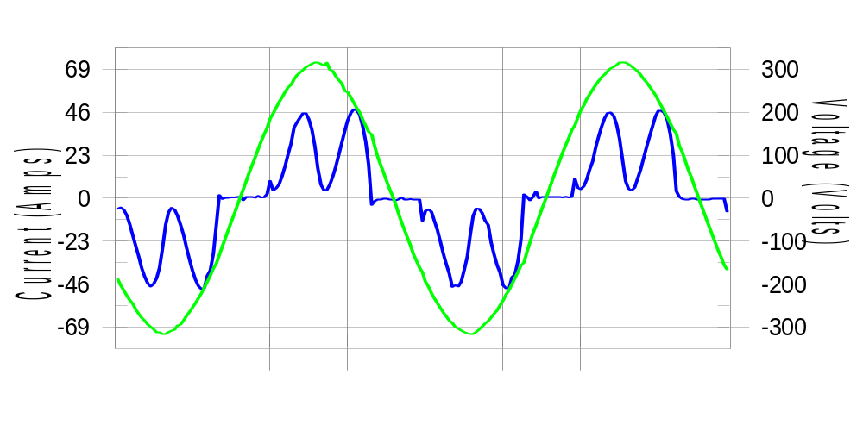

Harmonics and Class 3 limit line European Limits

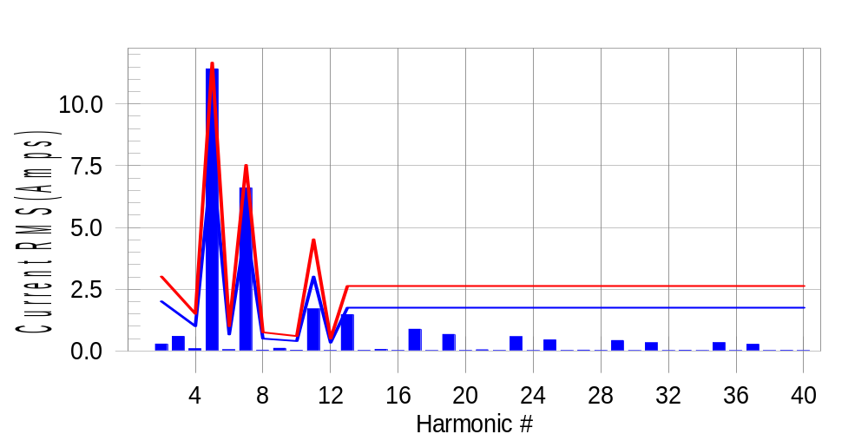

Test result: Fail Worst harmonic was #5 with 98.13 % of the limit.
Current Test Result Summary (Phase B-Run time)

EUT: Equipment under test Tested by: Tested by
Test category: Table:3, Rsce=250, Test Margin: 100
Test date: 2016/4/13 Start time: 18:25:31 End time: 18:28:23
Test duration (min): 2.5 Data file name: CTSMXH_H-000026.cts_data
Comment: Comment
Customer: Customer information

Test Result: Fail Measured I-ref: 25.231(Amps) Source: Distorted
I-THC(%): 53.8 Limit(%): 37.0 PWHC(%): 28.1 PWHC Limit(%): 38.0

Highest parameter values during test:
V_RMS (Volts): 220.22 Frequency(Hz): 50.00
I_Peak (Amps): 60.000 I_RMS (Amps): 25.231
I_Fund (Amps): 21.158 Crest Factor: 2.384
Power (Watts): 4629 Power Factor: 0.834

Harm# Harms(avg) 100%Limit %of Limit Harms(max) 150%Limit %of Limit Status

2 0.278 2.008 13.9 0.316 3.012 10.5 Pass
3 0.319 N/A N/A 0.633 N/A N/A N/A
4 0.091 1.004 9.1 0.108 1.506 7.2 Pass
5 11.415 7.782 146.7 11.440 11.673 98.0 Fail
6 0.052 0.669 7.8 0.064 1.004 6.4 Pass
7 6.598 5.021 131.4 6.609 7.531 87.8 Fail
8 0.032 0.502 6.4 0.048 0.753 6.4 Pass
9 0.034 N/A N/A 0.120 N/A N/A N/A
10 0.030 0.402 7.4 0.039 0.602 6.5 Pass
11 1.702 3.012 56.5 1.721 4.519 38.1 Pass
12 0.021 0.335 6.3 0.029 0.502 5.7 Pass
13 1.470 1.757 83.6 1.481 2.636 56.2 Pass
14 0.024 N/A N/A 0.032 N/A N/A N/A
15 0.062 N/A N/A 0.072 N/A N/A N/A
16 0.021 N/A N/A 0.030 N/A N/A N/A
17 0.880 N/A N/A 0.895 N/A N/A N/A
18 0.016 N/A N/A 0.023 N/A N/A N/A
19 0.670 N/A N/A 0.682 N/A N/A N/A
20 0.019 N/A N/A 0.037 N/A N/A N/A
21 0.046 N/A N/A 0.058 N/A N/A N/A
22 0.020 N/A N/A 0.036 N/A N/A N/A
23 0.578 N/A N/A 0.588 N/A N/A N/A
24 0.016 N/A N/A 0.023 N/A N/A N/A
25 0.447 N/A N/A 0.456 N/A N/A N/A
26 0.018 N/A N/A 0.033 N/A N/A N/A
27 0.034 N/A N/A 0.044 N/A N/A N/A
28 0.020 N/A N/A 0.034 N/A N/A N/A
29 0.423 N/A N/A 0.432 N/A N/A N/A
30 0.016 N/A N/A 0.028 N/A N/A N/A
31 0.331 N/A N/A 0.341 N/A N/A N/A
32 0.017 N/A N/A 0.029 N/A N/A N/A
33 0.031 N/A N/A 0.042 N/A N/A N/A
34 0.017 N/A N/A 0.025 N/A N/A N/A
35 0.337 N/A N/A 0.347 N/A N/A N/A
36 0.015 N/A N/A 0.023 N/A N/A N/A
37 0.270 N/A N/A 0.282 N/A N/A N/A
38 0.016 N/A N/A 0.023 N/A N/A N/A
39 0.025 N/A N/A 0.035 N/A N/A N/A
40 0.017 N/A N/A 0.022 N/A N/A N/A

Note: Measured I-ref was applied for this test.

Voltage Source Verification Data (Phase B-Run time)

EUT: Equipment under test Tested by: Tested by
Test category: Table:3, Rsce=250, Test Margin: 100
Test date: 2016/4/13 Start time: 18:25:31 End time: 18:28:23
Test duration (min): 2.5 Data file name: CTSMXH_H-000026.cts_data
Comment: Comment
Customer: Customer information

Test Result: Fail Source qualification: Distorted
Current harmonics are corrected for source distortion, and are within +/-5%
Measurements are compliant with IEC/EN61000-3-12 Ed.4 & IEC/EN61000-4-7

Highest parameter values during test:
Voltage (Vrms): 220.22 Frequency(Hz): 50.00
I_Peak (Amps): 60.000 I_RMS (Amps): 25.231
I_Fund (Amps): 21.158 Crest Factor: 2.384
Power (Watts): 4629 Power Factor: 0.834

Harm# Harmonics V-rms Limit V-rms % of Limit Status

2 0.171 0.880 19.46 OK
3 0.346 2.751 12.59 OK
4 0.137 0.880 15.56 OK
5 1.851 3.302 56.07 OK
6 0.102 0.880 11.55 OK
7 1.391 2.751 50.57 OK
8 0.116 0.880 13.17 OK
9 0.139 1.321 10.51 OK
10 0.112 0.881 12.66 OK
11 0.601 1.541 38.98 OK
12 0.109 0.660 16.48 OK
13 0.609 1.321 46.15 OK
14 0.120 0.660 18.23 OK
15 0.143 0.660 21.64 OK
16 0.101 0.660 15.23 OK
17 0.464 0.660 70.25 OK
18 0.111 0.660 16.76 OK
19 0.430 0.660 65.04 OK
20 0.130 0.660 19.65 OK
21 0.147 0.660 22.28 OK
22 0.107 0.660 16.17 OK
23 0.383 0.660 57.97 OK
24 0.101 0.660 15.26 OK
25 0.350 0.661 52.94 OK
26 0.108 0.660 16.38 OK
27 0.134 0.660 20.32 OK
28 0.115 0.660 17.47 OK
29 0.322 0.661 48.69 OK
30 0.095 0.660 14.39 OK
31 0.307 0.660 46.49 OK
32 0.095 0.660 14.39 OK
33 0.148 0.660 22.43 OK
34 0.128 0.660 19.39 OK
35 0.296 0.661 44.83 OK
36 0.099 0.660 14.96 OK
37 0.299 0.660 45.33 OK
38 0.097 0.660 14.74 OK
39 0.144 0.660 21.87 OK
40 0.117 0.660 17.70 OK

Harmonics – Per EN/IEC61000-3-12, Ed. 2.0(Phase C-Run time)

EUT: Equipment under test Tested by: Tested by
Test category: Table:3, Rsce=250, Test Margin: 100
Test date: 2016/4/13 Start time: 18:25:31 End time: 18:28:23
Test duration (min): 2.5 Data file name: CTSMXH_H-000026.cts_data
Comment: Comment
Customer: Customer information

Test Result: Fail Source qualification: Distorted

Current & voltage waveforms

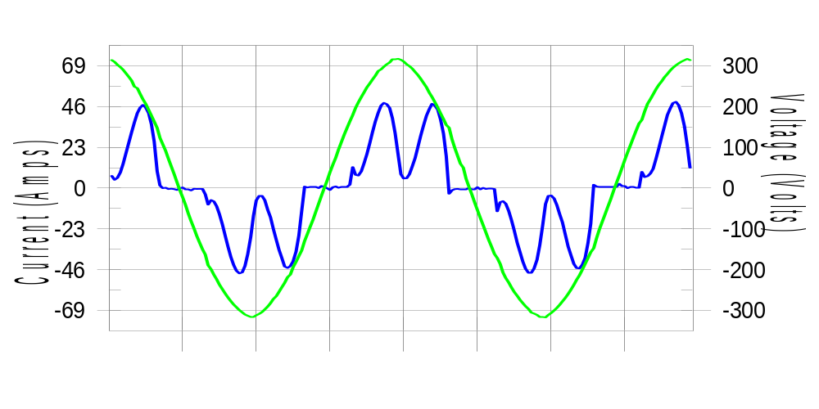

Harmonics and Class 3 limit line European Limits

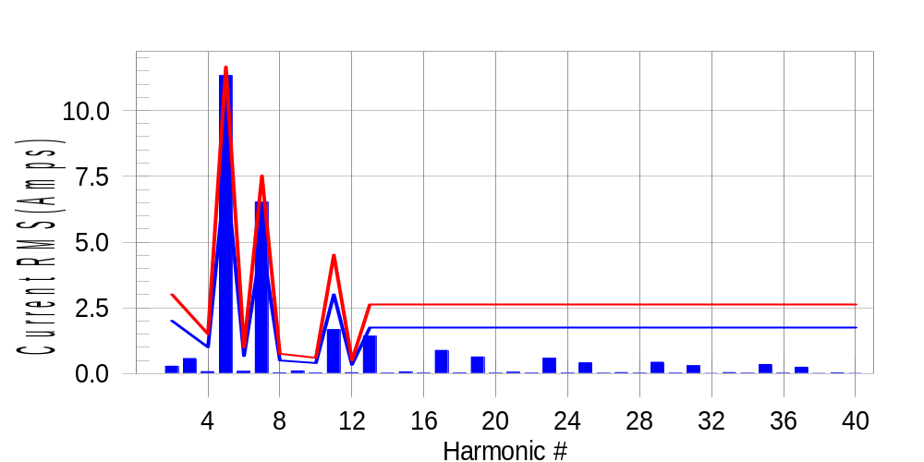

Test result: Fail Worst harmonic was #5 with 97.37 % of the limit.
Current Test Result Summary (Phase C-Run time)

EUT: Equipment under test Tested by: Tested by
Test category: Table:3, Rsce=250, Test Margin: 100
Test date: 2016/4/13 Start time: 18:25:31 End time: 18:28:23
Test duration (min): 2.5 Data file name: CTSMXH_H-000026.cts_data
Comment: Comment
Customer: Customer information

Test Result: Fail Measured I-ref: 25.252(Amps) Source: Distorted
I-THC(%): 53.3 Limit(%): 37.0 PWHC(%): 27.7 PWHC Limit(%): 38.0

Highest parameter values during test:
V_RMS (Volts): 220.15 Frequency(Hz): 50.00
I_Peak (Amps): 58.171 I_RMS (Amps): 25.252
I_Fund (Amps): 21.230 Crest Factor: 2.316
Power (Watts): 4680 Power Factor: 0.842

Harm# Harms(avg) 100%Limit %of Limit Harms(max) 150%Limit %of Limit Status

2 0.282 2.007 14.1 0.310 3.011 10.3 Pass
3 0.319 N/A N/A 0.626 N/A N/A N/A
4 0.076 1.004 7.5 0.092 1.505 6.1 Pass
5 11.326 7.778 145.6 11.357 11.667 97.3 Fail
6 0.085 0.669 12.7 0.094 1.004 9.4 Pass
7 6.517 5.018 129.9 6.530 7.527 86.7 Fail
8 0.029 0.502 5.8 0.041 0.753 5.5 Pass
9 0.034 N/A N/A 0.117 N/A N/A N/A
10 0.028 0.401 7.0 0.035 0.602 5.8 Pass
11 1.674 3.011 55.6 1.688 4.516 37.4 Pass
12 0.037 0.335 11.0 0.045 0.502 8.9 Pass
13 1.425 1.756 81.2 1.435 2.635 54.5 Pass
14 0.021 N/A N/A 0.028 N/A N/A N/A
15 0.067 N/A N/A 0.079 N/A N/A N/A
16 0.019 N/A N/A 0.026 N/A N/A N/A
17 0.882 N/A N/A 0.894 N/A N/A N/A
18 0.026 N/A N/A 0.035 N/A N/A N/A
19 0.635 N/A N/A 0.646 N/A N/A N/A
20 0.017 N/A N/A 0.024 N/A N/A N/A
21 0.054 N/A N/A 0.063 N/A N/A N/A
22 0.018 N/A N/A 0.025 N/A N/A N/A
23 0.583 N/A N/A 0.593 N/A N/A N/A
24 0.022 N/A N/A 0.030 N/A N/A N/A
25 0.413 N/A N/A 0.424 N/A N/A N/A
26 0.015 N/A N/A 0.024 N/A N/A N/A
27 0.042 N/A N/A 0.050 N/A N/A N/A
28 0.017 N/A N/A 0.024 N/A N/A N/A
29 0.435 N/A N/A 0.443 N/A N/A N/A
30 0.019 N/A N/A 0.034 N/A N/A N/A
31 0.305 N/A N/A 0.314 N/A N/A N/A
32 0.014 N/A N/A 0.022 N/A N/A N/A
33 0.040 N/A N/A 0.047 N/A N/A N/A
34 0.015 N/A N/A 0.021 N/A N/A N/A
35 0.348 N/A N/A 0.358 N/A N/A N/A
36 0.017 N/A N/A 0.025 N/A N/A N/A
37 0.244 N/A N/A 0.254 N/A N/A N/A
38 0.013 N/A N/A 0.019 N/A N/A N/A
39 0.034 N/A N/A 0.042 N/A N/A N/A
40 0.014 N/A N/A 0.021 N/A N/A N/A

Note: Measured I-ref was applied for this test.

Voltage Source Verification Data (Phase C-Run time)

EUT: Equipment under test Tested by: Tested by
Test category: Table:3, Rsce=250, Test Margin: 100
Test date: 2016/4/13 Start time: 18:25:31 End time: 18:28:23
Test duration (min): 2.5 Data file name: CTSMXH_H-000026.cts_data
Comment: Comment
Customer: Customer information

Test Result: Fail Source qualification: Distorted
Current harmonics are corrected for source distortion, and are within +/-5%
Measurements are compliant with IEC/EN61000-3-12 Ed.4 & IEC/EN61000-4-7

Highest parameter values during test:
Voltage (Vrms): 220.15 Frequency(Hz): 50.00
I_Peak (Amps): 58.171 I_RMS (Amps): 25.252
I_Fund (Amps): 21.230 Crest Factor: 2.316
Power (Watts): 4680 Power Factor: 0.842

Harm# Harmonics V-rms Limit V-rms % of Limit Status

2 0.158 0.880 17.98 OK
3 0.255 2.751 9.26 OK
4 0.105 0.880 11.88 OK
5 1.779 3.301 53.91 OK
6 0.095 0.880 10.77 OK
7 1.314 2.751 47.77 OK
8 0.094 0.880 10.74 OK
9 0.108 1.320 8.18 OK
10 0.096 0.880 10.86 OK
11 0.568 1.541 36.85 OK
12 0.099 0.660 15.02 OK
13 0.562 1.320 42.53 OK
14 0.083 0.660 12.57 OK
15 0.082 0.660 12.47 OK
16 0.099 0.660 14.94 OK
17 0.441 0.660 66.82 OK
18 0.088 0.660 13.33 OK
19 0.391 0.660 59.26 OK
20 0.104 0.660 15.83 OK
21 0.089 0.660 13.51 OK
22 0.089 0.660 13.49 OK
23 0.383 0.660 58.06 OK
24 0.090 0.660 13.57 OK
25 0.318 0.660 48.16 OK
26 0.101 0.660 15.27 OK
27 0.087 0.660 13.24 OK
28 0.099 0.660 15.06 OK
29 0.309 0.660 46.88 OK
30 0.090 0.660 13.66 OK
31 0.296 0.660 44.78 OK
32 0.092 0.660 13.91 OK
33 0.088 0.660 13.36 OK
34 0.090 0.660 13.62 OK
35 0.297 0.660 44.96 OK
36 0.091 0.660 13.73 OK
37 0.261 0.660 39.56 OK
38 0.093 0.660 14.09 OK
39 0.098 0.660 14.89 OK
40 0.099 0.660 14.93 OK

5th Harmonic Phase Angle and Magnitude for Phase A :
H-5_min_phase : 119.0 Degree (Leading)
H-5_max_phase : 119.5 Degree (Leading)
H-5_ave_phase : 119.3 Degree (Leading)

H-5_ave_vector_magnitude : 11.318 Amp
H-5_standard_ave_magnitude : 11.384 Amp
H-5_standard_max_magnitude : 11.357 Amp
Ratio of H-5_ave_vector / H-5_standard_ave : 0.999

Phase A = 142.643% of tested Rsce = 250.000, Rsce = 356.607
Phase B = 146.706% of tested Rsce = 250.000, Rsce = 366.765
Phase C = 145.633% of tested Rsce = 250.000, Rsce = 364.081
Minimum Rsce required: Rsce = 366.765

