Harmonics – Per EN/IEC61000-3-12, Ed. 2.0(Phase A-Run time)

EUT: Equipment under test Tested by: Tested by
Test category: Table:3, Rsce=250, Test Margin: 100
Test date: 2016/4/13 Start time: 18:44:15 End time: 18:47:08
Test duration (min): 2.5 Data file name: CTSMXH_H-000027.cts_data
Comment: Comment
Customer: Customer information

Test Result: Fail Source qualification: Normal

Current & voltage waveforms

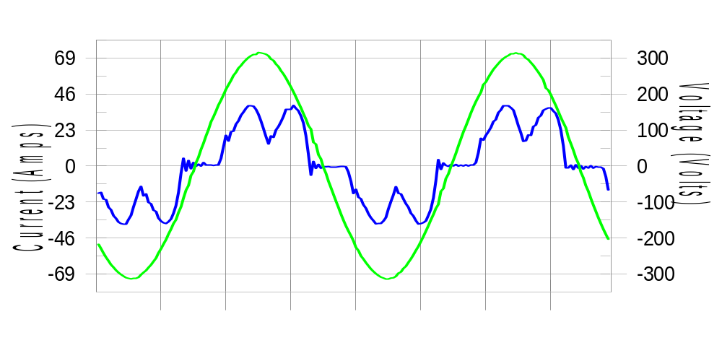

Harmonics and Class 3 limit line European Limits

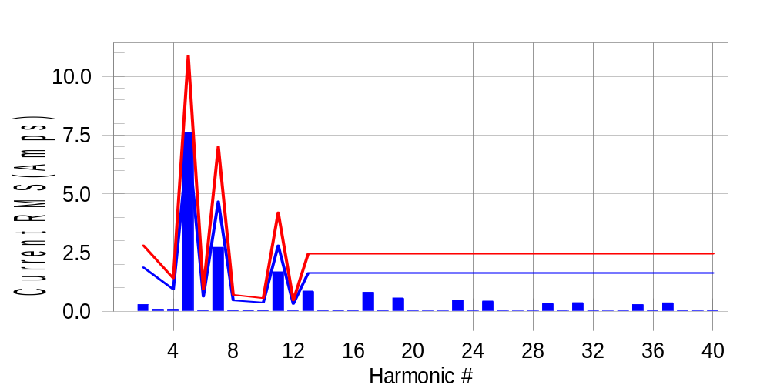

Test result: Fail Worst harmonic was #5 with 70.22 % of the limit.
Current Test Result Summary (Phase A-Run time)

EUT: Equipment under test Tested by: Tested by
Test category: Table:3, Rsce=250, Test Margin: 100
Test date: 2016/4/13 Start time: 18:44:15 End time: 18:47:08
Test duration (min): 2.5 Data file name: CTSMXH_H-000027.cts_data
Comment: Comment
Customer: Customer information

Test Result: Fail Measured I-ref: 23.562(Amps) Source: Normal
I-THC(%): 36.0 Limit(%): 37.0 PWHC(%): 27.9 PWHC Limit(%): 38.0

Highest parameter values during test:
V_RMS (Volts): 220.42 Frequency(Hz): 50.00
I_Peak (Amps): 48.935 I_RMS (Amps): 23.562
I_Fund (Amps): 21.825 Crest Factor: 2.100
Power (Watts): 4778 Power Factor: 0.920

Harm# Harms(avg) 100%Limit %of Limit Harms(max) 150%Limit %of Limit Status

2 0.288 1.874 15.4 0.319 2.811 11.3 Pass
3 0.088 N/A N/A 0.110 N/A N/A N/A
4 0.087 0.937 9.3 0.102 1.405 7.3 Pass
5 7.620 7.261 105.0 7.648 10.891 70.2 Fail
6 0.039 0.625 6.3 0.048 0.937 5.1 Pass
7 2.725 4.684 58.2 2.735 7.027 38.9 Pass
8 0.043 0.468 9.2 0.053 0.703 7.5 Pass
9 0.044 N/A N/A 0.056 N/A N/A N/A
10 0.033 0.375 8.8 0.043 0.562 7.7 Pass
11 1.684 2.811 59.9 1.697 4.216 40.2 Pass
12 0.024 0.312 7.5 0.032 0.468 6.9 Pass
13 0.863 1.640 52.7 0.874 2.459 35.5 Pass
14 0.025 N/A N/A 0.033 N/A N/A N/A
15 0.024 N/A N/A 0.035 N/A N/A N/A
16 0.023 N/A N/A 0.037 N/A N/A N/A
17 0.810 N/A N/A 0.824 N/A N/A N/A
18 0.023 N/A N/A 0.030 N/A N/A N/A
19 0.569 N/A N/A 0.577 N/A N/A N/A
20 0.020 N/A N/A 0.028 N/A N/A N/A
21 0.018 N/A N/A 0.029 N/A N/A N/A
22 0.019 N/A N/A 0.026 N/A N/A N/A
23 0.483 N/A N/A 0.495 N/A N/A N/A
24 0.022 N/A N/A 0.031 N/A N/A N/A
25 0.436 N/A N/A 0.448 N/A N/A N/A
26 0.020 N/A N/A 0.027 N/A N/A N/A
27 0.015 N/A N/A 0.022 N/A N/A N/A
28 0.019 N/A N/A 0.026 N/A N/A N/A
29 0.332 N/A N/A 0.340 N/A N/A N/A
30 0.022 N/A N/A 0.029 N/A N/A N/A
31 0.368 N/A N/A 0.377 N/A N/A N/A
32 0.021 N/A N/A 0.029 N/A N/A N/A
33 0.016 N/A N/A 0.025 N/A N/A N/A
34 0.020 N/A N/A 0.028 N/A N/A N/A
35 0.286 N/A N/A 0.296 N/A N/A N/A
36 0.024 N/A N/A 0.032 N/A N/A N/A
37 0.361 N/A N/A 0.370 N/A N/A N/A
38 0.025 N/A N/A 0.036 N/A N/A N/A
39 0.022 N/A N/A 0.029 N/A N/A N/A
40 0.023 N/A N/A 0.030 N/A N/A N/A

Note: Measured I-ref was applied for this test.

Voltage Source Verification Data (Phase A-Run time)

EUT: Equipment under test Tested by: Tested by
Test category: Table:3, Rsce=250, Test Margin: 100
Test date: 2016/4/13 Start time: 18:44:15 End time: 18:47:08
Test duration (min): 2.5 Data file name: CTSMXH_H-000027.cts_data
Comment: Comment
Customer: Customer information

Test Result: Fail Source qualification: Normal
Measured source distortion is within the requirements of the standards
Measurements are compliant with IEC/EN61000-3-12 Ed.4 & IEC/EN61000-4-7 Ed. 2.1

Highest parameter values during test:
Voltage (Vrms): 220.42 Frequency(Hz): 50.00
I_Peak (Amps): 48.935 I_RMS (Amps): 23.562
I_Fund (Amps): 21.825 Crest Factor: 2.100
Power (Watts): 4778 Power Factor: 0.920

Harm# Harmonics V-rms Limit V-rms % of Limit Status

2 0.165 0.881 18.70 OK
3 0.339 2.754 12.31 OK
4 0.163 0.881 18.47 OK
5 1.282 3.306 38.78 OK
6 0.110 0.881 12.43 OK
7 0.652 2.755 23.66 OK
8 0.100 0.882 11.33 OK
9 0.123 1.322 9.32 OK
10 0.081 0.881 9.16 OK
11 0.580 1.542 37.62 OK
12 0.098 0.661 14.83 OK
13 0.404 1.322 30.58 OK
14 0.093 0.661 14.03 OK
15 0.129 0.661 19.57 OK
16 0.084 0.661 12.71 OK
17 0.426 0.661 64.37 OK
18 0.082 0.661 12.41 OK
19 0.378 0.661 57.11 OK
20 0.161 0.661 24.34 OK
21 0.140 0.661 21.12 OK
22 0.097 0.661 14.64 OK
23 0.329 0.661 49.70 OK
24 0.080 0.661 12.10 OK
25 0.349 0.661 52.85 OK
26 0.088 0.661 13.37 OK
27 0.147 0.661 22.19 OK
28 0.087 0.661 13.23 OK
29 0.278 0.661 42.06 OK
30 0.079 0.661 11.97 OK
31 0.344 0.661 52.10 OK
32 0.089 0.661 13.43 OK
33 0.153 0.661 23.12 OK
34 0.096 0.661 14.49 OK
35 0.317 0.661 48.02 OK
36 0.096 0.661 14.58 OK
37 0.408 0.661 61.71 OK
38 0.089 0.661 13.42 OK
39 0.234 0.661 35.42 OK
40 0.163 0.661 24.58 OK

Harmonics – Per EN/IEC61000-3-12, Ed. 2.0(Phase B-Run time)

EUT: Equipment under test Tested by: Tested by
Test category: Table:3, Rsce=250, Test Margin: 100
Test date: 2016/4/13 Start time: 18:44:15 End time: 18:47:08
Test duration (min): 2.5 Data file name: CTSMXH_H-000027.cts_data
Comment: Comment
Customer: Customer information

Test Result: Fail Source qualification: Normal

Current & voltage waveforms

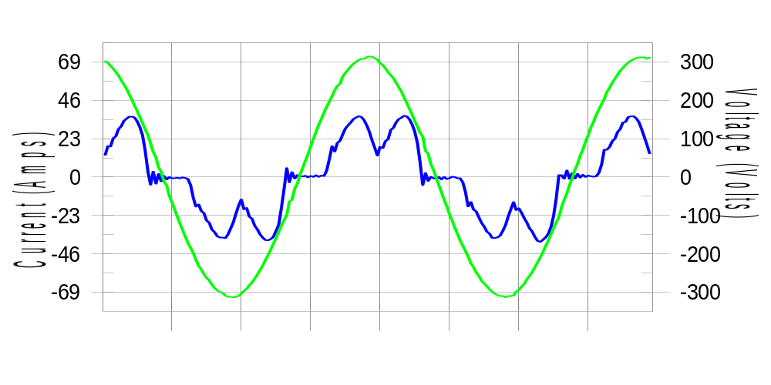

Harmonics and Class 3 limit line European Limits

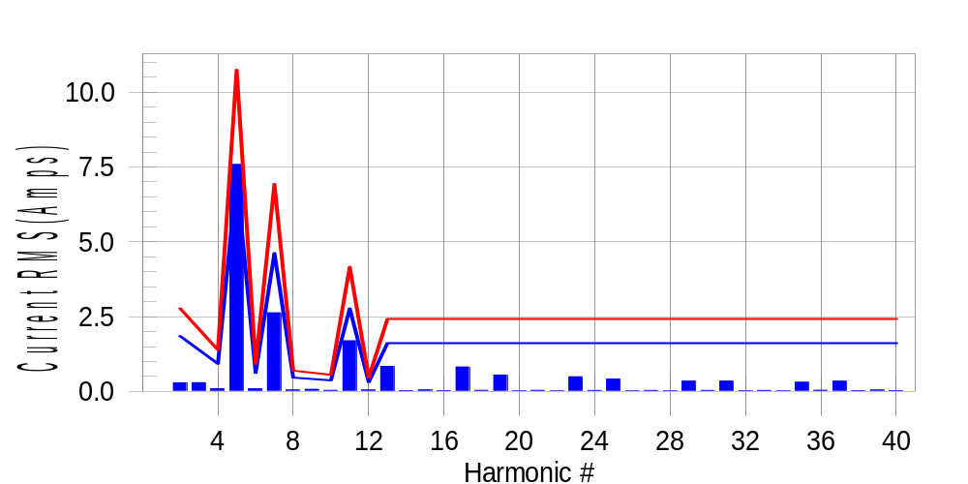

Test result: Fail Worst harmonic was #5 with 70.84 % of the limit.
Current Test Result Summary (Phase B-Run time)

EUT: Equipment under test Tested by: Tested by
Test category: Table:3, Rsce=250, Test Margin: 100
Test date: 2016/4/13 Start time: 18:44:15 End time: 18:47:08
Test duration (min): 2.5 Data file name: CTSMXH_H-000027.cts_data
Comment: Comment
Customer: Customer information

Test Result: Fail Measured I-ref: 23.242(Amps) Source: Normal
I-THC(%): 36.2 Limit(%): 37.0 PWHC(%): 28.1 PWHC Limit(%): 38.0

Highest parameter values during test:
V_RMS (Volts): 220.22 Frequency(Hz): 50.00
I_Peak (Amps): 50.032 I_RMS (Amps): 23.242
I_Fund (Amps): 21.522 Crest Factor: 2.168
Power (Watts): 4692 Power Factor: 0.918

Harm# Harms(avg) 100%Limit %of Limit Harms(max) 150%Limit %of Limit Status

2 0.291 1.850 15.7 0.321 2.774 11.6 Pass
3 0.088 N/A N/A 0.327 N/A N/A N/A
4 0.091 0.925 9.8 0.107 1.387 7.7 Pass
5 7.585 7.167 105.8 7.612 10.751 70.8 Fail
6 0.089 0.617 14.4 0.101 0.925 11.0 Pass
7 2.630 4.624 56.9 2.642 6.936 38.1 Pass
8 0.046 0.462 10.0 0.056 0.694 8.1 Pass
9 0.044 N/A N/A 0.083 N/A N/A N/A
10 0.036 0.370 9.6 0.044 0.555 7.9 Pass
11 1.693 2.774 61.0 1.707 4.162 41.0 Pass
12 0.047 0.308 15.2 0.055 0.462 11.9 Pass
13 0.836 1.618 51.7 0.845 2.428 34.8 Pass
14 0.027 N/A N/A 0.036 N/A N/A N/A
15 0.049 N/A N/A 0.057 N/A N/A N/A
16 0.026 N/A N/A 0.035 N/A N/A N/A
17 0.817 N/A N/A 0.828 N/A N/A N/A
18 0.036 N/A N/A 0.045 N/A N/A N/A
19 0.550 N/A N/A 0.560 N/A N/A N/A
20 0.022 N/A N/A 0.031 N/A N/A N/A
21 0.038 N/A N/A 0.046 N/A N/A N/A
22 0.022 N/A N/A 0.033 N/A N/A N/A
23 0.491 N/A N/A 0.501 N/A N/A N/A
24 0.033 N/A N/A 0.043 N/A N/A N/A
25 0.415 N/A N/A 0.425 N/A N/A N/A
26 0.021 N/A N/A 0.027 N/A N/A N/A
27 0.033 N/A N/A 0.041 N/A N/A N/A
28 0.022 N/A N/A 0.035 N/A N/A N/A
29 0.345 N/A N/A 0.362 N/A N/A N/A
30 0.034 N/A N/A 0.044 N/A N/A N/A
31 0.345 N/A N/A 0.353 N/A N/A N/A
32 0.023 N/A N/A 0.039 N/A N/A N/A
33 0.034 N/A N/A 0.049 N/A N/A N/A
34 0.022 N/A N/A 0.029 N/A N/A N/A
35 0.305 N/A N/A 0.325 N/A N/A N/A
36 0.039 N/A N/A 0.054 N/A N/A N/A
37 0.342 N/A N/A 0.350 N/A N/A N/A
38 0.027 N/A N/A 0.038 N/A N/A N/A
39 0.048 N/A N/A 0.058 N/A N/A N/A
40 0.027 N/A N/A 0.036 N/A N/A N/A

Note: Measured I-ref was applied for this test.

Voltage Source Verification Data (Phase B-Run time)

EUT: Equipment under test Tested by: Tested by
Test category: Table:3, Rsce=250, Test Margin: 100
Test date: 2016/4/13 Start time: 18:44:15 End time: 18:47:08
Test duration (min): 2.5 Data file name: CTSMXH_H-000027.cts_data
Comment: Comment
Customer: Customer information

Test Result: Fail Source qualification: Normal
Measured source distortion is within the requirements of the standards
Measurements are compliant with IEC/EN61000-3-12 Ed.4 & IEC/EN61000-4-7 Ed. 2.1

Highest parameter values during test:
Voltage (Vrms): 220.22 Frequency(Hz): 50.00
I_Peak (Amps): 50.032 I_RMS (Amps): 23.242
I_Fund (Amps): 21.522 Crest Factor: 2.168
Power (Watts): 4692 Power Factor: 0.918

Harm# Harmonics V-rms Limit V-rms % of Limit Status

2 0.176 0.881 20.03 OK
3 0.322 2.752 11.69 OK
4 0.142 0.880 16.14 OK
5 1.304 3.302 39.48 OK
6 0.108 0.880 12.25 OK
7 0.621 2.752 22.56 OK
8 0.105 0.880 11.95 OK
9 0.178 1.320 13.49 OK
10 0.102 0.881 11.54 OK
11 0.625 1.541 40.53 OK
12 0.108 0.660 16.30 OK
13 0.416 1.320 31.51 OK
14 0.103 0.660 15.60 OK
15 0.171 0.660 25.90 OK
16 0.106 0.660 15.99 OK
17 0.444 0.660 67.24 OK
18 0.099 0.660 15.04 OK
19 0.375 0.660 56.85 OK
20 0.129 0.660 19.48 OK
21 0.186 0.660 28.21 OK
22 0.092 0.660 13.99 OK
23 0.341 0.660 51.59 OK
24 0.099 0.660 15.00 OK
25 0.342 0.660 51.84 OK
26 0.110 0.660 16.64 OK
27 0.181 0.660 27.36 OK
28 0.114 0.660 17.30 OK
29 0.301 0.660 45.60 OK
30 0.121 0.660 18.40 OK
31 0.335 0.660 50.67 OK
32 0.100 0.660 15.08 OK
33 0.195 0.660 29.58 OK
34 0.095 0.660 14.38 OK
35 0.332 0.660 50.28 OK
36 0.127 0.660 19.21 OK
37 0.416 0.660 63.06 OK
38 0.120 0.660 18.17 OK
39 0.282 0.660 42.76 OK
40 0.122 0.660 18.44 OK

Harmonics – Per EN/IEC61000-3-12, Ed. 2.0(Phase C-Run time)

EUT: Equipment under test Tested by: Tested by
Test category: Table:3, Rsce=250, Test Margin: 100
Test date: 2016/4/13 Start time: 18:44:15 End time: 18:47:08
Test duration (min): 2.5 Data file name: CTSMXH_H-000027.cts_data
Comment: Comment
Customer: Customer information

Test Result: Fail Source qualification: Normal

Current & voltage waveforms

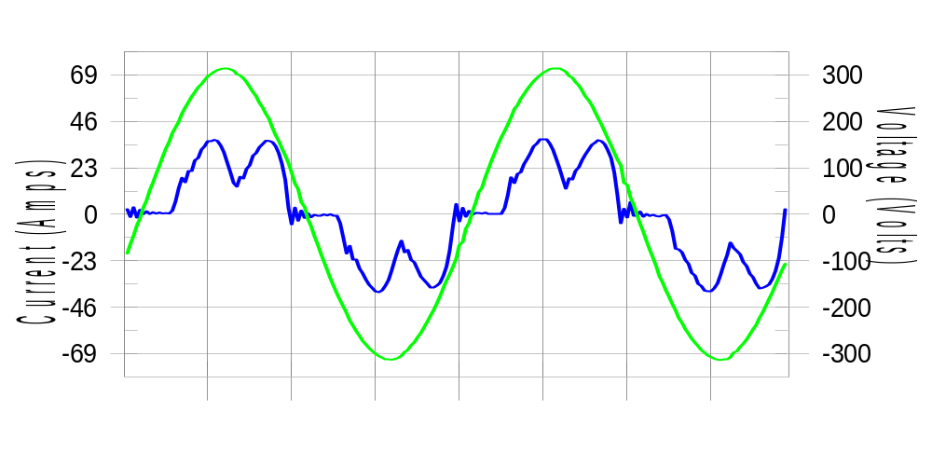

Harmonics and Class 3 limit line European Limits

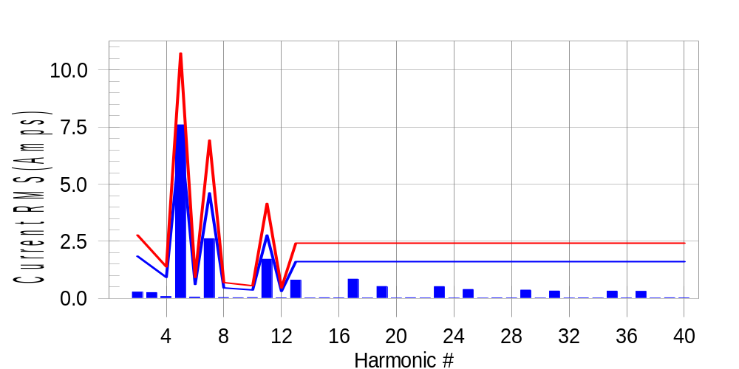

Test result: Fail Worst harmonic was #5 with 71.23 % of the limit.
Current Test Result Summary (Phase C-Run time)

EUT: Equipment under test Tested by: Tested by
Test category: Table:3, Rsce=250, Test Margin: 100
Test date: 2016/4/13 Start time: 18:44:15 End time: 18:47:08
Test duration (min): 2.5 Data file name: CTSMXH_H-000027.cts_data
Comment: Comment
Customer: Customer information

Test Result: Fail Measured I-ref: 23.212(Amps) Source: Normal
I-THC(%): 36.3 Limit(%): 37.0 PWHC(%): 28.1 PWHC Limit(%): 38.0

Highest parameter values during test:
V_RMS (Volts): 220.13 Frequency(Hz): 50.00
I_Peak (Amps): 47.666 I_RMS (Amps): 23.212
I_Fund (Amps): 21.490 Crest Factor: 2.064
Power (Watts): 4697 Power Factor: 0.920

Harm# Harms(avg) 100%Limit %of Limit Harms(max) 150%Limit %of Limit Status

2 0.275 1.847 14.9 0.309 2.771 11.1 Pass
3 0.088 N/A N/A 0.293 N/A N/A N/A
4 0.081 0.924 8.8 0.097 1.385 7.0 Pass
5 7.600 7.158 106.2 7.620 10.736 71.0 Fail
6 0.056 0.616 9.1 0.064 0.924 7.0 Pass
7 2.616 4.618 56.7 2.627 6.927 37.9 Pass
8 0.038 0.462 8.3 0.047 0.693 6.8 Pass
9 0.044 N/A N/A 0.042 N/A N/A N/A
10 0.037 0.369 10.0 0.051 0.554 9.2 Pass
11 1.716 2.771 61.9 1.728 4.156 41.6 Pass
12 0.026 0.308 8.5 0.033 0.462 7.0 Pass
13 0.803 1.616 49.7 0.812 2.424 33.5 Pass
14 0.022 N/A N/A 0.031 N/A N/A N/A
15 0.032 N/A N/A 0.038 N/A N/A N/A
16 0.026 N/A N/A 0.033 N/A N/A N/A
17 0.845 N/A N/A 0.854 N/A N/A N/A
18 0.020 N/A N/A 0.033 N/A N/A N/A
19 0.523 N/A N/A 0.531 N/A N/A N/A
20 0.018 N/A N/A 0.025 N/A N/A N/A
21 0.030 N/A N/A 0.039 N/A N/A N/A
22 0.021 N/A N/A 0.028 N/A N/A N/A
23 0.519 N/A N/A 0.527 N/A N/A N/A
24 0.018 N/A N/A 0.024 N/A N/A N/A
25 0.393 N/A N/A 0.400 N/A N/A N/A
26 0.016 N/A N/A 0.022 N/A N/A N/A
27 0.027 N/A N/A 0.035 N/A N/A N/A
28 0.021 N/A N/A 0.029 N/A N/A N/A
29 0.367 N/A N/A 0.375 N/A N/A N/A
30 0.018 N/A N/A 0.024 N/A N/A N/A
31 0.324 N/A N/A 0.335 N/A N/A N/A
32 0.017 N/A N/A 0.023 N/A N/A N/A
33 0.026 N/A N/A 0.034 N/A N/A N/A
34 0.022 N/A N/A 0.029 N/A N/A N/A
35 0.320 N/A N/A 0.331 N/A N/A N/A
36 0.020 N/A N/A 0.031 N/A N/A N/A
37 0.313 N/A N/A 0.320 N/A N/A N/A
38 0.019 N/A N/A 0.031 N/A N/A N/A
39 0.030 N/A N/A 0.038 N/A N/A N/A
40 0.029 N/A N/A 0.037 N/A N/A N/A

Note: Measured I-ref was applied for this test.

Voltage Source Verification Data (Phase C-Run time)

EUT: Equipment under test Tested by: Tested by
Test category: Table:3, Rsce=250, Test Margin: 100
Test date: 2016/4/13 Start time: 18:44:15 End time: 18:47:08
Test duration (min): 2.5 Data file name: CTSMXH_H-000027.cts_data
Comment: Comment
Customer: Customer information

Test Result: Fail Source qualification: Normal
Measured source distortion is within the requirements of the standards
Measurements are compliant with IEC/EN61000-3-12 Ed.4 & IEC/EN61000-4-7 Ed. 2.1

Highest parameter values during test:
Voltage (Vrms): 220.13 Frequency(Hz): 50.00
I_Peak (Amps): 47.666 I_RMS (Amps): 23.212
I_Fund (Amps): 21.490 Crest Factor: 2.064
Power (Watts): 4697 Power Factor: 0.920

Harm# Harmonics V-rms Limit V-rms % of Limit Status

2 0.152 0.880 17.30 OK
3 0.278 2.750 10.12 OK
4 0.137 0.880 15.53 OK
5 1.249 3.300 37.85 OK
6 0.100 0.880 11.37 OK
7 0.562 2.751 20.43 OK
8 0.089 0.880 10.08 OK
9 0.126 1.320 9.58 OK
10 0.096 0.880 10.90 OK
11 0.604 1.541 39.21 OK
12 0.082 0.660 12.45 OK
13 0.409 1.320 30.99 OK
14 0.091 0.660 13.75 OK
15 0.136 0.660 20.58 OK
16 0.086 0.660 12.99 OK
17 0.433 0.660 65.54 OK
18 0.095 0.660 14.34 OK
19 0.359 0.660 54.39 OK
20 0.099 0.660 15.01 OK
21 0.130 0.660 19.69 OK
22 0.075 0.660 11.38 OK
23 0.346 0.660 52.42 OK
24 0.091 0.660 13.80 OK
25 0.332 0.660 50.34 OK
26 0.095 0.660 14.43 OK
27 0.131 0.660 19.78 OK
28 0.089 0.660 13.48 OK
29 0.304 0.660 45.99 OK
30 0.094 0.660 14.30 OK
31 0.313 0.660 47.41 OK
32 0.088 0.660 13.30 OK
33 0.154 0.660 23.36 OK
34 0.077 0.660 11.74 OK
35 0.346 0.660 52.40 OK
36 0.091 0.660 13.74 OK
37 0.379 0.660 57.35 OK
38 0.087 0.660 13.12 OK
39 0.225 0.660 34.04 OK
40 0.087 0.660 13.22 OK

5th Harmonic Phase Angle and Magnitude for Phase A :
H-5_min_phase : 111.7 Degree (Leading)
H-5_max_phase : 112.4 Degree (Leading)
H-5_ave_phase : 112.1 Degree (Leading)

H-5_ave_vector_magnitude : 7.595 Amp
H-5_standard_ave_magnitude : 7.620 Amp
H-5_standard_max_magnitude : 7.620 Amp
Ratio of H-5_ave_vector / H-5_standard_ave : 0.999

Phase A = 104.961% of tested Rsce = 250.000, Rsce = 262.402
Phase B = 105.836% of tested Rsce = 250.000, Rsce = 264.590
Phase C = 106.197% of tested Rsce = 250.000, Rsce = 265.493
Minimum Rsce required: Rsce = 265.493

