Harmonics – Per EN/IEC61000-3-12, Ed. 2.0(Phase A-Run time)

EUT: Equipment under test Tested by: Tested by
Test category: Table:3, Rsce=250, Test Margin: 100
Test date: 2016/4/13 Start time: 18:55:02 End time: 18:57:54
Test duration (min): 2.5 Data file name: CTSMXH_H-000028.cts_data
Comment: Comment
Customer: Customer information

Test Result: Pass Source qualification: Normal

Current & voltage waveforms

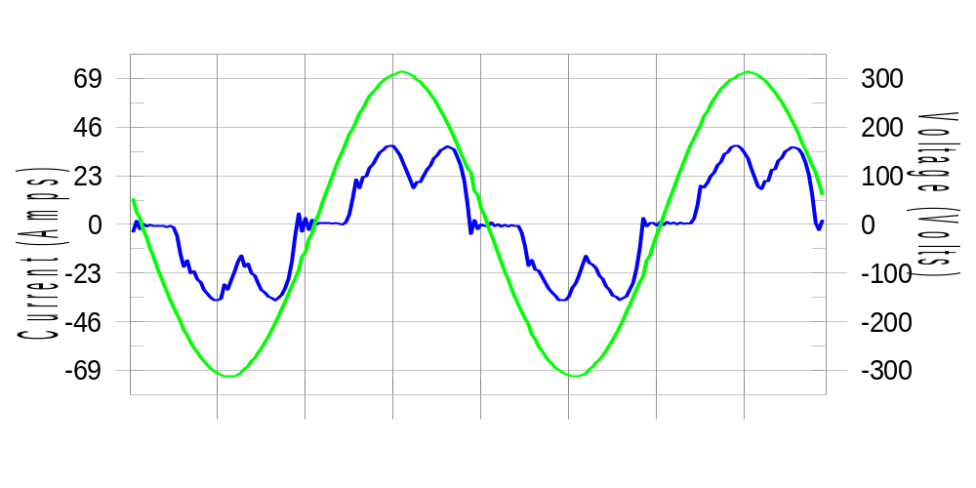

Harmonics and Class 3 limit line European Limits

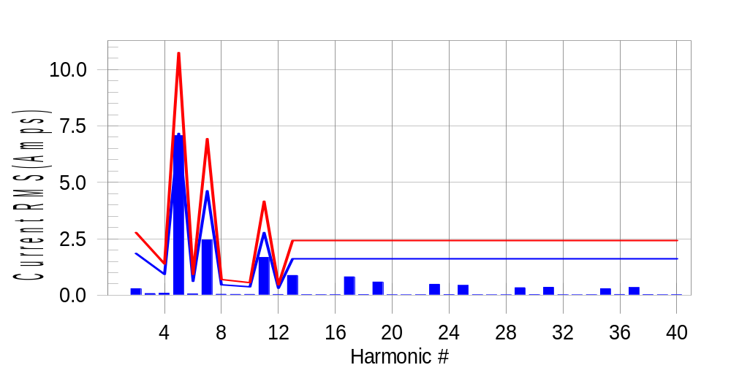

Test result: Pass Worst harmonic was #5 with 66.15 % of the limit.
Current Test Result Summary (Phase A-Run time)

EUT: Equipment under test Tested by: Tested by
Test category: Table:3, Rsce=250, Test Margin: 100
Test date: 2016/4/13 Start time: 18:55:02 End time: 18:57:54
Test duration (min): 2.5 Data file name: CTSMXH_H-000028.cts_data
Comment: Comment
Customer: Customer information

Test Result: Pass Measured I-ref: 23.317(Amps) Source: Normal
I-THC(%): 34.0 Limit(%): 37.0 PWHC(%): 28.2 PWHC Limit(%): 38.0

Highest parameter values during test:
V_RMS (Volts): 220.42 Frequency(Hz): 50.00
I_Peak (Amps): 49.305 I_RMS (Amps): 23.317
I_Fund (Amps): 21.712 Crest Factor: 2.128
Power (Watts): 4771 Power Factor: 0.929

Harm# Harms(avg) 100%Limit %of Limit Harms(max) 150%Limit %of Limit Status

2 0.289 1.849 15.6 0.338 2.773 12.2 Pass
3 0.072 N/A N/A 0.098 N/A N/A N/A
4 0.086 0.924 9.3 0.104 1.387 7.5 Pass
5 7.070 7.165 98.7 7.106 10.747 66.1 Pass
6 0.057 0.616 9.3 0.068 0.924 7.3 Pass
7 2.447 4.622 52.9 2.458 6.934 35.5 Pass
8 0.041 0.462 8.9 0.050 0.693 7.1 Pass
9 0.035 N/A N/A 0.044 N/A N/A N/A
10 0.035 0.370 9.4 0.044 0.555 7.9 Pass
11 1.675 2.773 60.4 1.690 4.160 40.6 Pass
12 0.032 0.308 10.3 0.041 0.462 8.9 Pass
13 0.876 1.618 54.2 0.887 2.427 36.5 Pass
14 0.023 N/A N/A 0.032 N/A N/A N/A
15 0.020 N/A N/A 0.030 N/A N/A N/A
16 0.024 N/A N/A 0.031 N/A N/A N/A
17 0.815 N/A N/A 0.824 N/A N/A N/A
18 0.028 N/A N/A 0.036 N/A N/A N/A
19 0.584 N/A N/A 0.595 N/A N/A N/A
20 0.020 N/A N/A 0.027 N/A N/A N/A
21 0.016 N/A N/A 0.022 N/A N/A N/A
22 0.020 N/A N/A 0.028 N/A N/A N/A
23 0.484 N/A N/A 0.493 N/A N/A N/A
24 0.027 N/A N/A 0.035 N/A N/A N/A
25 0.434 N/A N/A 0.443 N/A N/A N/A
26 0.020 N/A N/A 0.028 N/A N/A N/A
27 0.015 N/A N/A 0.023 N/A N/A N/A
28 0.019 N/A N/A 0.027 N/A N/A N/A
29 0.333 N/A N/A 0.340 N/A N/A N/A
30 0.027 N/A N/A 0.036 N/A N/A N/A
31 0.352 N/A N/A 0.363 N/A N/A N/A
32 0.021 N/A N/A 0.029 N/A N/A N/A
33 0.015 N/A N/A 0.023 N/A N/A N/A
34 0.021 N/A N/A 0.029 N/A N/A N/A
35 0.288 N/A N/A 0.296 N/A N/A N/A
36 0.030 N/A N/A 0.039 N/A N/A N/A
37 0.342 N/A N/A 0.352 N/A N/A N/A
38 0.026 N/A N/A 0.036 N/A N/A N/A
39 0.019 N/A N/A 0.026 N/A N/A N/A
40 0.024 N/A N/A 0.032 N/A N/A N/A

Note: Measured I-ref was applied for this test.

Voltage Source Verification Data (Phase A-Run time)

EUT: Equipment under test Tested by: Tested by
Test category: Table:3, Rsce=250, Test Margin: 100
Test date: 2016/4/13 Start time: 18:55:02 End time: 18:57:54
Test duration (min): 2.5 Data file name: CTSMXH_H-000028.cts_data
Comment: Comment
Customer: Customer information

Test Result: Pass Source qualification: Normal
Measured source distortion is within the requirements of the standards
Measurements are compliant with IEC/EN61000-3-12 Ed.4 & IEC/EN61000-4-7 Ed. 2.1

Highest parameter values during test:
Voltage (Vrms): 220.42 Frequency(Hz): 50.00
I_Peak (Amps): 49.305 I_RMS (Amps): 23.317
I_Fund (Amps): 21.712 Crest Factor: 2.128
Power (Watts): 4771 Power Factor: 0.929

Harm# Harmonics V-rms Limit V-rms % of Limit Status

2 0.185 0.881 21.05 OK
3 0.309 2.754 11.20 OK
4 0.170 0.882 19.23 OK
5 1.185 3.305 35.86 OK
6 0.112 0.881 12.73 OK
7 0.570 2.754 20.70 OK
8 0.105 0.882 11.86 OK
9 0.141 1.322 10.65 OK
10 0.094 0.881 10.69 OK
11 0.573 1.543 37.17 OK
12 0.090 0.661 13.63 OK
13 0.435 1.322 32.87 OK
14 0.083 0.661 12.60 OK
15 0.126 0.661 19.04 OK
16 0.090 0.661 13.59 OK
17 0.408 0.661 61.76 OK
18 0.084 0.661 12.68 OK
19 0.384 0.661 58.16 OK
20 0.154 0.661 23.36 OK
21 0.149 0.661 22.57 OK
22 0.079 0.661 11.91 OK
23 0.306 0.661 46.31 OK
24 0.079 0.661 12.00 OK
25 0.346 0.661 52.36 OK
26 0.085 0.661 12.85 OK
27 0.138 0.661 20.85 OK
28 0.103 0.661 15.61 OK
29 0.287 0.661 43.38 OK
30 0.085 0.661 12.84 OK
31 0.332 0.661 50.27 OK
32 0.084 0.661 12.69 OK
33 0.148 0.661 22.44 OK
34 0.088 0.661 13.26 OK
35 0.327 0.661 49.44 OK
36 0.095 0.661 14.32 OK
37 0.425 0.661 64.32 OK
38 0.089 0.661 13.41 OK
39 0.221 0.661 33.43 OK
40 0.158 0.661 23.97 OK

Harmonics – Per EN/IEC61000-3-12, Ed. 2.0(Phase B-Run time)

EUT: Equipment under test Tested by: Tested by
Test category: Table:3, Rsce=250, Test Margin: 100
Test date: 2016/4/13 Start time: 18:55:02 End time: 18:57:54
Test duration (min): 2.5 Data file name: CTSMXH_H-000028.cts_data
Comment: Comment
Customer: Customer information

Test Result: Pass Source qualification: Normal

Current & voltage waveforms

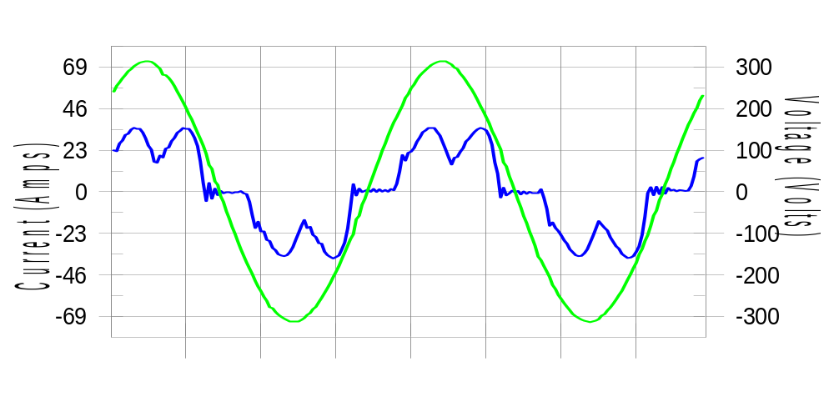

Harmonics and Class 3 limit line European Limits

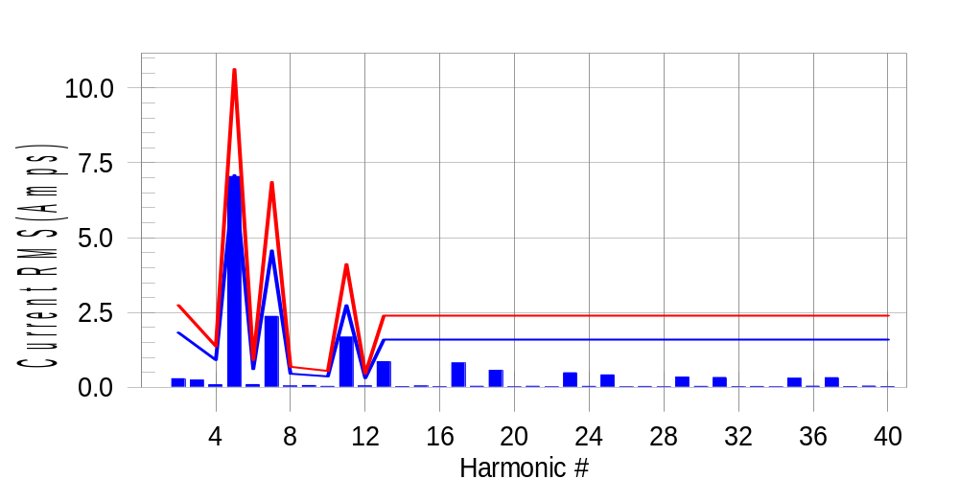

Test result: Pass Worst harmonic was #5 with 66.61 % of the limit.
Current Test Result Summary (Phase B-Run time)

EUT: Equipment under test Tested by: Tested by
Test category: Table:3, Rsce=250, Test Margin: 100
Test date: 2016/4/13 Start time: 18:55:02 End time: 18:57:54
Test duration (min): 2.5 Data file name: CTSMXH_H-000028.cts_data
Comment: Comment
Customer: Customer information

Test Result: Pass Measured I-ref: 23.084(Amps) Source: Normal
I-THC(%): 34.1 Limit(%): 37.0 PWHC(%): 28.4 PWHC Limit(%): 38.0

Highest parameter values during test:
V_RMS (Volts): 220.19 Frequency(Hz): 50.00
I_Peak (Amps): 46.357 I_RMS (Amps): 23.084
I_Fund (Amps): 21.469 Crest Factor: 2.035
Power (Watts): 4709 Power Factor: 0.927

Harm# Harms(avg) 100%Limit %of Limit Harms(max) 150%Limit %of Limit Status

2 0.290 1.829 15.8 0.318 2.744 11.6 Pass
3 0.072 N/A N/A 0.285 N/A N/A N/A
4 0.087 0.915 9.6 0.103 1.372 7.5 Pass
5 7.045 7.089 99.4 7.082 10.634 66.6 Pass
6 0.094 0.610 15.4 0.110 0.915 12.0 Pass
7 2.373 4.574 51.9 2.384 6.860 34.7 Pass
8 0.045 0.457 9.9 0.053 0.686 7.8 Pass
9 0.035 N/A N/A 0.077 N/A N/A N/A
10 0.035 0.366 9.5 0.043 0.549 7.9 Pass
11 1.680 2.744 61.2 1.698 4.116 41.2 Pass
12 0.050 0.305 16.4 0.060 0.457 13.1 Pass
13 0.859 1.601 53.7 0.868 2.401 36.1 Pass
14 0.027 N/A N/A 0.034 N/A N/A N/A
15 0.046 N/A N/A 0.054 N/A N/A N/A
16 0.025 N/A N/A 0.033 N/A N/A N/A
17 0.818 N/A N/A 0.829 N/A N/A N/A
18 0.037 N/A N/A 0.046 N/A N/A N/A
19 0.571 N/A N/A 0.580 N/A N/A N/A
20 0.022 N/A N/A 0.031 N/A N/A N/A
21 0.036 N/A N/A 0.044 N/A N/A N/A
22 0.022 N/A N/A 0.031 N/A N/A N/A
23 0.489 N/A N/A 0.500 N/A N/A N/A
24 0.035 N/A N/A 0.044 N/A N/A N/A
25 0.417 N/A N/A 0.425 N/A N/A N/A
26 0.021 N/A N/A 0.029 N/A N/A N/A
27 0.030 N/A N/A 0.044 N/A N/A N/A
28 0.021 N/A N/A 0.034 N/A N/A N/A
29 0.345 N/A N/A 0.354 N/A N/A N/A
30 0.035 N/A N/A 0.043 N/A N/A N/A
31 0.332 N/A N/A 0.341 N/A N/A N/A
32 0.023 N/A N/A 0.031 N/A N/A N/A
33 0.030 N/A N/A 0.036 N/A N/A N/A
34 0.021 N/A N/A 0.029 N/A N/A N/A
35 0.306 N/A N/A 0.317 N/A N/A N/A
36 0.039 N/A N/A 0.050 N/A N/A N/A
37 0.326 N/A N/A 0.341 N/A N/A N/A
38 0.028 N/A N/A 0.037 N/A N/A N/A
39 0.043 N/A N/A 0.053 N/A N/A N/A
40 0.026 N/A N/A 0.035 N/A N/A N/A

Note: Measured I-ref was applied for this test.

Voltage Source Verification Data (Phase B-Run time)

EUT: Equipment under test Tested by: Tested by
Test category: Table:3, Rsce=250, Test Margin: 100
Test date: 2016/4/13 Start time: 18:55:02 End time: 18:57:54
Test duration (min): 2.5 Data file name: CTSMXH_H-000028.cts_data
Comment: Comment
Customer: Customer information

Test Result: Pass Source qualification: Normal
Measured source distortion is within the requirements of the standards
Measurements are compliant with IEC/EN61000-3-12 Ed.4 & IEC/EN61000-4-7 Ed. 2.1

Highest parameter values during test:
Voltage (Vrms): 220.19 Frequency(Hz): 50.00
I_Peak (Amps): 46.357 I_RMS (Amps): 23.084
I_Fund (Amps): 21.469 Crest Factor: 2.035
Power (Watts): 4709 Power Factor: 0.927

Harm# Harmonics V-rms Limit V-rms % of Limit Status

2 0.178 0.881 20.17 OK
3 0.325 2.751 11.82 OK
4 0.163 0.881 18.55 OK
5 1.210 3.302 36.63 OK
6 0.111 0.880 12.62 OK
7 0.565 2.751 20.54 OK
8 0.103 0.881 11.73 OK
9 0.160 1.321 12.09 OK
10 0.088 0.880 9.97 OK
11 0.606 1.541 39.31 OK
12 0.105 0.660 15.85 OK
13 0.428 1.321 32.43 OK
14 0.106 0.660 16.03 OK
15 0.163 0.660 24.73 OK
16 0.104 0.660 15.71 OK
17 0.428 0.660 64.85 OK
18 0.117 0.660 17.75 OK
19 0.386 0.660 58.48 OK
20 0.126 0.660 19.05 OK
21 0.175 0.661 26.49 OK
22 0.111 0.660 16.74 OK
23 0.333 0.660 50.49 OK
24 0.098 0.660 14.79 OK
25 0.338 0.660 51.11 OK
26 0.101 0.660 15.37 OK
27 0.175 0.660 26.46 OK
28 0.101 0.660 15.35 OK
29 0.299 0.660 45.29 OK
30 0.109 0.660 16.56 OK
31 0.315 0.660 47.70 OK
32 0.105 0.660 15.89 OK
33 0.182 0.660 27.58 OK
34 0.111 0.660 16.82 OK
35 0.344 0.660 52.07 OK
36 0.120 0.660 18.12 OK
37 0.400 0.660 60.59 OK
38 0.128 0.660 19.31 OK
39 0.273 0.660 41.30 OK
40 0.122 0.660 18.47 OK

Harmonics – Per EN/IEC61000-3-12, Ed. 2.0(Phase C-Run time)

EUT: Equipment under test Tested by: Tested by
Test category: Table:3, Rsce=250, Test Margin: 100
Test date: 2016/4/13 Start time: 18:55:02 End time: 18:57:54
Test duration (min): 2.5 Data file name: CTSMXH_H-000028.cts_data
Comment: Comment
Customer: Customer information

Test Result: Pass Source qualification: Normal

Current & voltage waveforms

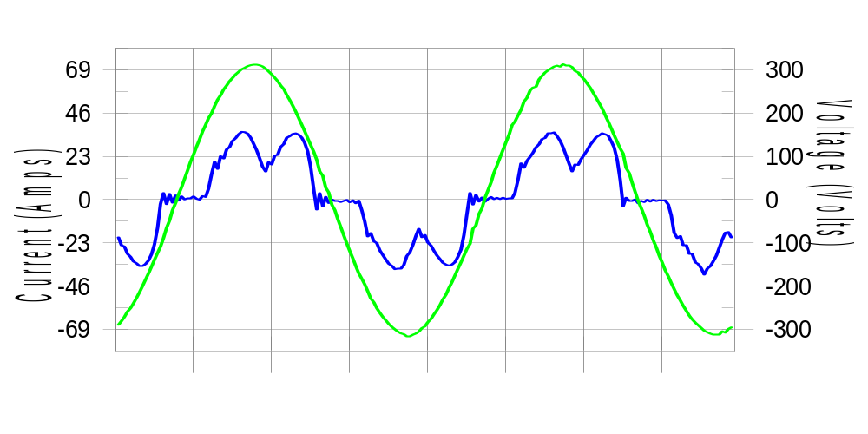

Harmonics and Class 3 limit line European Limits

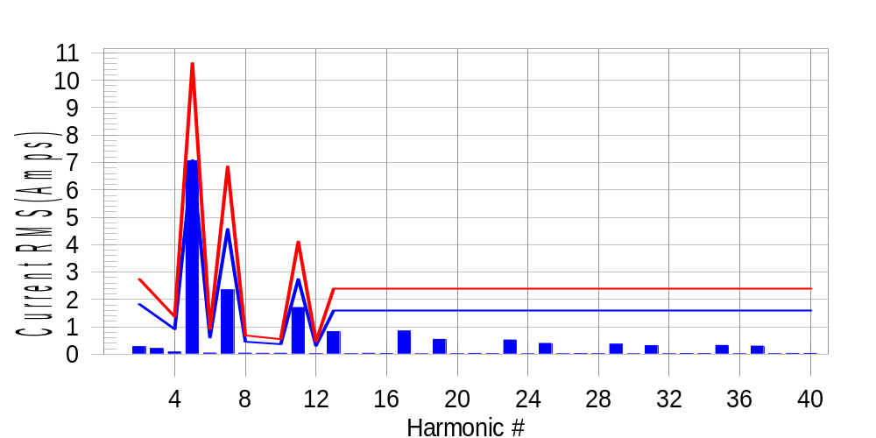

Test result: Pass Worst harmonic was #5 with 66.90 % of the limit.
Current Test Result Summary (Phase C-Run time)

EUT: Equipment under test Tested by: Tested by
Test category: Table:3, Rsce=250, Test Margin: 100
Test date: 2016/4/13 Start time: 18:55:02 End time: 18:57:54
Test duration (min): 2.5 Data file name: CTSMXH_H-000028.cts_data
Comment: Comment
Customer: Customer information

Test Result: Pass Measured I-ref: 23.058(Amps) Source: Normal
I-THC(%): 34.2 Limit(%): 37.0 PWHC(%): 28.4 PWHC Limit(%): 38.0

Highest parameter values during test:
V_RMS (Volts): 220.15 Frequency(Hz): 50.00
I_Peak (Amps): 45.791 I_RMS (Amps): 23.058
I_Fund (Amps): 21.454 Crest Factor: 1.991
Power (Watts): 4711 Power Factor: 0.929

Harm# Harms(avg) 100%Limit %of Limit Harms(max) 150%Limit %of Limit Status

2 0.278 1.828 15.2 0.307 2.742 11.2 Pass
3 0.072 N/A N/A 0.241 N/A N/A N/A
4 0.083 0.914 9.1 0.097 1.371 7.1 Pass
5 7.062 7.085 99.7 7.097 10.627 66.8 Pass
6 0.042 0.609 6.9 0.049 0.914 5.4 Pass
7 2.348 4.571 51.4 2.359 6.856 34.4 Pass
8 0.040 0.457 8.7 0.049 0.686 7.1 Pass
9 0.035 N/A N/A 0.055 N/A N/A N/A
10 0.037 0.366 10.2 0.045 0.548 8.2 Pass
11 1.706 2.742 62.2 1.720 4.114 41.8 Pass
12 0.020 0.305 6.7 0.029 0.457 6.3 Pass
13 0.822 1.600 51.4 0.833 2.400 34.7 Pass
14 0.022 N/A N/A 0.029 N/A N/A N/A
15 0.034 N/A N/A 0.042 N/A N/A N/A
16 0.026 N/A N/A 0.035 N/A N/A N/A
17 0.850 N/A N/A 0.859 N/A N/A N/A
18 0.015 N/A N/A 0.023 N/A N/A N/A
19 0.542 N/A N/A 0.551 N/A N/A N/A
20 0.018 N/A N/A 0.026 N/A N/A N/A
21 0.030 N/A N/A 0.037 N/A N/A N/A
22 0.021 N/A N/A 0.028 N/A N/A N/A
23 0.519 N/A N/A 0.525 N/A N/A N/A
24 0.014 N/A N/A 0.020 N/A N/A N/A
25 0.394 N/A N/A 0.402 N/A N/A N/A
26 0.017 N/A N/A 0.028 N/A N/A N/A
27 0.027 N/A N/A 0.034 N/A N/A N/A
28 0.022 N/A N/A 0.032 N/A N/A N/A
29 0.367 N/A N/A 0.388 N/A N/A N/A
30 0.015 N/A N/A 0.020 N/A N/A N/A
31 0.312 N/A N/A 0.318 N/A N/A N/A
32 0.018 N/A N/A 0.025 N/A N/A N/A
33 0.026 N/A N/A 0.047 N/A N/A N/A
34 0.023 N/A N/A 0.031 N/A N/A N/A
35 0.322 N/A N/A 0.329 N/A N/A N/A
36 0.016 N/A N/A 0.023 N/A N/A N/A
37 0.297 N/A N/A 0.304 N/A N/A N/A
38 0.021 N/A N/A 0.028 N/A N/A N/A
39 0.029 N/A N/A 0.036 N/A N/A N/A
40 0.029 N/A N/A 0.036 N/A N/A N/A

Note: Measured I-ref was applied for this test.

Voltage Source Verification Data (Phase C-Run time)

EUT: Equipment under test Tested by: Tested by
Test category: Table:3, Rsce=250, Test Margin: 100
Test date: 2016/4/13 Start time: 18:55:02 End time: 18:57:54
Test duration (min): 2.5 Data file name: CTSMXH_H-000028.cts_data
Comment: Comment
Customer: Customer information

Test Result: Pass Source qualification: Normal
Measured source distortion is within the requirements of the standards
Measurements are compliant with IEC/EN61000-3-12 Ed.4 & IEC/EN61000-4-7 Ed. 2.1

Highest parameter values during test:
Voltage (Vrms): 220.15 Frequency(Hz): 50.00
I_Peak (Amps): 45.791 I_RMS (Amps): 23.058
I_Fund (Amps): 21.454 Crest Factor: 1.991
Power (Watts): 4711 Power Factor: 0.929

Harm# Harmonics V-rms Limit V-rms % of Limit Status

2 0.166 0.880 18.91 OK
3 0.268 2.751 9.73 OK
4 0.163 0.880 18.51 OK
5 1.179 3.301 35.72 OK
6 0.100 0.880 11.42 OK
7 0.540 2.751 19.65 OK
8 0.087 0.880 9.86 OK
9 0.116 1.320 8.82 OK
10 0.085 0.880 9.70 OK
11 0.596 1.541 38.69 OK
12 0.083 0.660 12.60 OK
13 0.386 1.320 29.21 OK
14 0.087 0.660 13.19 OK
15 0.120 0.660 18.10 OK
16 0.089 0.660 13.50 OK
17 0.428 0.660 64.81 OK
18 0.085 0.660 12.82 OK
19 0.361 0.660 54.74 OK
20 0.100 0.660 15.19 OK
21 0.137 0.660 20.74 OK
22 0.099 0.660 15.03 OK
23 0.350 0.660 53.09 OK
24 0.083 0.660 12.58 OK
25 0.322 0.660 48.79 OK
26 0.086 0.660 13.10 OK
27 0.132 0.660 19.95 OK
28 0.088 0.660 13.33 OK
29 0.306 0.660 46.33 OK
30 0.086 0.660 13.03 OK
31 0.309 0.660 46.84 OK
32 0.121 0.660 18.26 OK
33 0.143 0.660 21.60 OK
34 0.087 0.660 13.25 OK
35 0.351 0.660 53.10 OK
36 0.077 0.660 11.73 OK
37 0.369 0.660 55.92 OK
38 0.098 0.660 14.90 OK
39 0.221 0.660 33.41 OK
40 0.101 0.660 15.24 OK

5th Harmonic Phase Angle and Magnitude for Phase A :
H-5_min_phase : 113.9 Degree (Leading)
H-5_max_phase : 114.6 Degree (Leading)
H-5_ave_phase : 114.2 Degree (Leading)

H-5_ave_vector_magnitude : 7.057 Amp
H-5_standard_ave_magnitude : 7.070 Amp
H-5_standard_max_magnitude : 7.097 Amp
Ratio of H-5_ave_vector / H-5_standard_ave : 0.999

Phase A = 98.696% of tested Rsce = 250.000, Rsce = 246.740
Phase B = 99.396% of tested Rsce = 250.000, Rsce = 248.491
Phase C = 99.688% of tested Rsce = 250.000, Rsce = 249.220
Minimum Rsce required: Rsce = 249.220

