Harmonics – Per EN/IEC61000-3-12, Ed. 2.0(Phase A-Run time)

EUT: Equipment under test Tested by: Tested by
Test category: Table:3, Rsce=250, Test Margin: 100
Test date: 2016/4/13 Start time: 19:04:41 End time: 19:07:34
Test duration (min): 2.5 Data file name: CTSMXH_H-000029.cts_data
Comment: Comment
Customer: Customer information

Test Result: Pass Source qualification: Normal

Current & voltage waveforms

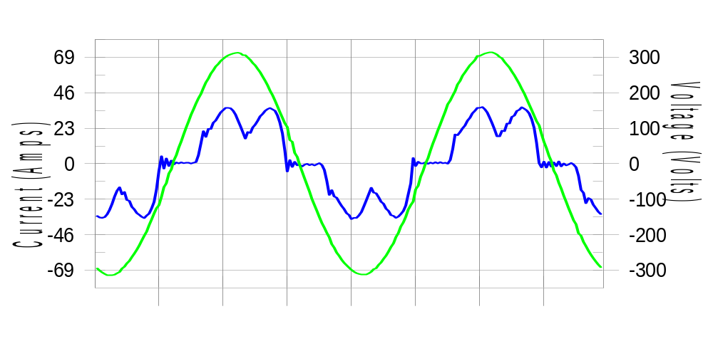

Harmonics and Class 3 limit line European Limits

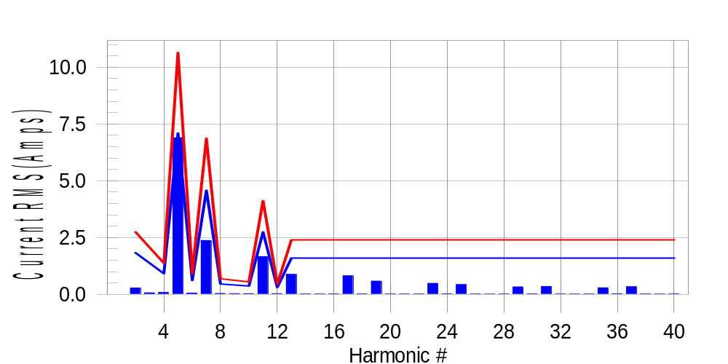

Test result: Pass Worst harmonic was #5 with 65.14 % of the limit.
Current Test Result Summary (Phase A-Run time)

EUT: Equipment under test Tested by: Tested by
Test category: Table:3, Rsce=250, Test Margin: 100
Test date: 2016/4/13 Start time: 19:04:41 End time: 19:07:34
Test duration (min): 2.5 Data file name: CTSMXH_H-000029.cts_data
Comment: Comment
Customer: Customer information

Test Result: Pass Measured I-ref: 23.121(Amps) Source: Normal
I-THC(%): 33.5 Limit(%): 37.0 PWHC(%): 28.4 PWHC Limit(%): 38.0

Highest parameter values during test:
V_RMS (Volts): 220.43 Frequency(Hz): 50.00
I_Peak (Amps): 48.072 I_RMS (Amps): 23.121
I_Fund (Amps): 21.551 Crest Factor: 2.097
Power (Watts): 4741 Power Factor: 0.931

Harm# Harms(avg) 100%Limit %of Limit Harms(max) 150%Limit %of Limit Status

2 0.281 1.832 15.3 0.307 2.748 11.2 Pass
3 0.069 N/A N/A 0.097 N/A N/A N/A
4 0.084 0.916 9.1 0.101 1.374 7.4 Pass
5 6.893 7.098 97.1 6.934 10.647 65.1 Pass
6 0.060 0.611 9.8 0.094 0.916 10.3 Pass
7 2.374 4.579 51.8 2.385 6.869 34.7 Pass
8 0.039 0.458 8.5 0.050 0.687 7.2 Pass
9 0.034 N/A N/A 0.045 N/A N/A N/A
10 0.034 0.366 9.2 0.049 0.550 9.0 Pass
11 1.665 2.748 60.6 1.683 4.121 40.8 Pass
12 0.033 0.305 10.8 0.042 0.458 9.1 Pass
13 0.878 1.603 54.8 0.890 2.404 37.0 Pass
14 0.023 N/A N/A 0.036 N/A N/A N/A
15 0.021 N/A N/A 0.028 N/A N/A N/A
16 0.023 N/A N/A 0.030 N/A N/A N/A
17 0.816 N/A N/A 0.829 N/A N/A N/A
18 0.028 N/A N/A 0.037 N/A N/A N/A
19 0.584 N/A N/A 0.597 N/A N/A N/A
20 0.020 N/A N/A 0.027 N/A N/A N/A
21 0.017 N/A N/A 0.029 N/A N/A N/A
22 0.020 N/A N/A 0.030 N/A N/A N/A
23 0.485 N/A N/A 0.493 N/A N/A N/A
24 0.027 N/A N/A 0.037 N/A N/A N/A
25 0.431 N/A N/A 0.440 N/A N/A N/A
26 0.020 N/A N/A 0.027 N/A N/A N/A
27 0.015 N/A N/A 0.031 N/A N/A N/A
28 0.022 N/A N/A 0.031 N/A N/A N/A
29 0.333 N/A N/A 0.342 N/A N/A N/A
30 0.027 N/A N/A 0.037 N/A N/A N/A
31 0.347 N/A N/A 0.360 N/A N/A N/A
32 0.020 N/A N/A 0.028 N/A N/A N/A
33 0.014 N/A N/A 0.021 N/A N/A N/A
34 0.021 N/A N/A 0.031 N/A N/A N/A
35 0.290 N/A N/A 0.301 N/A N/A N/A
36 0.031 N/A N/A 0.042 N/A N/A N/A
37 0.335 N/A N/A 0.345 N/A N/A N/A
38 0.024 N/A N/A 0.035 N/A N/A N/A
39 0.019 N/A N/A 0.026 N/A N/A N/A
40 0.025 N/A N/A 0.034 N/A N/A N/A

Note: Measured I-ref was applied for this test.

Voltage Source Verification Data (Phase A-Run time)

EUT: Equipment under test Tested by: Tested by
Test category: Table:3, Rsce=250, Test Margin: 100
Test date: 2016/4/13 Start time: 19:04:41 End time: 19:07:34
Test duration (min): 2.5 Data file name: CTSMXH_H-000029.cts_data
Comment: Comment
Customer: Customer information

Test Result: Pass Source qualification: Normal
Measured source distortion is within the requirements of the standards
Measurements are compliant with IEC/EN61000-3-12 Ed.4 & IEC/EN61000-4-7 Ed. 2.1

Highest parameter values during test:
Voltage (Vrms): 220.43 Frequency(Hz): 50.00
I_Peak (Amps): 48.072 I_RMS (Amps): 23.121
I_Fund (Amps): 21.551 Crest Factor: 2.097
Power (Watts): 4741 Power Factor: 0.931

Harm# Harmonics V-rms Limit V-rms % of Limit Status

2 0.164 0.881 18.65 OK
3 0.335 2.755 12.14 OK
4 0.197 0.881 22.40 OK
5 1.172 3.305 35.46 OK
6 0.117 0.882 13.29 OK
7 0.556 2.755 20.17 OK
8 0.116 0.881 13.13 OK
9 0.129 1.322 9.79 OK
10 0.091 0.881 10.32 OK
11 0.582 1.542 37.76 OK
12 0.091 0.661 13.73 OK
13 0.407 1.322 30.78 OK
14 0.078 0.661 11.83 OK
15 0.135 0.661 20.36 OK
16 0.075 0.661 11.36 OK
17 0.411 0.661 62.13 OK
18 0.077 0.661 11.66 OK
19 0.395 0.661 59.81 OK
20 0.156 0.661 23.66 OK
21 0.152 0.661 22.98 OK
22 0.087 0.661 13.22 OK
23 0.303 0.661 45.80 OK
24 0.080 0.661 12.10 OK
25 0.337 0.661 50.91 OK
26 0.084 0.661 12.69 OK
27 0.139 0.661 20.98 OK
28 0.090 0.661 13.62 OK
29 0.287 0.661 43.39 OK
30 0.095 0.661 14.39 OK
31 0.331 0.661 50.09 OK
32 0.100 0.661 15.18 OK
33 0.159 0.661 23.99 OK
34 0.083 0.661 12.54 OK
35 0.317 0.661 48.01 OK
36 0.093 0.661 14.03 OK
37 0.410 0.661 62.06 OK
38 0.089 0.661 13.54 OK
39 0.243 0.661 36.82 OK
40 0.147 0.661 22.27 OK

Harmonics – Per EN/IEC61000-3-12, Ed. 2.0(Phase B-Run time)

EUT: Equipment under test Tested by: Tested by
Test category: Table:3, Rsce=250, Test Margin: 100
Test date: 2016/4/13 Start time: 19:04:41 End time: 19:07:34
Test duration (min): 2.5 Data file name: CTSMXH_H-000029.cts_data
Comment: Comment
Customer: Customer information

Test Result: Pass Source qualification: Normal

Current & voltage waveforms

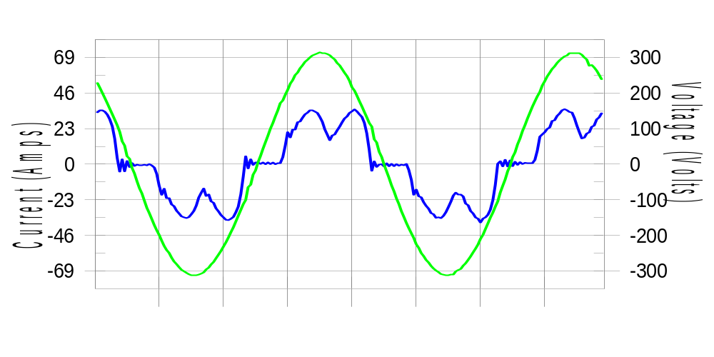

Harmonics and Class 3 limit line European Limits

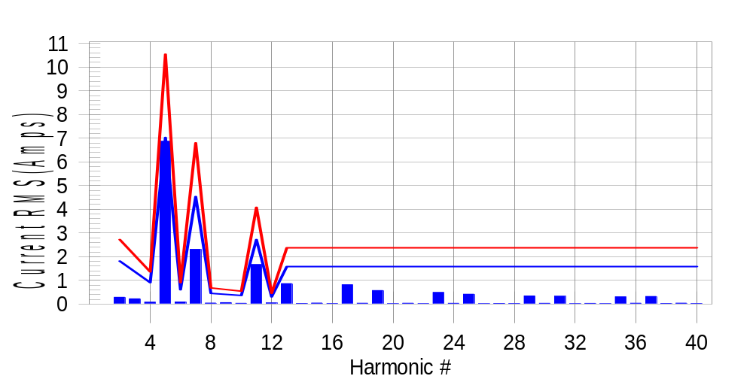

Test result: Pass Worst harmonic was #5 with 65.50 % of the limit.
Current Test Result Summary (Phase B-Run time)

EUT: Equipment under test Tested by: Tested by
Test category: Table:3, Rsce=250, Test Margin: 100
Test date: 2016/4/13 Start time: 19:04:41 End time: 19:07:34
Test duration (min): 2.5 Data file name: CTSMXH_H-000029.cts_data
Comment: Comment
Customer: Customer information

Test Result: Pass Measured I-ref: 22.918(Amps) Source: Normal
I-THC(%): 33.6 Limit(%): 37.0 PWHC(%): 28.5 PWHC Limit(%): 38.0

Highest parameter values during test:
V_RMS (Volts): 220.21 Frequency(Hz): 50.00
I_Peak (Amps): 47.377 I_RMS (Amps): 22.918
I_Fund (Amps): 21.329 Crest Factor: 2.087
Power (Watts): 4688 Power Factor: 0.929

Harm# Harms(avg) 100%Limit %of Limit Harms(max) 150%Limit %of Limit Status

2 0.286 1.814 15.8 0.321 2.721 11.8 Pass
3 0.069 N/A N/A 0.259 N/A N/A N/A
4 0.082 0.907 9.1 0.099 1.360 7.2 Pass
5 6.868 7.029 97.7 6.902 10.544 65.5 Pass
6 0.091 0.605 15.1 0.100 0.907 11.1 Pass
7 2.309 4.535 50.9 2.321 6.802 34.1 Pass
8 0.043 0.453 9.6 0.054 0.680 7.9 Pass
9 0.034 N/A N/A 0.073 N/A N/A N/A
10 0.034 0.363 9.3 0.042 0.544 7.7 Pass
11 1.668 2.721 61.3 1.680 4.081 41.2 Pass
12 0.048 0.302 15.8 0.058 0.453 12.8 Pass
13 0.864 1.587 54.4 0.878 2.381 36.9 Pass
14 0.026 N/A N/A 0.035 N/A N/A N/A
15 0.044 N/A N/A 0.053 N/A N/A N/A
16 0.025 N/A N/A 0.033 N/A N/A N/A
17 0.817 N/A N/A 0.825 N/A N/A N/A
18 0.036 N/A N/A 0.045 N/A N/A N/A
19 0.573 N/A N/A 0.589 N/A N/A N/A
20 0.022 N/A N/A 0.029 N/A N/A N/A
21 0.035 N/A N/A 0.044 N/A N/A N/A
22 0.021 N/A N/A 0.029 N/A N/A N/A
23 0.489 N/A N/A 0.498 N/A N/A N/A
24 0.033 N/A N/A 0.042 N/A N/A N/A
25 0.416 N/A N/A 0.426 N/A N/A N/A
26 0.021 N/A N/A 0.028 N/A N/A N/A
27 0.028 N/A N/A 0.037 N/A N/A N/A
28 0.023 N/A N/A 0.032 N/A N/A N/A
29 0.343 N/A N/A 0.354 N/A N/A N/A
30 0.033 N/A N/A 0.042 N/A N/A N/A
31 0.331 N/A N/A 0.340 N/A N/A N/A
32 0.022 N/A N/A 0.032 N/A N/A N/A
33 0.029 N/A N/A 0.037 N/A N/A N/A
34 0.021 N/A N/A 0.029 N/A N/A N/A
35 0.306 N/A N/A 0.315 N/A N/A N/A
36 0.038 N/A N/A 0.046 N/A N/A N/A
37 0.321 N/A N/A 0.330 N/A N/A N/A
38 0.028 N/A N/A 0.038 N/A N/A N/A
39 0.041 N/A N/A 0.049 N/A N/A N/A
40 0.025 N/A N/A 0.036 N/A N/A N/A

Note: Measured I-ref was applied for this test.

Voltage Source Verification Data (Phase B-Run time)

EUT: Equipment under test Tested by: Tested by
Test category: Table:3, Rsce=250, Test Margin: 100
Test date: 2016/4/13 Start time: 19:04:41 End time: 19:07:34
Test duration (min): 2.5 Data file name: CTSMXH_H-000029.cts_data
Comment: Comment
Customer: Customer information

Test Result: Pass Source qualification: Normal
Measured source distortion is within the requirements of the standards
Measurements are compliant with IEC/EN61000-3-12 Ed.4 & IEC/EN61000-4-7 Ed. 2.1

Highest parameter values during test:
Voltage (Vrms): 220.21 Frequency(Hz): 50.00
I_Peak (Amps): 47.377 I_RMS (Amps): 22.918
I_Fund (Amps): 21.329 Crest Factor: 2.087
Power (Watts): 4688 Power Factor: 0.929

Harm# Harmonics V-rms Limit V-rms % of Limit Status

2 0.163 0.881 18.49 OK
3 0.339 2.752 12.31 OK
4 0.153 0.880 17.35 OK
5 1.187 3.301 35.96 OK
6 0.120 0.881 13.63 OK
7 0.570 2.751 20.73 OK
8 0.107 0.881 12.13 OK
9 0.168 1.321 12.73 OK
10 0.093 0.881 10.51 OK
11 0.605 1.541 39.26 OK
12 0.101 0.660 15.36 OK
13 0.448 1.321 33.93 OK
14 0.108 0.660 16.38 OK
15 0.166 0.660 25.15 OK
16 0.128 0.660 19.41 OK
17 0.436 0.660 66.06 OK
18 0.122 0.660 18.53 OK
19 0.391 0.660 59.26 OK
20 0.125 0.660 19.00 OK
21 0.178 0.660 26.97 OK
22 0.118 0.660 17.94 OK
23 0.333 0.660 50.38 OK
24 0.120 0.660 18.12 OK
25 0.352 0.660 53.25 OK
26 0.104 0.660 15.76 OK
27 0.175 0.660 26.54 OK
28 0.125 0.660 18.88 OK
29 0.291 0.660 44.12 OK
30 0.116 0.660 17.64 OK
31 0.335 0.661 50.70 OK
32 0.112 0.660 16.99 OK
33 0.192 0.660 29.02 OK
34 0.105 0.660 15.91 OK
35 0.339 0.660 51.29 OK
36 0.114 0.660 17.26 OK
37 0.421 0.660 63.75 OK
38 0.125 0.660 18.95 OK
39 0.283 0.660 42.88 OK
40 0.150 0.660 22.72 OK

Harmonics – Per EN/IEC61000-3-12, Ed. 2.0(Phase C-Run time)

EUT: Equipment under test Tested by: Tested by
Test category: Table:3, Rsce=250, Test Margin: 100
Test date: 2016/4/13 Start time: 19:04:41 End time: 19:07:34
Test duration (min): 2.5 Data file name: CTSMXH_H-000029.cts_data
Comment: Comment
Customer: Customer information

Test Result: Pass Source qualification: Normal

Current & voltage waveforms

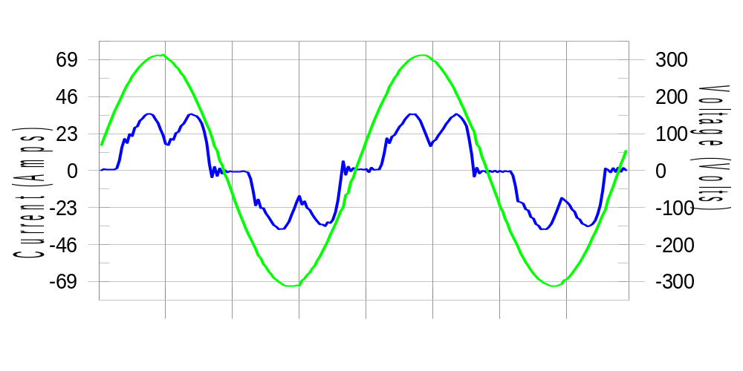

Harmonics and Class 3 limit line European Limits

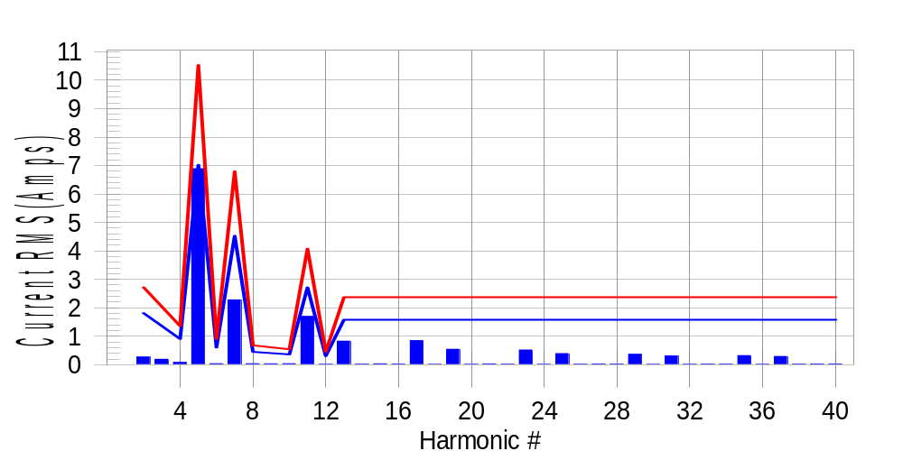

Test result: Pass Worst harmonic was #5 with 65.81 % of the limit.
Current Test Result Summary (Phase C-Run time)

EUT: Equipment under test Tested by: Tested by
Test category: Table:3, Rsce=250, Test Margin: 100
Test date: 2016/4/13 Start time: 19:04:41 End time: 19:07:34
Test duration (min): 2.5 Data file name: CTSMXH_H-000029.cts_data
Comment: Comment
Customer: Customer information

Test Result: Pass Measured I-ref: 22.900(Amps) Source: Normal
I-THC(%): 33.7 Limit(%): 37.0 PWHC(%): 28.6 PWHC Limit(%): 38.0

Highest parameter values during test:
V_RMS (Volts): 220.13 Frequency(Hz): 50.00
I_Peak (Amps): 45.512 I_RMS (Amps): 22.900
I_Fund (Amps): 21.302 Crest Factor: 2.011
Power (Watts): 4691 Power Factor: 0.931

Harm# Harms(avg) 100%Limit %of Limit Harms(max) 150%Limit %of Limit Status

2 0.270 1.812 14.9 0.301 2.718 11.1 Pass
3 0.069 N/A N/A 0.222 N/A N/A N/A
4 0.082 0.906 9.1 0.100 1.359 7.3 Pass
5 6.889 7.022 98.1 6.931 10.532 65.8 Pass
6 0.037 0.604 6.1 0.046 0.906 5.1 Pass
7 2.279 4.530 50.3 2.290 6.795 33.7 Pass
8 0.037 0.453 8.3 0.045 0.680 6.7 Pass
9 0.034 N/A N/A 0.042 N/A N/A N/A
10 0.036 0.362 9.9 0.044 0.544 8.1 Pass
11 1.696 2.718 62.4 1.709 4.077 41.9 Pass
12 0.018 0.302 5.9 0.024 0.453 5.4 Pass
13 0.828 1.586 52.2 0.841 2.378 35.3 Pass
14 0.023 N/A N/A 0.029 N/A N/A N/A
15 0.033 N/A N/A 0.042 N/A N/A N/A
16 0.025 N/A N/A 0.031 N/A N/A N/A
17 0.849 N/A N/A 0.858 N/A N/A N/A
18 0.014 N/A N/A 0.020 N/A N/A N/A
19 0.545 N/A N/A 0.553 N/A N/A N/A
20 0.019 N/A N/A 0.026 N/A N/A N/A
21 0.030 N/A N/A 0.040 N/A N/A N/A
22 0.021 N/A N/A 0.028 N/A N/A N/A
23 0.518 N/A N/A 0.526 N/A N/A N/A
24 0.014 N/A N/A 0.024 N/A N/A N/A
25 0.393 N/A N/A 0.401 N/A N/A N/A
26 0.018 N/A N/A 0.027 N/A N/A N/A
27 0.026 N/A N/A 0.033 N/A N/A N/A
28 0.023 N/A N/A 0.033 N/A N/A N/A
29 0.367 N/A N/A 0.375 N/A N/A N/A
30 0.014 N/A N/A 0.022 N/A N/A N/A
31 0.308 N/A N/A 0.315 N/A N/A N/A
32 0.017 N/A N/A 0.026 N/A N/A N/A
33 0.025 N/A N/A 0.033 N/A N/A N/A
34 0.022 N/A N/A 0.030 N/A N/A N/A
35 0.322 N/A N/A 0.331 N/A N/A N/A
36 0.014 N/A N/A 0.020 N/A N/A N/A
37 0.291 N/A N/A 0.303 N/A N/A N/A
38 0.020 N/A N/A 0.028 N/A N/A N/A
39 0.028 N/A N/A 0.037 N/A N/A N/A
40 0.028 N/A N/A 0.035 N/A N/A N/A

Note: Measured I-ref was applied for this test.

Voltage Source Verification Data (Phase C-Run time)

EUT: Equipment under test Tested by: Tested by
Test category: Table:3, Rsce=250, Test Margin: 100
Test date: 2016/4/13 Start time: 19:04:41 End time: 19:07:34
Test duration (min): 2.5 Data file name: CTSMXH_H-000029.cts_data
Comment: Comment
Customer: Customer information

Test Result: Pass Source qualification: Normal
Measured source distortion is within the requirements of the standards
Measurements are compliant with IEC/EN61000-3-12 Ed.4 & IEC/EN61000-4-7 Ed. 2.1

Highest parameter values during test:
Voltage (Vrms): 220.13 Frequency(Hz): 50.00
I_Peak (Amps): 45.512 I_RMS (Amps): 22.900
I_Fund (Amps): 21.302 Crest Factor: 2.011
Power (Watts): 4691 Power Factor: 0.931

Harm# Harmonics V-rms Limit V-rms % of Limit Status

2 0.162 0.880 18.40 OK
3 0.267 2.750 9.72 OK
4 0.156 0.880 17.70 OK
5 1.146 3.301 34.73 OK
6 0.096 0.880 10.86 OK
7 0.523 2.750 19.00 OK
8 0.103 0.880 11.71 OK
9 0.135 1.320 10.24 OK
10 0.086 0.880 9.83 OK
11 0.581 1.540 37.71 OK
12 0.091 0.660 13.77 OK
13 0.389 1.320 29.42 OK
14 0.097 0.660 14.67 OK
15 0.120 0.660 18.16 OK
16 0.091 0.660 13.77 OK
17 0.435 0.660 65.86 OK
18 0.091 0.660 13.84 OK
19 0.363 0.660 55.01 OK
20 0.097 0.660 14.72 OK
21 0.127 0.660 19.28 OK
22 0.100 0.660 15.13 OK
23 0.340 0.660 51.58 OK
24 0.086 0.660 13.04 OK
25 0.338 0.660 51.17 OK
26 0.091 0.660 13.71 OK
27 0.140 0.660 21.27 OK
28 0.106 0.660 16.09 OK
29 0.305 0.660 46.14 OK
30 0.102 0.660 15.43 OK
31 0.309 0.660 46.75 OK
32 0.088 0.660 13.35 OK
33 0.170 0.660 25.82 OK
34 0.087 0.660 13.15 OK
35 0.348 0.660 52.72 OK
36 0.086 0.660 13.08 OK
37 0.370 0.660 56.09 OK
38 0.098 0.660 14.89 OK
39 0.240 0.660 36.30 OK
40 0.105 0.660 15.95 OK

5th Harmonic Phase Angle and Magnitude for Phase A :
H-5_min_phase : 114.6 Degree (Leading)
H-5_max_phase : 115.3 Degree (Leading)
H-5_ave_phase : 114.9 Degree (Leading)

H-5_ave_vector_magnitude : 6.885 Amp
H-5_standard_ave_magnitude : 6.893 Amp
H-5_standard_max_magnitude : 6.931 Amp
Ratio of H-5_ave_vector / H-5_standard_ave : 0.999

Phase A = 97.110% of tested Rsce = 250.000, Rsce = 242.774
Phase B = 97.721% of tested Rsce = 250.000, Rsce = 244.303
Phase C = 98.122% of tested Rsce = 250.000, Rsce = 245.306
Minimum Rsce required: Rsce = 245.306

