Harmonics – Per EN/IEC61000-3-12, Ed. 2.0(Phase A-Run time)

EUT: Equipment under test Tested by: Tested by
Test category: Table:3, Rsce=250, Test Margin: 100
Test date: 2016/4/13 Start time: 19:14:49 End time: 19:17:41
Test duration (min): 2.5 Data file name: CTSMXH_H-000030.cts_data
Comment: Comment
Customer: Customer information

Test Result: Pass Source qualification: Normal

Current & voltage waveforms

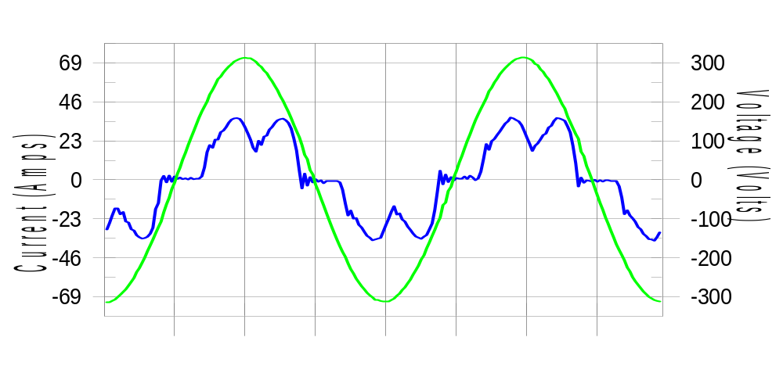

Harmonics and Class 3 limit line European Limits

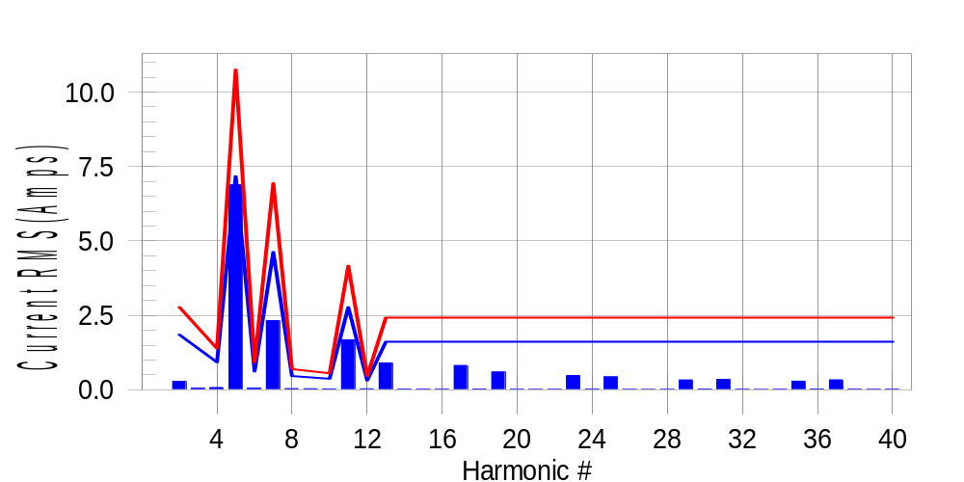

Test result: Pass Worst harmonic was #5 with 64.36 % of the limit.
Current Test Result Summary (Phase A-Run time)

EUT: Equipment under test Tested by: Tested by
Test category: Table:3, Rsce=250, Test Margin: 100
Test date: 2016/4/13 Start time: 19:14:49 End time: 19:17:41
Test duration (min): 2.5 Data file name: CTSMXH_H-000030.cts_data
Comment: Comment
Customer: Customer information

Test Result: Pass Measured I-ref: 23.398(Amps) Source: Normal
I-THC(%): 33.1 Limit(%): 37.0 PWHC(%): 28.2 PWHC Limit(%): 38.0

Highest parameter values during test:
V_RMS (Volts): 220.42 Frequency(Hz): 50.00
I_Peak (Amps): 46.611 I_RMS (Amps): 23.398
I_Fund (Amps): 21.817 Crest Factor: 2.012
Power (Watts): 4806 Power Factor: 0.933

Harm# Harms(avg) 100%Limit %of Limit Harms(max) 150%Limit %of Limit Status

2 0.279 1.852 15.1 0.307 2.777 11.1 Pass
3 0.055 N/A N/A 0.087 N/A N/A N/A
4 0.075 0.926 8.1 0.092 1.389 6.6 Pass
5 6.887 7.175 96.0 6.924 10.762 64.3 Pass
6 0.055 0.617 9.0 0.063 0.926 6.8 Pass
7 2.324 4.629 50.2 2.339 6.943 33.7 Pass
8 0.039 0.463 8.4 0.049 0.694 7.1 Pass
9 0.037 N/A N/A 0.052 N/A N/A N/A
10 0.032 0.370 8.6 0.041 0.555 7.5 Pass
11 1.677 2.777 60.4 1.692 4.166 40.6 Pass
12 0.033 0.309 10.6 0.042 0.463 9.0 Pass
13 0.902 1.620 55.7 0.914 2.430 37.6 Pass
14 0.023 N/A N/A 0.031 N/A N/A N/A
15 0.023 N/A N/A 0.030 N/A N/A N/A
16 0.023 N/A N/A 0.031 N/A N/A N/A
17 0.819 N/A N/A 0.829 N/A N/A N/A
18 0.028 N/A N/A 0.037 N/A N/A N/A
19 0.598 N/A N/A 0.609 N/A N/A N/A
20 0.020 N/A N/A 0.027 N/A N/A N/A
21 0.017 N/A N/A 0.027 N/A N/A N/A
22 0.020 N/A N/A 0.029 N/A N/A N/A
23 0.482 N/A N/A 0.491 N/A N/A N/A
24 0.026 N/A N/A 0.036 N/A N/A N/A
25 0.436 N/A N/A 0.444 N/A N/A N/A
26 0.019 N/A N/A 0.027 N/A N/A N/A
27 0.015 N/A N/A 0.022 N/A N/A N/A
28 0.021 N/A N/A 0.029 N/A N/A N/A
29 0.331 N/A N/A 0.342 N/A N/A N/A
30 0.026 N/A N/A 0.034 N/A N/A N/A
31 0.348 N/A N/A 0.356 N/A N/A N/A
32 0.020 N/A N/A 0.048 N/A N/A N/A
33 0.015 N/A N/A 0.022 N/A N/A N/A
34 0.020 N/A N/A 0.029 N/A N/A N/A
35 0.291 N/A N/A 0.300 N/A N/A N/A
36 0.029 N/A N/A 0.040 N/A N/A N/A
37 0.336 N/A N/A 0.344 N/A N/A N/A
38 0.024 N/A N/A 0.030 N/A N/A N/A
39 0.021 N/A N/A 0.028 N/A N/A N/A
40 0.023 N/A N/A 0.031 N/A N/A N/A

Note: Measured I-ref was applied for this test.

Voltage Source Verification Data (Phase A-Run time)

EUT: Equipment under test Tested by: Tested by
Test category: Table:3, Rsce=250, Test Margin: 100
Test date: 2016/4/13 Start time: 19:14:49 End time: 19:17:41
Test duration (min): 2.5 Data file name: CTSMXH_H-000030.cts_data
Comment: Comment
Customer: Customer information

Test Result: Pass Source qualification: Normal
Measured source distortion is within the requirements of the standards
Measurements are compliant with IEC/EN61000-3-12 Ed.4 & IEC/EN61000-4-7 Ed. 2.1

Highest parameter values during test:
Voltage (Vrms): 220.42 Frequency(Hz): 50.00
I_Peak (Amps): 46.611 I_RMS (Amps): 23.398
I_Fund (Amps): 21.817 Crest Factor: 2.012
Power (Watts): 4806 Power Factor: 0.933

Harm# Harmonics V-rms Limit V-rms % of Limit Status

2 0.184 0.881 20.89 OK
3 0.332 2.754 12.05 OK
4 0.187 0.881 21.22 OK
5 1.167 3.306 35.32 OK
6 0.123 0.881 13.98 OK
7 0.541 2.754 19.65 OK
8 0.093 0.881 10.51 OK
9 0.131 1.322 9.92 OK
10 0.096 0.882 10.84 OK
11 0.572 1.542 37.09 OK
12 0.090 0.661 13.55 OK
13 0.430 1.322 32.53 OK
14 0.085 0.661 12.88 OK
15 0.140 0.661 21.20 OK
16 0.091 0.661 13.77 OK
17 0.404 0.661 61.15 OK
18 0.088 0.661 13.30 OK
19 0.379 0.661 57.33 OK
20 0.148 0.661 22.44 OK
21 0.167 0.661 25.20 OK
22 0.097 0.661 14.66 OK
23 0.314 0.661 47.45 OK
24 0.084 0.661 12.77 OK
25 0.342 0.661 51.80 OK
26 0.081 0.661 12.18 OK
27 0.140 0.661 21.22 OK
28 0.088 0.661 13.33 OK
29 0.286 0.661 43.24 OK
30 0.104 0.661 15.70 OK
31 0.337 0.661 51.03 OK
32 0.087 0.661 13.23 OK
33 0.157 0.661 23.82 OK
34 0.098 0.661 14.90 OK
35 0.326 0.661 49.29 OK
36 0.107 0.661 16.22 OK
37 0.399 0.661 60.41 OK
38 0.099 0.661 14.99 OK
39 0.226 0.661 34.20 OK
40 0.152 0.661 23.05 OK

Harmonics – Per EN/IEC61000-3-12, Ed. 2.0(Phase B-Run time)

EUT: Equipment under test Tested by: Tested by
Test category: Table:3, Rsce=250, Test Margin: 100
Test date: 2016/4/13 Start time: 19:14:49 End time: 19:17:41
Test duration (min): 2.5 Data file name: CTSMXH_H-000030.cts_data
Comment: Comment
Customer: Customer information

Test Result: Pass Source qualification: Normal

Current & voltage waveforms

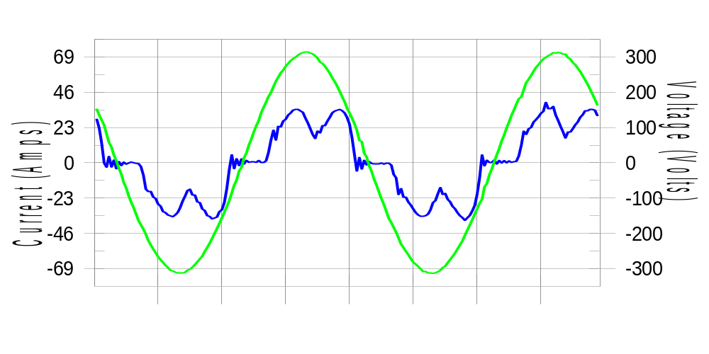

Harmonics and Class 3 limit line European Limits

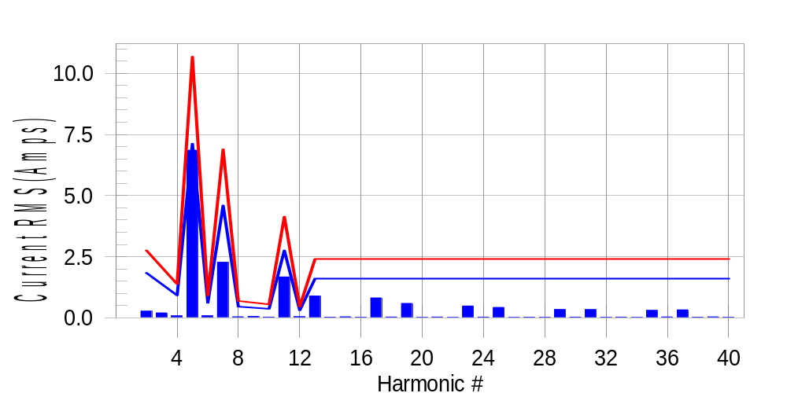

Test result: Pass Worst harmonic was #5 with 64.59 % of the limit.
Current Test Result Summary (Phase B-Run time)

EUT: Equipment under test Tested by: Tested by
Test category: Table:3, Rsce=250, Test Margin: 100
Test date: 2016/4/13 Start time: 19:14:49 End time: 19:17:41
Test duration (min): 2.5 Data file name: CTSMXH_H-000030.cts_data
Comment: Comment
Customer: Customer information

Test Result: Pass Measured I-ref: 23.254(Amps) Source: Normal
I-THC(%): 33.1 Limit(%): 37.0 PWHC(%): 28.3 PWHC Limit(%): 38.0

Highest parameter values during test:
V_RMS (Volts): 220.21 Frequency(Hz): 50.00
I_Peak (Amps): 46.395 I_RMS (Amps): 23.254
I_Fund (Amps): 21.645 Crest Factor: 2.026
Power (Watts): 4766 Power Factor: 0.931

Harm# Harms(avg) 100%Limit %of Limit Harms(max) 150%Limit %of Limit Status

2 0.272 1.837 14.8 0.300 2.756 10.9 Pass
3 0.055 N/A N/A 0.233 N/A N/A N/A
4 0.081 0.919 8.8 0.098 1.378 7.1 Pass
5 6.855 7.120 96.3 6.891 10.679 64.5 Pass
6 0.086 0.612 14.1 0.094 0.919 10.3 Pass
7 2.270 4.593 49.4 2.283 6.890 33.1 Pass
8 0.043 0.459 9.3 0.054 0.689 7.9 Pass
9 0.037 N/A N/A 0.070 N/A N/A N/A
10 0.032 0.367 8.7 0.040 0.551 7.3 Pass
11 1.674 2.756 60.7 1.690 4.134 40.9 Pass
12 0.045 0.306 14.9 0.056 0.459 12.1 Pass
13 0.891 1.608 55.4 0.904 2.411 37.5 Pass
14 0.026 N/A N/A 0.035 N/A N/A N/A
15 0.043 N/A N/A 0.055 N/A N/A N/A
16 0.024 N/A N/A 0.031 N/A N/A N/A
17 0.815 N/A N/A 0.824 N/A N/A N/A
18 0.035 N/A N/A 0.045 N/A N/A N/A
19 0.590 N/A N/A 0.598 N/A N/A N/A
20 0.022 N/A N/A 0.029 N/A N/A N/A
21 0.034 N/A N/A 0.048 N/A N/A N/A
22 0.021 N/A N/A 0.031 N/A N/A N/A
23 0.483 N/A N/A 0.492 N/A N/A N/A
24 0.031 N/A N/A 0.041 N/A N/A N/A
25 0.425 N/A N/A 0.435 N/A N/A N/A
26 0.022 N/A N/A 0.036 N/A N/A N/A
27 0.028 N/A N/A 0.035 N/A N/A N/A
28 0.023 N/A N/A 0.031 N/A N/A N/A
29 0.339 N/A N/A 0.349 N/A N/A N/A
30 0.032 N/A N/A 0.053 N/A N/A N/A
31 0.335 N/A N/A 0.344 N/A N/A N/A
32 0.023 N/A N/A 0.031 N/A N/A N/A
33 0.029 N/A N/A 0.043 N/A N/A N/A
34 0.021 N/A N/A 0.031 N/A N/A N/A
35 0.303 N/A N/A 0.313 N/A N/A N/A
36 0.037 N/A N/A 0.048 N/A N/A N/A
37 0.327 N/A N/A 0.336 N/A N/A N/A
38 0.027 N/A N/A 0.037 N/A N/A N/A
39 0.040 N/A N/A 0.050 N/A N/A N/A
40 0.024 N/A N/A 0.032 N/A N/A N/A

Note: Measured I-ref was applied for this test.

Voltage Source Verification Data (Phase B-Run time)

EUT: Equipment under test Tested by: Tested by
Test category: Table:3, Rsce=250, Test Margin: 100
Test date: 2016/4/13 Start time: 19:14:49 End time: 19:17:41
Test duration (min): 2.5 Data file name: CTSMXH_H-000030.cts_data
Comment: Comment
Customer: Customer information

Test Result: Pass Source qualification: Normal
Measured source distortion is within the requirements of the standards
Measurements are compliant with IEC/EN61000-3-12 Ed.4 & IEC/EN61000-4-7 Ed. 2.1

Highest parameter values during test:
Voltage (Vrms): 220.21 Frequency(Hz): 50.00
I_Peak (Amps): 46.395 I_RMS (Amps): 23.254
I_Fund (Amps): 21.645 Crest Factor: 2.026
Power (Watts): 4766 Power Factor: 0.931

Harm# Harmonics V-rms Limit V-rms % of Limit Status

2 0.166 0.881 18.90 OK
3 0.336 2.751 12.20 OK
4 0.147 0.881 16.72 OK
5 1.191 3.302 36.05 OK
6 0.106 0.880 12.04 OK
7 0.569 2.751 20.69 OK
8 0.100 0.880 11.38 OK
9 0.163 1.321 12.35 OK
10 0.115 0.881 13.01 OK
11 0.624 1.541 40.49 OK
12 0.106 0.660 15.99 OK
13 0.454 1.320 34.35 OK
14 0.092 0.660 13.90 OK
15 0.168 0.660 25.39 OK
16 0.101 0.660 15.30 OK
17 0.432 0.660 65.49 OK
18 0.125 0.660 18.88 OK
19 0.390 0.661 59.04 OK
20 0.126 0.660 19.11 OK
21 0.193 0.660 29.23 OK
22 0.107 0.661 16.25 OK
23 0.343 0.660 51.94 OK
24 0.113 0.660 17.18 OK
25 0.364 0.660 55.10 OK
26 0.119 0.660 18.08 OK
27 0.170 0.660 25.72 OK
28 0.116 0.660 17.57 OK
29 0.303 0.660 45.89 OK
30 0.112 0.660 16.93 OK
31 0.328 0.660 49.74 OK
32 0.099 0.660 14.99 OK
33 0.179 0.660 27.15 OK
34 0.108 0.660 16.34 OK
35 0.350 0.660 53.01 OK
36 0.108 0.660 16.37 OK
37 0.408 0.660 61.74 OK
38 0.134 0.660 20.24 OK
39 0.319 0.660 48.24 OK
40 0.136 0.660 20.66 OK

Harmonics – Per EN/IEC61000-3-12, Ed. 2.0(Phase C-Run time)

EUT: Equipment under test Tested by: Tested by
Test category: Table:3, Rsce=250, Test Margin: 100
Test date: 2016/4/13 Start time: 19:14:49 End time: 19:17:41
Test duration (min): 2.5 Data file name: CTSMXH_H-000030.cts_data
Comment: Comment
Customer: Customer information

Test Result: Pass Source qualification: Normal

Current & voltage waveforms

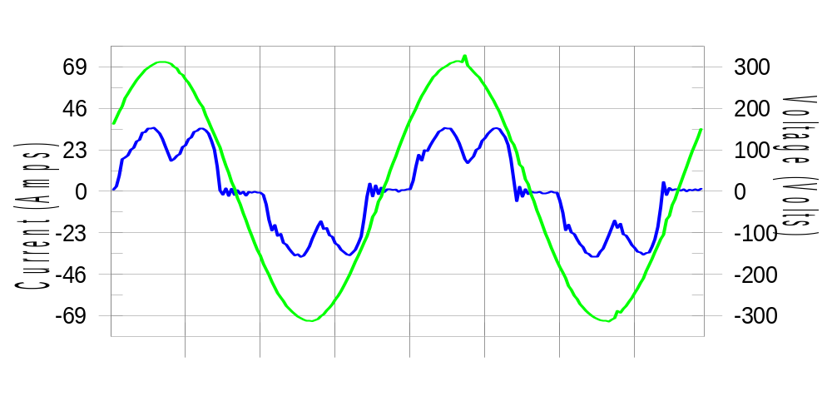

Harmonics and Class 3 limit line European Limits

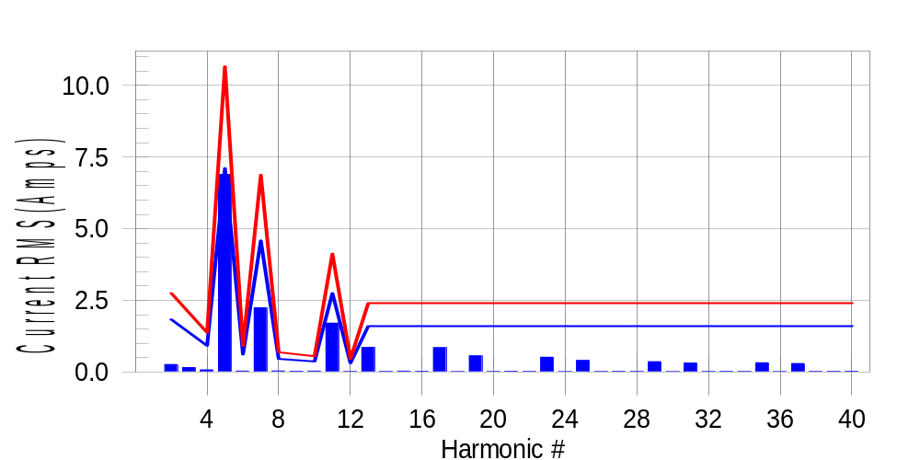

Test result: Pass Worst harmonic was #5 with 65.06 % of the limit.
Current Test Result Summary (Phase C-Run time)

EUT: Equipment under test Tested by: Tested by
Test category: Table:3, Rsce=250, Test Margin: 100
Test date: 2016/4/13 Start time: 19:14:49 End time: 19:17:41
Test duration (min): 2.5 Data file name: CTSMXH_H-000030.cts_data
Comment: Comment
Customer: Customer information

Test Result: Pass Measured I-ref: 23.226(Amps) Source: Normal
I-THC(%): 33.3 Limit(%): 37.0 PWHC(%): 28.4 PWHC Limit(%): 38.0

Highest parameter values during test:
V_RMS (Volts): 220.14 Frequency(Hz): 50.00
I_Peak (Amps): 46.243 I_RMS (Amps): 23.226
I_Fund (Amps): 21.602 Crest Factor: 2.003
Power (Watts): 4765 Power Factor: 0.932

Harm# Harms(avg) 100%Limit %of Limit Harms(max) 150%Limit %of Limit Status

2 0.261 1.835 14.2 0.293 2.752 10.6 Pass
3 0.055 N/A N/A 0.220 N/A N/A N/A
4 0.076 0.917 8.3 0.092 1.376 6.7 Pass
5 6.891 7.109 96.9 6.936 10.664 65.0 Pass
6 0.035 0.612 5.8 0.048 0.917 5.2 Pass
7 2.241 4.586 48.9 2.253 6.880 32.8 Pass
8 0.038 0.459 8.3 0.046 0.688 6.6 Pass
9 0.037 N/A N/A 0.036 N/A N/A N/A
10 0.034 0.367 9.4 0.043 0.550 7.8 Pass
11 1.706 2.752 62.0 1.722 4.128 41.7 Pass
12 0.017 0.306 5.7 0.023 0.459 5.1 Pass
13 0.857 1.605 53.4 0.869 2.408 36.1 Pass
14 0.022 N/A N/A 0.029 N/A N/A N/A
15 0.029 N/A N/A 0.040 N/A N/A N/A
16 0.025 N/A N/A 0.031 N/A N/A N/A
17 0.849 N/A N/A 0.860 N/A N/A N/A
18 0.014 N/A N/A 0.023 N/A N/A N/A
19 0.562 N/A N/A 0.572 N/A N/A N/A
20 0.018 N/A N/A 0.027 N/A N/A N/A
21 0.026 N/A N/A 0.033 N/A N/A N/A
22 0.021 N/A N/A 0.028 N/A N/A N/A
23 0.514 N/A N/A 0.530 N/A N/A N/A
24 0.013 N/A N/A 0.020 N/A N/A N/A
25 0.402 N/A N/A 0.414 N/A N/A N/A
26 0.018 N/A N/A 0.025 N/A N/A N/A
27 0.023 N/A N/A 0.035 N/A N/A N/A
28 0.022 N/A N/A 0.031 N/A N/A N/A
29 0.362 N/A N/A 0.370 N/A N/A N/A
30 0.013 N/A N/A 0.019 N/A N/A N/A
31 0.313 N/A N/A 0.319 N/A N/A N/A
32 0.018 N/A N/A 0.024 N/A N/A N/A
33 0.021 N/A N/A 0.028 N/A N/A N/A
34 0.021 N/A N/A 0.029 N/A N/A N/A
35 0.321 N/A N/A 0.332 N/A N/A N/A
36 0.014 N/A N/A 0.020 N/A N/A N/A
37 0.297 N/A N/A 0.328 N/A N/A N/A
38 0.020 N/A N/A 0.026 N/A N/A N/A
39 0.023 N/A N/A 0.033 N/A N/A N/A
40 0.027 N/A N/A 0.035 N/A N/A N/A

Note: Measured I-ref was applied for this test.

Voltage Source Verification Data (Phase C-Run time)

EUT: Equipment under test Tested by: Tested by
Test category: Table:3, Rsce=250, Test Margin: 100
Test date: 2016/4/13 Start time: 19:14:49 End time: 19:17:41
Test duration (min): 2.5 Data file name: CTSMXH_H-000030.cts_data
Comment: Comment
Customer: Customer information

Test Result: Pass Source qualification: Normal
Measured source distortion is within the requirements of the standards
Measurements are compliant with IEC/EN61000-3-12 Ed.4 & IEC/EN61000-4-7 Ed. 2.1

Highest parameter values during test:
Voltage (Vrms): 220.14 Frequency(Hz): 50.00
I_Peak (Amps): 46.243 I_RMS (Amps): 23.226
I_Fund (Amps): 21.602 Crest Factor: 2.003
Power (Watts): 4765 Power Factor: 0.932

Harm# Harmonics V-rms Limit V-rms % of Limit Status

2 0.171 0.880 19.39 OK
3 0.283 2.751 10.28 OK
4 0.153 0.880 17.37 OK
5 1.156 3.300 35.04 OK
6 0.121 0.880 13.72 OK
7 0.535 2.751 19.43 OK
8 0.089 0.880 10.15 OK
9 0.140 1.320 10.57 OK
10 0.086 0.880 9.73 OK
11 0.592 1.541 38.42 OK
12 0.082 0.660 12.46 OK
13 0.412 1.320 31.23 OK
14 0.091 0.660 13.75 OK
15 0.131 0.660 19.90 OK
16 0.112 0.660 16.92 OK
17 0.435 0.660 65.91 OK
18 0.091 0.660 13.74 OK
19 0.384 0.660 58.22 OK
20 0.098 0.660 14.81 OK
21 0.145 0.660 21.98 OK
22 0.099 0.660 14.97 OK
23 0.336 0.660 50.87 OK
24 0.082 0.660 12.38 OK
25 0.323 0.660 49.00 OK
26 0.093 0.660 14.13 OK
27 0.132 0.660 20.01 OK
28 0.107 0.660 16.14 OK
29 0.305 0.660 46.23 OK
30 0.087 0.660 13.24 OK
31 0.303 0.660 45.95 OK
32 0.091 0.660 13.73 OK
33 0.165 0.660 25.00 OK
34 0.087 0.660 13.18 OK
35 0.349 0.660 52.86 OK
36 0.095 0.660 14.34 OK
37 0.372 0.660 56.28 OK
38 0.088 0.660 13.37 OK
39 0.247 0.660 37.46 OK
40 0.106 0.660 16.03 OK

5th Harmonic Phase Angle and Magnitude for Phase A :
H-5_min_phase : 114.9 Degree (Leading)
H-5_max_phase : 115.7 Degree (Leading)
H-5_ave_phase : 115.3 Degree (Leading)

H-5_ave_vector_magnitude : 6.887 Amp
H-5_standard_ave_magnitude : 6.887 Amp
H-5_standard_max_magnitude : 6.936 Amp
Ratio of H-5_ave_vector / H-5_standard_ave : 0.999

Phase A = 96.003% of tested Rsce = 250.000, Rsce = 240.008
Phase B = 96.300% of tested Rsce = 250.000, Rsce = 240.749
Phase C = 96.956% of tested Rsce = 250.000, Rsce = 242.389
Minimum Rsce required: Rsce = 242.389

