R40 for 1 hour

Do you have play FPS games, have experience using Image, Video or similar editing software? If you do, you can earn R40 by participating in our study.

Sign up at: https://pointclouds.bookem.co.za
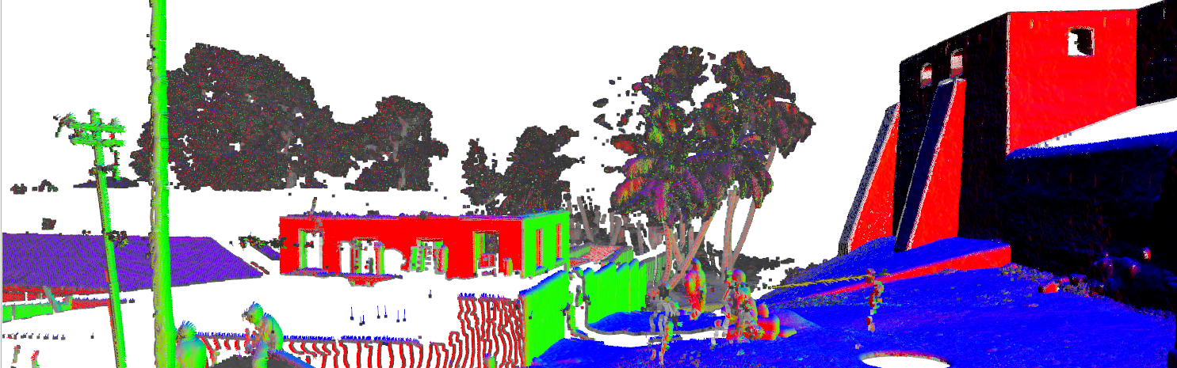


Computer Science Department

