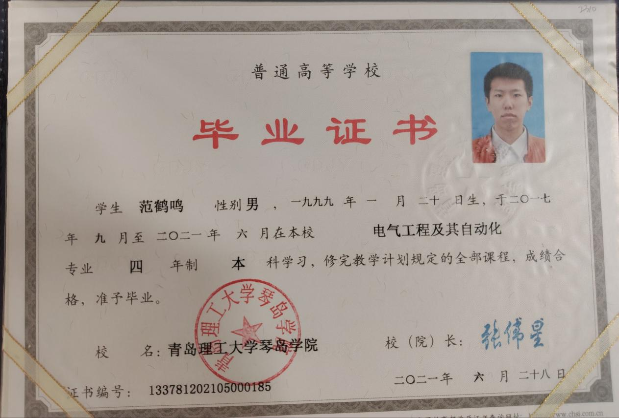
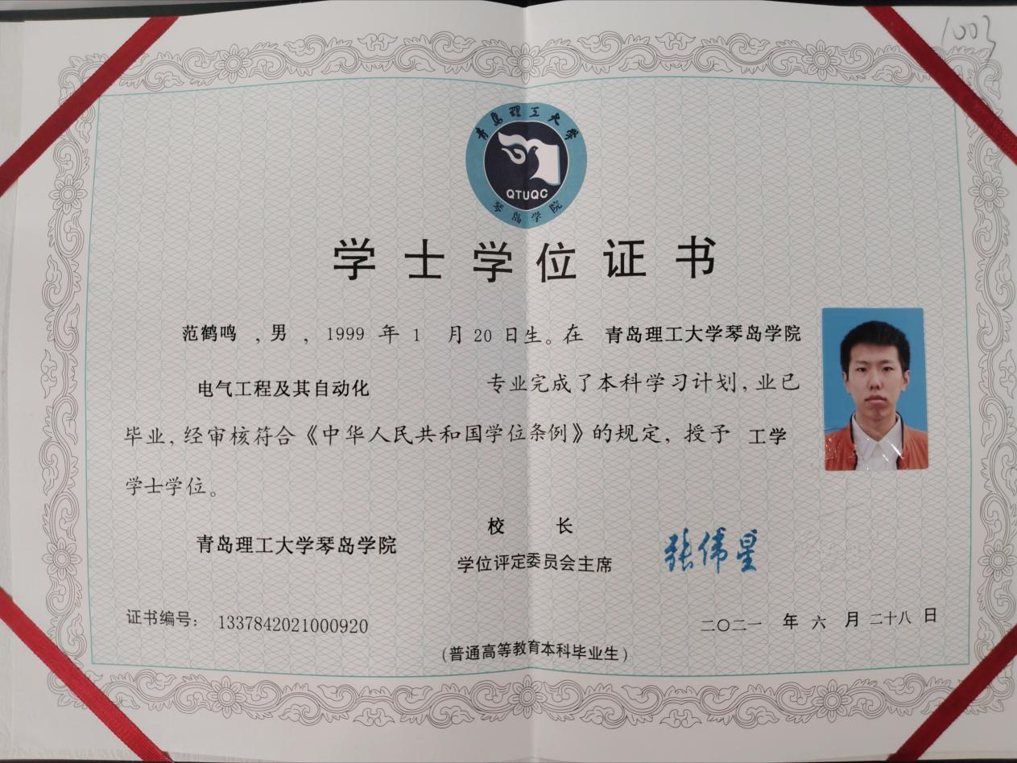
Note: Qingdao University of Technology Qindao College was renamed Qingdao City University in 2021.
CERTIFIED TRANSLATION
Original Document: Bachelor's Degree Certificate / Graduation Certificate
Institution: Qingdao City University (formerly known as Qingdao University of Technology Qindao College)
Student Name: Max Fan
Major: Electrical Engineering and Automation
Degree Awarded: Bachelor of Science (B.S.)
Graduation Date: June 2021
Certificate Number: 1337842021000920
Translator's Certification
I, Max Fan, hereby certify that I am competent to translate from Chinese to English, and that the above translation is accurate and complete.
Signature: ___________Max Fan____________
Date: ___________September 15, 2026____________

