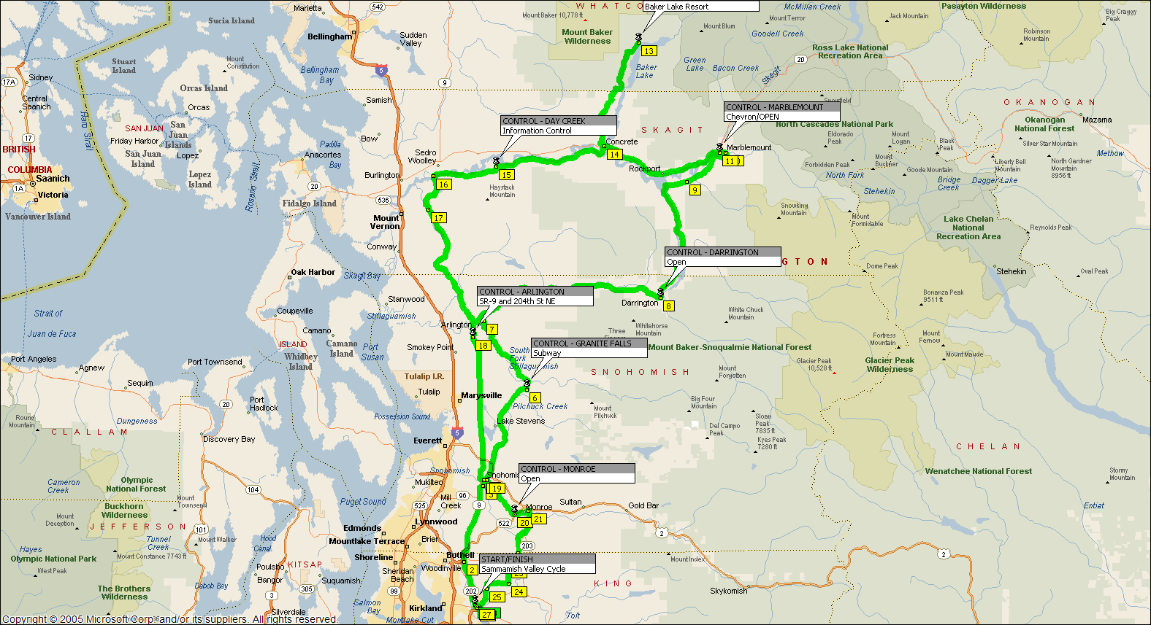
Baker Lake Permanent – 400 Km

