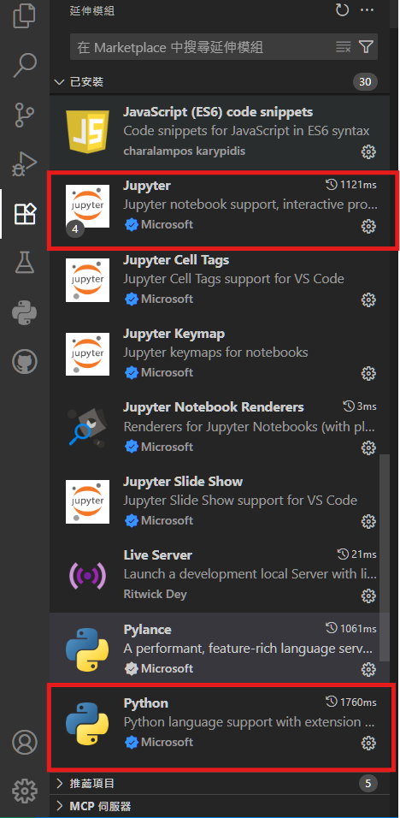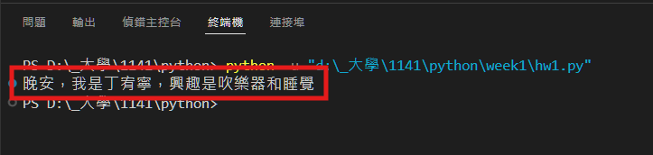

<https://github.com/seaturtle25/python_1141_01357014.git>