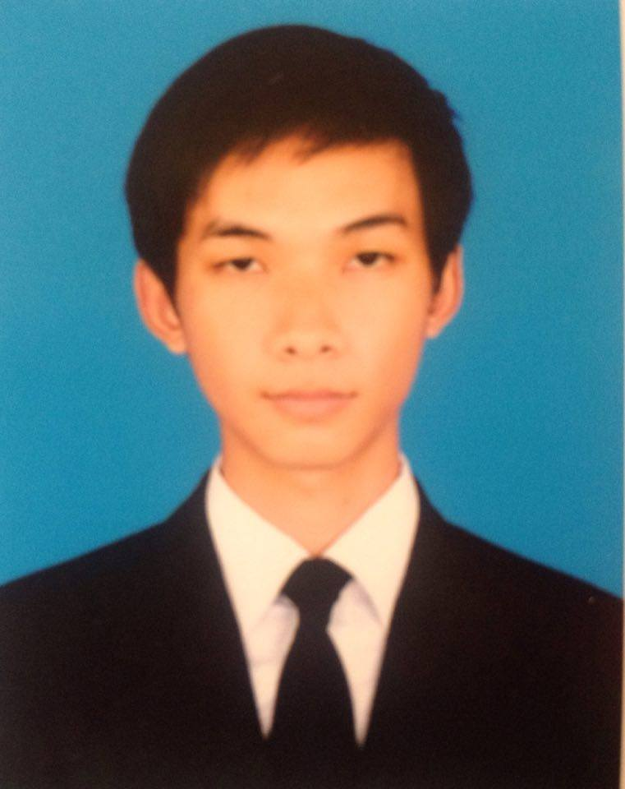
CURRICULUM VITAE

Name: CHHI PANHARATH
Address: Street 107, Sangkat Ou Russey 3, Khan 7 Makara, Phnom Penh
Mobile: (+855) 98 989 694
Apply for: Maintenance of Air Conditioner
Email: Chhipanharath1@gmail.com

PERSONAL DATA
Sex : Male
Nationality : Khmer
Date of Birth : 06/April/1997
Place of Birth : O’ambel Village, O’ambel Commune,
Sereisophoan District, Banteay Meanchey Province, Cambodia.

EDUCATION BACKGROUND
2003-2009 : Studied at O’ambel Primary School.
2009- 2012 : Studied at O’ambel High School.
2012- 2015 : Change from O’ambel High School to Samdach Ov High School.
2015-Present : Studying at Institute of Technology of Cambodia

QUALIFICATE
2012 : Certificate of Secondary School
2015 : Certificate of High School

LANGUAGES
Listening Reading Speaking Writing
Khmer: Good Good Good Good
English: Good Good Good Good

SKILS AND ABILITIES
- Microsoft Word and Excel
- Microsoft Power Point
- Upload and Download from Internet
- Computer Software

INTERESTS & HOBBIES
- Like Reading Books
- PC magazines
- Searching new IT from internet and what update newly
- Having good communication with others and coworkers
- Listening to music
- Like working with the team work
- Like talking about environment issues and the cause of pollution
REFERENCES
Name: Mr. Nhem Sophal
Position: Teacher at Institute of Technology of Cambodia
Tel: 077 555 997

Name: Mrs. Vong Sopheap
Position: Accounting Manager
Company: ATECH GROUP CO., LTD
Tel: 012 303 065

I’d like certify that the statements above is made by me in answering to for the ongoing questions are true and correct to the best of my knowledge and belief.

.

