Name:______________________________

RPG Maker MV Workbook

Contents
Flowchart Shapes 3
Flow Chart Shape “Color Code” 4
Testing Index 5
Create Your Home [Items, Text] 6
Game / Map Loader 7
Door Transfer [Animations, Movement] 8
Well [Items, Text] 9
Fishing Spot [Variables, Items, Animations, Loops, Branches] 10
Cooking / Crafting [Items, Branches] Requires “Well” and “Fishing Spot” 11
Time System [Switches, Branches, Common Events] 12
Day/Night System [Switches, Branches, Common Events] Required: Time System 13
Create the Boulder Pass 16
Power Bracelet [Items, Conditional Branches] Recommended: Create the Boulder Pass 17
Remote Door Lock [Switches, Event Pages] Recommended: Boulder Pass Dungeon 18
Dungeon Keys [Self- Switches, Event Pages] Recommended: Boulder Pass Dungeon 19
One Step Tile Puzzle [(Self) Switches, Event Pages] Recommended: Boulder Pass Dungeon 20
Create A Town 21
Bank Teller [Variables] 22
Reputation System [Variables] Required: Game / Map Loader 24
Market Stall Stealing [Switches, Branches, Movement, Event Pages] 25
Butterdog [Event Pages, Switches] Recommended: Forest Pass 26
Sniff Spot [Event Pages, Variables] Required: Forest Pass and Butterdog 27
Magic Feather Jump [Branches] 28
Torches [Common Events, Loops] Requires: Game/Map Loader 29
Fishing Skill and Rods 30
Fishing Varieties 31
Multi-Remote Door Lock 32
Combination Door Lock 32
Market Stall Theft (solutions by Russel FB) 33
Pickpocketing Error! Bookmark not defined.
Butterdog Sniff Spell 35
Dad Joke Generator 37

Flowchart Shapes
The function of a flowchart is determined by the shapes in it. There are five major shapes that are used in this workbook.

Start or End Step
An oval represents the beginning or the end of a flow chart. Start working on a flow chart from the Start shape. Every program will eventually flow into an End shape
Inputs / Outputs
Start can only have one output, because there is only one first step.
Start can never have any inputs. If the flowchart loops endlessly, the loop will go back to the first step after Start, not the Start
Process Step
yes
Inputs / Outputs

Input / Output Step
yes
Inputs / Outputs

Decision Step
yes
Inputs / Outputs

Insert Step
yes
Inputs / Outputs

Jump Step
yes
Inputs / Outputs

Flow Chart Shape “Color Code”
This workbook also uses shades of black to signify different things. White shapes are instructions for the programmer, whereas black shapes are instructions for the program.

White shapes are instructions for you, the programmer:

Black shapes are Command Events. The Event will be named in the “Start” oval.

Gray/Faded shapes tell you that you need to insert code into an existing event. For example, if we have a flow chart like the one below:

…and a different flow chart tells you to insert a new step, like this:

…then the original flow chart will look like this when you’ve inserted the new steps:

Testing Index
This section is a list of all challenges and the things you should test to make sure they work as intended by this book. You should answer ‘Yes’ to each of the questions for that challenge to be complete.

- Door Transfer
  - When you stand in front of the outside door and hit the Action Key, does it:
    - Play the correct sound effects (door opening, player walking in)
    - Show the door animating and swinging open
    - Cause the player to step into the doorway
    - Transfer the player in front of the doorway inside of your home?
  - When the player steps on the exit tile, does it play the walking sound effect and transfer the player in front of the outside door?
- Well
  - When you stand next to the Well and hit the Action Key, does it tell the user they received Water?
  - Does one new Water item show up in the player’s inventory?
- Fishing Spot
  - Does the game wait at least three seconds before telling you if you caught a fish or not?
  - Can you successfully catch a fish by random chance?
    - Does it tell the user they caught a fish?
    - Does it add one Fish item to their inventory?
  - Can you fail at catching a fish by random chance?
  - Did you decide if you want to fish everywhere or in specific spots?
    - If you chose specific spots, is there an animation for each fishing spot event?
    - If you chose specific spots, does the animation stay the same when you activate the event?
    - If you chose anywhere, are there any tiles of water you can reach but cannot fish in?
- Cooking / Crafting
  - When trying to cook Fish Soup, and you do not have Water, does it tell you you need Water and end?
  - When trying to cook Fish Soup, and you do not have Fish, does it tell you you need Fish and end?
  - When trying to cook Fish Soup, and you have both ingredients, does it add a Fish Soup to your inventory, and remove one Water and one Fish?
- Power Bracelet
  - If you do not have the Power Bracelet in your inventory, does it tell you you need it when you use the Action Key on the boulder event?
  - If you have the Power Bracelet in your inventory, does using the Action key push the boulder one tile away from you, in the direction you are facing?
  - After pushing the boulder into a wall, can you walk away from it without the boulder moving on it’s own?
- Remote Door Lock
  - If you flip the lever, does the event image show the lever flipped?
  - If you flip the lever, does the door open?
  - If you flip the lever again, does the event image change back to unflipped, and the door closes?
  - If you walk into the doorway while the lever is flipped, does it transfer you to a new map?
- Dungeon Keys
  - Do you have two Dungeon Keys and two Dungeon Doors that can be discovered in your dungeon?
  - Do you have one Boss Key and one Boss Door?
  - If you have the appropriate key, does the door animation show?
  - Does an open door open a passageway that can be walked through normally (do not “transfer” players for this challenge)?
- Bank Teller
  - Does depositing/withdrawing gold add/remove the correct amounts to or from your inventory/bank account?
  - Are you prevented from withdrawing gold that is not in your account, or depositing gold not in your inventory?

Create Your Home [Items, Text]
Create a well which your player can draw water from. This water will be an item the players can use later for healing and crafting.

Every adventure starts at home. The next several challenges will involve adding amenities to your home to help you prepare for adventure. They will also give you a place to come home and rest when you’re worn out from your travels. To create our home, we will create two new maps in the Maps List. Maps in the maps list can be easily organized like folders. I made my “ohouse” for the exterior (outside) of my home, and inside of that map in the Maps List, I place my “ihouse” for the interior (inside) of my home.
- Map Edit Mode
- Map Drawing Tools
- Tiles
- Tile Layer Selector
- Maps List
- Map Editing Area
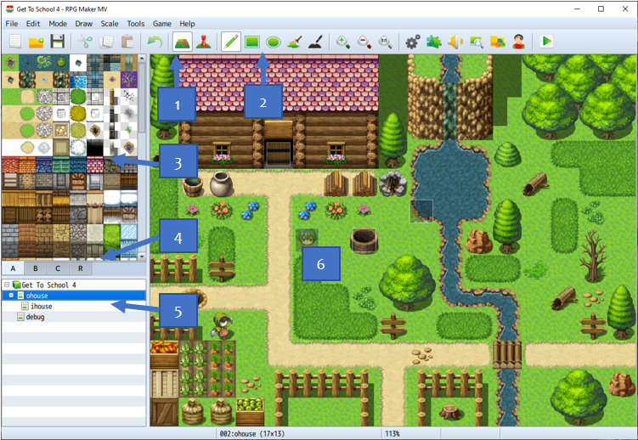
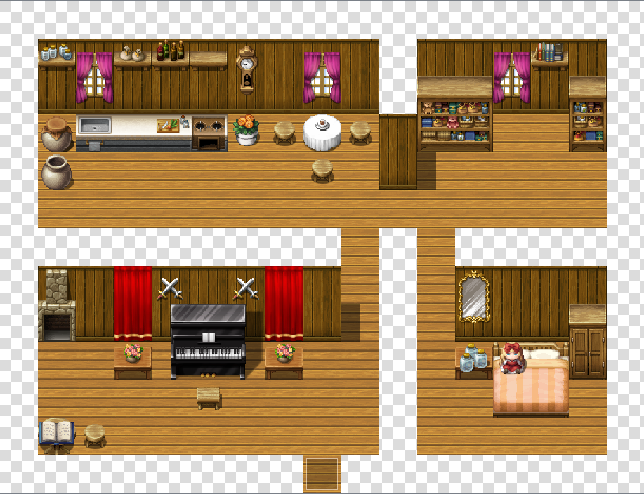
Have fun designing the outside and inside of your home. Take time to learn how the tiles work. The Tiles menu has four tabs by default: A, B, C, and R. Don’t worry about R, yet. Think of layer “A” as the ground layer. Layer “B” are things that go on top of the ground. Layer “C” are things that go on top of the things that go on top of the ground. For example, the floor of your house is Layer A, the table that goes on the floor is Layer B, and the tea cup that goes on the table is Layer C.
You cannot rotate tiles, but some tiles are “active tiles”, meaning they will adjust and draw new shapes as you paint them onto the map. Common examples of these are animated water tiles, hill/mountain tiles, walls, and roofs. There are also extra tiles that look like active tiles, but are static. You can use these to create manual effects, such as multi-level hills with stairs.
Start thinking about your design language. This is how you communicate to players what they can do in your game, without pulling them out of the immersive experience of their game. For example, we will need three paths leaving your home for these challenges. I used dirt paths to show the player this, but I also blocked the sides of the path with fences, signs, and trees. This forces the player to have to walk down that path to use it, instead of stumbling upon it randomly. You may also want a well/sink, a water area, a campfire/stove, some farming area, and some wood to do future challenges.

Game / Map Loader
A Game Loader sets the values of all of our Switches and Variables as soon as the game starts. A Map Loader changes the values of Switches and Variables every time we enter a map.

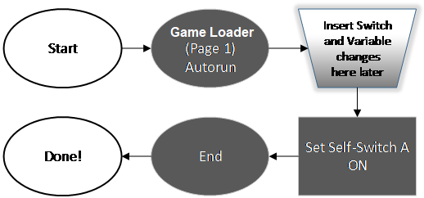
To make a Game Loader, create the following game object on the same map as your Player Starting Position, and follow the flow chart to the right.
Create: Map Event
No Image | Name | Game Loader
No Image | Page | 1
No Image | Trigger | Autorun

Create: Map Event
No Image | Name | Game Loader | Self-Switch | A
No Image | Page | 2 | Self-Switch | A
No Image | Trigger | Action | Self-Switch | A

The purpose of the Game Loader is to set all of the Switch and Variable values that we will need throughout the game.
Note that Page 2 of “Map Init” will always be blank. This is so the first page will run once, and the event will never run again. Self-Switches are “persistent”, so even if you come back to this map later, it will not run again.
As you complete more and more challenges, some of them will tell you to insert a Switch or Variable change by inserting it into the “Game Loader Event”. This means injecting that code where you see the trapezoid shape in the above flow chart.
To make a Map Loader, create the following event on each map that needs Switches and Variables changed when the map is loaded. Follows the flow chart for each Map Loader you create.
Create: Map Event
No Image | Name | Maploader
No Image | Page | 1
No Image | Trigger | Parallel

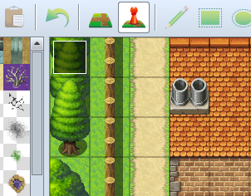
As you complete more challenges, some of those challenges will tell you to insert a Load Command by inserting it into the Map Loader. This means injecting those commands from the flowchart into the trapezoid in the flowchart above.
Unlike Self-Switches, “Erase Event” is not persistent. This means if you leave the map and come back, the Map Loader event will “respawn” and run its code again. If you only want something to run the first time you enter a map, such as a cutscene, use a second page and a Self-Switch, just like the Game Loader above.
I put all of my Game and Map Loader events in the top-left corner of the map, so I can always find them easily.

Door Transfer [Animations, Movement]
Create a door which the player can open to be transported to another map. On the second map, create a region that will take them back to the first map when walked into.

Start by creating two new maps. For my first two maps I like to do the outside of my player’s home, and the inside as the second map. On the first map (the outside), create a Door event as shown below. On the inside map, create an “exit” event.
Create: Map Event
 | Name | Door
 | Priority | Same As Character
 | Trigger | Action

Create: Map Event
 | Name | Exit
 | Priority | Same As Character
 | Trigger | Player Touch

Follow this flow chart to allow the door to swing open and make the player walk through before transferring them to the new map:
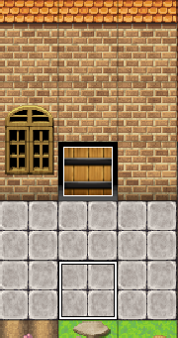
On the first map, be sure to leave a hole in the wall containing the door, and put a doorway tile (Page B) in the doorway.
Then follow this flow chart to create a exit area on the other map, that when stepped on, moves you back to the first map.
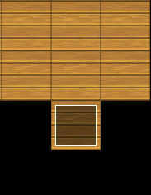
In the interior of the building, I like to add an extra floor tile to dhow the player where the exit is. Touching it will transfer them back out of the building onto the first map.
While you work on this challenge, think about your design language. How does the player know which doors they can and cannot open? By placing your doors and exits the same way every time, the players will never get confused about where they can go. It’s also good to block off exits and transfer events so the player can only touch them in one particular way. Whatever your choose, stay consistent throughout your whole game.

Well [Items, Text]
Create a well which your player can draw water from. This water will be an item the players can use later for healing and crafting.

Start by creating a Well map event on the map you want the players to be able to get Water. Then create an item in the database to represent the water. Finally, follow the flow chart to create the Well event.

Create: Map Event
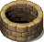 | Name | Well
 | Priority | Same As Player
 | Trigger | Action Button

Create: Item
  228 | Name | Water | Type | Regular Item
 | Consum. | No | Scope | None
 | Occasion | Never | Effect | None

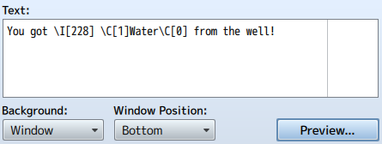When creating the text telling the player they got Water, you can use inserts. Hold your mouse still over the Text box to get a tooltip showing you the options. In this case, we display the Icon with \I[xxx], where ‘xxx’ is the number of the Icon you used for the Water Item. We also use \C[x] to switch the color of the text to blue ( 1 ) and switch it back to white ( 0 ).  You can always press the “Preview” button to see how your text will look in-game. It won’t show variables or gold correctly, however, so don’t rely on it 100% | 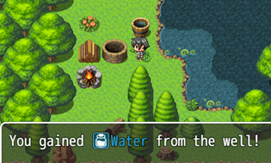 Using Icons and color in your text can greatly help your players understand what is an Item, what kind of item it is, and alerts them that this is something they should pay attention to. The Legend of Zelda: Ocarina of Time uses this to great effect. Have you played it? You should!

Fishing Spot [Variables, Items, Animations, Loops, Branches]
Design a fishing spot that goes over a body of water. Activating this spot gives you a random chance of catching a fish.

Start by creating a new Variable called “Fish Chance”. Then create a “Small Fish” item in the database. This fish will heal a party member if they “eat” it. Then create invisible event over a body of water to act as a fishing spot.

Create: Memory
Variables | Fish Chance

Create: Item
  260 | Name | Small Fish | Type | Regular Item
 | Consum. | Yes | Scope | 1 Ally
 | Occasion | Always | Effect | Recover 50 HP

Create: Map Event
 | Name | Fishing Spot
 | Priority | Same As Player
 | Trigger | Action Button

Follow this flow chart to program the game to let the player fish. Note that near the end, you as the programmer will be asked to make a decision. If you want there to just be one spot the player can fish at, you will have to add a splashing character image where the Fishing Spot is, so the player knows to fish there. Otherwise, you can decide that ANY body of water the player can reach can be fished at. If you do, you will have to copy and paste this event every there is water. This flow chart pattern is what we call a “for” loop. “For every blank space of water the player can touch, copy the Fishing Spot to it.”
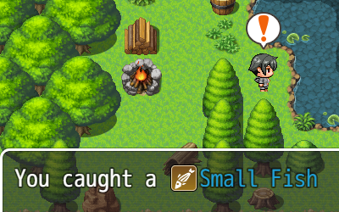
There are three kinds of animation used in this challenge. The first is choosing
a character image for the fishing spot if you want it to be visible. It should be
a whirlpool or bubbles, with “Stepping” checked in the options. You can make
splashing effects over the Fishing Spot with “Show Animation”, and you can
show player expressions by using “Show Balloon Icon”. Try them all out!

Cooking / Crafting [Items, Branches] Requires “Well” and “Fishing Spot”
Make a campfire that can be used to cook Fish Soup using Water and a Small Fish. After this challenge, you can create lots of recipes and add them to you game using the same concepts.

Start by creating a Fish Soup item in the database. This soup will heal a party member if they “eat” it, and should heal more than a Small Fish by itself. Then create a fire event over top of a campfire tile.

Create: Item
228 | Name | Fish Soup | Type | Regular Item
 | Consum. | Yes | Scope | 1 Ally
 | Occasion | Always | Effect | Recover 50 HP

Create: Map Event
 | Name | Campfire | Options | Stepping  Direction Fix
 | Priority | Same As Player |  | Stepping  Direction Fix
 | Trigger | Action Button |  | Stepping  Direction Fix

Follow this flow chart to program the game to let the player cook the soup:
There are two types of Decision Steps here. One is a “Show Choices”, with the option for many outputs. The other two are a normal “Conditional Branch”, each with an “Else Branch”.  p  You may want to experiment with adding fire animations over the Campfire when the player can successfully cook something. You can do this on your own, though. I won’t tell you how it’s done.  You can add more recipes to your cooking spot by adding more choices to the “Player Choice” step. | 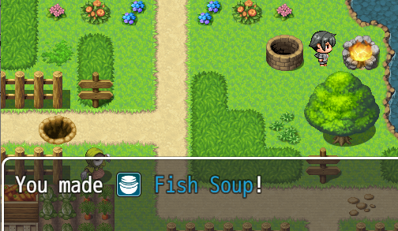

Time System [Switches, Branches, Common Events]
Add a time system to your game so that timed events can happen, such as a day/night system, farming and nocturnal monsters.

Create: Memory
Switch | Time Passing
Variable | Time Inc
Variable | Minutes
Variable | Hours
Variable | Days

In order to add a time system, we have to determine what speed we want the time system to move at. There are some cases where time passing in your game being as fast as time in real life is fun, but most of the time it would be super-boring. In the table below, a time system has been outlined for you to try out. An in-game increment is how many “game minutes” pass at a time, whereas “real increments” is how many real seconds it takes to move the game forward one time increment. When completing the flow charts below, refer to the table for amounts.

Purpose | In-Game Increments | Increments per In-Game Hour | Real Increments | Frames per Increment | Total Increments | Real Time / Day
Fast, Gameplay | 6 Minutes | 10 | 6 Seconds | 360 | 240 | 14.4 Minutes

Because the event we want to track time with could be used anywhere in the game, we should use a Common Event instead of a Map Event. Common Events are stored in the Database, instead of one particular map.

Complete the flowchart to add the Time System to your game:

A time system is no good if we don’t have a way of checking the time. For this, you can create a “Clock” map event, or a “Watch” item. This can call another Common Event that simply display the time in a Message. You can add a Control Character to your message to display the Variables for Minutes, Hours, and Days by their numbers.
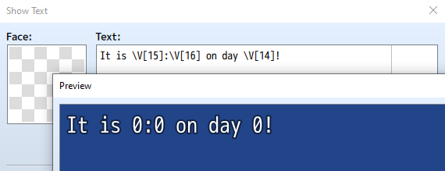

Day/Night System [Switches, Branches, Common Events] Required: Time System
Time systems are a little useless without Day and Night, so create the effect of the sun rising and falling.

Whenever we are outside, the sun should be lighting our game world in a way that is consistent with the current game time (unless you have a whacky fantasy world where the light doesn’t come from a sun). For this, we will create a switch called “Outside” and a Common Event called Day/Night.

In the new Common Event, add the commands as shown in the flow chart below:
The first of two really important things to remember is that we need to use the Map Loader event on every map to set whether or not that map is “Inside” or “Outside”, by turning the “Outside” switch ON or OFF. Inside maps should already be adjusting their light levels in their own map loader.
Insert the following into the flowchart for Time System:

The second important thing we need to know is that the only way make the game adjust the colors of the lighting is by “calling” the event. Unlike other events in the game, this “Day/Night” event cannot run automatically or whenever we press a button. It has to be run as part of another event. The game will “jump” from one event, do the commands in the day night event, then jump back to finish the first event. This is called a “jump”, “function”, or “subroutine”.

The event that will “call” the “Day/Night” event is the “Time System” event. Just insert a “Common Event…” command between where it adds to the “Time Inc” and checking to see if the day as passed.

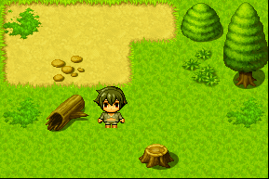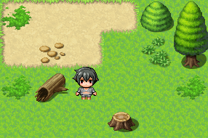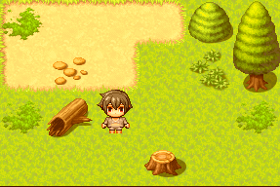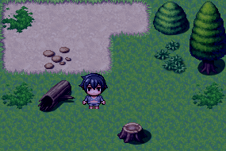

Achievements [Switches, Loops]
Track the things your players achieve as they progress through the game, so they can see all fo their accomplishments.

A videogame staple since the Xbox 360/PlayStation 3 era, achievements are addictive little awards your players can get as they progress through your game. A little bit of work on an achievement system can add hours of extra gameplay to your game as players track down and build towards unlocking them all.
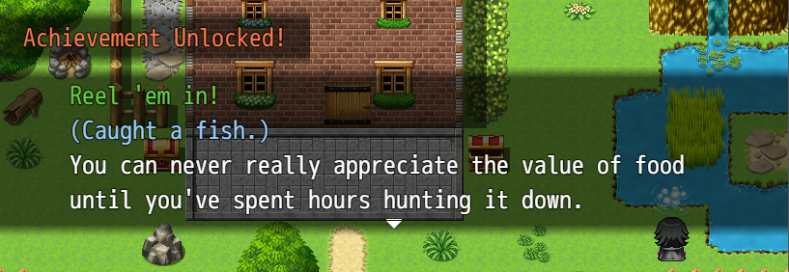
Each achievement will have two components: The initial unlock message, which turns the correlated Switch ON, and a place where we can check the achievements. The easiest way to do the second part is to just have events that only appear in your house if the achievement’s Switch is ON.
Follow the flow chart to complete this challenge:
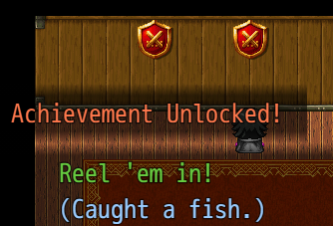

Lootboxes [Loops, Branches, Common Events]
Make an item with a random surprise inside. Players can unlock one or many at a time.

After achievements lost their effectiveness, the designers of the next generation had to come up with another gimmick to keep their players helplessly addicted and throwing their money away obtaining a sense of pride and accomplishment. We won’t be giving away any pay-to-win items or charging for any in-game microtransactions, but we will emulate this system in our game for a bit of fun. We will also allow the players to use a Lootbox to open every Lootbox they have at once.
This is a rare example in RPG Maker of a “while loop”. It works something like this: While the Boxes To Open’s value is greater than zero, repeat these steps. You will see other types of loops in other challenges, too, such as the “for loop” (For every item in this list, repeat these steps with each item). Loops are incredibly useful tools in programming that rarely appear in RPG Maker. However, there are “Autorun” and “Parallel” start conditions that always loop.
Create: Item
210 | Name | Lootbox | Type | Regular Item
 | Consum. | No | Scope | None
 | Occasion | Menu | Effect | Common  Event, Lootbox

Create: Memory
Variables | Boxes to Open  Random Generator

Another common programming technique we use here is called a “function”. This is when you have a premade block of code that you can jump to and jump back from. Technically, all events are “functions”, but Common Events are the best example. In the “Lootbox” Common Event, we jump to the “Unbox” Common Event, and the game jumps back to where we were in “Lootbox” when it is done. This allows us to use the “Unbox” code in other parts of our game without writing all of the code again. “Unbox” would be great to reuse for the “Sniff Spot” challenge, instead of giving the player a single item.

Create the Boulder Pass
Design the first “dangerous” region of the game. Players will explore this area, finding treasure and monsters, then defeat the local dungeon to progress.

Now that we have our home ready to go, we can work on the first region our players can adventure in. We will design the “Boulder Pass”, a rocky region whose path leads to Atown, the town our school is in. I made mine snowy in the image below, but you can make it grassy, rocky, or even sci-fi. The important part is there will be a nearby “Dungeon” that holds the treasure we need to move a boulder, or other heavy object.
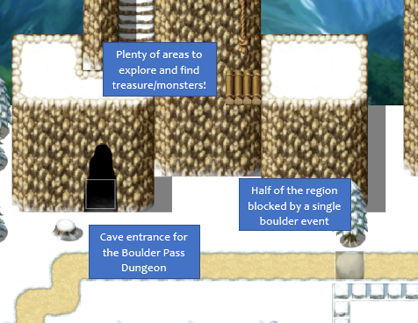
A classic Adventure RPG gameplay loop is one like the Zelda series, which typically goes like this:

- Find new region
- Explore the region, noting places you can’t get to yet
- Get to the region’s dungeon
- Fight the Dungeon’s Boss
- Get the Dungeon’s Treasure
- Use the treasure to get to the places you couldn’t earlier
- Repeat

We left our home to discover the Boulder Pass. We can go a few places, but half of the map is blocked off by a boulder. If we enter the Boulder Pass Dungeon, defeat the Boss, and get the treasure (the Power Bracelet), we can move the boulder and continue to the next region in the game.

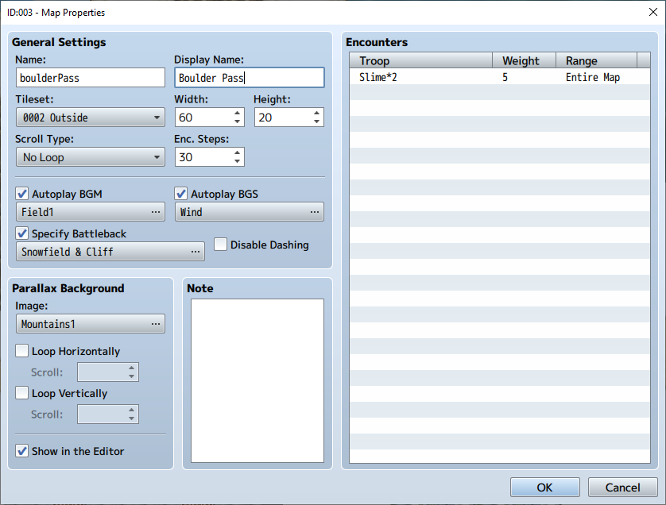
Let’s pay closer attention to our Map Properties this time (right-click on the Boulder Pass map you made in the Map Viewer and select “Edit…”). Because we will be fighting random monsters, we need to “Specify Battleback”, which is the background used in combat. If you do not, the game will just default to a picture of the game map without events.
You can add monster groups to be randomly encountered by double-clicking the first empty spot of the “Encounters” list, and adding a “Troop” in. Slimes are a classic first monster for Adventure RPGs, so I used that.
We will have to make the map a little larger as well. If you want, you can use a “Parallax Background”, which will show behind transparent or missing tiles in your map.
Finally, don’t forget to add a Transfer event from your home to the accessible part of Boulder Pass, and a Transfer event the sends you back to your home.

Power Bracelet [Items, Conditional Branches] Recommended: Create the Boulder Pass
Design a classic game mechanic to push “boulders” that block our path once we’ve obtained the magic item “Power Bracelet”.

A classic RPG item is the Strength Booster. Usually, this item has no real effect on your character’s actual Attack score or anything else in the game, but it does allow you to push movement blocking events out of your way. In our case, we will use the Power Bracelet to push a Boulder out of the way. Start by creating the Item and Event:

Create: Item
  145 | Name | Power Bracelet | Type | Key Item
 | Consum. | No | Scope | None
 | Occasion | Never | Effect | None

Create: Map Event
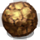 | Name | Boulder
 | Priority | Same As Player
 | Trigger | Action Button

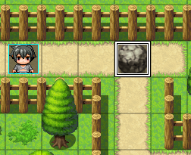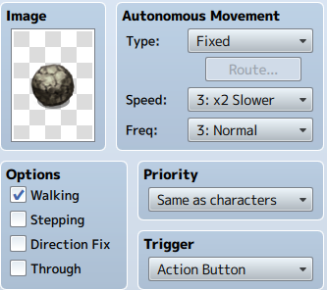
If this is your first time using a Decision Step (Diamond), be sure to explore the “Conditional Branch” command event in its entirety. You do not need to edit the Event’s “Conditions” section.
When complete, you can copy/paste the boulder event around your game.

Then follow the flow chart below to complete the challenge. This boulder will walk/move one step away from wherever the Player is standing when they use the Action button while possessing the Power Bracelet. Do not remove, teleport, or move the boulder in a fixed direction.

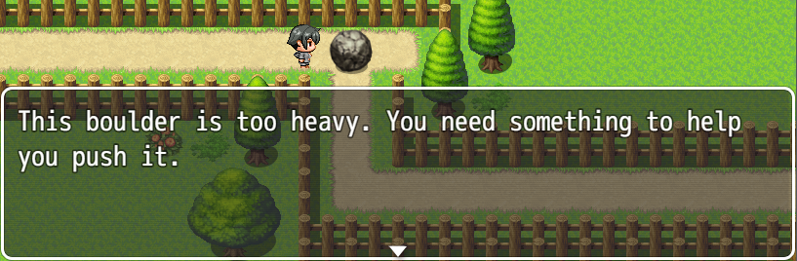

Bonus Challenge: Once you have this challenge complete, can you edit doors in your game to play an effect and explode when you try to open them? The Power Bracelet must be giving you too much power.

Remote Door Lock [Switches, Event Pages] Recommended: Boulder Pass Dungeon
Design a door that can only be opened by pulling a lever elsewhere in the game.

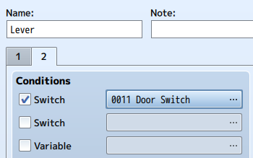
Another classic mechanic is many types of games, especially adventure games, is the remote door lock. In this case, we will use it to force our players to explore the Boulder Pass Region before entering the Boulder Pass.

Start by creating two map events, a door and an lever. Each will have two Pages, one for open and one for closed. In my game, I placed the lever high on a mountaintop, and the door inside the Boulder Pass dungeon cave. It will be the first door the players see before actually entering the dungeon.
Create: Memory
Switches | Door Switch

Create: Map Event
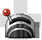 | Name | Lever
 | Priority | Same As Player
 | Trigger | Action Button
 | Page | 1
 | Condition | None
 | Options | Direction Fix

Create: Map Event
 | Name | Lever
 | Priority | Same As Player
 | Trigger | Action Button
 | Page | 2
 | Condition | Door Switch
 | Options | Direction Fix

Create: Map Event
 | Name | Door
 | Priority | Same As Player
 | Trigger | Action Button
 | Page | 1
 | Condition | None
 | Options | Direction Fix

Create: Map Event
 | Name | Door
 | Priority | Below Player
 | Trigger | Player Touch
 | Page | 2
 | Condition | Door Switch
 | Options | Direction Fix

Then follow the flow chart below to complete all of event pages and the challenge. You can also add your own screen shake and text messages to enhance the actions of the door/lever.

Create Events  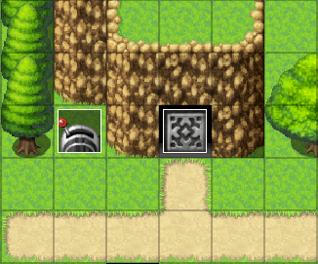 | Lever is off. Door is closed.  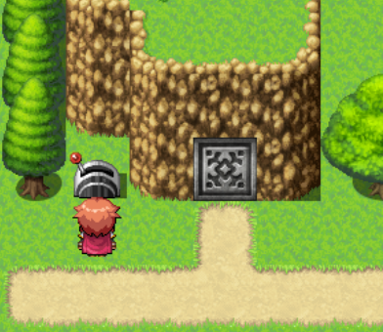 | Lever is on. Door is open.  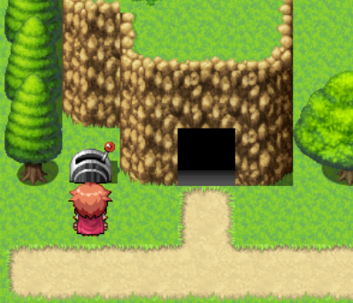 | The most important thing to remember from this challenge is that the Event Page with the highest number and all of its conditions met will be the active Event Page. When the Door Switch is ON, the Page 2 of each event has all of its conditions met. When it is OFF, Page 1 is the only one with all of it’s conditions met.

Dungeon Keys [Self- Switches, Event Pages] Recommended: Boulder Pass Dungeon
Every classic dungeon has a series of doors that can be opened with one-time-use keys found throughout the dungeon. The “Boss” monster has a special key for themselves.

A large portion of RPG game design is guiding your players through an experience at the right pace. Many games help do this in dungeons by adding a key system. These keys can only be used in the dungeon they were found in. The keys and doors are spread through the dungeon, creating a “linear” experience while giving the player a sense of exploration and discovery. For this challenge, you will create two kinds of doors and two kinds of keys. A ‘Dungeon Key’ opens all ‘Dungeon Doors’, and a ‘Boss Key’ opens the ‘Boss Door’. You can hide the keys in chests around the dungeon. One key per door.

Create: Map Event
 | Name | Dungeon Door
 | Priority | Same As Player
 | Trigger | Action Button
 | Page | 1
 | Condition | None
 | Options | Direction Fix

Create: Map Event
 | Name | Dungeon Door
 | Priority | Below Player
 | Trigger | Action Button
 | Page | 2
 | Condition | Self-Switch A
 | Options | Direction Fix

Create: Map Event
 | Name | Boss Door
 | Priority | Same As Player
 | Trigger | Action Button
 | Page | 1
 | Condition | None
 | Options | Direction Fix

Create: Map Event
 | Name | Boss Door
 | Priority | Below Player
 | Trigger | Action Button
 | Page | 2
 | Condition | Self-Switch A
 | Options | Direction Fix

Create: Item
  195 | Name | Boulder Pass Key | Type | Key Item
 | Consum. | No | Scope | None
 | Occasion | Never | Effect | None

Create: Item
195 | Name | Boulder Pass Boss Key | Type | Key Item
 | Consum. | No | Scope | None
 | Occasion | Never | Effect | None

The second page of each Door event will be left totally blank. This is the easiest way to allow the player to walk freely though the doorway once it’s been unlocked. Because of this, we only need one flow chart for the first page of each Door. Because the function is identical between doors except for the key we need, we will recycle the flow chart for both types of key/door combination.

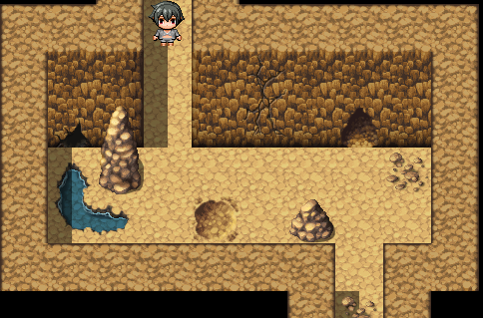
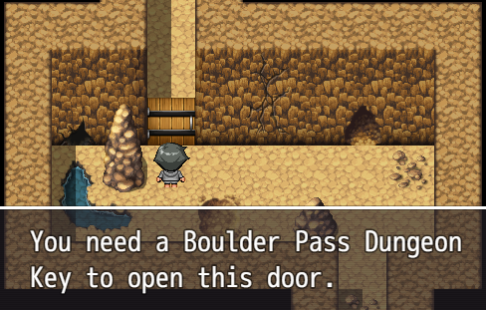
Self-Switches are different than regular switches, in that only the event that owns it can change it. They also retain their Switch state when leaving the map and coming back.

One Step Tile Puzzle [(Self) Switches, Event Pages] Recommended: Boulder Pass Dungeon
Yet another classic in RPG games. To solve the puzzle, you must step on each tile once, and only once.

In this challenge, we’ll add a One Step Tile Puzzle to our dungeon. There will be a grid of tiles, that when stepped on, change color. If you step on one twice, it will reset the puzzle and send the player back to the beginning.
To do this, we will use a variable to count how many tiles have been stepped on. If the number is greater than or equal to the number of tiles, the door opens!
Create: Memory
Variables | TileCount
Switches | ResetTiles

Create: Map Event
 | Name | Tile Door
 | Priority | Same As Player
 | Trigger | Action Button
 | Page | 1
 | Condition | None
 | Options | Direction Fix

Create: Map Event
 | Name | Tile Door
 | Priority | Same As Player
 | Trigger | Action Button
 | Page | 2
 | Condition | TileCount
 |  | >= 25

Create: Map Event
 | Name | Tile
 | Priority | Below Player
 | Trigger | Player Touch
 | Page | 1
 | Condition | None

Create: Map Event
 | Name | Tile
 | Priority | Below Player
 | Trigger | Player Touch
 | Page | 2
 | Condition | Self-Switch A

Create: Map Event
 | Name | Tile
 | Priority | Below Player
 | Trigger | Parallel
 | Page | 3
 | Condition | ResetTiles

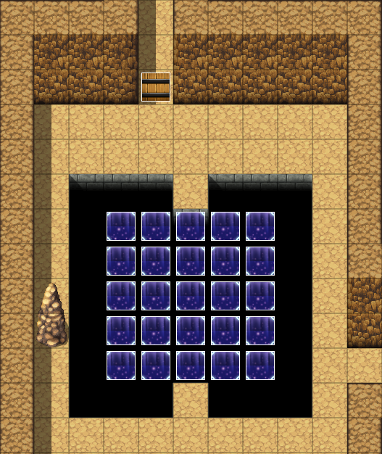
There are two events. A door with two pages, and a tile with three pages. After we finish the tile event code, we will copy and paste it to make the grid. In this challenge, the door event’s second page requires “TileCount” to be greater than or equal to 25, but if you have more or less tiles, you will need to change that number to the number of tiles in your puzzle. 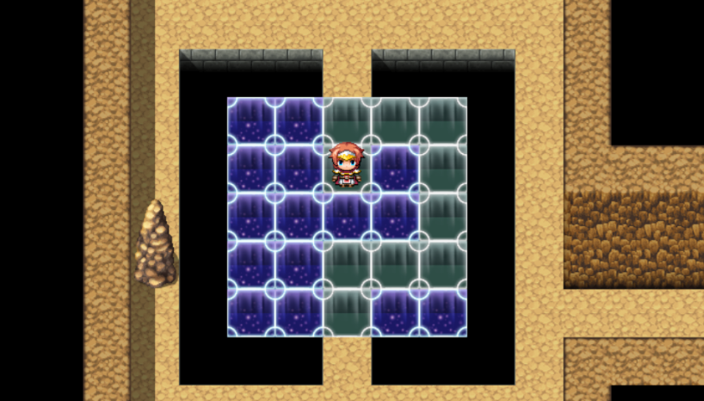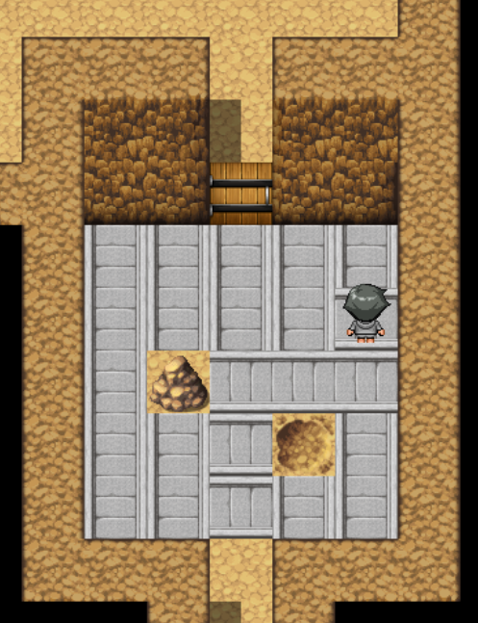

Create A Town
Every adventurer needs a place to rest their head, buy supplies, and get ready to head back out on the road. We’ll create a town for players to recharge their characters.

Bank Teller [Variables]
Add an NPC to a Bank in the town that can track your withdrawals and deposits of gold into your bank account.

I’ll be honest with you. I’ll even speak in first person for this one… We don’t really need a bank in our game. Runescape has a bank, because you have limited backpack space and drop your gold when you die. The Legend of Zelda: Majora’s Mask had a bank, because you would lose all of your rupees when you travelled back in time. In a classic RPG, your gold is pretty safe in your inventory. You don’t really need a bank to keep your gold safe in your game. However, this challenge is very good practice for those who want to become programmers. You will learn to compare variables directly to each other, and check for user errors. Follow the flowchart for the NPC below to make a bank teller who can handle all of your banking needs.
Create: Map Event
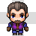 | Name | Bank Teller
 | Priority | Same As Player
 | Trigger | Action Button

Create: Memory
Variables | Transaction  HeldGold  BankAccount

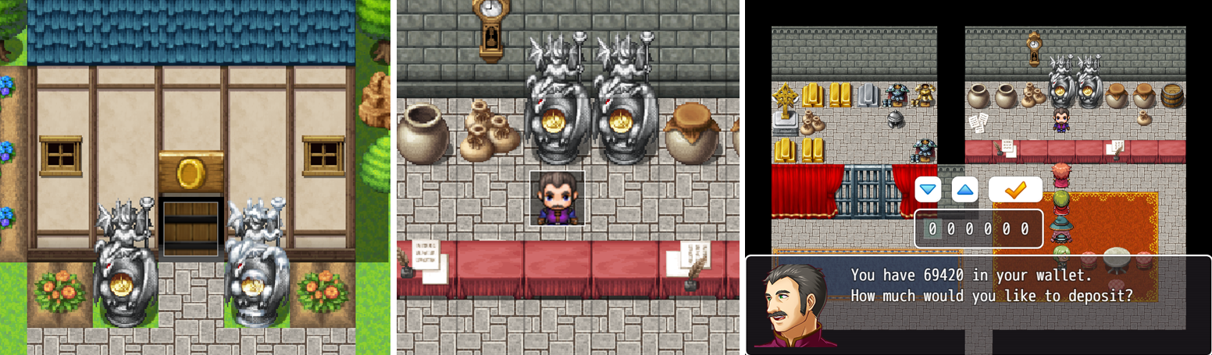

Reputation System [Variables] Required: Game / Map Loader
Add a series of variables that will be used to track your player’s “reputation” in the world. A single variable will be a “reputation score” that tracks your current reputation.

 | Create: Map Event
  Variable Name | Value
  Rep Default | 25
  Rep Bad | 10
  Rep Neutral | 20
  Rep Good | 30
  Rep Revered | 40
  Rep Max | 50
  Reputation | Rep Default
  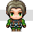 | Name | Gossip
   | Page | 1
   | Trigger | Action
  Reputation Level | Range
  Evil | 0-10
  Bad | 11-20
  Neutral | 21-30
  Good | 31-40
  Revered | 41-50
To create a Reputation system, you must do several things. First, determine the “ranges” of each reputation bracket. The last table to the right has done this for you. After that, create the 7 variables in the first table to the right. Then, in your Game Loader, insert commands to set the 7 variables values to the values in the first table to the left. Finally, make a Gossip NPC, and two events that can raise and lower your reputation.
Remember the trapezoid in the flow chart from “Game Initialization Event”? That is where you insert the command events from the table above. Variables whose values are set once and never change are known as “constants”. As we test our game, if we decide we want to change the values of our reputation system, we don’t have to track down every instance of them in the game. We just change the “constant” once. The Gossip NPC demonstrates this (flowchart below). Other challenges will use this system as well.
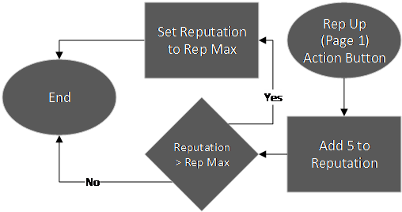
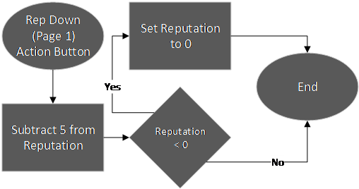
These two smaller flowcharts are code you can add to other events to add or subtract reputation from the player. For example, killing cute animals will make you lose reputation, while rescuing them makes you gain reputation.

Market Stall Stealing [Switches, Branches, Movement, Event Pages]
Add a market area where you can buy supplies, or even steal them! If you get caught, the guards will attack you.

In this challenge, you will not be given a flow chart or any creation prompts. You will instead get an outline of what the events are supposed to do, and you can build the challenge and flow chart yourself.
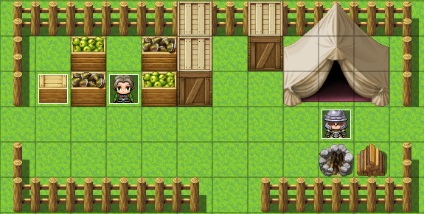
You will need four events:
- A Stall Vendor NPC with two pages
  - On the first page, give them a Custom Movement Route that makes them face up, right, down, and left. If you speak to them, they can sell you food items.
  - On the second page, the “Wanted” switch must be ON, and the Custom Movement Route instead faces the Player. If you speak to the NPC, they accuse you of being a thief.
- A Food Crate with two pages
  - On the first page, the Image is a full food crate. On Action Button:
    - if the Stall Vendor NPC is facing AWAY from the player, give the player one food item (always tell them when you give them an item), and turn Self-Switch A ON.
      - You can determine if the Stall Vendor is facing away by comparing the NPC’s and player’s X and Y coordinate on the map, or by hard-coding one direction into the NPC’s commands.
    - If the NPC is not facing away, make the Stall Vendor accuse you of stealing, and turn “Wanted” ON. If you have a reputation system, reduce the player’s reputation score.
  - On the second page, the Image is an empty crate. On Parallel Trigger, wait 5 seconds and turn Self-Switch A OFF.
- A Guard NPC with two pages
  - On the first page, the Action Button will make the guard tell you about how he used to be an adventurer like you.
  - On the second page, the “Wanted” switch must be on. The Custom route makes the guard approach the player rapidly, and if the guard NPC touches the player, start combat with a Guard Enemy. If the player wins the combat, Erase this event.
- A bartender, theifmaster or gossiper with one page
  - If “Wanted” is on, they will offer to turn it back off for money
    - Make sure the players cannot spend money they don’t have
  - Otherwise, they offer their normal services (shops, reputation, etc)

Butterdog [Event Pages, Switches] Recommended: Forest Pass
Create a new hero that can join us in our adventures. This one will have a wet noise and extra legs.

The “party” is one of the best conventions of RPG’s. A variety of non-playable characters (NPCs) help drive the story and cover weaknesses in your playable character’s (PC’s) stats. We will design a support character that can help heal and strengthen our main character throughout their adventure. What better way to help our character than with “man’s best friend”? And not just any dog. We are going to add Butterdog, the dog with the butter on him! (I’m sorry if you don’t understand this ancient meme)

Max HP | B | Max MP | A
Attack | E | Defense | B
M.Attack | A | M.Defense | B
Agility | D | Luck | D
In your Database, create a new class in Classes called “Companion Dog”. We will want to make a “pacifist” sort of character. They will be much more defensive than offensive, so when we edit their “Parameter Curves” we will use “Quick Setting” B for “Max HP”, “Defense”, and “M.Defense”. Butterdog would rather use healing moves than bit someone, so we’ll make their “Max MP” and “M.Attack” an A (M.Attack affects healing spells, too), and their “Attack” an E. Agility and Luck we will make a D.
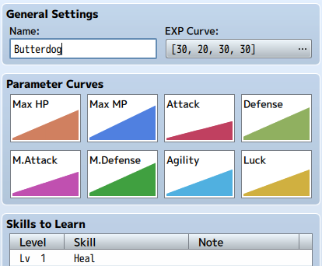
We also want to make sure they have any defensive/supportive spells listed under “Skills to Learn” on the levels you think they should learn them at.

While we’re here, let’s take a look at their traits. Butterdog doesn’t have thumbs, so we should probably delete the “Equip Weapon: Dagger” slot. We can also change their “Equip Armor” to “Light” or “Magic Armor”. By default, RPG Maker MV doesn’t have any of these kinds of armor, but you can easily make them. Finally, it’s critical that we add the trait “Add Skill Type: Magic”, otherwise, they will not be able to cast their spells.

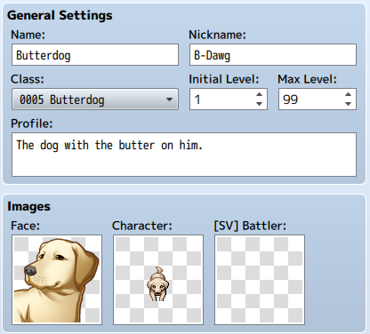

Now we just need to add an Actor that has the new Class. This is the actual character, so we’ll name him “Butterdog”. Maybe there will be another “Companion Dog” someday? Make sure the Images are set to a dog graphic. We don’t have a Battler graphic by default, but this only matters if you want to have a Side View battle system.

Once we have our new Actor, we need to add him to our game. Cutscenes are a classic way of introducing plot points. Dogs and humans love each other, so we don’t really need a compelling story reason to pair up with Butterdog. We do need a little bit of dialogue and flashy graphics/sounds to sell the new companionship to the player, though.

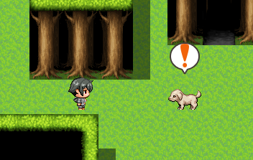
Find a place in your Forest Pass that the player has to step on to advance, and place an invisible event there that triggers when a player steps on it (or just Autorun an event when you first enter the map). Create a second event that’s a “dummy” Butterdog. Both events should have an empty second page that requires a Switch named “ButterDogMet” in the Conditions. This will keep the events from appearing again after you have seen the cutscene. On the first page of the triggering event, add some dialogue and animations, add Butterdog to your party, and finish by turning “ButterDogMet” ON.

Enjoy the new companion!

Sniff Spot [Event Pages, Variables] Required: Forest Pass and Butterdog
Design an event that randomly generates a spot that can only be found if Butterdog is in your party. Checking this spot will give you a free item!

In this challenge, you will not be given a flow chart or any creation prompts. You will instead get an outline of what the events are supposed to do, and you can build the challenge and flow chart yourself.
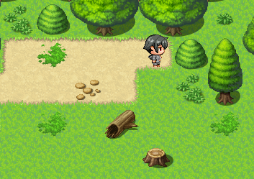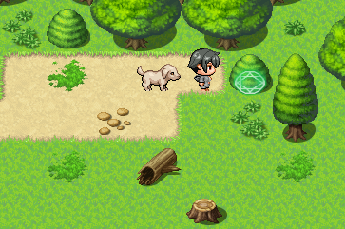
With Butterdog
Without Butterdog
Create: Map Event
 | Name | Sniff Spot
  No Image | Name
  No Image | Page
  No Image | Trigger
 | Page | 1
 | Trigger | Parallel

Create: Map Event
 | Name | Sniff Spot | Self-Switch  Options | A  Stepping
 | Page | 2 | Self-Switch  Options | A  Stepping
 | Trigger | Action | Self-Switch  Options | A  Stepping

Create a “Sniff Spot” event that has two pages:
- The first page Triggers on Parallel, allowing it to automatically run without locking up the game. It has no image.
  - Generate a random number between 1 and 100, and store it to a variable.
  - If that random number was greater than 70, turn Self-Switch A ON.
  - Otherwise, Erase this event. It will respawn when you re-enter the map.
- The second page requires Butterdog to be in the party, and Self-Switch A to be on. It is triggered by the Action Button and is the Same As Player. Give it an image that shows the player they can investigate that spot.
  - When the player interacts with this event, add an item of your choice to their inventory (always tell the player when you add an item to their inventory).
  - Turn Self-Switch A OFF, so the next time this event is spawned it will try to generate an item again.
  - Erase this event. It will respawn the next time you enter this map.

Once you are done, copy/paste this event to hiding spots throughout all maps in the game.

Magic Feather Jump [Branches]
Design a hole in the ground that can only be jumped over if the party owns a “Magic Feather” item. Make sure they cannot jump over something if the other side is blocked by an impassable tile.

Just like the Power Bracelet, many RPG games are filled with “progression items”. The gameplay loop is simple. Unlock new region, defeat challenge to receive item, use item to unlock next region. This time we will make a feather that makes the player character so light, they can jump over large gaps.
Create: Item
 | Name | Magic Feather | Type | Key Item
 | Consum. | No | Scope | None
 | Occasion | Never | Effect | None

Create: Map Event
 | Name | Hole
 | Priority | Same As Player
 | Trigger | Action Button

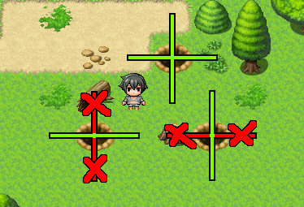
To keep the design language consistent, we’ll show the player which gaps they can jump by using a hole image. However, just like the Fish Spot, you can copy/paste an invisible hole event over any natural gap in the map if you prefer that.
Another unusual part about this challenge, is that while there is only one “hole” event that can be copy pasted, each iteration of the hole needs to have its commands checked. If the user cannot jump horizontally or vertically across it, because it is blocked on the other side, then we must remove the commands to handle jumping in that direction. There will be three variations of the hole in the end. Pay attention to the white shapes in the flowchart. Those are instructions for you, the programmer.

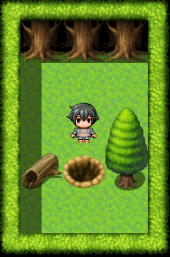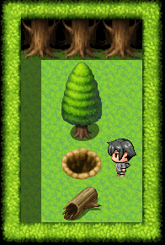

Torches [Common Events, Loops] Requires: Game/Map Loader
Make an item that can light up dark caves and dungeons. Add special effects to your game to really convince your players that they are using a torch.

Classic Pokémon games had a Hidden Machine ability called “Flash”. Some caves were so dark, you couldn’t see where you were going. Using the “Flash” ability lit up the cave and let you navigate it easily. We’ve talked about “progression items”, but now we will make a “soft progression item”, which isn’t required to beat the game, but is really helpful.
Create: Item
 | Name | Torch | Type | Regular
 | Consum. | Yes | Scope | None
 | Occasion | Menu | Effect | Common Event

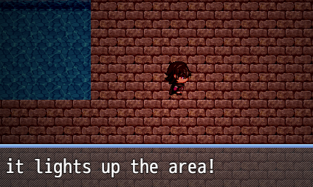
This challenge integrates with other challenges, such as Time System and Day/Night System, quite well. You absolutely need to complete the Game/Map Loader first, however. This allows you to correct the screen colors when extinguishing the torch, and to determine which maps are dark enough to need a torch.

We will use two Common Events. One to attempt to light a torch, and another handle turning off the torch when we enter a bright place again. You can make a “Torch” item or a “Light” spell to call the “Light Torch” Common Event.

Fishing Skill and Rods
Expand upon Fishing Spot by adding a Fishing Rod item and a skill that will grow over time.
New Item
  260 | Name | Small Fish | Type | Regular Item
 | Consum. | Yes | Scope | 1 Ally
 | Scope | 1 Ally | Effect | Recover 50 HP

Fishing Varieties
Expand upon Fishing Spot and Day/Night Cycle by adding larger fish, and fish that can only be caught at night.

Multi-Remote Door Lock
Dungeons across many games use the timeless multi-remote lock mechanic. To ensure your players use every inch of the dungeon you made, you can put a single lever at the end of each “wing” of the dungeon. Once the player has found and flipped every lever, the door in the center of the dungeon opens, allowing the players to proceed to the climax of the delve. For added flare, we can add magic torches that indicate to the player which levers have been flipped so far.

Combination Door Lock

Market Stall Theft (solutions by Russel FB)
Create a farmer’s market stall that we can steal from when the owner isn’t looking.

Start by creating the following game objects:
Create: Map Event
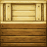 | Name | Stall
 | Page | 1
 | Trigger | Action

Create: Map Event
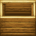 | Name | Stall | Self-Switch | B
 | Page | 2 | Self-Switch | B
 | Trigger | Parallel | Self-Switch | B

Create: Map Event
 | Name | Farmer | Auto Move | Custom
 | Page | 1 | Auto Move | Custom
 | Trigger | Action |  | Custom

Follow the flowchart below to complete the challenge:
For example, if the owner is standing to the upper right of the stall, you need to check to see if he’s facing RIGHT and check if he’s facing UP. Both of those directions turn Self-Switch A on. Self-Switch A signals a successful steal. Self-Switch B causes the owner to wait to “restock” the missing merchandise.

Pickpocketing
Make some NPCs in your game that you can steal items from if you approach and interact with them from behind.
This challenge uses one Variable named “Player Facing” and several “NPC Facing XX”. XX is the number of the NPC you are tracking with this Variable (see flowchart)
Create: Memory
Variables | Player Facing
 | NPC Facing XX

Follow the flowchart below:

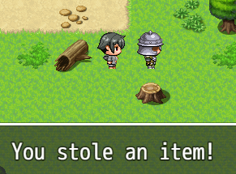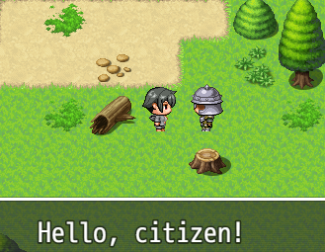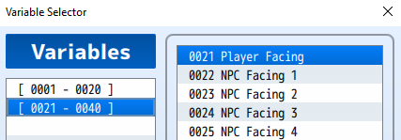
Normal
From behind
For example, the first NPC you want to track will use a variable named “NPC Facing 1”. The second will use “NPC Facing 2” and so on.

Butterdog Sniff Spell
Design a spell that can only be used by Butterdog that shows the HP of enemy monsters.

Starting Gear Chest  Guard Arrest  Magic Mirror Transfer  Thirty-Second Town Portal  Slot Machine/Dice/Lootbox  Door Switch Puzzle  Name Password  Lens of Truth  Lost Woods  Boss Monster HP Formbar  Granny Storekeep  Ice Skate Puzzle  Boulder Ice Puzzle  Lockpicking  Torches  Minimap + Compass  One-way Ledge  Walking Monsters + Mimics  Fishing/Farming/Cooking/Thieving Skill  Pogs and Pog Store  Pog pouch  Reputation Effects  Reputation Reset NPC (Thieves guild)  Sneaky Boots ???  Running Boots  Lava Walking Boots / Snorkel  Hookshot  Farming with Seeds  Farming with Watering Can  Magic toot  Jail Sentence  Sit/pass time  Bad rep bounty hunters | Mushrooms grow at night  Campfire from wood  Pog lottery  Poison mushroom  Blaster wand (ability weapon)  “Battlepass”  Weatherstone

Dad Joke Generator
function addNewlines(str) {
var result = '';
while (str.length > 0) {
result += str.substring(0, 50) + '\n';
str = str.substring(50);} return result;}
function reqListener () {
console.log(this.responseText);
$gameMessage.add(addNewlines(this.responseText))
}
var xhr = new XMLHttpRequest();
xhr.addEventListener("load", reqListener);
xhr.open("GET", "https://icanhazdadjoke.com/");
xhr.setRequestHeader('Accept', 'text/plain')
xhr.send();

Create: Actor
No Image | Name | Init
No Image | Other | This Actor totally blank!

dasdadasdadadasdadsaddddddddddddddddddddddddddddddddddddd

◆Text：None, Window, Bottom
：Text：Would you like to fish?
◆Show Choices：Yes, No (Window, Right, #1, #2)
：When Yes
◆Show Balloon Icon：Player, Exclamation (Wait)
◆Text：None, Window, Bottom
：Text：You caught a fish!
◆
：When No
◆Text：None, Window, Bottom
：Text：You're right. Fish murder is probably bad.
◆
：End

