e-home loan system
Business Requirements Document (BRD)

Version i

Version and Approvals
UTORS

Version History
Version # | Date |  | Revised By | Reason for change
0.1 | 2021-08-21 |  | Nick | init

This document has been approved as the official Business Requirements Document for e-home loan system, and accurately reflects the current understanding of business requirements. Following approval of this document, requirement changes will be governed by the project’s change management process, including impact analysis, appropriate reviews and approvals.

Document Approvals
Approver Name | Project Role |  | Signature/Electronic Approval | Date
Nick | PMO

Table of Contents

Version and Approvals i
项目详细 1
Overview 1
Document Resources 1
Glossary of Terms 1
Project Overview 1
4.1 Project Overview and Background 2
4.2 Project Dependencies 2
4.3 Stakeholders 2
Key Assumptions and Constraints 2
5.1 Key Assumptions and Constraints 2
Use Cases 2
Use Case Diagram 2
3
Use Case Narrative 4
5
Business Requirements 6
Appendixes 9
Appendix A – Business Process Flows 9
Appendix B – Business Rules Catalog 12
Appendix C- Models 12
Traceability Matrix 12
Use Case Narrative Instructions 12

Business Requirements Document (BRD)

项目详细

项目名称 | E-home loan system
项目类型 | New Initiative
项目开始日期
项目结束日期
项目发起人 | Nick
Primary Driver | 安全，风险控制，监管，抵押物品处置
Secondary Driver
Division | none
项目经理

概要

本文档从高层次定义项目的业务需求。他将作为基础被使用在以下方面：

- 创建解决方案设计
- 开发测试计划，测试脚本，测试用例
- 决定项目完工
- 评估项目成功

文档资源

Name | Business Unit | Role
2020Advisory_Philhelp.pdf | 法务部门 | 菲律宾关于p2p业务的法律
https://www.sec.gov.ph/lending-companies-and-financing-companies-2/relevant-laws-and-irrs/ | 法务部门 | 菲律宾关于p2p行业的相关法律和实施细则
https://www.moneymax.ph/personal-finance/articles/credit-score-philippines | 法务部门 | 菲律宾信用得分以及信用得分的影响
https://filipinowealth.com/how-to-set-up-a-lending-business-in-the-philippines-full-guide/ | 法务部门 | 怎样注册p2p公司
https://www.biia.com/credit-information-corporation-cic-cibi-information-inc-and-crif-philippines-report-an-increase-in-credit-report-inquiries | 开发部 | 隶属于菲律宾政府的信用评级机构

术语表

Term/Acronym | Definition
P2P借贷(peer-to-peer lending) | P2P借贷 按照字面意思就是点对点的借贷方式。这是一种基于互联网的新的投资理财方式。这种投资理财的特点就是P2P作为一个中介平台，撮合投资方和借贷方完成借贷交易。P2P平台会将收集到借贷信息打包成金融产品在平台上发布，P2P平台对信息的真实性负责。所有公布出来的产品一般需要有明确的借贷周期以及借贷利息。平台方除了提供必要的基本信息，也会提供一些收款并且将收取的钱按照合同规则规定的数额打到投资人账户。投资人的资金原则上不进入平台方的账户，只在借贷人由于自然原因无法提供账户或者电子钱包的情况下，平台方代收，并且在2个工作日之内将资金转给贷款人。投资方和借贷方不需要面对面，投资人根据合同约定，获取固定利息，而借贷人根据合同约定偿还投资人本金和利息。
众筹(crowdFunding)
投资人(investor/lender) | 想通过自有资金在本p2p平台上进行投资从而获取收益的自然人。目前暂时不考虑接受任何机构或者群体进行投资行为。
借贷人(borrower) | 借贷人是进过平台身份信息核实的具有借款需求的自然人。在系统建设初期我们将把主要关注力放在菲律宾OFW上面，当然如果有其他一些具有良好信用记录的用户也可以成为本平台的借贷人，但不是目前的主要关注人群。有特别重要的一点是，目前将借贷人特别限定在自然人上，不接受公司或者群体的贷款。
借贷利率(interest rate) | 借贷利率是借贷双方通过p2p平台撮合最终确定的贷款利息比率.利息=贷款金额 * 贷款利率。
人脸识别 | 人脸识别技术是一种人体生物特征的一种身份验证的技术，可以确保每个使用本p2p平台的借贷人和投资人都是自然人本身，不会被别有用心的人用假身份信息进行欺诈
区块链(block chain) | 区块链技术从技术上对p2p业务的真实性进行数据层面的保障，确保没一笔平台业务都是真实的，可以接入监管机构，从而方便监管机构可以对业务进行实时的监控。
业务监管机构 | 业务监管机构负责对p2p 贷款业务进行监管，确保没有或者减少欺诈行为的发生，对p2p平台的业务进行规范化管理，确保p2p平台在法律框架范围内正常合法的运行，从而保障投资人利益以及不对社会金融秩序进行冲击。

Project Overview

4.1 Project Overview and Background
<This information can be taken from the Project Charter. This is a brief description of what the project is about. It includes the current situation, the problem and the objectives. This section serves as the vision statement for the requirements. Each requirement should bring the project closer to the vision.>

4.2 Project Dependencies
<List any related known projects that relate in whole or in part, or has a dependency on this project.>

4.3 Stakeholders
The following comprises the internal and external stakeholders whose requirements are represented by this document:

Stakeholders
1.
2.

3.

Key Assumptions and Constraints

5.1 Key Assumptions and Constraints

# | Assumptions
 | List any assumptions the requirements are based on
# | Constraints
 | List any constraints the requirements are based on

Use Cases
< The primary purpose of the Use Case is to capture the required system behavior from the perspective of the end-user in achieving one or more desired goals. A Use Case contains a description of the flow of events describing the interaction between actors and the system. The use case may also be represented visually in UML in order to show relationships with other the use cases and actors>.

Use Case Diagram

Use Case Narrative

<Each Use Case should be documented using this template. Refer to the Appendix for Use Case Narrative instructions>

Use Case ID:
Use Case Name:
Created By: |  | Last Updated By:
Date Created: |  | Date Last Updated:

Actors:
Description:
Preconditions:
Postconditions:
Normal Course:
Alternative Courses:
Exceptions:
Includes:
Priority:
Frequency of Use:
Business Rules
Special Requirements:
Assumptions:
Notes and Issues:
Use Case Graphic

Example of a completed use case:

Use Case ID: | 1
Use Case Name: | View Interactive Campus Map
Created By: | Dan Sward | Last Updated By:
Date Created: | 4/19/09 | Date Last Updated:

Actors: | User
Description: | This use case describes the main way this interactive campus map will be used – as a web browser accessed application. The user accesses the appropriate URL and interacts with the functionality made available.
Preconditions: | Web browser opened, and interactive campus map URL accessed.
Postconditions: | User navigates from interactive campus map web site.
Normal Course: | - Open browser  - Navigate to campus map URL  - Interact with the campus map using available functionality
Alternative Courses: | None
Exceptions: | None
Includes:
Priority: | High
Frequency of Use: | Once per visit.
Business Rules | TBD…
Special Requirements: | - 24/7 access  - Response times comparable to common web mapping solutions (e.g. Google Maps)  - U of M accessibility requirements  - U of M eCommunications requirements
Assumptions:
Notes and Issues:
Use Case Graphic | 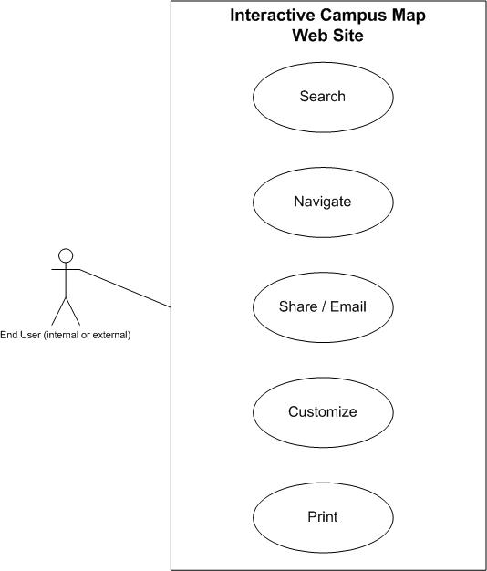

Business Requirements

The following sections document the various business requirements of this project.

Requirement Type | ID – Prefix ?? | ID – Number | Function – Feature - Requirement | Use Case Reference | Required | ?? | ?? | ?? | Comments
 | Business User Requirements
 | f | 0001
 | f | 0002
 | f | 0003
 | f | 0004
 | F | 0005
 | F | 0007
 | f | 0007
 | f | 0008
 | Reporting Requirements
 | f | 0001
 | f | 0002
 | f | 0003
 | f | 0004
 | F | 0005
 | F | 0007
 | f | 0007
 | f | 0008
 | User Access/Security Requirements
 | f | 0001
 | f | 0002
 | f | 0003
 | f | 0004
 | F | 0005
 | F | 0007
 | f | 0007
 | f | 0008
 | Service Level/Performance Requirements
 | f | 0001
 | f | 0002
 | f | 0003
 | f | 0004
 | F | 0005
 | F | 0007
 | f | 0007
 | f | 0008
 | Scalability Requirements
 | f | 0001
 | f | 0002
 | f | 0003
 | f | 0004
 | F | 0005
 | F | 0007
 | f | 0007
 | f | 0008
 | Support and Maintenance Requirements
 | f | 0001
 | f | 0002
 | f | 0003
 | f | 0004
 | F | 0005
 | F | 0007
 | f | 0007
 | f | 0008

Appendixes

Appendix A – Business Process Flows
<Describe the current existing process workflow using flow diagrams (i.e. Visio Flowcharts) and/or a detailed narrative.>
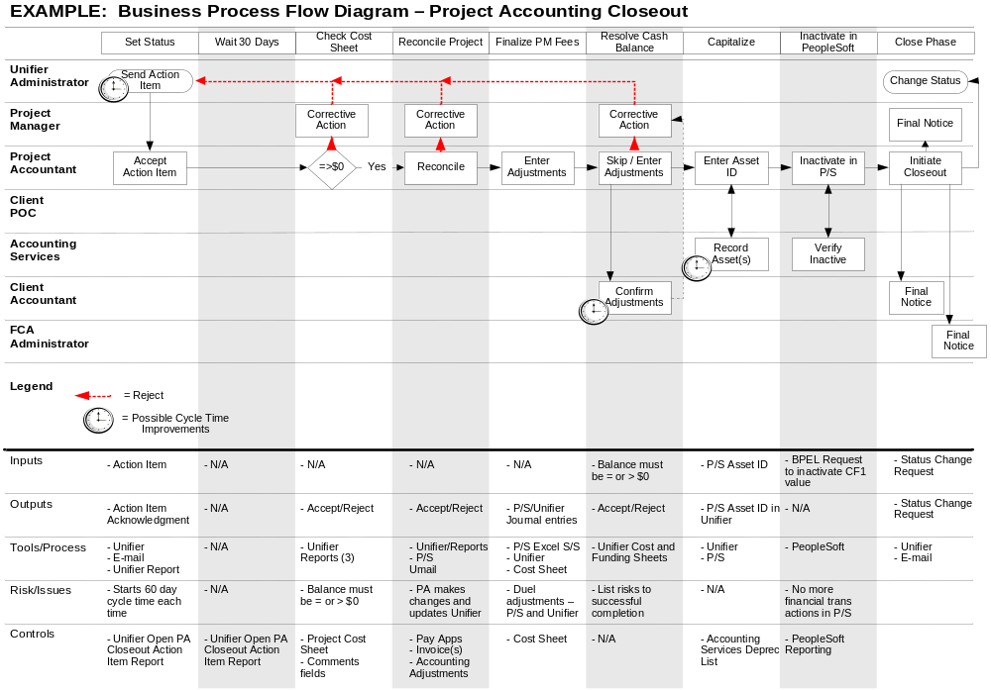

As Is Diagrams
<Insert As Is Diagrams here (if applicable)>

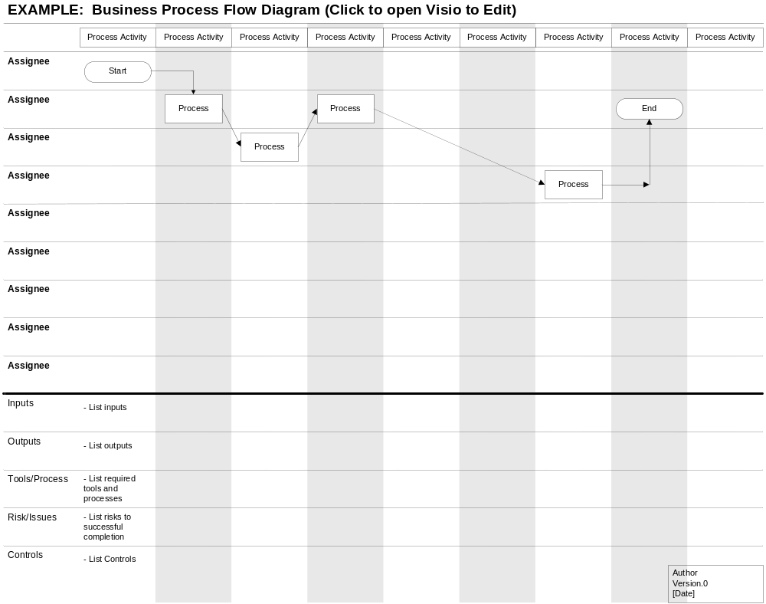
To Be Diagrams
<Insert To Be Diagrams here (if applicable)>

Appendix B – Business Rules Catalog
<Instructions: Use the following template for each business rule. >

Business Rule Name: | <The name should give you a good idea about the topic of the business rule.>
Identifier | <Defines unique identifier.> EXAMPLE: BR1
Description | <Defines the rule in detail.> EXAMPLE: “All employee labor is tracked, reported and billed in 15 minute increments.”
Example | <(Optional) An example of the rule>
Source | <Source of the rule. E.g. stakeholder>
Related Rules | <List of related rules, to support traceability>

Appendix C- Models
<Insert models here>

Traceability Matrix
<Insert traceability matrix here>

Use Case Narrative Instructions
<Instructions for completing the Use Case Narrative are included here. Remove these instructions from the completed Business Requirements Document>.

Use Case Field Name | Definition
Use Case ID | Give each use case a unique numeric identifier, in hierarchical form: X.Y. Related use cases can be grouped in the hierarchy. Functional requirements can be traced back to a labeled Use Case.
Use Case Name | State a concise, results-oriented name for the use case. These reflect the tasks the user needs to be able to accomplish using the system. Include an action verb and a noun. Some examples:  - View part number information.  - Manually mark hypertext source and establish link to target.  - Place an order for a CD with the updated software version
Created By | Include the name of the person who initially documented this Use Case.
Date Created | Enter the date on which the use case was initially documented
Date Last Updated | Enter the date on which the use case was most recently updated
Last Updated By | Include the name of the person who performed the most recent update to the use case description.
Actor | Enter the person or other entity external to the software system being specified who interacts with the system and performs use cases to accomplish tasks. Different actors often correspond to different user classes, or roles, identified from the customer community that will use the product. Name the actor(s) that will be performing this Use Case.
Description | Provide a brief description of the reason for and outcome of this use case, or a high-level description of the sequence of actions and the outcome of executing the Use Case.
Preconditions | List any activities that must take place, or any conditions that must be true, before the Use Case can be started. Number each precondition. Examples:  - User’s identity has been authenticated.  - User’s computer has sufficient free memory available to launch task
Post conditions | Describe the state of the system at the conclusion of the use case execution. Number each post condition. Examples:  - Document contains only valid SGML tags.  - Price of item in database has been updated with new value
Normal Course | Provide a detailed description of the user actions and system responses that will take place during execution of the use case under normal, expected conditions. This dialog sequence will ultimately lead to accomplishing the goal stated in the use case name and description. This description may be written as an answer to the hypothetical question, “How do I <accomplish the task stated in the use case name>?” This is best done as a numbered list of actions performed by the actor, alternating with responses provided by the system.
Alternative Courses | Document other, legitimate usage scenarios that can take place within this use case separately in this section. State the alternative course, and describe any differences in the sequence of steps that take place. Number each alternative course using the Use Case ID as a prefix, followed by “AC” to indicate “Alternative Course”. Example: X.Y.AC.1
Exceptions | Describe any anticipated error conditions that could occur during execution of the use case, and define how the system is to respond to those conditions. Also, describe how the system is to respond if the use case execution fails for some unanticipated reason. Number each exception using the Use Case ID as a prefix, followed by “EX” to indicate “Exception”. Example: X.Y.EX.1
Includes | List any other use cases that are included (“called”) by this use case. Common functionality that appears in multiple use cases can be split out into a separate use case that is included by the ones that need that common functionality.
Priority | Indicate the relative priority of implementing the functionality required to allow this use case to be executed. The priority scheme used must be the same as that used in the software requirements specification.
Frequency of Use | Estimate the number of times this Use Case will be performed by the actors per some appropriate unit of time.
Business Rules | List any business rules that influence this Use Case.
Special Requirements | Identify any additional requirements, such as nonfunctional requirements, for the use case that may need to be addressed during design or implementation. These may include performance requirements or other quality attributes.
Assumptions | List any assumptions that were made in the analysis that led to accepting this use case into the product description and writing the use case description.
Notes and Issues | List any additional comments about this use case or any remaining open issues or TBDs (To Be Determined) that must be resolved. Identify who will resolve each issue, the due date, and what the resolution ultimately is.

