The Navi Network

The Navi Network is comprised of LLM servers, the Navi Hub and the Navi Ecosystem.

The purpose of the Navi Network is to relay user input to LLMs. Output from LLMs is then relayed to “services” to execute functionality. These services comprise the Navi Ecosystem.

The Navi Hub

The “Hub” relays information between all nodes on the network. It provides a protocol for all parties to facilitate this communication. Nodes are only able to communicate with one another through the Hub. An instance of the Navi Network could look like this:

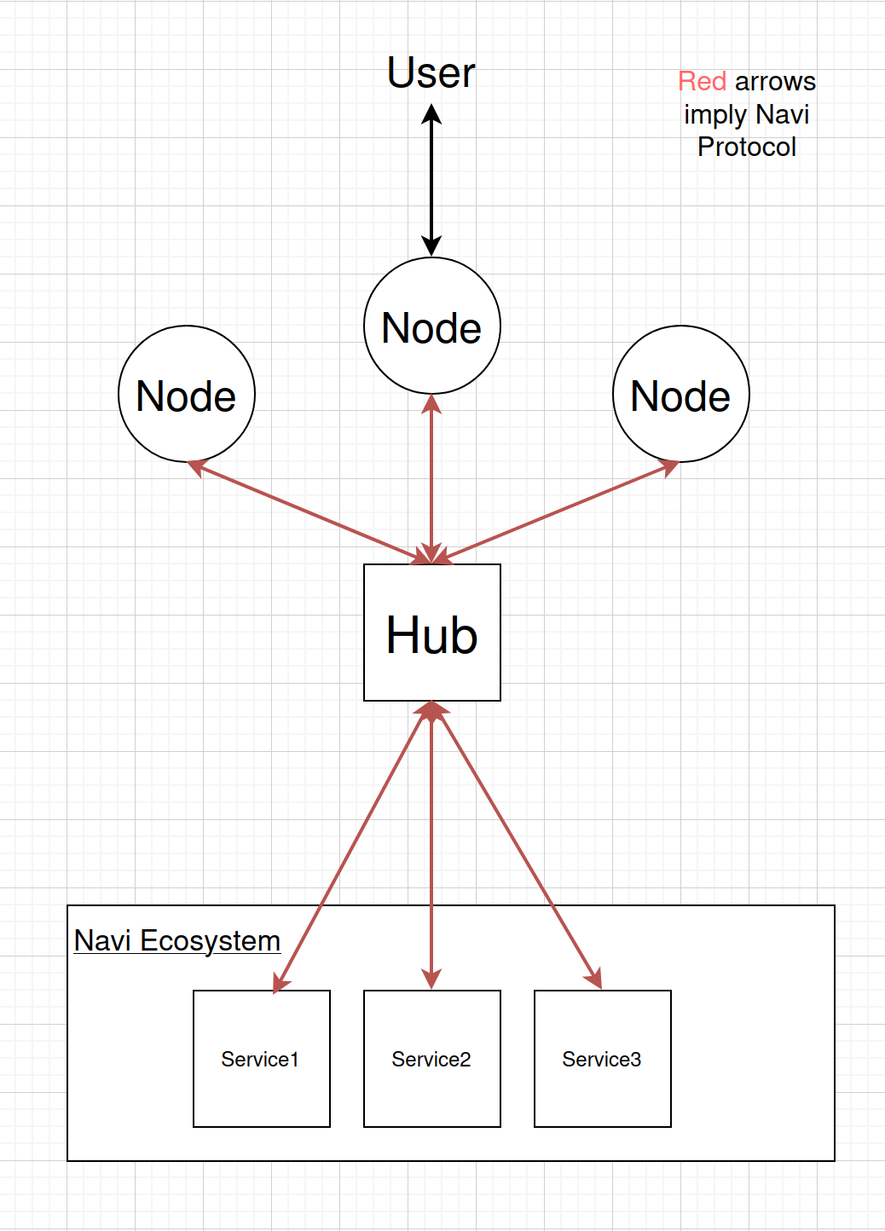

The Hub expects JSON in this form:

{
"service_calls":
[
{
"service_name": {"parameters"}
},
{
"service_name2": {"parameters"}
}
]
}

The Hub expects a list of services to execute. The hub executes each service in this list in order.

The Hub returns JSON in this form:

{
"service_call_returns":
[
{
"service_name": {"return values"}
},
{
"service_name2": {"return values"}
}
]
}

The Hub will always return this to the node that submitted the initial service request block. Each service call return block corresponds to the initial service requests.

To give an abstract example:

I’m a user and I want to talk into a microphone and say “Create a file on my desktop that contains a poem about cats”.
I then want to hear a response through my speakers that sounds something like “File created successfully”. Graphically, this looks roughly like this:

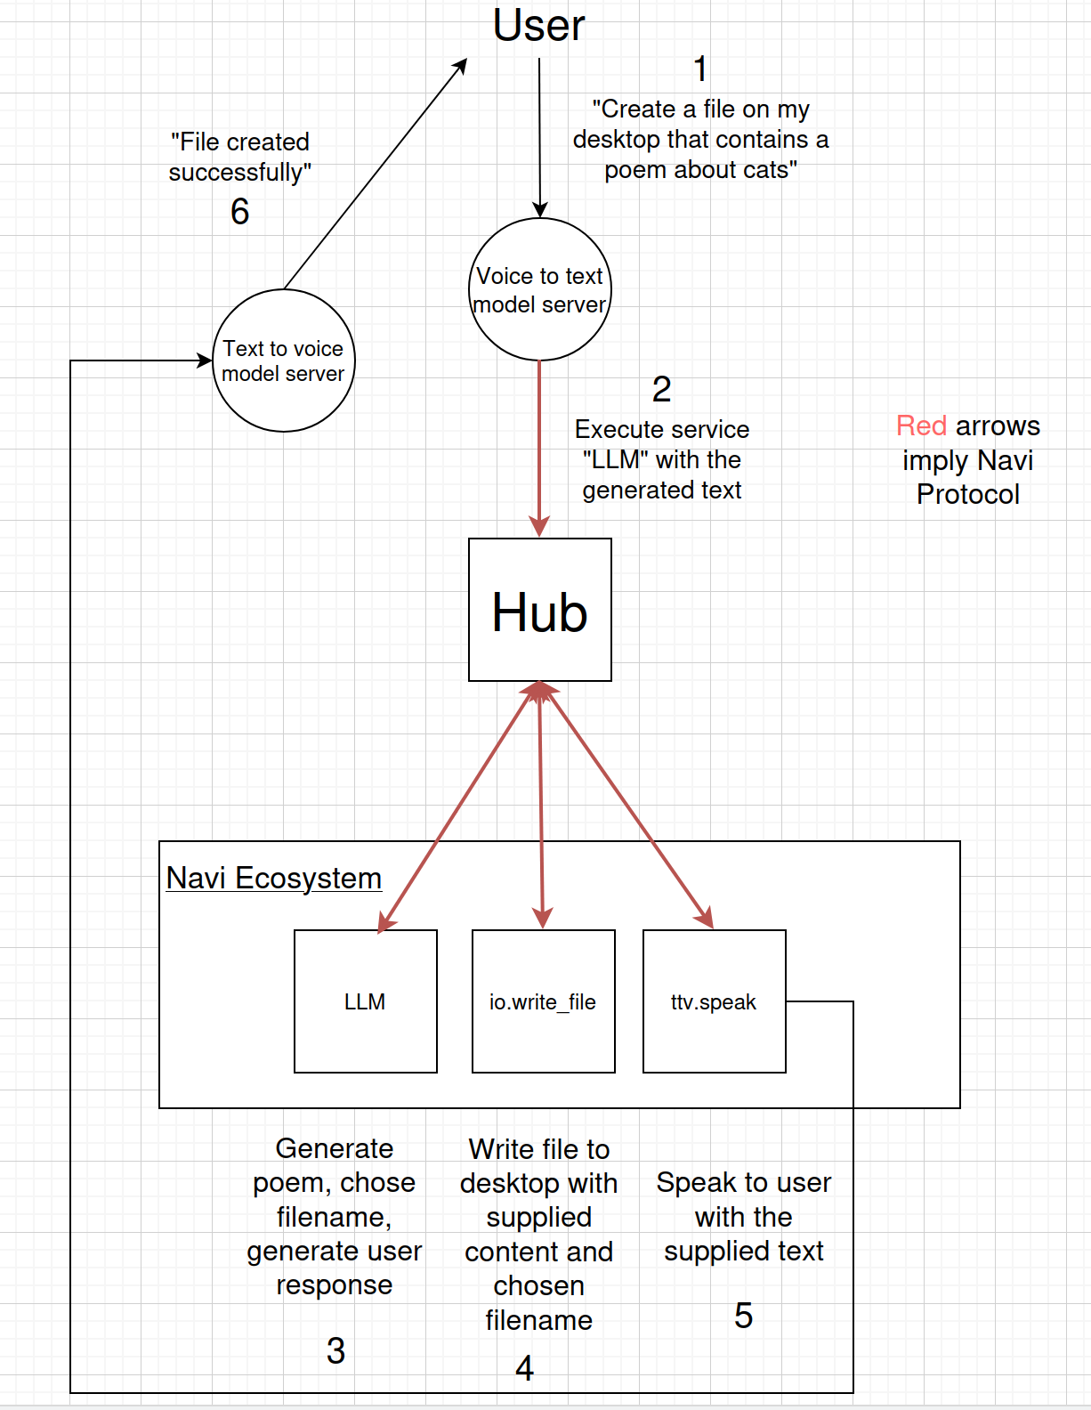

The JSON that the Hub would receive from the VTT server might look like this:

{
"service_calls":
[
{
"LLM.prompt": {"prompt": "Create a file on my desktop that contains a poem about cats"}
}
]
}

The LLM would then instruct the Hub to write the file and respond to the user through the TTV model. The JSON that Hub would receive from the LLM server might look like this:

{
"service_chain":
[
{
"IO.write_file": {"file_name": "cat_poem.txt", "file_content" : "Cats, hats,,,"}
},
{
"TTV.speak": {"text": "File created successfully"}
}
]
}

The Hub has no appreciation of what information each service needs or gives. The responsibility of sending the correct information to each node within the network lies with the Nodes themselves. The LLMs on the network are key to bridging the gap between different services and intelligently completing tasks submitted by the user.

The Hub exposes one function to the other Nodes on the network and that is “GetAllServiceDescriptions”. This function takes no parameters and returns a JSON block that contains the summaries, parameters and service names of all services. This block looks something like this:
{
"service_descriptions":
[
{
"LLM.prompt": {"summary": "Prompts with the supplied text and returns the result.", "parameters": ["prompt_text"]}
},
{
"IO.write_file": {"summary": "Creates a file at the supplied path with the supplied content. Returns True or False depending on success", "parameters": ["file_directory", "file_name", "file_content"]}
}
]
}

It should be noted at this point that all services that form the Navi Ecosystem define a “Description” function which returns a JSON block containing parameter information and a summary of the service. This in turn, feeds into the Hub which eventually gets passed to an LLM through the system prompt. This allows the LLMs on the network to understand the services at their disposal. This definition is part of the Navi protocol. This is expanded on in the Navi Ecosystem chapter.

The responsibility of defining whether services need user authentication before executing and enforcing this authentication lies solely with the Hub. In the interest of safety, it is not recommended for any node but the Hub to communicate with the user to ascertain authentication.

The Navi Ecosystem

The Navi Ecosystem is all the services available to the Hub. Services perform tasks. They can write files, read files, retrieve information from servers, turn on a light in a house, turn on a microphone, output audio through a speaker etc. The services available to the LLMs on the Navi Network are the “arms” of the LLMs and each one extends its functionality.

Every service must define a “Run” function which executes the service. Every service must define a function called “Description” which returns a JSON block conforming to this structure:

{
"description":
{
"parameters": ["parameter list"]
},
{
"Summary": "A summary of what the service does"
}
}

LLMs

LLMs essentially serve as translators. LLMs translate the user’s desires into a sequence of tasks that are available to the Hub.

It is the responsibility of the User to manage the LLMs on the Navi Network. This responsibility includes loading, unloading and defining system prompts. The LLMs on the network would be represented by a service which would allow for loading, unloading, setting the system prompt, prompting etc. The first LLM on the network would have to be loaded manually by the user but in theory, once the first one is loaded, the first LLM could load others at the user’s request.

