NTFSecur
System Management Panel
Technical Documentation
Version 2.1.0
Author | Sebastian Januchowski
Email | polsoft.its@fastservice.com
GitHub | https://github.com/seb07uk
Version | 2.1.0
Document Date | February 2026
Copyright | © 2026 polsoft.ITS™. All rights reserved.
Platform | Windows 10 / 11 (x64)
Requirements | Python 3.10+, Administrator (UAC)

1. System Overview
NTFSecur System Management Panel (version 2.1.0) is an advanced desktop application written in Python, designed for comprehensive Windows system management. The program combines NTFS security features, BitLocker encryption management, process and service monitoring, network analysis, USB device tracking, and disk diagnostics – all within a single graphical interface built on the Tkinter framework.

The application was created by merging the NTFSecur v2.0.0 module with a new v1.0.0 component, resulting in version 2.1.0 which includes full internationalisation (PL/EN), an extended HTML reporting system, BitLocker support, and advanced startup program management.

1.1 Design Goals
- Centralise Windows system security management within a single application
- Protect NTFS partitions against unauthorised writes (diskpart readonly)
- Provide full BitLocker encryption management (enable, disable, recovery keys, TPM)
- Real-time monitoring of processes, network interfaces, services, and USB devices
- Maintain USB device history in an SQLite database
- Generate comprehensive HTML reports and CSV data exports
- Bilingual interface (Polish / English) with runtime language switching

1.2 System Architecture
The application follows a modular architecture. The main file NTFSecur.py acts as the orchestrator – it loads optional components from the ntfsecur package (if installed) or operates in standalone mode using built-in implementations. The user interface is based on the Tkinter framework with a custom styling and colour system.

2. System Requirements
Component | Minimum | Recommended
Operating System | Windows 10 (x64) | Windows 11 (x64)
Python | 3.10+ | 3.12+
Privileges | Administrator (UAC) | Administrator (UAC)
RAM | 512 MB free | 1 GB+
Disk | 50 MB free space | 100 MB+
Display | 1024×768 | 1920×1080

Note: NTFSecur features (NTFS protection), BitLocker, system service control, and autostart management require the application to be launched with Administrator privileges. The program automatically detects missing privileges and initiates a UAC elevation request at startup.

2.1 Python Dependencies
Standard library modules (built into Python, no installation required):
Module | Purpose
tkinter / ttk | Graphical user interface (GUI)
subprocess | System calls (diskpart, manage-bde, sc)
ctypes | Admin privilege checks, WinAPI calls (ShellExecuteW)
sqlite3 | USB device history database
threading | Asynchronous operations (non-blocking UI)
socket | Network information retrieval
json | Configuration and settings storage
logging | Application event logging
csv | CSV data export
datetime | Timestamps for logs and reports
tempfile / os / sys / platform | File system and environment operations

3. Functional Modules
The management panel consists of 10 main modules, accessible from the sidebar navigation. Each module covers a specific category of administrative functions.

3.1 NTFSecur – NTFS Partition Protection
The NTFSecur module is the core of the application. It enables management of write protection on NTFS volumes using the Windows system tool diskpart. The user can set a partition to read-only mode (readonly=yes) or restore full read-write access (readonly=no).

Key features:
- Scan and list all NTFS partitions in the system
- Toggle write protection per partition (ON/OFF)
- Bulk operations: lock or unlock all partitions simultaneously
- Visual protection status indicator for each volume
- Display drive label, size, and drive letter

3.2 BitLocker – Drive Encryption
The BitLocker module provides comprehensive management of Windows drive encryption via the manage-bde command-line tool and the PowerShell cmdlet Get-BitLockerVolume. Available exclusively on Windows Pro and Enterprise editions.

Supported BitLocker operations:
Operation | Description | Requires Admin
Enable encryption | Initiates encryption of the selected volume | Yes
Disable encryption | Decrypts the volume | Yes
Lock drive | Restricts access to the volume | Yes
Unlock with password | Unlocks the volume using a password | No
Unlock with recovery key | Unlocks using a 48-digit recovery key | No
Suspend protection | Temporarily disables BitLocker protection | Yes
Resume protection | Restores suspended protection | Yes
Get recovery key | Displays the 48-digit recovery key | Yes
Backup key to AD | Archives the recovery key to Active Directory | Yes
Add TPM protector | Adds a TPM-based protector | Yes
Add password protector | Adds an additional BitLocker password | Yes
Generate recovery key | Creates a new 48-digit recovery key | Yes
Change PIN | Changes the BitLocker PIN (old → new) | Yes
Wipe free space | Securely overwrites free space on drive | Yes

3.3 Processes – Process Manager
The process module provides a real-time view of all running Windows processes. Data is refreshed asynchronously to avoid blocking the graphical interface.
- Process list with columns: Name, PID, Memory (MB)
- Search/filter processes by name
- Terminate a selected process (taskkill /PID)
- Column sorting by clicking headers
- Automatic list refresh

3.4 Network – Network Information
The network module presents detailed information about the machine's network configuration: interfaces, IP addresses, hostname, and connection type. Data is retrieved from the socket module and ipconfig/ip addr depending on the platform.

3.5 Services – System Service Control
The services module enables browsing and managing Windows services. Service operations are executed via sc.exe with the appropriate privileges.
- Full service list with status (Running / Stopped)
- Start a selected service (sc start)
- Stop a selected service (sc stop)
- Restart a service
- Filter the service list by name

3.6 Logs – Logging System
The logs module displays records from the application log and allows export of system logs. Includes filtering by log level (INFO, WARNING, ERROR, DEBUG) and keyword search.

3.7 USB – Devices and History
The USB module is one of the most fully-featured components. It offers real-time monitoring of USB devices and maintains a historical connection database in SQLite.
- List of actively connected USB devices (name, manufacturer, file system, capacity, serial number)
- Full USB device history in SQLite (last 200 events)
- Safe device removal
- Export history to CSV file
- Delete history entries (individually or all at once)
- Sort and filter history records

3.8 Drives – Diagnostics and Repair
The drives module serves as a comprehensive centre for storage media diagnostics and operations. It contains four functional tabs:

SMART Scanning
Runs SMART tests for HDD/SSD drives. Supports short test (~2 min) and long test (background). Integrates with the smartctl tool (separate installation required).

File System Repair
Runs chkdsk on a selected partition. Available modes: verify only (read-only) and full repair with error correction. Option to format the partition as FAT32 or NTFS.

Secure Erase
Three data overwriting methods: zero-fill (fastest), secure multi-pass erase (shred/cipher /w), and random data overwrite (recommended for SSDs).

Regeneration
HDD sector repair, MBR/GPT refresh, partition table restoration. Integration with TestDisk and PhotoRec (data recovery), and drive cloning via dd (Linux).

3.9 Autostart – Startup Program Management
The autostart module enables browsing and managing programs that run automatically with Windows. It scans the Windows registry and startup folders.
- List autostart entries from the registry (HKCU\Run, HKCU\RunOnce, HKLM\Run, HKLM\RunOnce)
- List entries from startup folders
- Remove autostart entries
- Add new entries (name, registry key, executable path)
- Scan drives for autorun.inf files (malicious autorun detection)
- Delete detected autorun.inf files
- View Windows Scheduled Tasks

3.10 Dashboard – Main Panel
The Dashboard is the welcome screen and summary centre. It displays the overall system state: number of active processes, drive encryption status, service status, and system information. It also contains the HTML report generation button.

4. Internationalisation System (i18n)
The application includes a built-in internationalisation system supporting two languages: Polish (pl) and English (en). Translations are stored in the _TRANSLATIONS dictionary as key (PL) → value (EN) pairs. The active language can be changed at runtime by calling set_locale().

Implementation
_LOCALE: str = 'en' # default locale
def _t(key: str, locale: str = None) -> str:
# Returns translation or key if not found
if locale == 'pl' or _LOCALE == 'pl': return key
return _TRANSLATIONS.get(key, key)

All UI text strings are wrapped in the _t() function. This allows the interface to switch languages without restarting the application.

5. Security and Privilege Management

5.1 Automatic UAC Elevation
On startup, the application checks whether it has administrator privileges using ctypes.windll.shell32.IsUserAnAdmin(). If not, it automatically initiates a relaunch via ShellExecuteW with the 'runas' verb, which triggers the Windows UAC prompt.

def _elevate_if_needed() -> bool:
is_elevated = ctypes.windll.shell32.IsUserAnAdmin() != 0
if not is_elevated:
ctypes.windll.shell32.ShellExecuteW(None, 'runas', sys.executable, ...)
return False # New elevated process launched
return True # Already running as Administrator

5.2 SecureString Class
The core.security module provides the SecureString class for securely storing passwords and keys in memory. When the object is destroyed, it overwrites the memory region to prevent sensitive data from being read by other processes.

5.3 Operational Security and Validation
- Drive letter validation before executing BitLocker operations (validate_drive())
- Confirmation dialogs required for all destructive operations (erase, format, wipe free space)
- All system calls are wrapped in safe_run() with exception handling and timeout
- Subprocess calls use no_window_kwargs to suppress console windows
- Error logs written to crash.log in the application folder

6. Asynchronous Operations and Threading
Critical for UI responsiveness: all operations that may take more than an instant are executed in separate threads (threading.Thread with daemon=True). Results are passed back to the GUI thread via Tkinter's after() method (thread-safe).

Pattern used in the BitLocker module:
def worker():
rc, out, err = bl_run([...], timeout=20)
def done():
self._write(self._txt_adv, result)
self._set_bot('✔ Operation completed.')
self.after(0, done) # Thread-safe GUI callback
threading.Thread(target=worker, daemon=True).start()

7. Reporting System
The application supports generating comprehensive HTML reports and exporting data to CSV. HTML reports include configurable appearance, metadata (date, time, host, user) and sections corresponding to individual modules.

Format | Modules | Options
HTML | Dashboard, Processes, Network, Services, BitLocker | Theme, sections, logo, open in browser
CSV | USB History, Logs | All columns, separator, UTF-8 encoding
TXT | BitLocker log | Timestamp, drive letter, full log content

8. Standalone Mode vs. Package Mode
NTFSecur.py can operate in two modes:

8.1 Package Mode (ntfsecur package)
When the ntfsecur package is installed, the application imports modules from ntfsecur.core.*, ntfsecur.ui.*, and ntfsecur.i18n. This provides full functionality, structured logging, and extension support.

8.2 Standalone Mode
When the package is unavailable (_PACKAGE_LOADED = False), the application uses built-in implementations defined directly in the main file. This mode retains full basic functionality, though some advanced mechanisms may be absent.

try:
from ntfsecur.core.security import is_admin, ...
_PACKAGE_LOADED = True
except ImportError as _pkg_err:
_PACKAGE_LOADED = False # Standalone mode

9. Error Handling and Logging

9.1 Application Logging
The application uses the standard logging module with a custom format. In package mode, log_info, log_debug, log_warn, and log_error functions from ntfsecur.core.logging are available. Logs are written to a file and displayed in the Logs module.

9.2 Critical Error Handling
The application startup block is wrapped in a try/except. In the event of an unhandled exception:
- Full traceback is written to crash.log next to the executable
- Logger is called at CRITICAL level
- Error dialog displayed with the message (first 1,200 characters)
- Process exits with code 1 (sys.exit(1))

10. Distribution and Packaging (PyInstaller)
The application supports compilation to an EXE file using PyInstaller. The resource_path() function automatically detects frozen (EXE) mode and returns resource paths from the temporary sys._MEIPASS directory.

def resource_path(*parts: str) -> str:
base = getattr(sys, '_MEIPASS', _HERE) # EXE vs. Python mode
return os.path.join(base, *parts)

In EXE mode, the UAC relaunch mechanism runs the same EXE file (sys.executable) instead of the .py script. This ensures correct automatic elevation works in the compiled version of the program as well.

11. User Interface

11.1 Main Window Structure
Component | Description
Title bar | Program name, version, admin status (ADMIN/USER), 'Always on Top' toggle
Menu bar | Bulk NTFSecur operations (Lock/Unlock all), settings, help
Sidebar panel | Navigation between modules, view refresh buttons
Content area | Active module content: tables, buttons, logs
Status bar (Footer) | Operation status messages: ✔ success, ✘ error, ⏳ in progress

11.2 Colour Themes
The application offers two themes: Dark and Light. The selected theme is saved in settings and restored on the next launch. GlassScrollbar provides styled scrollbars adapted to the active theme.

11.3 Keyboard Shortcuts
Shortcut | Action
F1 | Opens the built-in user handbook
Ctrl+F | Search within the handbook
Esc | Close the active dialog window
Ctrl+R | Refresh the current view

12. Application Files and Folders
File / Folder | Description
NTFSecur.py | Main application file (entry point)
ntfsecur/ | Module package (optional)
ntfsecur/core/security.py | Security: is_admin, SecureString, safe_run
ntfsecur/core/bitlocker.py | All BitLocker operations (bl_*)
ntfsecur/core/system.py | Processes, network, services, logs, USB, NTFS partitions
ntfsecur/core/backup.py | Backups: file history, registry, BCD
ntfsecur/core/logging.py | Logging system (log_info, log_warn, ...)
ntfsecur/core/paths.py | AppPaths – application directory paths
ntfsecur/core/settings.py | Settings management (get_settings)
ntfsecur/ui/helpers.py | thread_worker, AdminMixin
ntfsecur/i18n.py | Internationalisation (t, set_locale, get_locale)
reports/ | Folder containing generated HTML reports
crash.log | Critical error log (generated on crash)
ntfsecur.log | Main application log

13. Screenshot – Built-in User Handbook
The screenshot below shows the built-in user handbook (Handbook) available in NTFSecur v2.1.0. The handbook is opened with the F1 key and contains chapter-based documentation for all modules, along with a full-text search function.

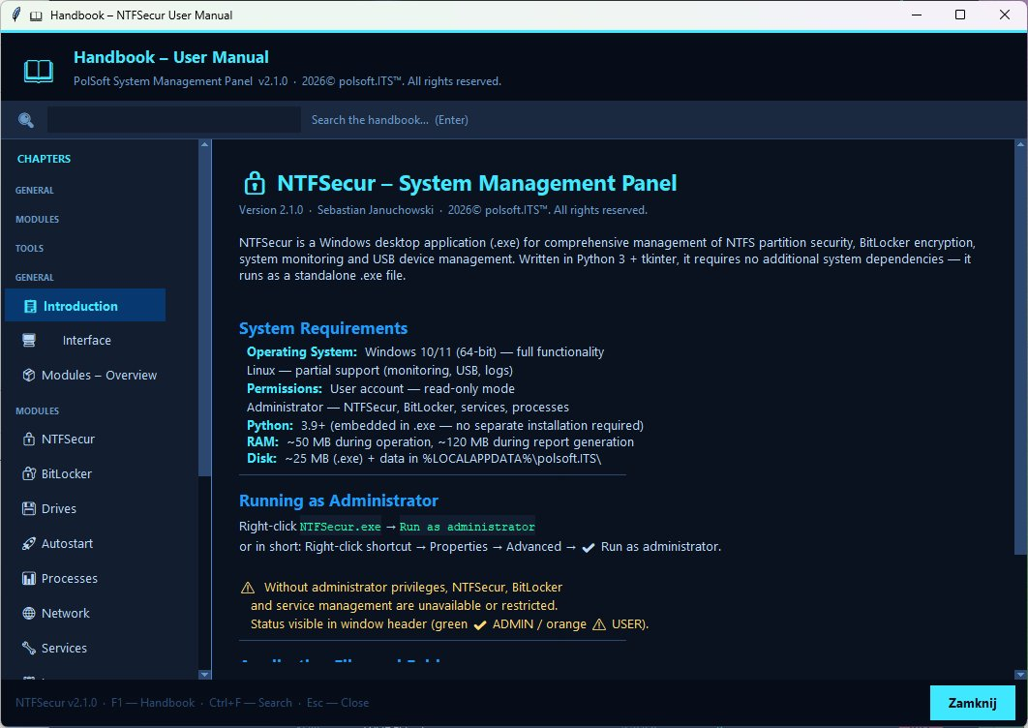
Fig. 1 – Built-in User Handbook – NTFSecur v2.1.0

14. Changelog – Version 2.1.0
Version 2.1.0 was created by merging NTFSecur v2.0.0 with the new v1.0.0 component. The following are the main changes:
- Added full internationalisation (PL/EN) with runtime switching
- Implemented GlassScrollbar – styled scrollbars for both themes
- Added BitLocker panel with complete encryption management
- Added Autostart module with autorun.inf scanning and Task Scheduler management
- Extended HTML report system with configurable appearance and sections
- Added 'Always on Top' toggle (topmost)
- Enhanced colour palette across both themes
- Added automatic UAC elevation for EXE mode (PyInstaller)
- Extended USB history SQLite database with events table and sorting

15. Licence Information
⚠ Copyright and Licence
© 2026 polsoft.ITS™. All rights reserved.
This software is protected by copyright. Copying, distributing, or modifying without the author's consent is prohibited.
Author: Sebastian Januchowski
Contact: polsoft.its@fastservice.com | GitHub: https://github.com/seb07uk

