SignTool's-ITS GUI v2.0
Software Documentation — Code Signing & Certificate Generation

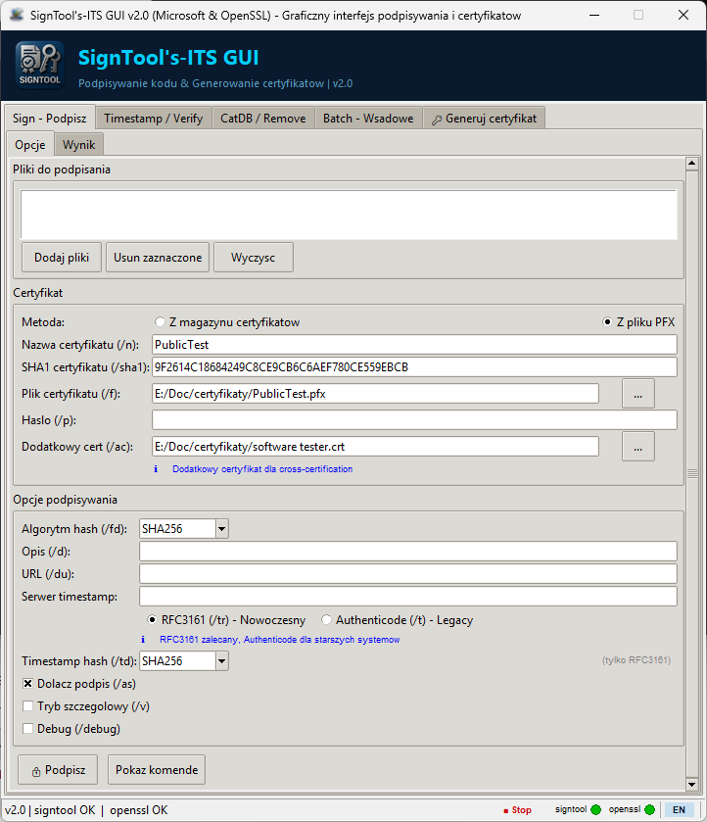

Product | SignTool's-ITS GUI
Version | 2.0
Author | Sebastian Januchowski
Company | polsoft.ITS™ Group
Contact | polsoft.its@fastservice.com
GitHub | https://github.com/seb07uk
License | Proprietary — All Rights Reserved
Copyright | 2026 © polsoft.ITS™

1. Overview
SignTool's-ITS GUI v2.0 is a professional graphical user interface that wraps Microsoft's signtool.exe and OpenSSL, providing an integrated environment for code signing, timestamp management, certificate verification, and certificate generation. The application is written in Python using Tkinter and ships as a single-file script — no additional pip packages are required.

Key Capabilities
- Auto-detection: Scans all available drives for signtool.exe and openssl.exe at startup. Results are shown in a summary dialog with retry and manual override options.
- Code Signing: Sign EXE, DLL, SYS, MSI, CAT and PS1 files using certificates from the Windows certificate store or PFX files.
- Timestamping: Add RFC 3161 (modern, recommended) or Authenticode (legacy) timestamps to signed files.
- Signature Verification: Verify digital signatures using default (/pa) or page-hash (/pg) policies, with optional catalog file support.
- Catalog Management: Add or remove catalog (.cat) files from the Windows catalog database via the CatDB command.
- Signature Removal: Strip all Authenticode signatures from selected files using the signtool remove command.
- Batch Execution: Write signtool response files directly in the built-in editor and execute them with a single click.
- Certificate Generation: Generate Self-signed, Root CA, and CA-signed certificates using OpenSSL (cross-platform) or PowerShell New-SelfSignedCertificate (Windows only).
- Multilingual UI: Built-in Polish/English language switcher — no external plugins required.

2. System Requirements
Operating System | Windows 10 / Windows 11 (64-bit recommended)
Python | 3.8 or later (CPython; tested on 3.10–3.12)
Python packages | None — stdlib only (tkinter, subprocess, os, json, pathlib, threading, tempfile, base64)
signtool.exe | From Windows SDK (auto-detected or manually specified)
openssl.exe | Optional — required only for certificate generation (auto-detected)
Disk space | ~50 KB for main.py + optional assets
RAM | ~30 MB typical (Python + Tkinter)

3. Installation & First Launch

Build Standalone EXE
To distribute the application without requiring Python, build a single-file executable using PyInstaller:
pip install pyinstaller
pyinstaller --onefile --windowed --icon=SignTool-ico.ico main.py
# Output: dist/main.exe
- Install Python 3.8+ from https://python.org. Ensure python is in the system PATH.
- Copy main.py (and optional assets: SignTool-ico.ico, logo.png) to any folder.
- Open a terminal and run: python main.py
- On first launch the application scans all drives for signtool.exe and openssl.exe. A summary dialog reports what was found.
- If a tool is not found, click Retry scan or navigate to the Options tab to set the path manually.
- Settings are saved to %USERPROFILE%\.polsoft\software\SignToolGUI\SignToolGUI.json.

4. User Interface Guide
Sign — Sign one or more files using a Windows certificate store certificate (by name /n or SHA1 /sha1) or a PFX file (/f + /p). Options include hash algorithm (/fd), description (/d), URL (/du), timestamp protocol (RFC3161 /tr or Authenticode /t), timestamp hash (/td), append signature (/as), verbose (/v) and debug.
Timestamp / Verify — Add a timestamp to already-signed files (RFC 3161 or Authenticode). Verify signatures using /pa (default policy) or /pg (page hash), with optional catalog file (/c).
CatDB / Remove — CatDB: add (/u) or remove (/r) a .cat file from the Windows catalog database. Remove: strip all Authenticode signatures from selected files (signtool remove /s).
Batch — Write a signtool response file in the built-in text editor — one argument per line, first line is the command. Save to disk or execute directly.
Generate Certificate — Generate certificates using OpenSSL (cross-platform, recommended) or PowerShell New-SelfSignedCertificate (Windows only). Types: Self-signed, Root CA, Signed by CA. Key algorithms: RSA 2048/4096, EC P-256/P-384/P-521. Outputs: .key, .crt, .pfx.
Options — Set signtool.exe and openssl.exe paths, default hash algorithm, timestamp server, and UI language.
Output — Colour-coded output pane shared across all tabs. Green = success, red = error, blue = informational.

5. Security Considerations

6. Troubleshooting
- Password handling: PFX passwords are held exclusively in memory during the signing session and are never persisted to disk or to the configuration file.
- Batch temp file: The response file (_batch_response.txt) written before batch execution is deleted immediately after the subprocess exits, preventing sensitive command-line arguments from lingering on disk.
- No network calls: The application makes no network connections. Timestamp requests are made by signtool.exe, not by the GUI itself.
- Admin operations: Installing a certificate into the Windows store requires elevated privileges. The application delegates this to PowerShell and does not attempt to escalate its own privileges.

- signtool.exe not found: Click Retry scan in the startup detection dialog, or navigate to Options and paste the full path to signtool.exe.
- openssl.exe not found: Only needed for the Generate Certificate tab. Set the path directly in that tab's OpenSSL path field.
- Garbled Polish text: The app forces PYTHONIOENCODING=utf-8. If characters still appear wrong, check that your terminal emulator is set to UTF-8.
- Console window flashes: Should not occur — CREATE_NO_WINDOW is applied globally to all subprocess.Popen calls. Verify that the PyInstaller build uses --windowed.
- Exit code non-zero: Check the Output tab for details. Common causes: invalid certificate, wrong password, file already signed (use /as to append).

7. Author & License
SignTool's-ITS GUI v2.0 is proprietary software developed and maintained by Sebastian Januchowski at polsoft.ITS™ Group. All rights reserved.
Unauthorized copying, redistribution, or modification of this software, in whole or in part, is strictly prohibited without the prior written consent of polsoft.ITS™ Group.
Contact: polsoft.its@fastservice.com
GitHub: https://github.com/seb07uk
© 2026 polsoft.ITS™. All rights reserved.

