Corporation Techs Network Design
Project Part 1: Network Design
Sebastian Romo
CTS2314 – Network Defense and Countermeasures
Dr. Martins Donbruce Idahosa
September 5, 2026

Introduction
Corporation Techs currently operates on an unsegmented network architecture where all 50 workstations, internal applications servers, and the public web server exist in a single broadcast domain. The poor design for this network leaves sensitive data and database info vulnerable to lateral movement if the web server were to be compromised. This report demonstrates a fully redesigned network architecture that maintains the existing endpoints with added subnet isolation between departments, eliminated single points of failure, and an updated IP addressing schema for IPv4 and IPv6.

Current Infrastructure Elements
- 1 public web server: Linux/Apache
- 2 application servers: Windows Server
- 2 database servers: Windows Server
- 2 file and print servers: Windows Server
- 50 workstations: Windows, divided between Accounting and Sales
- A series of switches with no VLAN segmentation
- A single border firewall connecting the LAN to the Internet
- IPv4 addressing throughout; no physical connection to any other network

Proposed Physical and Logical Topology

Physical Topology
The network was redesigned using a standard layered layout, including core switches at the top and access switches at the bottom. At the perimeter, there are two firewalls in an active/backup pair, each linked to a different internet provider so hardware failure would not compromise availability. Behind the firewalls are two core switches tied together, linked to dedicated switches for Accounting, Sales, and the series of servers. Everything has redundant uplinks, which ensures no single switch failure can isolate a department. The public web server is isolated by plugging it to a separate interface on the firewall, ensuring internet traffic is never received by the internal switches.

Logical Topology and Department Separation
Logically, the design splits the network into three VLANS. VLAN 10 for shared servers, VLAN 20 for Accounting, and VLAN 30 for Sales. Routing is done through the core switches using access control lists that allow both depratments to reach shared systems and the internet, but block Accounting and Sales teams from directly sending traffic to each other. Isolating both departments eliminates the risk that comes with infected workstations being able to reach the non-compromised department.

Protecting Internal Access While Keeping the Website Public
The web server has its own DMZ port on the firewall, aligning with established security practices for isolating public systems (Scarfone & Hoffman, 2009). Firewall rules permit only inbound HTTP and HTTPS traffic to the DMZ and block any outgoing connections from the DMZ into internal VLANS. This keeps the public website fully accessible while ensuring a compromised web server cannot reach internal application, database, or file servers.

Plan for 24/7 Communications
To ensure 24/7 availability with no single points of failure, the design integrates redundancy into each layer:
- Internet & Firewalls: Two separate ISP’s plug into an active/backup firewall pair. If an internet provider drops or a firewall fails, the backup takes over automatically.
- Switching: Core switches are cross-linked, and every department switch connects to both core units so a dead switch or hardware failure would not disable a department.
- Power: Battery backups protect the firewalls, core switches, and server racks from momentary blinks, while a generator handles long blackouts.
- Backups: Daily backups save data both locally and off-site/cloud for quick recovery if hardware fails.
- Monitoring: Real-time SNMP and syslog alerts flag failing hardware or dead links before they cause downtime issues.

IPv4 or IPv6 Recommendation
Recommendation: Keep the internal network on IPv4 and integrate dual-stack for the public DMZ. Considering half of the global web traffic now uses IPv6, the public web server needs to support both protocols so outside visitors can interact with it. IPv6 integrated into the internal network is unnecessary, considering it would make security configurations too complex for little-to-no reward.

Network Diagram

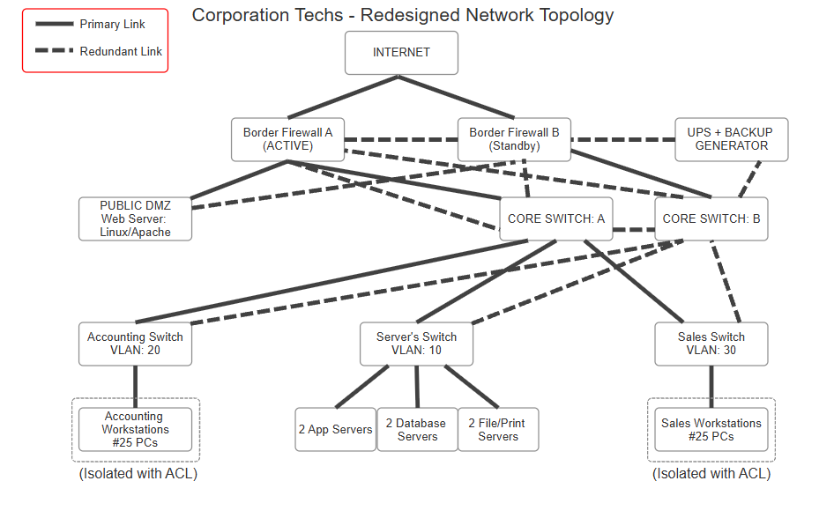
A redundant firewall pair with dual ISP links, a DMZ hosting the public web server, cross-linked core switches, and three access switches (Accounting, Sales, and the shared server farm) representing the 50 workstations and six back-end servers described above.

Conclusion
This design keeps Corporation Techs' existing equipment inventory in place while isolating the public web server in its own DMZ, separating Accounting from Sales with VLANS and access control lists, and adding redundant ISP links, firewalls, switches, and power so communications stay available 24/7. The network remains on IPv4 internally, with the DMZ made dual-stack so the public site keeps pace with growing IPv6 adoption.

References
Cisco Press. (2005, March 18). CCDP self-study: Designing high-availability services. https://www.ciscopress.com/articles/article.asp?p=375501
Ford, M. (2026, April 19). 18 years later, IPv6 reaches majority. Internet Society Pulse. https://pulse.internetsociety.org/en/blog/18-years-later-ipv6-reaches-majority/
National Institute of Standards and Technology. (2010). Guidelines for the secure deployment of IPv6 (NIST Special Publication 800-119). U.S. Department of Commerce. https://csrc.nist.gov/publications/nistpubs/800-119/sp800-119.pdf
Scarfone, K., & Hoffman, P. (2009). Guidelines on firewalls and firewall policy (NIST Special Publication 800-41, Revision 1). National Institute of Standards and Technology. https://tsapps.nist.gov/publication/get_pdf.cfm?pub_id=901083

