PyMoDAQ : Modular Data Acquisition with Python. Development and continuous integration of the software

Project Summary

PyMoDAQ is a software providing a solution to the community of experimental physicist faced with the time consuming task of building computer interfaces to control more and more complex experimental apparatus. Being adopted by an ever-growing community of users and developers, PyMoDAQ has to be stable, meet evolving requirements and answer the need of FAIR [Findable, Accessible, Interoperable and reusable/reproducible] data. This project will fund a research engineer to pursue this goal for the benefit of the NanoX community and beyond.

Scientific Context:

Data acquisition concerns all experimental disciplines (spectroscopy, metrology, biology, etc.), each of which relies on dedicated instruments and appropriate measurement techniques. There is a wide variety of software tools available for acquiring such data. These tools, providing user interfaces, are either developed to meet a specific experimental need or provided by the manufacturer of the instrument being used. Everything works well until the experimental setup evolves and additional instruments are added in order to obtain more information. In most cases, the software then needs to be extended or even rewritten if its initial structure does not allow for further evolution. The development of in-house, experiment-specific software suffers from another major issue: obsolescence. This is linked to several factors, including the licensing of the programming language used, compatibility with one or more operating systems, the replacement or addition of an instrument, and above all, the departure of the original developer. The reality is that many of these in-house software tools are written by early-career researchers who, particularly in academia, tend to leave after a few years, taking with them the knowledge and expertise required to maintain the software. Finally, there is the issue of usability. For a piece of software to be adopted, it must provide clear and comprehensive documentation, a simple yet complete graphical user interface, and efficient data management. To achieve a sustainable data acquisition and experimental orchestration system, it is therefore essential to build or choose modular and application-agnostic software.

In parallel, the concept of FAIR data introduced by the Open Science paradigm should play a central role in the development of data acquisition software. The project aims to propose solutions to the challenges that must be addressed to design a data acquisition system applicable to any experimental setup and to make the recorded data as FAIR as possible.

To address the issues of instrumental modularity, graphical user interfaces, and experiment-specific requirements simultaneously, PyMoDAQ has been created around two generic graphical interfaces (control modules) for its instruments easily configured for each experimental setup and grouped together in a dashboard (see Figure 1). Because the interface is identical for all instruments of a given type, it is easy to load as many modules as needed and to replace one at any time. This solution enables full computer control of the experimental setup without concern for the scientific domain or the intended use. Experiment-specific functionality, when required, is achieved by building extensions to the dashboard, which are capable of programmatically controlling the control modules. For example, scan-type experiments can be easily performed by loading the DAQ_Scan extension, which handles instrument selection, scan strategies (e.g., linear, random, etc.), and appropriate data saving. This separation allows a faulty instrument to be replaced by another without impacting the extension; only the dashboard needs to be reconfigured. Many other extensions are available and address a wide range of experimental situations. However, all of this is only possible if the library of instruments supported by PyMoDAQ is sufficiently comprehensive.

PyMoDAQ already benefits from a substantial library of diverse instruments (electrical measurements, spectrometers, oscilloscopes, cameras, position and rotation controllers, etc.), and above all from rich documentation and annual training sessions (often supported by FERMI and NanoX) that enable users to add their own instruments to the existing library.

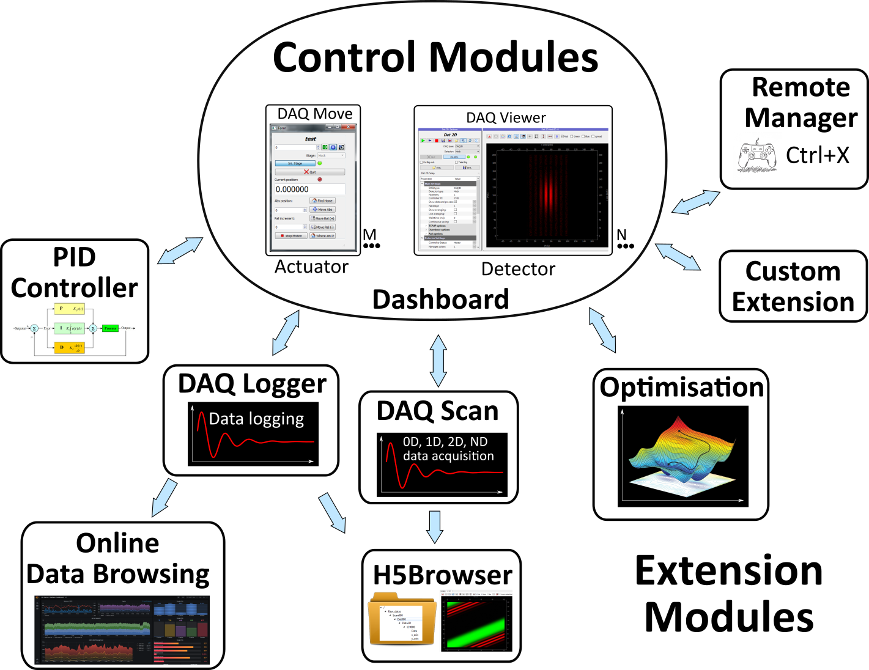Figure 1: PyMoDAQ Diagram – Each instrument is represented by a standardised interface, a control module, grouped in a dashboard offering modularity. Specific tasks are done using extensions orchestrating tasks for the control modules: acquisition, optimisation…

