Introduction

The figure below shows the state transition diagram of a Finite State Machine(FSM) which describes the functionality of a soda vending machine. The machine sells soda cans that cost **€2** each. Also, the machine accepts only three types of currency denominations: **€1, €2 and €5**. The machine determines when to dispense a can and also, returns the required change.

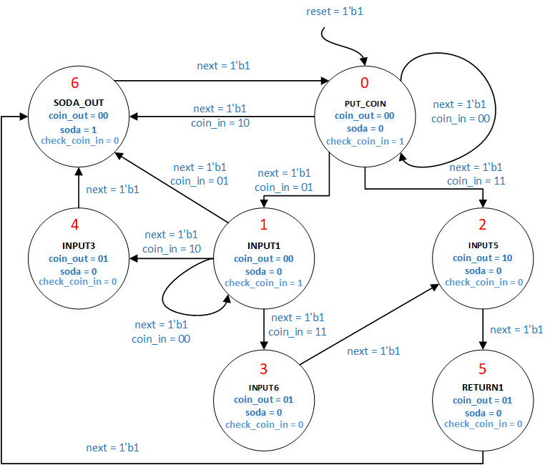

Assignment

You will be provided with a buggy implementation of the above fsm. You need to find the bugs and change it to make it working as per the state transition diagram given above. The FSM module you will modify is named **[soda_top](https://exam.oncourse.tue.nl/exam/pluginfile.php/2233/mod_vpl/intro/soda_top%20%282%29.v)** which takes four input signals **clk, reset, next, coin_in** and produces four output signals **soda, coin_out, state_display, check_coin_in**. The **reset**input always makes a transition to the **PUT_COIN**state. Input signal **coin_in** and output signal **coin_out** are **2 bit (little endian)**signals representing the type of currency denomination being given in or given out respectively. Signal **check_coin_in**is a 1 bit signal which is set whenever an input coin is required by the vending machine.

**The currency denominations are encoded as follows: No input = 00, €1 = 01, €2 = 10 & €5 = 11.**

Signal **soda** is a 1-bit signal which indicates whether the soda is given out or not. Signal **state_display** is a 3 bit signal indicating the number of the current state using the same numbers as the states in the FSM diagram above (shown in red). All input and output signals are 1 bit wide and little endian, unless otherwise mentioned.

**Note:**A transition will happen only if **next** is high. If **next** is low, the **state does not change**. Make sure that you only make one transition when the **next** is set from 0 to 1. For doing this check whether the current value is different from its previous value. Do not use: always @ (posedge **next**).

Debug

Click on the symbol marked below to see the waveforms produced by your design. Please note that if your code has an error that prevents it being simulated it will not produce any waveforms.