Introduction

In this exercise, you will create a test to check the functionality of a Finite State Machine (FSM) which detects the accumulation of number of 1 at the input. It has the following properties:

* one input (**in**) and one output (**out**)
* output is **1**when the number of input bit equal to 1 is accumulated to **4**.
* the i/o behaviour in the FSM is encoded as follows: **in/out (eg. 1/0 means in = 1'b1 and out = 1'b0).**

The following shows the input/output behavior for the FSM:

**in : 0 0 1 0 1 1 0 1 1 1 0 1 1 ....  
 out : 0 0 0 0 0 0 0 1 0 0 0 0 1 ...**

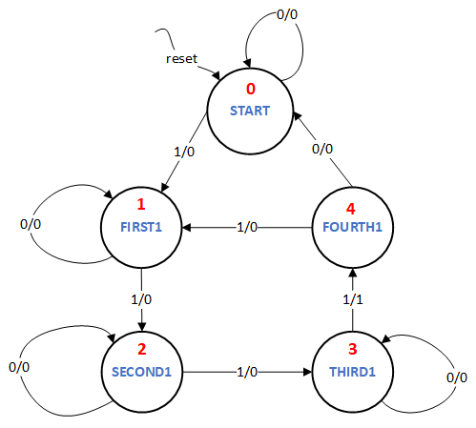

The diagram above illustrates the transitions of the FSM that should be implemented to achieve this. It shows a Mealy Machine where the output is defined both by the state as well as the input. The machine has five states. The state numbers are marked in red.

Assignment

Write a FSM testbench named **accu_top_tb**. It will drive the module named **accu_top** which takes **input signals: clk, reset, in, next** and produces **output signals: out, state_display**. Assume all input and output signals to be 1 bit wide except state_display which is 3 bits wide and little endian.

**Note:**A transition will happen only if **next** is high.

You have write the testbench which tests the given finite state machine for the following input sequence:

**1 => 0  => 0  => 1  => 0 => 1  => 0 => 1  => 1  => 1 =>  1 => 1**

Print the following after each input stimuli:

$display("state %x, out %x", state_display, out);

Use the following template for writing the testbench:

`timescale 1ns / 1ps  
module accu_top_tb();  
  
 <<DECLARE SIGNALS TO DRIVE MODULE accu_top>>  
     
 accu_top accu_top_inst(  
 .clk(clk),  
 .reset(reset),  
 .next(next),  
 .in(in),  
 .out(out),  
 .state_display(state_display));

<<DECLARE CLOCK>>  
     
             
   initial begin  
   $dumpfile("dut.vcd");  
      $dumpvars(0, accu_top_inst);

<<INITIALIZE INPUT SIGNALS>>

  <<RESET>>  
   #500  
   $display("state %x, out %x", state_display, out);  
     
     
   <<STIMULI 1>>  
   #500  
   $display("state %x, out %x", state_display, out);  
     
   <<STIMULI 2>>  
   #500  
   $display("state %x, out %x", state_display, out);  
     
   .................. continue for the rest of the stimuli ..............................  
     
   #100  
      $finish;  
   end  
endmodule

**STRICT NOTE:** Just change the portions marked in red in the tesbench template.

**Debug**

Click on the symbol marked below to see the waveforms produced by your design. Please note that if your code has an error that prevents it being simulated it will not produce any waveforms.

The following message shows a possible debug information you can obtain when running your code:

< state 1, out 0

---

> state 1, out 1

The lines starting with the **"<"**symbol are the **expected output**, while the ones starting with the**">"**are the **obtained output**(from your testbench).