rmarkdown_docx

Sébastien Renaut

2018-09-06

Table of Contents

# Different outputs

* There are six versions of this document:
  + *.Rmd*: The Rmarkdown document.
  + *.html*: A Webpage as we saw in the previous section. Follow using this version.
  + *rmarkdown_word_pdf2.html*: A radix webpage.
  + *.docx*: A MS Word document.
  + *.tex*: A [LaTeX](https://www.latex-project.org) document.
  + *.pdf*: A PDF document.

## html document

---   
title: "rmarkdown_pdf"   
author: "Sébastien Renaut"   
date: '2018-09-06'   
output:   
 html_document:   
 toc: yes   
---

## Microsoft Word

---   
title: "rmarkdown_docx"   
author: "Sébastien Renaut"   
date: '2018-09-06'   
output:   
 word_document:   
 toc: yes  
---

* You can specify it when you create a new Rmarkdown document.
* You can also specify it later in the header.
* Then, it’s just a matter of kniting the document!
* Little documentation, few options & configurations are possible (This is probably not the format that should be promoted, as it moves away from an open source environment).
* (FYI, there is a spellchecker in Rstudio: Edit >Check Spelling…)

## Portable Document Format (.pdf)

---   
title: "rmarkdown_pdf"   
author: "Sébastien Renaut"   
date: '2018-09-06'   
output:   
 pdf_document:   
 toc: yes   
---

* You need a extra step to go from a LaTeX (*.tex*) format to a *.pdf*. This is handled by the pdflatex function in R.
* [LaTeX software](https://www.latex-project.org) is a high-quality typesetting system.
* It is the *de facto* standard for the communication and publication of scientific documents.
* LaTeX is available as free software [here](https://www.latex-project.org/get/).

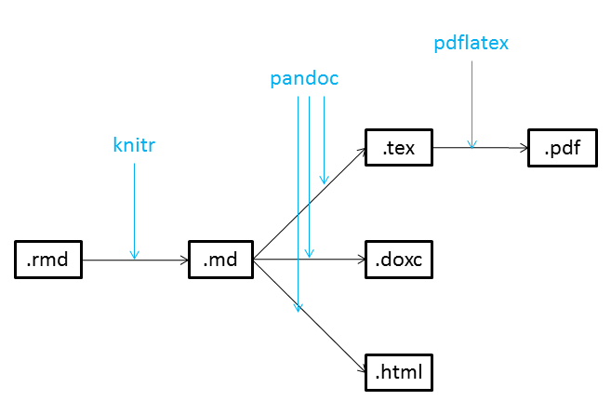

* If interested, follow this discussion: [*Why LaTeX is such a bloated system?*](https://ubuntuforums.org/showthread.php?t=395863)
* So…[*TinyTeX*](https://yihui.name/tinytex/r/) is a custom LaTeX distribution based on TeX Live that is small in size (~150MB) but functions well in most cases, especially for R users .
* tinytex R package is a wrapper function that installs *TinyTeX*.

## Exercice 1 (10min.)

* Install the tinytex R package from the console. It may take a few minutes to download and compile (~150MB)

install.packages("tinytex")   
library(tinytex)   
install_tinytex()

* Create a new document, compile it as *.pdf*.
  + Add a Table of Content.
  + Add a graphic.
* Now compile it as a Word document (*.docx*)
* Add some reference by specifying the csl: ../csl/peerj.csl and bibliography: ../biblio/test_library.bib in the header

# LaTeX template

* This allows further options in the *.Rmd* file when going from *.tex* file to *.pdf*.
* You can build your own *.tex* template if you know LaTeX…
* There are many templates available on the web that you can use.
* Here is one I like for [manuscripts](https://github.com/svmiller/svm-r-markdown-templates/blob/master/svm-latex-ms.tex) (Thanks [svmiller](https://github.com/svmiller) on )
  + Using this (sligthly modified) template, I am writing [my first *.Rmd* manuscript](https://github.com/seb951/Acadian_seaplants/blob/master/manuscript_Rmd/Acadian_seaplants_v5.pdf).  
       
    
* Here is one I like for [*Curriculum Vitae*](https://github.com/svmiller/svm-r-markdown-templates/blob/master/svm-latex-cv.tex)
  + Using this template, I re-wrote my [CV](http://sebastien.renaut.com/wp-content/uploads/2019/02/cv.pdf) to give it a fresh look!  
       
    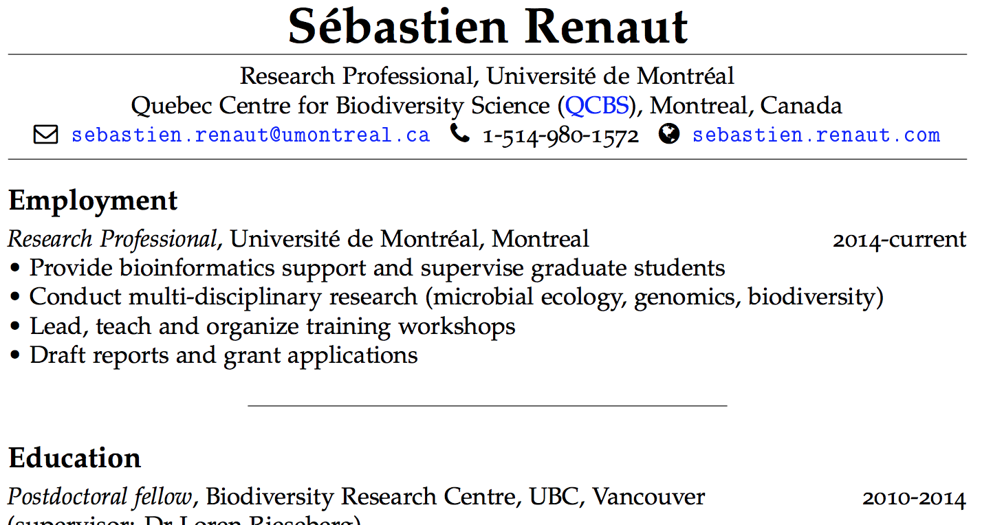
* Download template and add it to the header. Not however that you should download or at least take a look at the [*.Rmd* to see options](https://github.com/svmiller/svm-r-markdown-templates/blob/master/svm-rmarkdown-article-example.Rmd), and [*.pdf* to see output](https://github.com/svmiller/svm-r-markdown-templates/blob/master/svm-rmarkdown-article-example.pdf).

---   
output:   
 pdf_document:   
 keep_tex: true   
 fig_caption: true   
 latex_engine: pdflatex   
 template: ../reference_material/svm-latex-ms.tex   
title: "**This is my first Rmarkdown manuscript**   
#many more options can go here which will be using by pdflatex.  
---

* You should know have all the tools to generate your fully reproducible manuscripts from R. The only objection I see is formatting manuscript this way is integrating comments from co-authors who do not use R, R markdown, git or github.

# Exercice 2 (10min.)

* R packages rticles is (potentially) a nice package to format articles according to the specification of a journal.
* But first, you need to install it in the R console.
* Once installed, try starting a new R markdown document according to your journal of interest.

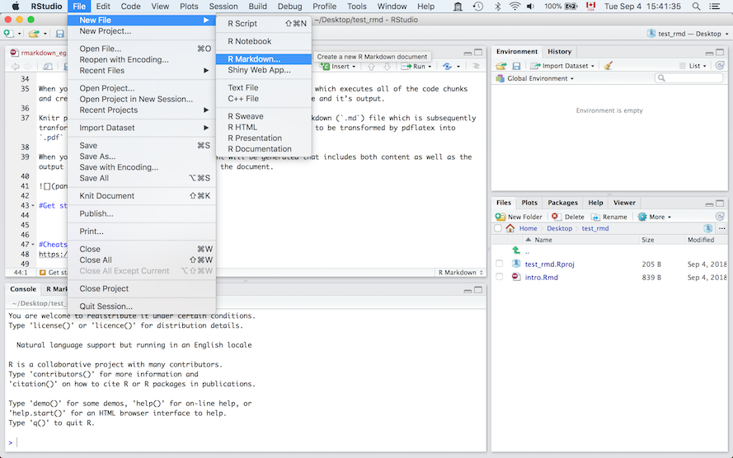  
   
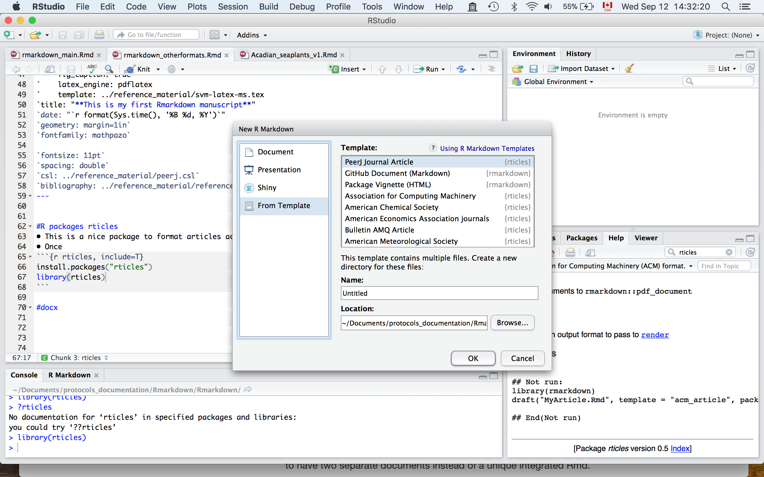

* Right now, few templates available.
* Some templates may be slower to render, depending on what *LaTeX* package they depend on and need to be downloaded (e.g PNAS).

# Other possibilities

## Presentations

* You can also generate Powerpoint-like presentations.  
  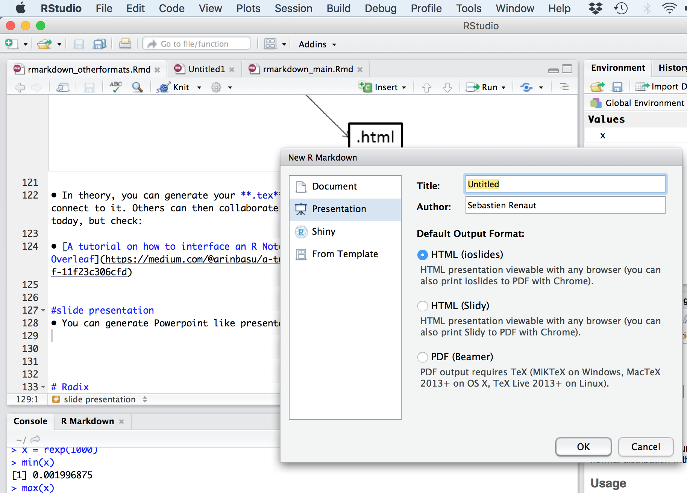

## Overleaf

* Overleaf is an online LaTeX and Rich Text collaborative writing and publishing tool that makes the whole process of writing, editing and publishing scientific documents much quicker and easier.

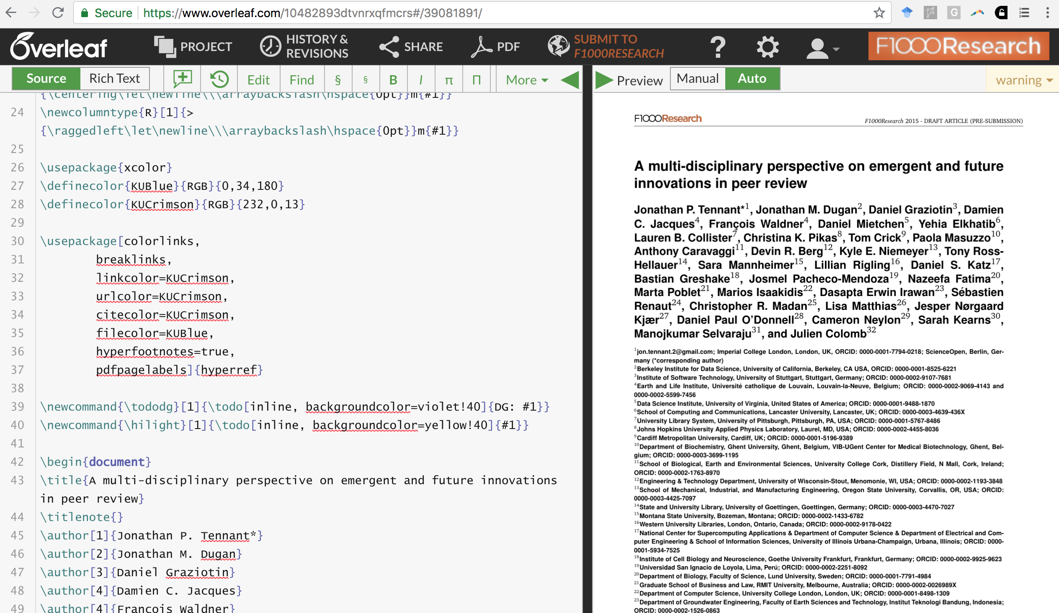

* Remember this:  
  
* So you can generate your *.tex* file, upload it to a github repo and Overleaf will connect to it. Others can then collaborate and modify the *.tex* file.
* Let’s take a quick look at [overleaf](https://www.overleaf.com/). Once you have an overleaf account, you can connect it to a [github](https://www.github.com/) repository. You can then pull/push from overleaf to github, allowing others to modify your *.tex* file.

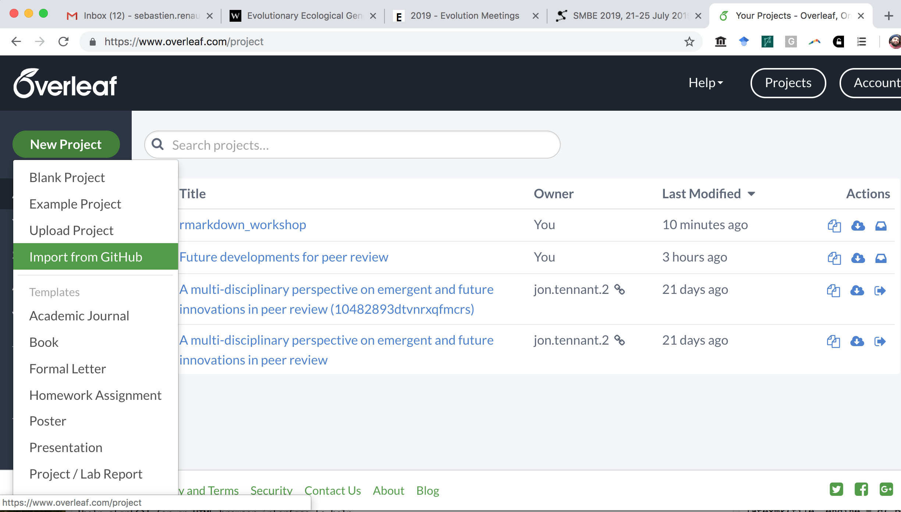

* [A tutorial on how to interface an R Notebook with Overleaf](https://medium.com/@arinbasu/a-tutorial-on-how-to-interface-an-r-notebook-with-overleaf-11f23c306cfd)
* [How do I connect an Overleaf project with a repo on GitHub, GitLab or BitBucket?](https://www.overleaf.com/learn/how-to/How_do_I_connect_an_Overleaf_project_with_a_repo_on_GitHub,_GitLab_or_BitBucket%3F)

## Bookdown

* [Bookdown](https://bookdown.org/)  is an open-source R package that facilitates writing books and long-form articles/reports with R Markdown.

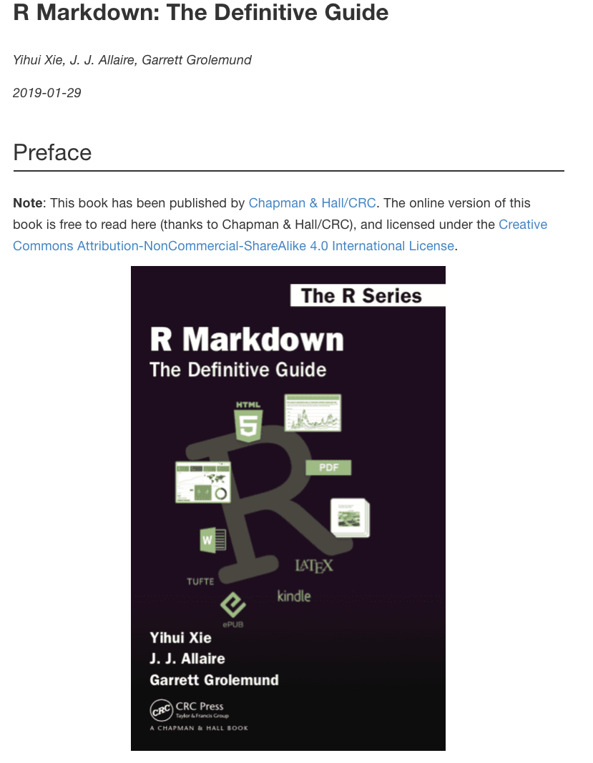

## Radix

* [Radix](https://blog.rstudio.com/2018/09/19/radix-for-r-markdown/) offers a better look for publishing blog, webpages, adapted to mobile devices.  
  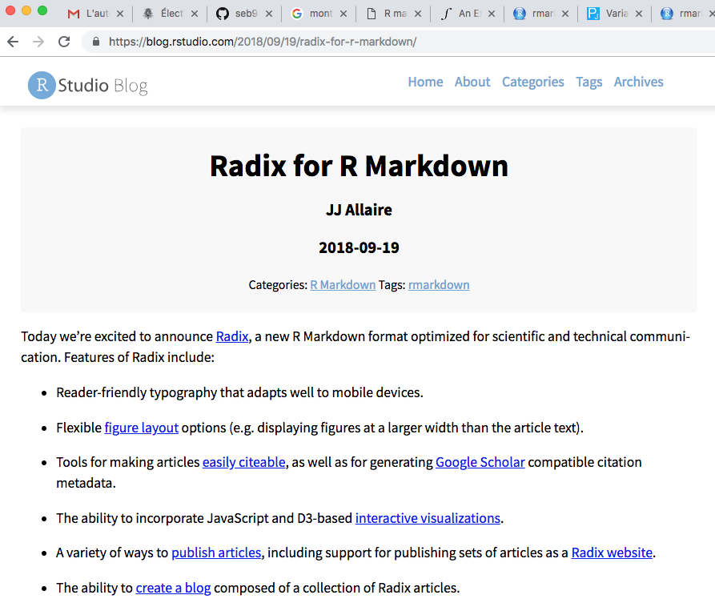
* You will need [Rstudio v1.2](https://www.rstudio.com/products/rstudio/download/preview/), radix and leaflet.

install.packages("radix")   
install.packages("leaflet")

* Change output in header to:

---   
title: "Rmarkdown: radix"   
author: "Sébastien Renaut"   
output: radix::radix_article   
---

* Then you can start playing with the radix options, such as in this example below (full width figures):

#Note that you may need to set eval = F for some formats (pdf, docx) to compile properly  
  
```{r radix_example, echo = F, eval = T, layout='l-screen-inset'}   
library(leaflet)   
leaflet() %>%   
addTiles() %>%   
addMarkers(lng=174.768, lat=-36.852,popup="The birthplace of R")   
```

## Exercice 3

* Use a previously generate document to generate a radix html output.
* What does it look like? Better?