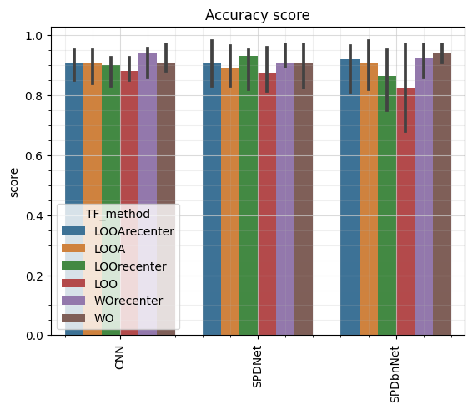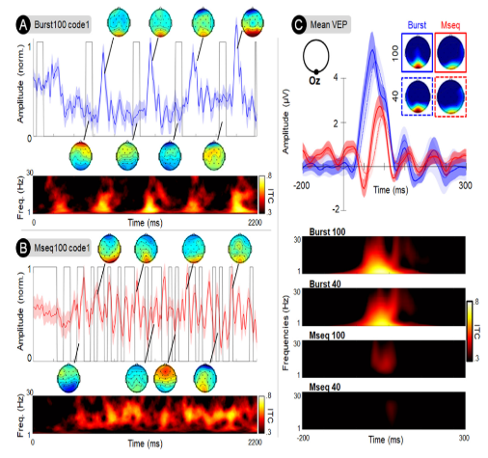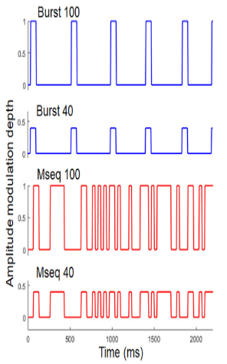

Variability between subjects/sessions:

The variability in BCI across sessions and subjects stems from various factors, including anatomical differences such as variations in grey matter quantity, personal factors like differences in education and lifestyle habits, and physiological disparities such as variations in power across cerebral frequencies. Additionally, factors like fatigue, concentration levels, and stress levels can contribute to this variability.

To address this variability, extensive research has been conducted, and several techniques are employed, including:

* Leave One Out: This technique involves training the model on data from n-1 subjects and testing it on the nth subject. Sometimes, a small portion of the nth subject's data is also used for training.
* Data alignment: This method involves aligning the data from all subjects to ensure a similar feature space across subjects. [4]
* Training a Deep Learning (DL) algorithm on n-1 subjects, freezing one or more layers, and then retraining it on the data from the last subject.

Conclusion:

We have look at the performance of Riemannian algorithms, SPDNet and SPDBNNet, compared with the performance of a CNN in the transfer learning context with a Burst C-VEP based BCI. We looked at the effect of recentering the data before the classifier too. We have seen that recentering and using a SPDNet can improve the accuracy using a LOO or LOOA approach or can reach the accuracy obtain with the CNN and the classical training approach.

In a future work, new transfer learning techniques should be studied, and a finest statistical study should be done.

Reference:

[1] J. Thielen, P. Marsman, J. Farquhar, et P. Desain, « From full calibration to zero training for a code-modulated visual evoked potentials for brain–computer interface », *J. Neural Eng.*, vol. 18, no 5, p. 056007, avr. 2021, doi: 10.1088/1741-2552/abecef.

[2] S. Saha et M. Baumert, « Intra- and Inter-subject Variability in EEG-Based Sensorimotor Brain Computer Interface: A Review », *Frontiers in Human Neuroscience*, p. 8, 21 janvier 2020.

[3] K. Cabrera Castillos, S. Ladouce, L. Darmet, et F. Dehais, « Burst c-VEP Based BCI: Optimizing stimulus design for enhanced classification with minimal calibration data and improved user experience », *NeuroImage*, p. 11, novembre 2023.

[4] R. L. C. Rodrigues, C. Jutten, et M. Congedo, « Riemannian Procrustes Analysis : Transfer Learning for Brain-Computer Interfaces », *HAL Open science*, p. 13, 7 janvier 2019.

[5] Z. Huang et L. Van Gool, « A Riemannian Network for SPD Matrix Learning ». arXiv, 22 décembre 2016. Consulté le: 18 mars 2024. [En ligne]. Disponible sur: <http://arxiv.org/abs/1608.04233>

Results:

We conducted a comparative analysis of two algorithms, SPDNet [5] and SPDBNNet,

with a CNN model introduced in our paper on Burst-CVEP. Our investigation focused

on evaluating the median accuracy of 2 transfer learning techniques, LOO and LOOA,

as illustrated in the graph, alongside a conventional training approach (WO).

Additionally, we examined the impact of recentering the data. Our results indicate

that transfer learning techniques had lower accuracy compared to subject-specific

training, which is consistent with the literature. Notably, SPDNet demonstrates slightly

lower accuracy compared to the CNN overall, while SPDBNNet exhibits superior

performance in WO accuracy, albeit with lower LOO accuracy. However, when

considering data recentering, the Riemannian algorithm showed improved accuracy

with LOO and LOOA. The CNN's performance remained consistent with LOOA but

varied with WO. Further statistical analysis is needed to confirm these findings.

C-VEP and BurstVEP:

A code-VEP, also known as a sequence of 0s and 1s (often referred to

as an m-sequence), is generated using a linear feedback shift register.

The initial sequence is produced, and subsequent sequences are then

generated by phase-shifting this initial sequence. It's crucial for these

sequences to be as uncorrelated as possible.  
The burst C-VEP is a variation of the C-VEP. In a burst sequence,

there are fewer onsets and more time between two onsets, allowing

for the emergence of a P100 response. This facilitates clearer responses

to onsets, making the detection and classification of the code bits

easier. Additionally, when utilizing the Burst C-VEP, we can reduce

the amplitude of the flash while still achieving satisfactory results,

significantly enhancing the visual comfort for the user.

Introduction:

Code Visually Evoked Potentials (c-VEP) have emerged as a promising approach in the Brain-Computer Interface (BCI) community. Utilizing pseudo-random visual flickers, c-VEP offers advantages such as reduced calibration times, as learning one brain response associated with a specific code facilitates the inference of others. Additionally, alternative decoding methods like bitwise decoding [1] have enabled self-paced rBCI with adaptable decoding times.  
However, despite these advancements, c-VEP-based BCIs encounter challenges related to cross-subject and cross-session variability [2]. To address this issue, we present a study focusing on cross-subject/sessions variability in BCIs, leveraging a derivative of C-VEP known as Burst C-VEP (or BurstVEP) [3]. Our study compares the accuracy achieved by different algorithms (CNN, SPDNet, SPDBNNet) under various training modes, including WithinSubject, Leave-One-Out (LOO), LOO with adaptation, and with or without recentering.

Studying the variability between subjects and sessions in CVEP based BCI