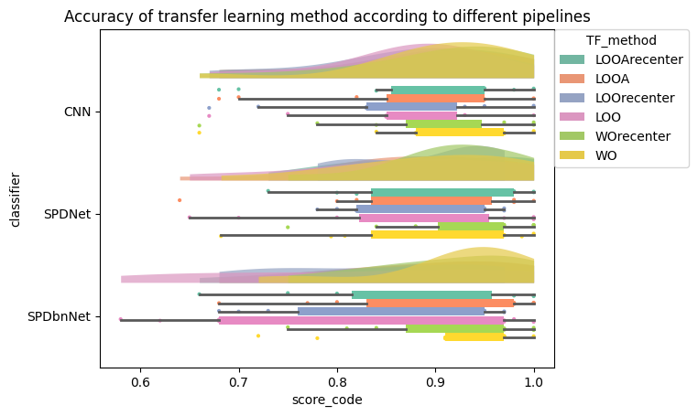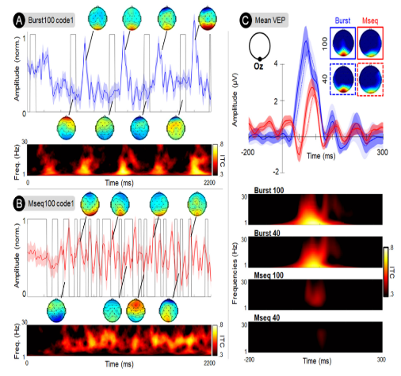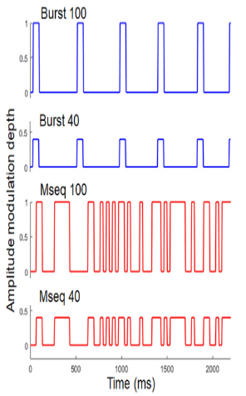

Introduction:

Code Visually Evoked Potentials (c-VEP) have emerged as a promising approach in the Brain-Computer Interface (BCI) community. Utilizing pseudo-random visual flickers, c-VEP offers advantages such as reduced calibration times, as learning one brain response associated with a specific code facilitates the inference of others. Additionally, alternative decoding methods like bitwise decoding [1] have enabled self-paced rBCI with adaptable decoding times.  
However, despite these advancements, c-VEP-based BCIs encounter challenges related to cross-subject and cross-session variability [2]. To address this issue, we present a study focusing on cross-subject/sessions variability in BCIs, leveraging a derivative of C-VEP known as Burst C-VEP (or BurstVEP) [3]. Our study compares the accuracy achieved by different algorithms (CNN, SPDNet, SPDBNNet) under various training modes, including WithinSubject, Leave-One-Out (LOO), LOO with adaptation, and with or without recentering.

Variability between subjects/sessions:

The variability in BCI across sessions and subjects stems from various factors, including anatomical differences such as variations in grey matter quantity, personal factors like differences in education and lifestyle habits, and physiological disparities such as variations in power across cerebral frequencies. Additionally, factors like fatigue, concentration levels, and stress levels can contribute to this variability.

To address this variability, extensive research has been conducted, and several techniques are employed, including:

* Leave One Out: This technique involves training the model on data from n-1 subjects and testing it on the nth subject. Sometimes, a small portion of the nth subject's data is also used for training.
* Data alignment: This method involves aligning the data from all subjects to ensure a similar feature space across subjects. [4]
* Training a Deep Learning (DL) algorithm on n-1 subjects, freezing one or more layers, and then retraining it on the data from the last subject.

C-VEP and BurstVEP:

A code-VEP, also known as a sequence of 0s and 1s (often referred to

as an m-sequence), is generated using a linear feedback shift register.

The initial sequence is produced, and subsequent sequences are then

generated by phase-shifting this initial sequence. It's crucial for these

sequences to be as uncorrelated as possible.  
The burst C-VEP is a variation of the C-VEP. In a burst sequence,

there are fewer onsets and more time between two onsets, allowing

for the emergence of a P100 response. This facilitates clearer responses

to onsets, making the detection and classification of the code bits

easier. Additionally, when utilizing the Burst C-VEP, we can reduce

the amplitude of the flash while still achieving satisfactory results,

significantly enhancing the visual comfort for the user.

Results:

We conducted a comprehensive comparative analysis between two algorithms, SPDNet

[5] and SPDBNNet, alongside a CNN model introduced in our paper on Burst-CVEP.

Our investigation primarily centered on assessing the median accuracy of two transfer

learning techniques, Leave-One-Out of all (LOO) and Leave-One-Out with Adaptation

(LOOA), as depicted in the accompanying graph, in comparison to a conventional

training approach WithOut transfer (WO). Additionally, we explored the influence of

recentering the data. Our findings reveal that transfer learning techniques exhibited

diminished accuracy when compared to subject-specific training (**0.873/0.916**),

aligning with existing literature. Notably, SPDNet displayed marginally lower accuracy

compared to the CNN overall, whereas SPDBNNet showcased superior performance in

WO accuracy (**0.93/0.905**), albeit with lower LOO accuracy. However, upon

considering data recentering, the Riemannian algorithm demonstrated enhanced accuracy with LOO and LOOA (resp. **0.94/0.87** & **0.905/0.89** for the SPDNet and **0.86/0.83** & **0.92/0.91** for the SPDBNNet). The CNN's performance remained relatively stable with LOOA but exhibited variability with WO. Further statistical analyses are warranted to validate these observations.

Conclusion and Perspectives:

We examined the performance of Riemannian algorithms, SPDNet, and SPDBNNet, juxtaposed with that of a CNN within the realm of transfer learning, specifically focusing on a Burst C-VEP based BCI. We also investigated the impact of recentering the data before classification. Our findings suggest that recentering, coupled with the use of SPDNet, can enhance accuracy when employing a LOO or LOOA approach, potentially reaching levels comparable to those achieved with the CNN and classical training methods. In future research endeavors, it is imperative to explore novel transfer learning techniques and conduct a more comprehensive statistical analysis to further elucidate these observations.

Reference:

[1] J. Thielen, P. Marsman, J. Farquhar, et P. Desain, « From full calibration to zero training for a code-modulated visual evoked potentials for brain–computer interface », *J. Neural Eng.*, vol. 18, no 5, p. 056007, avr. 2021, doi: 10.1088/1741-2552/abecef.

[2] S. Saha et M. Baumert, « Intra- and Inter-subject Variability in EEG-Based Sensorimotor Brain Computer Interface: A Review », *Frontiers in Human Neuroscience*, p. 8, 21 janvier 2020.

[3] K. Cabrera Castillos, S. Ladouce, L. Darmet, et F. Dehais, « Burst c-VEP Based BCI: Optimizing stimulus design for enhanced classification with minimal calibration data and improved user experience », *NeuroImage*, p. 11, novembre 2023.

[4] R. L. C. Rodrigues, C. Jutten, et M. Congedo, « Riemannian Procrustes Analysis : Transfer Learning for Brain-Computer Interfaces », *HAL Open science*, p. 13, 7 janvier 2019.

[5] Z. Huang et L. Van Gool, « A Riemannian Network for SPD Matrix Learning ». arXiv, 22 décembre 2016. Consulté le: 18 mars 2024. [En ligne]. Disponible sur: <http://arxiv.org/abs/1608.04233>

Studying the variability between subjects and sessions in CVEP based BCI