Project-Phase 1
  - Deadline: Day 26/07/2026 @ 23:59
[Total Mark is 5]

Computer Networks
DS360

Student Details: CRN:
Name: SABA HASSAN ALANSARI  Name: MANAR AHMED ALATA  Name: SEREEN HASSAN ALELYANI  Name: HOUR MOHAMMED ALJUWAYSIR |  | ID: 240023452  ID: 20030069  ID: 240007069  ID: 240028663

Instructions:
- You must submit two separate copies (one Word file and one PDF file) using the Assignment Template on Blackboard via the allocated folder. These files must not be in compressed format.
- It is your responsibility to check and make sure that you have uploaded both the correct files.
- Zero mark will be given if you try to bypass the SafeAssign (e.g., misspell words, remove spaces between words, hide characters, use different character sets, convert text into image or languages other than English or any kind of manipulation).
- Email submission will not be accepted.
- You are advised to make your work clear and well-presented. This includes filling your information on the cover page.
- You must use this template, failing which will result in zero mark.
- You MUST show all your work, and text must not be converted into an image, unless specified otherwise by the question.
- Late submission will result in ZERO mark.
- The work should be your own, copying from students or other resources will result in ZERO mark.
- Use Times New Roman font for all your answers.

Phase 1 Requirements
5 Marks
Students are required to submit a short mid progress report, which must include the following:
- Work completed this period (2 marks): This includes the installation of Cisco Packet Tracer, and a study of Packet Tracer for creating nodes, using different types of links (copper straight-through, copper cross-over, serial DCE/DTE), and assigning IP addresses.
A straight-through cable is often used to connect a PC to a switch or a switch to a router.
A crossover cable is used between similar devices in certain scenarios.
A serial DCE/DTE cable is used to connect two routers to simulate a WAN.
  - Note: You must show a screenshot of the installation of Packet Tracer (with your system visible, e.g., date/time or username). (1 mark)
  - Give a description of the objectives and advantages of using Packet Tracer for this project. (1 mark)
Cisco Packet Tracer network simulation and visualization tool.

The Cisco Packet Tracer
1-helps you to practice your network configuration
2-troubleshooting skills using your desktop or laptop computer. It allows you to simulate networks without having access to physical equipment.
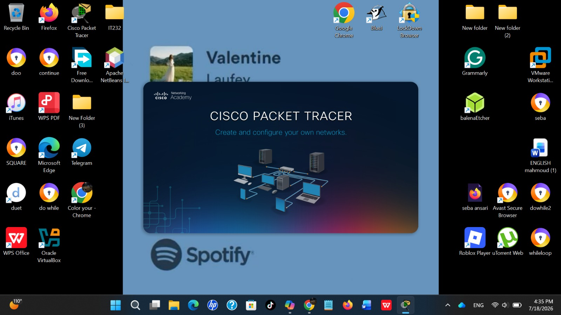
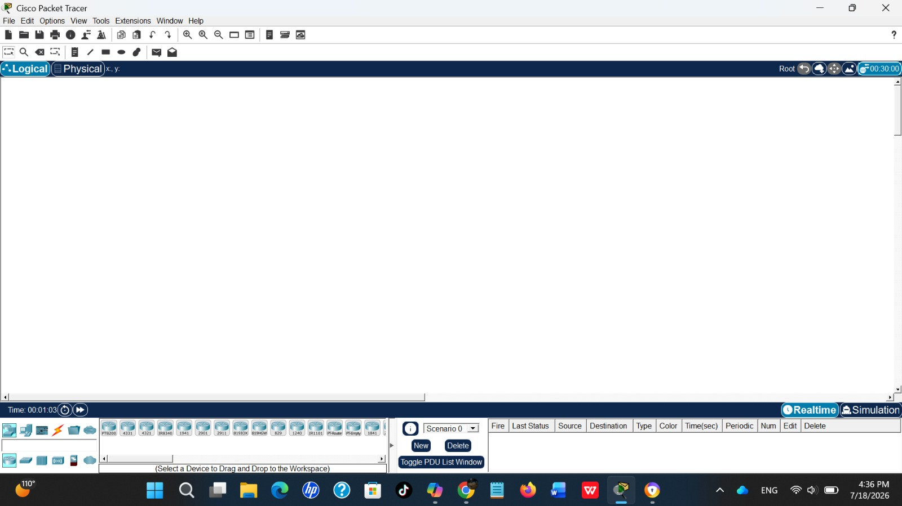

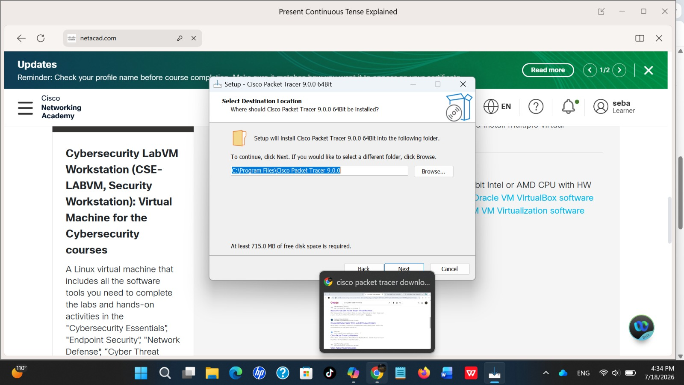

- One key decision made during this period (1 mark): For example, your choice of IP addressing scheme, choice of routing method to study, or division of work among group members. Explain briefly why the decision was made.
Task division.
To organize work, save time, and improve collaboration.
- One problem encountered (1 mark): Describe one genuine problem faced so far (technical or organizational) and its current status (resolved / in progress).
The router interface was initially disabled. We enabled it, and the issue was resolved.

- Plan for the next period (0.5 mark): Briefly list the tasks you plan to complete before the final submission (e.g., building the topology, configuring routers, testing with ping).
• Build the network topology.
• Configure routers and switches.
• Assign IP addresses to all devices.
• Test connectivity using the Ping command.
- Each group member's input/participation (0.5 mark): State each member's name and their specific contribution during this period.
SABA: | Installed Cisco Packet Tracer and captured the installation screenshot.

MANAR: | Explored the Packet Tracer interface and added the router, switch, and PCs.

SEREEN: | Studied cable types and connected the devices using the appropriate cables.

HOUR : Configured the IP addresses and prepared the Phase 1 progress report.

