**Police Strategy Controls in Chicago for Crime**

**Buero, Sebastián**

**1. Introduction**

**1.1. Background**

Crime in Chicago has been tracked by the [Chicago Police Department](https://en.wikipedia.org/wiki/Chicago_Police_Department)'s Bureau of Records since the beginning of the 20th century. The city's overall crime rate, especially the [violent crime](https://en.wikipedia.org/wiki/Violent_crime) rate, is higher than the US average. [Chicago](https://en.wikipedia.org/wiki/Chicago) was responsible for nearly half of 2016's increase in homicides in the US, though the nation's crime rates remain near historic lows. The reasons for the higher numbers in Chicago remain unclear. An article in [The Atlantic](https://en.wikipedia.org/wiki/The_Atlantic) detailed how researchers and analysts had come to no real consensus on the cause for the violence.

**1.2 Problem**

Data that might contribute to determining wich is the best locations and places to set police controls.

**1.3 Interest**

The interest on the problem has de origin in the high overall crime rate on Chicago City.

**2. Data Acquisition and Cleaning**

**2.1 Data sources**

The data provides from a complete dataset from Chicago crimes wich in the web in csv format on the follow link <https://ibm.box.com/shared/static/svflyugsr9zbqy5bmowgswqemfpm1x7f.csv>

**2.2 Data Cleaning**

The downloaded data in the csv file its 99% ready to use without any drop o clean, just a little rows has been removed because it was a problem with the data typing on latitude and longitude columns, just 4 rows in the entire dataset wich demonstrated that is a good font of data. Also we take a sample of the most relevant crimes (appears >= 30 times)

**2.3 Feature Selection**

After data cleaning, there were 508 samples and 8 features in the data. Upon examining the meaning of each feature, it was clear that there was some redundancy in the features. After all, 5 features were selected.

**3. Exploratory Data Analysis**

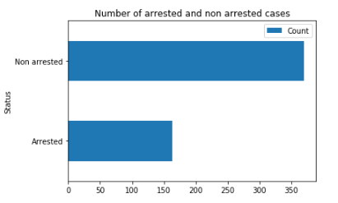

In the following image, as we can see, it is a good proportion of total arrested based in total cases (lot of them are minus crimes).

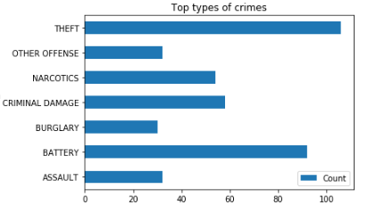

The more repetitive crimes are theft, criminal damage, battery and narcotics also there is important to keep in mind that assault it’s a non minor crime and it will be included in the geospital analysis

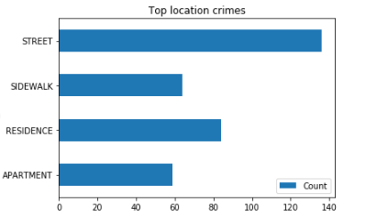

Also, big part of them are in the street / sidewalk, wich evidences the necessity of more police controls in the street.

**4. Crime maps analysis**

**4.1 Theft Crime map**

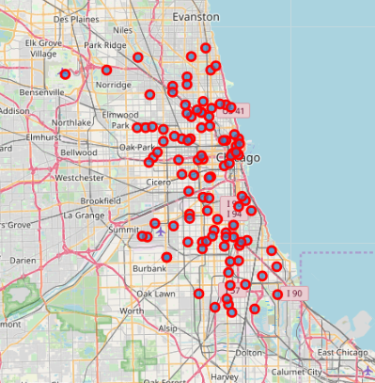

As the image shows, theft crime doesn’t follow a patter, it is randomly situated in the centre of city street wich evidence that the best way to prevent it its highy impact police monitoring in the streets, also, theft it’s the most common crime in Chicago city as we have seen before.

**4.2 Battery Crime map**

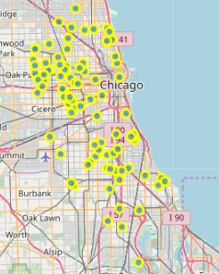

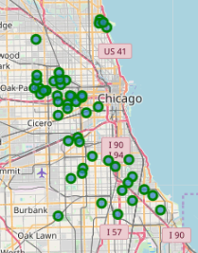In battery crime cases, it mays follow a pattern in oak park and cicero zones for most cases, and such a few oters in the south of main zone. The best way to prevent this crime is installing police controls in the focus zones.

**4.3 Narco Crime map**

For narco crime cases, it mays follow a pattern in oak park and cicero zones for most cases, and such a few oters in the south of main zone with some outliers. But it seems follows the same pattern as battery crimes. The best way to prevent this crime is installing police controls in the focus zones

**4.3 Criminal Damage Crime Map**

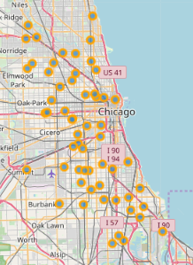

As the map shows, criminal damage crime is a crime highly randomly distributed as theft, the best way to prevent it is random highly impact police monitoring in the streets.

.

**5. Conlusions**

The most relevant crimes are theft, battery, narcotics and criminal damage, each one have their own best way to prevent it… in some cases the way match each other as battery and narcotics cases. My professional recommendation is that set points of anti narcotic police on Cicero and Oak-Park in company with a same proportion of oficials to prevent most cases of narcotics and battery crimes. For theft and criminal damage crimes the pololice MUST incarese the monitoring in the streets because there are highly random distributed in the city