Week 5: Cloud and API deployment

Name: Sebastián J. Castro
Batch code: LISP01
Submitted date: 28/03/2021
Submitted to: Data Glacier

Project structure:

1. __pycache__ (folder)
2. static/css (folder)
-style.css
3. templates (folder)
-index.html
-predict.html
4. venv (folder)
5. Procfile
6. README.md
7. app.py
8. model.pkl
9. model.py
10. requirements.txt

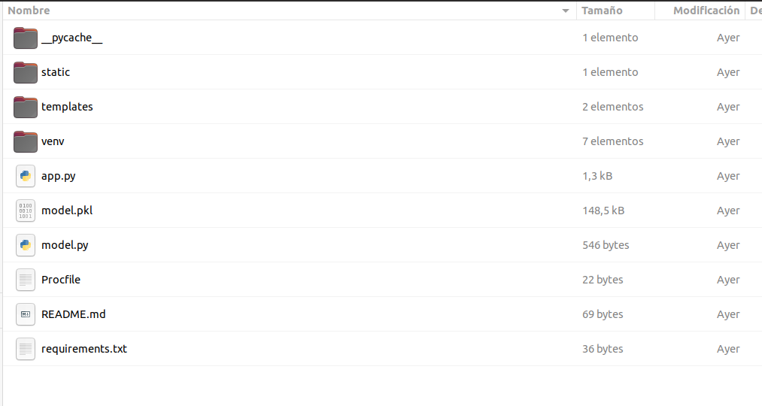

Step 1. Model deployment in Heroku: Login

Taking into account the app developed in Flask week 4 (with iris species toy dataset), now it will be deployed at Heroku. So, the first step is to install Heroku and sign in. Once we have created the account we are ready to log in and start creating the web app.

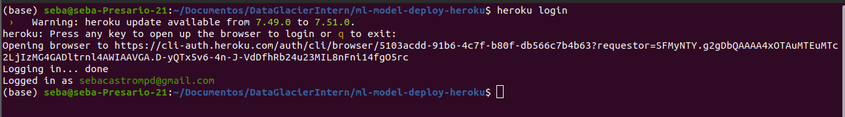
Step 2: Creating Web App at Heroku

Then, we create the web app. We can do it directly from the terminal with the next code:

heroku apps: name_of_app

The name of the app is: iris-species-predictor-web-app

Step 3: Creating important files: Procfile and requirements.txt

Heroku requires Procfile to be present in the root directory of your application. It will tell Heroku how to run the application. This file must be a simple file with no extension.

requirements.txt will install all the necessary dependencies to run the code. It will tell heroku that this project will require all these libraries to run the application correctly.

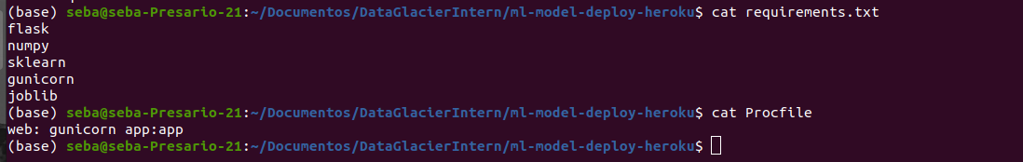
Step 4: Creating github repository

In this step we create a github repository with the files and folder that are mentioned before. And created a branch named “deploy” in order to connect this branch with Heroku dashboard.
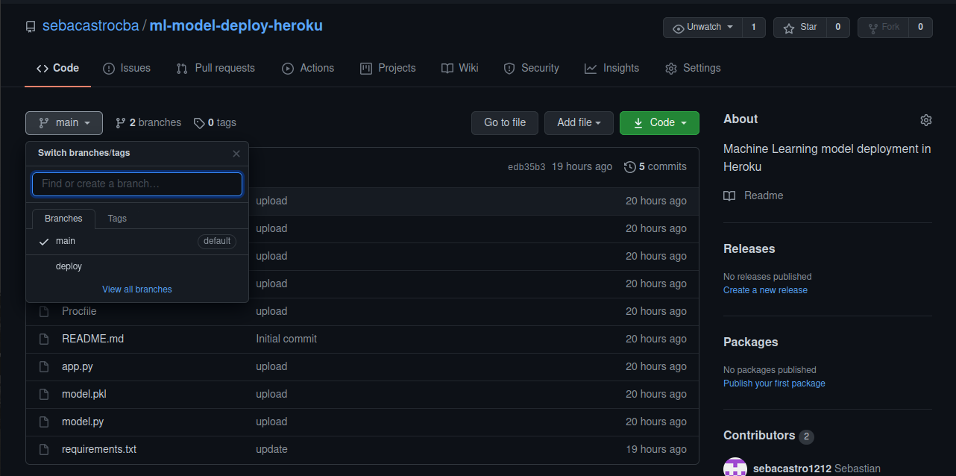

Step 5: connect the repository created before and select the deploy branch for enabling the automatic deployment. To do that, go to the deploy tab in the dashboard:

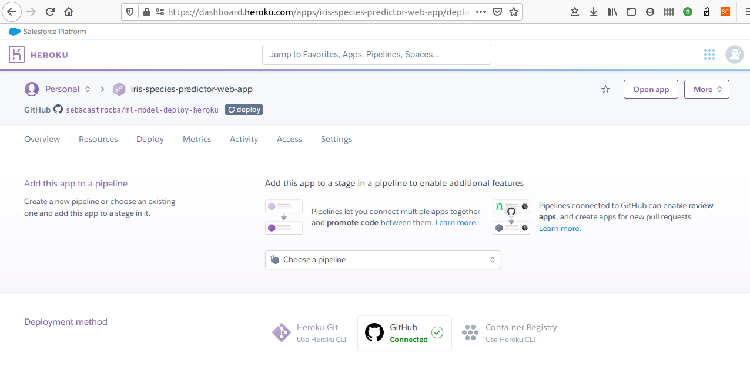
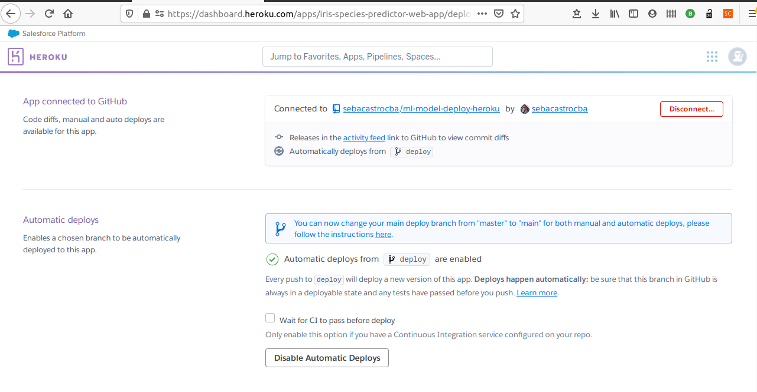

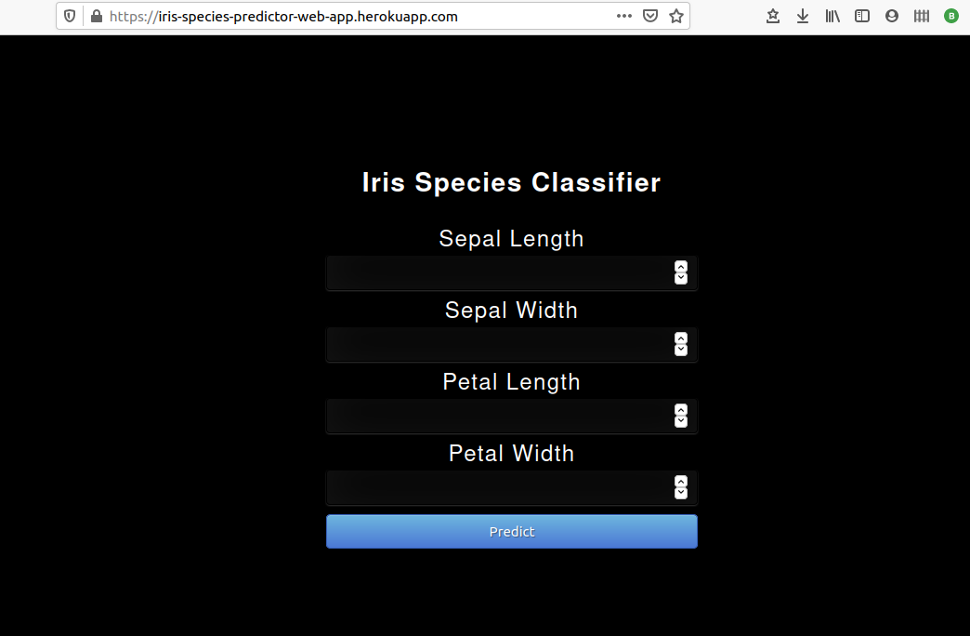
Step 5: wait for the process of deployment and then go to the url of the web app and use it.

,

