Documentation

PROJECT MODULE FILE (IT DEPARTAMENT)

GROUP (DAM2 | DAW2 | ASIX2 | SMX2A | SMX2B)

DAW2

TITLE

Web application languages ​​for ONCE

GROUP MEMBERS (The students' names that will develop the project)

Sergio Baena López

DESCRIPTION (Write in no more than 15 text lines the objectives of the project)

The purpose of the project is to create an educational web application languages can also be accessed visually impaired children (also who do not have these problems). To do that, my application will incorporate sounds (a person speaking) along its execution describe any event that is happening inside it and a navigation through keys. Therefore, this application to the be adapted to children with visual deficiency does not require any type of screen reader for use. Not so, we must point out that this application can also use any other child in the way they have always done, as also support normal navigation by mouse and without any sound. The usefulness of this software is to make learning more fun for children. Here children will have exercises of count number of syllables, monosyllabic words to find, to categorize by type of word, ie, acute plain or antepenultimate, etc. Definitely, with this application we provide a learning tool for any child, of any.

MATERIALS REQUIRED AND TECHNICAL SPECIFICATIONS OF THE PROJECT

For this project the following requirements:

Programming Languages:

- XHTML (also HTML5)
- CSS
- JavaScript
- JQuery
- PHP
- Ajax
- SQL

Software:

- MySQL
- Apache
- PHP interpreter
- Linux
- Komodo Edit (IDE)
- JAWS (screen reader)
- Recorder

Materials:

- Computer
- External hard disk

FUNCTIONAL REQUIREMENTS
(Draft version: it is a first version to specify all functionalities and their results, as well as the profile users who may run each functionality)

An example of functional requirements:

RF1. THE MANAGEMENT OF CARDS (short description of the functionality and priority level: high, medium, low)
RF1.1 NEW ENTRY CARD (short description of the functionality and priority level: high, medium, low)
RF1.2 CANCEL CARD (short description of the functionality and priority level: high, medium, low)
RF1.3 MODIFY DATA CARD (short description of the functionality and priority level: high, medium, low)
RF1.4 CONSULT DATA CARD (short description of the functionality and priority level: high, medium, low)
RF2. ...

(NOTE: as a result of your initial interviews with the clients, you may use whatever you consider necessary in order to clarify what the client precisely wants: diagram, graphic, description, etc)

We will have three users for this application, namely, students, teachers and webmasters.

RF1. MANAGING USER PROFILE
RF1.1 REGISTERING A STUDENT. Register a new student in the system so he/she can use it as such. Priority: high
RF1.2 REGISTERING A TEACHER. Register a new teacher in the system so he/she can use it as such. Priority: high
RF1.3 VIEW A STUDENT. Students can view their profile at any time. Also the teacher and webmaster can see its. Priority: high
RF1.4 VIEW A TEACHER. Teachers can view their profile at any time. Also webmaster can see its. Priority: high
RF1.5 VIEW A WEBMASTER. Webmaster can view their profile at any time. Priority:
RF1.6 MODIFY A STUDENT. The student can at any time modify some data on his/her user profile. Also the webmaster can. Prority: medium
RF1.7 MODIFY A TEACHER. The teacher can at any time modify some data on his/her user
profile. Also the webmaster can. Prority: medium
RF1.8 MODIFY A WEBMASTER. The webmaster can at any time modify some data on his/her user profile. Prority: low
RF1.9 DELETE A STUDENT. The student may at any time unsubscribe from the system and no longer have access to games and other things. Also the webmaster can. Prority: low
RF1.10 DELETE A TEACHER. The teacher at any time may unsubscribe to the system and no longer have access to the activities of their associated students and other things. Also the webmaster can. Prority: low
RF1.11 DELETE A WEBMASTER. The web administrator at any time may unsubscribe to no longer the system and be disable to manage the site using this utility. Prority: low
RF2. GAME COUNT NUMBER OF SYLLABLES. Set of 10 words by game. A word is displayed on the screen and there will be time to respond. It is scored as follows: 10 points for the first correctly, 1 point for the second correctly and 0 points for not doing it correctly. Priority: high
RF3. GAME TO FIND MONOSYLLABIC WORDS. Game is a list of some monosyllabic words that the user has to to find what they are. Response time will be. Scores will correctly 10 points completely, if you do not select the proportional part will be discounted based on the number of monosyllables beech (no decimals accepted in the ratings). 10 lists for departure. Priority: high

RF4. GAME OF CATALOGING WORDS BY ACUTE, PLAIN OR ANTEPENULTIMATE. Set of 10 words per game. For each screen will display a word and should be indicated if is acute, plain or antepenultimate at a given time. Scores will be 10 points for the first correctly, 1 point for correctly the second and 0 points for no right or finish time. Priority: high
RF5. GAME TO INDICATE WHETHER THAT WORD HAS AN ACCENT OR NOT. Set of 10 words per game. For each screen presented with a word without accent and should be indicated in a particular time if have an accent or not. 6 points will be given for correctly and no points for failure or time completion. Priority: high
RF6. MANAGEMENT OF WORDS. Add new word with its characteristics (number of syllables, if monosyllabic or not, if is acute ..., etc), list words, modify, delete. Priority: low
RF7. LIST ALL TEACHERS. Lists all teachers currently registered in the system. Priority: low
RF8. LIST ALL STUDENTS. Lists all students currently registered in the system. Priority: low
RF9. LIST ALL WEBMASTERS. Lists all webmasters currently registered in the system. Priority: low
RF10 – DISPLAY INFORMATION ABOUT THE RULES OF THE GAMES. Priority: high

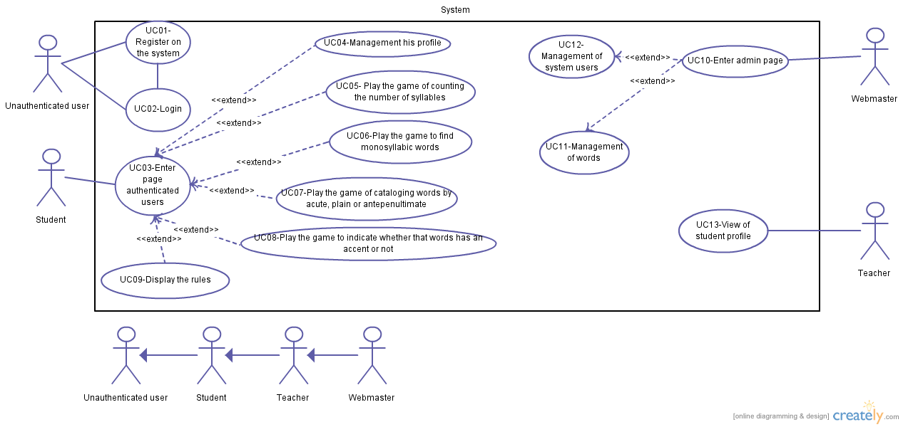

Code | UC01
Name | Register on the system
Author | Sergio Baena López
Date | 2014-05-07
Description | Register as a new user in the system
Actors | Unauthenticated user
Preconditions | Nothing
Normal flow | - The actor requesting registration option.  - The system displays a registration form.  - The actor fill out the form by typing in text fields: the name, surnames,  school, selected from a select the province, city, username, password, confirmation of the password. We must also say that the actor has above all a select whose options are student and teacher.  - The actor clicks the student option  - The system extends the form.  - The actor entered the course and date of birth.  3.2. The actor clicks the teacher option  3.2.1. The system extends the form.  3.2.2. The actor entered the courses separated by commas  4. The actor clicks the Register button.  5. The system validates all fields.  6. The system makes an insert on the table User, Student or Teacher and the Ranking.  7. The system displays on the screen Registro satisfactorio.  8. The system redirects the actor to login page.
Alternative flow | 5.1. The system finds some incorrect data. Displays an error message telling the actor the error and marking the field in red.
Postconditions | The actor is registered in the system (present in the table User, Student or Teacher and Ranking).

Code | UC02
Name | Login
Author | Sergio Baena López
Date | 2014-05-07
Description | An user authentication system.
Actors | Unauthenticated user
Preconditions | The actor has to be registered in the system.
Normal flow | 1. The actor requested the option to log in.  2. The system displays the form of logging  3. The actor enters his username and password.  4. The actor clicks the button "Entrar".  5. The system verifies that the user is present in the DB.  6. The system to open the session  7. The system will redirect to the page authenticated users.
Alternative flow | 5.1. The system detects that the user is not present in the DB.  5.2. The system shows the actor an error message: Nombre de usuario y/o contraseña no válidas.  5.3. The system deletes the content entered in the form.
Postconditions | The session of the actor has to opened.

Code | UC03
Name | Enter page authenticated users
Author | Sergio Baena López
Date | 2014-05-07
Description | The authenticated actor could view and run any functionality present on the page of authenticated users.
Actors | Student
Preconditions | The user session must be open.
Normal flow | 1. The system show page authenticated users.  2. The actor performs the functionality he wants
Alternative flow | Nothing
Postconditions | The actor has executed a functionality

Code | UC04
Name | Management his profile
Author | Sergio Baena López
Date | 2014-05-07
Description | The actor can view, modify and delete his profile.
Actors | Student
Preconditions | The user session must be open.
Normal flow | 1. The actor requested the option to manage their profile  2. The system has five forms, filled. The first contains the attributes of the student (table User and Student), the second contains the attributes of the student ranking of a specific game (read only fields), the third in another and so, successively. In addition, the bottom, we have two buttons, namely Guardar and Eliminar cuenta.  2.1. The actor displays his profile data  2.2. The actor modifies any of his profile data (first form)  2.2.1. The actor clicks the Guardar button.  2.2.2. The system validates the data.  2.2.3. The system updates the active user (stored in the session).  2.2.4. The system displays the screen Tu perfil ha sido modificado . correctamente.  2.3. The actor clicks the Eliminar cuenta button.  2.3.1. The system launches a confirm to the actor asking if he is sure he . wants to delete his account.  2.3.2. The system makes a DELETE table User, Student. And also, last . four DELETE's on the table Ranking eliminating the rankings . associated actor.  2.3.3. The system close the user session.  2.3.4. The system shows the actor the message Tu cuenta ha sido . eliminada correctamente (alert).  2.3.5. The system redirects the web to the home page.
Alternative flow | 2.2.2.1. The system discovers that some data is incorrect.  2.2.2.2. The system displays an error message indicating the errors found.  2.2.2.3. The system puts the wrong fields in red.  2.3.1.1. The actor has indicated a "no" on the "confirm".
Postconditions | If the actor has not just looked at his profile, the user stored in the session must have been modified

Code | UC05
Name | Play the game of counting the number of syllables
Author | Sergio Baena López
Date | 2014-05-08
Description | The actor plays the game of counting the number of syllables
Actors | Student
Preconditions | The user session must be open.
Normal flow | 1. The actor requested the option to play this game.  2. The system shows, first, a text decribes the game (short_description), second game scores (punctuation_at_the_first_attempt and punctuation_at_the_second_attempt) and, finally, two buttons, namely, Jugar ahora and Ver reglas.  2.1. The actor clicks the Jugar ahora button.  2.1.1. The system changes the contents by a word (from the DB), the . time remaining to the actor, and the number of attempts.  2.1.2. The actor press the number of syllables believes there within . time.  2.1.3. The system indicates that the actor has correctly the word.  2.1.4. The system displayed again a new word, and thus successively.  2.1.5. The system displays the end of the game, statistics of this game . and statistics every game. The bottom, there will be a button to play . again.  2.2. The actor clicks the Ver reglas button.  2.2.1. The system shows the actor rules of the game together with a . button Jugar ahora.
Alternative flow | 2.1.1.1. The actor does not press a key on the time his has.  2.1.1.2. The actor lost an attempt or loses this word. If lost, a new word appears.  2.1.2.1. The system indicates that it is wrong and adds one more try.  2.1.2.2. The system indicates that the actor has pressed a key that is not a number.
Postconditions | The ranking stored in the session has been updated.

Code | UC06
Name | Play the game to find monosyllabic words
Author | Sergio Baena López
Date | 2014-05-08
Description | The actor plays the game to find monosyllabic words
Actors | Student
Preconditions | The user session must be open.
Normal flow | 1. The actor requested the option to play this game.  2. The system shows, first, a text decribes the game (short_description), second game scores (punctuation_at_the_first_attempt and, finally, two buttons, namely, Jugar ahora and Ver reglas.  2.1. The actor clicks the Jugar ahora button.  2.1.1. The system displays a list of words with some monosyllabic . with a checkbox next to her, then the time remaining and, finally, the . Aceptar button.  2.1.2. The actor checks the words believes appropriate.  2.1.3. The actor clicks the Aceptar within the proper time.  2.1.4. The system indicates that your choice is correct.  2.1.5. The system displayed again a new list of words, and thus . successively.  2.1.6. The system displays the end of the game, statistics of this game . and statistics every game. The bottom, there will be a button to play . again.  2.2. The actor clicks the Ver reglas button.  2.2.1. The system shows the actor rules of the game together with a . button Jugar ahora.
Alternative flow | 2.1.2.1. The actor did not click the Aceptar button and the time is already past.  2.1.2.2. The system shown any successful word  2.1.2.3. The system again displays a list of words and thus successively.  2.1.3.1. The system indicates that the selected words do not correspond to 100%.  2.1.3.2. The system again displays a list of words and thus successively.
Postconditions | The ranking stored in the session has been updated.

Code | UC07
Name | Play the game of cataloging words by acute, plain or antepenultimate.
Author | Sergio Baena López
Date | 2014-05-08
Description | The actor plays he game of cataloging words by acute, plain or antepenultimate.
Actors | Student
Preconditions | The user session must be open.
Normal flow | 1. The actor requested the option to play this game.  2. The system shows, first, a text decribes the game (short_description), second game scores (punctuation_at_the_first_attempt and punctuation_at_the_second_attempt) and, finally, two buttons, namely, Jugar ahora and Ver reglas.  2.1. The actor clicks the Jugar ahora button.  2.1.1. The system displays a word, three options (acute, flat and . antepenultimate) along with a radiobutton, the remaining time . and the number of attempts.  2.1.2. The actor checked an option within the correct time interval.  2.1.3. The system verifies that it is a valid response.  2.1.4. The system reports that the answer is correct.  2.2.5. The system displayed again a new word, and thus . successively.  2.1.6. The system displays the end of the game, statistics of this . game and statistics every game. The bottom, there will be a button . to play again.  2.2. The actor clicks the Ver reglas button.  2.2.1. The system shows the actor rules of the game together with a . button Jugar ahora.
Alternative flow | 2.1.1.1. The actor does not check any option on all the time.  2.1.1.2. The system tells the actor that the time is over and it increases a try.  2.1.1.2.1. Step 2.1.1 runs if more attempts are not possible.  2.1.1.2.2. The system deselects the radiobutton, put back a new time and . indicates that now is the second attempt. All this, in case a possible retry.  2.1.1.2.2.1. It runs from step 2.1.1.  2.1.3.1. The system indicates that it is not the right answer.  2.1.3.2. The system increases a try.  2.1.3.3. It runs what it contains step 2.1.1.2
Postconditions | The ranking stored in the session has been updated.

Code | UC08
Name | Play the game to indicate whether that words has an accent or not
Author | Sergio Baena López
Date | 2014-05-08
Description | The actor plays the game to indicate whether that words has an accent or not
Actors | Student
Preconditions | The user session must be open.
Normal flow | 1. The actor requested the option to play this game.  2. The system shows, first, a text decribes the game (short_description), second game scores (punctuation_at_the_first_attempt) and, finally, two buttons, namely, Jugar ahora and Ver reglas.  2.1. The actor clicks the Jugar ahora button.  2.1.1. The system displays a word, three options (Tiene acento, No . tiene acento) along with a radiobutton, the remaining time . and the number of attempts.  2.1.2. The actor checked an option within the correct time interval.  2.1.3. The system verifies that it is a valid response.  2.1.4. The system reports that the answer is correct.  2.2.5. The system displayed again a new word, and thus . successively.  2.1.6. The system displays the end of the game, statistics of this . game and statistics every game. The bottom, there will be a button . to play again.  2.2. The actor clicks the Ver reglas button.  2.2.1. The system shows the actor rules of the game together with a . button Jugar ahora.
Alternative flow | 2.1.1.1. The actor does not check any option on all the time.  2.1.1.2. The system tells the actor that the time is over  2.1.1.3. Step 2.1.1 runs  2.1.3.1. The system indicates that it is not the right answer.  2.1.3.2. It runs step 2.1.1
Postconditions | The ranking stored in the session has been updated.

Code | UC09
Name | Display the rules
Author | Sergio Baena López
Date | 2014-05-08
Description | The rules of a game is shown.
Actors | Student
Preconditions | The user session must be open.
Normal flow | 1. The actor requested the option to see the rules of a particular game.  2. The system displays on screen rules of the game in particular, and a button to play this game.  2.1. The actor clicks on the Jugar ahora.  2.1.1. Runs the use case specific game.  2.2. The actor did not click anything.
Alternative flow
Postconditions | Nothing

Code | UC10
Name | Enter admin page
Author | Sergio Baena López
Date | 2014-05-08
Description | Page links to all the functionalities of the administrator.
Actors | Webmaster
Preconditions | The user session must be open.
Normal flow | 1. The actor requested the option to enter the site administrator.  2. The system directs the actor to the administrator page.  3. The actor displays the page.  4. The actor executed some of the functionality of the administrator.
Alternative flow | Nothing
Postconditions | An administrator functionality is running.

Code | UC11
Name | Management of words
Author | Sergio Baena López
Date | 2014-05-08
Description | The actor can add, view, modify and delete a word. He can also delete all the words.
Actors | Webmaster
Preconditions | The user session must be open.
Normal flow | 1. The actor has a menu Management of words from which hang from it options to Añadir, Buscar and Eliminar todo.  1.1. The actor clicks on Añadir  1.1.1. The system displays a form with three fields, namely, palabra,  . número de sílabas and categoría.  1.1.2. The actor introduces the new word, the number of syllables . and category (select).  1.1.3. The actor clicks the button Añadir  1.1.4. The system validates the data.  1.1.5. The system makes an INSERT with the new word.  1.1.6. The system displays the message: La palabra se ha añadido . correctamente.  1.1.7. The form is reset.  1.2. The actor clicks on Buscar.  1.2.1. The system displays a form with two fields, namely, Criterio  . de búsqueda and Valor.  1.2.2. The actor selects the criteria (id, valor, número de sílabas, . categoría) and writes the value to search.  1.2.3. The actor clicks the Buscar button  1.2.4. The system goes to the table word and does a LIKE.  1.2.5. The system displays a list of search results with this format:  <within result criteria> <link to see> <link to modify> <link to . remove>.  1.2.5.1. The actor clicks on Ver.  1.2.5.1.1. The system displays a read-only form . identical to add. The information it contains are those of . the selected word.  1.2.5.2. The actor clicks on Modificar.  1.2.5.2.1. The system displays a form identical to add. . The information it contains are those of the selected . word.  1.2.5.2.2. The actor makes some changes.  1.2.5.2.3. The actor clicks Modificar.  1.2.5.2.4. The system validates the data.  1.2.5.2.5. The system makes an UPDATE to the table . word.  1.2.5.2.6. The system displays a message: La palabra . se ha modificado correctamente.  1.2.5.3. The actor clicks on Eliminar.  1.2.5.4. The system launches a confirm asking if you . are sure you want to delete.  1.2.5.5. The system does a DELETE on the table word.  1.2.5.6. The system displays a message: La palabra . se ha eliminado correctamente.  1.2.5.7. The system deletes the entry for that word in . the search result.  1.3. The actor clicks on Eliminar todo.  1.3.1. The system launches a confirm asking if he is sure he wants to . delete all.  1.3.2. The actor indicates yes.  1.3.3. The system does a DELETE all records in the table word.  1.3.4. The system displays a message: Todas las palabras se han . eliminado correctamente.
Alternative flow | 1.1.4.1. The system detects any wrong data.  1.1.4.2. The system displays an error message indicating the wrong fields.  1.1.4.3. The system marks the wrong fields in red.  1.2.4.1. The system detects that there is no match.  1.2.4.2. The system will then display a message: No hay coincidencias.  1.2.4.3. The system resets the form.  1.2.5.2.4.1. Step 1.1.4.1. is executed  1.2.5.4.1. The actor says he is not sure.  1.3.1.1. The actor indicates no.
Postconditions | The database was updated (if the actor has only seen the word not this is true).

Code | UC12
Name | Management of system users
Author | Sergio Baena López
Date | 2014-05-09
Description | The actor can add, view, modify and delete an user. He can also delete all the users.
Actors | Webmaster
Preconditions | The user session must be open.
Normal flow | 1. The actor has a menu Management of users from which hang from it options to Añadir, Buscar and Eliminar todo.  1.1. The actor clicks on Añadir  1.1.1. The system displays an identical form to register.  1.1.2. The actor introduces the username, password (two times), . name, surnames, school, city and more data. Also select what type of . user the actor wants to add.  1.1.3. The actor clicks the button Añadir  1.1.4. The system validates the data.  1.1.5. The system makes some INSERT's for the new user.  1.1.6. The system displays the message: El usuario se ha añadido . correctamente.  1.1.7. The form is reset.  1.2. The actor clicks on Buscar.  1.2.1. The system displays a form with two fields, namely, Criterio  . de búsqueda and Valor.  1.2.2. The actor selects the criteria (id, nombre, apellidos, etc) and . writes the value to search.  1.2.3. The actor clicks the Buscar button  1.2.4. The system goes to the DB and does a LIKE.  1.2.5. The system displays a list of search results with this format:  <within result criteria> <link to see> <link to modify> <link to . remove>.  1.2.5.1. The actor clicks on Ver.  1.2.5.1.1. The system displays a read-only form . identical to add. The information it contains are those of . the selected user.  1.2.5.2. The actor clicks on Modificar.  1.2.5.2.1. The system displays a form identical to add. . The information it contains are those of the selected . user.  1.2.5.2.2. The actor makes some changes.  1.2.5.2.3. The actor clicks Modificar.  1.2.5.2.4. The system validates the data.  1.2.5.2.5. The system makes an UPDATE to the DB.  1.2.5.2.6. The system displays a message: El usuario . se ha modificado correctamente.  1.2.5.3. The actor clicks on Eliminar.  1.2.5.4. The system launches a confirm asking if you . are sure you want to delete.  1.2.5.5. The system does a DELETE on the DB.  1.2.5.6. The system displays a message: El usuario . se ha eliminado correctamente.  1.2.5.7. The system deletes the entry for that user in the search result.  1.3. The actor clicks on Eliminar todo.  1.3.1. The system launches a confirm asking if he is sure he wants to . delete all.  1.3.2. The actor indicates yes.  1.3.3. The system does a DELETE all records in the table User, . Student, Teacher or Webmaster.  1.3.4. The system displays a message: Todas los usuarios se han . eliminado correctamente.
Alternative flow | 1.1.4.1. The system detects any wrong data.  1.1.4.2. The system displays an error message indicating the wrong fields.  1.1.4.3. The system marks the wrong fields in red.  1.2.4.1. The system detects that there is no match.  1.2.4.2. The system will then display a message: No hay coincidencias.  1.2.4.3. The system resets the form.  1.2.5.2.4.1. Step 1.1.4.1. is executed  1.2.5.4.1. The actor says he is not sure.  1.3.1.1. The actor indicates no.
Postconditions | The database was updated (if the actor has only seen the user not this is true).

Code | UC13
Name | View of student profile
Author | Sergio Baena López
Date | 2014-05-09
Description | View of student profile
Actors | Teacher
Preconditions | The user session must be open.
Normal flow | 1. The actor requested the option to see the profile of the student.  2. The system displays a search form associated to its students. This form has two fields, namely, Criterio de búsqueda and Valor.  3. The actor selects the criteria (id, nombre, apellidos, etc) and writes the value to search.  4. The actor clicks the Buscar button  5. The system goes to the DB and does a LIKE.  6. The system displays a list of search results with this format: <within result criteria> <link to see>  7. The actor clicks on Ver link of a student.  8. The system displays a read-only form selected student profile (same style as specified in the UC04).
Alternative flow | 5.1. The system detects that there is no match.  5.2. The system will then display a message: No hay coincidencias.  5.3. The system resets the form.
Postconditions | Nothing

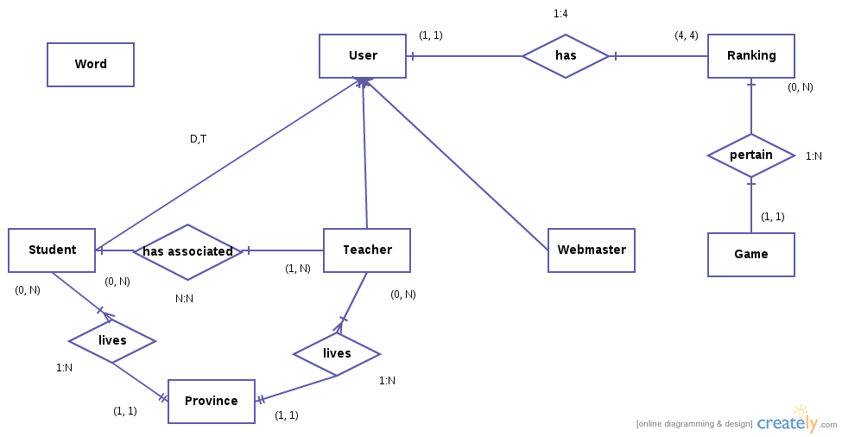

User
Name | Type | Default values | Possibles values
Id | INT(6) | - | -
Username | VARCHAR(10) | - | -
Password | VARCHAR(200) | - | -
Name | VARCHAR(50) | - | -
Surnames | VARCHAR(100) | - | -

Student
Name | Type | Default values | Possibles values
School | VARCHAR(50) | - | -
city | VARCHAR(50) | - | -
Course (NL) | VARCHAR(2) | - | -
date_of_birth | DATE | - | -

Teacher
Name | Type | Default values | Possibles values
School | VARCHAR(50) | - | -
city | VARCHAR(50) | - | -
Courses (NL, NL, ...) | VARCHAR(50) | - | -

Webmaster
Name | Type | Default values | Possibles values
Role | VARCHAR(20) | - | -
Description_of_their_role | VARCHAR(100) | - | -

Ranking
Name | Type | Default values | Possibles values
Id | INT(6) | - | -
points | INT(20) | 0 | -
number_of_hits | INT(10) | 0 | -
number_of_failures | INT(10) | 0 | -
number_of_attempts | INT(10) | 0 | -

Game
Name | Type | Default values | Possibles values
Id | INT(6) | - | -
Name | VARCHAR(50) | - | -
Short_description | VARCHAR(100) | - | -
Rules | VARCHAR(200) | - | -
Punctuation_at_the_first_attempt | INT(2) | - | -
Punctuation_at_the_second_attempt | INT(2) | - | -
Time_of_first_attempt | INT(2) | - | -
Time_of_second_attempt | INT(2) | - | -
num_of_words | INT(2) | - | -

Word
Name | Type | Default values | Possibles values
Id | INT(6) | - | -
Value | VARCHAR(20) | - | -
number_of_syllabes | INT(1) | - | -
category | VARCHAR(16) | - | 'aguda', 'llana', 'esdr&uacute;jula'

Province
Name | Type | Default values | Possibles values
Id | INT(6) | - | -
Value | VARCHAR(20) | - | -

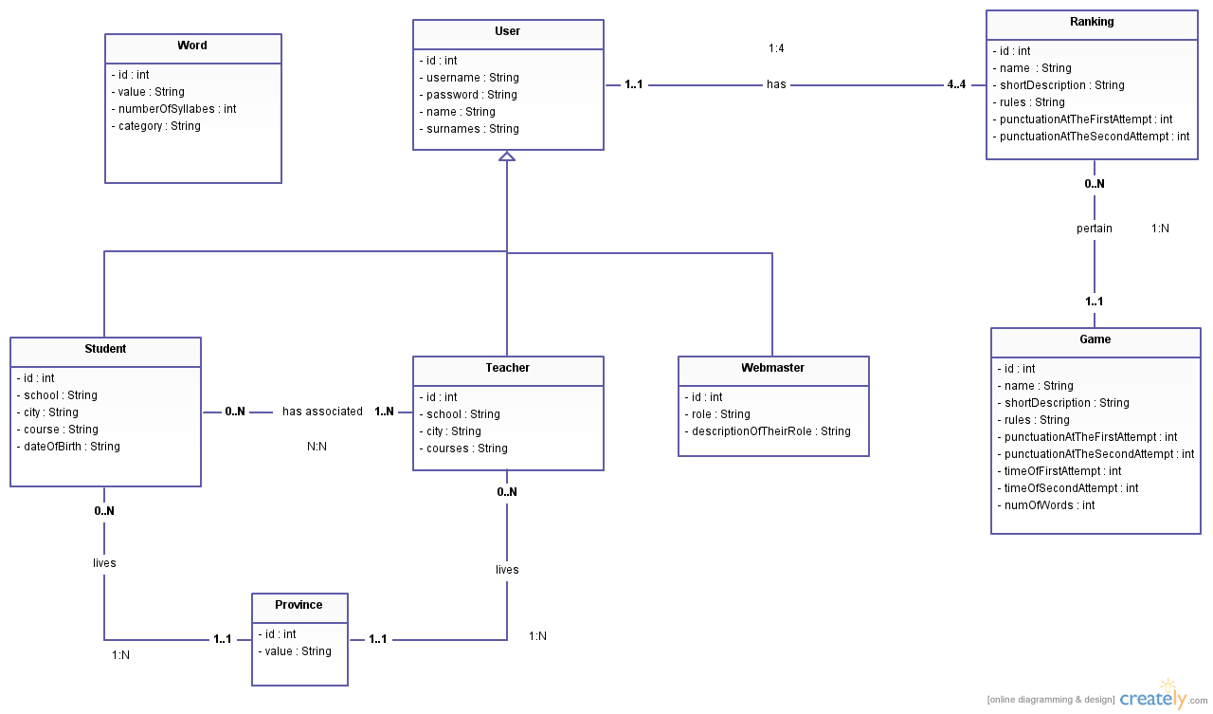

TEST CASES

Name | TC01 - Register on the system
Creator | Sergio Baena López
Version | 1.0
Description / purpose | Register as a new user in the system
Actor | Unauthenticated user
Test data | Name [valid, invalid], surnames [valid, invalid],  school [valid, invalid], city [valid, invalid], username [valid, invalid], password [valid, invalid], course [valid, invalid], date of birth [valid, invalid], courses [valid, invalid]
Precondition | Nothing

Condition | Valid classes | Invalid classes
Name | Field containing only letters and spaces (1) | * Empty field (2)  * Contains only spaces (3)  * Contain any character that is not letter or space. (4)
Surnames | Field containing only letters and spaces (5) | * Empty field (6)  * Contains only spaces (7)  * Contain any character that is not letter or space. (8)
School | Not empty string neither contains only spaces. (9) | * Empty string (10)  * Contains only spaces (11)
City | Not empty string neither contains only spaces (12) | * Empty string (13)  * Contains only spaces (14)
Username | First character must be a letter of the English alphabet (uppercase or lowercase), and the following characters may be as a the first character or contain a number or point a dash or underscore. The minimum length of 4 characters. (15) | * We did not start by letter of the English alphabet. (16)  * The second character or one of the following is not a letter of the English alphabet, a number, a dot, a dash or underscore. (17)  * Length less than 4. (18)
Password | Length greater than 6, and match the confirmation password. (19) | * Smaller than 7 length.(20)  * The password does not match the confirmation password.(21)
Course | Number from 1-6 and a letter of the English alphabet. (22) | * The number is out of range. (23)  * The next character after the number is not a letter of the English alphabet. (24)  * Where a number is expected to enter otherwise. (25)  * Different length to 2. (26)
Date of birth | Last date with DD/MM/YYYY format.(27) | * Format is not followed.(28)  * Impossible date.(29)  * Today's Date.(30)  * Future date.(31)
Courses | Right courses separated by comma and space. (32) | * Any course is incorrect.(33)  * Format is not followed.(34)  * Empty string(35)

Name | TC02 - Login
Creator | Sergio Baena López
Version | 1.0
Description / purpose | An user authentication system.
Actor | Unauthenticated user
Test data | Username and password [valid, invalid]
Precondition | The actor has to be registered in the system.

Condition | Valid classes | Invalid classes
Username and password | The combination of user name (valid username) and password (valid password) exist in the database. (1) | * The combination of user name and password does not exist in the database. (2)  * Is invalid username (3)  * Is invalid password (4)

Management his profile is identical to the register.

Name | TC03 - Management of words
Creator | Sergio Baena López
Version | 1.0
Description / purpose | The actor can add, view, modify and delete a word. He can also delete all the words.
Actor | Webmaster
Test data | Word[valid, invalid], number of syllabes [valid, invalid] and category [valid, invalid]
Precondition | The user session must be open.

Condition | Valid classes | Invalid classes
Word | Only letters.(1) | * Contains something that is not letter.(2)  * Empty string.(3)
Number of syllabes | Integer between 0 and 10. (4) | * Integer out of range.(5)  * There is an decimal number.(6)  * It is something other than a number.(7)
Category | Valores admitidos: 'Aguda', 'Llana' o 'Esdr&uacute;jula'(8) | No es un valor admitido.(9)

Sprint 12 – 16th May
Id | Description | Owner | Importance | Estimate (hours) | Date start | Date end | Real time | Cost (hours) | Status
1 | Add sounds to register page and key capture | Sergio | High | 6 | 12/05/14 | 14/05/14 | 10 |  | DONE
2 | Create inteface of login page | Sergio | High | 1 | 15/05/14 | 15/04/14 |  |  | DONE
3 | Create functionality of login page (JS) | Sergio | High | 2 | 15/04/14 | 15/04/14 | 3 |  | DONE
4 | Create functionality of login page (PHP) | Sergio | High | 2 | 16/04/14 | 16/04/14 | 2 |  | DONE

Sprint 12 – 16th May
Id | Description | Owner | Importance | Estimate (hours) | Date start | Date end | Real time | Cost (hours) | Status
1 | Add sounds to register page and key capture | Sergio | High | 6 | 12/05/14 | 14/05/14 | 10 |  | DONE
2 | Create inteface of login page | Sergio | High | 1 | 15/05/14 | 15/04/14 |  |  | DONE
3 | Create functionality of login page (JS) | Sergio | High | 2 | 15/04/14 | 15/04/14 | 3 |  | DONE
4 | Create functionality of login page (PHP) | Sergio | High | 2 | 16/04/14 | 16/04/14 | 2 |  | DONE

Sprint 26 – 30th May – 04th May
Id | Description | Owner | Importance | Estimate (hours) | Date start | Date end | Real time | Cost (hours) | Status
1 | Create interface of the game | Sergio | Low | 1 | 26/05/14 | 26/05/14 | 2 |  | DONE
2 | Create functionality of game | Sergio | High | 4 | 26/05/14 | 26/05/14 | 9 |  | DONE
3 | Add sounds to game and key capture | Sergio | High | 4 | 27/05/14 | 27/05/14 | 6 |  | DONE
4 | Create interface of the end game | Sergio | Low | 1 | 28/05/14 | 28/05/14 | 1 |  | DONE
5 | Create functionality of end game (JS) | Sergio | High | 3 | 28/05/14 | 28/05/14 | 3 |  | DONE
6 | Create functionality of end game (PHP) | Sergio | High | 2 | 29/05/14 | 29/05/14 | 2 |  | DONE
7 | Add sounds to end game page and key capture | Sergio | High | 3 | 29/05/14 | 30/05/14 | 5 |  | DONE

Sprint 02 – 06th April – 04th May
Id | Description | Owner | Importance | Estimate (hours) | Date start | Date end | Real time | Cost (hours) | Status
1 | Create functionality of logout | Sergio | Low | 5 | 02/06/14 | 03/06/14 | 6 |  | DONE
2 | Add sounds to logout | Sergio | High | 2 | 04/06/14 | 04/06/14 | 3 |  | DONE

Problems and solutions

- Sounds: We have had problems with the sounds because it's something that we have barely touched.
  - One problem is that I was wanting to stop all sounds from the web and try it threw an exception. A loop that ran through a list of sounds and call its "pause()" method and then set your "currentTime" attribute to 0 was not correct. The reason is that sound behaves asynchronously. The solution was to capture an event, "onpause" to only set the "currentTime" attribute when the sound degas paused.
  - Another problem I had with the "duration" attribute. When used, it did not work. The reason, very similar to the above. I had to capture an event to avoid trying to get the duration before he had time to load.
- Ajax: Another problem was with Ajax. I went several times the error 500, which gives no hint of what was the cause of the error. The solution to resolve the server failure without going blind was to use the Apache log.
- HTML entities. The database contains words coded HTML, to avoid encoding problems. I had problems when I wanted to pass a string with HTML entities to sounds. The "espeak" command did not do well. The solution was to use a JavaScript library "encoder.js" to decode the string so that the command can interpret well.

Final conclusions

I liked to have learned a way to make a page also accessible to the blind. Good to know make this pages also, apart from the usual. It has also been nice to start learning HTML5, which is the future of web programming. The "audio" tag is a very powerful and interesting tag and have already started to use it's fine. Also one of the first experiences in making a real project, which among other things, is knowing how to combine several languages ​​properly for a big objective.

In conclusion, there has been a great experience.

1) Primero de todo, descargamos e instalamos el paquete apache2 con el comando sudo apt- get install apache2.

2) A continuación, descargamos e instalamos el paquete php5 con el comando sudo apt- get install php5.

3) Para instalar mysql, tenemos que descagar e instalar los siguientes paquetes, a saber, mysql-server, mysql-client. En primer lugar, descargamos e instalamos el paquete mysql-server con la orden: sudo apt-get install mysql-server. Durante la instalación, la terminal nos solicita que introduzcamos una contraseña para el usuario root de MySQL:

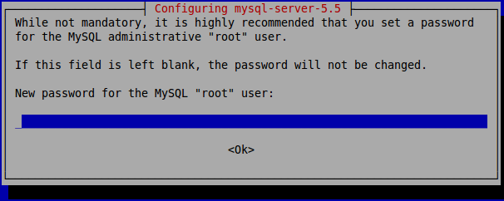
La introducimos, la confirmamos en otra ventana similar y dejamos que la shell termine de instalar y configurar el paquete.

- Instalamos el siguiente paquete de MySQL, mysql-client, con la sentencia sudo apt-get install mysql-client.
- Ahora, toca instalar el paquete phpmyadmin. Introducimos en la consola sudo apt-get install phpmyadmin. En medio del proceso de instalación, nos saldrá este ventana:

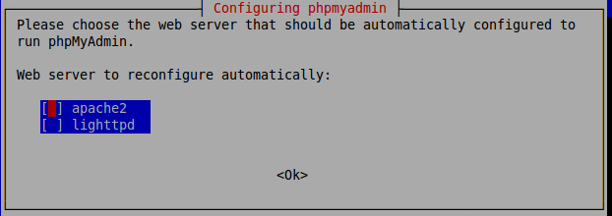
Esta ventana nos pregunta qué servidor web queremos reconfigurar para ejecutar el software phpMyAdmin. Seleccionamos el servidor apache2 con la barra espaciadora y con el tabulador hacemos clic en <Ok>. Después de un pequeño rato, la terminal vuelve a lanzar una nueva ventana para nosotros:

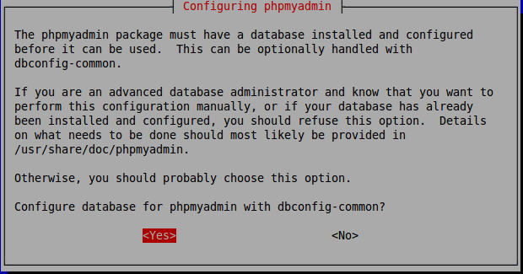
Nos pregunta aquí si queremos que se nos configure la base de datos para poder ser usada por phpmyadmin de forma automática por el paquete dbconfig-common o si preferimos nosotros ser lo que lo hagamos. Seleccionamos Yes para que se haga automáticamente. Después de ello, casi al instante, vuelve a salir otra ventana:
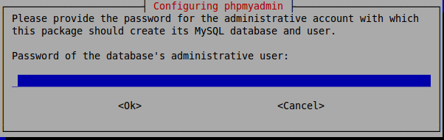

Introducimos una contraseña para el usuario administrador de la base de datos. Y, después, se lanza esta ventana:

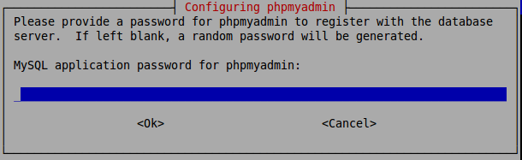
Introducimos una contraseña para la aplicación MySQL para phpmyadmin. A continuación, y después de confirmarla, se continúa ejecutando APT hasta que se finaliza la instalación de phpmyadmin.

6) Instalamos el convertidor de cadenas a sonidos (espeak) . Ejecutamos el comando sudo apt-get install espeak

7) Instalamos ahora el conversor de formato de audios lame. Ejecutamos el comando sudo apt-get install lame

Ya hemos acabado de instalar todo lo necesario y, en teoría, tendría que funcionar todo. Vamos a comprobarlo.

- Comprobamos que el servidor Apache funciona, para ello, escribimos en el navegador la ruta localhost y tendría que salir la página índice de nuestro servidor. Y, como podemos ver, se muestra lo que debería mostrarse:
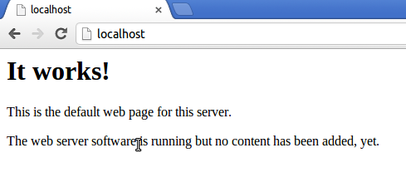

2) Comprobamos que el intérprete de PHP funcione y este asociado con Apache. Esto lo podemos hacer ejecutando un código PHP:

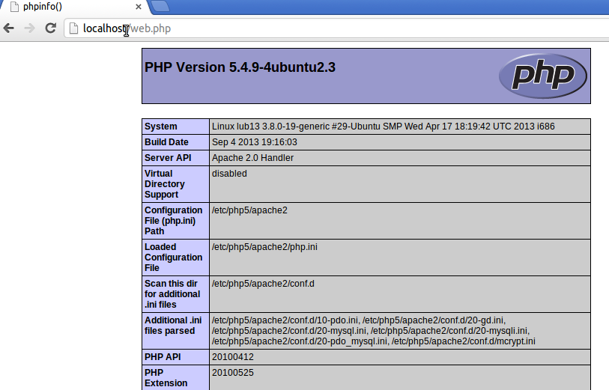
- Por último, comprobamos que MySQL y phpMyAdmin funciona y este asociado a Apache:

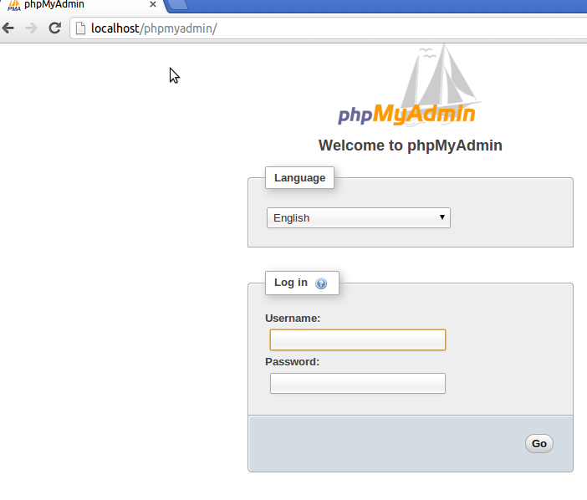
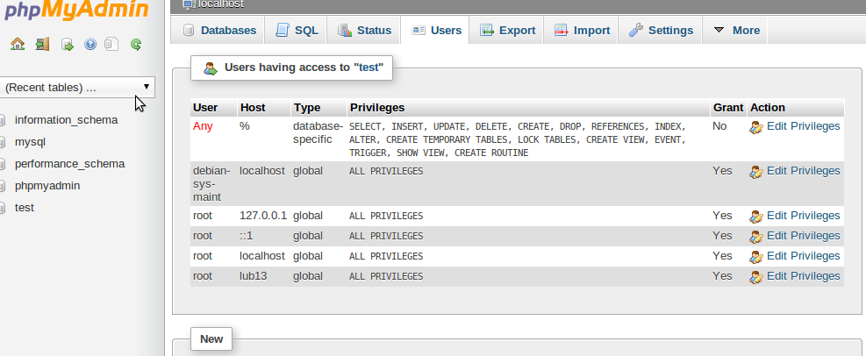

Para empezar a utilizar mi aplicación web, ¿qué necesitamos hacer, una vez está todo instalado?

- Obtén el directorio contenedor de toda mi aplicación web.
- Lo mueves en la raíz del servidor web. Si está configurado por defecto, hay que dirigirse a /var/www/
- Inicias el servicio de apache2 en el caso que no esté ya iniciado mediante el comando sudo service apache2 start.
- Inicias el servicio de mysql en el caso que no esté ya iniciado mediante el comando sudo service mysql start.
- Nos dirigimos a phpmyadmin. Donde pone Importar nos dirigimos para importar los ficheros SQL. Primero el create_database.sql y luego el create_tables.sql. Importante, obviamente, cuando importamos el segundo script, hay que, previamente, estar dentro de la base de datos que acaba de crear el script create_database.sql (letters_game_db).
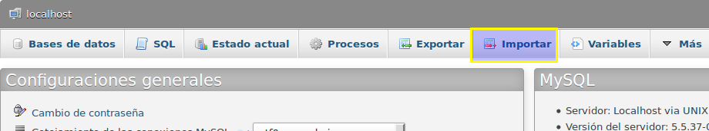

6) Por último, abrimos un navegador web (versión que soporte la etiqueta audio de HTML5) y escribimos la dirección http://localhost/lettersGame.
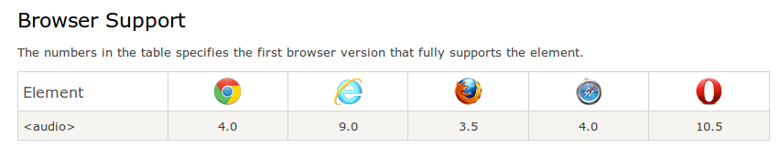

Innovation

My application has innovative use of multimedia on the web without using the outdated "Adobe Flash Player". We made use of the "audio" tag of HTML5.

